Supporting Information

Photocatalytic upcycling of polylactic acid into alanine by sulfur vacancies rich cadmium sulfide

Yue Wu^{a,b‡}, Phuc T.T. Nguyen^{a,c,‡} Tianyong Zhang ^{b} and Ning Yan^{a,c,d*}

ªDepartment of Chemical and Biomolecular Engineering, National University of Singapore, 4 Engineering Drive 4, 117585, Singapore
^{b}Tianjin Key Laboratory of Applied Catalysis Science and Technology, School of Chemical Engineering and Technology, Tianjin University, Tianjin 300354, People’s Republic of China
^{c}Joint School of National University of Singapore and Tianjin University, Fuzhou 350207, Fujian, China
^{d}Centre for Hydrogen Innovations, National University of Singapore, Singapore 117580, Singapore.

‡Both authors contributed equally to this work.

*Corresponding author: ning.yan@nus.edu.sg

Number of pages: 11
Number of tables: 3
Number of figures: 9

Table S1. The amount and speed of dropping the S precursor in different CdS samples
Catalyst | Na₂S solution amount (mL) | Drop speed
CdS-1 | 3 | 0.05 mL/min
CdS-2 | 6 | 0.10 mL/min
CdS-3 | 9 | 0.15 mL/min
CdS-4 | 12 | 0.20 mL/min
CdS-5 | 15 | 0.25 mL/min
CdS-6 | 18 | 0.30 mL/min
CdS-8 | 24 | 0.40 mL/min

Table S2. BET surface area of CdS with different S vacancy
Samples | BET Surface Area (m² g⁻¹)
CdS-6 | 113.1
CdS-5 | 133.7
CdS-4 | 146.0
CdS-3 | 145.6
CdS-2 | 144.1
CdS-1 | 147.3
Table S3. The molar ratio of Cd to S in CdS
Samples | ICP-OES | XPS
CdS-6 | 0.98 | 1.01
CdS-5 | 1.12 | 1.14
CdS-4 | 1.20 | 1.18
CdS-3 | 1.25 | 1.30
CdS-2 | 1.32 | 1.39
CdS-1 | 1.50 | 1.60

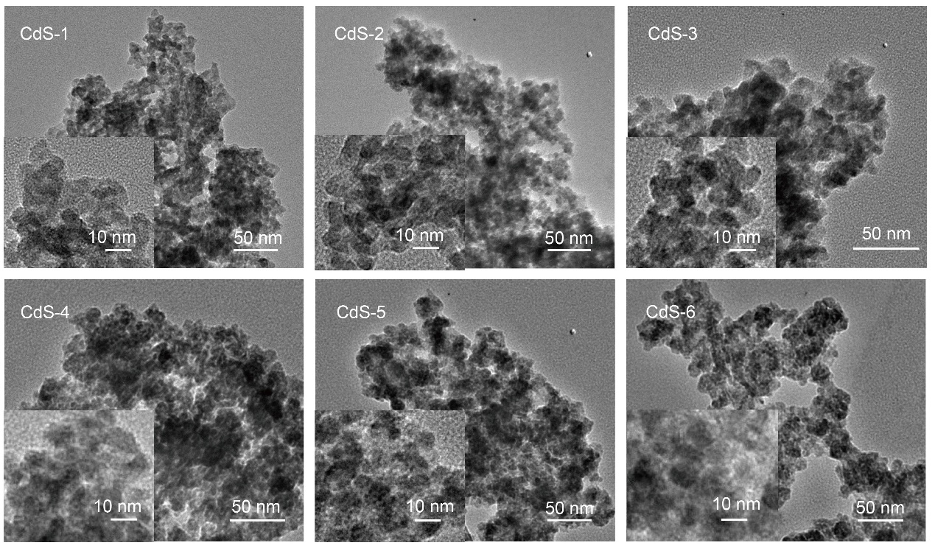
Figure S1. TEM images of CdS with different Cd:S molar ratio.

Figure S2. N₂ adsorption-desorption isotherms for CdS with different Cd:S ratio.

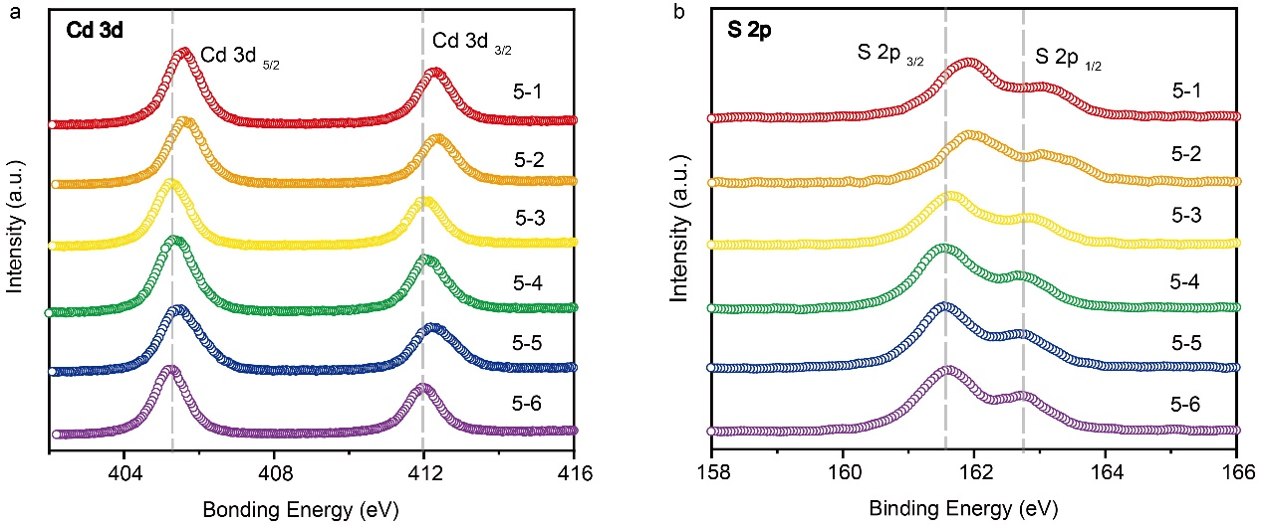
Figure S3. High-resolution XPS spectra of a Cd 3d, b S 2p for CdS with different sulfur vacancy content.

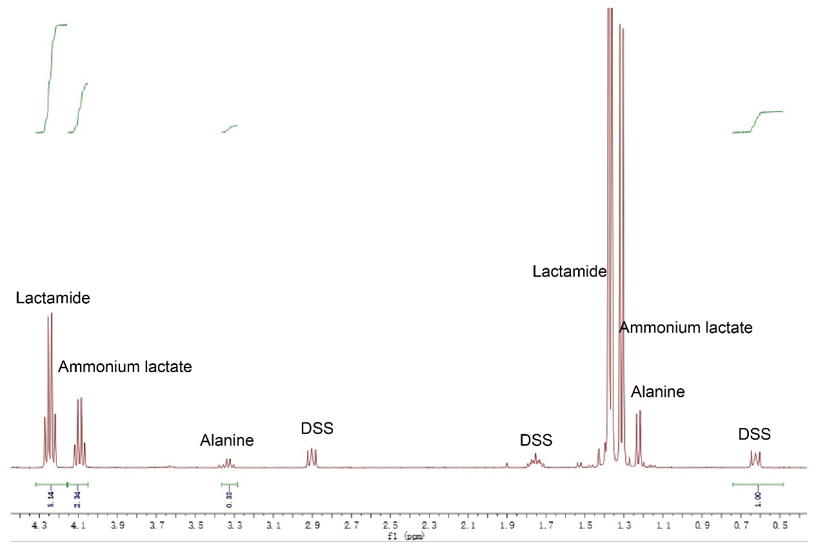
Figure S4. ¹H NMR spectra of reaction mixture. Reaction conditions: 200 mg PLA, 10 mg CdS-3, 4 mL aqueous NH₃ 25% solution, 16 mL deaerated water, 50 ℃, 4 h, 1 bar N₂, visible light. DSS: 2,2-dimethyl-2-silapentane-5-sulfonic acid.

Figure S5. Catalytic conversion of PLA to alanine at different a time (at 50 ℃) and b temperature (for 4 h). Reaction conditions: 200 mg PLA, 10 mg CdS-3, 4 mL aqueous NH₃ 25% solution, 16 mL deaerated water, 1 bar N₂, visible light.

Figure S6. Mechanism study for the photocatalytic amination of lactic acid to alanine. a Control experiments with different scavengers. Reaction conditions: scavengers, 10 mg CdS-3, 20 mmol lactic acid, 4 mL aqueous NH₃ 25% solution, 16 mL deaerated water, 50 °C, 4 h, 1 bar N₂. C₃H₈O: isopropanol, C₆H₅NO₂: nitrobenzene, DMPO: 5,5-dimethyl-1-pyrroline N-oxide. b Reaction pathways for the photocatalytic amination of lactic acid and side reaction. c In situ ESR spectra for CdS in a mixture of lactic acid, ammonia and the spin-trapping agent (DMPO) with or without visible-light irradiation.

Figure S7. FT-IR of lactic acid and the CdS NCs mixed with lactic acid. LA: lactic acid.

Fig. S8. Catalytic performances with pyruvic acid as substrates over CdS. Reaction conditions: 1.76 g pyruvic acid, 10 mg catalyst, 4 mL aqueous NH₃ 25% solution, 16 mL deaerated water, 50 ℃, 4 h, 1 bar N₂, visible light.

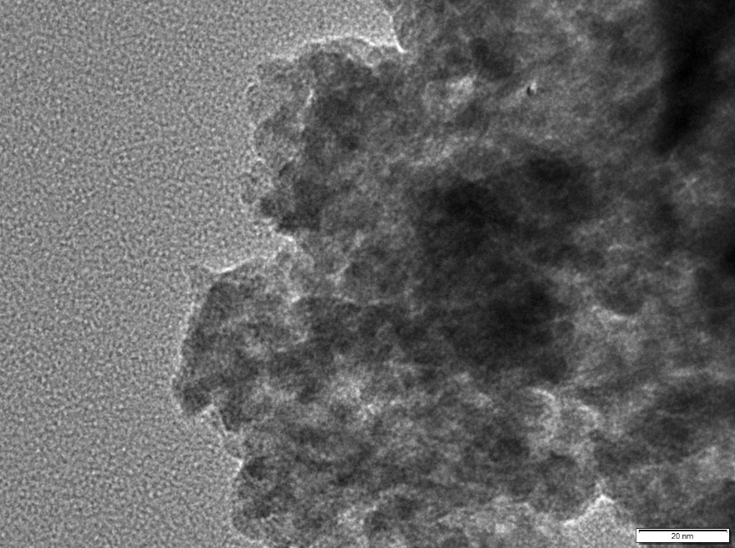
Figure S9. TEM image of CdS-3 after five cycles. Reaction conditions: 200 mg PLA, 10 mg CdS-3, 4 mL aqueous NH₃ 25% solution, 16 mL deaerated water, 50 ℃, 4 h, 1 bar N₂, visible light.

