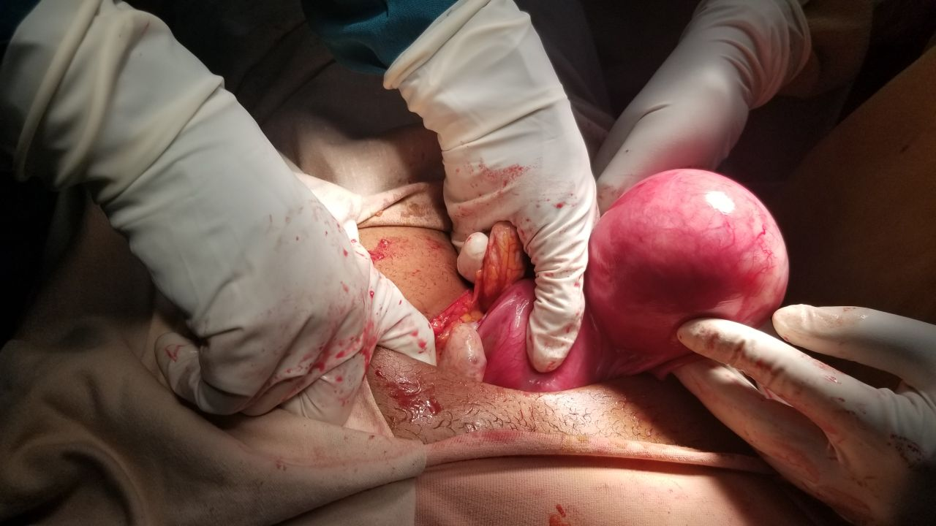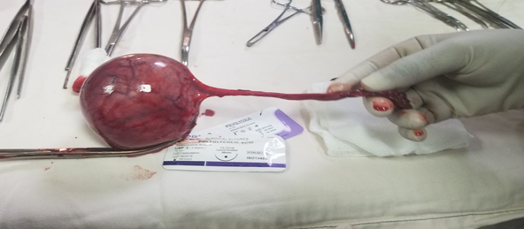
Figure-1S1 (A&B): Intra-operative finding of unicorunate horn with rudimentary horn

