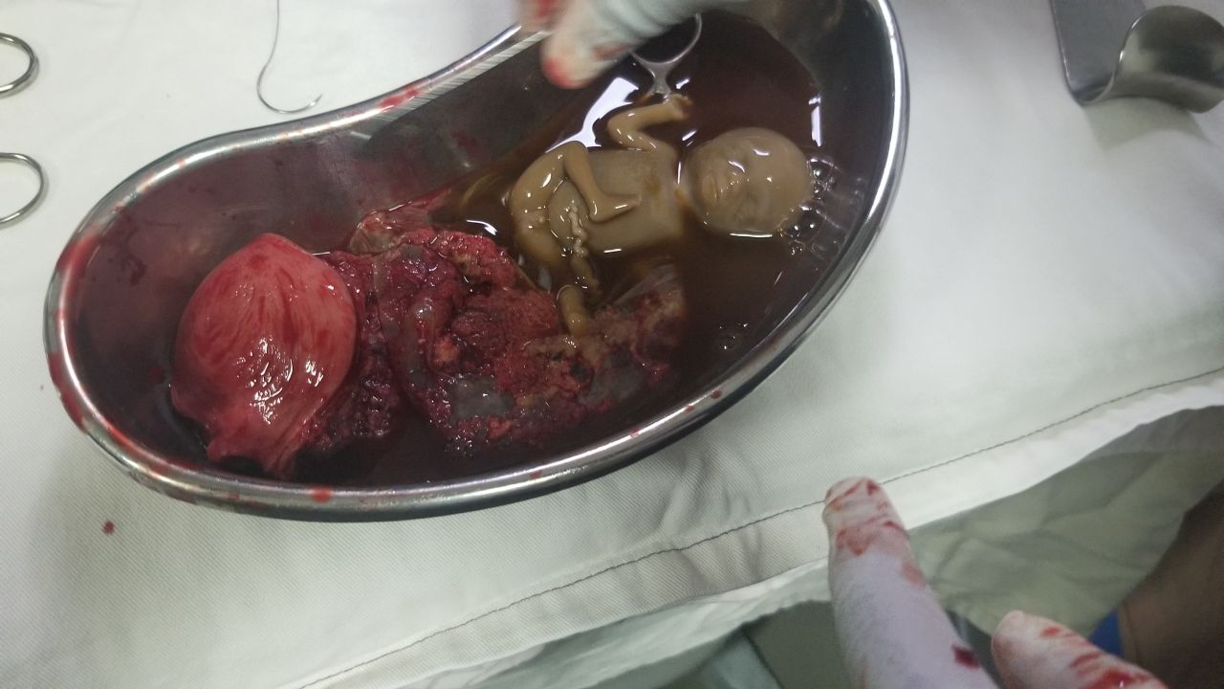
Figure-1S2: The fetal part and placenta in the rudimentary horn after the sac is dissected, which revealed a non-communicating rudimentary horn with fetus appreciatively 14 weeks

