Supplementary Information

Synthesis, structural property and bioactivity of the hydrazones derived from 2-methylsulfonyl-5-nitrobezaldehyde against the breast (MCF-7) and cervical (HeLa) cancer cell lines and their antioxidant potential.

M.M Maluleka and M.J. Mphahlele

Fig. S1: NMR spectra of compounds 2, 3a and 3b
Fig. S2: FT-IR spectra of compounds 2, 3a and 3b
Table S1: X-ray crystal data collection and structure refinement for 3a and 3b
Fig. S3. Curves used to calculate the IC₅₀ values of 2 and 3 against the Hela and MCF-7 cells
Fig. S4. Curves used to calculate the IC₅₀ values of 2, 3a and 3b against DPPH

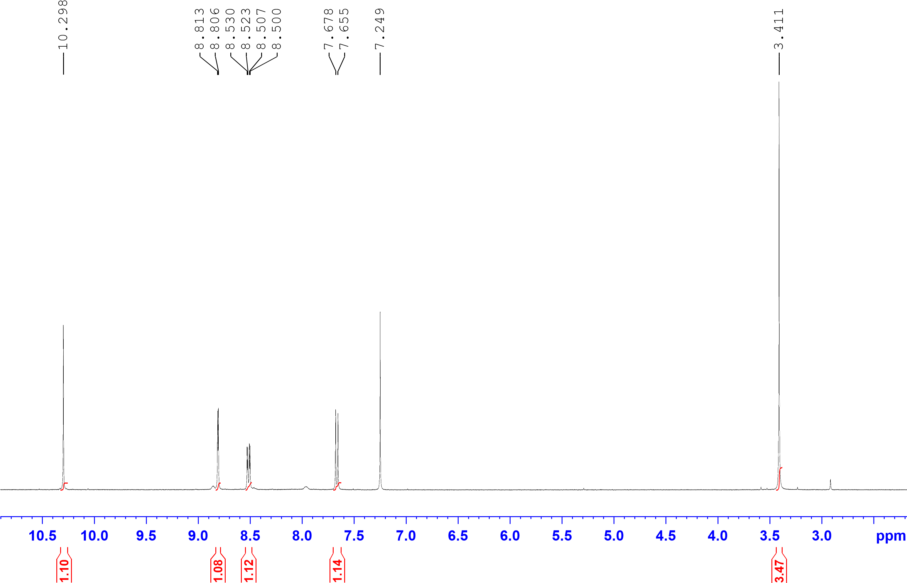
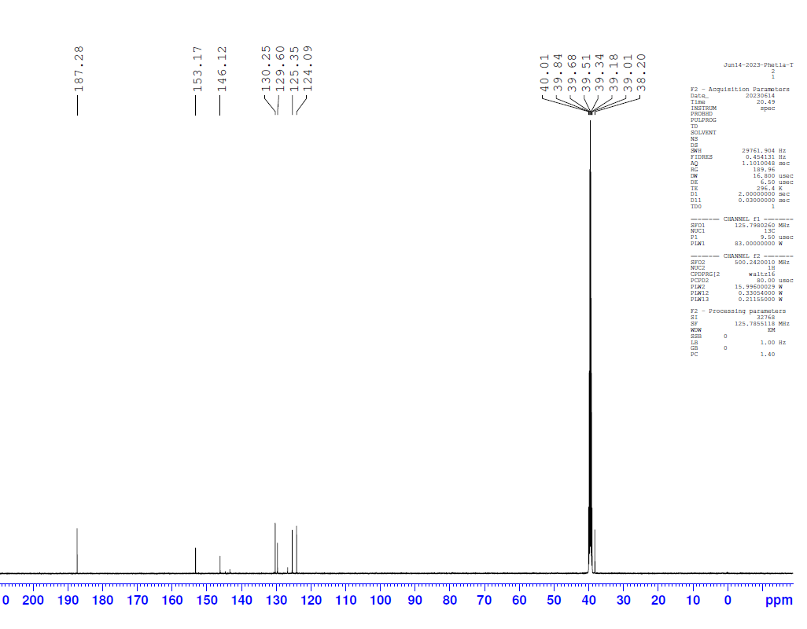
Figure S1.1. The ¹H- and ¹³C NMR spectrum of 2 in DMSO-d₆ at 500 and125 MHz, respectively.
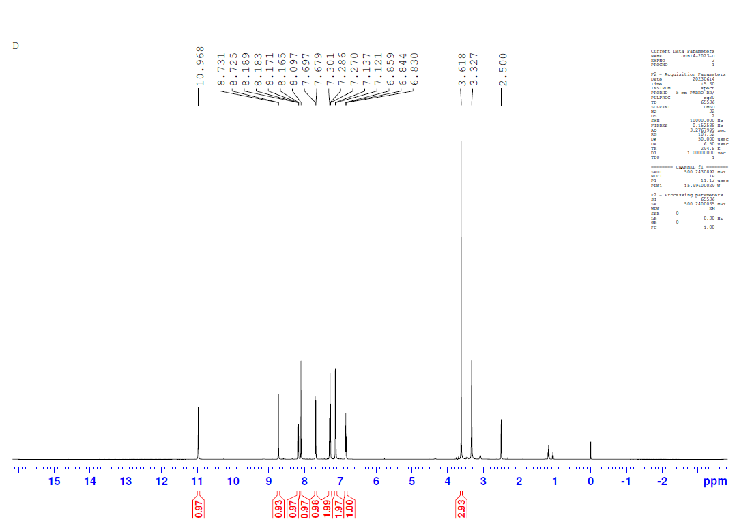
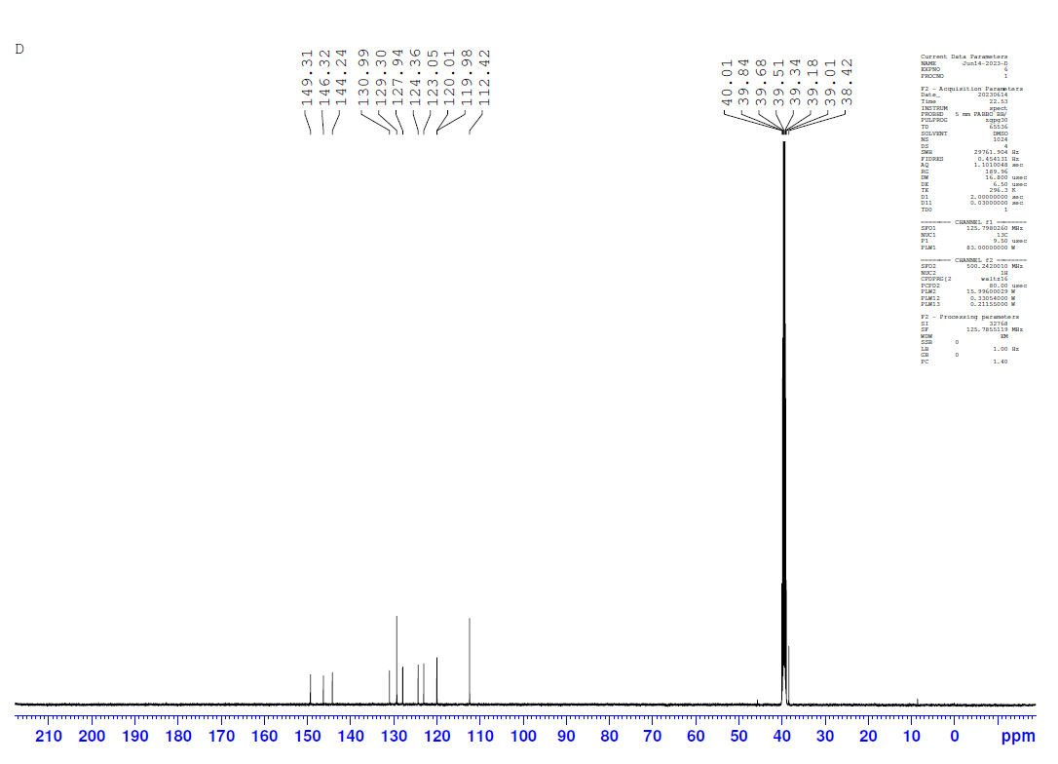
Figure S1.2. The ¹H- and ¹³C NMR spectra of 3a in DMSO-d₆ at 500 and 125 MHz, respectively
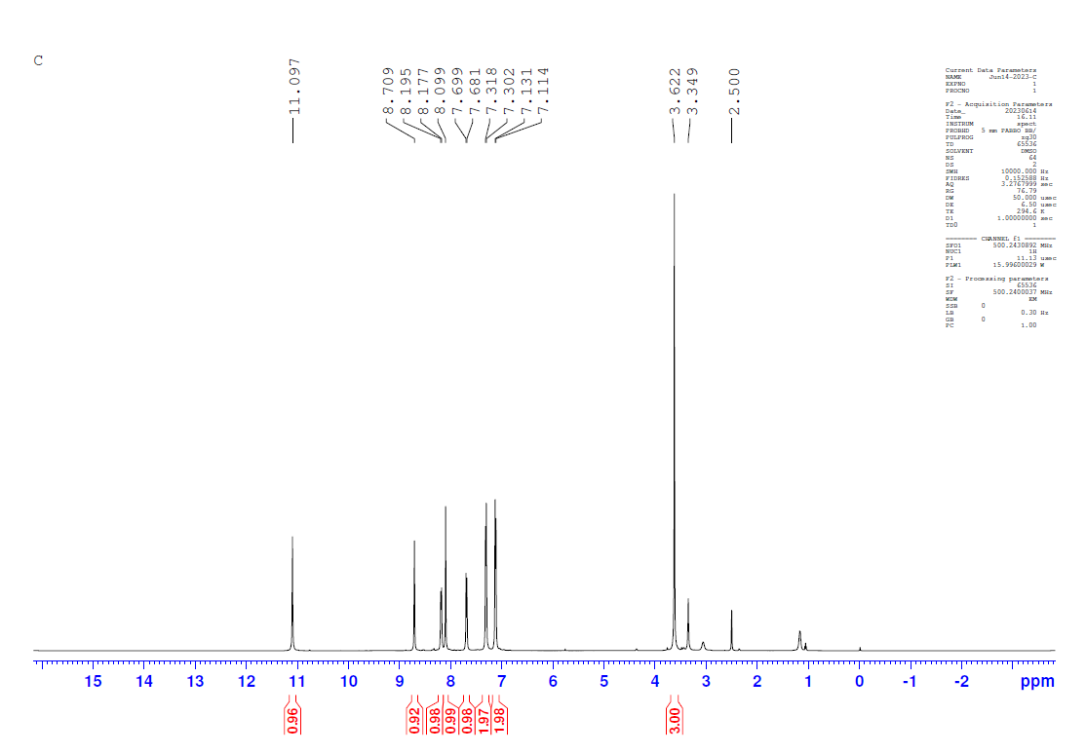
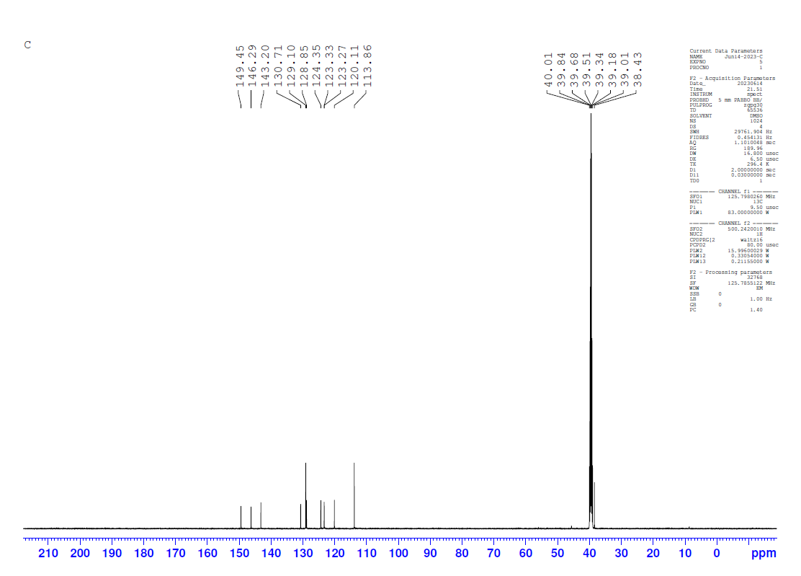
Figure S1.3. The ¹H and ¹³C NMR spectra of 3b in DMSO-d₆ at 500 and 125 MHz, respectively
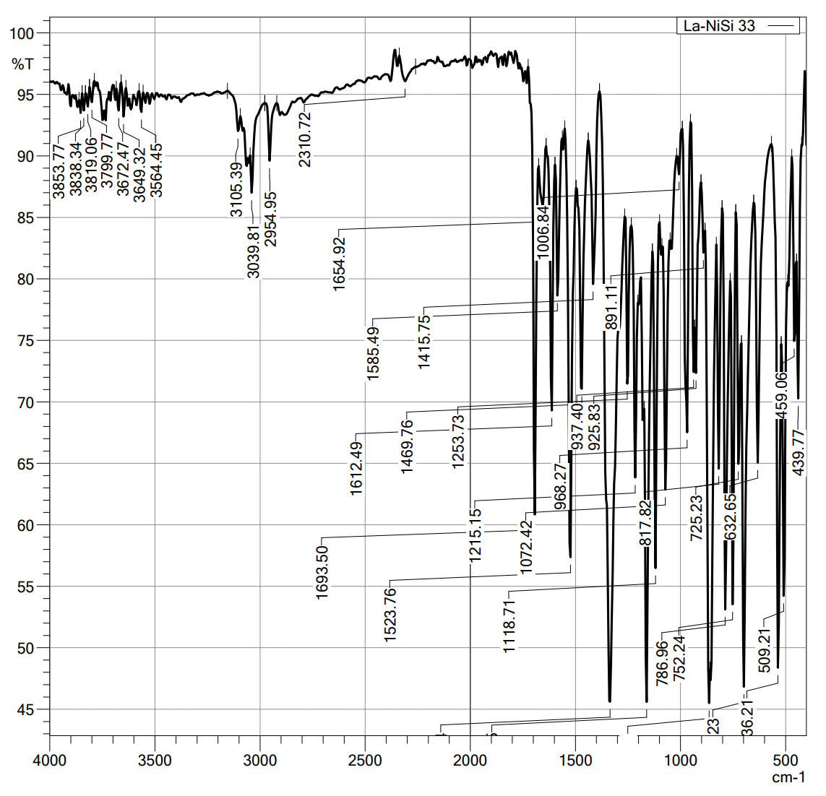
Figure S2.1. FT-IR spectrum of 2

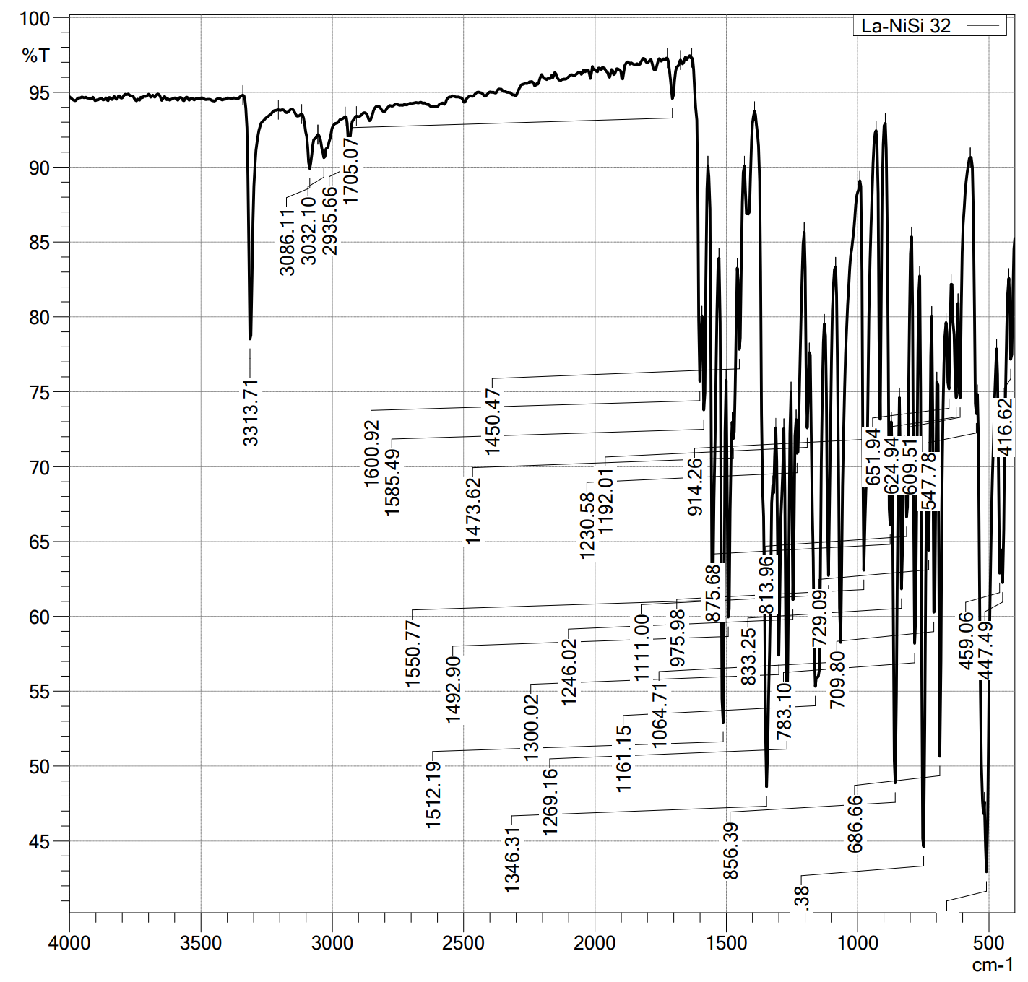
Figure S2.2. FT-IR spectrum of 3a

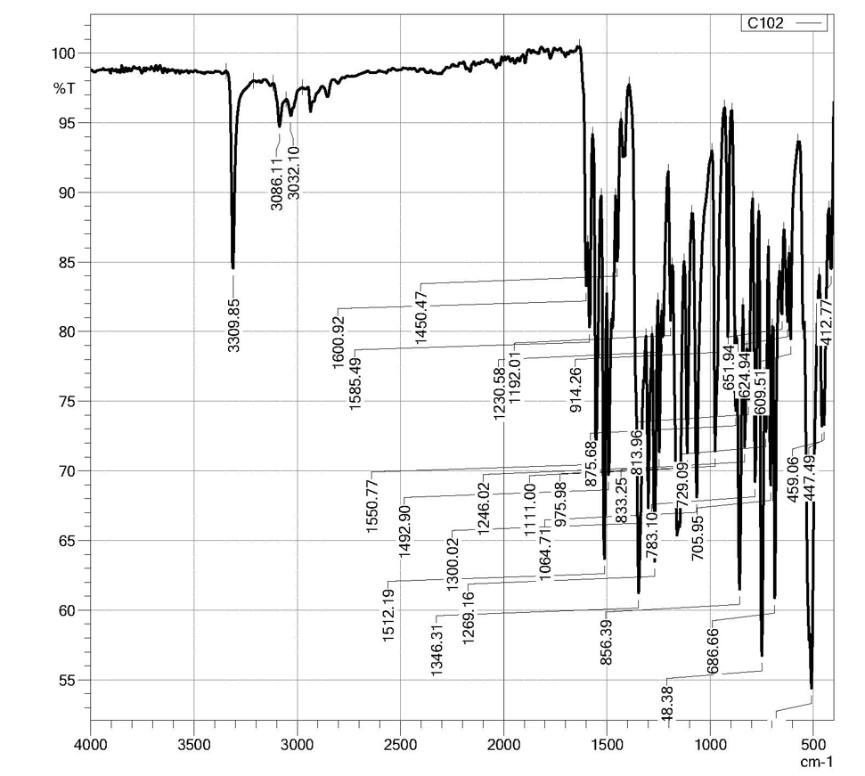
Figure S2.2. FT-IR spectrum of 3b.

 | 3a | 3b
CCDC | 2266319 | 2266325
Empirical formula | C₁₄H₁₃N₃O₅S | C₁₄H₁₂N₃O₅SCl
Formula weight | 335.33 | 369.78
Temperature/K | 173(2) | 173(2)
Crystal system | monoclinic | monoclinic
Space group | P2₁/n | P2₁/c
a/Å | 5.4471(2) | 20.3151(10)
b/Å | 16.9999(8) | 9.1917(4)
c/Å | 16.1180(7) | 8.6396(4)
α/° | 90 | 90
β/° | 95.624(2) | 100.699(2)
γ/° | 90 | 90
Volume/Å³ | 1485.35(11) | 1585.23(13)
Z | 4 | 4
ρ_{calc}g/cm³ | 1.5 | 1.549
μ/mm⁻¹ | 0.248 | 0.404
F(000) | 696.0 | 760.0
Crystal size/mm³ | 0.392 × 0.146 × 0.068 | 0.468 × 0.272 × 0.03
Radiation | MoKα (λ = 0.71073) | MoKα (λ = 0.71073)
2Θ range for data collection/° | 3.49 to 55.998 | 4.08 to 55.998
Index ranges | -7 ≤ h ≤ 7, -22 ≤ k ≤ 22, -21 ≤ l ≤ 21 | -26 ≤ h ≤ 26, -12 ≤ k ≤ 12, -11 ≤ l ≤ 11
Reflections collected | 62183 | 80132
Independent reflections | 3586 [R_{int} = 0.0586, R_{sigma} = 0.0269] | 3822 [R_{int} = 0.07, R_{sigma} = 0.0329]
Data/restraints/parameters | 3586/0/213 | 3822/0/222
Goodness-of-fit on F² | 1.094 | 1.066
Final R indexes [I>=2σ (I)] | R₁ = 0.0319, wR₂ = 0.0884 | R₁ = 0.0328, wR₂ = 0.0902
Final R indexes [all data] | R₁ = 0.0357, wR₂ = 0.0934 | R₁ = 0.0355, wR₂ = 0.0937
Largest diff. peak/hole / e Å⁻³ | 0.24/-0.39 | 0.51/-0.39

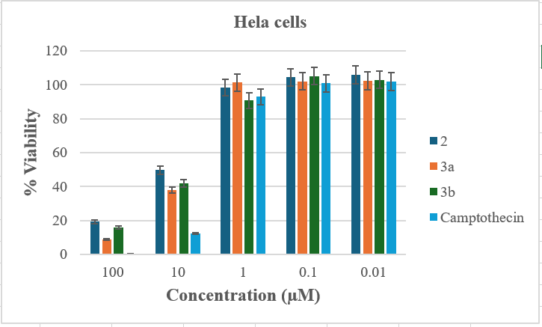
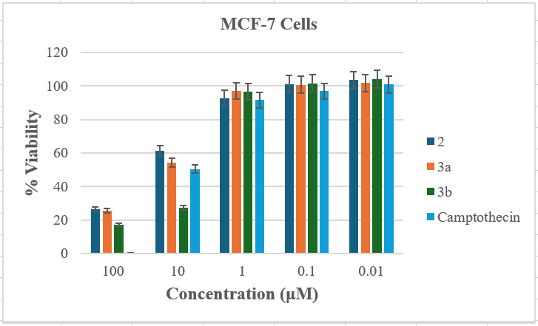

Fig. S3. Curves used to calculate the IC₅₀ values of 2 and 3 against the Hela and MCF-7 cells.
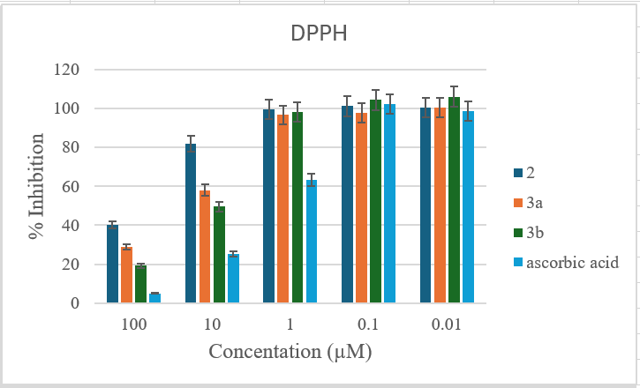

Fig. S4. Curves used to calculate the IC₅₀ values of 2, 3a and 3b against DPPH.

