Supplementary Material
In our preestablished AI pipeline, we incorporate four separate AI models dedicated to tasks such as classifying MRI sequences, segmenting and measuring the prostate gland, identifying the zonal anatomy of the prostate, and detecting prostate cancer. Below, we provide specific descriptions for each of these AI models.

(i) MRI sequence classification

Data enrollment
A total of 1,153 mpMRI examinations taken from 1,086 patients between July 28, 2009, and Nov. 26, 2021, were retrospectively gathered. Following the import of anonymized data, DICOM files underwent conversion to Nifty format using dicom2nii.py in Python 3.5 to obtain the image data.
The DICOM data were initially divided into multiple scan sequences per MR examination, with individual sequences containing more than 15 slices being considered for the study.
Each sequence was then further subdivided into image groups based on matching acquisition parameters and spatial location. Diffusion weighted imaging (DWI) sequences were grouped by their b-value; for instance, a DWI sequence with 3 b-values was split into 3 separate image groups, each with a unique b-value.
Ultimately, a total of 5,151 images from five distinct types were classified. These included 1) DWI_High (b value ≥ 500 s/mm², n=1045), 2) DWI_Low (b value ≤ 100 s/mm², n=1012), 3) apparent diffusion coefficient (ADC) map (n=906), 4) T2-weighted imaging_nan (T2WI_nan) (nonfat-sat T2WI, n=1000), and 5) T2WI_fs (fat-sat T2WI, n=1188). T1-weighted imaging (T1WI) and dynamic contrast-enhanced (DCE) images were acquired but not included in the study.

MR scanners and imaging protocols
The mpMRI images were obtained from a total of 15 MR scanners from four different vendors. The transmit coils employed were body coils, while the receive coils utilized were phased array coils. No endorectal coil was utilized in this process. Further details regarding the MR scanners and image types can be found in Table S1.

Development of the deep learning model
The input image utilized an automatic window width and window level. Histogram equalization was applied, followed by resizing each image to 64×128×128 pixels. The training and validation datasets underwent augmentation through various image transformations, including rotation within a range of -10° to 10°, addition of random noise, perspective transformation, and translation by 0.01 pixels in cardinal or ordinal directions.
A total of 5,151 MR sequences were randomly divided into sets: 80% for training, 10% for validation, and 10% for testing. The modified Med3D network (refer to Figure S1) was retrained for classifying prostate mpMRI sequences. Utilizing transfer learning, we employed the encoder weights to extract image features. The encoder section was retained, while the decoder section (deconvolution part) was replaced with the convolution and fully connected layers of a conventional classification network structure. The classification convolution layer comprised four layers: 1) a max-pooling layer (stride: 2); 2) a convolution layer (kernel: 3); 3) another max-pooling layer (stride: 2); and 4) another convolution layer (kernel: 3). The fully connected layer of the classification network consisted of 128 neurons, where the image features were amalgamated and classified. The classification array was computed and output using the softmax function.
All training processes were executed on an NVIDIA Tesla P100 16G GPU. The algorithm was implemented in Python 3.6, utilizing PyTorch 0.4.1, OpenCV 3.4.0.12, Numpy 1.16.2, and SimpleITK 1.2.0. Training parameters were configured as follows: initial learning rate of 0.0001, mini-batch size of 4, and a maximum of 400 epochs. Classification efficiency was assessed using the confusion matrix.

Results
The confusion matrix depicting the prediction results across various datasets can be found in Figure S2. Additionally, the corresponding prediction accuracies for the image classification model in different datasets are provided in Table S2. Specifically, the prediction accuracies for the training, validation, and testing datasets ranged between 99.2% and 100.0%, 98.9% and 100.0%, and 99.5% and 100.0%, respectively.

(ii) Prostate gland segmentation and measurement

Data enrollment
The mpMRI images were obtained retrospectively from a cohort of 2,673 patients, involving a total of 2,849 mpMRI examinations conducted between July 28, 2009, and Nov. 26, 2021.
Following the import of anonymized data, the DICOM files underwent conversion to Nifty format using dicom2nii.py in Python 3.5. ADC maps (n=2320) were derived from the DWI sequence with both high and low b-values. Additionally, conventional T2WI and fat saturation T2WI (n=3654) were selected for further analysis.

MR scanners and imaging protocols
The mpMRI images were acquired from a total of 19 MR scanners sourced from four different vendors. The transmit coils employed were body coils, while the receive coils utilized were phased array coils. Further details regarding the MR scanners and image types can be found in Table S3.

Development of the deep learning model
The ground truth for the prostate gland was manually outlined by two experts with over 5 years of experience. The ADC and T2WI images were resized to 64×256×224 (z, y, x) pixels and used as input for the network. Data in the training set were augmented by applying random rotation (within 10°), adding random noise, and performing parallel translation within a range of [(-0.1; 0.1); (-0.1; 0.1)] pixels.
In a preliminary experiment (1), the classic U-Net (2) framework was employed. The U-Net model consists of an encoder-decoder structure with skip connections. The encoder portion is responsible for extracting features from the input image through a series of downsampling operations using convolutional layers. The decoder, on the other hand, upsamples the features back to the original image resolution through a series of upsampling operations. We downloaded the code of the U-Net model (https://github.com/milesial/Pytorch-UNet/tree/master) for the image segmentation task. The model training was conducted on a personal computer with an Intel Core i5 3.2 GHz CPU, 16 GB of main memory, and an NVIDIA GTX1060 GPU.

Results
The Dice similarity coefficient (DSC), Jaccard index, volumetric similarity (VS), Hausdorff distance (HD), and average distance (AD) were used to compare the model and manual segmentation results. The right and left (RL) diameter, anterior and posterior (AP) diameter, and superior and inferior (SI) diameter of the prostate gland were automatically measured using the algorithm rule of the minimum volume bounding box (Figure S3).
The DSC, Jaccard index, VS, HD, and AD in different datasets are shown in Table S4 and Figure S4. Bland‒Altman analysis of the measured values of the prostate gland, including RL diameter, AP diameter, SI diameter, volume, and signal intensity, are shown in Table S5 and Figure S5. The differences between the manual label and the predicted label to their means were -2.058% to 4.257%.

(iii) Prostate zonal anatomy segmentation

Prostate sextant locations model
First, the prostate gland is segmented by the established model (refer to part ii). For sextant location, the prostatic gland was then trisected to obtain the base, mid-gland, and apex in the longitudinal axis direction. It was bisected to divide the prostate gland into left and right parts in the horizontal axis direction. Thus, the sextants were automatically generated (Figure S6).

Prostate zonal anatomy segmentation
Second, for the anatomic zone locations, we developed an anatomic regional model to segment the peripheral zone (PZ), transition zone (TZ), central zone (CZ), anterior fibromuscular stroma (AFS), urethra (URE), left seminal vesicle (LS) and right seminal vesicle (RS) (Figure S7).

Data enrollment
The mpMRI images were gathered retrospectively from a total of 1,225 patients, spanning from August 29, 2012, to November 26, 2021. Subsequent to importing the anonymized data, the DICOM files underwent conversion to Nifty format using dicom2nii.py in Python 3.5. T2WI was utilized for the creation of the prostate zonal anatomy segmentation model.

MR scanners and imaging protocols
T2WI images were acquired from a total of 17 MR scanners provided by four different vendors. The transmit coils utilized were body coils, while the receive coils employed were phased array coils. Detailed information regarding the MR scanning protocols can be found in Table S6.

Development of the deep learning model
T2WI images were resized to dimensions of 64×256×224 (z, y, x) pixels and served as the input for the network. Data augmentation in the training set involved random rotation (within a range of 10°), addition of random noise, and parallel translation within a range of [(-0.1; 0.1); (-0.1; 0.1)] pixels.
A total of 1,225 images were randomly divided into sets: 80% for training, 10% for validation, and 10% for testing. For prostate anatomic segmentation, a 3D U-Net segmentation framework (2) was employed. All training processes were carried out using the NVIDIA Tesla P100 16G GPU. The algorithm was implemented in Python 3.6, utilizing PyTorch 0.4.1, OpenCV 3.4.0.12, Numpy 1.16.2, and SimpleITK 1.2.0. The batch size was set to 10, and the networks were trained for a total of 300 epochs. The optimizer used was Adam, with a learning rate of 0.0001 and a binary cross-entropy loss function to minimize loss.

Result
The DSC, JACRD, VS, HD, and AD in different datasets are shown in Table S7.

(iv) Prostate cancer segmentation

Data enrollment
A total of 2,221 MRI images acquired between January 2014 and December 2019 were gathered retrospectively for the purpose of training an AI model for PCa segmentation. The inclusion criteria were specifically defined as follows: (a) a series of patients who underwent mpMRI prior to biopsy, primarily due to clinical suspicion of PCa arising from elevated serum prostate-specific antigen (PSA) levels, abnormal findings during digital rectal examination, and/or abnormal transrectal ultrasound results; (b) patients who subsequently underwent image-guided biopsy, transurethral prostatectomy, or radical prostatectomy within one month following the MRI examination and obtained pathological confirmation; (c) patients who had not received any PCa-related treatment prior to the examination; and (d) patients who tested negative for PCa during biopsy and exhibited no potential signs of PCa during clinical follow-up for a period exceeding one year.
The exclusion criteria encompassed (a) incomplete image data, (b) substandard image quality, and (c) discrepancies between the MRI image and the pathology result, including variances in tumor location, clinically significant PCa (csPCa) not discernible through MRI, and cases where imaging suggested csPCa but pathology confirmed its absence.

MR scanners and imaging protocols
Prostate MRI images were obtained from a total of 16 different MR scanners to compile the model development dataset. The MRI sequences encompassed T1WI, T2WI, DWI, and ADC maps. Detailed information regarding the MR scanning protocols is presented in Table S11.

Development of the deep learning model
The ground truth of the prostate gland was meticulously delineated by two experts, each with over 5 years of experience. To ensure accurate alignment, the DWI, ADC maps, and T2WI images were registered through rigid transformation using the coordinate information stored in the DICOM image headers. Standardization and cropping were applied to all prostate areas, resulting in a uniform size of 64×64×64 (x, y, z), with pixel intensities normalized within the range of [0, 1]. To augment the training set, random rotations (within a range of 10°), random noise, and parallel translations within the range of [(-0.1, 0.1); (-0.1, 0.1)] pixels were applied.
The dataset was randomly divided into three sets: 80% for training, 10% for validation, and 10% for internal testing. The AI model utilized a combination of DWI and ADC maps as input for PCa segmentation. For the segmentation process, a cascade 3D U-Net framework was employed. Model training was conducted on an NVIDIA Tesla P100 16G GPU, with the algorithm implemented using Python 3.6, PyTorch 0.4.1, OpenCV 3.4.0.12, Numpy 1.16.2, and SimpleITK 1.2.0.

Result
In the test set, the model demonstrated excellent performance in lesion segmentation, achieving a DSC value of 0.80 [0.61, 0.86]. Additional evaluation metrics, including the Jaccard Index (JACRD), VS, HD, and AD in different datasets, can be found in Table S12.
Furthermore, Table S13 provides the outcomes of the Bland‒Altman analysis for the measured values of PCa foci, encompassing the right-left (RL) diameter, anteroposterior (AP) diameter, superoinferior (SI) diameter, volume, and ADC value. The Bland‒Altman analysis compares the AI-generated measurements with those annotated by radiologists, serving as the reference standard. These results indicate a high degree of agreement in the predicted volumes, three-dimensional diameters, and ADC values of prostate cancer lesions when compared to the reference standard. The observed differences between the majority of AI results and the reference standard fall within the 95% limit of agreement.

Reference
1. Zhu Y, Wei R, Gao G, Ding L, Zhang X, Wang X, Zhang J. Fully automatic segmentation on prostate MR images based on cascaded fully convolution network. J Magn Reson Imaging 2019;49:1149-56.
2. Çiçek Ö, Abdulkadir A, Lienkamp SS, Brox T, Ronneberger O, editors. 3D U-Net: Learning Dense Volumetric Segmentation from Sparse Annotation. Medical Image Computing and Computer-Assisted Intervention – MICCAI 2016; 2016 2016//; Cham: Springer International Publishing.

Supplementary Tables
Table S1 Information on the MR scanners and the image types
 | Overall | Training | Validation | Testing | P value
 | (n=5151) | (n=4122) | (n=513) | (n=516) | P value
Age (yrs)
Median [Q1, Q3] | 71.0 [65.0, 76.0] | 71.0 [65.0, 76.0] | 71.0 [66.0, 77.0] | 71.0 [65.0, 76.0] | 0.46
Image Type
ADC | 906 (17.6%) | 730 (17.7%) | 86 (16.8%) | 90 (17.4%) | P>0.99
DWI_High | 1045 (20.3%) | 835 (20.3%) | 105 (20.5%) | 105 (20.3%)
DWI_Low | 1012 (19.6%) | 808 (19.6%) | 102 (19.9%) | 102 (19.8%)
T2WI_Fs | 1188 (23.1%) | 950 (23.0%) | 120 (23.4%) | 118 (22.9%)
T2WI_nan | 1000 (19.4%) | 799 (19.4%) | 100 (19.5%) | 101 (19.6%)
Magnetic Field
1.5 T | 657 (12.8%) | 523 (12.7%) | 59 (11.5%) | 75 (14.5%) | 0.33
3.0 T | 4494 (87.2%) | 3599 (87.3%) | 454 (88.5%) | 441 (85.5%)
Manufacture
GE Medical Systems | 2635 (51.2%) | 2100 (50.9%) | 253 (49.3%) | 282 (54.7%) | 0.50
Philips Medical Systems | 491 (9.5%) | 397 (9.6%) | 50 (9.7%) | 44 (8.5%)
SIEMENS | 2025 (39.3%) | 1625 (39.4%) | 210 (40.9%) | 190 (36.8%)
Station Name
AWP145938 | 597 (11.6%) | 468 (11.4%) | 73 (14.2%) | 56 (10.9%) | 0.17
AWP152194 | 119 (2.3%) | 96 (2.3%) | 12 (2.3%) | 11 (2.1%)
AWP166059 | 194 (3.8%) | 164 (4.0%) | 17 (3.3%) | 13 (2.5%)
AWP174090 | 8 (0.2%) | 5 (0.1%) | 0 (0%) | 3 (0.6%)
AWP39300 | 6 (0.1%) | 5 (0.1%) | 0 (0%) | 1 (0.2%)
DVMRDVMR | 1172 (22.8%) | 939 (22.8%) | 124 (24.2%) | 109 (21.1%)
GEHC | 1023 (19.9%) | 821 (19.9%) | 87 (17.0%) | 115 (22.3%)
GEHCGEHC | 440 (8.5%) | 340 (8.2%) | 42 (8.2%) | 58 (11.2%)
MRC35207 | 696 (13.5%) | 567 (13.8%) | 69 (13.5%) | 60 (11.6%)
MRC40764 | 387 (7.5%) | 306 (7.4%) | 37 (7.2%) | 44 (8.5%)
MRSUZTB03A | 57 (1.1%) | 49 (1.2%) | 4 (0.8%) | 4 (0.8%)
PHILIPS-8FA1B4E | 72 (1.4%) | 62 (1.5%) | 5 (1.0%) | 5 (1.0%)
PHILIPS-CB0GKAC | 12 (0.2%) | 9 (0.2%) | 0 (0%) | 3 (0.6%)
PHILIPS-DSALI1J | 156 (3.0%) | 124 (3.0%) | 17 (3.3%) | 15 (2.9%)
PHILIPS-NK6RG9A | 194 (3.8%) | 153 (3.7%) | 24 (4.7%) | 17 (3.3%)
Quantitative variables are given as the median [Q1, Q3] for nonnormalized data. Fs fat saturation, T2WI T2-weighted imaging, ADC apparent diffusion coefficient, DWI diffusion-weighted imaging.

Table S2 Prediction efficacies of the image classification model in different datasets
 | Image Type | Image Number | Accuracy | Sensitivity | Specificity | PPV | NPV | F1 | Kappa | Prevalence | Detection Rate | Detection Prevalence
Train
 | ADC | 718 | 1.000 | 1.000 | 1.000 | 0.999 | 1.000 | 0.999 | 0.999 | 0.174 | 0.174 | 0.174
 | DWI_High | 849 | 0.996 | 0.994 | 0.998 | 0.991 | 0.998 | 0.992 | 0.990 | 0.206 | 0.205 | 0.207
 | DWI_Low | 815 | 0.992 | 0.987 | 0.998 | 0.991 | 0.997 | 0.989 | 0.986 | 0.198 | 0.195 | 0.197
 | T2WI_Fs | 957 | 0.998 | 0.997 | 0.999 | 0.998 | 0.999 | 0.997 | 0.997 | 0.232 | 0.231 | 0.232
 | T2WI_nan | 783 | 1.000 | 1.000 | 1.000 | 0.999 | 1.000 | 0.999 | 0.999 | 0.190 | 0.190 | 0.190
Validation
 | ADC | 96 | 1.000 | 1.000 | 1.000 | 1.000 | 1.000 | 1.000 | 1.000 | 0.187 | 0.187 | 0.187
 | DWI_High | 93 | 0.989 | 0.978 | 1.000 | 1.000 | 0.995 | 0.989 | 0.987 | 0.181 | 0.177 | 0.177
 | DWI_Low | 101 | 0.998 | 1.000 | 0.995 | 0.981 | 1.000 | 0.990 | 0.988 | 0.197 | 0.197 | 0.201
 | T2WI_Fs | 107 | 1.000 | 1.000 | 1.000 | 1.000 | 1.000 | 1.000 | 1.000 | 0.209 | 0.209 | 0.209
 | T2WI_nan | 116 | 1.000 | 1.000 | 1.000 | 1.000 | 1.000 | 1.000 | 1.000 | 0.226 | 0.226 | 0.226
Test
 | ADC | 92 | 1.000 | 1.000 | 1.000 | 1.000 | 1.000 | 1.000 | 1.000 | 0.178 | 0.178 | 0.178
 | DWI_High | 103 | 0.995 | 0.990 | 1.000 | 1.000 | 0.998 | 0.995 | 0.994 | 0.200 | 0.198 | 0.198
 | DWI_Low | 96 | 0.999 | 1.000 | 0.998 | 0.990 | 1.000 | 0.995 | 0.994 | 0.186 | 0.186 | 0.188
 | T2WI_Fs | 124 | 1.000 | 1.000 | 1.000 | 1.000 | 1.000 | 1.000 | 1.000 | 0.240 | 0.240 | 0.240
 | T2WI_nan | 101 | 1.000 | 1.000 | 1.000 | 1.000 | 1.000 | 1.000 | 1.000 | 0.196 | 0.196 | 0.196
ADC apparent diffusion coefficient, T2WI T2-weighted imaging, DWI diffusion weighted imaging, Fs fat saturation, PPV positive predictive value, NPV negative predictive value.

Table S3 Information on the MR scanners and the image types
 | Overall | Train | Validation | Test | P Value
 | (n=5974) | (n=4780) | (n=601) | (n=593) | P Value
Magnetic Field |  |  |  |  | 0.50
1.5T | 1034 (17.3%) | 841 (17.6%) | 96 (16.0%) | 97 (16.4%)
3.0T | 4940 (82.7%) | 3939 (82.4%) | 505 (84.0%) | 496 (83.6%)
Image Type |  |  |  |  | 0.35
ADC | 2320 (38.8%) | 1873 (39.2%) | 217 (36.1%) | 230 (38.8%)
T2WI | 3654 (61.2%) | 2907 (60.8%) | 384 (63.9%) | 363 (61.2%)
Manufacture |  |  |  |  | 0.79
GE MEDICAL SYSTEMS | 3243 (54.3%) | 2599 (54.4%) | 316 (52.6%) | 328 (55.3%)
Philips Medical Systems | 810 (13.6%) | 637 (13.3%) | 91 (15.1%) | 82 (13.8%)
SIEMENS | 1695 (28.4%) | 1368 (28.6%) | 168 (28.0%) | 159 (26.8%)
UIH | 226 (3.8%) | 176 (3.7%) | 26 (4.3%) | 24 (4.0%)
Model Name |  |  |  |  | 0.87
Achieva | 150 (2.5%) | 123 (2.6%) | 17 (2.8%) | 10 (1.7%)
Ingenia | 583 (9.8%) | 456 (9.5%) | 64 (10.6%) | 63 (10.6%)
Ingenia CX | 3 (0.1%) | 2 (0.0%) | 1 (0.2%) | 0 (0%)
Discovery MR750 | 2753 (46.1%) | 2204 (46.1%) | 276 (45.9%) | 273 (46.0%)
Discovery MR750w | 304 (5.1%) | 250 (5.2%) | 21 (3.5%) | 33 (5.6%)
Signa EXCITE | 173 (2.9%) | 135 (2.8%) | 16 (2.7%) | 22 (3.7%)
Signa HDxt | 11 (0.2%) | 9 (0.2%) | 2 (0.3%) | 0 (0%)
Signa Premier | 2 (0.0%) | 1 (0.0%) | 1 (0.2%) | 0 (0%)
Aera | 889 (14.9%) | 724 (15.1%) | 81 (13.5%) | 84 (14.2%)
Amira | 4 (0.1%) | 3 (0.1%) | 1 (0.2%) | 0 (0%)
Essenza | 2 (0.0%) | 2 (0.0%) | 0 (0%) | 0 (0%)
Multiva | 74 (1.2%) | 56 (1.2%) | 9 (1.5%) | 9 (1.5%)
Prisma | 127 (2.1%) | 99 (2.1%) | 16 (2.7%) | 12 (2.0%)
Skyra | 188 (3.1%) | 156 (3.3%) | 18 (3.0%) | 14 (2.4%)
TrioTim | 348 (5.8%) | 273 (5.7%) | 39 (6.5%) | 36 (6.1%)
Verio | 137 (2.3%) | 111 (2.3%) | 13 (2.2%) | 13 (2.2%)
uMR 790 | 226 (3.8%) | 176 (3.7%) | 26 (4.3%) | 24 (4.0%)
Quantitative variables are given as the median [Q1, Q3] for nonnormalized data. ADC apparent diffusion coefficient, T2WI T2-weighted imaging

Table S4 Segmentation metrics in different datasets
 | Overall |  |  | Train |  |  | Validation |  |  | Test
 | ADC | T2WI |  | ADC | T2WI |  | ADC | T2WI |  | ADC | T2WI
 | (n=2320) | (n=3654) |  | (n=1873) | (n=2907) |  | (n=217) | (n=384) |  | (n=230) | (n=363)
DSC | 0.921 (0.0337) | 0.937 (0.0322) |  | 0.925 (0.0279) | 0.940 (0.0270) |  | 0.902 (0.0491) | 0.922 (0.0445) |  | 0.900 (0.0446) | 0.923 (0.0449)
JACRD | 0.854 (0.0549) | 0.883 (0.0537) |  | 0.862 (0.0467) | 0.889 (0.0458) |  | 0.825 (0.0755) | 0.857 (0.0717) |  | 0.822 (0.0704) | 0.861 (0.0726)
VS | 0.970 (0.0303) | 0.979 (0.0245) |  | 0.974 (0.0236) | 0.981 (0.0200) |  | 0.953 (0.0478) | 0.967 (0.0370) |  | 0.955 (0.0449) | 0.971 (0.0339)
HD | 6.460 (3.150) | 5.880 (2.830) |  | 6.20 (2.720) | 5.640 (2.490) |  | 7.450 (4.700) | 6.780 (3.730) |  | 7.700 (3.990) | 6.840 (3.730)
AD | 0.140 (0.149) | 0.168 (4.01) |  | 0.122 (0.0962) | 0.172 (4.49) |  | 0.213 (0.293) | 0.152 (0.196) |  | 0.214 (0.233) | 0.149 (0.186)
Data conforming to a normal distribution are presented as the mean (standard deviation). DSC Dice similarity coefficient, VS volumetric similarity, HD Hausdorff distance, AD Average distance, T2WI T2-weighted imaging, ADC apparent diffusion coefficient.

Table S5 Bland‒Altman analysis of the measured values of the prostate gland

 | RL Diameter  (mm) | AP Diameter  (mm) | SI Diameter  (mm) | Volume  (cm³) | Signal Intensity
Means of label and plabel | 56.025 | 59.670 | 63.655 | 108.623 | 56.025
Differences | 2.230 | 2.540 | -1.310 | -0.924 | 2.230
Means/differences proportion | 3.980 | 4.257 | -2.058 | -0.851 | 3.980
Means of label | 57.140 | 60.940 | 63.000 | 108.160 | 57.140
Means of plabel | 54.910 | 58.400 | 64.310 | 109.085 | 54.910
Bias of the label and plabel | 0.733 | 1.094 | -1.180 | -0.623 | 0.733
Bias Upper CI | 0.800 | 1.172 | -1.063 | -0.477 | 0.800
Bias Lower CI | 0.665 | 1.017 | -1.298 | -0.769 | 0.665
Bias Std Dev | 2.679 | 3.057 | 4.643 | 5.756 | 2.679
Bias Standard Error | 0.035 | 0.040 | 0.060 | 0.745 | 0.035
LOA Standard Error | 0.059 | 0.068 | 0.103 | 0.127 | 0.059
Upper LOA | 5.984 | 7.085 | 7.919 | 10.659 | 5.984
Upper LOA_upperCI | 6.100 | 7.218 | 8.120 | 10.908 | 6.100
Upper LOA_lowerCI | 5.868 | 6.953 | 7.718 | 10.409 | 5.868
Lower LOA | -4.519 | -4.897 | -10.280 | -11.904 | -4.519
Lower LOA_upperCI | -4.403 | -4.764 | -10.078 | -11.655 | -4.403
Lower LOA_lowerCI | -4.635 | -5.029 | -10.481 | -12.154 | -4.635
Regression fixed slope | 0.076 | 0.071 | 0.032 | 0.023 | 0.076
Regression fixed intercept | -3.100 | -2.100 | -2.700 | -1.900 | -3.100
LOA limits of agreement, CI confidence interval, RL right and left, AP anterior and posterior, SI superior and inferior
Table S6 Scanning protocols of the T2WI
 | Overall | train | validate | test | P value
 | (N=1225) | (N=973) | (N=99) | (N=153) | P value
Magnetic Field
1.5T | 271 (22.1%) | 213 (21.9%) | 14 (14.1%) | 44 (28.8%) | 0.02
3.0T | 954 (77.9%) | 760 (78.1%) | 85 (85.9%) | 109 (71.2%)
Manufacture
GE MEDICAL SYSTEMS | 665 (54.3%) | 540 (55.5%) | 65 (65.7%) | 60 (39.2%) | <0.001
Philips Medical Systems | 155 (12.7%) | 111 (11.4%) | 10 (10.1%) | 34 (22.2%)
SIEMENS | 365 (29.8%) | 289 (29.7%) | 20 (20.2%) | 56 (36.6%)
UIH | 40 (3.3%) | 33 (3.4%) | 4 (4.0%) | 3 (2.0%)
Model Name
Achieva | 26 (2.1%) | 20 (2.1%) | 3 (3.0%) | 3 (2.0%) | 0.01
Aera | 239 (19.5%) | 192 (19.7%) | 8 (8.1%) | 39 (25.5%)
Amira | 1 (0.1%) | 1 (0.1%) | 0 (0%) | 0 (0%)
DISCOVERY MR750 | 547 (44.7%) | 446 (45.8%) | 54 (54.5%) | 47 (30.7%)
DISCOVERY MR750w | 78 (6.4%) | 64 (6.6%) | 5 (5.1%) | 9 (5.9%)
Ingenia | 111 (9.1%) | 79 (8.1%) | 5 (5.1%) | 27 (17.6%)
Ingenia CX | 1 (0.1%) | 1 (0.1%) | 0 (0%) | 0 (0%)
MAGNETOM_ESSENZA | 1 (0.1%) | 1 (0.1%) | 0 (0%) | 0 (0%)
Multiva | 17 (1.4%) | 11 (1.1%) | 2 (2.0%) | 4 (2.6%)
Prisma | 10 (0.8%) | 7 (0.7%) | 1 (1.0%) | 2 (1.3%)
SIGNA EXCITE | 36 (2.9%) | 28 (2.9%) | 5 (5.1%) | 3 (2.0%)
Signa HDxt | 3 (0.2%) | 1 (0.1%) | 1 (1.0%) | 1 (0.7%)
SIGNA Premier | 1 (0.1%) | 1 (0.1%) | 0 (0%) | 0 (0%)
Skyra | 34 (2.8%) | 28 (2.9%) | 3 (3.0%) | 3 (2.0%)
TrioTim | 41 (3.3%) | 35 (3.6%) | 2 (2.0%) | 4 (2.6%)
uMR 790 | 40 (3.3%) | 33 (3.4%) | 4 (4.0%) | 3 (2.0%)
Verio | 39 (3.2%) | 25 (2.6%) | 6 (6.1%) | 8 (5.2%)
FatSat
fs | 87 (7.1%) | 67 (6.9%) | 10 (10.1%) | 10 (6.5%) | 0.47
nonfs | 1138 (92.9%) | 906 (93.1%) | 89 (89.9%) | 143 (93.5%)
Repetition Time (ms)
Median [Q1, Q3] | 3560 [3040, 3880] | 3460 [3040, 3850] | 3560 [3070, 3790] | 3730 [3000, 4200] | 0.30
Echo Time (ms)
Median [Q1, Q3] | 92.9 [87.5, 112] | 92.2 [87.4, 110] | 90.3 [87.4, 103] | 99.0 [88.0, 115] | 0.05
Pixel Bandwidth (Hz)
Median [Q1, Q3] | 163 [163, 200] | 163 [163, 200] | 163 [122, 188] | 200 [160, 218] | <0.001
Flip Angle
Median [Q1, Q3] | 111 [111, 140] | 111 [111, 140] | 111 [111, 111] | 111 [111, 150] | 0.37
Reconstruction Diameter
Median [Q1, Q3] | 240 [200, 240] | 240 [200, 240] | 240 [200, 240] | 220 [200, 240] | 0.01
Slice Thickness (mm)
Median [Q1, Q3] | 4.00 [3.50, 4.00] | 4.00 [3.50, 4.00] | 4.00 [3.40, 4.00] | 4.00 [3.50, 4.00] | 0.44
Slice Spacing (mm)
Median [Q1, Q3] | 4.00 [4.00, 4.00] | 4.00 [4.00, 4.00] | 4.00 [4.00, 4.00] | 4.00 [3.60, 4.00] | 0.06
Pixel Spacing (mm)
Median [Q1, Q3] | 0.469 [0.469, 0.577] | 0.469 [0.469, 0.625] | 0.469[0.417, 0.469] | 0.469 [0.344, 0.625] | 0.05

Table S7 Segmentation metrics of the model
 | Overall | train | validate | test | P Value
 | (N=1225) | (N=979) | (N=123) | (N=123) | P Value
AFS
DSC
Median [Min, Max] | 0.790 [0, 0.920] | 0.800 [0, 0.920] | 0.710 [0, 0.890] | 0.690 [0.0300, 0.860] | <0.001
Missing | 11 (0.9%) | 8 (0.8%) | 1 (0.8%) | 2 (1.6%)
JACRD
Median [Min, Max] | 0.650 [0, 0.850] | 0.670 [0, 0.850] | 0.550 [0, 0.800] | 0.530 [0.020, 0.760] | <0.001
Missing | 11 (0.9%) | 8 (0.8%) | 1 (0.8%) | 2 (1.6%)
VS
Median [Min, Max] | 0.930 [0.0300, 1.00] | 0.940 [0.0300, 1.00] | 0.885 [0.230, 1.00] | 0.890 [0.140, 1.00] | <0.001
Missing | 11 (0.9%) | 8 (0.8%) | 1 (0.8%) | 2 (1.6%)
HD
Median [Min, Max] | 5.05 [1.56, 50.3] | 4.77 [1.56, 50.3] | 6.89 [2.21, 47.0] | 6.64 [2.50, 48.6] | <0.001
Missing | 11 (0.9%) | 8 (0.8%) | 1 (0.8%) | 2 (1.6%)
AD
Median [Min, Max] | 0.260 [0.0900, 25.3] | 0.230 [0.090, 25.3] | 0.410 [0.100, 9.58] | 0.450 [0.130, 3.73] | <0.001
Missing | 11 (0.9%) | 8 (0.8%) | 1 (0.8%) | 2 (1.6%)
PZ
DSC
Median [Min, Max] | 0.870 [0, 0.960] | 0.88 [0, 0.96] | 0.84 [0.48, 0.92] | 0.840 [0.390, 0.930] | <0.001
Missing | 1 (0.1%) | 1 (0.1%) | 0 (0%) | 0 (0%)
JACRD
Median [Min, Max] | 0.770 [0, 0.920] | 0.780 [0, 0.920] | 0.720 [0.31, 0.86] | 0.720 [0.240, 0.870]
Missing | 1 (0.1%) | 1 (0.1%) | 0 (0%) | 0 (0%)
VS
Median [Min, Max] | 0.970 [0.100, 1.00] | 0.970 [0.100, 1.00] | 0.95 [0.61, 1.00] | 0.960 [0.530, 1.00] | <0.001
Missing | 1 (0.1%) | 1 (0.1%) | 0 (0%) | 0 (0%)
HD
Median [Min, Max] | 7.55 [2.50, 50.2] | 7.20 [2.50, 43.7] | 8.91 [2.58, 50.2] | 8.11 [3.85, 44.3] | <0.001
Missing | 1 (0.1%) | 1 (0.1%) | 0 (0%) | 0 (0%)
AD
Median [Min, Max] | 0.160 [0.0500, 19.5] | 0.150 [0.0500, 19.5] | 0.240 [0.080, 2.05] | 0.240 [0.080, 4.43] | <0.001
Missing | 1 (0.1%) | 1 (0.1%) | 0 (0%) | 0 (0%)
CZ
DSC
Median [Min, Max] | 0.810 [0, 0.930] | 0.820 [0.410, 0.930] | 0.650 [0.05, 0.87] | 0.630 [0, 0.900] | <0.001
Missing | 6 (0.5%) | 6 (0.6%) | 0 (0%) | 0 (0%)
JACRD
Median [Min, Max] | 0.680 [0, 0.880] | 0.700 [0.260, 0.880] | 0.480 [0.03, 0.770] | 0.460 [0, 0.810] | <0.001
Missing | 6 (0.5%) | 6 (0.6%) | 0 (0%) | 0 (0%)
VS
Median [Min, Max] | 0.920 [0.170, 1.00] | 0.930 [0.490, 1.00] | 0.88 [0.180, 1.00] | 0.880 [0.170, 1.00] | <0.001
Missing | 6 (0.5%) | 6 (0.6%) | 0 (0%) | 0 (0%)
AD
Median [Min, Max] | 4.60 [2.00, 45.5] | 4.29 [2.00, 34.1] | 6.53 [2.80, 45.5] | 6.50 [2.73, 33.0] | <0.001
Missing | 6 (0.5%) | 6 (0.6%) | 0 (0%) | 0 (0%)
HD
Median [Min, Max] | 0.240 [0.0600, 9.09] | 0.220 [0.060, 3.89] | 0.600 [0.140, 8.41] | 0.610 [0.120, 9.09] | <0.001
Missing | 6 (0.5%) | 6 (0.6%) | 0 (0%) | 0 (0%)
TZ
DSC
Median [Min, Max] | 0.930 [0.610, 0.970] | 0.940 [0.720, 0.970] | 0.910 [0.610, 0.970] | 0.920 [0.700, 0.970] | <0.001
Missing | 1 (0.1%) | 1 (0.1%) | 0 (0%) | 0 (0%)
JACRD
Median [Min, Max] | 0.870 [0.440, 0.950] | 0.880 [0.560, 0.950] | 0.830 [0.44, 0.940] | 0.850 [0.540, 0.940] | <0.001
Missing | 1 (0.1%) | 1 (0.1%) | 0 (0%) | 0 (0%)
VS
Median [Min, Max] | 0.980 [0.770, 1.00] | 0.990 [0.840, 1.00] | 0.970 [0.770, 1.00] | 0.970 [0.830, 1.00] | <0.001
Missing | 1 (0.1%) | 1 (0.1%) | 0 (0%) | 0 (0%)
HD
Median [Min, Max] | 4.59 [2.34, 38.3] | 4.46 [2.34, 34.0] | 5.33 [2.47, 38.3] | 4.91 [2.72, 19.4] | <0.001
Missing | 1 (0.1%) | 1 (0.1%) | 0 (0%) | 0 (0%)
AD
Median [Min, Max] | 0.080 [0.020, 1.07] | 0.080 [0.020, 0.890] | 0.130 [0.03, 1.07] | 0.110 [0.0300, 0.730] | <0.001
Missing | 1 (0.1%) | 1 (0.1%) | 0 (0%) | 0 (0%)
URE
DSC
Median [Min, Max] | 0.910 [0, 0.980] | 0.920 [0.520, 0.980] | 0.830 [0, 0.960] | 0.830 [0.490, 0.960] | <0.001
Missing | 8 (0.7%) | 5 (0.5%) | 1 (0.8%) | 2 (1.6%)
JACRD
Median [Min, Max] | 0.830 [0, 0.960] | 0.840 [0.350, 0.960] | 0.700 [0, 0.930] | 0.700 [0.320, 0.930] | <0.001
Missing | 8 (0.7%) | 5 (0.5%) | 1 (0.8%) | 2 (1.6%)
VS
Median [Min, Max] | 0.940 [0.0800, 1.00] | 0.950 [0.550, 1.00] | 0.890 [0.080, 1.00] | 0.900 [0.490, 1.00] | <0.001
Missing | 8 (0.7%) | 5 (0.5%) | 1 (0.8%) | 2 (1.6%)
HD
Median [Min, Max] | 1.88 [0.780, 49.5] | 1.75 [0.780, 49.5] | 3.31 [0.940, 17.1] | 3.13 [0.780, 33.8] | <0.001
Missing | 8 (0.7%) | 5 (0.5%) | 1 (0.8%) | 2 (1.6%)
AD
Median [Min, Max] | 0.0900 [0.020, 723] | 0.080 [0.020, 1.18] | 0.220 [0.04, 723] | 0.200 [0.03, 1.13] | <0.001
Missing | 8 (0.7%) | 5 (0.5%) | 1 (0.8%) | 2 (1.6%)
RS
DSC
Median [Min, Max] | 0.920 [0, 0.970] | 0.930 [0, 0.970] | 0.900 [0.710, 0.97] | 0.900 [0, 0.970] | <0.001
Missing | 1 (0.1%) | 1 (0.1%) | 0 (0%) | 0 (0%)
JACRD
Median [Min, Max] | 0.860 [0, 0.940] | 0.860 [0, 0.940] | 0.82 [0.550, 0.930] | 0.830 [0, 0.940] | <0.001
Missing | 1 (0.1%) | 1 (0.1%) | 0 (0%) | 0 (0%)
VS
Median [Min, Max] | 0.970 [0.760, 1.00] | 0.980 [0.780, 1.00] | 0.970 [0.760, 1.00] | 0.960 [0.760, 1.00] | <0.001
Missing | 1 (0.1%) | 1 (0.1%) | 0 (0%) | 0 (0%)
AD
Median [Min, Max] | 4.17 [1.37, 52.9] | 3.98 [1.37, 52.9] | 4.94 [1.92, 39.7] | 4.74 [1.88, 37.0] | <0.001
Missing | 1 (0.1%) | 1 (0.1%) | 0 (0%) | 0 (0%)
HD
Median [Min, Max] | 0.090 [0.030, 805] | 0.080 [0.030, 805] | 0.130 [0.03, 107] | 0.120 [0.030, 15.1] | <0.001
Missing | 1 (0.1%) | 1 (0.1%) | 0 (0%) | 0 (0%)
LS
DSC
Median [Min, Max] | 0.920 [0.080, 0.970] | 0.930 [0.260, 0.970] | 0.90 [0.08, 0.960] | 0.900 [0.260, 0.960] | <0.001
Missing | 1 (0.1%) | 1 (0.1%) | 0 (0%) | 0 (0%)
JACRD
Median [Min, Max] | 0.860 [0.040, 0.950] | 0.860 [0.150, 0.950] | 0.830 [0.04, 0.920] | 0.830 [0.150, 0.920] | <0.001
Missing | 1 (0.1%) | 1 (0.1%) | 0 (0%) | 0 (0%)
VS
Median [Min, Max] | 0.980 [0.120, 1.00] | 0.980 [0.800, 1.00] | 0.970 [0.120, 1.00] | 0.960 [0.260, 1.00] | <0.001
Missing | 1 (0.1%) | 1 (0.1%) | 0 (0%) | 0 (0%)
HD
Median [Min, Max] | 3.75 [1.33, 42.3] | 3.75 [1.33, 41.3] | 4.26 [1.88, 35.5] | 4.42 [2.08, 42.3] | <0.001
Missing | 1 (0.1%) | 1 (0.1%) | 0 (0%) | 0 (0%)
AD
Median [Min, Max] | 0.0900 [0.030, 9.54] | 0.080 [0.030, 9.54] | 0.110 [0.04, 4.80] | 0.130 [0.0400, 1.70] | <0.001
Missing | 1 (0.1%) | 1 (0.1%) | 0 (0%) | 0 (0%)
Categorical variables are given as numbers (percentages). Quantitative variables are given as the median [Q1, Q3] for nonnormalized data. DSC Dice similarity coefficient, VS volumetric similarity, HD Hausdorff distance, AD Average distance, AFS anterior fibromuscular stroma, PZ peripheral zone, CZ central zone, TZ transition zone, URE urethra, LS left seminal vesicle, RS right seminal vesicle.

Table S8 Scanning protocols of the DWI/ADC images
 | Overall | train | validate | test | P value
 | (N=2105) | (N=1681) | (N=212) | (N=212) | P value
Magnetic Field
1.5T | 316 (15.0%) | 254 (15.1%) | 36 (17.0%) | 26 (12.3%) | 0.38
3.0T | 1789 (85.0%) | 1427 (84.9%) | 176 (83.0%) | 186 (87.7%)
Manufacture
GE MEDICAL SYSTEMS | 1206 (57.3%) | 959 (57.0%) | 127 (59.9%) | 120 (56.6%) | 0.41
Philips Medical Systems | 226 (10.7%) | 184 (10.9%) | 15 (7.1%) | 27 (12.7%)
SIEMENS | 571 (27.1%) | 451 (26.8%) | 62 (29.2%) | 58 (27.4%)
UIH | 102 (4.8%) | 87 (5.2%) | 8 (3.8%) | 7 (3.3%)
Model Name
Achieva | 61 (2.9%) | 52 (3.1%) | 5 (2.4%) | 4 (1.9%) | 0.87
Aera | 271 (12.9%) | 217 (12.9%) | 32 (15.1%) | 22 (10.4%)
Amira | 2 (0.1%) | 1 (0.1%) | 1 (0.5%) | 0 (0%)
DISCOVERY MR750 | 1065 (50.6%) | 844 (50.2%) | 112 (52.8%) | 109 (51.4%)
DISCOVERY MR750w | 95 (4.5%) | 75 (4.5%) | 13 (6.1%) | 7 (3.3%)
Ingenia | 134 (6.4%) | 107 (6.4%) | 8 (3.8%) | 19 (9.0%)
Ingenia CX | 1 (0.0%) | 1 (0.1%) | 0 (0%) | 0 (0%)
Multiva | 30 (1.4%) | 24 (1.4%) | 2 (0.9%) | 4 (1.9%)
Prisma | 35 (1.7%) | 29 (1.7%) | 2 (0.9%) | 4 (1.9%)
SIGNA EXCITE | 42 (2.0%) | 36 (2.1%) | 2 (0.9%) | 4 (1.9%)
Signa HDxt | 3 (0.1%) | 3 (0.2%) | 0 (0%) | 0 (0%)
SIGNA Premier | 1 (0.0%) | 1 (0.1%) | 0 (0%) | 0 (0%)
Skyra | 60 (2.9%) | 46 (2.7%) | 6 (2.8%) | 8 (3.8%)
TrioTim | 149 (7.1%) | 114 (6.8%) | 17 (8.0%) | 18 (8.5%)
uMR 790 | 102 (4.8%) | 87 (5.2%) | 8 (3.8%) | 7 (3.3%)
Verio | 54 (2.6%) | 44 (2.6%) | 4 (1.9%) | 6 (2.8%)
B value (s/mm2)
Median [Q1, Q3] | 1400 [1400, 1400] | 1400 [1400, 1400] | 1400 [1400, 1400] | 1400 [1400, 1400] | 0.70
Repetition Time (ms)
Median [Q1, Q3] | 2930 [2640, 4370] | 3000 [2640, 4380] | 2930 [2640, 4110] | 2910 [2640, 4130] | 0.76
Echo Time (ms)
Median [Q1, Q3] | 61.3 [59.7, 63.8] | 61.3 [59.7, 63.8] | 61.2 [60.0, 63.7] | 61.3 [59.7, 63.5] | 0.97
Pixel Bandwidth (Hz)
Median [Q1, Q3] | 1950 [1570, 1950] | 1950 [1630, 1950] | 1950 [1540, 1950] | 1950 [1610, 1950] | 0.21
Reconstruction Diameter (mm)
Median [Q1, Q3] | 240 [200, 240] | 240 [200, 240] | 240 [200, 240] | 240 [220, 240] | 0.34
Slice Thickness (mm)
Median [Q1, Q3] | 4.00 [4.00, 4.00] | 4.00 [4.00, 4.00] | 4.00 [4.00, 4.00] | 4.00 [4.00, 4.00] | 0.96
Slice Spacing (mm)
Median [Q1, Q3] | 4.00 [4.00, 4.50] | 4.00 [4.00, 4.50] | 4.00 [4.00, 4.50] | 4.00 [4.00, 4.50] | 0.87
Pixel Spacing (mm)
Median [Q1, Q3] | 0.938 [0.938, 1.30] | 0.938 [0.938, 1.30] | 0.938 [0.938, 1.30] | 0.938 [0.938, 1.30] | 0.81
Categorical variables are given as numbers (percentages). Quantitative variables are given as the median [Q1, Q3] for nonnormalized data.

Table S9 Segmentation metrics of the model
 | Overall | train | validate | test | P value
 | (N=2105) | (N=1681) | (N=212) | (N=212) | P value
DSC | 0.920 [0.870, 0.940] | 0.930 [0.910, 0.950] | 0.810 [0.698, 0.870] | 0.800 [0.615, 0.865] | <0.001
JACRD | 0.850 [0.770, 0.890] | 0.870 [0.830, 0.900] | 0.675 [0.528, 0.770] | 0.670 [0.445, 0.760] | <0.001
VS | 0.990 [0.950, 0.990] | 0.990 [0.980, 1.00] | 0.900 [0.800, 0.950] | 0.870 [0.735, 0.950] | <0.001
HD | 7.40 [3.08, 13.5] | 5.63 [2.50, 12.4] | 9.94 [6.76, 18.0] | 12.5 [7.91, 20.4] | <0.001
AD | 0.110 [0.0600, 0.300] | 0.0800 [0.0500, 0.180] | 0.400 [0.180, 1.11] | 0.490 [0.225, 1.67] | <0.001
Quantitative variables are given as the median [Q1, Q3] for nonnormalized data. DSC Dice similarity coefficient, VS volumetric similarity, HD Hausdorff distance, AD Average distance.

Table S 10 Measurements of the manually labeled areas and the predicted areas (median [Q1, Q3])
 | Overall | train | validate | test | P Value
 | (N=2105) | (N=1681) | (N=212) | (N=212) | P Value
Lesion number | 1.00 [0, 2.00] | 1.00 [0, 2.00] | 1.00 [0, 2.00] | 1.00 [0, 3.00] | 0.56
pLesion number | 1.00 [1.00, 1.00] | 1.00 [1.00, 1.00] | 1.00 [1.00, 1.00] | 1.00 [1.00, 1.00] | 0.72
Volume | 1.49 [0, 11.3] | 1.53 [0, 11.1] | 1.36 [0, 11.8] | 1.60 [0, 12.7] | 0.99
pVolume | 3.12 [0.864, 13.1] | 3.16 [0.864, 12.9] | 2.99 [0.730, 14.3] | 2.99 [1.06, 13.1] | 0.95
Intensity | 15300 [12900, 18100] | 15400 [13000, 18100] | 15200 [12800, 17800] | 14800 [13100, 18100] | 0.78
pIntensity | 16100 [13400, 18800] | 16100 [13400, 18900] | 16200 [13200, 18600] | 15600 [13200, 18400] | 0.42
DiaX | 2.12 [0, 4.10] | 2.11 [0, 4.10] | 1.88 [0, 4.12] | 2.21 [0, 4.12] | 0.99
pDiaX | 2.69 [1.38, 4.20] | 2.64 [1.37, 4.22] | 2.82 [1.39, 4.11] | 2.72 [1.62, 4.18] | 0.92
DiaY | 1.90 [0, 3.63] | 1.91 [0, 3.56] | 1.89 [0, 3.73] | 1.84 [0, 3.94] | 0.86
pDiaY | 2.32 [1.34, 3.73] | 2.31 [1.34, 3.67] | 2.38 [1.25, 3.90] | 2.32 [1.32, 3.85] | 0.81
DiaZ | 1.95 [0, 3.60] | 1.95 [0, 3.60] | 1.70 [0, 3.58] | 1.94 [0, 3.97] | 0.90
pDiaZ | 2.41 [1.35, 3.98] | 2.41 [1.32, 3.98] | 2.44 [1.31, 3.77] | 2.40 [1.61, 3.98] | 0.70

Table S11 Information on MR scanners and protocols
 | Train | Validate | Test
 | (N=1681) | (N=212) | (N=212)
DWI/ADC
Model Name
Achieva | 52 (3.1%) | 5 (2.4%) | 4 (1.9%)
Aera | 217 (12.9%) | 32 (15.1%) | 22 (10.4%)
Amira | 1 (0.1%) | 1 (0.5%) | 0 (0%)
DISCOVERY MR750 | 844 (50.2%) | 112 (52.8%) | 109 (51.4%)
DISCOVERY MR750w | 75 (4.5%) | 13 (6.1%) | 7 (3.3%)
Ingenia | 107 (6.4%) | 8 (3.8%) | 19 (9.0%)
Ingenia CX | 1 (0.1%) | 0 (0%) | 0 (0%)
Multiva | 24 (1.4%) | 2 (0.9%) | 4 (1.9%)
Prisma | 29 (1.7%) | 2 (0.9%) | 4 (1.9%)
SIGNA EXCITE | 36 (2.1%) | 2 (0.9%) | 4 (1.9%)
Signa HDxt | 3 (0.2%) | 0 (0%) | 0 (0%)
SIGNA Premier | 1 (0.1%) | 0 (0%) | 0 (0%)
Skyra | 46 (2.7%) | 6 (2.8%) | 8 (3.8%)
TrioTim | 114 (6.8%) | 17 (8.0%) | 18 (8.5%)
uMR 790 | 87 (5.2%) | 8 (3.8%) | 7 (3.3%)
Verio | 44 (2.6%) | 4 (1.9%) | 6 (2.8%)
MAGNETOM_ESSENZA | 0 (%) | 0 (%) | 0 (%)
Magnetic Field
1.5T | 254 (15.1%) | 36 (17.0%) | 26 (12.3%)
3.0T | 1427 (84.9%) | 176 (83.0%) | 186 (87.7%)
B value (s/mm²) | 1400 [1400, 1400] | 1400 [1400, 1400] | 1400 [1400, 1400]
Slice Thickness, mm | 4.00 [4.00, 4.00] | 4.00 [4.00, 4.00] | 4.00 [4.00, 4.00]
Slice Spacing, mm | 4.00 [4.00, 4.50] | 4.00 [4.00, 4.50] | 4.00 [4.00, 4.50]
Repetition Time, ms | 3000 [2640, 4380] | 2930 [2640, 4110] | 2910 [2640, 4130]
Echo Time, ms | 61.3 [59.7, 63.8] | 61.2 [60.0, 63.7] | 61.3 [59.7, 63.5]
Field of View, mm | 240 [220, 250] | 240 [220, 250] | 240 [220, 250]
Flip Angle | 90 [90, 90] | 90 [90, 90] | 90 [90, 90]
T2WI
Slice Thickness, mm | - | - | -
Slice Spacing, mm | - | - | -
Repetition Time, ms | - | - | -
Echo Time, ms | - | - | -
Field of View, mm | - | - | -
Flip Angle | - | - | -

Table S12 Segmentation metrics of the model in the model development dataset
 | Train | Validate | Test | P value
 | (N=1681) | (N=212) | (N=212) | P value
DSC | 0.93 [0.91, 0.95] | 0.81 [0.70, 0.87] | 0.80 [0.61, 0.86] | <0.001
JACARD | 0.87 [0.83, 0.90] | 0.68 [0.53, 0.77] | 0.67 [0.44, 0.76] | <0.001
VS | 0.99 [0.98, 1.00] | 0.90 [0.80, 0.95] | 0.87 [0.73, 0.95] | <0.001
HD | 5.63 [2.50, 12.4] | 9.94 [6.76, 18.0] | 12.5 [7.91, 20.4] | <0.001
AD | 0.08 [0.05, 0.18] | 0.40 [0.18, 1.11] | 0.49 [0.23, 1.67] | <0.001

Table S 13 Bland‒Altman analysis of the measured values of prostate cancer
 | RL Diameter | AP Diameter | SI Diameter | Volume | ADC value
bias | -0.464 | -0.431 | -0.526 | -1.306 | -0.464
biasUpperCI | -0.394 | -0.37 | -0.464 | -1.053 | -0.394
biasLowerCI | -0.533 | -0.492 | -0.588 | -1.56 | -0.533
biasStdDev | 1.63 | 1.425 | 1.453 | 5.926 | 1.63
biasSEM | 0.036 | 0.031 | 0.032 | 0.129 | 0.036
LOA_SEM | 0.061 | 0.053 | 0.054 | 0.221 | 0.061
upperLOA | 2.73 | 2.361 | 2.322 | 10.309 | 2.73
upperLOA_upperCI | 2.85 | 2.465 | 2.428 | 10.742 | 2.85
upperLOA_lowerCI | 2.611 | 2.257 | 2.216 | 9.876 | 2.611
lowerLOA | -3.657 | -3.223 | -3.374 | -12.922 | -3.657
lowerLOA_upperCI | -3.538 | -3.119 | -3.267 | -12.489 | -3.538
lowerLOA_lowerCI | -3.777 | -3.327 | -3.48 | -13.355 | -3.777
regression.fixed.slope | 0.15 | 0.12 | 0.12 | -0.02 | 0.15
regression.fixed.intercept | -0.83 | -0.71 | -0.82 | -1.1 | -0.83
LOA limits of agreement, CI confidence interval, SEM standard error of mean, ADC apparent diffusion coefficient

Table S 14 Odds ratios and their significance in the models
 | Value | Std. Error | t value | OR (95% CI) | P value
Age | -0.01 | 0.003 | -3.193 | 0.001 (-0.032, 0.012) | 0.001
PSA | 0.046 | 0.008 | 5.524 | 1.047 (0.030, 0.063) | <0.001
PCaLocation=PZ | 2.203 | 0.159 | 13.861 | 9.054 (0.937, 3.471) | <0.001
PCaLocation=TZ | 2.001 | 0.135 | 14.792 | 7.396 (0.830, 3.213) | <0.001
PCaLocation=PZ+TZ | 2.363 | 0.119 | 19.787 | 10.626 (1.150, 3.592) | <0.001
PIRADS=PIRADS_2 | 0.105 | 0.162 | 0.647 | 1.110 (-2.579, 2.752) | 0.518
PIRADS=PIRADS_3 | 0.157 | 0.123 | 1.277 | 1.170 (-2.817, 2.433) | 0.201
PIRADS=PIRADS_4 | 0.099 | 0.161 | 0.615 | 1.104 (-2.618, 2.625) | 0.538
PIRADS=PIRADS_5 | -0.156 | 0.17 | -0.922 | 0.855 (-2.455, 2.797) | 0.357
p_m1_volume | 0.010 | 0.019 | 0.542 | 1.010 (-0.027, 0.048) | 0.588
p_m1_z | -0.006 | 0.012 | -0.497 | 0.994 (-0.031, 0.020) | 0.619
p_m1_ADC | -0.002 | 0.000 | -4.347 | 0.998 (-0.003, 0.000) | <0.001
p_m1_DWIsingal | 0.000 | 0.001 | 0.427 | 1.000 (-0.001, 0.001) | 0.670
p_m1_T2WIsignal | 0.000 | 0.000 | -0.576 | 1.000 (-0.001, 0.000) | 0.565

Table S 15 Selected features and their coefficients in the radiomics and deep-radiomics models
Model | Selected covariates | Coefficients
Radiomics model
 | log-sigma-5-0-mm-3D_glcm_Imc1 | 0.187
 | original_gldm_LargeDependenceHighGrayLevelEmphasis | 0.287
 | original_glrlm_LongRunLowGrayLevelEmphasis | -0.123
 | original_glrlm_LowGrayLevelRunEmphasis | -0.263
 | original_glszm_LowGrayLevelZoneEmphasis | -0.390
 | wavelet-HLH_gldm_DependenceEntropy | 0.517
 | wavelet-LHH_gldm_DependenceEntropy | 0.357
 | wavelet-LHL_gldm_DependenceEntropy | 0.405
 | wavelet-LLL_firstorder_Entropy | 0.421
 | wavelet-LLL_firstorder_Minimum | -0.162
 | wavelet-LLL_firstorder_Uniformity | -0.480
 | wavelet-LLL_glcm_DifferenceEntropy | 0.090
 | wavelet-LLL_glrlm_LongRunLowGrayLevelEmphasis | -0.169
Deep-radiomics model
 | ResNet_feature_4 | 0.138
 | ResNet_feature_13 | 0.160
 | ResNet_feature_56 | 0.278
 | ResNet_feature_194 | 0.294
 | ResNet_feature_200 | 0.414
 | ResNet_feature_319 | 0.257
 | ResNet_feature_363 | 0.285
 | ResNet_feature_372 | 0.419
 | ResNet_feature_422 | -0.155
 | ResNet_feature_423 | -0.115
 | ResNet_feature_471 | 0.127
 | ResNet_feature_475 | 0.180
 | ResNet_feature_487 | 0.362

Table S 16 DeLong test of the AUCs in the training and external validation datasets
 | Clinical model | PIRADS category | Radiomics model | Deep-radiomics model | Biopsy pathology
Training dataset
ISUP_1 (N=10)
Clinical model | NA | 0.002 | 0.339 | 0.358 | 0.884
PIRADS category | 0.002 | NA | 0.001 | 0.001 | 0.053
Radiomics model | 0.339 | 0.001 | NA | 0.646 | 0.605
Deep-radiomics model | 0.358 | 0.001 | 0.646 | NA | 0.292
Biopsy pathology | 0.884 | 0.053 | 0.605 | 0.292 | NA
ISUP_2 (N=148)
Clinical model | NA | 0.109 | 0.020 | < 0.001 | 0.008
PIRADS category | 0.109 | NA | 0.914 | < 0.001 | 0.142
Radiomics model | 0.020 | 0.914 | NA | < 0.001 | 0.273
Deep-radiomics model | < 0.001 | < 0.001 | < 0.001 | NA | < 0.001
Biopsy pathology | 0.008 | 0.142 | 0.273 | < 0.001 | NA
ISUP_3~5 (N=187)
Clinical model | NA | 0.011 | 0.035 | < 0.001 | 0.007
PIRADS category | 0.011 | NA | 0.236 | < 0.001 | 0.896
Radiomics model | 0.035 | 0.236 | NA | < 0.001 | 0.193
Deep-radiomics model | < 0.001 | < 0.001 | < 0.001 | NA | < 0.001
Biopsy pathology | 0.007 | 0.896 | 0.193 | < 0.001 | NA
External validation dataset
ISUP_1 (N=52)
Clinical model | NA | < 0.001 | 0.019 | 0.120 | < 0.001
PIRADS category | < 0.001 | NA | 0.109 | < 0.001 | 0.705
Radiomics model | 0.019 | 0.109 | NA | < 0.001 | 0.050
Deep-radiomics model | 0.120 | < 0.001 | < 0.001 | NA | < 0.001
Biopsy pathology | < 0.001 | 0.705 | 0.05 | < 0.001 | NA
ISUP_2 (N=152)
Clinical model | NA | 0.753 | 0.207 | 0.001 | 0.547
PIRADS category | 0.753 | NA | 0.228 | 0.005 | 0.29
Radiomics model | 0.207 | 0.228 | NA | < 0.001 | 0.714
Deep-radiomics model | 0.001 | 0.005 | < 0.001 | NA | < 0.001
Biopsy pathology | 0.547 | 0.29 | 0.714 | < 0.001 | NA
ISUP_3~5 (N=329)
Clinical model | NA | 0.066 | 0.002 | 0.005 | < 0.001
PIRADS category | 0.066 | NA | 0.735 | < 0.001 | 0.016
Radiomics model | 0.002 | 0.735 | NA | < 0.001 | 0.111
Deep-radiomics model | 0.005 | < 0.001 | < 0.001 | NA | < 0.001
Biopsy pathology | < 0.001 | 0.016 | 0.111 | < 0.001 | NA

Table S 17 DeLong test of the AUCs among different hospitals in the external validation dataset
 | ISUP_2 (N=152) |  |  |  | ISUP_3~5 (N=329)
 | Hospital_2 | Hospital_3 | Hospital_4 |  | Hospital_2 | Hospital_3 | Hospital_4
Clinical model
Hospital_2 | NA | 0.686 | 0.848 |  | NA | 0.399 | 0.981
Hospital_3 | 0.686 | NA | 0.074 |  | 0.399 | NA | 0.008
Hospital_4 | 0.848 | 0.074 | NA |  | 0.981 | 0.008 | NA
PIRADS category
Hospital_2 | NA | 0.822 | 0.457 |  | NA | 0.655 | 0.413
Hospital_3 | 0.822 | NA | 0.148 |  | 0.655 | NA | 0.278
Hospital_4 | 0.457 | 0.148 | NA |  | 0.413 | 0.278 | NA
Radiomics model
Hospital_2 | NA | 0.638 | 0.784 |  | NA | 0.421 | 0.664
Hospital_3 | 0.638 | NA | 0.554 |  | 0.421 | NA | 0.239
Hospital_4 | 0.784 | 0.554 | NA |  | 0.664 | 0.239 | NA
Deep-radiomics model
Hospital_2 | NA | 0.970 | 0.826 |  | NA | 0.665 | 0.840
Hospital_3 | 0.970 | NA | 0.602 |  | 0.665 | NA | 0.464
Hospital_4 | 0.826 | 0.602 | NA |  | 0.840 | 0.464 | NA
Biopsy pathology
Hospital_2 | NA | 0.559 | 0.796 |  | NA | 0.614 | 0.919
Hospital_3 | 0.559 | NA | 0.021 |  | 0.614 | NA | 0.082
Hospital_4 | 0.796 | 0.021 | NA |  | 0.919 | 0.082 | NA

Supplementary Figures
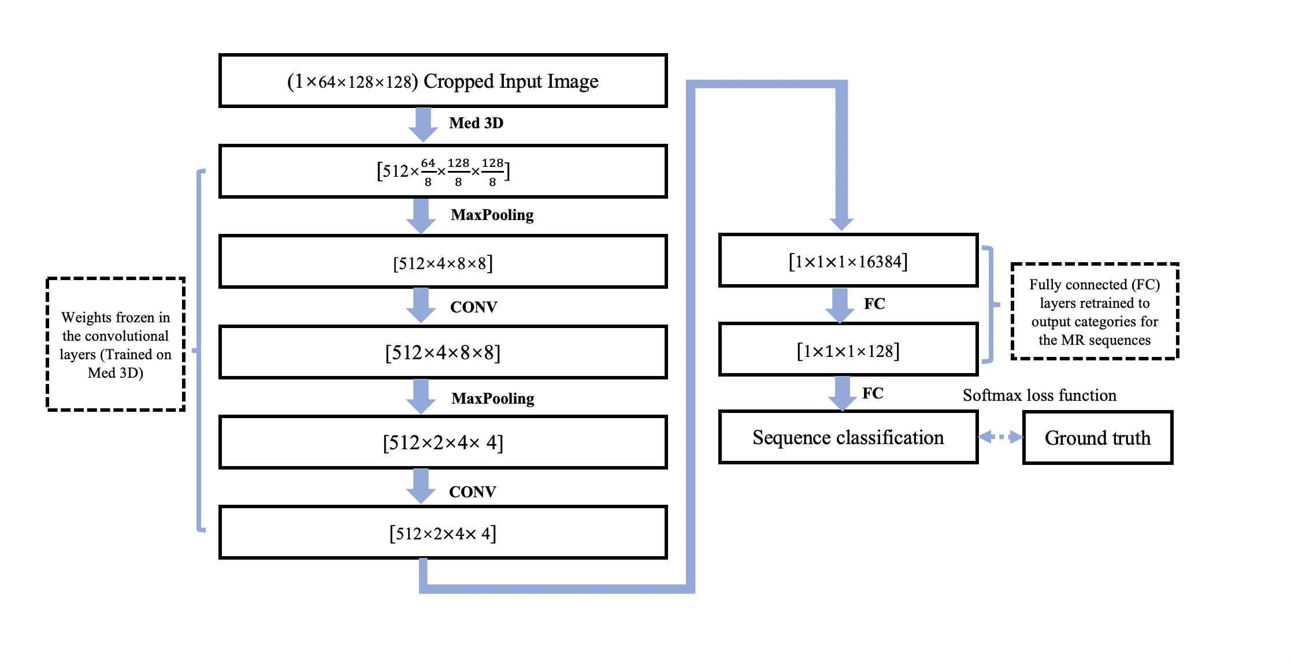
Figure S1 The modified Med3D network. 3D three-dimensional, CONV Convolution, FC Fully connected.

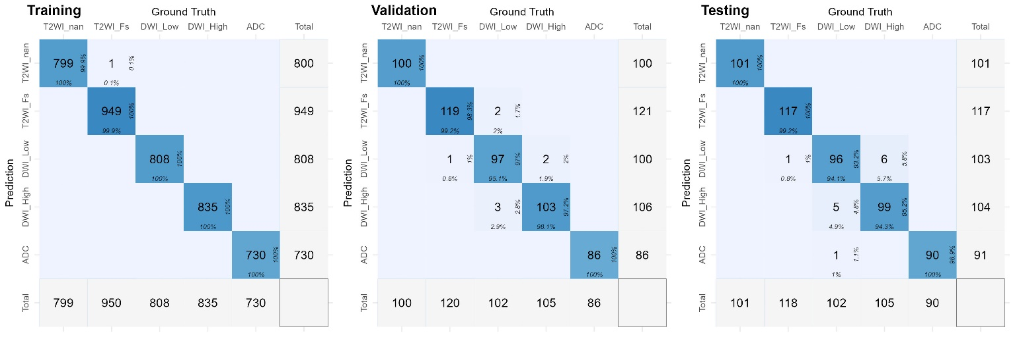
Figure S2 Confusion matrix of the prediction results in the training, validation, and testing datasets. The number in the middle of each tile is the counted number of images. The percentage number at the bottom of each tile is the column percentage. The percentage number on the right side of each tile is the row percentage. The color intensity is based on the counts. T2WI T2-weighted imaging, Fs fat saturation, DWI diffusion-weighted imaging, ADC apparent diffusion coefficient.

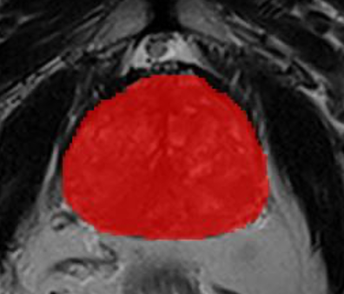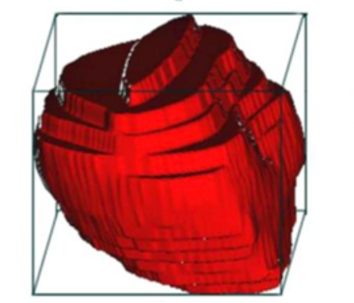
Figure S3 Whole prostate segmentation and the algorithm rule of the minimum volume bounding box.

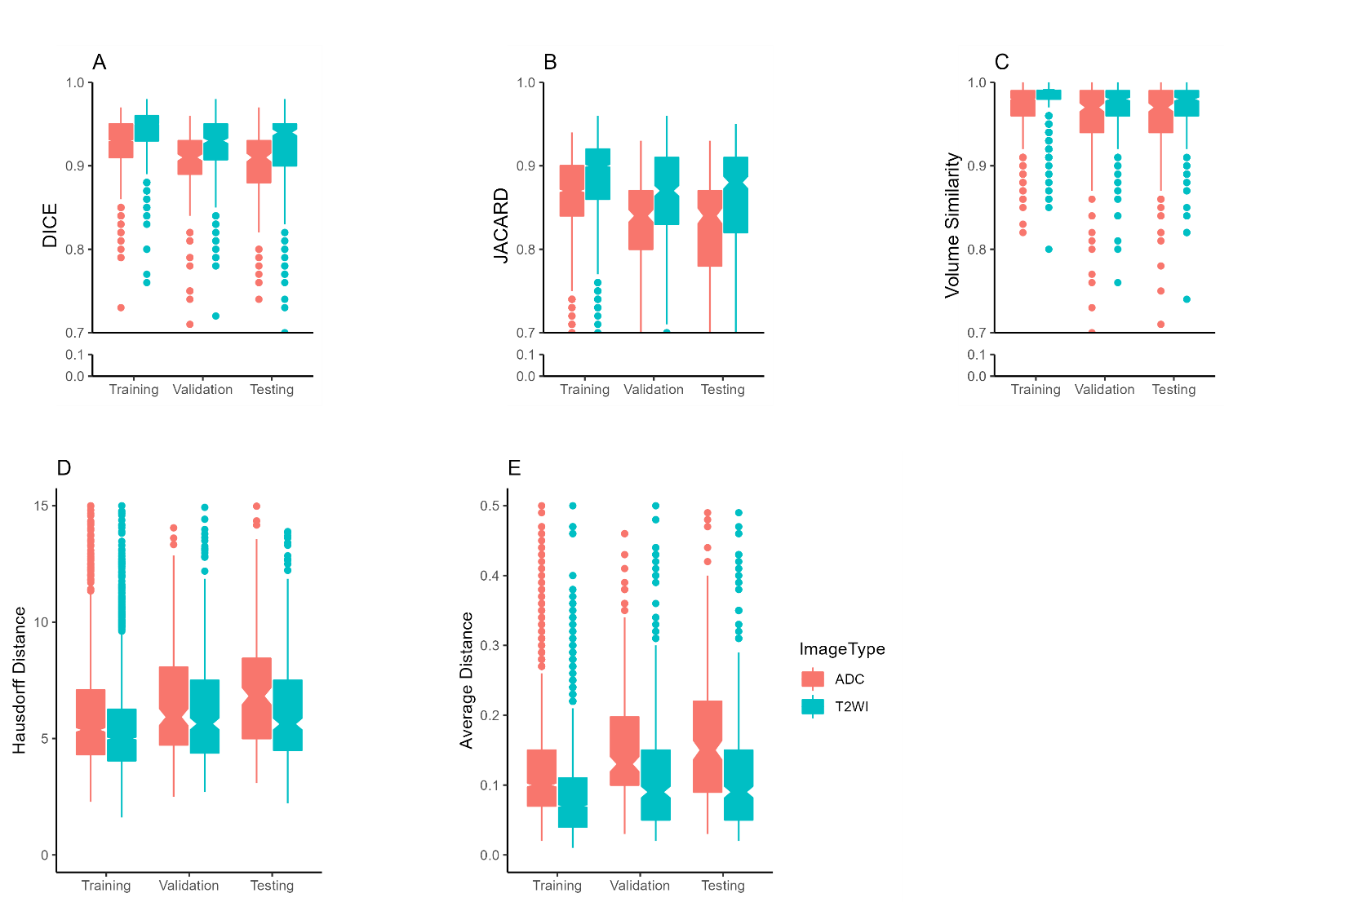
Figure S4 The DSC, Jaccard index, VS, HD, and AD in different datasets. The metrics of the T2WI were superior to those of the ADC map in all datasets (all P< 0.001). DSC Dice similarity coefficient, VS volumetric similarity, HD Hausdorff distance, and AD Average distance. T2WI T2-weighted imaging, ADC apparent diffusion coefficient.

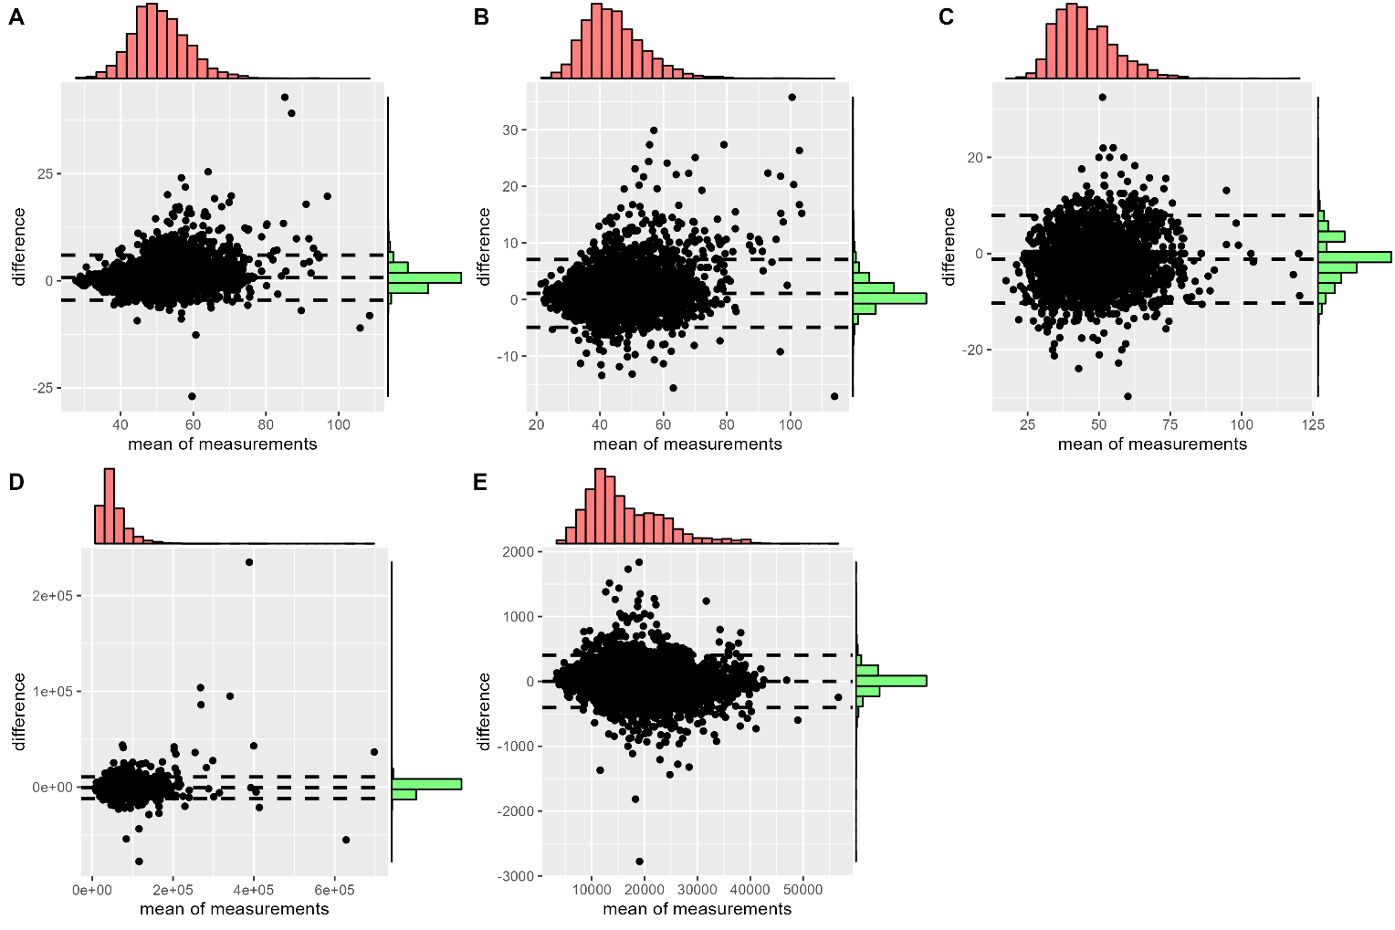
Figure S5 Bland‒Altman analysis of the values of the RL diameter (A), AP diameter (B), SI diameter (C), volume (D), and signal intensity (E) of the manual label and the predicted label of the prostate gland. RL right and left, AP anterior and posterior, SI superior and inferior.

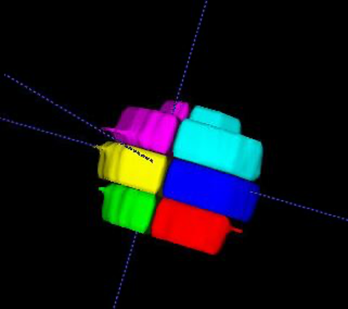
Figure S6 Sextant locations.

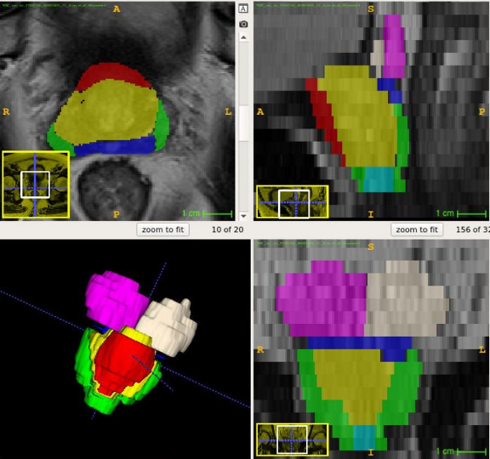
Figure S7 Anatomic zone locations.

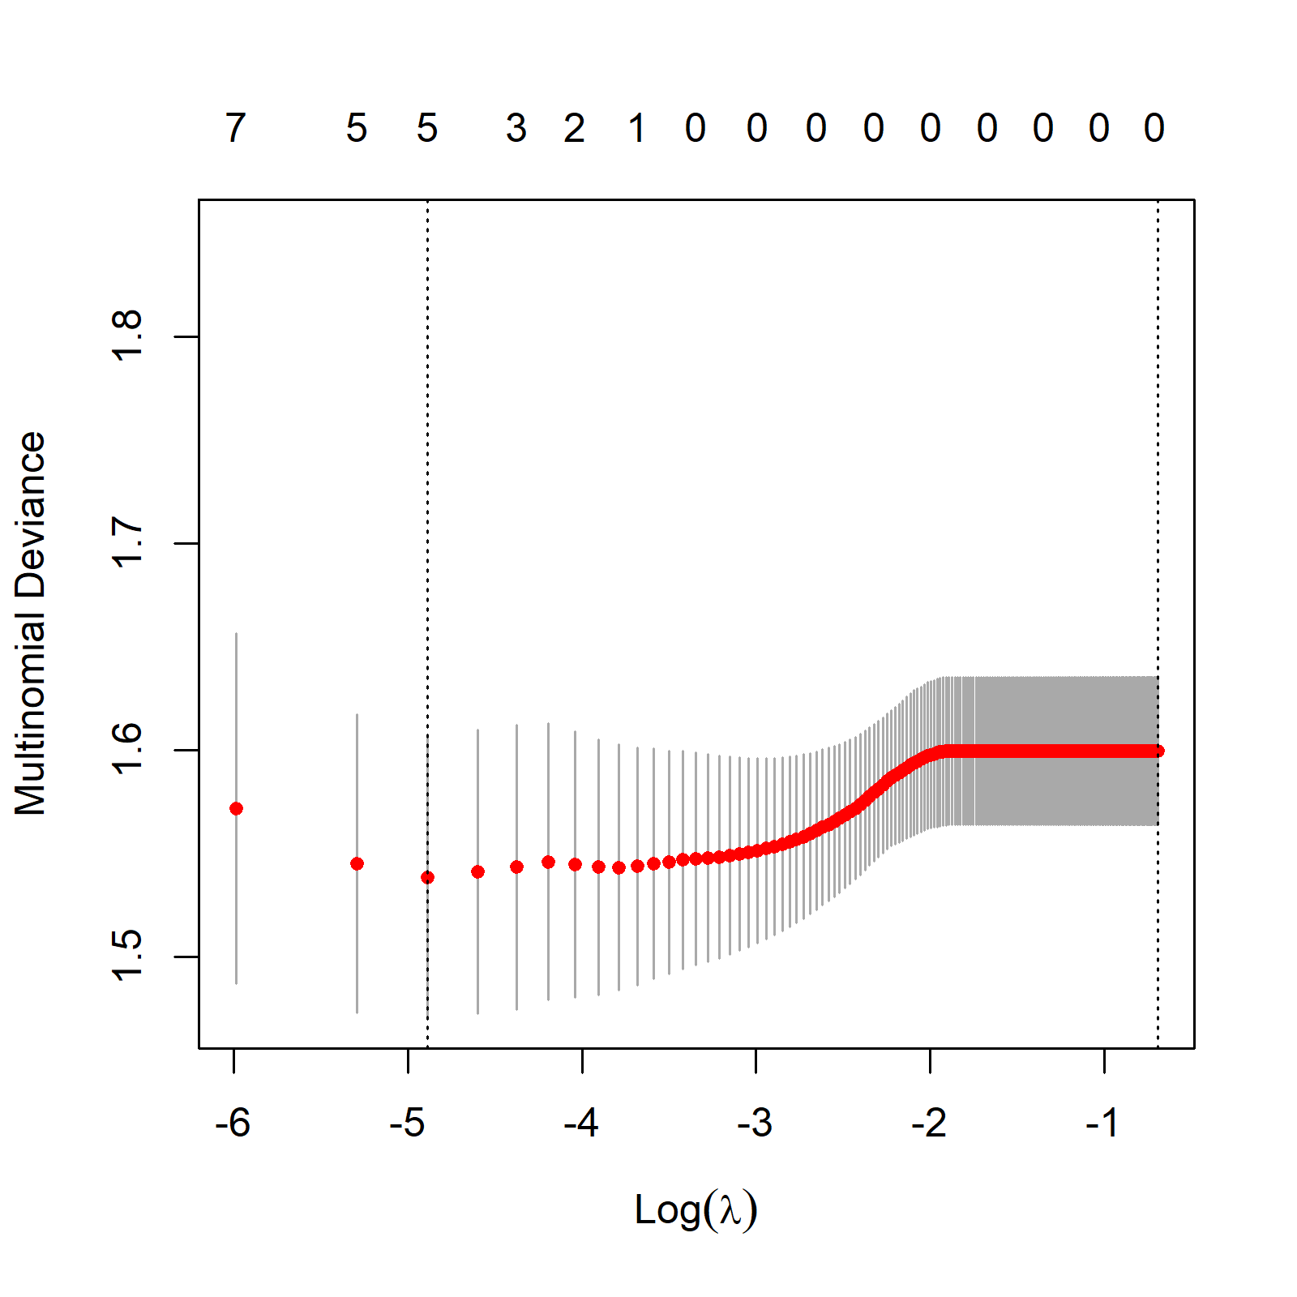
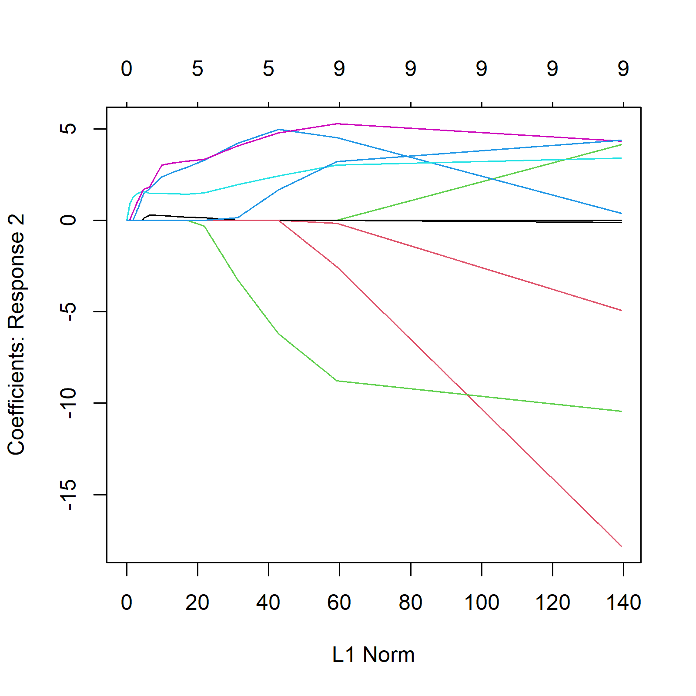

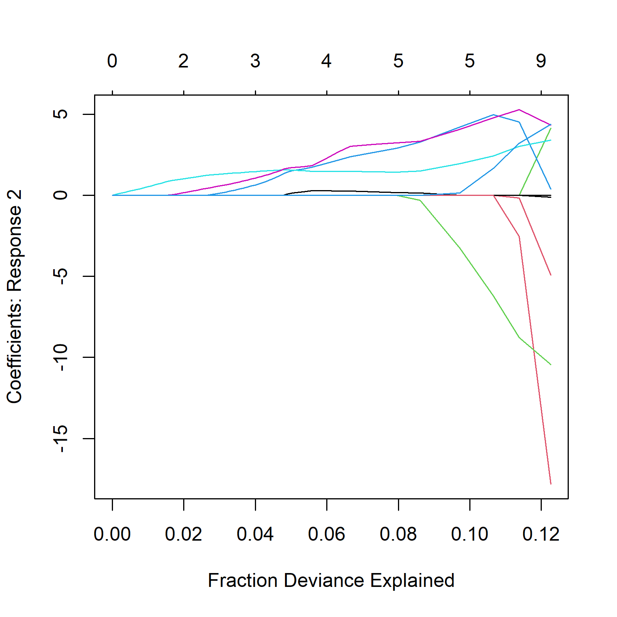
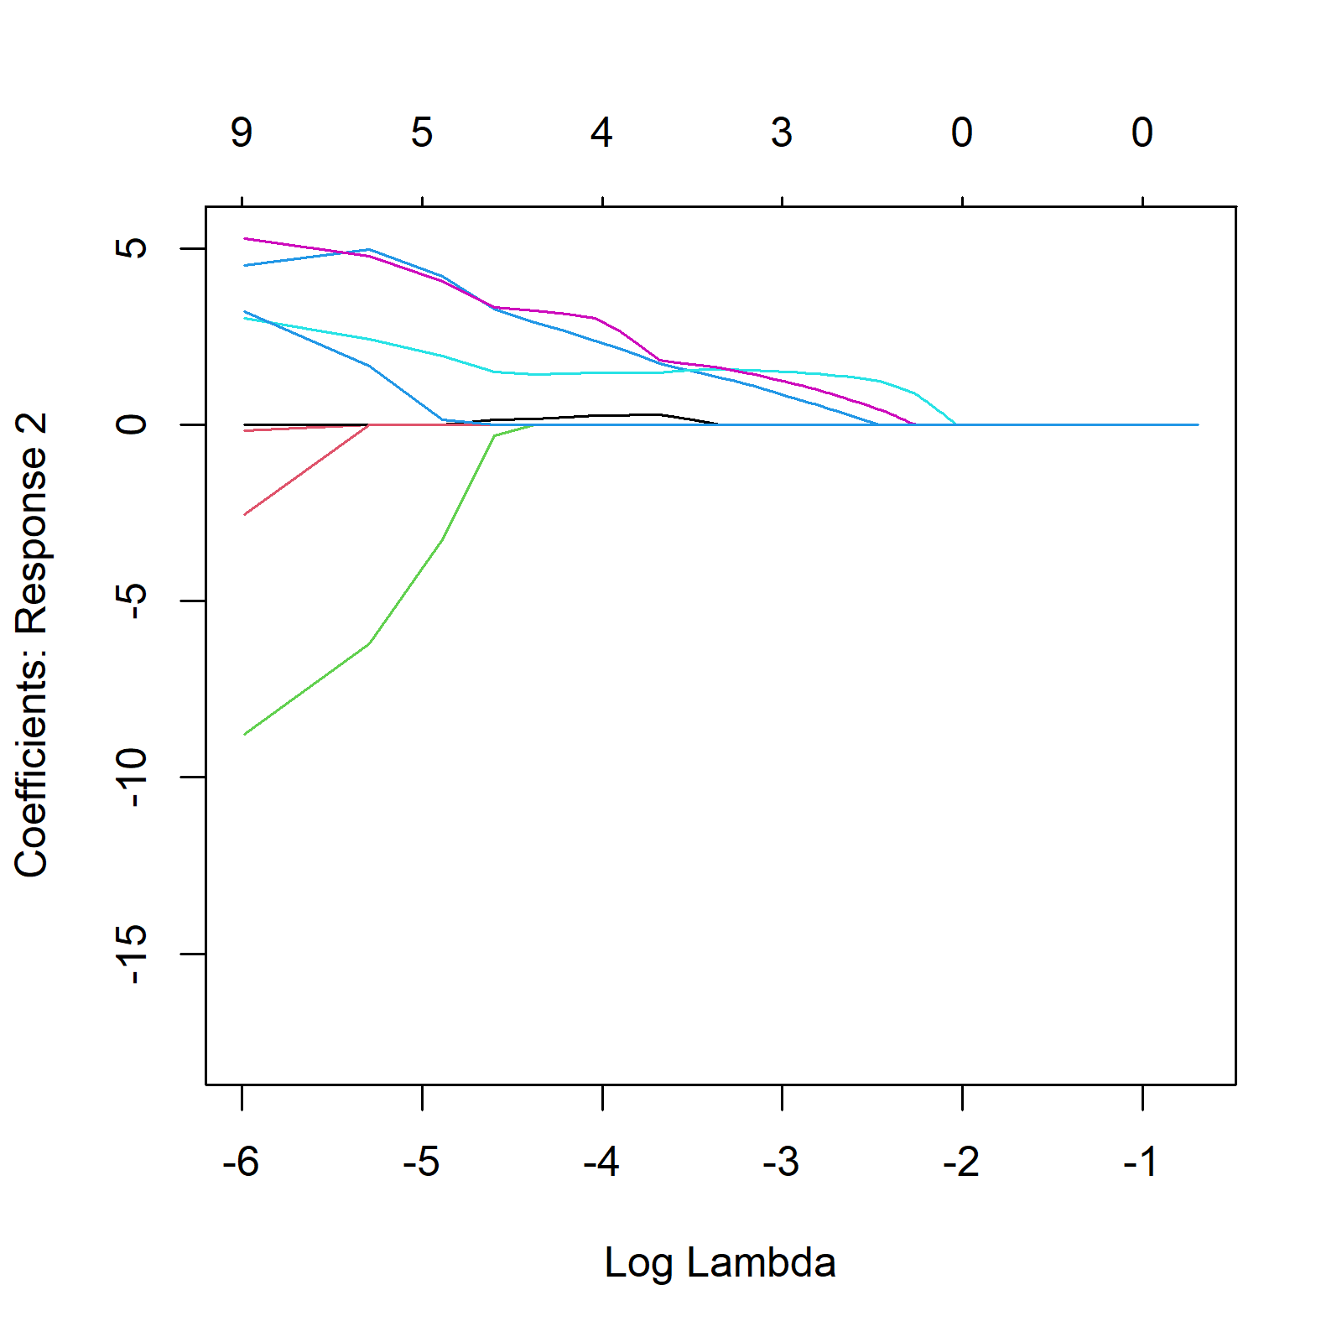
Figure S 8 Development of the radiomics and deep-radiomics LASSO classification
A) to D) how the development of the radiomics model. E) to H) show the development of the deep-radiomics model. Figure 4a and Figure 4e provide visual representations of the cross-validated performance of the LASSO regression model across different values of the regularization parameter lambda. The x-axis represents the logarithm (base 10) of the lambda values used in the cross-validation process. The y-axis represents the multinomial deviance across all folds in the cross-validation process. The vertical lines indicate different lambda values. These lines represent the cross-validated error for each lambda value. The dotted vertical line at a specific point on the x-axis represents the lambda value that gives the minimum cross-validated error. This is considered the optimal lambda for the Lasso model. The red dots compose the performance curve, which helps us understand the trade-off between model complexity and performance. The cross-validation process helps in selecting an optimal lambda value for the LASSO regression model, which in turn helps prevent overfitting and improves the model's ability to generalize to new data.
The other plots provide detailed insights into how the coefficient for the predictor variable is influenced by different aspects of the LASSO regression model, including the L1 norm (B and F), the logarithm of the regularization parameter (lambda) (Figure C and G), and the fraction of deviance explained (D and H) by the model.

