Supplementary Methods. Doubly labeled water study of total energy expenditure and body composition.
The use of the stable isotope method in the field presents methodological and ethical difficulties that explain the small sample of data available on TEE in wild primates (7 species). Consequently, the feasibility criterion for the experiment led us to look for favourable logistical and local conditions to ensure captures/recaptures while applying the unique and rigorous protocol of doubly labelled water in the field. TEE was determined
by the two-point doubly labeled water (DLW) method [1].
Animals captured and brought to the field station were immediately blood sampled to obtain baseline isotope levels, followed by a subcutaneous injection of a dose of ²H₂¹⁸O of 0.71g.kg⁻¹ total body water (98% H₂¹⁸O and 99.9% ²H₂O; CortecNet, France). The DLW dose was weighed to the nearest 0.1 mg, controlling for DLW-syringe weight prior to and after injection. The dose was calculated to ensure an in vivo enrichment of about 255 and 992 ‰ for 18-oxygen and deuterium, respectively [δ ‰ (delta per mil) = (R_{sample} / R_{standard} – 1) * 1000 with R being the ratio ²H/¹H in case of hydrogen)]. The isotopic equilibration time after injection was determined through a second blood sample collected at 2-h post-dose, based on our previous experience with lemurs of similar size. Between the third and fifth day after injection (depending on the ease of darting the lemurs), the animals were recaptured, as far as possible at the same time of day as on the first day of DLW injection, and a final blood sample was taken to analyse isotope depletion. The blood collected was flame-sealed in glass capillaries, totalling 500 µL. until analysis by isotope ratio mass spectrometry. Isotope ratio ¹⁸O and ²H enrichment was measured in body water after cryodistillation of the blood. 0.1µL of the treated samples was injected in an elemental analyzer (TC/EA, Thermo. Bremen, Germany) connected to a continuous flow isotope ratio mass spectrometer (Delta V, ThermoFisher). Samples were reduced to H₂ and CO at 1400°C on glassy carbon. H₂ and CO were further separated at 105°C on a GC column before sequential analysis of deuterium and 18-oxygen isotopic abundances. The results were scaled using two laboratory standards. Analyses were performed in quadruplicate and repeated if the SD exceeded 2 ‰ for deuterium and 0.5 ‰ for 18-oxygen. We used the “plateau” method with TEE equation being that of Lifson modified according to Speakman [2] (single pool model). C0₂ production was converted to TEE using Wier’s equation. The food quotient was set at 0.973 and 0.975 for each season, after diet nutritional composition was determined (using FAO Tables). Total body water (TBW) was calculated from the 18-oxygen dilution space after correction by the factor 1.007 for isotope exchanges [3]. Fat-free mass was derived from TBW assuming a hydration coefficient of 73.2% [4]. Fat mass was calculated from the difference between body mass and fat-free mass.

References
- Schoeller, D. A. et al. Energy expenditure by the doubly labeled water: validation in humans and proposed calculations. Am. J. Physiol. 250, R823–R830 (1986).
- Speakman, J. R. Doubly labelled water: theory and practice (Chapman, Hall, 1997).
- Racette, S. B. et al. Relative dilution spaces of 2H and 18 O-labelled water in humans. Am. J. Physiol 30, E585–E590 (1994).
- Blanc, S. et al. Assessment of nutritional status in rhesus monkeys: comparison of dual-energy X-ray absorptiometry and stable isotope dilution. J. Med. Primatol. 34, 130–138 (2005).

Supplementary Table SI1. Morphometric parameters of lemurs captured

Individual | Sex | Group | Season | Month of capture | Body mass | Crown-to-rump length (CRL) | QIª | Skinfold thickness score | Thigh thickness
 |  |  |  |  | g | cm | kg.m⁻² | cm | cm
EFM1* | Male | G1 | wet | March | 2368 | 38 | 16.4 | 13.1 | 3^{b}
EFM2 | Male | G2 | wet | March | 1911 | 36.5 | 14.34 | 12.55 | 2.1
EFM3 | Male | G2 | wet | March | 2238 | 37 | 16.35 | 13.8 | 3.3
EFM4 | Male | G1 | wet | March | 2178 | 37 | 15.91 | 12.2 | 2.9
EFM5 | Male | G3 | wet | March | 2503 | 35.8 | 19.53 | 16.7 | 3.6
EFM6* | Male | G3 | wet | March | 2528 | NA | NA | 17.65 | 3.2
EFM7 | Male | G3 | wet | March | 2049 | 37 | 14.97 | 14.1 | 3.8
EFM8* | Male | G2 | wet | March | 1811 | 34.6 | 15.13 | 13.8 | 3.8
EFM9 | Male | G1 | wet | March | 1795 | 33 | 16.48 | 11.2 | 3
EFF1* | Female | G1 | wet | March | 1746 | 37.3 | 12.55 | 9.55 | 2.65
EFF2 | Female | G2 | wet | March | 2204 | 36.2 | 16.82 | 13.1 | 3.55
EFF3* | Female | G4 | wet | March | 1917 | 35.4 | 15.3 | 12.2 | 2.1
EFF4 | Female | G2 | wet | March | 1674 | 38.2 | 11.47 | 11.5 | 2
EFM1* | Male | G1 | dry | June | 2282 | 38 | 15.8 | 10.2 | 2.3
EFM7* | Male | G3 | dry | June | 2095 | 37 | 15.3 | 9.4 | 2.7
EFM8 | Male | G2 | dry | June | 1711 | 34.6 | 14.29 | 8.15 | 2
EFM9 | Male | G1 | dry | June | 1912 | 33 | 17.56 | 9.4 | 3
EFM12* | Male | G2 | dry | June | 1832 | 37.5 | 13.03 | 7.8 | 1.85
EFM13* | Male | G3 | dry | June | 1713 | 35.4 | 13.67 | 7.4 | 1.7
EFM14 | Male | G1 | dry | June | 1791 | 36.3 | 13.59 | 9.8 | 2.3
EFM15 | Male | G2 | dry | June | 1601 | 35.9 | 12.42 | 9.15 | 1.8

* Individuals equipped with an accelerometer
ª Quetelet index
^{b} Extrapolated from the correlation of thigh thickness with skinfold thickness index (r²=0.56)

Supplementary Table SI2. Abiotic variables measured during TEE measurements
Individual | # experimental days | Month of capture | Minimal T° | Maximal T° | mean T° | Cumulative rainfall | NLIª
 |  |  | (range) °C | (range) °C | (range) °C | mm
EFM1 | 5 | March | 21-21.5 | 29-31.5 | 25-26.5 | 25 | 0.007
EFM2 | 5 | March | 21-21.5 | 29-31.5 | 25-26.3 | 27 | 0.013
EFM4 | 5 | March | 21-22 | 29-31.5 | 25-26.3 | 39 | 0.02
EFM5 | 5 | March | 21-22 | 29-31.5 | 25-26.3 | 39 | 0.02
EFM8 | 3 | March | 21-22 | 29-31 | 25-26.3 | 9 | 0.022
EFM9 | 3 | March | 21-22 | 29-31 | 25-26.3 | 9 | 0.022
EFF1 | 3 | March | 21-21.5 | 29-31.5 | 25-26.3 | 25 | 0.005
EFF2 | 5 | March | 21-22 | 29-31.5 | 25-26.3 | 39 | 0.02
EFF4 | 3 | March | 21-22 | 29-31 | 25-26.3 | 9 | 0.022
EFM13 | 4 | June | 18-19.5 | 27.5-28 | 23-23.5 | 8.5 | 0
EFM14 | 5 | June | 16-19.5 | 27-28 | 21.5-23.5 | 1.5 | 0.014
EFM15 | 5 | June | 16-18 | 27-28 | 21.5-23.5 | 6.5 | 0.023
ª Nocturnal luminosity index (composite score based on moon phase and moon duration between sunset and sunrise. varying between 0 and 0.51 between March and July)

Supplementary Table SI3. Dilution space and body composition parameters

Individual | Nd/No | Total body water  (kg) | Fat-free mass  (kg) | Fat mass  (kg)
EFF1 | 1.022354 | 1.220 | 1.667 | 0.077
EFF2 | 1.048407 | 1.334 | 1.822 | 0.381
EFF4 | 1.013936 | 1.183 | 1.616 | 0.057
EFM1 | 1.033067 | 1.357 | 1.853 | 0.514
EFM2 | 1.049647 | 1.209 | 1.652 | 0.258
EFM4 | 1.046607 | 1.413 | 1.930 | 0.247
EFM5 | 1.046918 | 1.409 | 1.925 | 0.574
EFM8 | 1.047065 | 1.195 | 1.632 | 0.178
EFM9 | 1.042172 | 1.212 | 1.656 | 0.138
EFM8 (June) | 1,02549914 | 1,184 | 1,618 | 0,035
EFM9 (June) | 1,03985138 | 1,378 | 1,883 | -0,028
EFM13 (June) | 1.039563 | 1.277 | 1.745 | -0.032
EFM14 (June) | 1.041884 | 1.274 | 1.740 | 0.050
EFM15 (June) | 1.042342 | 1.126 | 1.539 | 0.061

Supplementary Table SI4. Isotope elimination data and energy expenditure parameters

Individual | Kd | Ko | rH₂O (kg d⁻¹) | rCO₂ (L.d⁻¹) | TEE  (kJ.d⁻¹)
EFF1 | 0.26847198 | 0.30247996 | 0.3445 | 22.166 | 478
EFF2 | 0.29876399 | 0.33905098 | 0.4191 | 28.901 | 623
EFF4 | 0.22647685 | 0.25119116 | 0.2818 | 15.333 | 330
EFM1 | 0.26652783 | 0.29621474 | 0.3803 | 21.178 | 456
EFM2 | 0.31498781 | 0.35930447 | 0.4006 | 28.949 | 624
EFM4 | 0.31526979 | 0.35561427 | 0.4685 | 30.486 | 657
EFM5 | 0.24113854 | 0.28044568 | 0.3574 | 30.334 | 654
EFM8 | 0.21113831 | 0.2432141 | 0.2653 | 20.859 | 449
EFM9 | 0.45373618 | 0.5128304 | 0.5785 | 38.386 | 827
EFM13 | 0.26775892 | 0.30541009 | 0.3598 | 25.982 | 559
EFM14 | 0.20575545 | 0.23593531 | 0.2756 | 20.850 | 449
EFM15 | 0.1811839 | 0.21363403 | 0.2146 | 20.171 | 434

Supplementary Figure SI1. Field station and location of the 4 focal lemur groups. The home ranges are analyzed as kernel 95 (green dotted line) and kernel 50 (orange dotted line). Map data: Google. CNES/Airbus. Maxar Technologies

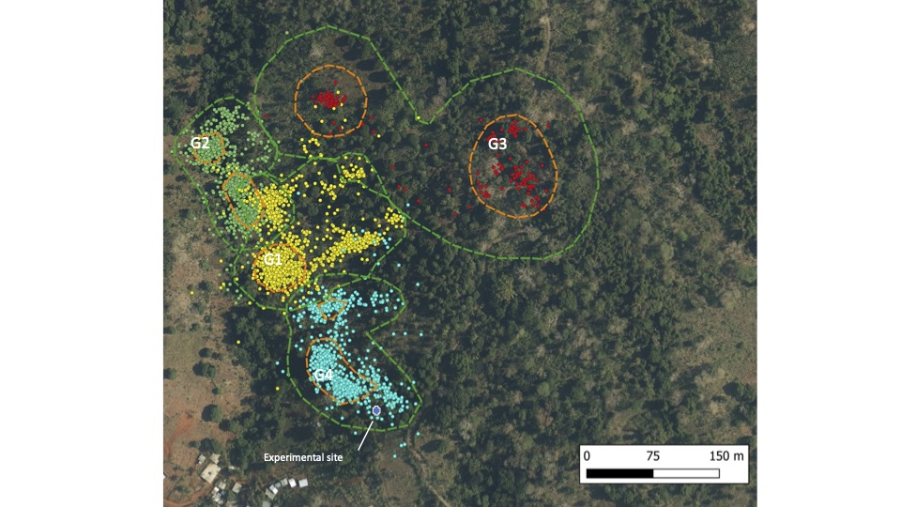

Figure SI2. Predictor effects of energy expenditure in the multiple
regression model 1

