SUPPLEMENTARY INFORMATION

Expiratory Efforts During Insufflation are Associated with Increased Mortality in Ventilated Patients
Guillermo Gutierrez, MD, PhD¹
Hülya Türkan, MD, PhD²

- The George Washington University. Washington, D.C,
- University of Health Sciences.
Gulhane School of Medicine. Ankara, Turkey

- ADDITIONAL TABLES
Table 1e

Cohort Ethnic Distribution
 | Decedents | Survivors
 | n=67 | n = 200
Asian | 3% | 4%
Black | 63% | 55%
Caucasian | 30% | 36%
Hispanic | 3% | 5%
Multi-racial | 1% | 2%

Table 2e

ICU Admission Diagnoses According to 28-day Mortality Rate

 | Decedents | Survivors | Statistics
 | n=67 | n = 200 | Statistics
Acute CVA | 6% | 3% | N.S.
Acute Respiratory Failure | 0% | 4% | N.S.
ARDS | 0% | 3% | N.S.
Asthma | 0% | 3% | N.S.
Cardiogenic shock | 13% | 10% | N.S.
COPD exacerbation | 3% | 4% | N.S.
Decreased mental status | 4% | 4% | N.S.
Hemorrhagic shock | 4% | 7% | N.S.
Intracranial bleed | 9% | 8% | N.S.
Pneumonia | 28% | 11% | p < 0.01
Post-operative complication | 7% | 19% | p < 0.05
Pulmonary edema | 4% | 4% | N.S.
Seizures | 3% | 4% | N.S.
Septic Shock | 10% | 8% | N.S.
Trauma | 4% | 9% | N.S.
Other diagnoses | 1% | 4% | N.S.

Acute Respiratory Failure includes patients with other breathing disorders, such as vocal cord swelling and smoke inhalation. ARDS = Acute respiratory distress syndrome; COPD = Chronic Obstructive Pulmonary Disease; CVA = Cerebrovascular accident. Statistics refer to Mann–Whitney test corrected with Benjamini-Yekutieli procedure for multiple comparisons.
Table 3e
Results from Logistic Analysis
First iteration: Chi Square= 91.3545; df=19; p = 0
 |  | Odds Ratios and 95% Confidence Limits.
 | Variable | Coeff. | StdErr | p | O.R. | Low | High
FIO2 | 1 | 0.0363 | 0.0212 | 0.0877 | 1.0369 | 0.9947 | 1.081
pos_num | 2 | 0.0165 | 0.03 | 0.5828 | 1.0166 | 0.9586 | 1.0782
pos_PTP | 3 | 0.0088 | 0.0259 | 0.7334 | 1.0089 | 0.959 | 1.0613
sum_pos_PTP | 4 | 0 | 0 | 0.7604 | 1 | 1 | 1
e_dyn_C | 5 | 0.022 | 0.0256 | 0.3894 | 1.0223 | 0.9723 | 1.0748
e_meanP | 6 | -0.1183 | 0.2054 | 0.5646 | 0.8884 | 0.594 | 1.3287
e_plateau | 7 | -0.0644 | 0.1305 | 0.6218 | 0.9376 | 0.726 | 1.2109
e_PEEP | 8 | -6.3891 | 4.3256 | 0.1397 | 0.0017 | 0 | 8.0764
e_RR | 9 | 0.0241 | 0.1451 | 0.8681 | 1.0244 | 0.7708 | 1.3615
e_Te | 10 | -1.0926 | 0.8989 | 0.2242 | 0.3353 | 0.0576 | 1.9527
mech_power | 11 | -0.0133 | 0.0749 | 0.8587 | 0.9868 | 0.852 | 1.1428
c_epoch_C | 12 | 0.0022 | 0.0255 | 0.9301 | 1.0022 | 0.9534 | 1.0536
c_true_C | 13 | -0.0211 | 0.0195 | 0.2785 | 0.9791 | 0.9425 | 1.0172
mean_flow | 14 | 0.0216 | 0.0268 | 0.4202 | 1.0219 | 0.9695 | 1.0771
c_DP | 15 | -6.1802 | 4.3419 | 0.1546 | 0.0021 | 0 | 10.2753
c_plateau | 16 | 6.3526 | 4.3422 | 0.1435 | 573.96 | 0.115 7.3673
Age | 17 | 0.0306 | 0.0134 | 0.0221 | 1.0311 | 1.0044 | 1.0585
SAPS | 18 | 0.0493 | 0.0162 | 0.0023 | 1.0506 | 1.0177 | 1.0844
SOFA | 19 | -0.0103 | 0.06 | 0.8641 | 0.9898 | 0.88 | 1.1133
Intercept | -4.8346 | 5.2964 | 0.3613

Second iteration: Chi Square = 84.9069; df=8; p=0
 |  | Odds Ratios and 95% Confidence Limits.
Variable |  | Coeff. | StdErr | p | O.R. | Low | High
FIO2 | 1 | 0.0322 | 0.0198 | 0.1045 | 1.0327 | 0.9934 | 1.0736
Dyn_C | 2 | 0.0183 | 0.0154 | 0.2364 | 1.0184 | 0.9881 | 1.0497
PEEP | 3 | -0.1734 | 0.1241 | 0.1625 | 0.8408 | 0.6593 | 1.0724
Te | 4 | -1.0298 | 0.2841 | 0.0003 | 0.3571 | 0.2046 | 0.6231
Static_C | 5 | -0.0153 | 0.0137 | 0.2615 | 0.9848 | 0.9588 | 1.0115
DP | 6 | 0.0799 | 0.0716 | 0.2646 | 1.0832 | 0.9413 | 1.2464
Age | 7 | 0.0307 | 0.0127 | 0.0157 | 1.0312 | 1.0058 | 1.0572
SAPS | 8 | 0.0478 | 0.0144 | 0.0009 | 1.0489 | 1.0197 | 1.0791
Intercept | -4.1671 | 2.0874 | 0.0459

Table 4e

Number of Epochs and Ventilatory Mode Used

 | Decedents (n = 67) | Survivors (n = 200)
Number of epochs analyzed | 98,156 | 245,743
% Mode Distribution
Pressure Support | 2.8% | 0.1%
Pressure Controlled | 11.3% | 10.3%
Volume Controlled | 8.9% | 17.4%
Pressure Regulated Volume Control | 77.0% | 72.3%

- EPOCH EXAMPLES.
Figure 1e Epoch on volume-controlled ventilation.
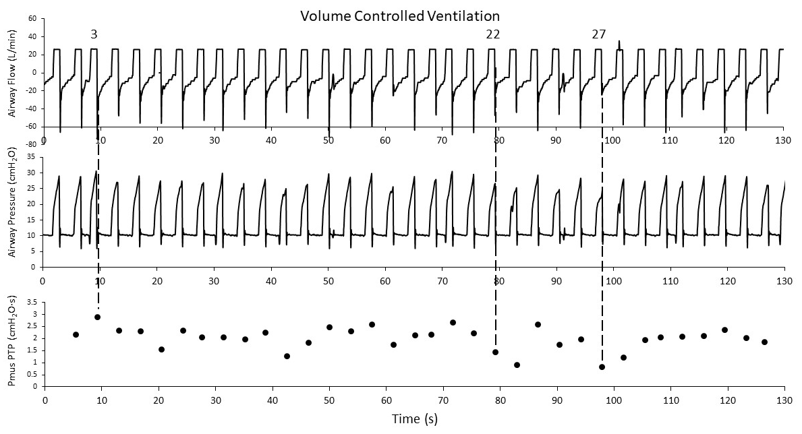
Figure 1e depicts an epoch from a 70-year-old woman with acute heart failure on VC ventilation with fractional inspired O₂ (F_{I}O₂) of 80%, mean TV of 450 mL, respiratory rate (RR) of 16 bpm, and PEEP_{a} of 10 cmH₂O. The upper and middle panels represent the F_{aw}(t) and P_{aw}(t) signals, respectively, while the lower panel shows P_{mus}PTP as discrete points, each corresponding to the breath above.

Figure 1e
The epoch displays both ventilator and patient triggered breaths, typical of a heavily sedated patient. Other than showing some fluctuation in P_{aw}Peak, the signals are uniform in configuration and timing (RRVI = 30%). The computed P_{mus}PTP values are positive for all insufflation phases, highlighting the presence of expiratory efforts that may not be immediately evident from the examination of the airway signals. Particular attention is drawn to breaths designated 3, 22, and 27, exemplifying the peak, middle, and nadir P_{mus}PTP values for this epoch, respectively.
Figure 2e Epoch on pressure-controlled ventilation.
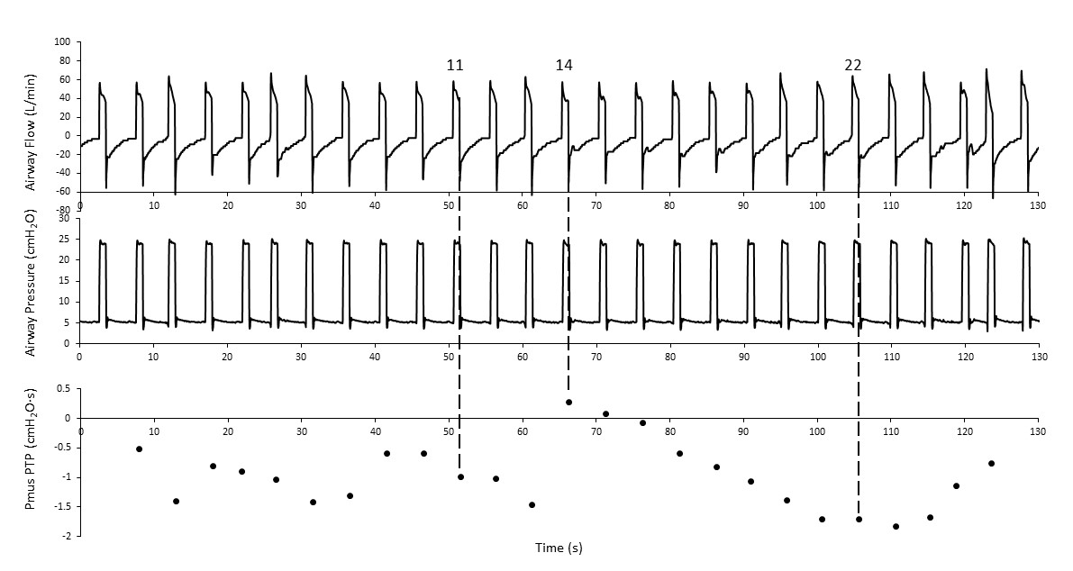
Figure 2e shows a subsequent epoch taken from the same patient, now on PC mode with F_{I}O₂ = 60%, RR = 12 bpm, P_{aw}Peak = 22 cmH₂O, and PEEP_{a} = 5 cmH₂O. All breaths are ventilator triggered with a low RRVI (24%) and TV values ranging from 620 to 740 mL. Visual examination of the airway signals provides little insight into respiratory muscle activity, however, predominantly negative P_{mus}PTP values are observed in the lower panel, ranging from -1.8 to 0.3 cmH₂O·s. The source of these inspiratory efforts is not apparent from these data, but they could indicate air hunger or the presence of reverse triggering. Attention is drawn to breaths 6, 16, and 20, as they encompass the range of P_{mus}PTP values for the epoch.
Figure 2e

Figure 3e Examples of calculated P_{mus}(t) from Figs 1e and 2e.
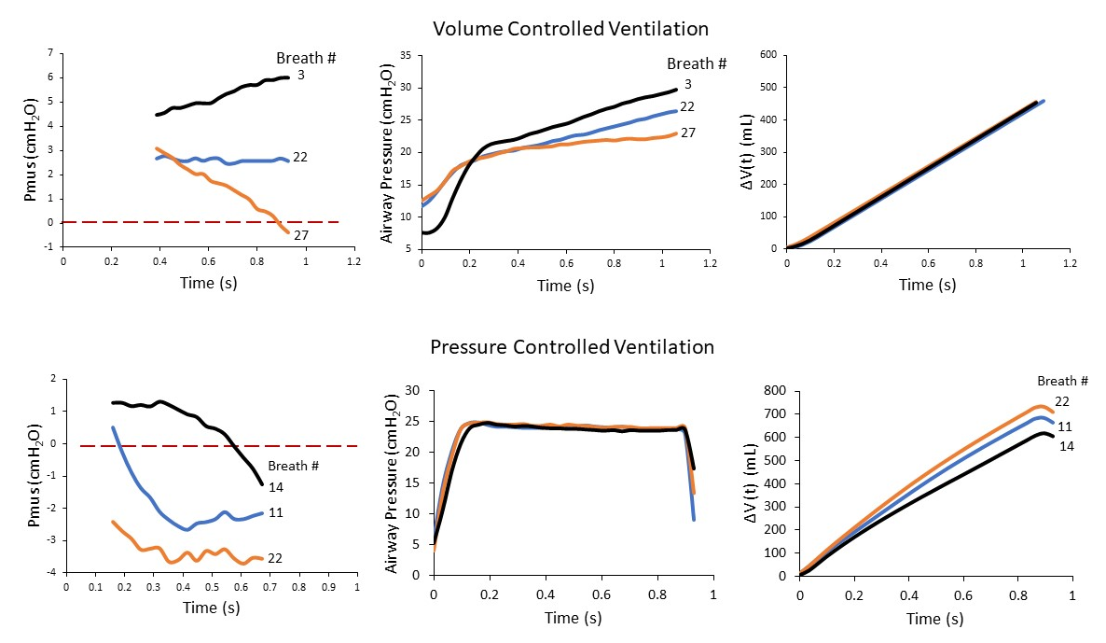
Figure 3e shows calculated P_{mus}(t) (upper left panel) and measured P_{aw}(t) and ΔV(t) (upper middle and right panels, respectively) for the breaths referenced in Figures 1e and 2e. The top figures show the P_{mus}(t) functions corresponding to the data of Figure 1e. The P_{mus}(t) functions are mostly positive (expiratory) and readily distinguishable from one another. The calculated P_{mus}PTP values are 2.9, 1.4, and 0.8 cmH₂O·s for breaths 3, 22, and 27, respectively. These values appear to correlate directly with the peak values of the P_{aw}(t) functions, with no discernible relationship noted for ΔV(t).
Figure 3e
The lower graphs of the figure show P_{mus}(t), P_{aw}(t) and ΔV(t) functions for the referenced breaths of Figure 2e. P_{mus}(t) for breath 16 exhibits a mix of positive and negative values, whereas those for breaths 20 and 6 are predominantly negative. Consequently, the corresponding P_{mus}PTP values show a progressive decrease at -0.9, -1.2, and -1.8 cmH₂O·s. As expected, there is minimal fluctuation in P_{aw}(t) across the breaths. Conversely, there are significant variations in ΔV(t), apparently in inverse relation to P_{mus}PTP.
Figure 4e. Pressure regulated volume control (PRVC) with P_{mus}(t) = 0.
Figure 4e depicts an epoch from a 76-year-old man squamous cell carcinoma following surgery for neck dissection. He is ventilated with pressure regulated volume control (PRVC) mode, V_{T} = 500 mL (7.6 mL·kg⁻¹), RR = 16 bpm and regular (RRVI = 11%); and F_{I}O₂ = 50%. Calculated C_{rs} = 53 mL·cmH₂O⁻¹; R_{rs} = 16 cmH₂O·s· L⁻¹; ΔP = 9 cmH₂O; and MP = 13 J·min⁻¹. F_{aw} and Paw signals are shown by the upper and middle plots, respectively. The bottom plot displays breath-specific P_{mus}PTP as solid black circles. The patient is in perfect synchrony with the ventilator (RRVI = 10%), being either paralyzed or heavily sedated. All breaths are ventilator-triggered with nil P_{mus}PTP. There is a total lack of correlation between P_{mus}PTP and P_{aw}PTP (R² = 0).

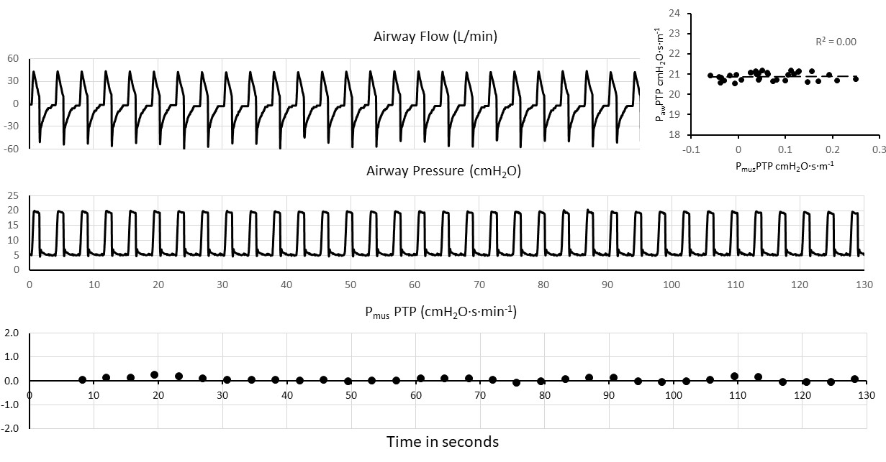

Figure 4e

Figure 5e. Volume control ventilation with small expiratory efforts.
Figure 5e depicts an epoch from a 79-year-old woman with acute heart failure and malignant arrhythmias, ventilated with constant flow, volume-control mode (VC), V_{T} = 450 mL (9.5 mL·kg⁻¹), RR = 12 bpm and regular (RRVI = 14%); and F_{I}O₂ = 35%. Calculated C_{rs} = 58 mL·cmH₂O⁻¹; R_{rs} = 23 cmH₂O·s· L⁻¹; ΔP = 9 cmH₂O; and MP = 7 J·min⁻¹. The patient appears sedated with all breaths being triggered by the ventilator. F_{aw} signal is uniform with P_{aw} showing small variations in peak values. P_{mus}PTP values are predominantly positive, indicative of small exhalation efforts during insufflation. The insert graph now shows a close relationship between P_{mus}PTP and P_{aw}PTP (R² = 0.95).

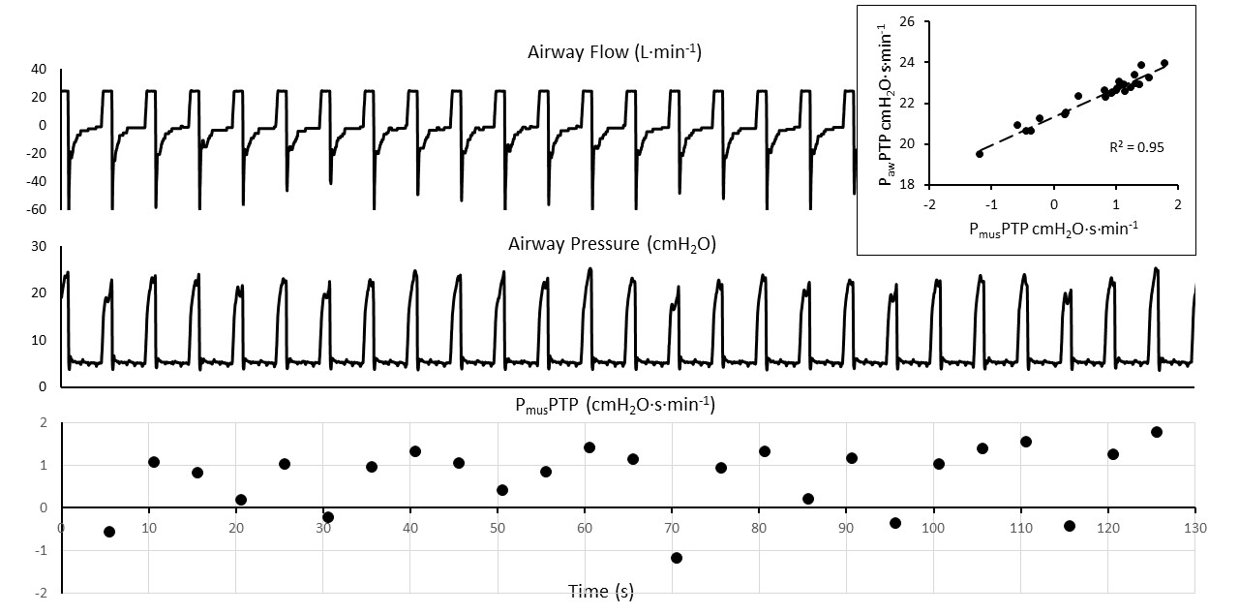

Figure 5e

Figure 6e. Volume control mode with large expiratory efforts.
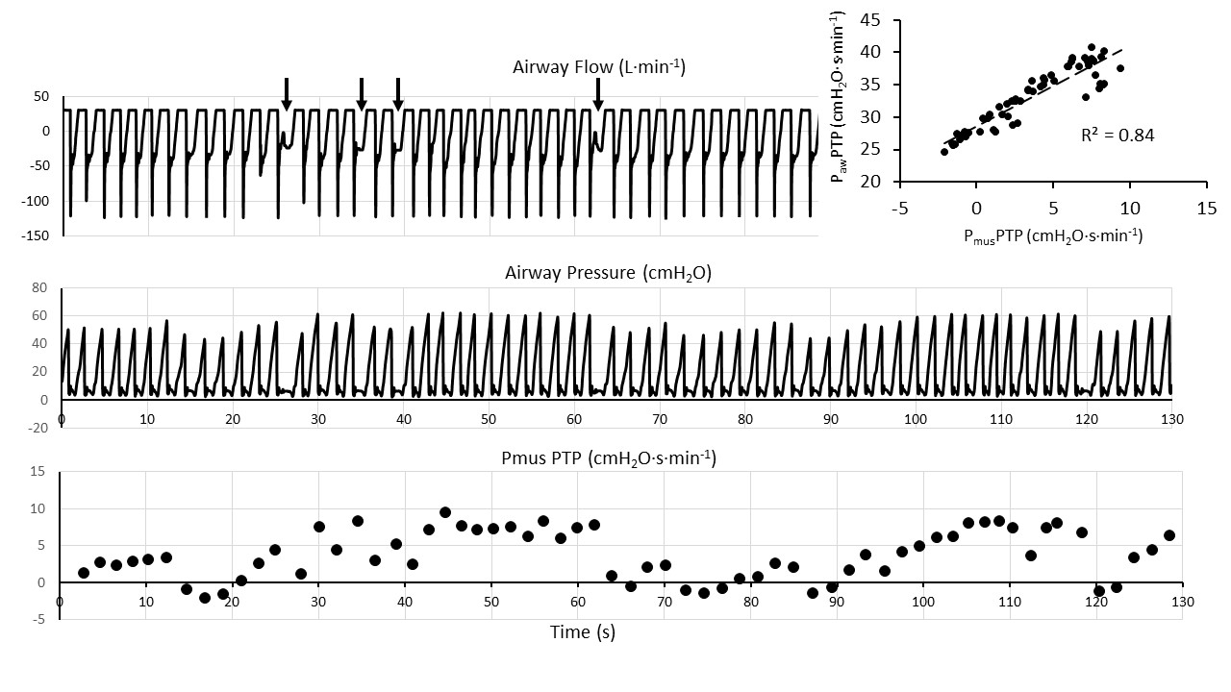
Figure 6e shows an epoch from a 70-year-old woman admitted to the ICU following coronary artery bypass graft surgery (CABG) ventilated with constant flow, volume-control mode, V_{T} = 460 mL (7.8 mL·kg⁻¹); RR =12 bpm; and F_{I}O₂ = 40%. Calculated C_{rs} is low at 29 mL·cmH₂O⁻¹; R_{rs} = 16 cmH₂O·s· L⁻¹; ΔP = 34 cmH₂O; and MP = 36 J·min⁻¹. F_{aw} shows substantial rate variability (RR = 30 bpm; RRVI = 68%) with occasional early cycling asynchronies (down arrows). The P_{aw} signal is highly variable with elevated peak values resulting in possibly injurious lung parenchymal strain. The lower graph shows mostly positive (exhalation) P_{mus}PTP. Except for a few outliers corresponding to the noted asynchronies, a close relationship is again noted between P_{aw}PTP and P_{mus}PTP (Inset graph; R² = 0.84).

Figure 6e
Figure 7e. Components of airway pressure Paw.
Figure 7e displays P_{aw}Peak and its contributing elements: the pressure related to muscle effort, P_{mus} and the pressure provided by the ventilator to effect passive lung inflation (P_{vent}) for the data shown Figure 3e. Whereas P_{vent} is relatively constant, fluctuations in P_{aw}Peak demonstrate a strong correlation with P_{mus}Peak (R² = 0.89), indicative of P_{mus} as a key factor in significant,
and possibly harmful, P_{aw} increases.
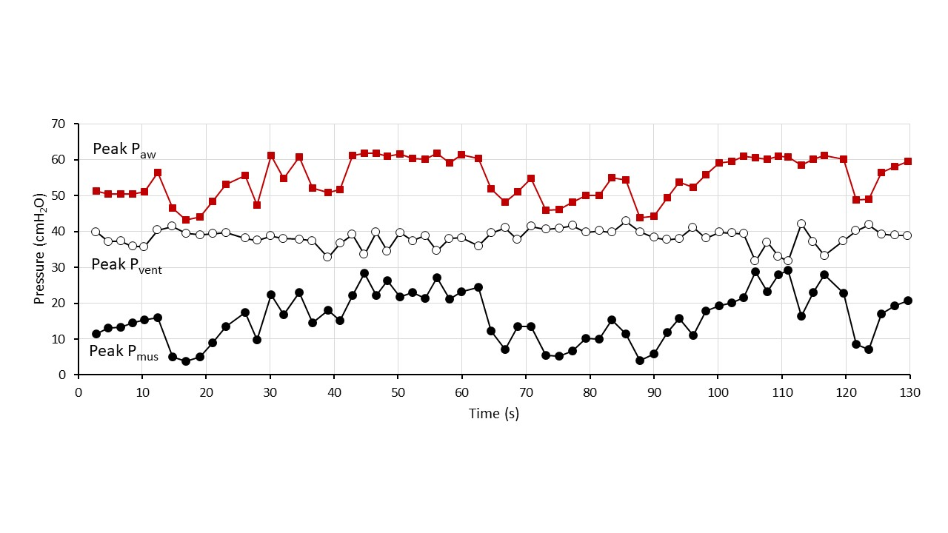

Figure 7e

Figure 8e. Pressure support ventilation.
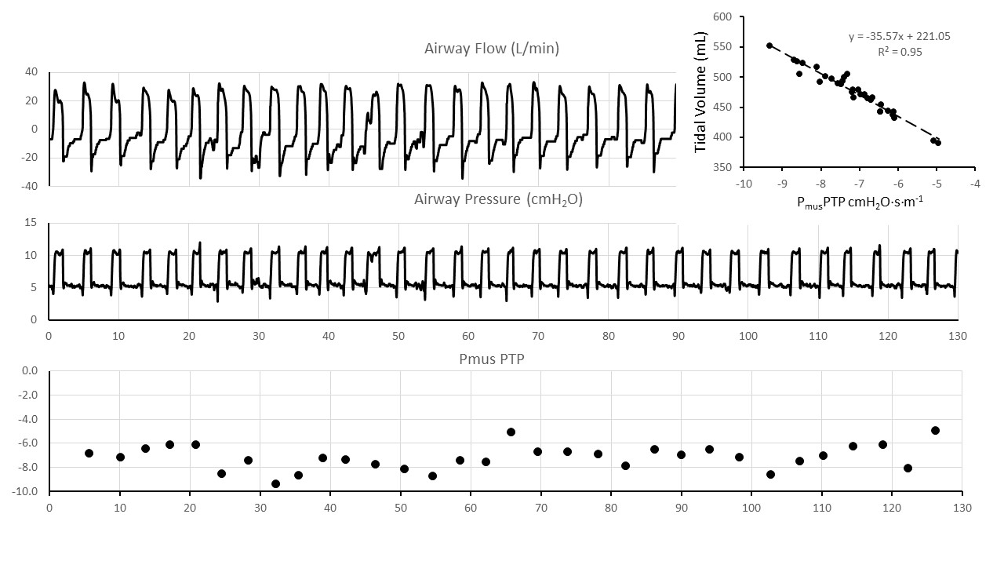
Figure 8e shows data from a 59-year-old woman with COPD admitted to the ICU with a diagnosis of pneumonia. The patient is on pressure support ventilation of 10 cmH₂O, resulting in a V_{T} = 480 mL (9.0 mL·kg⁻¹); RR =16 bpm; and F_{I}O₂ = 100%. RRVI = 53%. The patient has developed significant negative Pmus efforts throughout the epoch that are inversely to changes in V_{T} ranging from 400 to 550 mL.

Figure 8e

Figure 9e. Rapid increase in P_{mus} and P_{aw} during PRVC.
Figure 8e shows data from a 51-year-old man with pneumonia and sepsis on PRVC mode, F_{I}O₂ = 80%, with V_{T} = 480 mL (9.0 mL·kg⁻¹). RR is set at 26 bpm with an actual rate of 34 bpm. There is significant rate variation with RRVI = 56% About one minute into the epoch, for unknown reasons, the patient starts to increase exhalatory Pmus efforts, leading to significant rises in P_{aw}Peak. With the exception of one outlier, there is a close correlation between P_{mus}PTP and P_{aw}PTP.

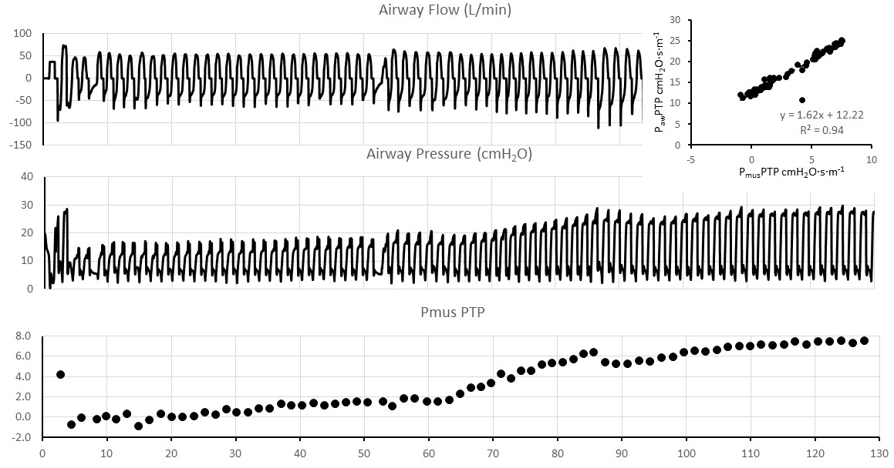

Figure 9e

Figure 10e. Volume control ventilation with strong expiratory efforts.
Figure 10e shows data from a 59-year-old woman with COPD admitted to the ICU with a diagnosis of pneumonia on VC ventilation with F_{I}O₂ = 80%; V_{T =} 500 mL (9.5 mL·kg⁻¹); RR set at 18 bpm but measured at 30 bpm; and RRVI = 52%. Static C_{rs} is low at 25 mL·cmH₂O⁻¹ with normal R_{rs} of 9 cmH₂O·s· L⁻¹. Both ΔP = 34 cmH₂O and MP = 34 J·min⁻¹ are elevated. Although the elevated P_{aw}Peak values are partly related to respiratory system stiffness, the close relationship between P_{mus}PTP and P_{aw}PTP (insert plot) indicates that expiratory respiratory efforts during insufflation play a pivotal role in Paw elevation.

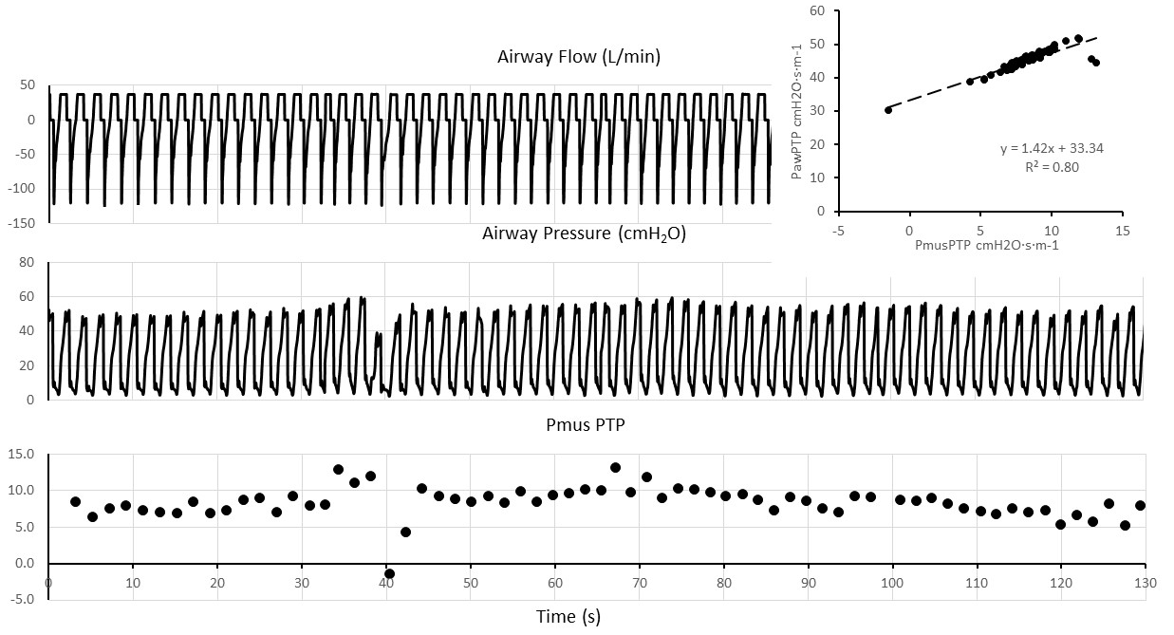

Figure 10e

Yoshida T, Nakahashi S, Nakamura MAM, Koyama Y, Roldan R, Torsani V, De Santis RR, Gomes S, Uchiyama A, Amato MBP, Kavanagh BP, Fujino Y (2017) Volume-controlled Ventilation Does Not Prevent Injurious Inflation during Spontaneous Effort. Am J Respir Crit Care Med. 196:590-601. doi: 10.1164/rccm.201610-1972OC. PMID: 28212050.

