Supplementary Data

Preparation of carvacrol β-cyclodextrin inclusions and 1-methylcyclopropene-α-CD coated paper by water-free method for postharvest preservation of peach
Zhaoxin Caoª, Jingyi Suª, Yali Luoª, Xinyu Wangª, Zhiming Liuª,Yanqi Chenª,Yijing Zouª, Wen Shen^{c}, Xuemei Ge^{a, b*}
ª Department of Food Science and Technology, College of Light Industry Science and Engineering, Nanjing Forestry University, Nanjing 210037, PR China; caozhaoxin1225@163.com
b State Key Laboratory of Bioactive Substance and Function of Natural Medicines, Institute of Materia Medica, Chinese Academy of Medical Sciences and Peking Union Medical College, Beijing 100050, P. R. China
c School of Food and Biological Engineering, Shaanxi University of Science & Technology, Xi’an 710021,
^{People’s Republic of China}

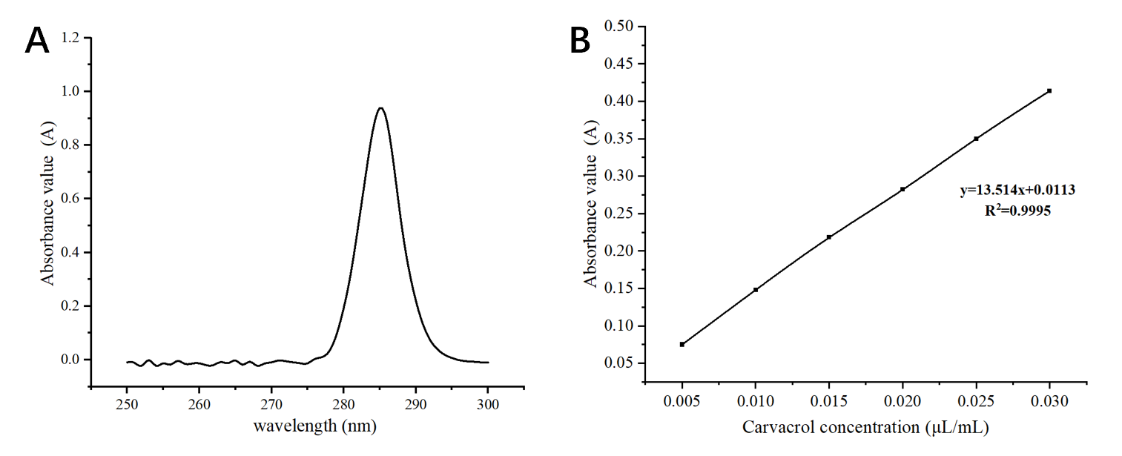
Figure S1. Maximum absorption peak (A) and standard curve of carvacrol (B) (page 7, line 186)
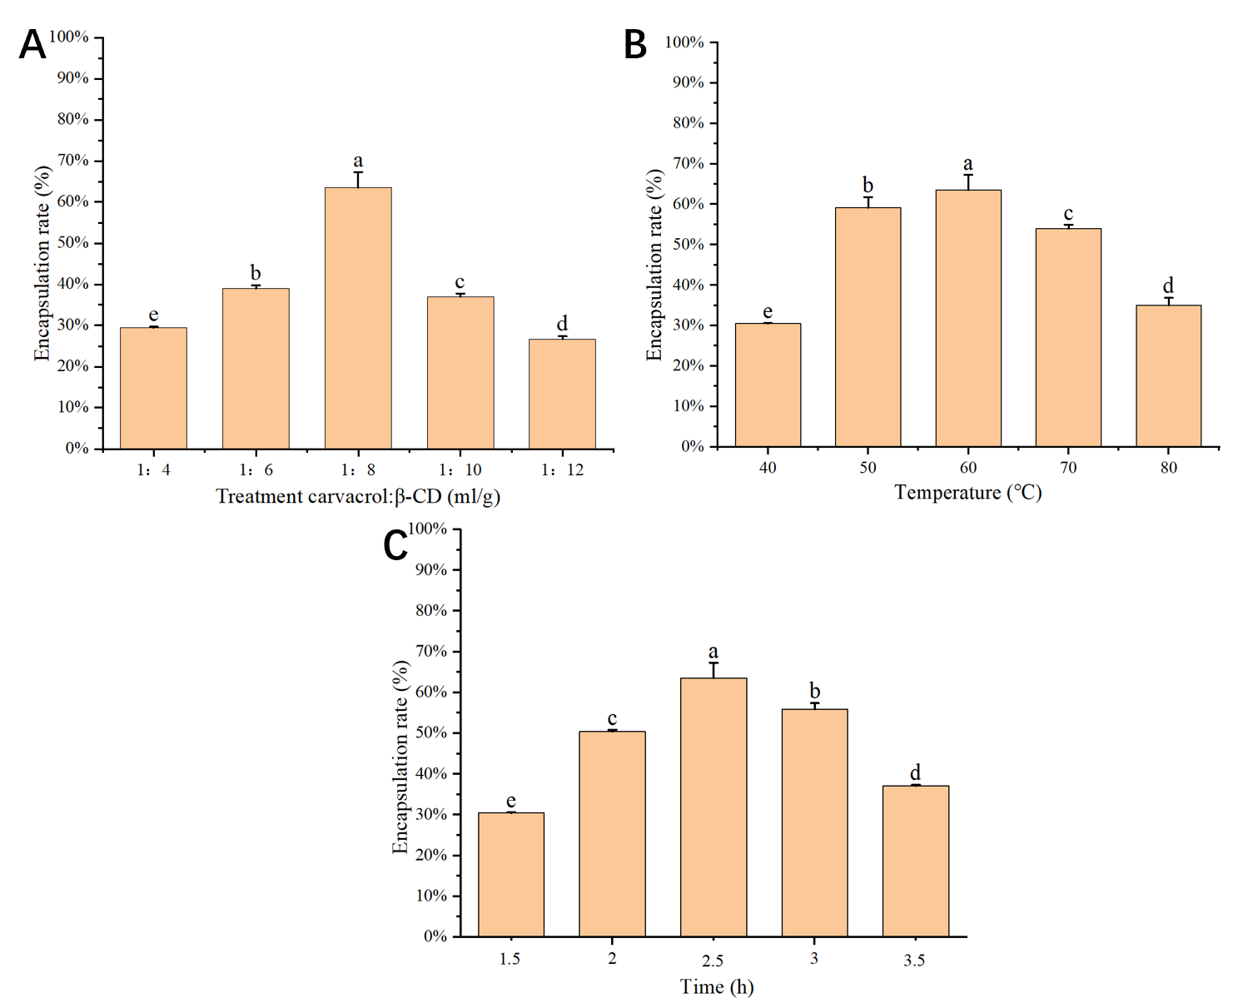
Figure S2. Effect of single factors on ICs encapsulation rate: core-to-wall ratio (A); temperature (B); stirring time (C) (page 15, line 407)

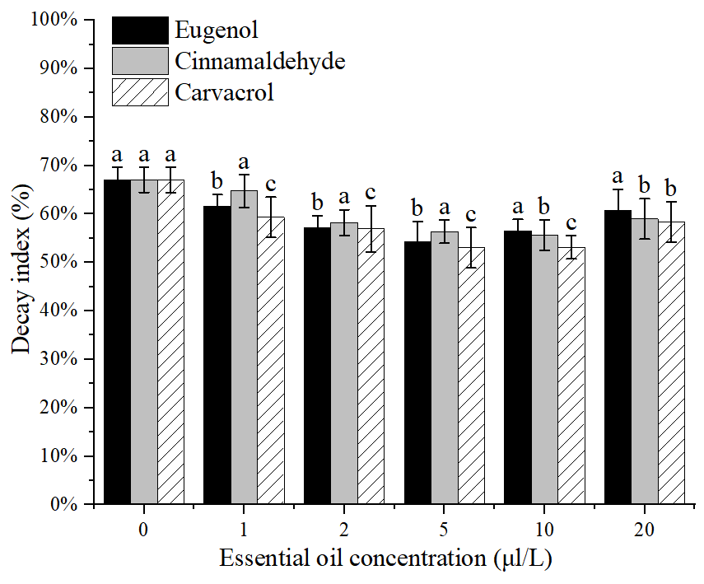
Figure S3. Effect of different essential oils on the decay index of peach fruit (page 14, line 390)

Table S1. Factors and levels of RSM (page 7, line 177)
Levels | X₁ | X₂ | X₃
Levels | Core-wall ratio | Inclusion temperature /°C | Inclusion time /h
-1 | 1:6 | 40 | 2
0 | 1:8 | 50 | 2.5
1 | 1:10 | 60 | 3

Table S2. ANOVA for Response Surface Quadratic Model (page 15, line 409)
Source | Sum of squares | df | Mean square | F-value | p-value Prob >F
Model | 1768.82 | 9 | 196.54 | 61.43 | < 0.0001ª
A | 2.81 | 1 | 2.81 | 0.88 | 0.3800^{c}
B | 86.66 | 1 | 86.66 | 27.08 | 0.0012ª
C | 19.25 | 1 | 19.25 | 6.02 | 0.0439^{b}
AB | 1.43 | 1 | 1.43 | 0.45 | 0.5255^{c}
AC | 1.63 | 1 | 1.63 | 0.51 | 0.4990^{c}
BC | 2.07 | 1 | 2.07 | 0.65 | 0.4473^{c}
A² | 1048.86 | 1 | 1048.86 | 327.81 | < 0.0001ª
B² | 295.01 | 1 | 295.01 | 92.20 | < 0.0001ª
C² | 168.21 | 1 | 168.21 | 52.57 | 0.0002ª
Residual | 22.4 | 7 | 3.2
Lack of Fit | 11.5 | 3 | 3.83 | 1.41 | 0.3636^{c}
Pure Error | 10.9 | 4 | 2.72
Core Total | 1791.22 | 16
R-Squared |  |  |  |  | 0.9875
Adj R-Squared |  |  |  |  | 0.9714
Pred R-Squared |  |  |  |  | 0.8878
ª Significant at p <0.0001, ^{b} Significant at p <0.05, ^{c} Significant at p >0.05.

