Stroke and its diagnosis age on incidence dementia, and the mediating role of inflammation: A matched cohort study

Contents
Supplementary Methods 1. the definition of stroke 2
Supplementary Methods 2. the definition of dementia 3
Supplemental Table 1. Association between age on the index date and incidence dementia by sex using competing risk model. 4
Supplemental Table 2. Association between age on the index date and incidence dementia by APOE ε4 carrier status. 5
Supplemental Table 3. Association between age on the index date and incidence dementia by blood type using competing risk model. 6
Supplemental Table 4 the association between stroke and dementia restricting population to the 30 years follow-up periods. 7
Supplemental Table 5. Associations of stroke with incident all-cause and subsequent dementia using competing risk model. 9
Supplemental Table 6. Associations of age on the index date and incidence dementia using competing risk model. 10
Supplementary Figure 1. The K-M plots of Stroke with Incident All-Cause Dementia in the prevalent stroke cohort. 11
Supplementary Figure 2. The K-M plots of Stroke subtype with Incident All-Cause Dementia in the prevalent stroke cohort. 12
Supplementary Figure 3. the forest plots of age on the index date and incidence dementia by sex in the incident stroke cohort. 13
Supplementary Figure 4. the forest plots of age on the index date and incidence dementia by blood type in the incident stroke cohort. 14

Supplementary Methods 1. the definition of stroke
Stroke subtype | ICD-10 | ICD-9
Ischemic stroke | I63,I63.0,,I63.1,I63.2,I63.3,I63.4,I63.5,I63.6,I63.8,I63.9,I64.X | 434.X,434.0,434.1,434.9,436.X
Intracerebral haemorrhage | I61,I61.0,I61.1,I61.2,I61.3,I61.4,I61.5,I61.6,I61.8,I61.9 | 431.X
Subarachnoid haemorrhage | I60,I60.0,I60.1,I60.2,I60.3,I60.4,I60.5,I60.6,I60.7,I60.8,I60.9 | 430.X
stroke | I63,I63.0,,I63.1,I63.2,I63.3,I63.4,I63.5,I63.6,I63.8,I63.9,I64.X,I61,I61.0,I61.1,I61.2,I61.3,I61.4,I61.5,I61.6,I61.8,I61.9,I60,I60.0,I60.1,I60.2,I60.3,I60.4,I60.5,I60.6,I60.7,I60.8,I60.9 | 434.X,434.0,434.1,434.9,436.X,431.X,430.X

Supplementary Methods 2. the definition of dementia
In UK Biobank, dementia was ascertained using hospital inpatient records which contains data on admissions and diagnoses from the Hospital Episode Statistics for England, Scottish Morbidity Record data for Scotland, and the Patient Episode Database for Wales. Additional cases were detected through linkage to death register data provided by the NHS Digital for England and Wales and the Information and Statistics Division for Scotland. Diagnoses were recorded using the International Classification of Diseases (ICD) coding system. Participants with dementia were identified as having a primary/secondary diagnosis (hospital records) or underlying/contributory cause of death (death register) using ICD-10 codes for Alzheimer’s disease and other dementia classifications. The list of ICD-10 codes and subtypes of all-cause dementia as well more details on definition of all relevant outcomes can be found in https://biobank.ndph.ox.ac.uk/showcase/showcase/docs/alg_outcome_dementia.pdf.

 | ICD10 | ICD9
Alzheimer disease | F00, F00.0, F00.1, F00.2, F00.9, G30, G30.0, G30.1, G30.8, G30.9 | 331.0
Vascular dementia | F01, F01.0, F01.1, F01.2, F01.3, F01.8, F01.9, I67.3 | 290.4
frontotemporal dementia | F02.0, G31.0 | 331.1
dementia in other diseases classified elsewhere and unspecified dementia | A81.0, F02,F02.1, F02.2, F02.3,F02.4, F02.8, F03,F05.1, F10.6, G31.1, G31.8 | 290.2, 290.3, 291.2, 294.1, 331.2,331.5

Supplemental Table 1. Association between age on the index date and incidence dementia by sex using competing risk model.
 | No. of dementia | Incidence rate per
 | cases/Person-years | 1000 person-years (95%CI) | HR (95% CI) | P value
Female
18-65 y (n = 4702)
Matched Non-Stroke | 13/29208.942 | 0.45 (0.26, 0.77) | 1 [Reference]
Stroke | 19/5442.5479 | 3.49 (2.23, 5.48) | 6.66(3.22, 13.78) | < 0.001
65-71 y (n = 5062)
Matched Non-Stroke | 58/28681.923 | 2.02 (1.56, 2.62) | 1 [Reference]
Stroke | 57/5150.726 | 11.07 (8.54, 14.35) | 4.39(2.97, 6.43) | < 0.001
71-76 y (n = 5201)
Matched Non-Stroke | 109/19639.858 | 5.55 (4.60, 6.70) | 1 [Reference]
Stroke | 54/3560.6329 | 15.17 (11.61, 19.80) | 2.38(1.67, 3.39) | < 0.001
>76 y (n = 4134)
Matched Non-Stroke | 68/7824.6877 | 8.69 (6.85, 11.02) | 1 [Reference]
Stroke | 37/1551.8493 | 23.84 (17.27, 32.91) | 2.24(1.46, 3.45) | < 0.001
Male
18-65 y (n = 6941)
Matched Non-Stroke | 28/41644.701 | 0.67 (0.46, 0.97) | 1 [Reference]
Stroke | 23/7655.0877 | 3.00 (2.00, 4.52) | 2.83(1.53, 5.23) | 0.001
65-71 y (n = 6988)
Matched Non-Stroke | 135/40147.392 | 3.36 (2.84, 3.98) | 1 [Reference]
Stroke | 95/7038.2959 | 13.50 (11.03, 16.50) | 3.04(2.28, 4.05) | < 0.001
71-76 y (n = 6384)
Matched Non-Stroke | 143/24571.088 | 5.82 (4.94, 6.86) | 1 [Reference]
Stroke | 93/4543.4466 | 20.47 (16.70, 25.08) | 2.98(2.26, 3.93) | < 0.001
>76 y (n = 4321)
Matched Non-Stroke | 76/8159.4411 | 9.31 (7.44, 11.66) | 1 [Reference]
Stroke | 47/1775.1562 | 26.48 (19.89,35.24) | 2.69(1.83, 3.96) | < 0.001

Supplemental Table 2. Association between age on the index date and incidence dementia by APOE ε4 carrier status.
 | No. of dementia | Incidence rate per | Cox model |  |  | Competing risk model
 | cases/Person-years | 1000 person-years (95%CI) | HR (95% CI) | P value |  | HR (95% CI) | P value
APOE non-carrier
18-65 y (n = 8264)
Matched Non-Stroke | 22/50156.384 | 0.44 (0.29, 0.67) | 1 [Reference] |  |  | 1 [Reference]
Stroke | 32/9252.3041 | 3.45 (2.45, 4.89) | 6.27(3.49, 11.27) | < 0.001 |  | 5.73(3.11, 10.54) | < 0.001
65-71 y (n = 8565)
Matched Non-Stroke | 88/49599.195 | 1.77 (1.43, 2.19) | 1 [Reference] |  |  | 1 [Reference]
Stroke | 87/8800.137 | 9.89 (8.01, 12.20) | 4.97(3.62, 6.84) | < 0.001 |  | 4.29(3.17, 5.81) | < 0.001
71-76 y (n = 8149)
Matched Non-Stroke | 96/31193.581 | 3.08 (2.52, 3.76) | 1 [Reference] |  |  | 1 [Reference]
Stroke | 81/5712.5178 | 14.18 (11.40, 17.63) | 4.46(3.27, 6.10) | < 0.001 |  | 3.88(2.83, 5.34) | < 0.001
>76 y (n = 6116)
Matched Non-Stroke | 76/11653.704 | 6.52 (5.21, 8.17) | 1 [Reference] |  |  | 1 [Reference]
Stroke | 42/2432.1178 | 17.27 (12.76, 23.37) | 2.37(1.59, 3.53) | < 0.001 |  | 2.20(1.46, 3.33) | < 0.001
APOE carrier
18-65 y (n = 3379)
Matched Non-Stroke | 19/20697.26 | 0.92 (0.59, 1.44) | 1 [Reference] |  |  | 1 [Reference]
Stroke | 10/3845.9315 | 2.60 (1.40, 4.83) | 2.21(0.98, 4.99) | 0.055 |  | 1.92(0.88, 4.23) | 0.102
65-71 y (n = 3485)
Matched Non-Stroke | 105/19230.121 | 5.46 (4.51, 6.61) | 1 [Reference] |  |  | 1 [Reference]
Stroke | 65/3389.0877 | 19.18 (15.04, 24.46) | 3.28(2.35, 4.57) | < 0.001 |  | 2.81(1.88, 4.22) | < 0.001
71-76 y (n = 3436)
Matched Non-Stroke | 68/4330.4247 | 15.70 (12.38, 19.91) | 1 [Reference] |  |  | 1 [Reference]
Stroke | 42/899.73699 | 46.68 (34.50, 63.17) | 3.04(2.03, 4.55) | < 0.001 |  | 2.75(1.93, 3.94) | < 0.001
>76 y (n = 2339)
Matched Non-Stroke | 156/13017.364 | 11.98 (10.24, 14.02) | 1 [Reference] |  |  | 1 [Reference]
Stroke | 66/2392.4603 | 27.59 (21.67, 35.11) | 2.20(1.63, 2.99) | < 0.001 |  | 1.90(1.40, 2.58) | < 0.001

Supplemental Table 3. Association between age on the index date and incidence dementia by blood type using competing risk model.
 | No. of dementia | Incidence rate per
 | cases/Person-years | 1000 person-years (95%CI) | HR (95% CI) | P value
blood type O
18-65 y (n = 5029)
Matched Non-Stroke | 21/30674.852 | 0.68 (0.45, 1.05) | 1 [Reference]
Stroke | 14/5518.5753 | 2.53 (1.50, 4.28) | 2.47(1.20, 5.08) | 0.014
65-71 y (n = 5274)
Matched Non-Stroke | 83/30202.647 | 2.74 (2.22, 3.41) | 1 [Reference]
Stroke | 62/5401.0548 | 11.48 (8.95, 14.72) | 3.18(2.22, 4.56) | < 0.001
71-76 y (n = 5067)
Matched Non-Stroke | 111/19453.616 | 5.71 (4.34, 6.87) | 1 [Reference]
Stroke | 62/3438.3452 | 18.03 (14.06, 23.13) | 2.75(1.96, 3.85) | < 0.001
>76 y (n = 3695)
Matched Non-Stroke | 57/7013.9041 | 8.13 (6.27, 10.54) | 1 [Reference]
Stroke | 41/1438.5315 | 28.50 (20.99, 28.71) | 3.30(2.13, 5.11) | < 0.001
blood type Non-O
18-65 y (n = 6597)
Matched Non-Stroke | 20/40019.115 | 0.50 (0.32, 0.77) | 1 [Reference]
Stroke | 28/7568.2164 | 3.70 (2.54, 5.35) | 5.50(2.87, 10.56) | < 0.001
65-71 y (n = 6763)
Matched Non-Stroke | 109/38557.688 | 2.83 (2.34, 3.41) | 1 [Reference]
Stroke | 89/6769.8329 | 13.14 (10.68, 16.18) | 3.67(2.73, 4.93) | < 0.001
71-76 y (n = 6507)
Matched Non-Stroke | 141/24718.786 | 5.70 (4.84, 6.72) | 1 [Reference]
Stroke | 85/4651.611 | 18.27 (14.77, 22.60) | 2.69(2.03, 3.57) | < 0.001
>76 y (n = 4747)
Matched Non-Stroke | 87/8949.6055 | 9.72 (7.88, 11.99) | 1 [Reference]
Stroke | 43/1885.0055 | 22.81 (16.92, 30.76) | 1.96(1.33, 2.87) | 0.001

Supplemental Table 4 the association between stroke and dementia restricting population to the 30 years follow-up periods.

 | No. of dementia | Incidence rate per | Model 1 |  |  | Model 2 |  |  | Model 3
 | cases/Person-years | 1000 person-years (95%CI) | HR (95% CI) | P |  | HR (95% CI) | P |  | HR (95% CI) | P
Prevalence Stroke Cohort
18-48 y (n = 9624)
Matched Non-Stroke | 76/224943.93 | 0.34 (0.27, 0.42) | 1 [Reference] |  |  | 1 [Reference] |  |  | 1 [Reference]
Stroke | 39/38772.625 | 1.01 (0.73, 1.38) | 8.08(4.89, 13.35) | < 0.001 |  | 5.81(3.44, 9.81) | < 0.001 |  | 5.45(2.68, 11.10) | < 0.001
48-55 y (n = 9120)
Matched Non-Stroke | 130/159579.63 | 0.81 (0.69, 0.97) | 1 [Reference] |  |  | 1 [Reference] |  |  | 1 [Reference]
Stroke | 66/30479.252 | 2.17 (1.70, 2.76) | 3.07(2.27, 4.15) | < 0.001 |  | 2.77(2.01, 3.82) | < 0.001 |  | 2.24(1.49, 3.38) | < 0.001
55-61 y (n = 9678)
Matched Non-Stroke | 273/149671.41 | 1.82 (1.62, 2.05) | 1 [Reference] |  |  | 1 [Reference] |  |  | 1 [Reference]
Stroke | 126/28131.833 | 4.48 (3.76, 5.33) | 2.68(2.17, 3.31) | < 0.001 |  | 2.24(1.79, 2.79) | < 0.001 |  | 2.09(1.57, 2.78) | < 0.001
>61 y (n = 7576)
Matched Non-Stroke | 332/97177.444 | 3.42 (3.07, 3.80) | 1 [Reference] |  |  | 1 [Reference] |  |  | 1 [Reference]
Stroke | 119/18127.795 | 6.56 (5.48, 7.86) | 2.03(1.65, 2.51) | < 0.001 |  | 1.84(1.48, 2.28) | < 0.001 |  | 1.43(1.08, 1.89) | 0.013
Incident Stroke Cohort
18-65 y (n = 11838)
Matched Non-Stroke | 41/70853.644 | 0.58 (0.43, 0.79) | 1 [Reference] |  |  | 1 [Reference] |  |  | 1 [Reference]
Stroke | 42/13097.636 | 3.21 (2.37, 4.34) | 5.68(3.69, 8.73) | < 0.001 |  | 4.43(2.78, 7.06) | < 0.001 |  | 3.71(2.08,6.63) | < 0.001
65-71 y (n = 12390)
Matched Non-Stroke | 193/68829.315 | 2.80 (2.44, 3.23) | 1 [Reference] |  |  | 1 [Reference] |  |  | 1 [Reference]
Stroke | 152/12189.022 | 12.47 (10.64, 14.62) | 4.69(3.79, 5.80) | < 0.001 |  | 4.04(3.22, 5.07) | < 0.001 |  | 3.69(2.77, 4.93) | < 0.001
71-76 y (n = 12300)
Matched Non-Stroke | 252/44210.945 | 5.70 (5.04, 6.45) | 1 [Reference] |  |  | 1 [Reference] |  |  | 1 [Reference]
Stroke | 147/8104.0795 | 18.14 (15.43, 21.32) | 3.31(2.70, 4.06) | < 0.001 |  | 3.12(2.52, 3.86) | < 0.001 |  | 3.23(2.47, 4.21) | < 0.001
>76 y (n = 9743)
Matched Non-Stroke | 144/15984.129 | 9.01 (7.65, 10.61) | 1 [Reference] |  |  | 1 [Reference] |  |  | 1 [Reference]
Stroke | 84/3327.0055 | 25.25 (20.39, 31.27) | 2.83(2.16, 3.70) | < 0.001 |  | 2.69(2.03, 3.57) | < 0.001 |  | 2.43(2.74, 3.41) | < 0.001

Supplemental Table 5. Associations of stroke with incident all-cause and subsequent dementia using competing risk model.
 | No. of dementia | Incidence rate per
 | cases/Person-years | 1000 person-years (95%CI) | HR (95% CI) | P value
Prevalence Stroke Cohort
All-cause dementia
Matched Non-Stroke | 811/631372.41 | 1.28 (1.20, 1.38) | 1 [Reference]
Stroke | 378/120672.52 | 3.13 (2.83, 3.46) | 1.49(1.25,1.76) | < 0.001
Alzheimer’s disease
Matched Non-Stroke | 273/621570.75 | 0.44 (0.39, 0.49) | 1 [Reference]
Stroke | 65/115373.95 | 0.56 (0.44, 0.72) | 0.84(0.59,1.20) | 0.335
Vascular dementia
Matched Non-Stroke | 133/618659.03 | 0.21 (0.18, 0.25) | 1 [Reference]
Stroke | 129/116323.49 | 1.11 (0.93, 1.32) | 3.21(2.24,4.60) | < 0.001
Other dementia
Matched Non-Stroke | 405/624052.32 | 0.65 (0.59, 0.72) | 1 [Reference]
Stroke | 184/117357.13 | 1.57 (1.36, 1.81) | 1.39(1.09,1.78) | 0.008
Incident Stroke Cohort
All-cause dementia
Matched Non-Stroke | 630/199878.03 | 3.15 (2.92, 3.41) | 1 [Reference]
Stroke | 425/36717.742 | 11.57 (10.53, 12.73) | 2.54(2.16,2.99) | < 0.001
Alzheimer’s disease
Matched Non-Stroke | 260/197952 | 1.31 (1.16, 1.48) | 1 [Reference]
Stroke | 50/35167.866 | 1.42 (1.08, 1.88) | 0.82(0.57,1.69) | 0.27
Vascular dementia
Matched Non-Stroke | 77/197116.25 | 0.39 (0.31, 0.49) | 1 [Reference]
Stroke | 177/ 35620.129 | 4.97 (4.29, 5.76) | 8.23(5.73,11.81) | < 0.001
Other dementia
Matched Non-Stroke | 293/198219.82 | 1.48 (1.32, 1.66) | 1 [Reference]
Stroke | 198/35769.847 | 5.54 (4.82, 6.36) | 2.79(2.20,5.56) | < 0.001

Supplemental Table 6. Associations of age on the index date and incidence dementia using competing risk model.
 | No. of dementia | Incidence rate per
 | cases/Person-years | 1000 person-years (95%CI) | HR (95% CI) | P value
Prevalence Stroke Cohort
18-48 y (n = 9624)
Matched Non-Stroke | 76/224943.93 | 0.34 (0.27, 0.42) | 1 [Reference]
Stroke | 64/43818.479 | 1.46 (1.43, 1.87) | 2.60(1.63, 4.14) | < 0.001
48-55 y (n = 9120)
Matched Non-Stroke | 130/159579.63 | 0.81 (0.69, 0.97) | 1 [Reference]
Stroke | 69/30594.408 | 2.26 (1.78, 2.86) | 1.71(1.15, 2.66) | < 0.001
55-61 y (n = 9677)
Matched Non-Stroke | 273/149671.41 | 1.82 (1.62, 2.05) | 1 [Reference]
Stroke | 126/28131.833 | 4.48 (3.76, 5.33) | 1.84(1.37, 2.46) | < 0.001
>61 y (n = 7571)
Matched Non-Stroke | 332/97177.444 | 3.42 (3.07, 3.80) | 1 [Reference]
Stroke | 119/18127.795 | 6.56 (5.48, 7.86) | 1.31(0.99, 1.74) | 0.057
Incident Stroke Cohort
18-65 y (n = 11643)
Matched Non-Stroke | 41/70853.644 | 0.58 (0.43, 0.79) | 1 [Reference]
Stroke | 42/13097.636 | 3.21 (2.37, 4.34) | 3.31(1.91, 5.74) | < 0.001
65-71 y (n = 12050)
Matched Non-Stroke | 193/68829.315 | 2.80 (2.44, 3.23) | 1 [Reference]
Stroke | 152/12189.022 | 12.47 (10.64, 14.62) | 3.08(2.30, 4.16) | < 0.001
71-76 y (n = 111585)
Matched Non-Stroke | 252/44210.945 | 5.70 (5.04, 6.45) | 1 [Reference]
Stroke | 147/8104.0795 | 18.14 (15.43, 21.32) | 2.80(2.14, 3.67) | < 0.001
>76 y (n = 8455)
Matched Non-Stroke | 144/15984.129 | 9.01 (7.65, 10.61) | 1 [Reference]
Stroke | 84/3327.0055 | 25.25 (20.39, 31.27) | 2.27(1.64, 3.13) | < 0.001

Supplementary Figure 1. The K-M plots of Stroke with Incident All-Cause Dementia in the prevalent stroke cohort.

Supplementary Figure 2. The K-M plots of Stroke subtype with Incident All-Cause Dementia in the prevalent stroke cohort.

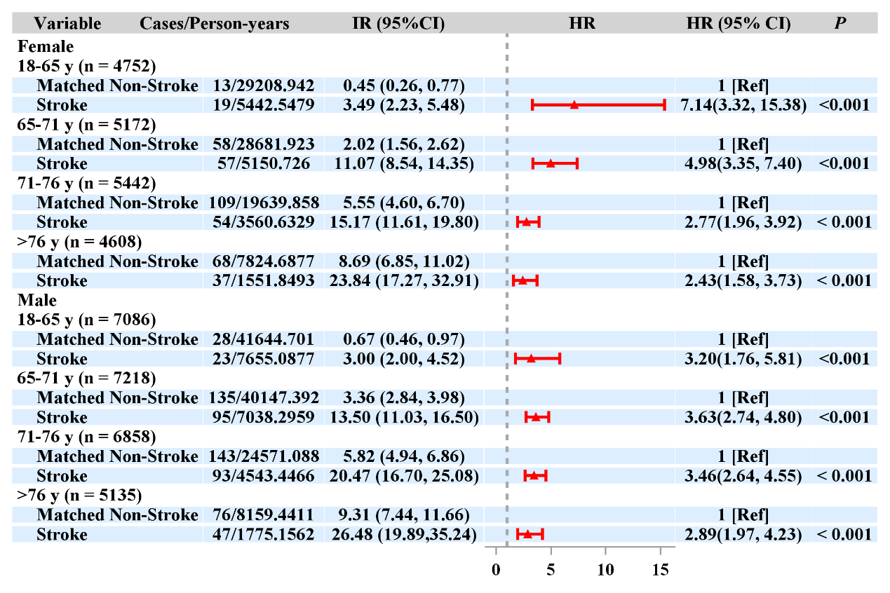

Supplementary Figure 3. the forest plots of age on the index date and incidence dementia by sex in the incident stroke cohort.

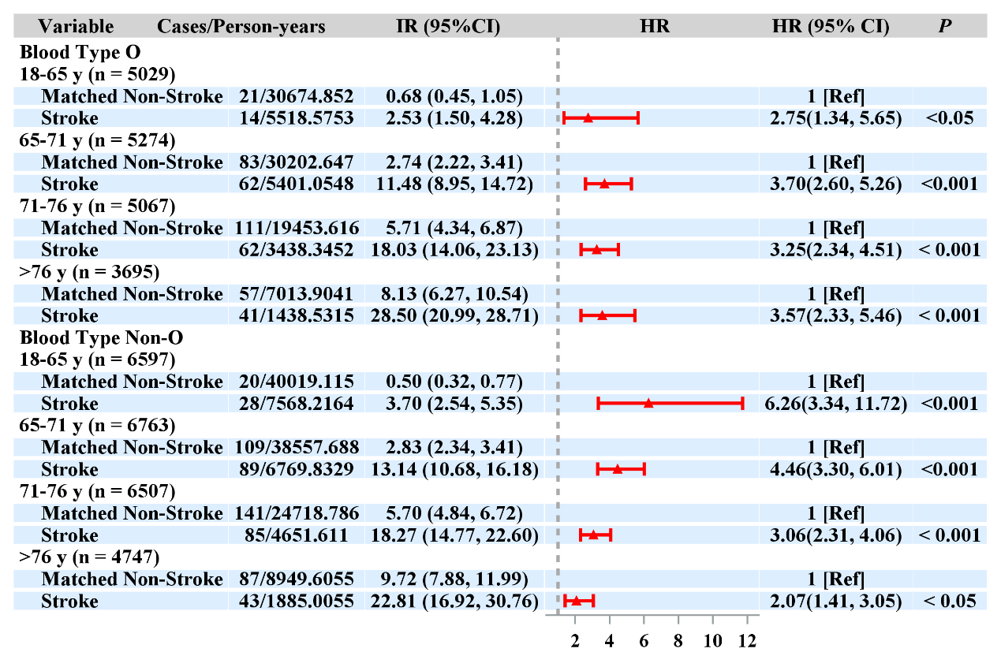

Supplementary Figure 4. the forest plots of age on the index date and incidence dementia by blood type in the incident stroke cohort.

