Supplementary information

Supplementary Figure 1: Monthly interpolated time series of (a) B/Ca and (b) Ba/Ca for Even in yellow, Anemone in blue, and Siwa in brown. Shading indicates analytical uncertainty.

Supplementary Figure 2: Maps of sea surface temperature, precipitation and sea surface salinity in the Maritime Continent in August during the (a,c,e) dry season and in January during (b,d,f) the wet season, respectively highlighting the contrast between monsoon seasons.

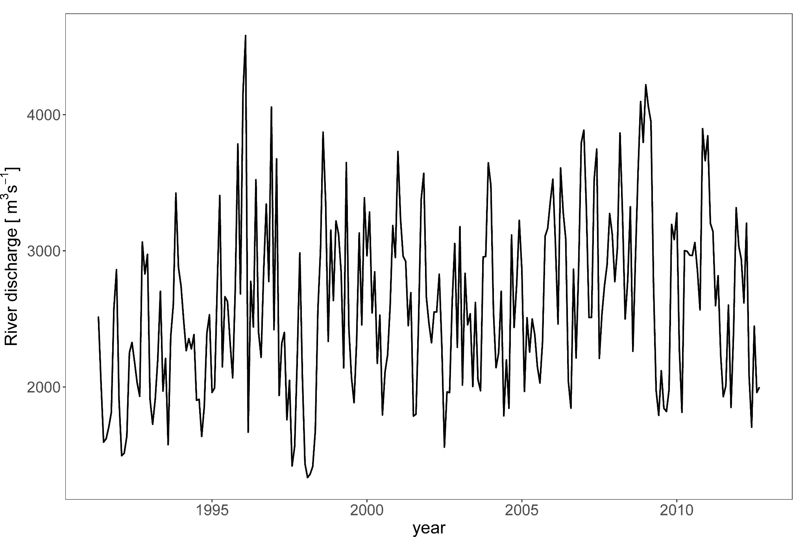
Supplementary Figure 3: Monthly record of the Baram River discharge based on the flow at the Marudi station (4.178° N, 114.311° E).
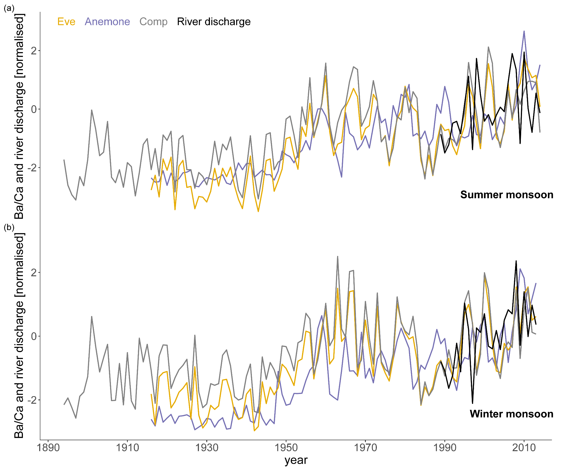
Supplementary Figure 4: Annual Ba/Ca records of Eve, Anemone and the composite (in yellow, blue and grey, respectively) as well as river discharge (in black) during the summer (a) and winter (b) monsoon.
Supplementary Figure 5: Changepoint analysis¹ based on significant arithmetic mean change for (a) Eve and (b) Siwa between 1916 and 2015, and 1916 and 1994, respectively.
Supplementary Figure 6: Changepoint analysis¹ based on significant arithmetic mean change displaying no significant change across the record for rainfall (a) at our study site (4-5° N, 113­-114° E) and (b) for the whole Baram river catchment (2.75-4.5° N, 114-115° E).

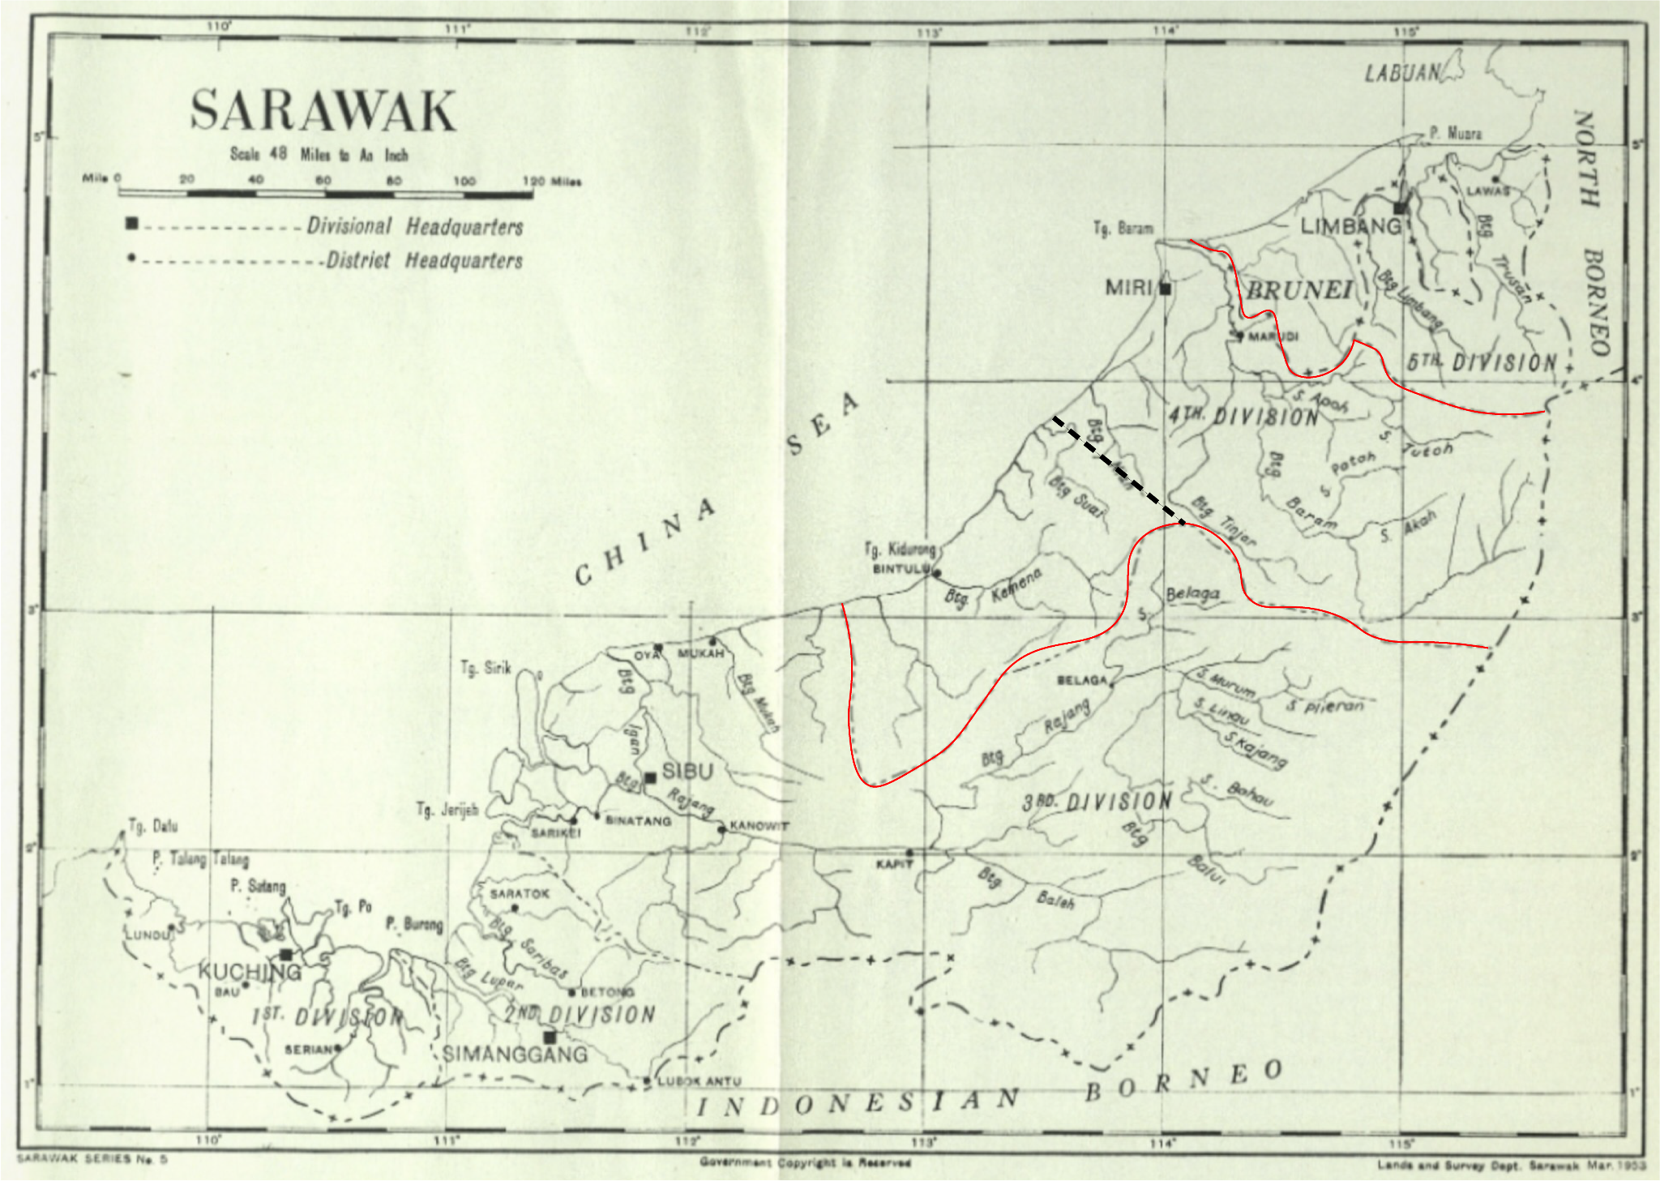
Supplementary Figure 7: Map of Sarawak and its divisions (1st to 5th) extracted from Browne². The 4th division is marked in red. The data differentiates the 4th division into Miri (in the North next to Brunei) and Bintulu (in the South, next to the 3rd division) separated by the dashed black line.

References
1. MATLAB. MATLAB and Signal Processing Toolbox. The MathWorks, Inc. (Release 2023b).
2. Browne, F. G. Sarawak: Miscellaneous Reports. (1956).

