Supplemental Information

Engineering M1 macrophages with targeting aptamers for enhanced adoptive immunotherapy by modifying the cell surface

Qian Yang^{1,2}, Shiyi Hu^{1,2}, Yiqiu Wang^{1,2}, Luyi Zhong^{1,2}, Xiaoli Yu^{1,2}, Yifeng Zhang^{1,2}, Yiting Zhang^{1,2}, Honghua Zhang^{1,2}, Shuling Wang^{1,2}, Qingchang Tian^{1,2}*

1. School of Pharmacy, Hangzhou Normal University, Hangzhou, Zhejiang 311121, China.
2. Key Laboratory of Elemene Class Anti-Cancer Chinese Medicines; Engineering Laboratory of Development and Application of Traditional Chinese Medicines; Collaborative Innovation Center of Traditional Chinese Medicines of Zhejiang Province, Hangzhou Normal University, Hangzhou, Zhejiang 311121, China.

Corresponding authors:
Qingchang Tian (tianqc@hznu.edu.cn);
Permanent affiliation: 1. School of Pharmacy, Hangzhou Normal University, Hangzhou, Zhejiang 311121, China.

Fig. S1. (A) Standard curve of LPS content of 0.01 to 0.1 EU/mL. (B) Standard curve with LPS content of 0.1-1 EU/mL. (C) Determination of LPS concentration in each group. n=3, x ± SD.

Table S1. Aptamers sequences used in this work.
Name | Sequence（5’ – 3’）
AS1411 | GGTGGTGGTGGTTGT  GGTGGTGGTGG
Chol-AS1411 | Cholesteryl-GGTGGTGGTGGTTGT  GGTGGTGGTGG
Chol-AS1411-FAM | Cholesteryl-GGTGGTGGTGGTTGT  GGTGGTGGTGG-FAM
Chol-AS1411-Cy5.5 | Cholesteryl-GGTGGTGGTGGTTGT  GGTGGTGGTGG-Cy5.5
AS1411-FAM | GGTGGTGGTGGTTGT  GGTGGTGGTGG-FAM
C-AS1411 | CGATCGATCGATCGAT  CGATCGATCGA
C-AS1411- FAM | CGATCGATCGATCGAT  CGATCGATCGA-FAM
Chol-C-AS1411 | Cholesteryl-CGATCGATCGATCGAT  CGATCGATCGA
Chol-C-AS1411- FAM | Cholesteryl-CGATCGATCGATCGAT  CGATCGATCGA-FAM

We labeled tumor cells with CellTracker Green CMFDA cytoplasmic green fluorescent probe, and the tumor cells were incubated with macrophages from each group for 2 hours, and the macrophages were stained with anti-F4/80-PE. Thus, when the red macrophages phagocytose the tumor cells, they will also pick up the green fluorescence of the tumor cells, thus becoming double positive cells. The results showed that CAM1 cells had the most significant phagocytic effect on B16 cells (vs.M0, ****P<0.0001; vs.M1, ***P<0.001). Similarly, the phagocytic capacity of CAM1 cells was much higher than that of M0 cells (P<0.0001), but the phagocytic rate of CAM1 cells was not significantly different from that of M1 cells (Fig. S2).
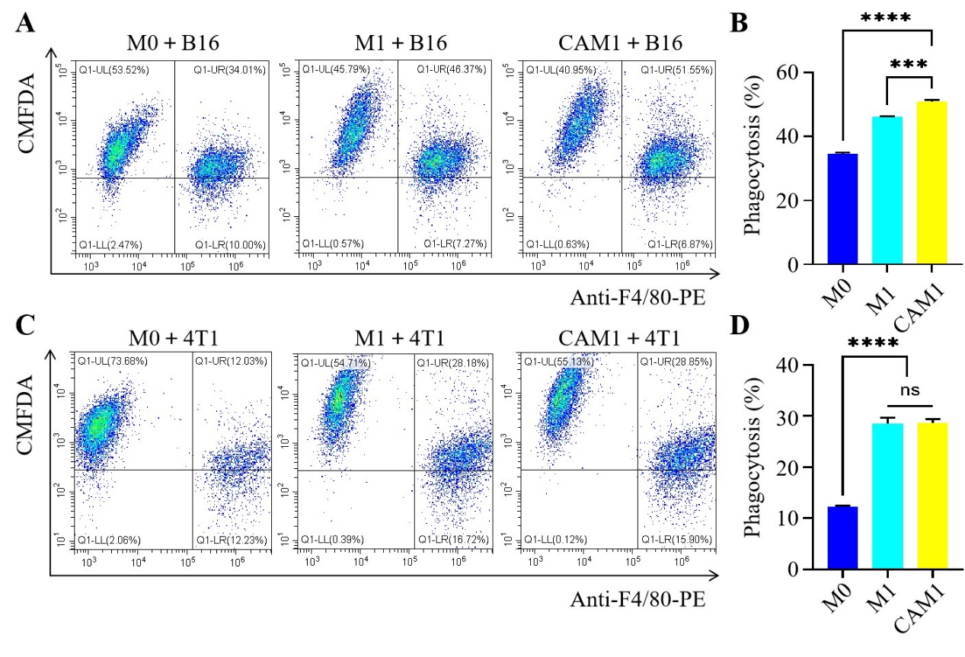
Fig. S2. (A) Flow cytometry was used to detect the phagocytosis of B16 cells by macrophages and its quantitative analysis. (B) Analysis of phagocytosis rate of macrophages engulfing B16 cells. (C) Flow cytometry and quantitative analysis of phagocytosis of 4T1 cells by macrophages. (D) Analysis of phagocytosis rate of macrophages engulfing 4T1 cells. n=3, x ± SD, ***P<0.001, ****P<0.0001, ns is no significant difference.

Table S2 primers in the RT-PCR
primer | sequence（5’-3’） | Source
GAPDH（Forward） | TGTGTCCGTCGTGGATCTGA | Tsingke Biotechnology Co.
GAPDH（Reverse） | TTGCTGTTGAAGTCGCAGGAG | Tsingke Biotechnology Co.
iNOS（Forward） | CAAGCACATTTGGGAATGGAGA | Tsingke Biotechnology Co.
iNOS（Reverse） | CAGAACTGAGGGTACATGCTGGAG | Tsingke Biotechnology Co.
IL-6（Forward） | CTGGGAAATCGTGGAAATGAG | Tsingke Biotechnology Co.
IL-6（Reverse） | GACTCTGGCTTGTCTTTCTTGTTA | Tsingke Biotechnology Co.
IL-1β（Forward） | AGATAGAAGTCAAGAGCAAAGTGGA | Tsingke Biotechnology Co.
IL-1β（Reverse） | TGGGGAAGGCATTAGAAACAG | Tsingke Biotechnology Co.
TNF-α（Forward） | CCCTCCTGGCCAACGGCATG | Tsingke Biotechnology Co.
TNF-α（Reverse） | TCGGGGCAGCCTTGTCCCTT | Tsingke Biotechnology Co.

Table S3. Antibodies and ELISA kits in this work.
Name | Source
Rabbit monoclonal [EPR19514] to CD4 | Abcam, ab183685
Rabbit monoclonal [EPR21769] to CD8 alpha | Abcam, ab217344
Goat Anti-Rabbit IgG H&L (Alexa Fluor® 488) | Abcam, ab150077
TNF-α ELISA Kit | Abcam, ab208348
IL-6 ELISA Kit | Abcam, ab222503
IL-12 p70 ELISA Kit | Abcam, ab25036
IL-10 ELISA Kit | Abcam, ab255729
TruStain FcXTM (anti-mouse CD16/32) | Biolegend, 101319
FITC anti-mouse CD206 (MMR) Antibody | Biolegend, 141703
PE anti-mouse F4/80 Antibody | Biolegend, 123110
FITC anti-mouse CD86 Antibody | Biolegend, 105005

