Bulk and single-cell transcriptional profiles reveal roles of fibroblasts and immunocytes in pan-cancer progression

Yan Sun ^{1, 2, 3}, Bin Song ^{1, 2}, Qichao Yu ^{1, 2}, Huanming Yang ^{1, 2, 3}, Wei Dong ^{1, 2, 3, *}

1 College of Life Sciences, University of Chinese Academy of Sciences, Beijing 100049, China.
2 BGI Research, Shenzhen 518083, China.
3 HIM-BGI Omics Center, Hangzhou Institute of Medicine (HIM), Chinese Academy of Sciences (CAS), Zhejiang Cancer Hospital, Hangzhou 310022, China
* Correspondence: Wei Dong, dongw@bgi.com

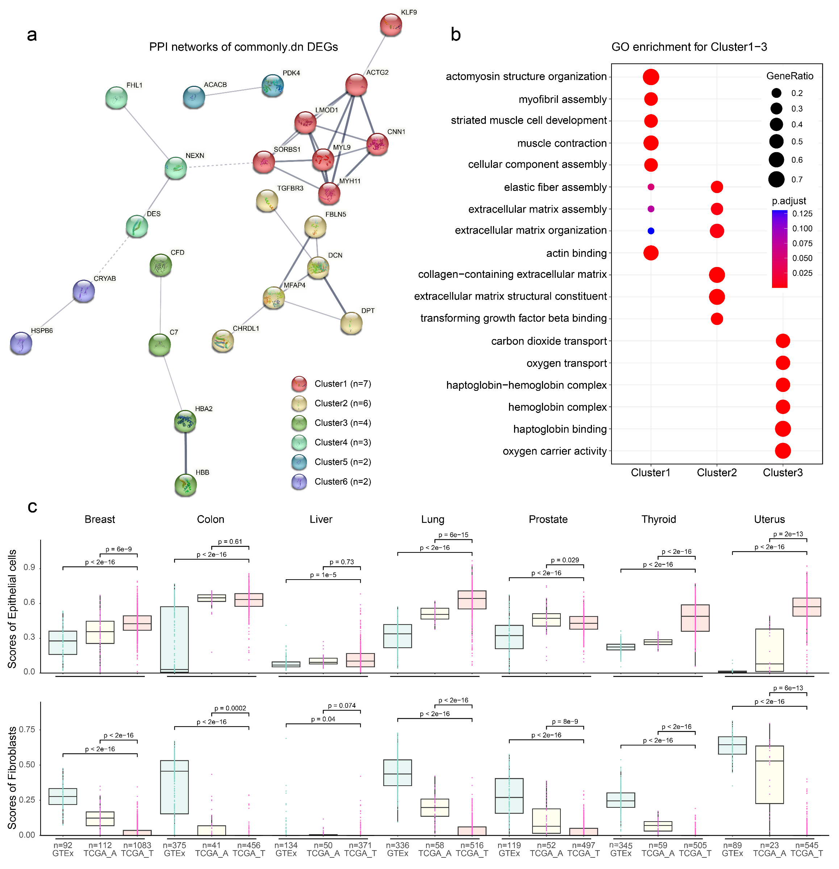
Figure S1. Commonly down-regulated genes and bulk sample deconvolution. a: PPI network of commonly down-regulated genes. Six clusters are identified by MCL clustering with inflation parameter = 2.5. Line thickness indicates the strength of data support. Nodes within a cluster are connected with solid lines, from different clusters with dashed lines. Disconnected proteins are hided. b: GO enrichment of Cluster1-3. c. xCell scores of Epithelial (upper) and Fibroblast (lower) cells in GTEx non-tumor, TCGA adjacent and tumor bulk samples of 7 organs. There are three boxes in each organ‘s panel. GTEx: GTEx non-tumor samples. TCGA_A: adjacent samples of TCGA patients. TCGA_T: tumor samples of TCGA patients. Two-tailed Wilcoxon test is applied.

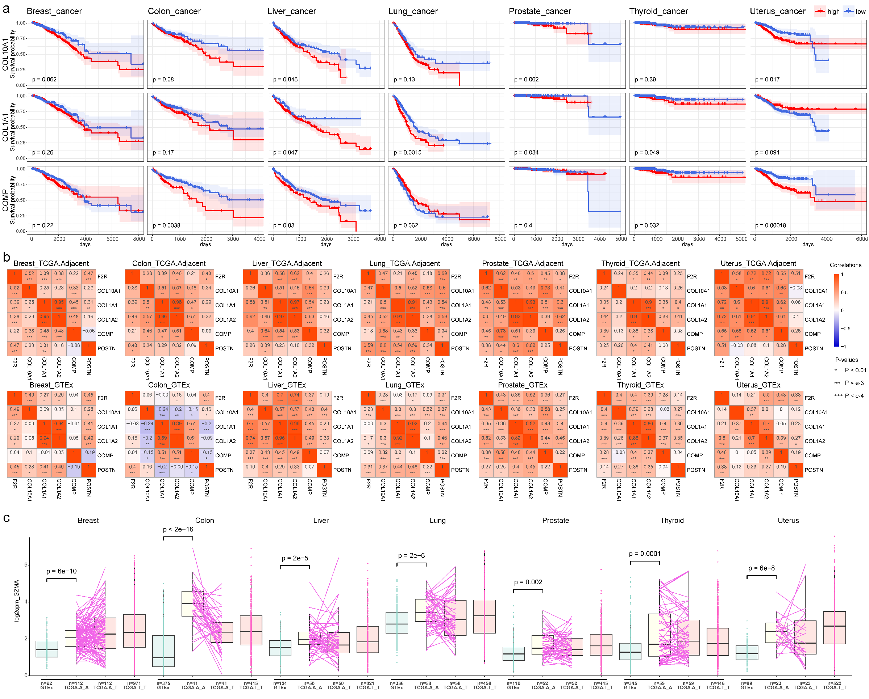
Figure S2. a: Survival analysis on COL10A1, COL1A1, COMP. b: Gene expression correlations of PARs receptor F2R and commonly up regulated genes in TCGA adjacent samples and GTEx non-tumor samples of 7 organs. c: log2-CPM of GZMA in GTEx non-tumor, TCGA adjacent and tumor bulk samples of 7 organs. There are four boxes in panel of each organ. GTEx: GTEx non-tumor samples. TCGA.A_A: adjacent samples of TCGA patients. TCGA.A_T: corresponding TCGA tumor samples from patients with adjacent tissues. Adjacent samples and tumor samples from the same patients are connected with a solid line. TCGA.T_T: tumor samples from tumor only TCGA patients. Two-tailed Wilcoxon test is applied.

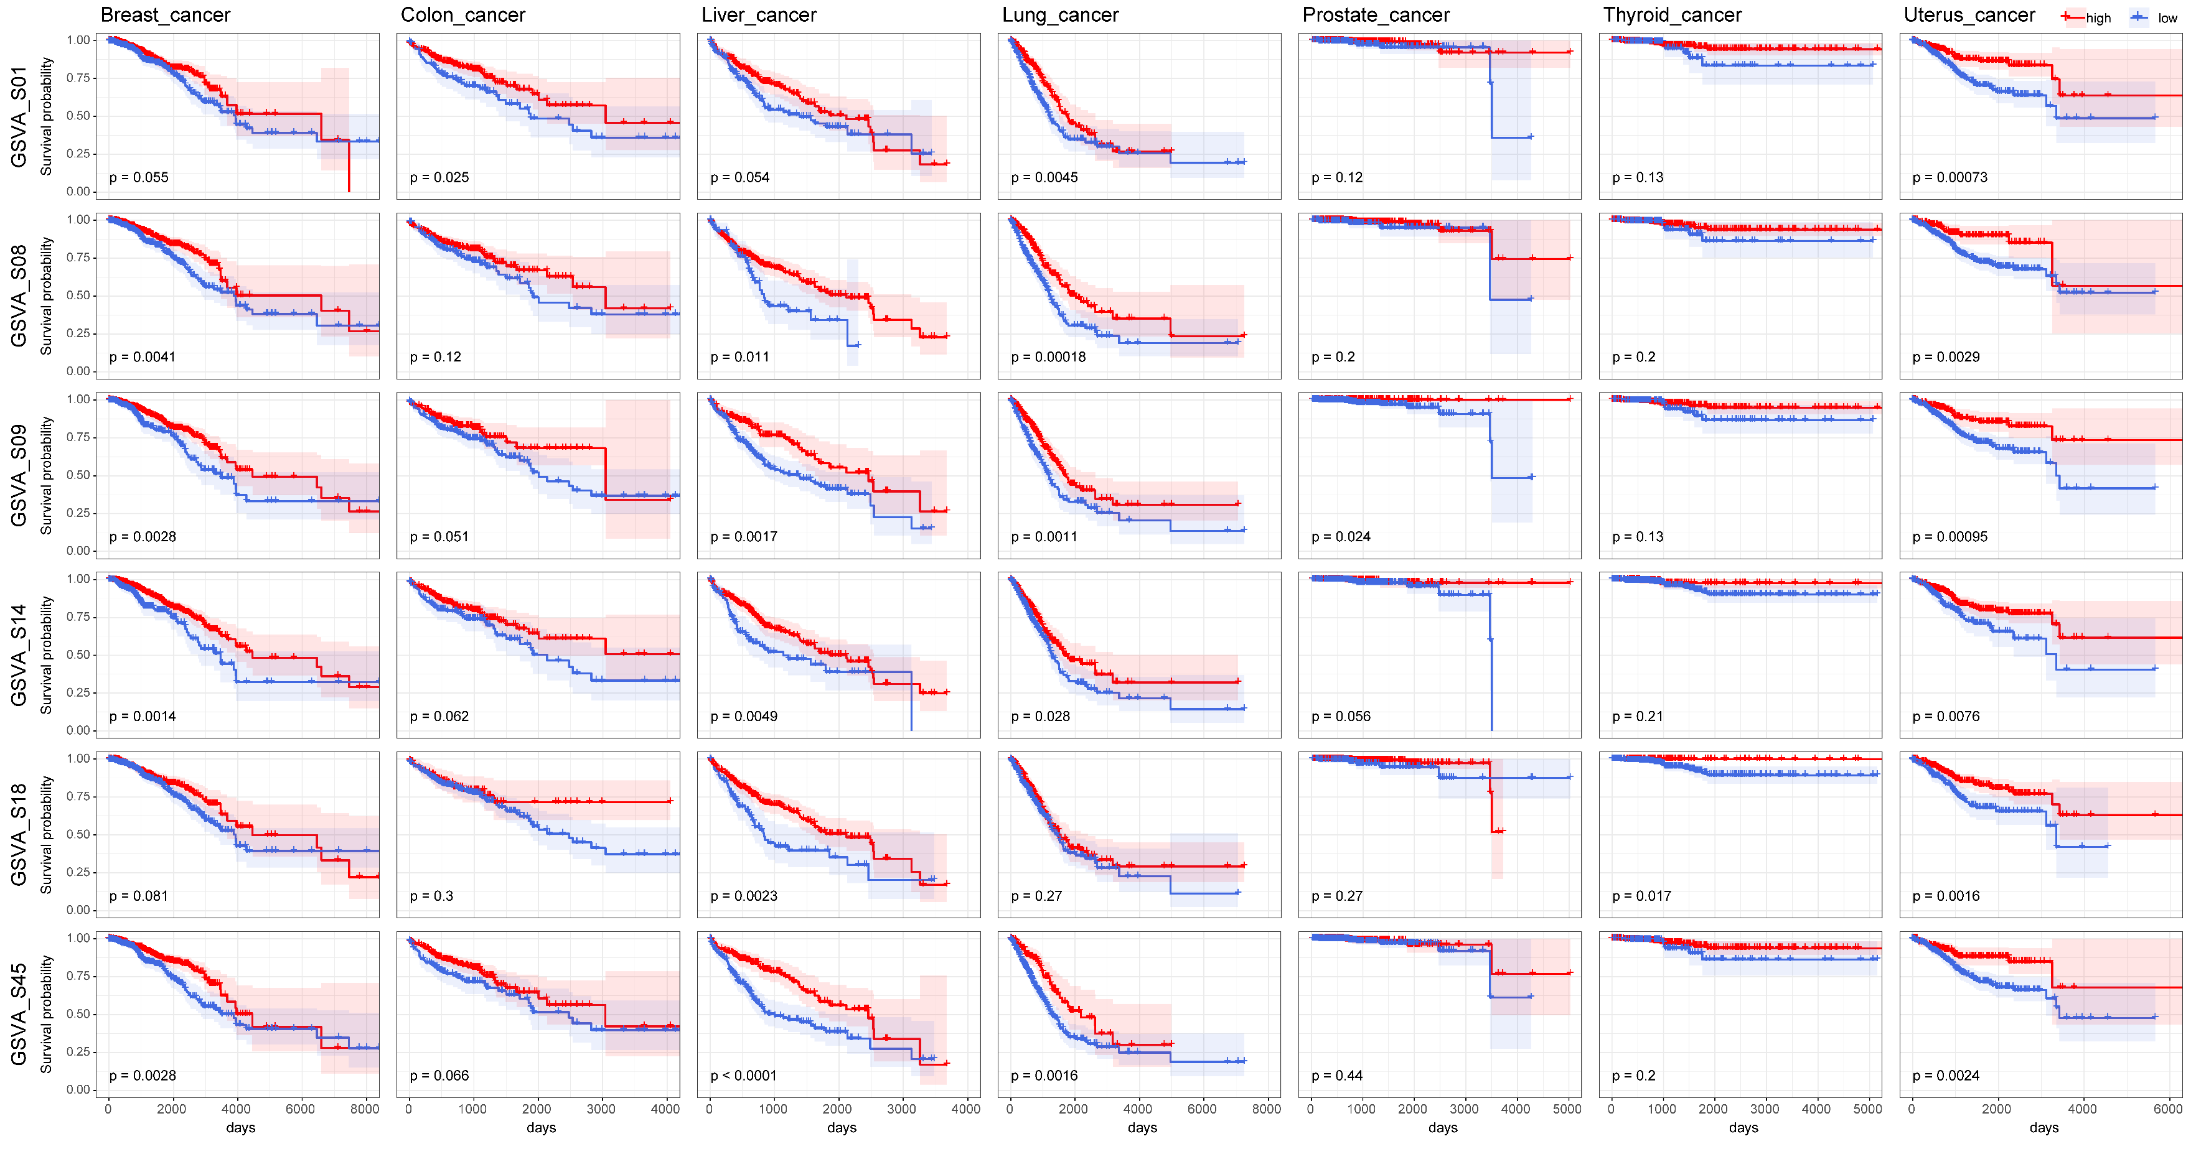
Figure S3. Survival analysis on GSVA scores of commonly co-expressed gene sets S01, S08, S09, S14, S18, S45. High expressions of these gene sets are correlated with favorable prognosis in all the 7 cancer types.
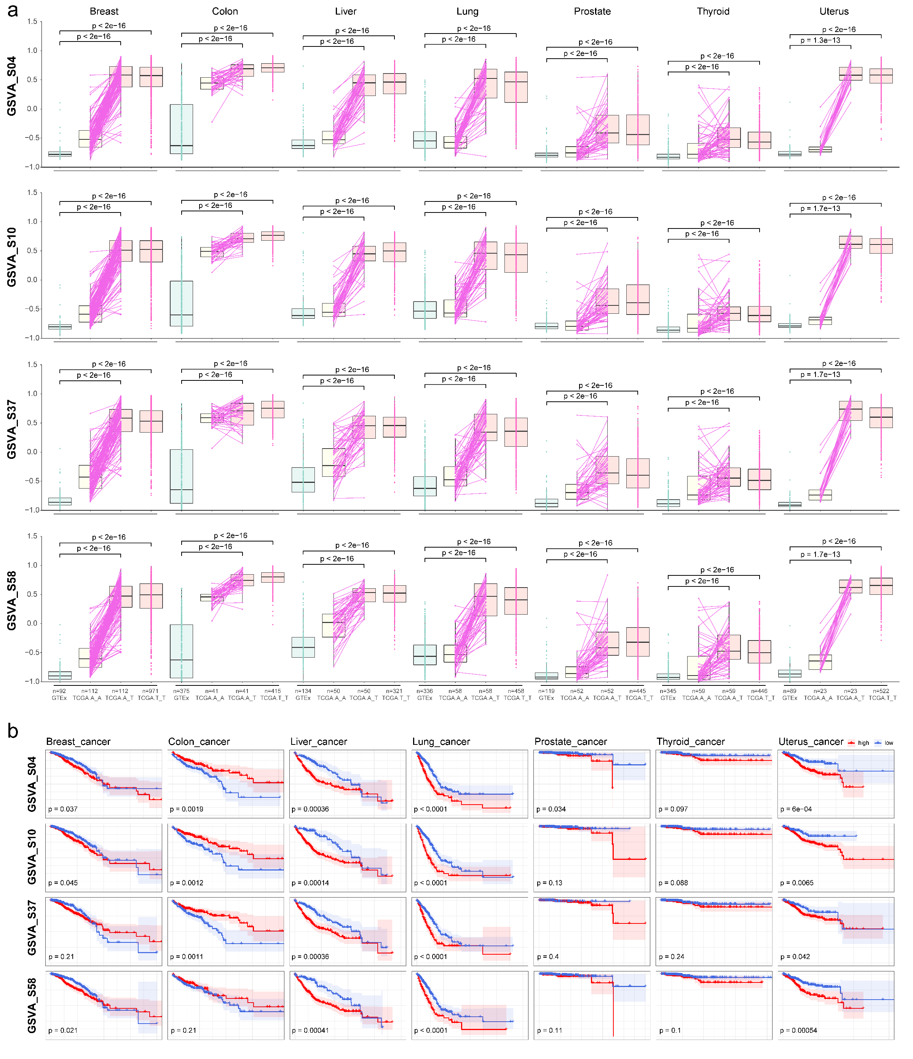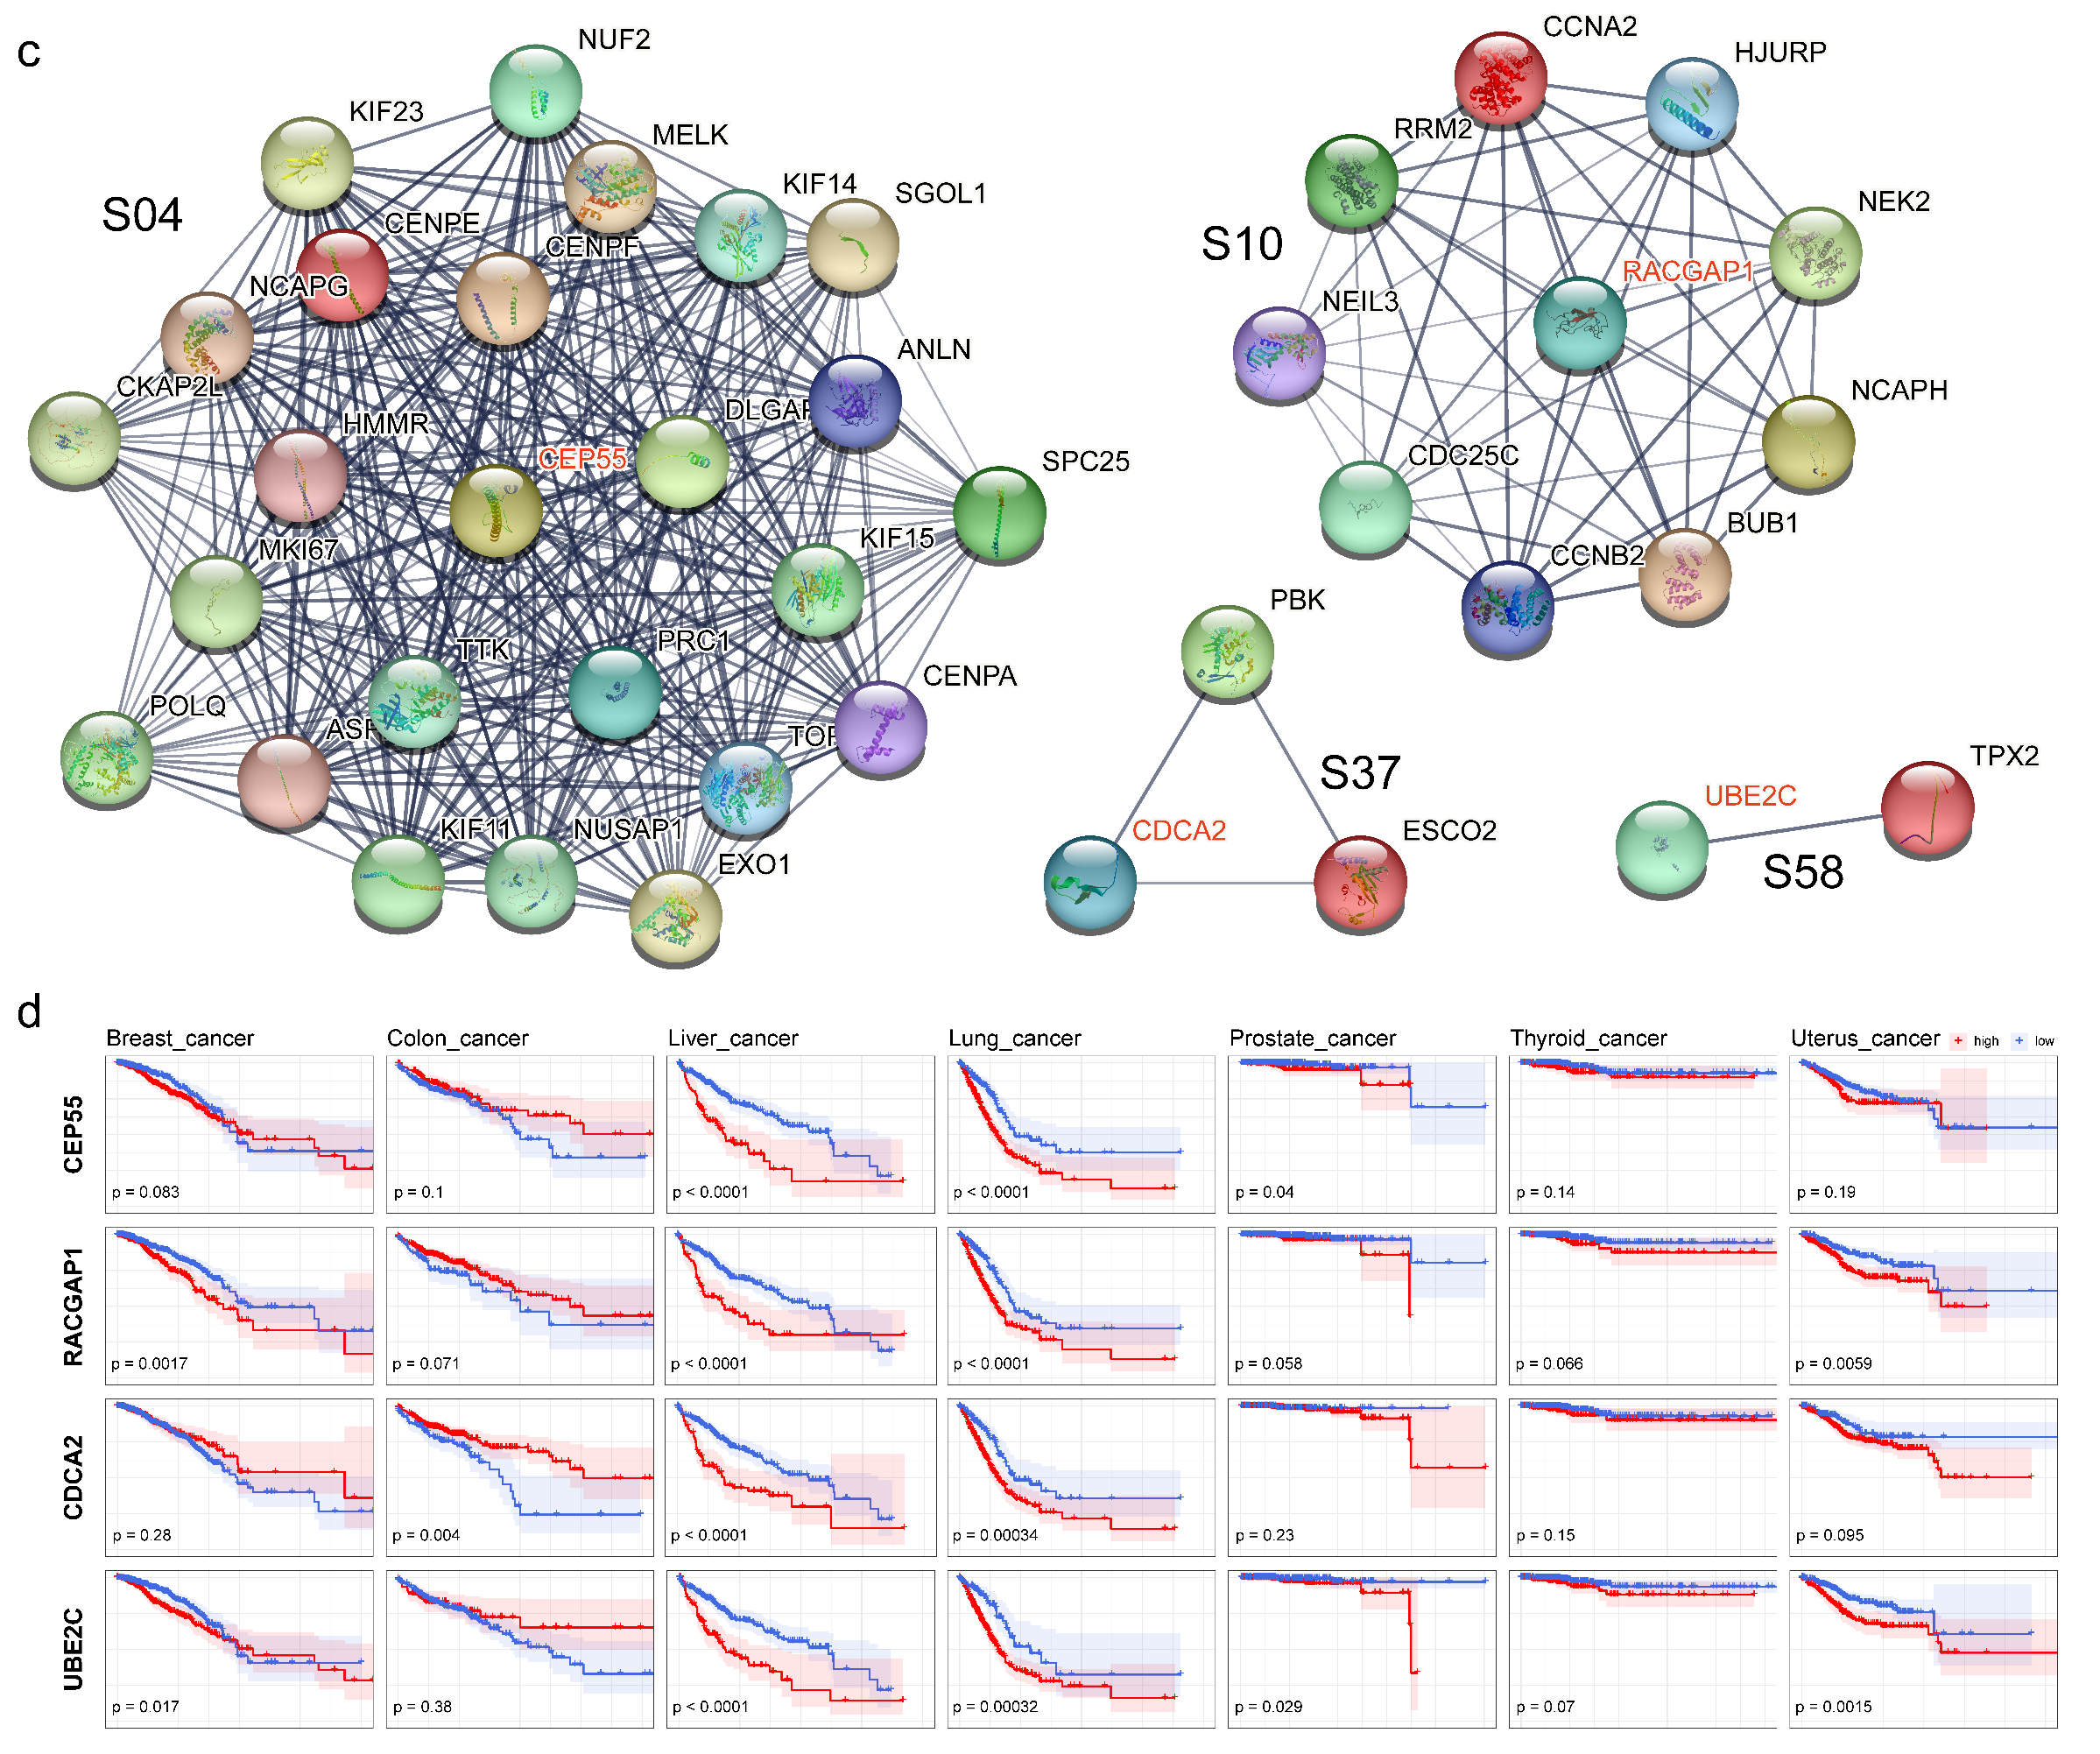

Figure S4. Cell cycle related gene sets. a: GSVA scores of commonly co-expressed gene sets S04, S10, S37, S58 in tissues from 7 organs. GTEx: GTEx non-tumor samples. TCGA.A_A: adjacent samples of TCGA patients. TCGA.A_T: corresponding TCGA tumor samples from patients with adjacent tissues. Adjacent samples and tumor samples from the same patients are connected with a solid line. TCGA.T_T: tumor samples from tumor only TCGA patients. Two-tailed Wilcoxon test is applied. b: Survival analysis based on GSVA scores of S04, S10, S37, S58. c: PPI networks of S04, S10, S37, S58. d: Survival analysis on expressions of CEP55, RACGAP1, CDCA2, UBE2C, which belong to S04, S10, S37, S58, respectively.

