Appendix 1. HEI. Because the HEI relies on density (usually dietary ingredient content per 1000 kcal) and a common scoring scale, it can be applied to any group of foods. Table S1 lists the minimum and maximum scoring criteria for the HEI-2015. For all ingredients, densities between the minimum and maximum criteria are scored proportionally¹.

Table A1. Healthy Eating Index-2015 components, point values, and standards for scoring
Component | Maximum points | Standard for maximum score | Standard for minimum score of zero

Adequacy
Total Fruits | 5 | ≥0.8 c equivalents/1,000 kcal | No fruit
Whole Fruits | 5 | ≥0.4 c equivalents/1,000 kcal | No whole fruit
Total Vegetables | 5 | ≥1.1 c equivalents/1,000 kcal | No vegetables
Greens and Beans | 5 | ≥0.2 c equivalents/1,000 kcal | No dark green vegetables or beans and peas
Whole Grains | 10 | ≥1.5 oz equivalents/1,000 kcal | No whole grains
Dairy | 10 | ≥1.3 c equivalents/1,000 kcal | No dairy
Total Protein Foods | 5 | ≥2.5 oz equivalents/1,000 kcal | No protein foods
Seafood and Plant Proteins | 5 | ≥0.8 c equivalents/1,000 kcal | No seafood or plant proteins
Fatty Acids | 10 | (PUFAsª+MUFAs^{b})/SFAs^{c} ≥2.5 | (PUFAs+MUFAs)/SFAs ≤1.2

Moderation
Refined Grains | 10 | ≤1.8 oz equivalents/1,000 kcal | ≥4.3 oz equivalents/1,000 kcal
Sodium | 10 | ≤1.1 g/1,000 kcal | ≥2.0 g/1,000 kcal
Added Sugars | 10 | ≤6.5% of energy | ≥26% of energy
Saturated Fats | 10 | ≤8% of energy | ≥16% of energy

Note: ªPUFAs=polyunsaturated fatty acids.

^{b}MUFAs=monounsaturated fatty acids.

^{c}SFAs=saturated fatty acids.

Appendix 2. A-HEI. The A-HEI was calculated in the same way as the HEI, but the A-HEI utilized a more food-based approach to dietary recommendations rather than a nutrition-based approach. We excluded trans fats from the study due to enacted policy changes as well as the fact that trans fats were not collected in NHANES, which could have biased the study results. We also adjusted the whole grain cutoff to reflect the recent USDA dietary guidelines to consume ≥50% of total grains as whole grains because of dataset limitations and the availability of reliable data in the USDA MPED/FPED dietary documents², as shown in Table S2.

Table A2. Adapted AHEI-2010 Score Description
Component | Serving definitions | Description | Criteria for minimum score (0) | Criteria for maximum score (10)
Vegetables, servings/d | 1 cup of raw, canned, frozen, or cooked vegetable, 2 cups of raw, leafy vegetables | All vegetables, except white potatoes and juice | 0 | ≥5
Fruit, servings/d | 1 cup of raw, canned, or frozen fruit | Includes only whole fruit, excluding fruit juice | 0 | ≥4
Whole grains, g/d | N/A | Includes grams of whole grain in “whole grain” products | 0 | ≥50
Sugar-sweetened beverages and fruit juice, servings/d | 8 oz | Includes soda, fruit juice, and fruit drinks, presweetened iced teas, sports drinks and energy drinks | ≥1 | 0
Nuts and legumes, servings/d | ¼ cup of cooked beans and peas (legumes) | Includes nuts and vegetable proteins (i.e., legumes, beans, and tofu) | 0 | ≥1
Red/processed meat, servings/d | 4 oz of unprocessed meat or 1.5 oz of processed meat | Red and processed meat | ≥1.5 | 0
Long-chain (n-3) fats (EPA + DHA), mg/d | N/A |  | 0 | 250
PUFA, % of energy | N/A |  | ≤2 | ≥10
Sodium, mg/d | N/A |  | Highest decile | Lowest decile
Alcohol, drinks/d | 4 oz of wine, 12 oz of beer, or 1.5 oz of liquor | Includes wine, beer, and distilled spirits
Women |  |  | ≥2.5 | 0.5–1.5
Men |  |  | ≥3.5 | 0.5–2.0
Total |  |  | 0 | 100

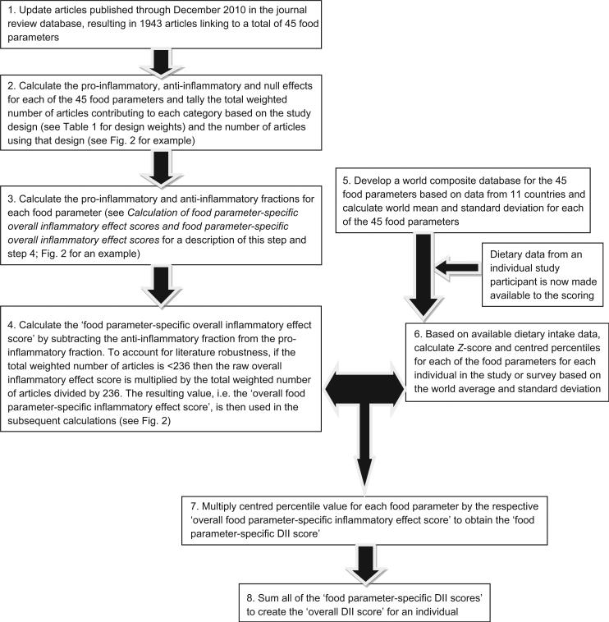
Appendix 3. DII. 26 nutrients were used for the calculation of the DII score, which included alcohol, vitamin B12/B6, β-carotene, caffeine, carbohydrate, cholesterol, total fat, fiber, folic acid, Fe, Mg, Zn, Se, MUFA, niacin, n-3 fatty acids, n-6 fatty acids, protein, PUFA, riboflavin, saturated fat, thiamin, and vitamins A/C/E. Importantly, even if the nutrients applied for the number of calculations of DII were less than 30, the DII was still available³. The calculation steps were shown in Figure S1.
Figure A1. Sequence of steps in creating the DII.

Appendix 4. DASH. DASH was calculated as follows. Calculate the average value of nutrients for two days. Fat*9, saturated fat*9, protein*4, to get the kcal provided by the respective. Fat kcal, saturated fat kcal, protein kcal/total energy*100, calculate fat, saturated fat, protein energy ratio. The rest of the nutrients / total energy*1000, to get the level of nutrients per 1000 kcal. Assign values according to the Table S3. Calculate the total DASH score⁴.
Table A3. DASH diet nutrient values
DASH diet nutrient values | 1 point | 0.5 point | 0 point
Saturated fat | ≤6 | (6-11] | >11
Fat | ≤27 | (27-32] | >32
protein | ≥18 | [16.5-18） | <16.5
Fiber | ≥14.8 | [9.5-14.8） | <9.5
Total cholesterol | ≤71.4 | (71.4-107.1] | >107.1
Magnesium | ≥238 | [158-238） | <158
Calcium | ≥590 | [402-590） | <402
Potassium | ≥2238 | [1534-2238） | <1534
Sodium | ≤1143 | (1143-1286] | >1286
Appendix 5. Deleting participants with a history of diabetes. To avoid the effect of history of diabetes on GWG and GDM, we performed a sensitivity analysis on pregnant women with a history of diabetes, and logistic regression tests were performed again after deleting pregnant women with a history of diabetes, as shown in Table S4 and Table S5.
Table A4. Logistic regressions of GWG with dietary indices after deleting participants with a history of diabetes
Dietary index | Sample size(N) | GWG | Model1ª |  |  |  | Model2^{b} |  |  |  | Model3^{c}
Dietary index | Sample size(N) | GWG | β | P | OR (95%CI) |  | β | P | OR (95%CI) |  | β | P | OR (95%CI)
HEI | 276 | Insufficient | -0.073 | 0.159 | 0.929(0.838,1.030) |  | -0.097 | 0.055 | 0.907(0.821,1.002) |  | -0.091 | 0.075 | 0.913(0.826,1.010)
HEI | 276 | Excessive | -0.086 | 0.073 | 0.918(0.835,1.008) |  | -0.120 | 0.008 | 0.887(0.814,0.967) |  | -0.118 | 0.002 | 0.889(0.827,0.955)
A-HEI | 276 | Insufficient | -0.093 | 0.142 | 0.912(0.804,1.033) |  | -0.139 | 0.021 | 0.870(0.774,0.978) |  | -0.175 | 0.002 | 0.840(0.754,0.936)
A-HEI | 276 | Excessive | -0.116 | 0.013 | 0.890(0.814,0.974) |  | -0.182 | <0.001 | 0.834(0.765,0.909) |  | -0.226 | <0.001 | 0.798(0.729,0.872)
DII | 656 | Insufficient | 0.072 | 0.599 | 1.074(0.820,1.408) |  | 0.019 | 0.875 | 1.020(0.798,1.303) |  | 0.160 | 0.327 | 1.173(0.849,1.621)
DII | 656 | Excessive | 0.219 | 0.089 | 1.245(0.967,1.603) |  | 0.170 | 0.125 | 1.186(0.953,1.475) |  | 0.281 | 0.072 | 1.324(0.974,1.799)
DASH | 656 | Insufficient | -0.181 | 0.265 | 0.834(0.605,1.151) |  | -0.118 | 0.479 | 0.888(0.638,1.237) |  | -0.034 | 0.825 | 0.967(0.713,1.310)
DASH | 656 | Excessive | -0.283 | 0.033 | 0.754(0.581,0.978) |  | -0.236 | 0.082 | 0.790(0.605,1.031) |  | -0.228 | 0.089 | 0.796(0.611,1.037)
Note: a Model1: Dietary index.
b Model2: Model1+ age+ race + education levels+ marital status+ family PIR.
c Model3: Model2+ smoking+ physical activity+ number of live births+ total energy intake.

Table A5. Logistic regressions of GDM with dietary indices after deleting participants with a history of diabetes
Dietary index | Sample size(N) | GDM | Model1ª |  |  |  | Model2^{b} |  |  |  | Model3^{c}
Dietary index | Sample size(N) | GDM | β | P | OR (95%CI) |  | β | P | OR (95%CI) |  | β | P | OR (95%CI)
HEI | 137 | Yes | -0.020 | 0.228 | 0.980(0.949,1.013) |  | 0.007 | 0.723 | 1.007(0.968,1.048) |  | -0.081 | 0.101 | 0.922(0.836,1.018)
A-HEI | 137 | Yes | -0.002 | 0.962 | 0.998(0.923,1.080) |  | 0.077 | 0.092 | 1.080(0.986,1.183) |  | 0.055 | 0.348 | 1.056(0.938,1.190)
DII | 328 | Yes | 0.087 | 0.582 | 1.090(0.797,1.492) |  | 0.054 | 0.754 | 1.056(0.747,1.492) |  | 0.670 | 0.012 | 1.955(1.168,3.271)
DASH | 328 | Yes | -0.434 | 0.009 | 0.648(0.469,0.894) |  | -0.335 | 0.032 | 0.716(0.528,0.971) |  | -0.405 | 0.025 | 0.667(0.470,0.947)
Note: a Model1: Dietary index.
b Model2: Model1+ age+ race + education levels+ marital status+ family PIR.
c Model3: Model2+ smoking+ physical activity+ number of live births+ total energy intake+ GWG.

Appendix 6. Interaction results on the multiplicative scale for the effect of advanced maternal age on GDM per 1 count dietary index increase. Considering the high risk of adverse pregnancy outcomes in pregnant women of advanced maternal age, we performed a multiplicative interaction analysis, but for GDM, we did not find an interaction between dietary index and advanced maternal age, as shown in Table S6.
Table A6. Interaction results on the multiplicative scale for the effect of advanced maternal age on GDM per 1 count dietary index increase
Advanced maternal age*Dietary index | Sample size(N) | GDM | β-interaction(95%CI) | P-interaction
Advanced maternal age*HEI | 138 | Yes | 0.153(-0.158,0.463) | 0.317
Advanced maternal age*A-HEI | 138 | Yes | -0.067(-0.293,0.159) | 0.543
Advanced maternal age*DII | 333 | Yes | 0.272(-0.322,0.866) | 0.362
Advanced maternal age*DASH | 333 | Yes | 0.569(-0.158,1.296) | 0.122
Note: Adjusted for race, education levels, marital status, family PIR, smoking, physical activity, number of live births, total energy intake and GWG.

References
1. Krebs-Smith SM, Pannucci TE, Subar AF, et al. Update of the Healthy Eating Index: HEI-2015. J Acad Nutr Diet. 2018;118(9):1591-1602.
2. Brown AGM, Houser RF, Mattei J, et al. Diet quality among US-born and foreign-born non-Hispanic blacks: NHANES 2003-2012 data. Am J Clin Nutr. 2018;107(5):695-706.
3. Shivappa N, Steck SE, Hurley TG, Hussey JR, Hébert JR. Designing and developing a literature-derived, population-based dietary inflammatory index. Public Health Nutr. 2014;17(8):1689-1696.
4. Tyson CC, Davenport CA, Lin PH, et al. DASH Diet and Blood Pressure Among Black Americans With and Without CKD: The Jackson Heart Study. Am J Hypertens. 2019;32(10):975-982.

