Appendix
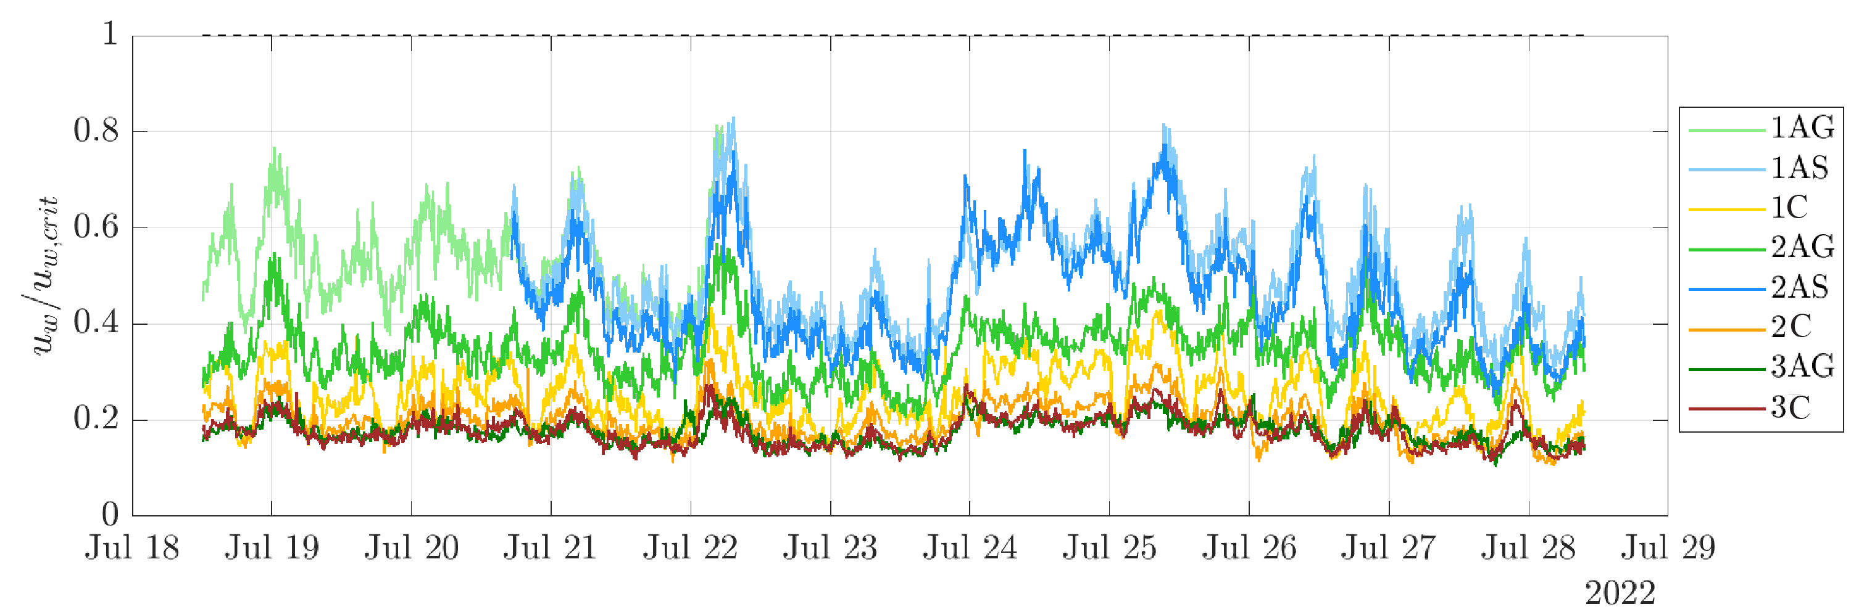Fig. A1 Critical wave velocities from July 18th to July 29th 2022 across spur and groove (SAG, 1AG-3AG, 1AS, 2AS) and non-SAG sites (1C-3C). Wave orbital velocity sediment movement threshold ($u_{m}/u_{m,crit}$): every time the lines of the time series go beyond 1, the is expected to be suspended. The thresholds are expressed as fractions so that 1 indicates the threshold across all the time series and sites
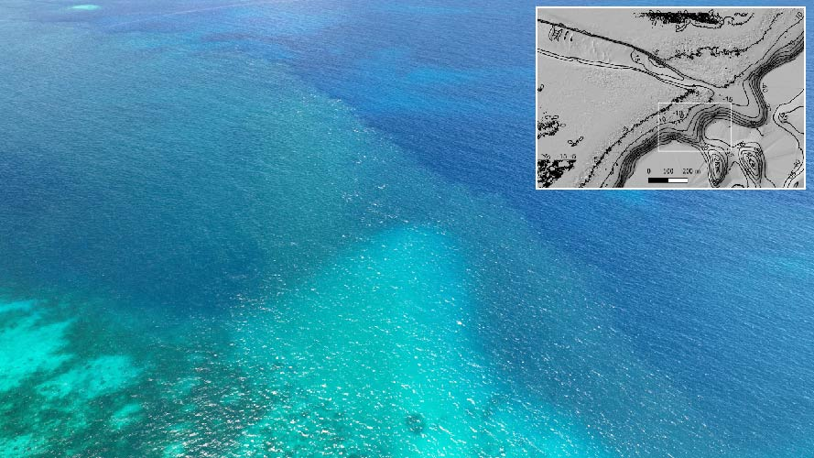
Fig. A2 Sediment plume exiting Ngel channel. The picture was taken at ebbing tide on June 29th 2022 at 11:17 am (picture by Professor Robert Dunbar)
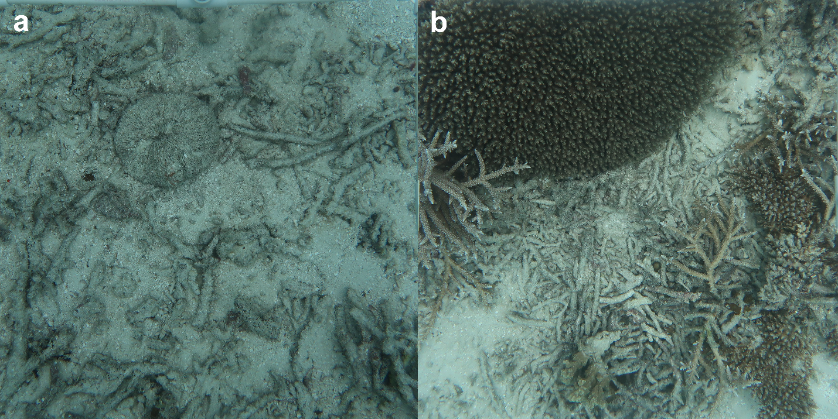
Fig. A3 a) Rubble scattered in non-spur and groove (SAG) area and b) rubble accumulated seaward of SAGs is stabilized by Acropora spp. fragments
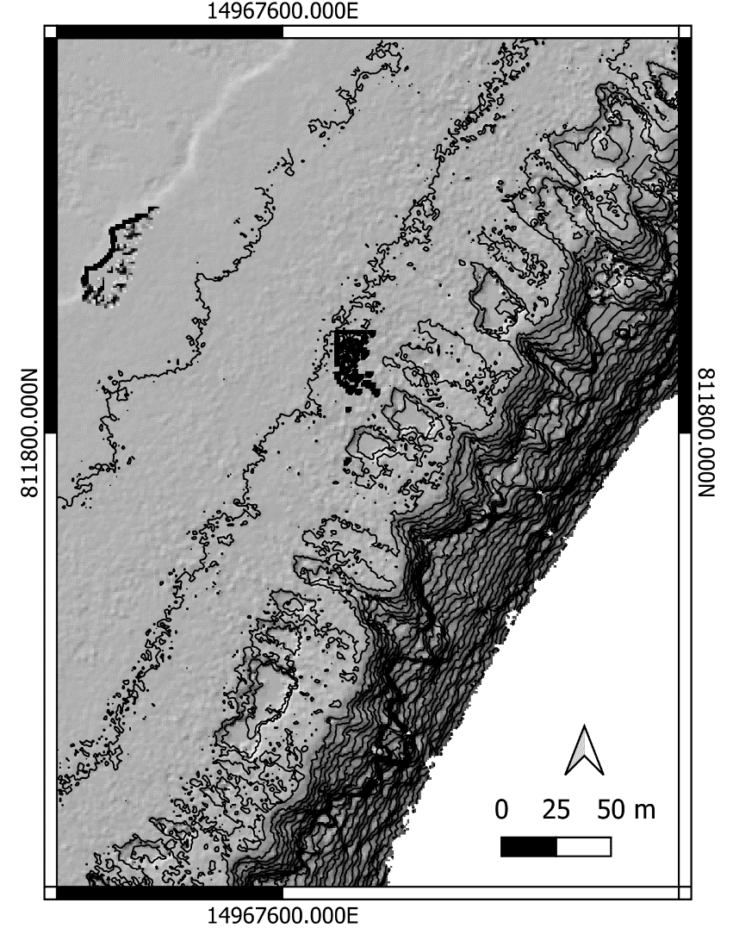
Fig. A4 LiDAR bathymetry of coalescent spur and grooves (SAGs) in Lighthouse Reef

