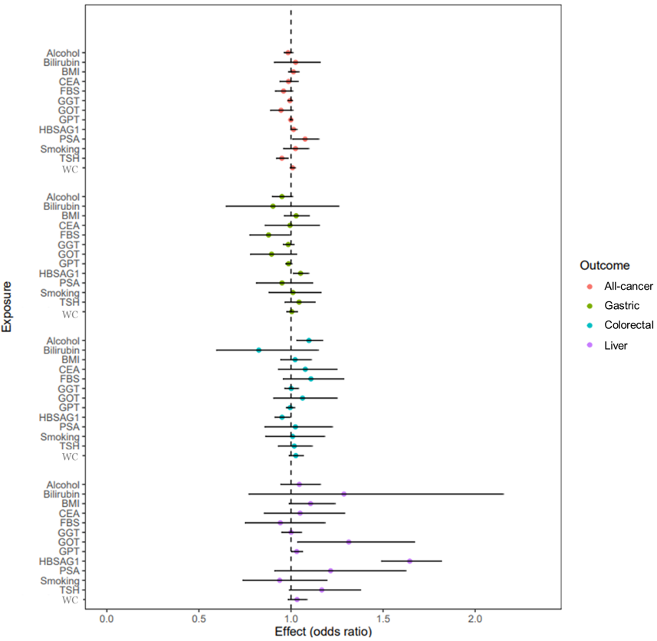

Supplementary Figure 1-A

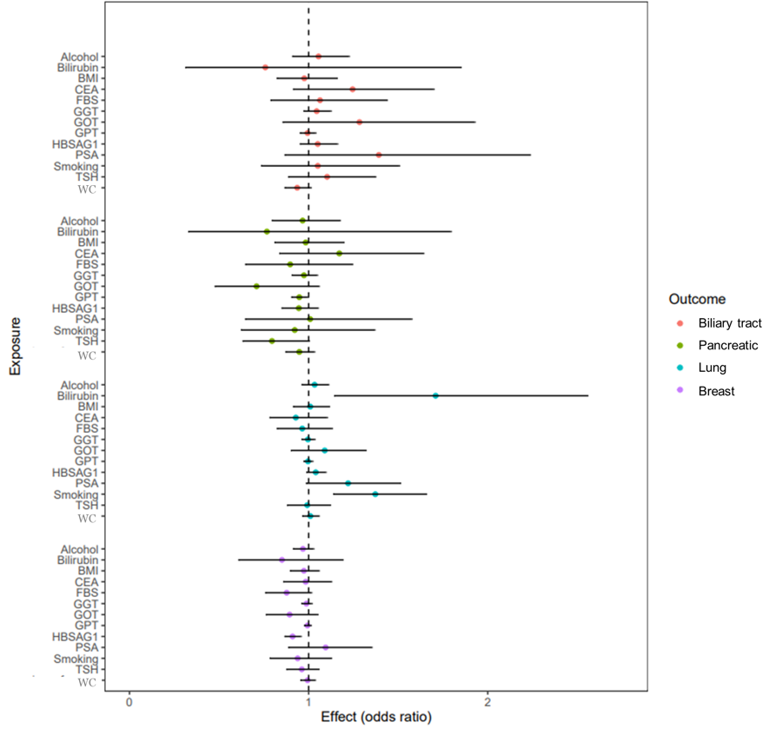

Supplementary Figure 1-B

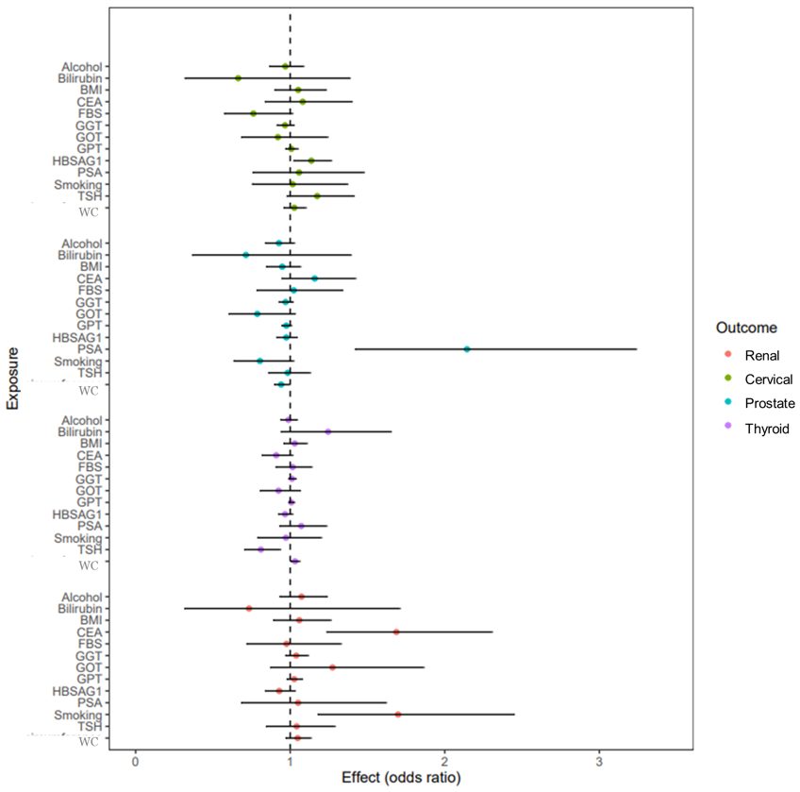

Supplementary Figure 1-C
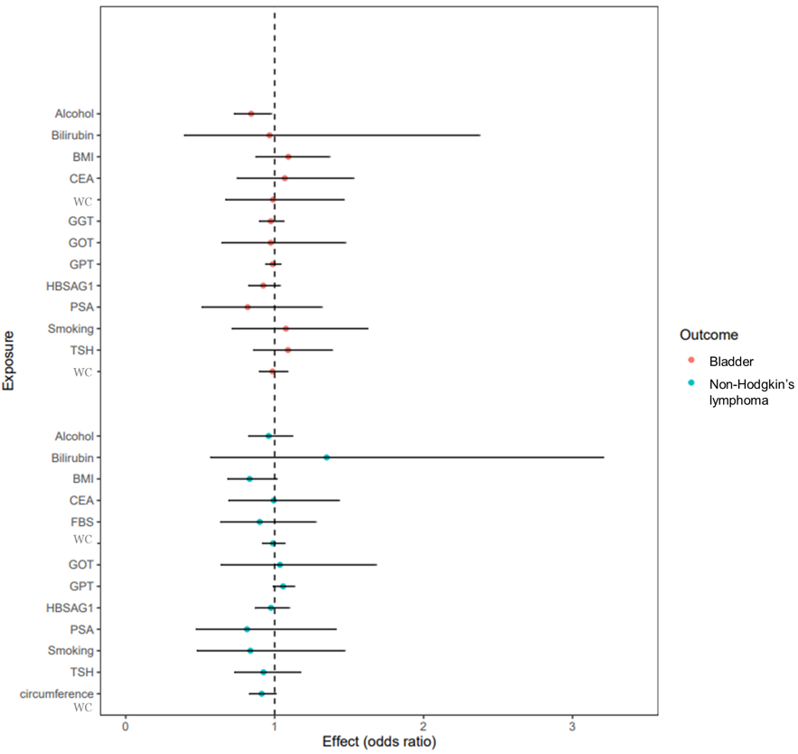

Supplementary Figure 1-D

Supplementary Figure 1. A forest plot showing IVW univariable MR estimates. Estimates are grouped by outcome. Effect estimates on the odds ratio scale, with accompanying 95% confidence intervals are illustrated, with corresponding values shown to the right of the plot. (A: All cancer, Gastric cancer, Colorectal cancer, Liver cancer, B: Biliary tract cancer, Pancreatic cancer, Lung cancer, Breast cancer, C: Renal cancer, Cervical cancer, Prostate cancer, Thyroid cancer, D: Bladder cancer, Non-Hodgkin’s lymphoma)

