Supplemental Materials
Here, we give detailed assembly instructions on how to build the device. While these instructions will be effective, please see the project’s GitHub page for the most up-to-date design information.
Based on feedback from others attempting to construct the device, we give the following general guidance:
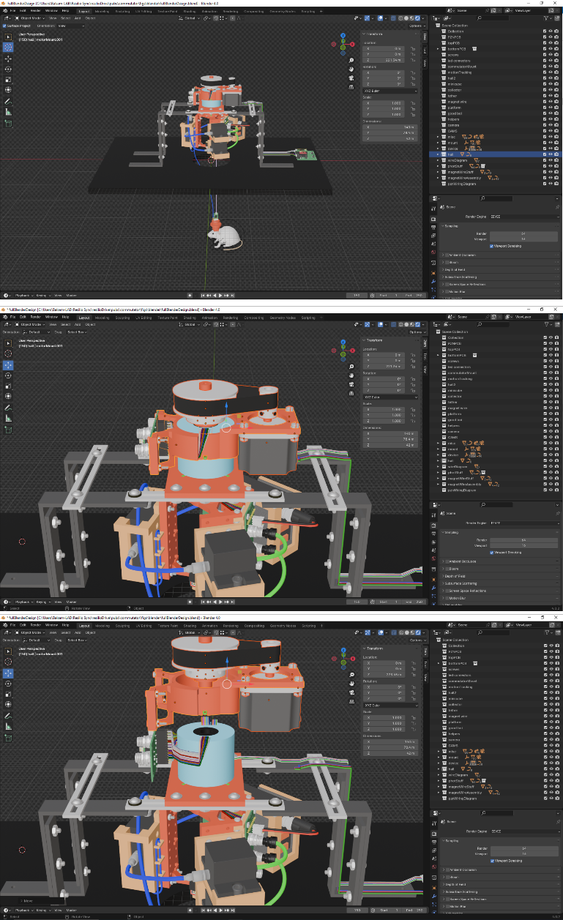
- We strongly encourage you to view the blender model associated with the design (Fig S1). Blender is a free, 3D-rendering software package, and we have used it to create a detailed virtual representation of the device. This provides an easy-to-use interface that allows you to interactively ‘explore’ the design, providing far more information than we can capture in the figures here.
- Some of the parts will be held in place with epoxy. While most epoxies will be adequate, we recommend a combination of Slo-Zap epoxy (Zap) and Zip-Kicker accelerant (Pacer), listed in the bill-of-materials (BOM). The epoxy provides a strong bond, dissolves in acetone (for fixing errors), and cures in seconds (rather than hours) when the accelerant is applied.
- Use flux when soldering any components, as this is critical for creating robust electrical connections. After soldering, clean any remaining flux with 100% ethanol or formal flux-remover. We do not have specific recommendation on brands, but note that, in our experience, so-called ‘no-clean’ flux brands should never be purchased.
Figure S1. Blender as a tool for interactively inspecting the design. Simple illustration of navigating around/inspecting the device with Blender.
- Some of the 3D-printed parts are designed to be held in place via friction-fits (e.g., the magnet holder in the bearing). Due to variability across 3D-prints and/or 3D printers, they might not fit perfectly at the start. If you find yourself ‘forcing’ the parts together, please incrementally sand down the surfaces instead, to avoid damage.
- If you primarily have an engineering background, we acknowledge that what we refer to as a ‘commutator’ here should actually be referred to as a ‘slip-ring’—as commutators (a specialized type of slip-ring) typically transform voltage signals, in addition to providing rotatable connections. However, in the field of behavioral neuroscience, the term commutator has become the standard for this type of device, and as this is our target-audience, we choose to adhere to this convention.
Hardware assembly instructions
Initial setup. Perform the following initial steps as follows:
- Apply the motor mount, device mount adapter, and gear-pin (Fig S2a). Importantly, when applying the mount and adapter, make sure to orient them relative to the two wire-bundles at the top of the commutator as depicted.
- The parts will hold well with friction-fits, but for added security, apply a small amount of epoxy to the slots provided within each part (Fig S2b). When applying epoxy to the gear-pin openings, avoid allowing the epoxy to leak onto the edge of the commutator’s cylinder (i.e., the rotatable component of the commutator), as this will prevent movement.
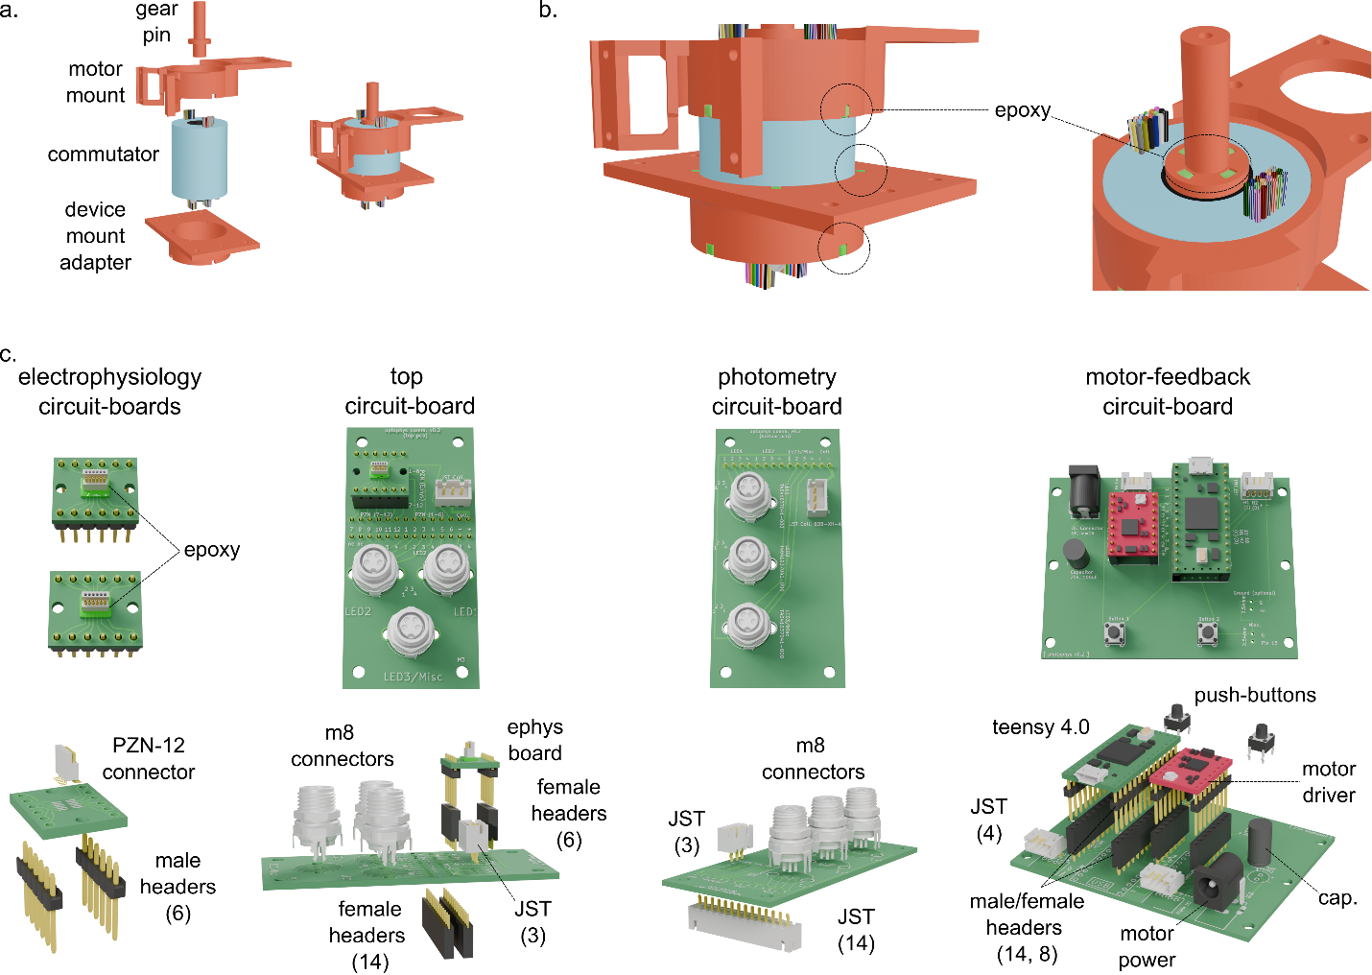
- Assemble all printed circuit-board components, as outlined in Figure S2c. Always check for shorted/weak connections and clean off residual flux.
Figure S2. Initial setup. a) Inserting the gear-pin, motor mount, and device mount adapter onto the commutator. Note the orientation of the mount-related items relative to the wire bundles at the top. b) Applying epoxy to further secure the parts. c) Assembling all circuit-boards and components that must be soldered to them for the device. See BOM for specific ordering information for each part. The numbers in parentheses for connector/header labels indicate number of connections they contain.

Assigning wires. The next step is to assign wires to be used for each part of the device (Fig. S3). The process of picking wires is generally arbitrary, but we highly recommend following the steps below (in order), as it will help avoid ‘awkward’ wire-crosses later in the construction process:
- Pick wires to use for the motion-sensing system that will be able to run neatly from the top of the commutator to the motor-electronics circuit-board. Specifically, all wires exit from the top of the commutator in two bundles on opposing sides. Choose four wires exiting from the same bundle/side (Fig S3a). Mark them distinctly (e.g., wrap with electrical tape) at both the top and bottom of the commutator.
- Select wires to use or the electrophysiology system. In this case, the emphasis should be on picking wires at the bottom of the commutator that will help hold the circuit-board level and centered with respect to the commutator (Fig S3b). The best approach is to select two sets of 6 wires (i.e., 12 total) that exit the bottom on opposing sides of the commutator’s cylinder, as each set can run to either side of the circuit-board.
- Reserve all remaining wires for the photometry system.
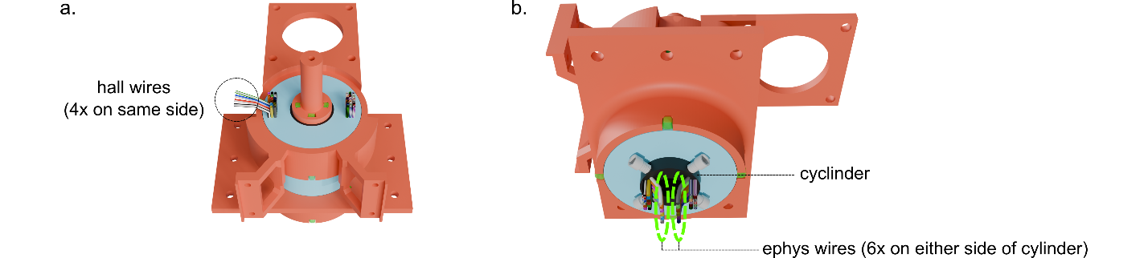
Bottom-connections. The next step is to assemble the electrical connections at the bottom of the commutator as follows.
Figure S3. Initial setup. a) Inserting the gear-pin, motor mount, and device mount adapter onto the commutator. Note the orientation of the mount-related items relative to the wire bundles at the top. b) Applying epoxy to further secure the parts. c) Assembling all circuit-boards and components that must be soldered to them for the device. See BOM for specific ordering information for each part.
First, assemble the connections for the electrophysiology system according to the following steps (Fig S4a):
- Slide female headers onto the male headers on the circuit board.
- Solder wires to the four-corners of the circuit board (Fig S4a). Specifically, cut/strip the wires to where, when soldered, the circuit board will sit roughly 20mm from the bottom of the commutator’s cylinder. When soldering, make sure that the board will sit level with the ground and centered with respect to the commutator itself. Because these connections can be resoldered later (see below), the soldering can be ‘messy’ at this point to accommodate these criteria.
- Cut, strip, and solder all intermediate wires.
- If needed, you can resolder the corners, as the intermediate wires will hold the board in place.
- Briefly verify that the board is centered enough to allow the 3D-printed frame to slide onto the commutator’s cylinder (note: do not screw in the frame at this point, just a simple check).
- Use a multimeter to verify that all circuit-board pins are electrically connected to the corresponding wires at the top of the commutator.
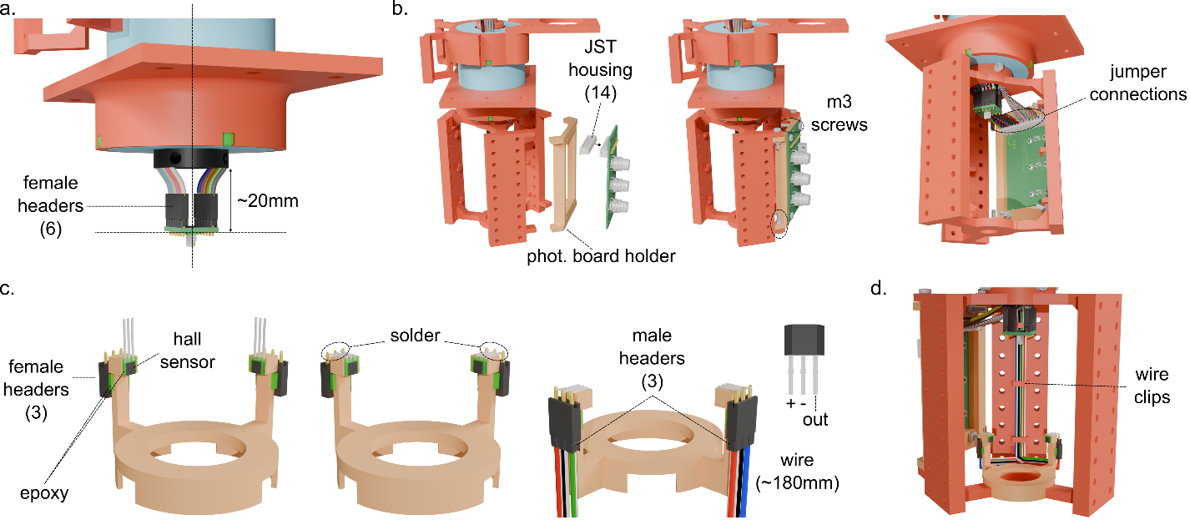
Figure S4. Bottom connections. a) Soldering the electrophysiology circuit-board. Lines emphasize the board should be level/centered. b) Assembling the photometry circuit-board. c) Assembling the hall sensors. We recommend assembling the hall-holder components before inserting onto the frame. d) Routing wires to the bottom of the commutator. Highlights clips on frame-arms for holding wires in place.
Second, assemble the connections for the photometry system, as follows (Fig S4b):
- Insert an (empty) male JST connector into the photometry system’s circuit-board (Fig S4b).
- Secure the circuit-board to the holder and the holder to the frame with m3 screws/nuts (Fig S4b).
- Screw the frame onto the commutator, using the screws provided with the commutator (Fig S4b).
- Cut, strip, and crimp a JST header to each wire and insert it into one of the openings of the male JST connector (Fig S4b). Importantly, when cutting each wire, make sure it will be taut enough to not hang below the electrophysiology circuit-board, as this could interfere with the magnet-wire bridge-connection’s ability to rotate. Furthermore, crimping the wires correctly is critical for maintaining good electrical contact. If you do not have experience with this crimping, consult this excellent instructional video.
- Use a multimeter to test that all circuit-board pins for the JST connector electrically connect to the corresponding wires exiting at the top of the commutator.
Third, assemble the hall-sensors and their connections to the commutator, as follows (Fig S4c):
- Epoxy each hall sensor to a mount on the holder, making sure that the sensor rests flat and it sits flush with the bottom of the mount’s face (Fig S4c). Note that epoxy can cover the sensor’s face without impacting function.
- Epoxy a 3-pin female header to the back of each opening’s post, ensuring that no epoxy covers the header-openings/pins and that the pins extend slightly above the post’s top (~1mm).
- Gently bend each sensor’s lead backward and solder it to its corresponding header-pin (Fig S4c).
- Insert male headers into the female headers and solder a silicon-insulated wire (see BOM) to each of the male pins (Fig S4c). Make sure that each silicon wire is ‘more than long enough’ to reach the bottom of the commutator, with 180mm being a conservative estimate.
- Braid each wire triplet and run them through the wire clips on the frame ((Fig S4d; note: for practical purposes, the braiding is not shown in the blender file/figures).
- Solder each silicon wire to the commutator wires you selected earlier to serve for the motion-tracking system, cutting/stripping them to proper length and connecting the two sensor’s wires for power and ground. Insulate each connection with heat-shrink tubing. When cutting the wires to length, make sure that they will not be able to interfere with the magnet-wire connection. A simple approach is to route them to where they run along the top of the photometry system’s wires that connect to the JST connector.
Top circuit-board. The next step is to install and solder wires to the circuit-board at the top of the commutator, as follows (Fig S5):
- To avoid damage, we recommend removing the frame, delicately unplugging the hall sensors and the photometry system’s JST connector and sliding the frame off (note that you will need to gently bend the JST connector so that it can fit through the frame’s hole).
- Insert male headers into the circuit-board and secure it to the commutator’s mount as shown (Fig S5a).
- As outlined in the wiring diagram, cut, strip, and solder each wire to its corresponding male pin, routing all wires through the cover (Fig S5b,c). To make sure the wires run neatly and are cut to the proper length, we recommend running each wire toward its pin by hand, cutting the wire, stripping, and then soldering it in place. Note that soldering each wire in-place in this manner primarily helps ensure each wire is cut to proper length and angled appropriately toward its pin; therefore, if you experience a short or are not confident a given soldered connection is secure after finishing, you can remove the circuit-board and adjust as needed.
- Use a multimeter to test that each pin is electrically connected to its appropriate pin on the bottom of the commutator.
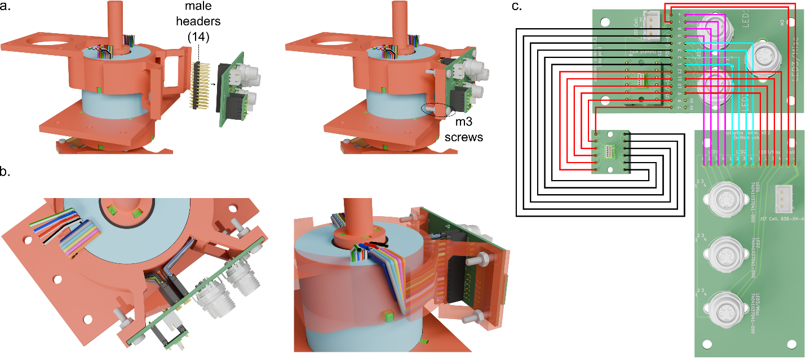
Assembling motor and pulley system. Next, assemble the motor and pulley system, as follows (Fig S6):
Figure S5. Bottom connections. a) Inserting male headers into the top circuit-board and securing it to the motor-mount. b) Two angles highlighting how the wires should route through the wire-cover and solder to the male headers on the board. c) Wiring diagram. Colors only being used for contrast.
- Slide the large-gear onto the gear-pin and tighten the screws (Fig S6a).
- Apply the bore-adapter and small-gear to the motor and tighten the screws (Fig S6a).
- Hang the belt loosely on the large-gear (Fig S6b).
- Insert the motor into its opening, using a ‘tucking’ motion to get the belt onto the small gear appropriately (Fig S6b).
- Holding the motor in place by hand, screw it to the mount using m5 screws (Fig S6c).
- If needed, loosen the screws on the small gear and shift it vertically to where the belt sits evenly across the large and small gears and re-tighten the screws (Fig S6c). Note that, depending on your 3D printer, sliding the small gear upward on the bore adapter might be difficult, but we have success by gently prying with a flat-head screwdriver.
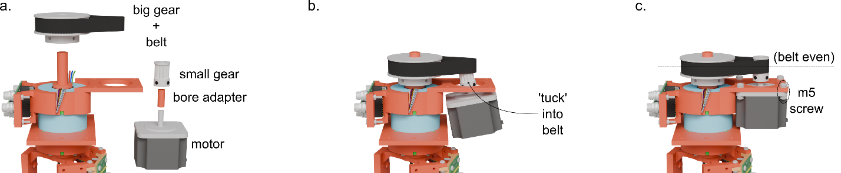
Figure S6. Assembling motor and pulley system. a) Shows relevant components separate from the mount. b) Highlights that you should tuck/sweep the small gear into the inner portion of the belt (do not try to stretch the belt onto the small gear while vertical, as this will likely cause damage). c) Assembled components. Highlights that the belt should be even across the gears and motor secured with m5 screws.

Device mount. Next, assemble the mount that will hold the full device, using the following steps (Fig S7):
- Make four ‘legs’ for the mount by screwing pairs of L-brackets together (Fig S7b).
- Make a ‘bridge’ between each pair of legs using the straight-brackets (Fig S7b), making sure the screws are as far as possible to the end of the straight brackets.
- Lay the commutator on its side and screw the mount-adapter into the straight brackets (Fig 7b). Make sure to keep the commutator as centered as possible with respect to the straight brackets.
- Gently stand the commutator/mount upright (straighten the legs if they tilt in the process) and use the second pair of straight-brackets to make brace connections across the top of the mount (Fig 7b).
- Ensure that all screws are tightened.
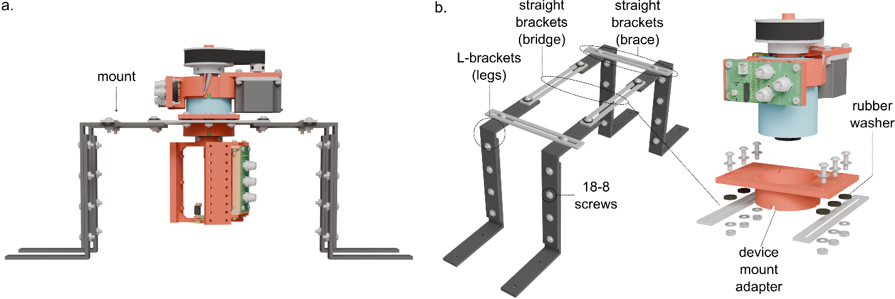
Motor-feedback circuit-board. Next, assemble the circuit-board that will communicate with the hall-sensors and motor, using the following steps (Fig S8):
Figure S7. Device mount. a) Overview of device mount. b) Shows key components when disassembled, clarifying the labels we use for each component in the instruction-steps (e.g., legs, bridge, etc.). Note that the frame must be removed to insert the commutator into the mount adapter.
- Place the circuit-board near the mount (Fig S8a), and insert pre-wired JST connectors into each slot (see BOM). Note that in the figures/blender file, we omit the wires from these connectors, to emphasize that the colors of the wires from the commutator and motor themselves are the only relevant detail.
- Run the wires for the hall sensors and motor down one leg of the mount, securing them with twist-ties (Fig S8a; note: for practical purposes, the ties are not depicted in the blender file).
- Following the wiring diagram (Fig S8b), cut, strip, and solder each wire from the top of the commutator to the JST connections, insulating each connection with the heat-shrink tubing.
- Use a multimeter to test that each pin from the hall sensors is electrically connected to its corresponding pin on the JST-connector.

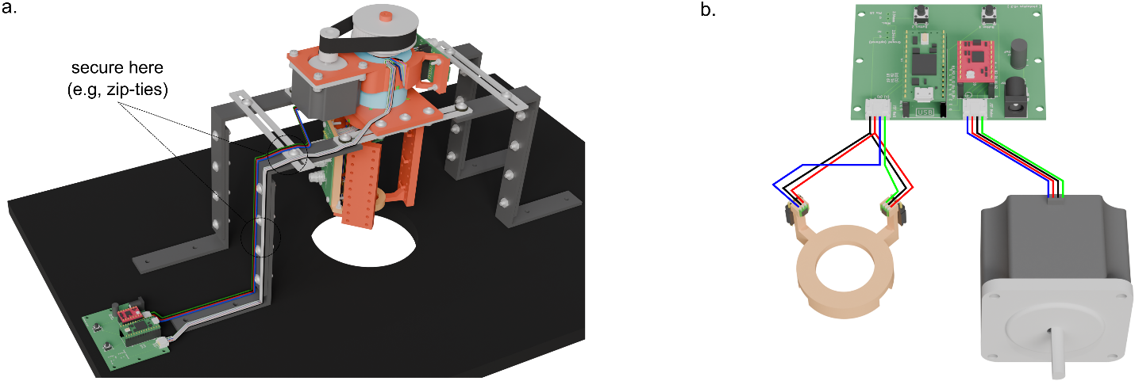
Figure S8. Motor-feedback circuit-board. a) Overview of device mount. b) Shows key components when disassembled, clarifying the labels we use for each component in the instruction-steps (e.g., legs, bridge, etc.). Note that the frame must be removed to insert the commutator into the mount adapter.
Photometry attachments. Next, secure all photometry components to the frame, as follows (Fig S9):
- Screw the frame to the commutator.
- Place the LEDs, filter, and photocollector into their respective attachments, and screw them to the frame (Fig S9a). Make sure that the LEDs and photocollector are placed appropriately relative to the photometry circuit board (Fig S9b). Furthermore, before inserting the photocollector, cover each wall (aside from the top and the side with the buttons) with neoprene foam (see BOM). See Figure 4 of the main text for further details on assembling the attachments.
- Connect the LEDs to the photometry system’s PCB on the frame (Fig S9b).
- Connect the bare-lead BNC connector to the photocollector and cut the wires to where they will meet the JST connector on the photometry system’s PCB (Fig S9b).
- Remove the connector, and strip/solder the wires to a male 3-pin JST connector according to the wiring diagram (Fig S9b), insulating the connections with heat-shrink tubing.
- Reconnect the BNC connection, plugging the JST connector into the circuit-board.
- Using appropriate optical patch-cords for your system, connect the filter to the photocollector, the LEDs to the filter, and the patch-cord that will run to the subject from the filter (see Fig S9b; additional views provided in main text).
Note that, to avoid requiring you to order custom LEDs and patch-cords that will fit precisely to the device’s dimensions, you will likely have to wrap loose cabling around the attachments. We have designed each attachment to accommodate this process. The only thing to prioritize is making sure the cabling will not unwind or ‘snag’ on the mount during rotation.

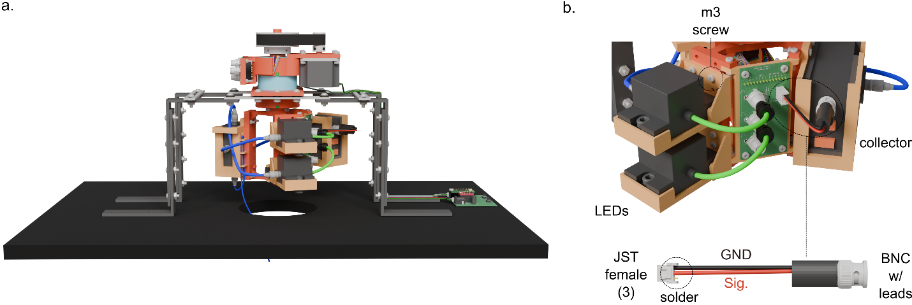
Figure S9. Photometry attachments. a) Shows device with photometry equipment in place (see main text for further details on appending attachments). b) Wiring the LEDs and photocollector through the circuit-board. Bottom shows custom-connection between the photocollector and circuit-board, made from a BNC-connector soldered to a 3-pin female JST connector.
Remaining motion-tracking hardware. Next, assemble the remaining components needed to accomplish motion-tracking, using the following steps (Fig S10):
- Insert the bearing into the frame (Fig S10b). This fit should be ‘snug,’ but if it feels loose, you should apply very small amounts of epoxy between the bearing’s wall to the frame at two points, being extremely careful not to let epoxy leak into the bearing itself.
- Insert the hall holder over the bearing (Fig S10b). Note that the holder should be oriented to where the backs of the hall sensors point toward the arm containing the LEDs. To ensure this occurs, we have designed the holder so that it will only fit on the frame in this orientation (beam is slightly wider for that arm than the others).
- Insert the magnet into the magnet holder (Fig S10b).
- Thread the data-cable through the bearing from the bottom, and then, slide the magnet holder into the bearing from the top (Fig S10b).
- Tuck the tether into the slot on the magnet holder, making a friction-fit.
- Slide the torque arm onto the bottom of the magnet holder as depicted, and secure the connection with epoxy, making sure the torque arm will sit level with the ground during experiments (Fig S10b).
- Route the data-cable through the end of the torque arm, slide it to the desired height, and secure it with the pinch-screw (Fig S10b).
- Wrap any excess cable around the spools provided on the torque arm, making a best-effort to keep the weight balanced (we recommend wrapping with a ‘figure 8’ pattern). Secure the wrapped cable to the posts with twist ties, using the slots provided.

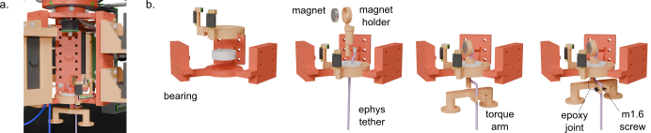
Figure S10. Remaining motion-tracking hardware. a) Shows the assembled parts in context. Note that some photometry parts (e.g., tethers) are hidden for clarity/emphasis. b) Overview of the assembly process.
Magnet-wire bridge connection. The final hardware-based step is to assemble the magnet-wire bridge connection that runs from the data cable to the electrophysiology circuit-board at the bottom of the commutator, as follows (Fig S11):
- Cut 12, 70mm lengths of magnet wire (see BOM), and solder the ends to two PZN connectors (Fig S11b), following the wiring diagram (Fig S11c).
- Cover all connections with a small amount of epoxy (Fig S11b).
- Use the two ends to connect the electrophysiology data-cable to the bottom circuit-board.

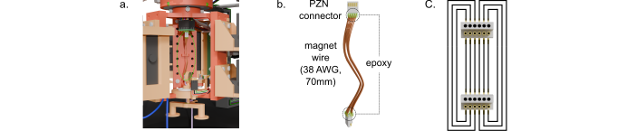
Figure S11. Magnet wire bridge. a) Highlights assembled part in-context. Note that some photometry parts (e.g., tethers) are hidden for clarity/emphasis. b) Isolates different components of the bridge-connection. c) Wiring diagram between pins on the PZN-12 connectors.
Software assembly instructions
Before using the device for experiments, complete the following software-based steps. Make sure to install the Arduino IDE and teensy support software. Note that, in recent Arduino software versions, the teensy software can be installed as an add-on; otherwise, install separately with the link provided above.
Regulating motor-current. The initial step is to regulate the amount of current sent to the motor during operation. Use the following steps (Fig S12):
- Plug the teensy microcontroller into the computer via the micro-USB port, and provide power to the motor (5V, >= 3A, 2.1mm barrel jack; see BOM).
- Upload the script named ‘adjustCurrent,’ (Fig S12a) which simply instructs the motor-driver to begin delivering current to the motor.
- Measure how much current is currently flowing to the motor by measuring the voltage between the driver’s ground and VREF pins (Fig S12b). For this particular motor-driver, the voltage level converts to current via the following equation: Amps = voltage * 3.5. We find best operation when the motor receives .7 Amps, corresponding to a voltage of 0.2V. Turn the potentiometer with a flat-head screwdriver, until the voltage reaches this value (Fig S12b).
- Disconnect the teensy and motor-power.

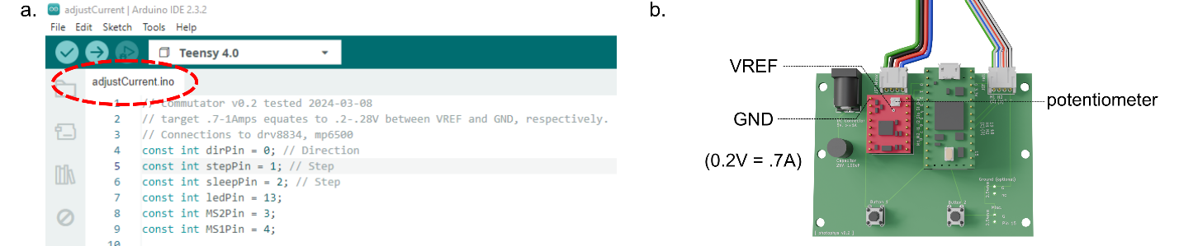
Figure S12. Regulating motor-current. a) Highlights relevant arduino code to upload via Teensy 4.0 USB connection. b) Relevant pins on the motor driver. After script uploads, provide power to the motor and measure voltage between VREF and GND pins. Turn the potentiometer until desired voltage achieved.
Motor test. Next, conduct a simple motor test, following these steps:
- First, place the motor wherever it will be used for experiments, and make sure the frame has enough room to spin freely (e.g., by manually rotating the large gear).
- Next, provide power to the motor, and upload the ‘testMotor’ script to the teensy.
- Once the script is uploaded, the motor should make two clockwise and two counterclockwise turns. The source of any errors should be visually obvious (e.g., the motor belt not being even across the two gears). Adjust as needed.
- Disconnect the motor and microcontroller.

Hall sensor test. Next, run a simple verification that the hall sensors are functioning properly, as follows (Fig S13):
- Connect the hall-sensors to the circuit-board’s JST connector if not done so already.
- Upload the ‘plotHallValues’ script to the teensy, which will begin reading from the hall sensors’ outputs (Fig S13a).
- To visualize the values, open the arduino IDE’s serial monitor (Fig S13b).
- Rotate the torque-arm/magnet by-hand and make sure that both hall-sensor outputs vary with the movement (e.g., Fig S13b).

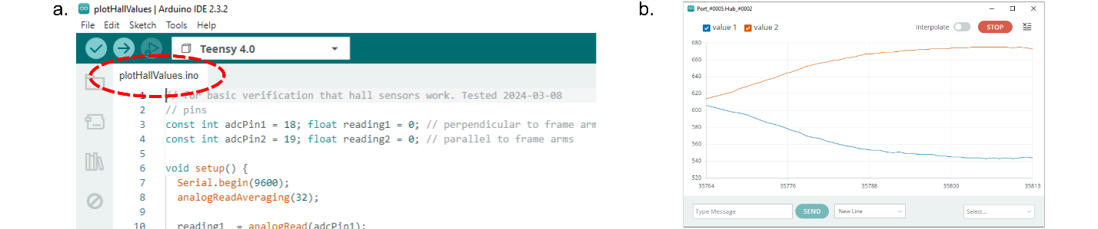
Figure S13. Hall sensor test. a) Highlights relevant arduino code to upload via Teensy 4.0 USB connection. b) shows output from both hall sensors varying when magnet turned manually.
Get null position. Next, calibrate the hall sensors for your setup. Specifically, the motor algorithm used during experiments will always attempt to rotate the commutator to where the magnet’s face sits at a (roughly) 45-degree angle between the two hall sensors–where the output of the two hall sensors is equal. We refer to this orientation as the ‘null position,’ and the precise hall sensor output-values at the null position will vary slightly from one system to another. Therefore, we must manually identify them, using the following steps:
- Rotate the magnet’s face to where it points roughly in-between the two hall sensors.
- Upload the ‘getNullPosition’ script and open the arduino IDE’s serial monitor (fig).
- Slowly rotate the face of the magnet back and forth between pointing directly at one hall sensor to the other. The algorithm will read the hall sensors and track whenever they show equal values (i.e., when the magnet crosses the null position). Values should start appearing on the serial monitor (Fig S14b), and these reflect a running average of those readings.
- Continue rotating the magnet back and forth until the values stabilize (generally, varying by less than .1 for five consecutive updates).
- Finally, write down the final value to use later (e.g., bottom-value in Fig. S14b).

As an important note for this step, do not rotate the magnet beyond the 90-degree range between the faces of the two hall sensors, as there will be other (irrelevant) orientations where the hall-readings are equal. These values will contaminate the average. Also, you should repeat this step if you ever make adjustments to the orientation-tracking hardware (e.g., replace the magnet, hall-sensors, etc). Otherwise, you should only need to perform this process once.

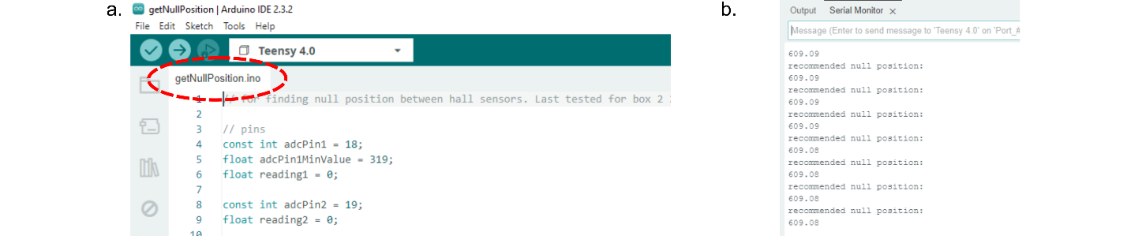
Test algorithm. The final step is to upload the main algorithm and perform a brief test by-hand, following these steps (Fig S15):
Figure S14. Hall sensor test. a) Highlights relevant arduino code to upload via Teensy 4.0 USB connection. b) Algorithm outputs a running average of the recommended null-position on the serial monitor window.
- Open the ‘motorAlgorithm’ script.
- Input your null-position reading from the calibration step, as shown in the figure.
- Upload the script to the teensy and provide power to the motor.
- Test the algorithm manually, by moving the electrophysiology data-cable in different orientations.
- Make sure the motor turns in the same direction as you move the magnet. If it turns in the opposite direction, it simply means that the hall-sensors are ‘flipped,’ relative to our construction (i.e., your ‘hall 1’ wire was our ‘hall 2’ wire). Do not panic. To resolve this, simply adjust the script as shown in the figure, which will reverse what the algorithm defines as the clockwise/counterclockwise turning directions.
- As with any commercial/open-source commutator, optimizing the automated anti-tangling process typically requires tuning the amount of slack on the tether(s). As noted in the main text, problematic tangles (i.e., those that put resistance on the subject’s ability to move) should only occur once every 1.5-2 hours on average, and should virtually never occur if you check on your subjects every 20-30 minutes, offsetting minor errors with the push-buttons. If problematic tangles are more frequent on your device, adjusting the slack on the tethers is the primary place to start. The ideal amount of slack will undoubtedly differ across recording environments, yet we generally find better performance when the optical tether is looser than the electrophysiology tether.
- Once this step is complete, your device is ready to use (good job!).

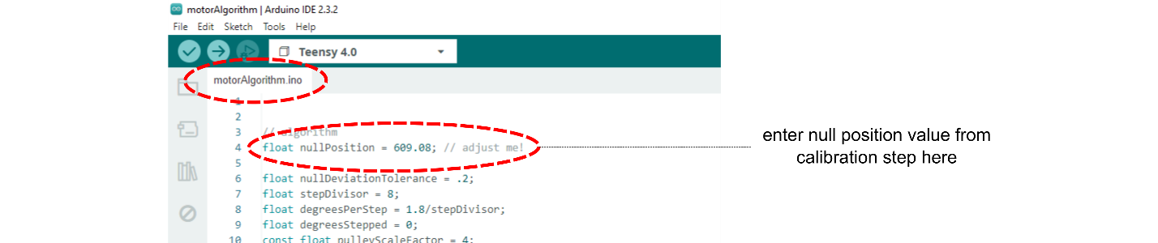
Tips and general notes
Figure S15. Hall sensor test. Highlights code containing main algorithm for use during experiments and the ‘nullPosition’ value that must be adjusted based on the prior calibration step.

We provide the following advice for using the device properly and improving its functionality:
- Maintenance. This is a large device with many ‘moving parts,’ so make sure to periodically inspect the equipment for wear-and-tear (e.g., loosening connections, cracks in the 3D printed parts, etc.). Fortunately, if you follow the above steps carefully, any issues should be exceedingly rare (we have yet to see a severe malfunction), but as a matter of best-practice, check over the components, at least once per month.
- User feedback. We hope this method will be useful across labs and, as with any open-source system, having feedback from users and collaborators greatly facilitates this process. If you develop an improvement to the device or have questions/recommendations for clarifying the assembly instructions, please reach out to the authors via GitHub.
- Note to commercial vendors. If you are a commercial vendor who hopes to adapt this design for your system, please reach out to the authors. We are more than happy to provide input.

