Supplementary Information

Molecular–Squeeze Triggers Guest Desorption from Sponge–Like Macrocyclic Crystals

Linnan Zhang, Lifeng Zheng, Yingying Song, Jingwei Huang, Hailong Ning, Leyong Wang, Jing Ma,∗ Kecheng Jie∗

Electronic Supplementary Information (40 pages)

1. | Materials | S2
2. | Methods | S2
3. | Characterizations of Desolvated Pillar[5]arene[1]quinone Crystals | S4
4. | Adsorption and Separation Performance of the Two EtP5Q1 Polymorphs | S16
5. | Vapor–Triggered Guest Release | S28
6. | Computational Details and Calculation Results | S36
7. | References | S40

1. Materials
All reagents were commercially available and used as supplied without further purification. According to a previously published procedure, pillar[5]arene[1]quinone (EtP5Q1) was synthesized by partial oxidation of perethylated pillar[6]arene with ammonium cerium nitrate in a mixed solution of tetrahydrofuran and water^{S1,S2}, purified by column chromatography.

2. Methods
2.1. Solution NMR. Solution ¹H NMR and ¹³C NMR spectra were recorded with BRUKER AVANCE III HD 500 instrument.
2.2. Powder X–Ray Diffraction (PXRD). The powder X–ray diffraction (PXRD) patterns were recorded on a Bruker D8 Advance diffractometer with Cu Kα radiation (λ = 1.5418 Å) at room temperature. Data were measured over the range of 5–45° in 0.1 sec/step over 4 min.
2.3. N₂ and Vapor Sorption Analysis. Low–pressure gas sorption measurements were performed on a Micrometritics Accelerated Surface Area and Porosimetry System (ASAP) 2020 surface area analyzer. Samples were degassed under dynamic vacuum for 12 h at 80°C prior to each measurement. N₂ sorption isotherms were measured using a liquid nitrogen bath (77 K). Vapor sorption isotherms were measured using a water bath (293 K).
2.4. Thermogravimetric Analysis (TGA). Thermogravimetric analyses (TGA) was performed under nitrogen atmosphere with a heating rate of 10 °C min^{–1} using a Netzsch STA 449 F3 thermal analyzer. The samples were heated at 10 °C/min using N₂ as the protective gas.
2.5. Differential Scanning Calorimetry (DSC). Differential scanning calorimetry (DSC) curves were performed using a Mettler–Toledo DSC1 STARe analyzer under a dry N₂ atmosphere (flow rate of 50 mL min^{–1}). The samples were heated at 10 °C/min using N₂ as the protective gas.
2.6. Single Crystal X–ray Diffraction. The single–crystal X–ray diffraction data were collected on a Bruker D8 venture diffractometer equipped with a PHOTON–100 COMS detector (Mo–Kα, λ = 0.71073 Å, and Ga–Kα, λ = 1.34139 Å) at 193 K.
2.7. Gas Chromatography. Gas Chromatography (GC) Analysis: GC measurements were carried out using an Agilent 7890B instrument configured with an FID detector and a DB–624 column (30 m × 0.53 mm × 3.0 μm). Samples were analyzed using headspace injections and were performed by incubating the sample at 70 °C for 10 min followed by sampling 1 mL of the headspace. The following GC method was used: the oven was programmed from 50 °C, and ramped in 10 °C min⁻¹ increments to 150 °C with 15 min hold; the total run time was 25 min; injection temperature was 250 °C; detector temperature was 280 °C with nitrogen, air, and make–up flow–rates of 35, 350, and 35 mL min⁻¹, respectively; helium (carrier gas) flow–rate was 3.0 mL min⁻¹. The samples were injected in the split mode (30:1).
2.8. High–Resolution Mass Spectrometry (HRMS). High–resolution mass spectra were obtained by ESI on a TOF mass analyzer.
2.9. Solid−Vapor Selective Adsorption Experiments. An open 5 mL vial containing 25 mg of guest–free EtP5Q1 crystals were placed in a sealed 20 mL vial containing 2 mL of binary hydrocarbon mixture with an equal volume for 24 h to make sure the adsorption reaches the saturation point.
2.10. Solid−Vapor Desorption Experiments. An open 5 mL vial containing 25 mg of guest–loaded EtP5Q1 crystals were placed in a sealed 20 mL vial containing 2 mL of EA for 24 h to make sure that guests within the crystals were totally removed.
3. Characterizations of Desolvated Pillar[5]arene[1]quinone (EtP5Q1) Crystals
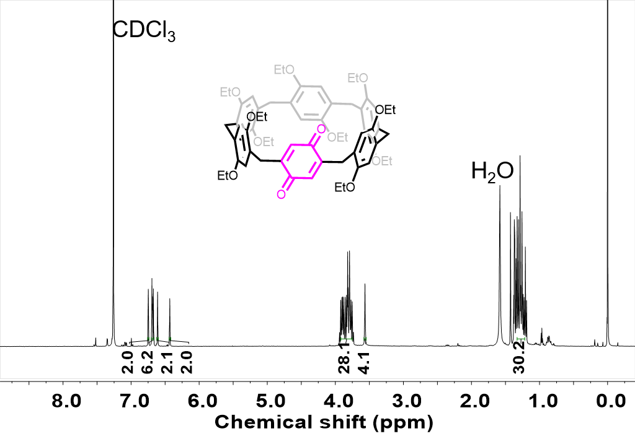
Figure S1. ¹H NMR spectrum (400 MHz, CDCl₃, 298 K) of the as–synthesized EtP5Q1 crystals after desolvation in vacuum.

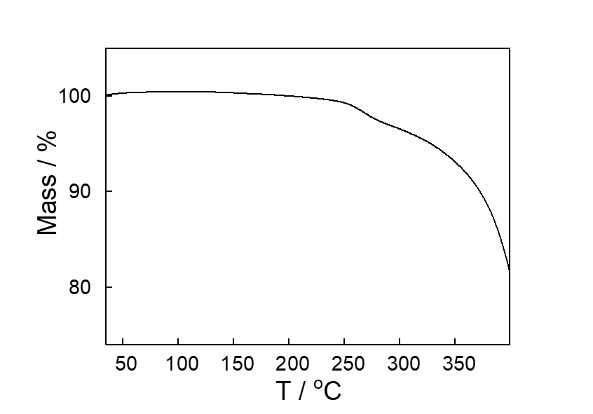
Figure S2. Thermogravimetric analysis of the as–synthesized EtP5Q1 crystals after desolvation in vacuum.

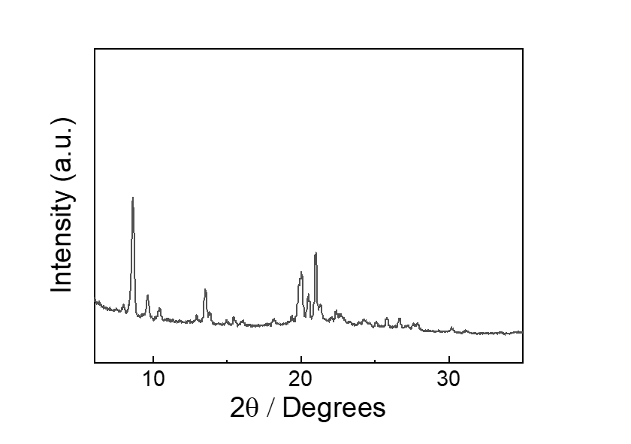

Figure S3. Powder X–ray diffraction pattern of the as–synthesized EtP5Q1 crystals after desolvation in vacuum (EtP5Q1α).

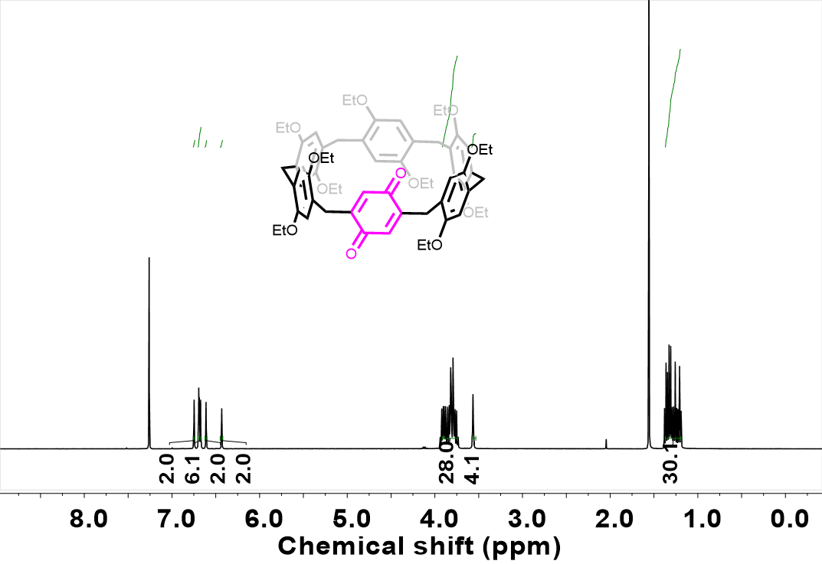

Figure S4. ¹H NMR spectrum (400 MHz, CDCl₃, 298 K) of the recrystallized EtP5Q1 crystals from ethyl acetate after desolvation in vacuum.

Figure S5. Thermogravimetric analysis of the recrystallized EtP5Q1 crystals from ethyl acetate after desolvation in vacuum.

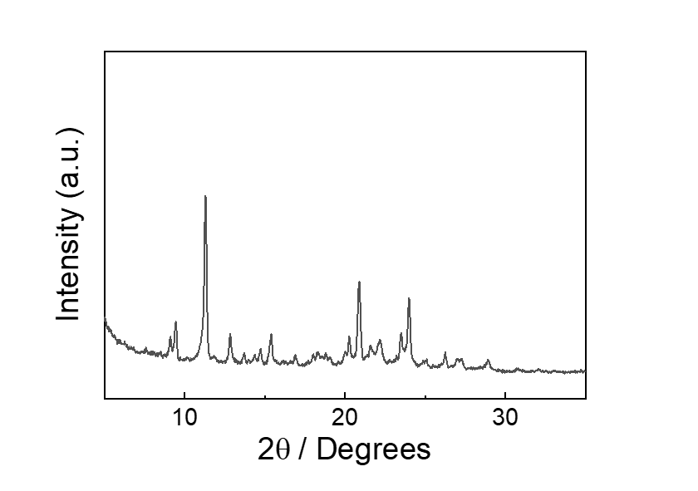

Figure S6. Powder X–ray diffraction pattern of the recrystallized EtP5Q1 crystals from ethyl acetate after desolvation in vacuum (EtP5Q1β).

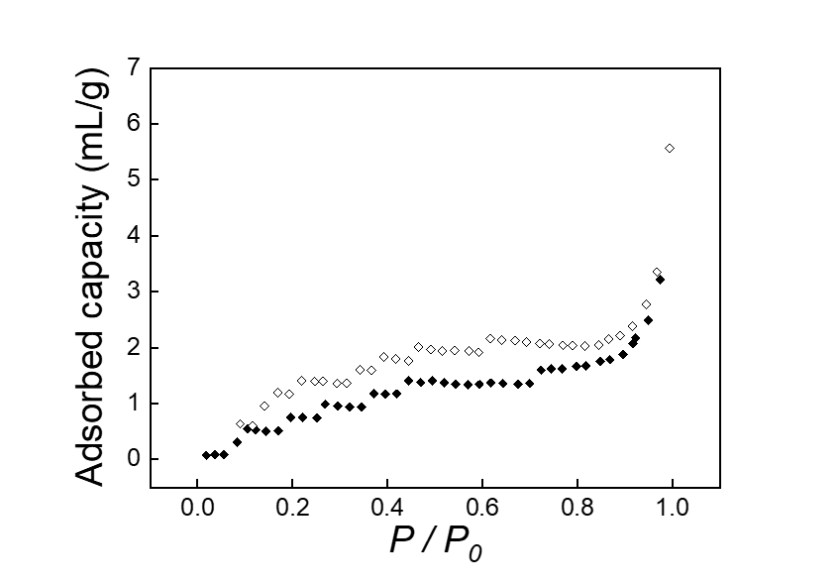
Figure S7. N₂ sorption isotherm of EtP5Q1α.

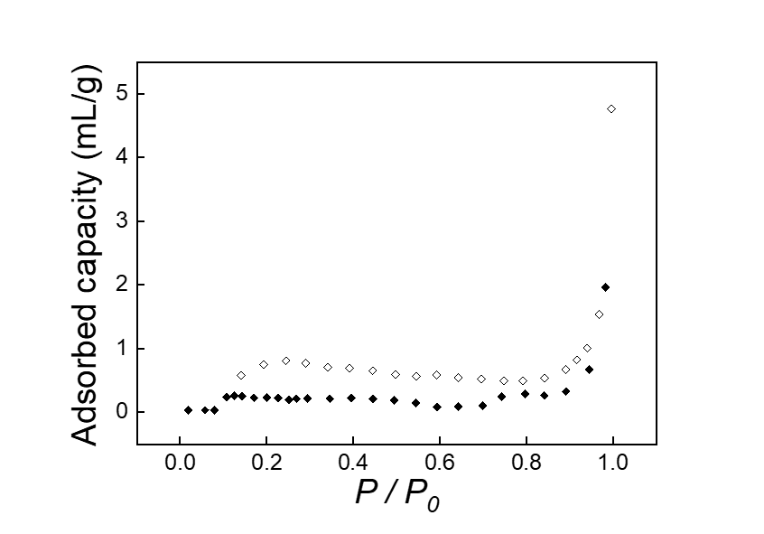
Figure S8. N₂ sorption isotherm of EtP5Q1β.

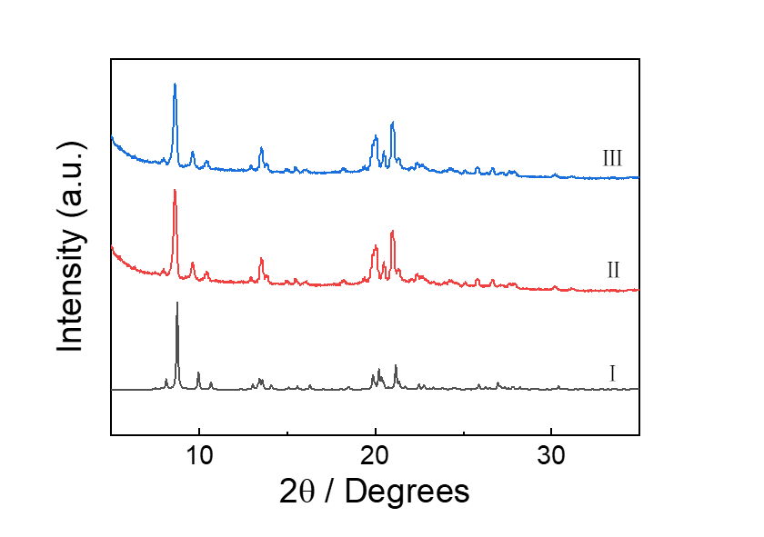
Figure S9. Powder X–ray diffraction patterns of (I) CH@EtP5Q1 simulated from the single crystal structure, (Ⅱ) experimental EtP5Q1α and (ⅡI) CH@EtP5Q1 upon desolvation at 80 °C in vacuum over night.

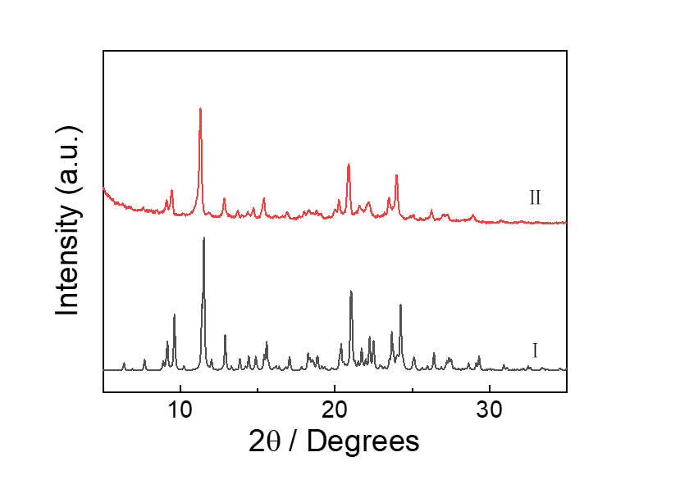
Figure S10. Powder X–ray diffraction patterns of (I) EtP5Q1β simulated from the single crystal structure and (Ⅱ) experimental EtP5Q1β.
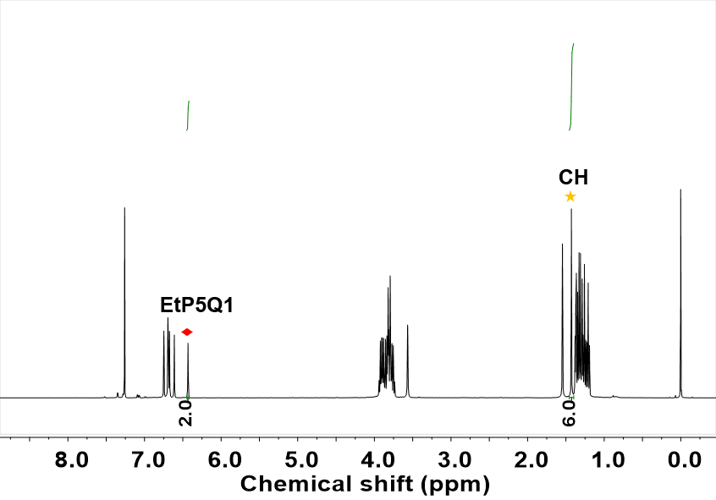

Figure S11. ¹H NMR spectrum (400 MHz, CDCl₃, 298 K) of EtP5Q1α upon exposure to CH.

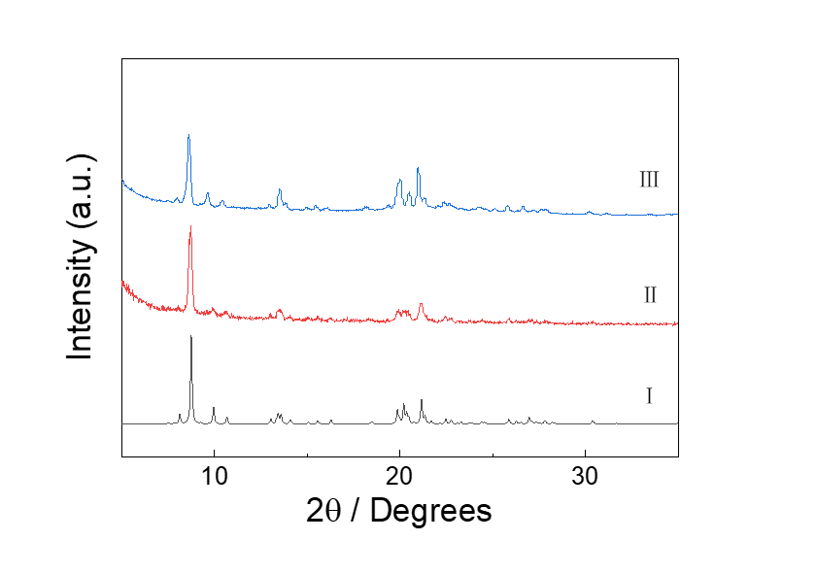
Figure S12. Powder X–ray diffraction patterns of (I) CH@EtP5Q1 simulated from the single crystal structure; (Ⅱ) experimental EtP5Q1α and (ⅡI) EtP5Q1α upon exposure to CH.

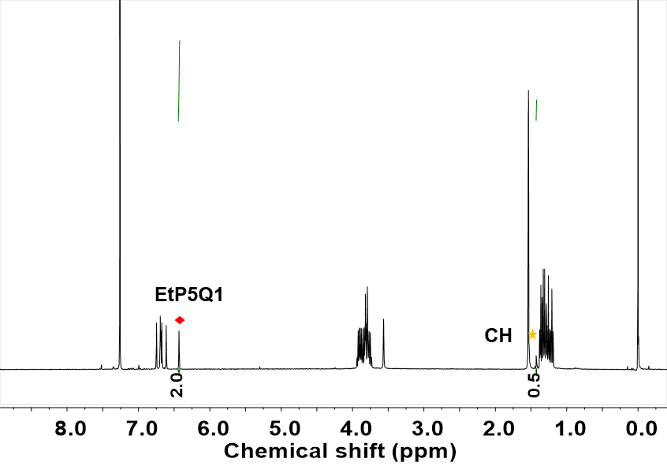

Figure S13. ¹H NMR spectrum (400 MHz, CDCl₃, 298 K) of EtP5Q1β upon exposure to CH.

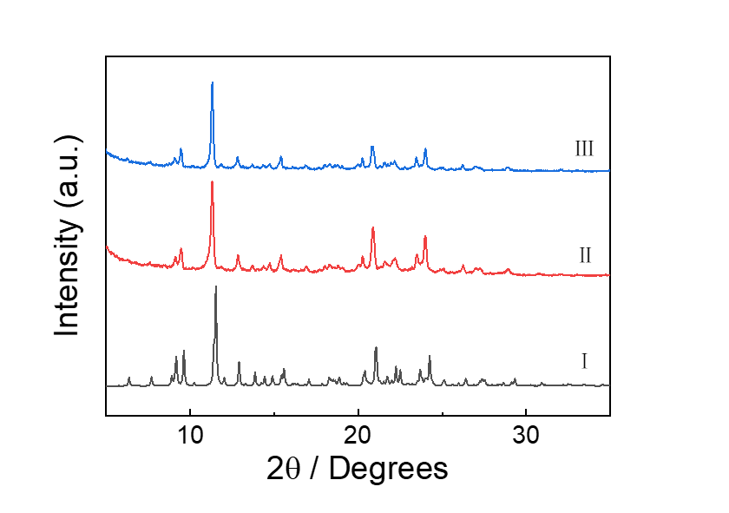
Figure S14. Powder X–ray diffraction patterns of (I) EtP5Q1β simulated from the single crystal structure; (Ⅱ) experimental EtP5Q1β and (ⅡI) EtP5Q1β upon exposure to CH.

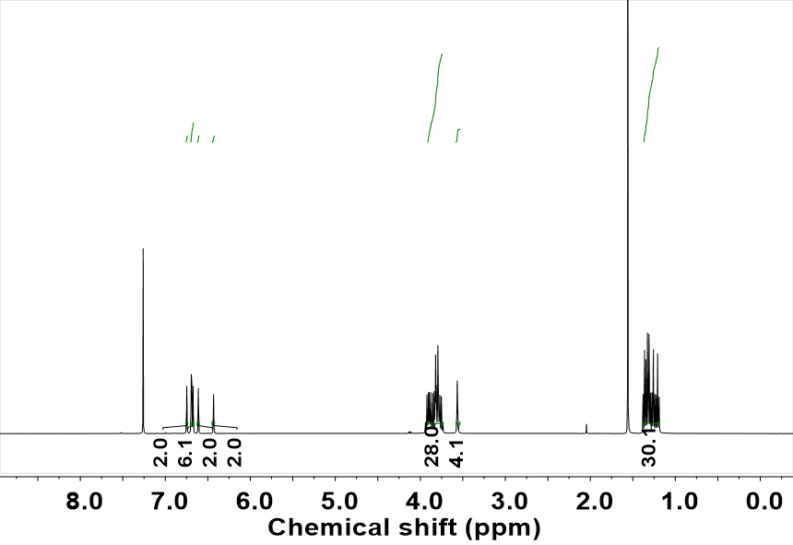

Figure S15. ¹H NMR spectrum (400 MHz, CDCl₃, 298 K) of EtP5Q1α upon exposure to EA.

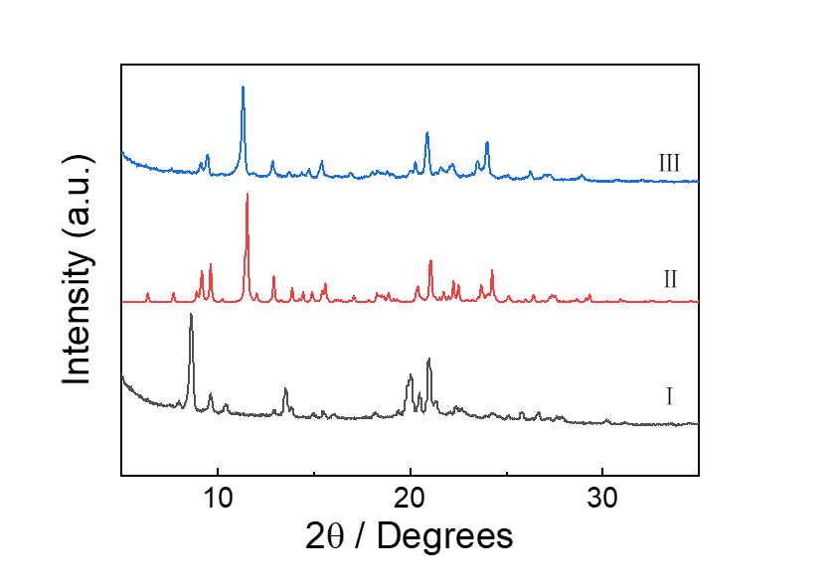
Figure S16. Powder X–ray diffraction patterns of (I) experimental EtP5Q1α; (Ⅱ) EtP5Q1β simulated from the single crystal structure and (ⅡI) EtP5Q1α upon exposure to EA.
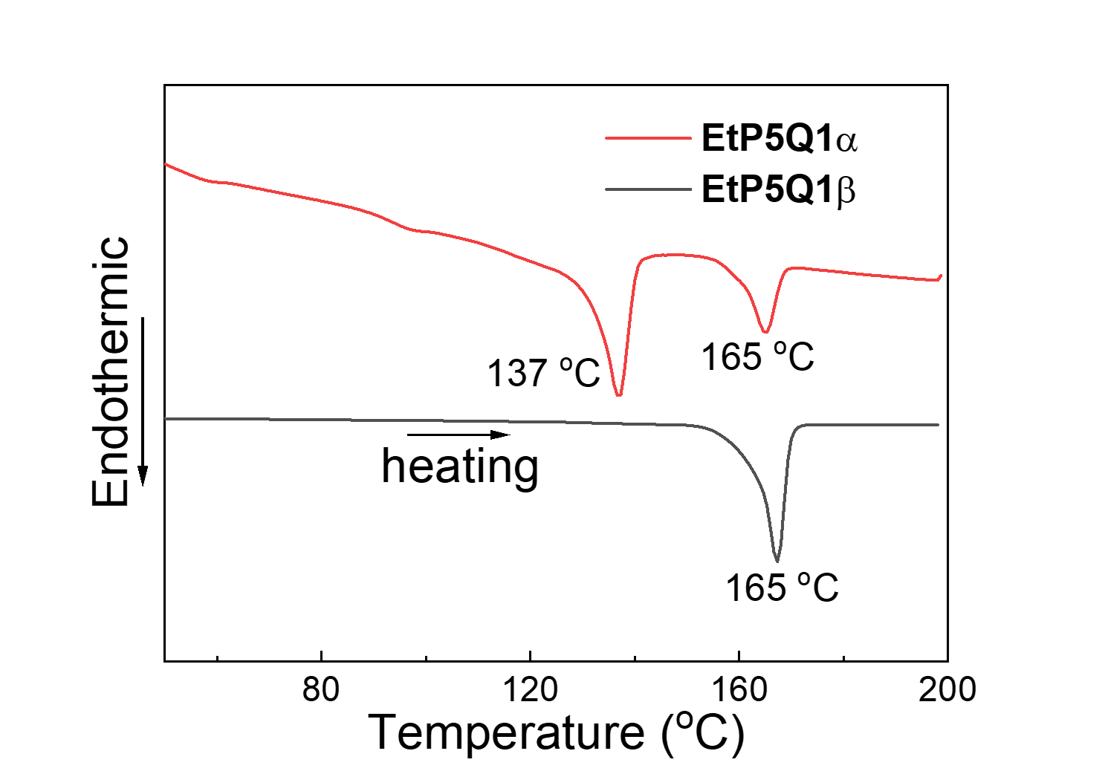
Figure S17. DSC curves of EtP5Q1α and EtP5Q1β.

4. Adsorption and Separation Performance of the Two EtP5Q1 Polymorphs.

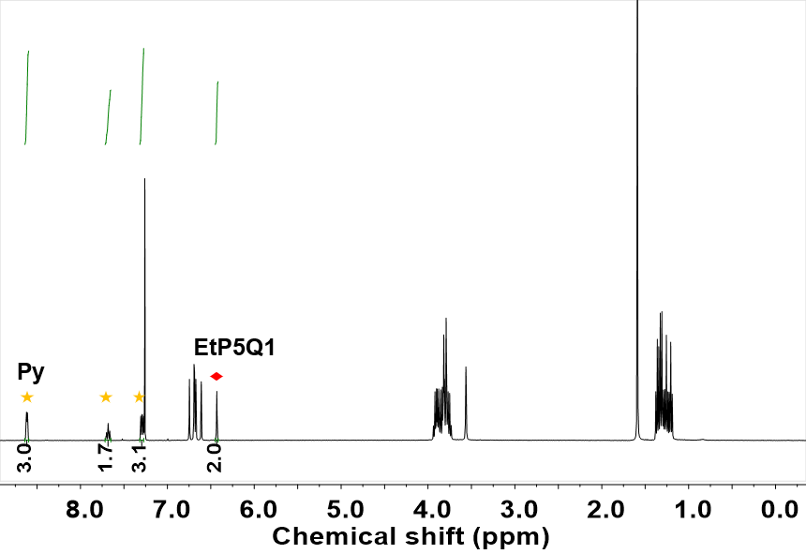
Figure S18. ¹H NMR spectrum (400 MHz, CDCl₃, 298 K) of EtP5Q1α after adsorption of Py.
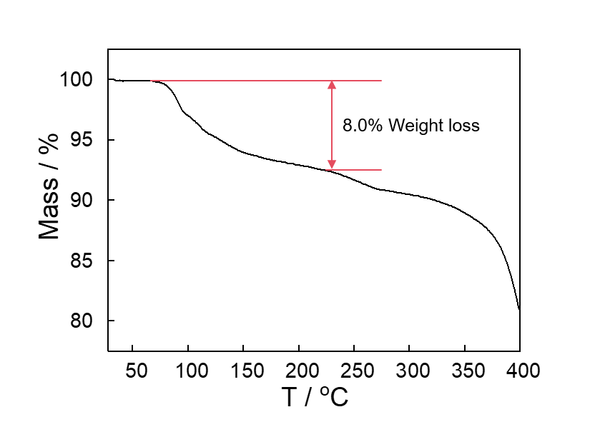
Figure S19. Thermogravimetric analysis of EtP5Q1α after adsorption of Py.

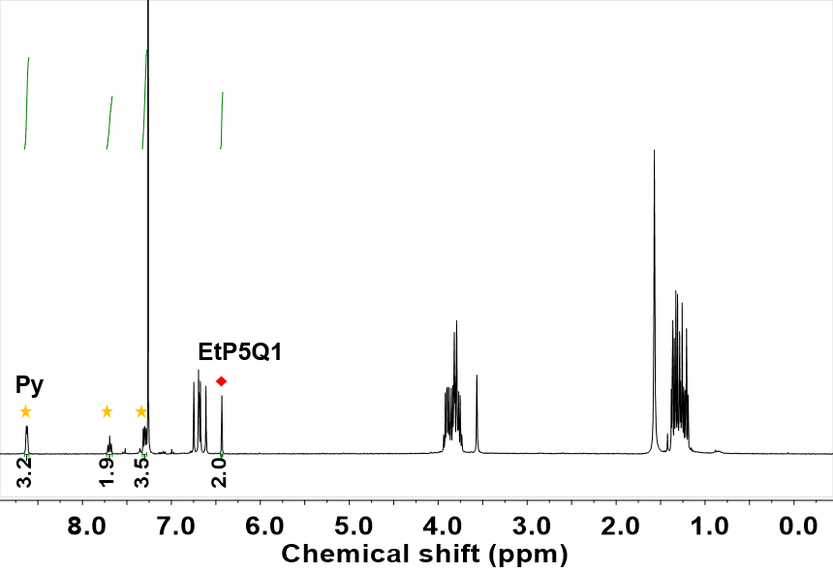
Figure S20. ¹H NMR spectrum (400 MHz, CDCl₃, 298 K) of EtP5Q1β after adsorption of Py.

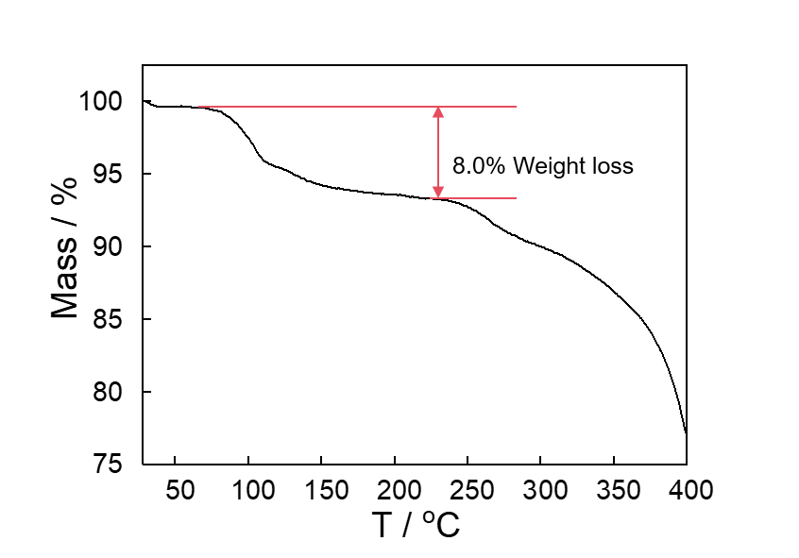
Figure S21. Thermogravimetric analysis of EtP5Q1β after adsorption of Py.

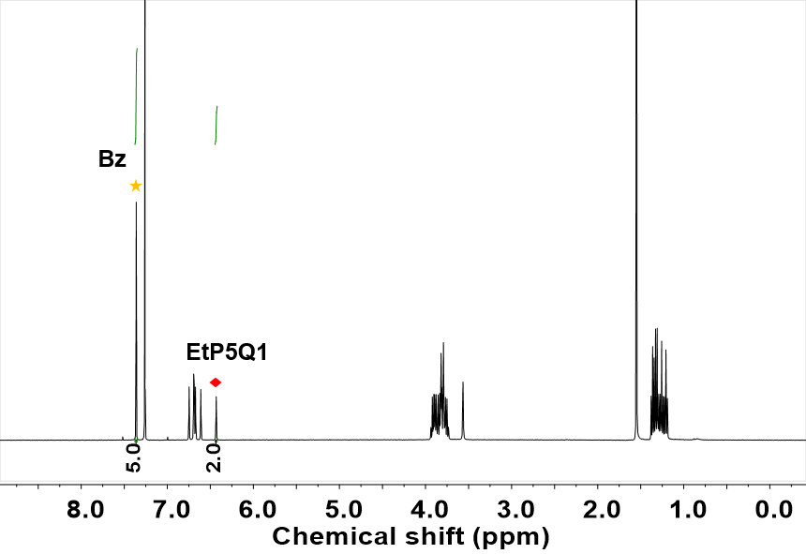
Figure S22. ¹H NMR spectrum (400 MHz, CDCl₃, 298 K) of EtP5Q1α after adsorption of Bz.
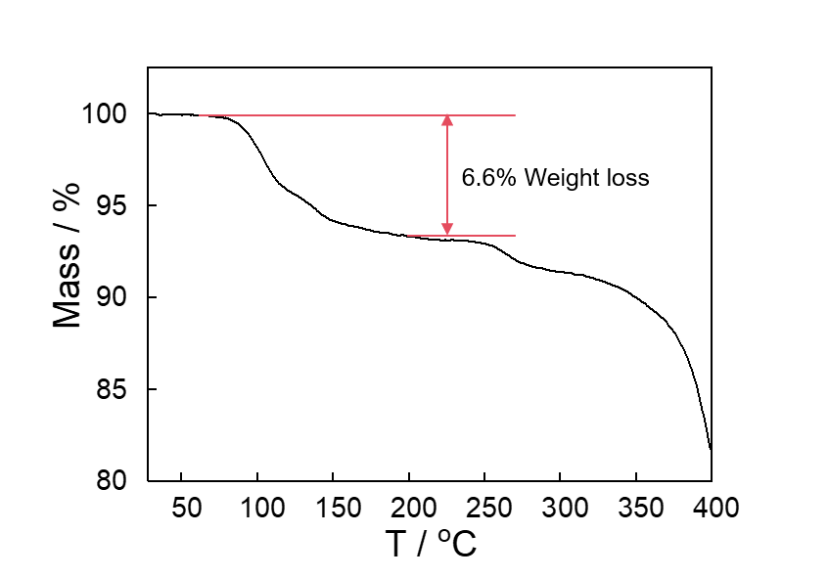
Figure S23. Thermogravimetric analysis of EtP5Q1α after adsorption of Bz.

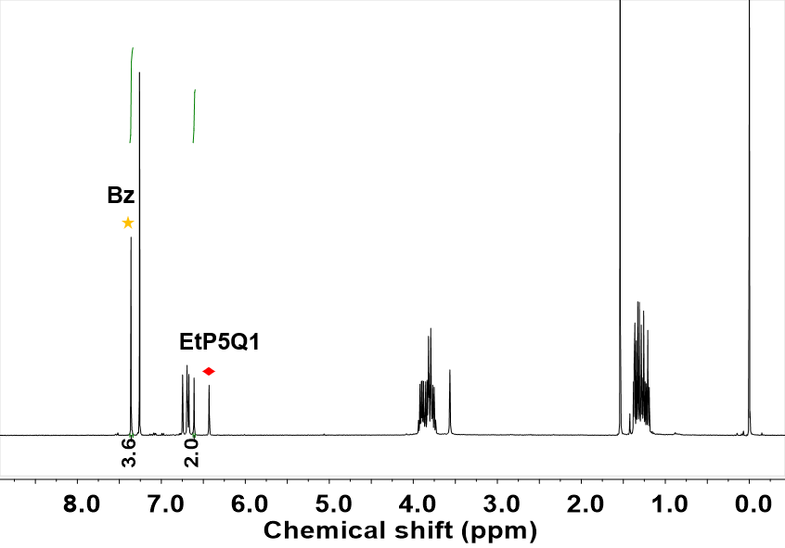
Figure S24. ¹H NMR spectrum (400 MHz, CDCl₃, 298 K) of EtP5Q1β after adsorption of Bz.
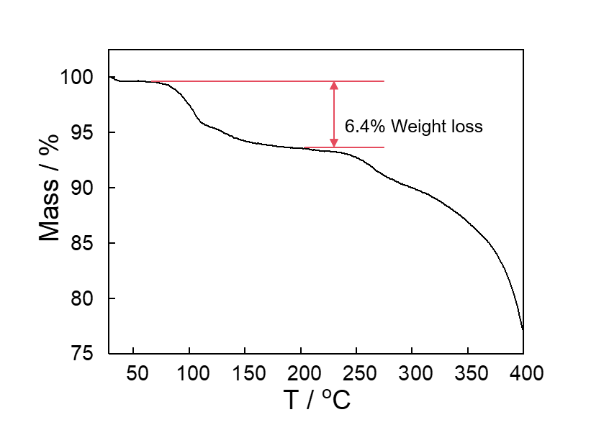
Figure S25. Thermogravimetric analysis of EtP5Q1β after adsorption of Bz.

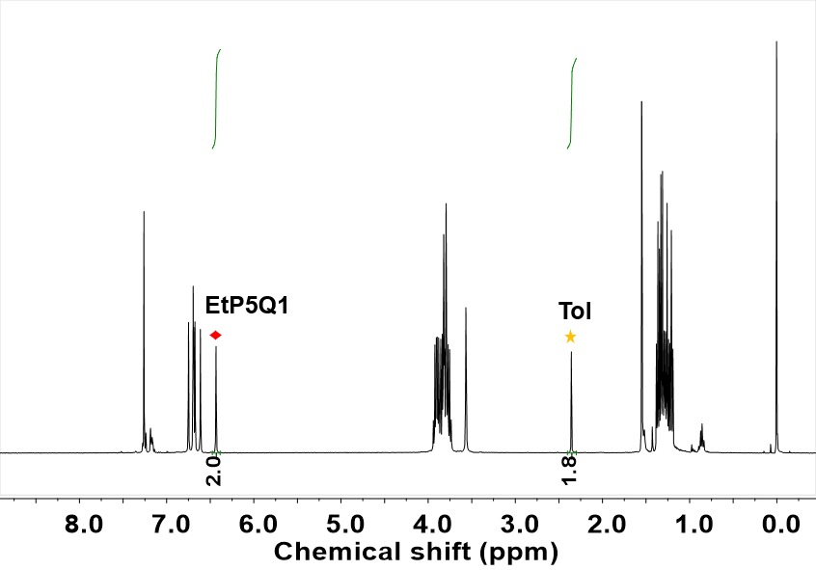
Figure S26. ¹H NMR spectrum (400 MHz, CDCl₃, 298 K) of EtP5Q1α after adsorption of Tol.
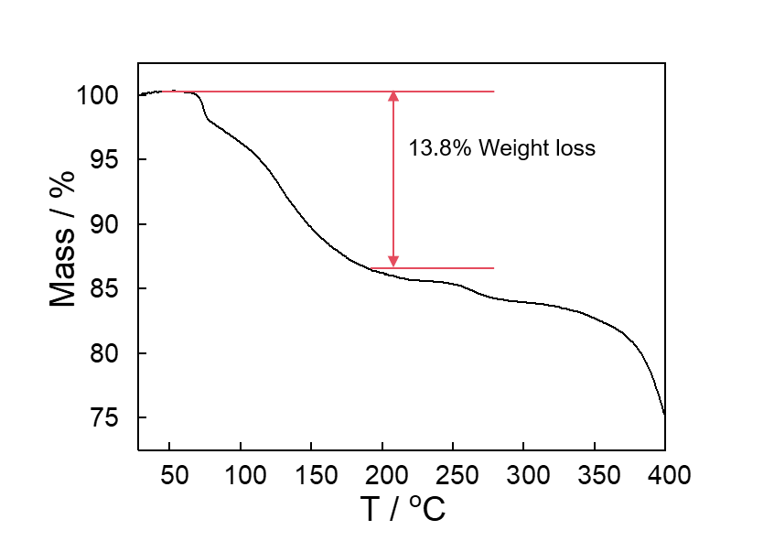
Figure S27. Thermogravimetric analysis of EtP5Q1α after adsorption of Tol.

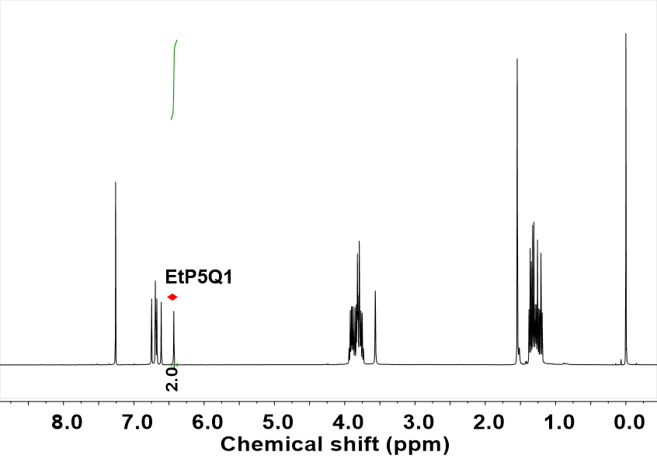
Figure S28. ¹H NMR spectrum (400 MHz, CDCl₃, 298 K) of EtP5Q1β after adsorption of Tol. No signals corresponding to Tol can be found, indicating that EtP5Q1β cannot adsorb Tol.
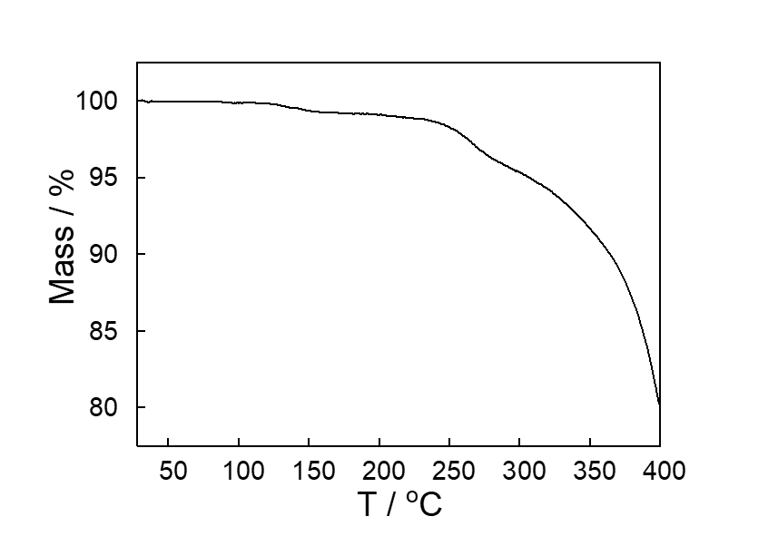
Figure S29. Thermogravimetric analysis of EtP5Q1β after adsorption of Tol.
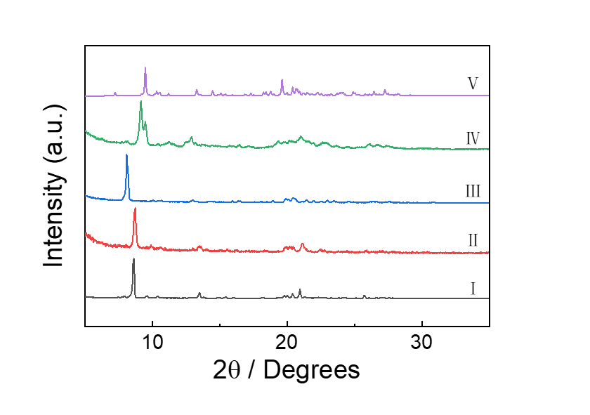
Figure S30. Powder X–ray diffraction patterns of (I) experimental EtP5Q1α; (Ⅱ) EtP5Q1α after adsorption of CH; (ⅡI) EtP5Q1α after adsorption of Py; (IV) EtP5Q1α after adsorption of Bz and (V) EtP5Q1α after adsorption of Tol.
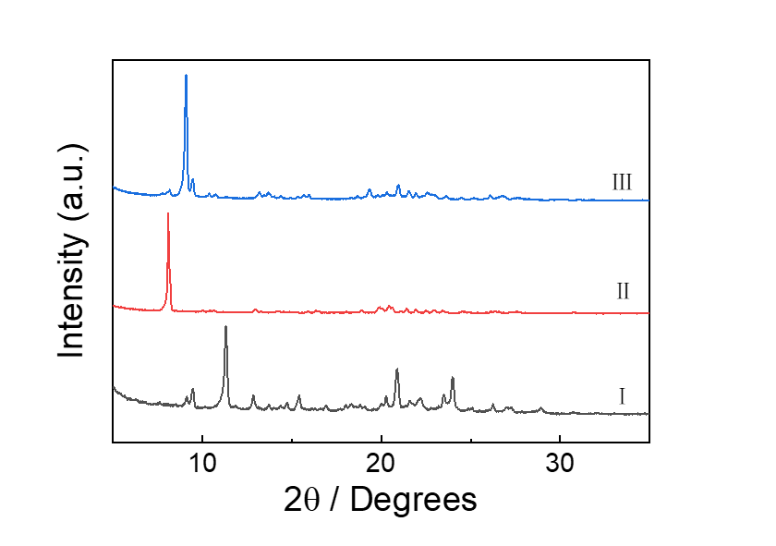
Figure S31. Powder X–ray diffraction patterns of (I) experimental EtP5Q1β; (Ⅱ) EtP5Q1β after adsorption of Py and (V) EtP5Q1β after adsorption of Bz.
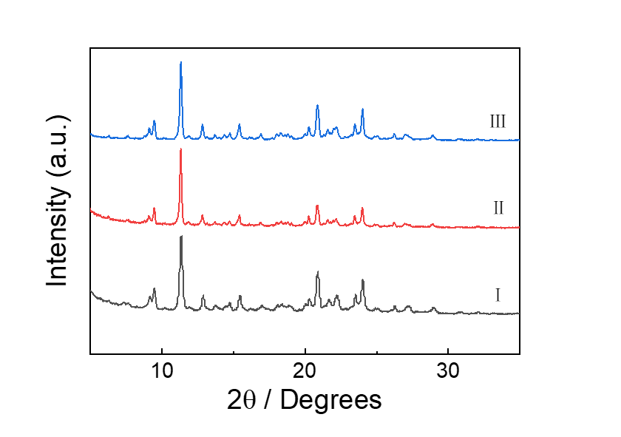
Figure S32. Powder X–ray diffraction patterns of (I) experimental EtP5Q1β; (Ⅱ) EtP5Q1β after adsorption of CH and (III) EtP5Q1β after adsorption of Tol.
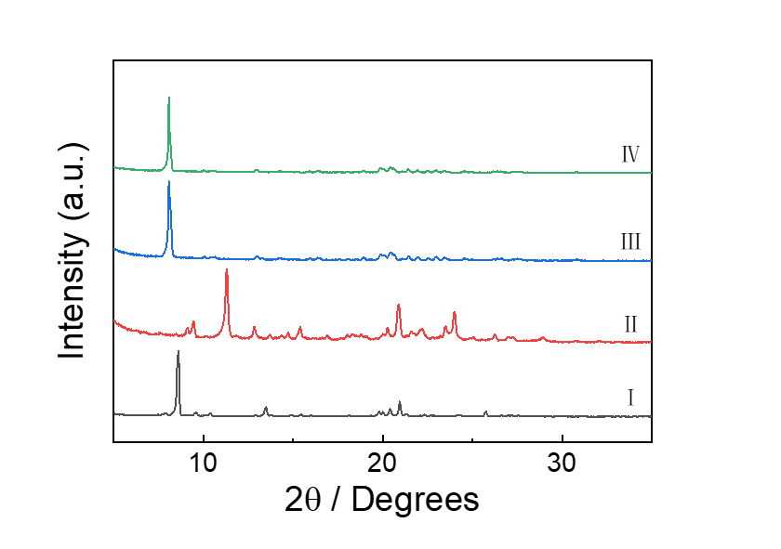
Figure S33. Powder X–ray diffraction patterns of (I) experimental EtP5Q1α; (Ⅱ) experimental EtP5Q1β; (III) EtP5Q1α after adsorption of Py and (IV) EtP5Q1β after adsorption of Py.

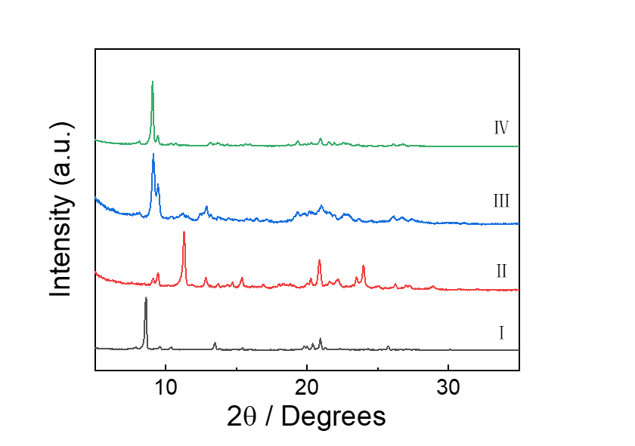
Figure S34. Powder X–ray diffraction patterns of (I) experimental EtP5Q1α; (Ⅱ) experimental EtP5Q1β; (III) EtP5Q1α after adsorption of Bz and (IV) EtP5Q1β after adsorption of Bz.

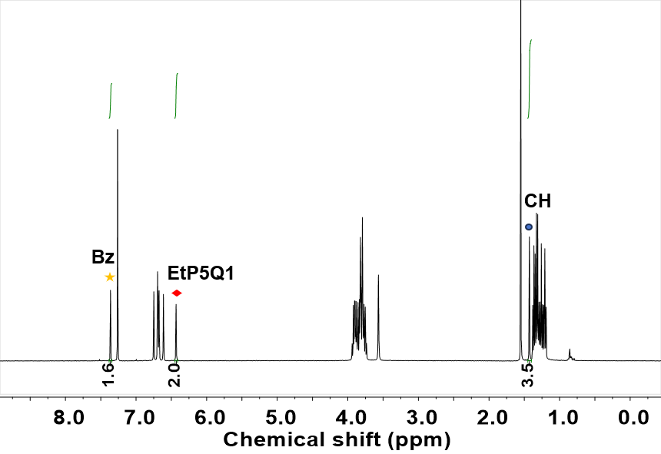
Figure S35. ¹H NMR spectrum (400 MHz, CDCl₃, 298 K) of EtP5Q1α after adsorption of a mixture of Bz and CH with 1:1 volumetric ratio.

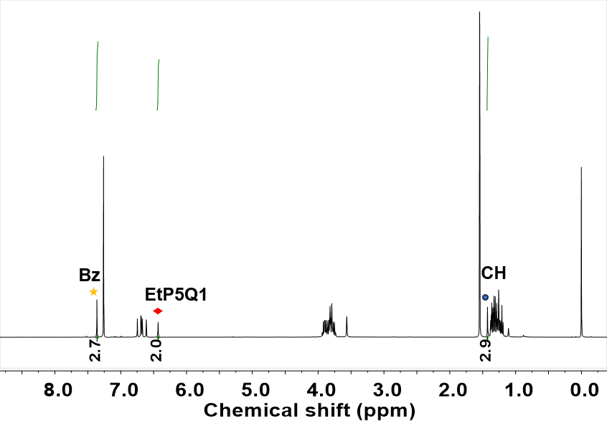
Figure S36. ¹H NMR spectrum (400 MHz, CDCl₃, 298 K) of EtP5Q1β after adsorption of a mixture of Bz and CH with 1:1 volumetric ratio.

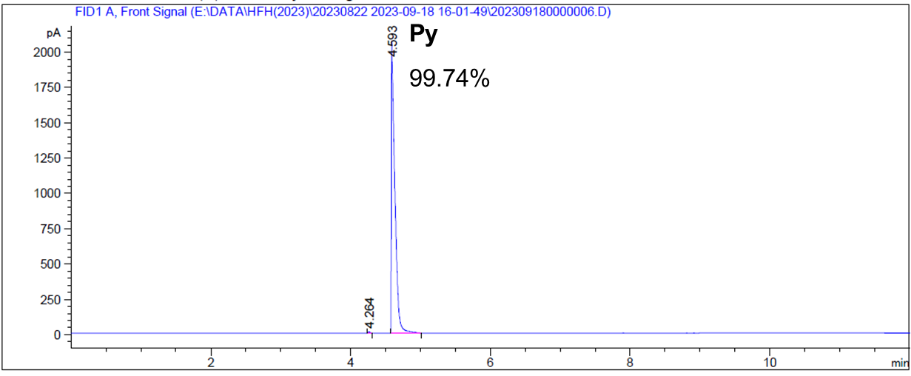

Figure S37. Relative uptake of a mixture of Py and Tol with 1:1 volumetric ratio in EtP5Q1α measured by a headspace method using gas chromatography.

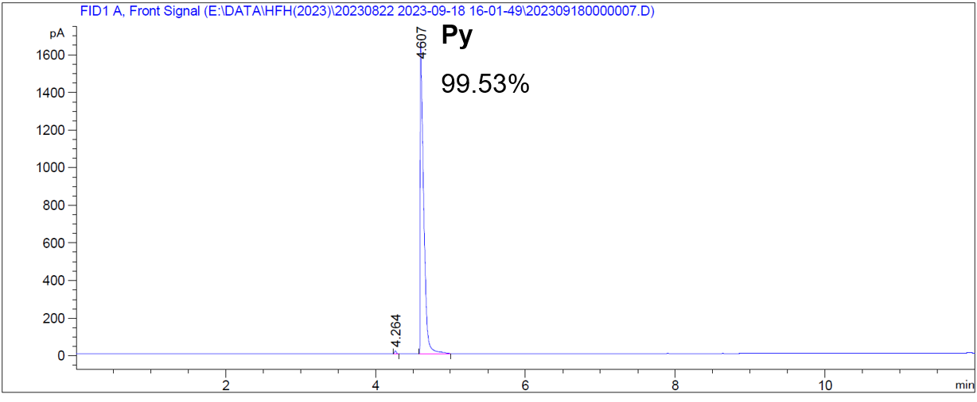

Figure S38. Relative uptake of a mixture of Py and Tol with 1:1 volumetric ratio in EtP5Q1β measured by a headspace method using gas chromatography.

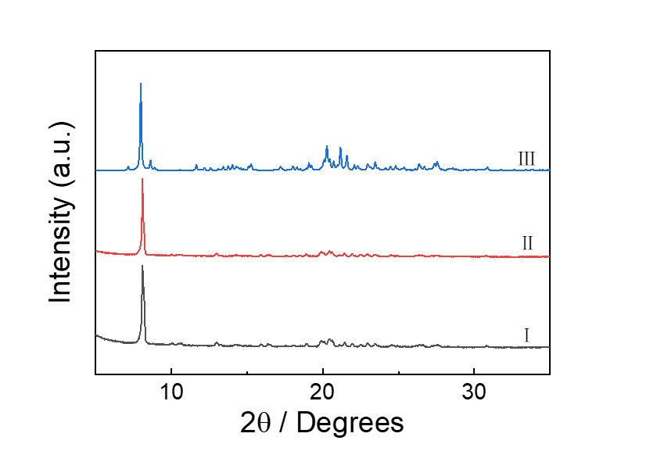
Figure S39. Powder X–ray diffraction patterns of (I) EtP5Q1α after adsorption of a mixture of Py and Tol with 1:1 volumetric ratio; (Ⅱ) EtP5Q1β after adsorption of a mixture of Py and Tol with 1:1 volumetric ratio and (III) simulated from Py₃@EtP5Q1.

5. Vapor–Triggered Guest Release
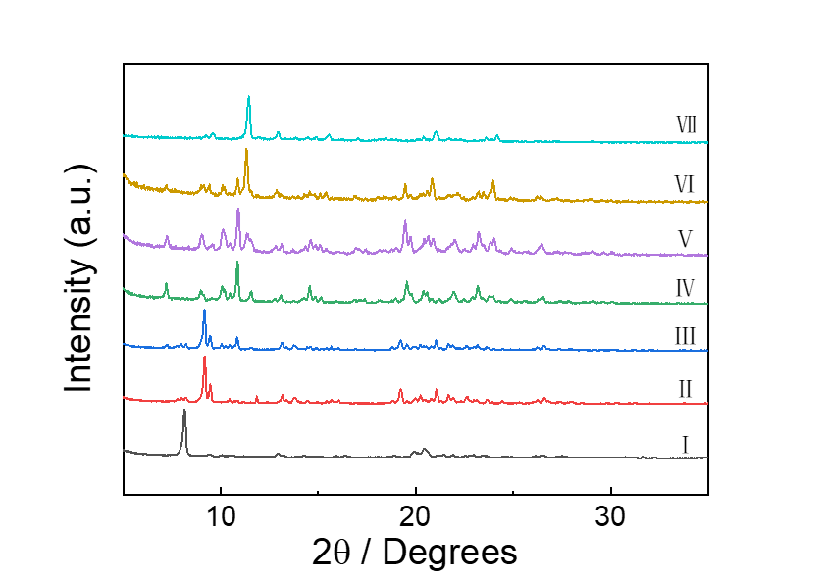
Figure S40. Time–dependent PXRD patterns of Py₃@EtP5Q1 upon exposure to EA vapor.

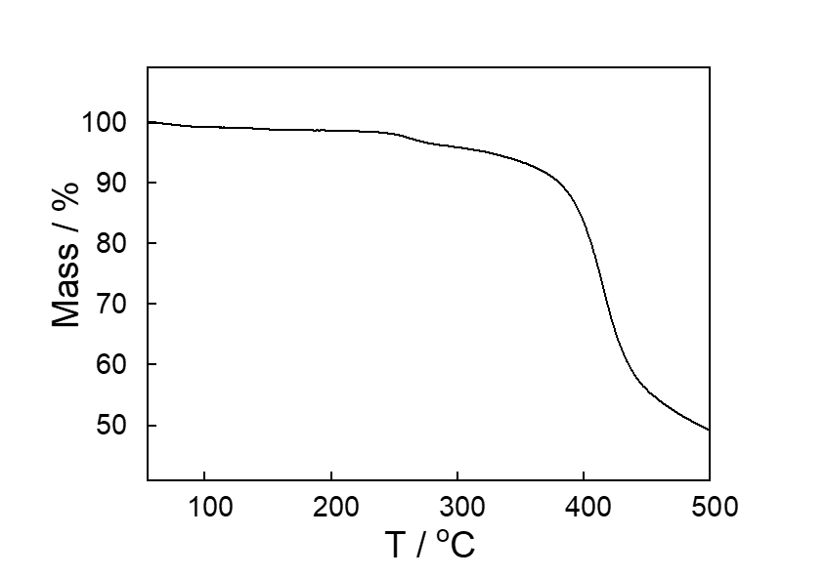
Figure S41. Thermogravimetric analysis of Py₃@EtP5Q1 after exposure to EA vapor.
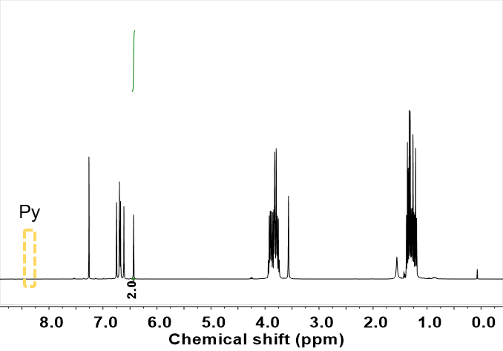
Figure S42. ¹H NMR spectrum (400 MHz, CDCl₃, 293 K) of Py₃@EtP5Q1 after exposure EA vapor.
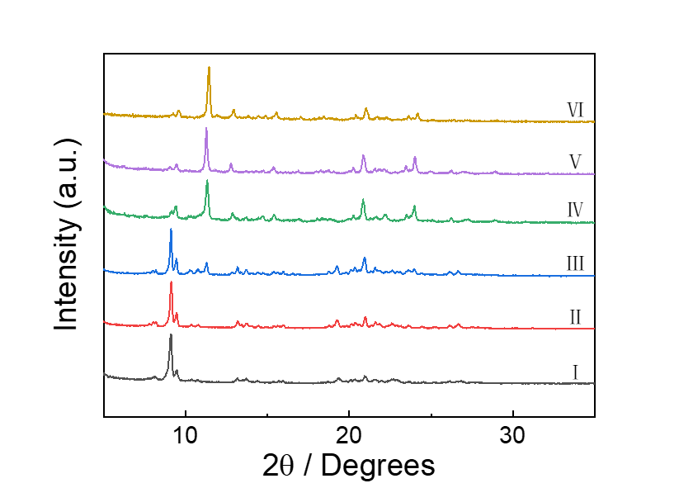

Figure S43. Time–dependent PXRD patterns of Bz₂@EtP5Q1 upon exposure to EA vapor.

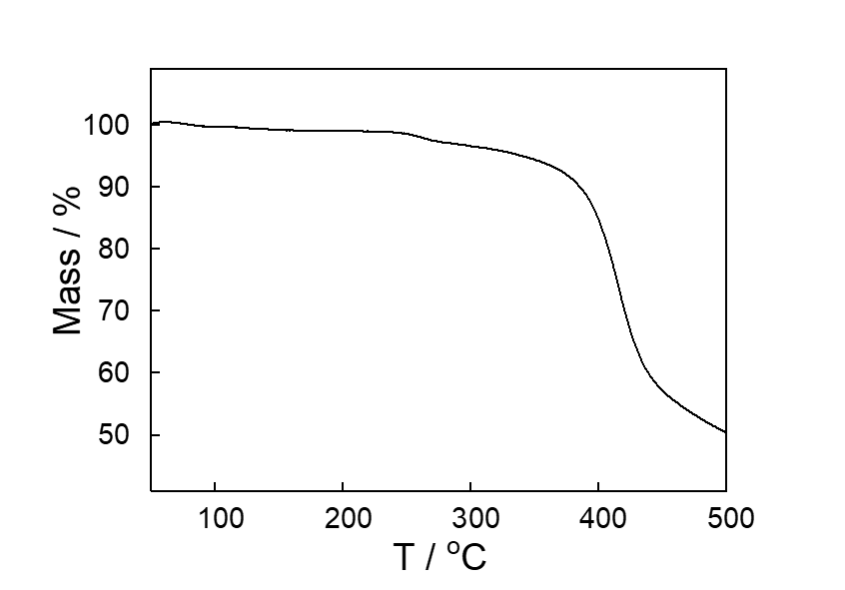
Figure S44. Thermogravimetric analysis of Bz₂@EtP5Q1 after exposure to EA vapor.
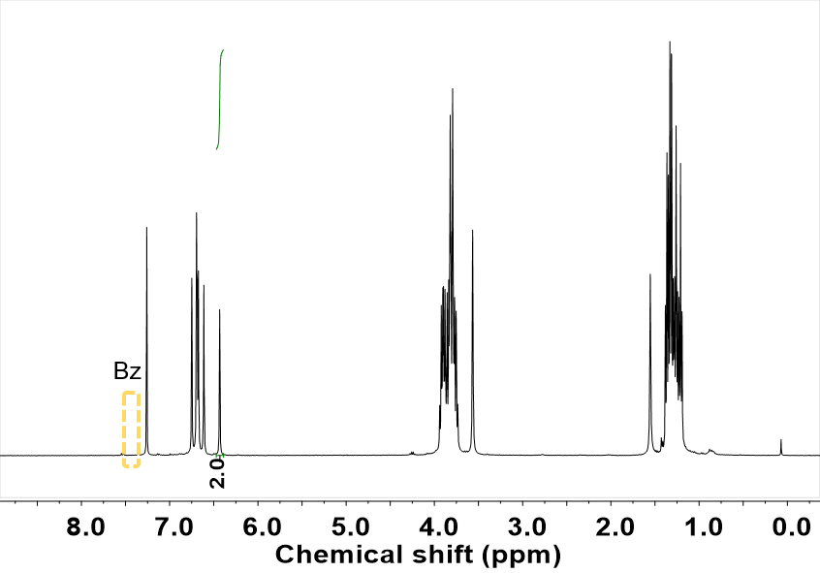
Figure S45. ¹H NMR spectrum (400 MHz, CDCl₃, 293 K) of Bz₂@EtP5Q1 after exposure EA vapor.
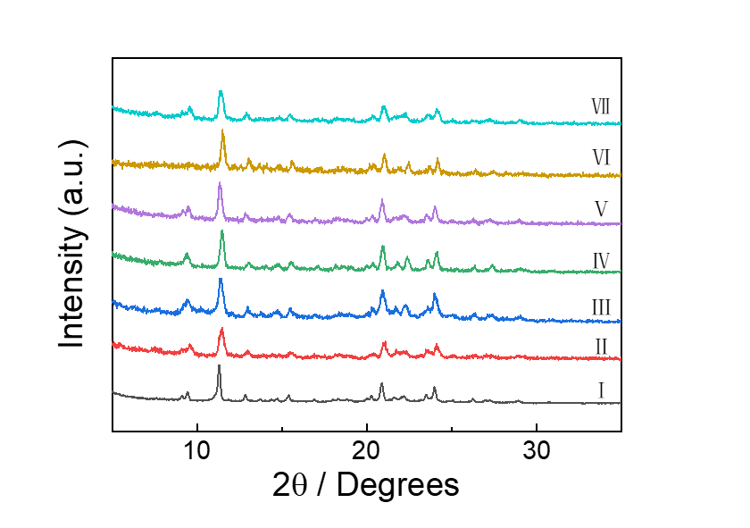

Figure S46. PXRD patterns of (I) EtP5Q1β; (II) CH@EtP5Q1 after exposure to ethyl propionate; (III) CH@EtP5Q1 after exposure to ethyl lactate; (IV) CH@EtP5Q1 after exposure to 2–butanone; (V) CH@EtP5Q1 after exposure to 3–pentanone; (VI) CH@EtP5Q1 after exposure to 3–hexanone; (VII) CH@EtP5Q1 after exposure to diethyl ether.
Table S1. Chemical names and structures similar to EA and their vapor induced guest release behavior.

Vapor names | Chemical structures | Vapor induced guest release
ethyl acetate | 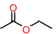 | Yes
ethyl propionate | 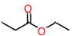 | Yes
ethyl lactate | 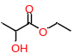 | Yes
2–butanone | 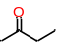 | Yes
3–pentanone | 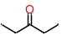 | Yes
2–pentanone | 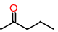 | Yes
3–hexanone | 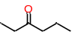 | Yes
2–hexanone | 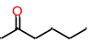 | Yes
diethyl ether |  | Yes
methyl acetate | 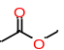 | No
methyl formate | 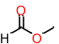 | No
acetone | 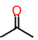 | No
2–butanol | 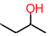 | No
n–pentane |  | No

Table S2. Experimental single crystal X–ray data for EtP5Q1β, CH@EtP5Q1, Bz₂@EtP5Q1, Tol₂@EtP5Q1 and Py₃@EtP5Q1.
Formula | EtP5Q1β | CH@EtP5Q1 | Bz₂@EtP5Q1
Empirical formula | C₆₂H₇₄O₁₂ | C₆₈H₈₆O₁₂ | C₇₇H₈₉O₁₂
Formula weight | 1011.21 | 1095.36 | 1206.48
Temperature/K | 193.00 | 298.15 | 193.00
Crystal system | triclinic | monoclinic | monoclinic
Space group | P–1 | Cc | C2
a/Å | 12.7930(3) | 23.496(8) | 48.676(3)
b/Å | 14.1809(3) | 13.760(4) | 13.6969(6)
c/Å | 15.6540(4) | 21.088(7) | 23.6856(10)
α/° | 101.291(2) | 90 | 90
β/° | 90.784(2) | 106.55(3) | 105.182(2)
γ/° | 92.5540(10) | 90 | 90
Volume/Å³ | 2781.43(11) | 6535(4) | 15240.4(12)
Z | 2 | 4 | 8
ρ_{calc}g/cm³ | 1.207 | 1.113 | 1.052
μ/mm^{–1} | 0.667 | 0.601 | 0.070
F(000) | 1084.0 | 2360.0 | 5176.0
Crystal size/mm³ | 0.2 × 0.18 × 0.17 | 0.15 × 0.15 × 0.12 | 0.22 × 0.24 × 0.19
Radiation | CuKα (λ = 1.54178) | CuKα (λ = 1.54178) | MoKα (λ= 0.71073)
2Θ range for data collection/° | 5.758 to 137.036 | 7.528 to 131.208 | 1.734 to 49.998
Index ranges | –15 ≤ h ≤ 15, –17 ≤ k ≤ 17, –18 ≤ l ≤ 18 | –27 ≤ h ≤ 27, –15 ≤ k ≤ 16, –24 ≤ l ≤ 24 | –56 ≤ h ≤ 57, –13 ≤ k ≤ 16, –28 ≤ l ≤ 28
Reflections collected | 40679 | 27778 | 86670
Independent reflections | 10234 [R_{int} = 0.0541, R_{sigma} = 0.0627] | 10691 [R_{int} = 0.0416, R_{sigma} = 0.0440] | 23680 [R_{int} = 0.0735, R_{sigma} = 0.0792]
Data/restraints/parameters | 10234/18/723 | 10691/514/888 | 23680/6975/1872
Goodness–of–fit on F² | 1.057 | 1.022 | 1.092
Final R indexes [I>=2σ (I)] | R₁ = 0.0750,  wR₂ = 0.2172 | R₁ = 0.0510,  wR₂ = 0.1360 | R₁ = 0.1337,  wR₂ = 0.3631
Final R indexes [all data] | R₁ = 0.1025,  wR₂ = 0.2459 | R₁ = 0.0995,  wR₂ = 0.1692 | R₁ = 0.1931,  wR₂ = 0.4130
Largest diff. peak/hole / e Å^{–3} | 0.51/–0.44 | 0.16/–0.12 | 0.77/–0.55
CCDC | 2339420 | 2339422 | 2339423

Formula | Tol₂@EtP5Q1 | Py₃@EtP5Q1
Empirical formula | C₇₆H₉₀O₁₂ | C₇₇H₈₈N₃O₁₂
Formula weight | 1195.47 | 1247.50
Temperature/K | 193.15 | 170.01
Crystal system | triclinic | triclinic
Space group | P–1 | P–1
a/Å | 10.2879(7) | 13.2412(7)
b/Å | 13.2004(10) | 13.4280(7)
c/Å | 26.664(2) | 21.5498(10)
α/° | 94.362(2) | 77.653(3)
β/° | 98.624(2) | 81.074(4)
γ/° | 110.705(4) | 69.527(4)
Volume/Å³ | 3316.1(4) | 3493.0(3)
Z | 2 | 2
ρ_{calc}g/cm³ | 1.197 | 1.186
μ/mm^{–1} | 0.080 | 0.410
F(000) | 1284.0 | 1334.0
Crystal size/mm³ | 0.12 × 0.111 × 0.11 | 0.22 × 0.2 × 0.15
Radiation | MoKα (λ = 0.71073) | GaKα (λ = 1.34139)
2Θ range for data collection/° | 3.87 to 55.07 | 6.206 to 105.962
Index ranges | –13 ≤ h ≤ 12, –16 ≤ k ≤ 17, –34 ≤ l ≤ 34 | –15 ≤ h ≤ 15, –14 ≤ k ≤ 15, –24 ≤ l ≤ 25
Reflections collected | 27781 | 39916
Independent reflections | 15054 [R_{int} = 0.0335, R_{sigma} = 0.0695] | 12279 [R_{int} = 0.0791, R_{sigma} = 0.0923]
Data/restraints/parameters | 15054/0/805 | 12279/571/775
Goodness–of–fit on F² | 1.046 | 1.024
Final R indexes [I>=2σ (I)] | R₁ = 0.0646,  wR₂ = 0.1174 | R₁ = 0.1488,  wR₂ = 0.4133
Final R indexes [all data] | R₁ = 0.1201,  wR₂ = 0.1439 | R₁ = 0.2038,  wR₂ = 0.4547
Largest diff. peak/hole / e Å^{–3} | 0.23/–0.25 | 0.68/–0.51
CCDC | 2339419 | 2339421

6. Computational Details and Calculation Results
Geometries of the complexes were optimized in Vienna ab initio simulation package (VASP)^{S3}, where the vdW–D3^{S4} correction were considered. The generalized gradient approximation (GGA) with PBE functional was applied to describe the exchange–correction potential. The projector–augmented wave (PAW) method was used to describe the interaction between electrons and ions. Electronic convergence accuracy was set to 1×10^{–5} eV and the cutoff was set to 400 eV. Multiwfn^{S5}, Vaspkit^{S6}, and Materials Studio^{S7} software were used in data processing and analysis. The deformation energy per atom (E_{deform}) represents the energy change after geometry optimization in Eq. (S1), where E is the energy of different species with DFT optimization, E* is calculated by using the geometry in crystal without further DFT optimization, and N is the number of atoms. The lattice energy per atom (E_{lattice}) was defined as Eq. (S2), where E_{total} is the total crystal energy, E_{guest@lattice} and E_{EtP5Q1@lattice} are the energies of different guests and host EtP5Q1 in the same simulation lattice, and n is the number of guests.
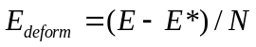 (S1)
(S2)
In order to obtain the evolution of the complex configuration with time, molecular dynamics (MD) simulations were carried out in NPT (constant pressure and constant temperature of 298 K) and NVT ensemble. Simulation models were built with the periodic boundary condition (in size of 40 Å × 40 Å × 40 Å), and the host and guest molecules were fully mixed by Packmol program^{S8}. The polymer consistent force field (PCFF) in the Material Studio software package was used in MD simulations. After energy minimization, 2 ns MD simulations were run at 298 K for getting the initial configurations. The 10 ns MD simulations (step size of 1 fs) were used for trajectory analysis.

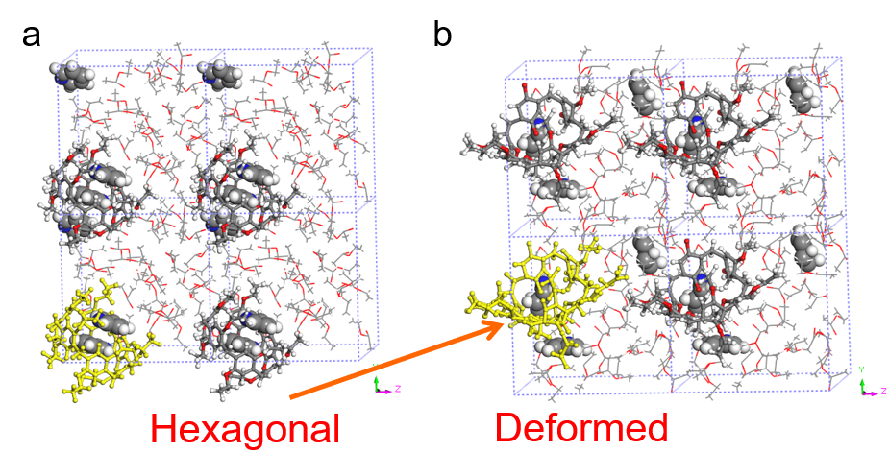
Figure S47. Molecular dynamics simulation of configuration transition of Py₃@EtP5Q1 and in an EA atmosphere. (a) The initial configuration of Py₃@EtP5Q1. (b) Equilibrium configuration of Py₃@EtP5Q1 showed that the hexagonal EtP5Q1 in Py₃@EtP5Q1 configuration collapsed and changed to the deformed configuration.

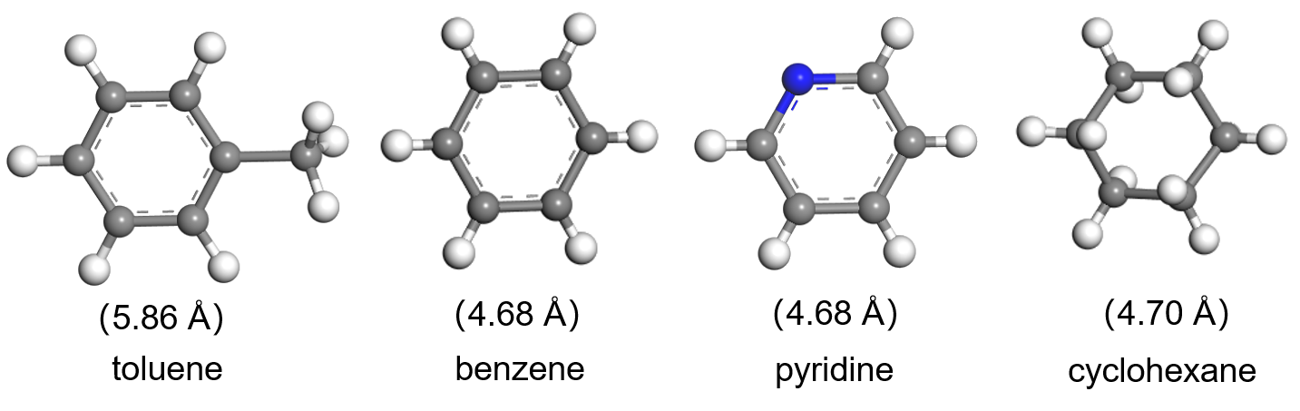
Figure S48. Optimized geometry of guest molecule using PAW/PBE calculations. The length of each guest is shown in parentheses.

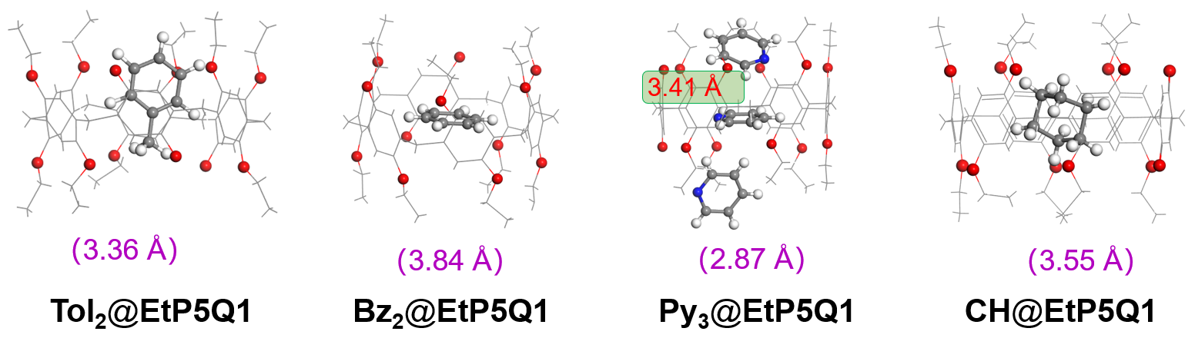
Figure S49. Illustration of intramolecular interactions of host and guest. The numbers in parentheses indicate the hydrogen bond length, and the red numbers represent the π–π stacking interaction between the guests.
Table S3. Calculated deformation energies of different species.
Category | Species | E (eV) | E* (eV) | E_{deform} (eV/atom)
Host | EtP5Q1α | –1808.31 | –1760.67 | –0.16
 | EtP5Q1β | –1965.58 | –1535.75 | –1.45
Guest | Bz | –1470.83 | –1466.69 | –0.02
 | CH | –396.31 | –373.82 | –0.31
 | Py | –66.22 | –68.22 | 0.18
 | Tol | –1111.69 | –1110.37 | –0.02
Complex | Bz₂@EtP5Q1 | –9592.19 | –9594.47 | 0.00
 | CH@EtP5Q1 | –4034.79 | –3876.17 | –0.24
 | Py₃@EtP5Q1 | –2256.44 | –2190.21 | –0.18
 | Tol₂@EtP5Q1 | –11525.26 | –10080.72 | –4.06

Table S4. Calculated lattice energies of supramolecular system with EtP5Q1 and different guest molecules.
Category | Guest | E_{lattice} (eV/atom)
CH@EtP5Q1 | CH | –7.40
Bz₂@EtP5Q1 | Bz | –0.27
Tol₂@EtP5Q1 | Tol | –0.73
Py₃@EtP5Q1 | Py | –5.44
EtP5Q1β | / | –7.08

References
S1. Han, C., Zhang, Z., Yu, G. & Huang, F. Syntheses of a pillar[4]arene[1]quinone and a difunctionalized pillar[5]arene by partial oxidation. Chem. Commun. 48, 9876–9878 (2012).
S2. Li, E., Jie, K., Zhou, Y., Zhao, R. & Huang, F. Post–Synthetic Modification of Nonporous Adaptive Crystals of Pillar[4]arene[1]quinone by Capturing Vaporized Amines. J. Am. Chem. Soc. 140, 15070–15079 (2018).
S3. Kresse, G. & Furthmiiller, J. Efficiency of ab–initio total energy calculations for metals and semiconductors using a plane–wave basis set. Comput. Mater. Sci 6, 15–50 (1996).
S4. Grimme, S., Antony, J., Ehrlich, S. & Krieg, H. A consistent and accurateab initioparametrization of density functional dispersion correction (DFT–D) for the 94 elements H–Pu. The Journal of Chemical Physics 132, 154104 (2010).
S5. Lu, T. & Chen, F. Multiwfn: A multifunctional wavefunction analyzer. J. Comput. Chem. 33, 580–592 (2011).
S6. Wang, V., Xu, N., Liu, J.–C., Tang, G. & Geng, W.–T. VASPKIT: A user–friendly interface facilitating high–throughput computing and analysis using VASP code. Comput. Phys. Commun. 267, 108033 (2021).
S7. Materials Studio, version 7.0; Accelrys Inc.: San Diego, 2013.
S8. Martínez, L., Andrade, R., Birgin, E. G. & Martínez, J. M. PACKMOL: A package for building initial configurations for molecular dynamics simulations. J. Comput. Chem. 30, 2157–2164 (2009).

