Supplement 2:
Ten risk factors that were used to calculate the risk mapping.
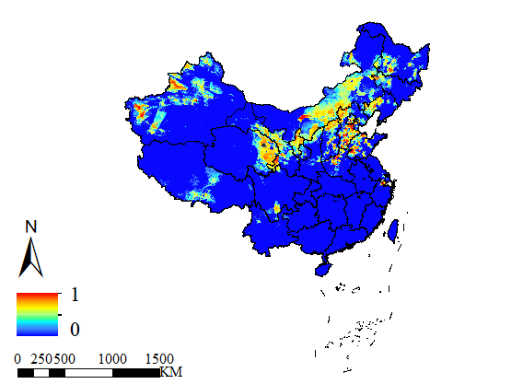
Fig 1. Map of sheep density with standardization.
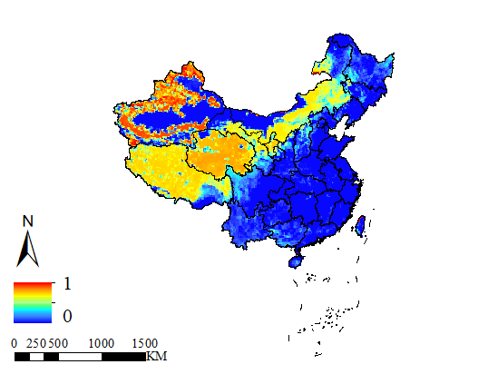
Fig 2. Map of rangeland with standardization.
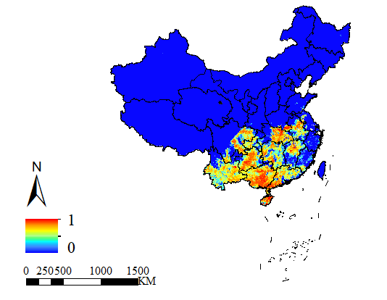
Fig 3. Map of buffalo density with standardization.
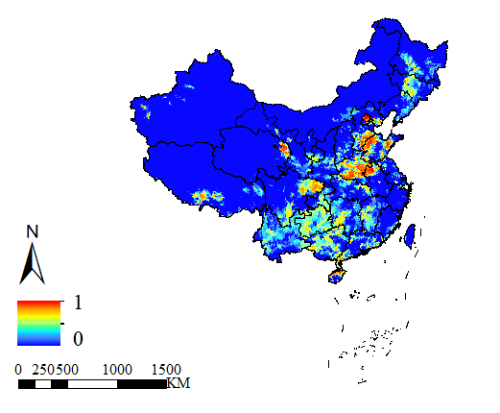
Fig 4. Map of cattle density with standardization.
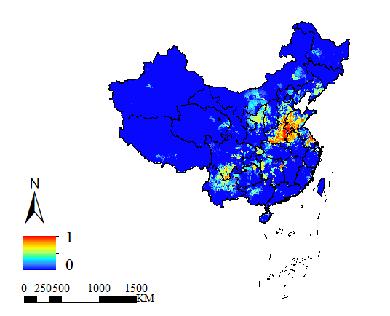
Fig 5. Map of goat density with standardization.
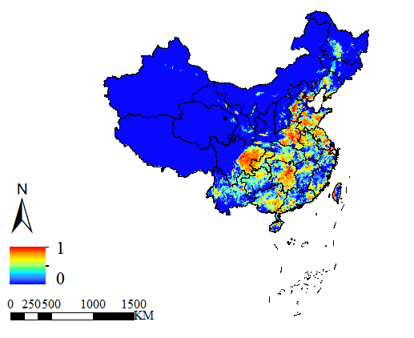
Fig 6. Map of pig density with standardization.
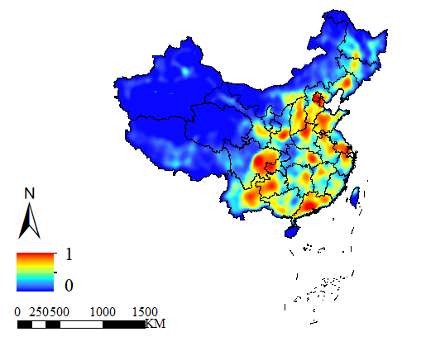
Fig 7. Map of major road density with standardization.
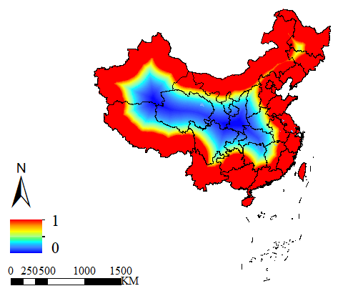
Fig 8. Map of distance to national boundaries with standardization.
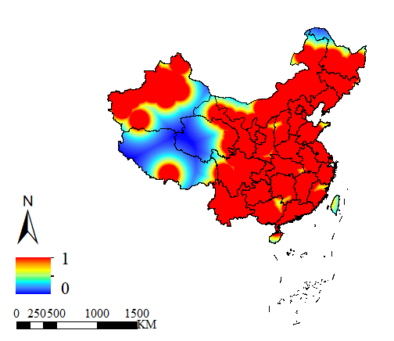
Fig 9. Map of distance to livestock market and slaughterhouse with standardization.
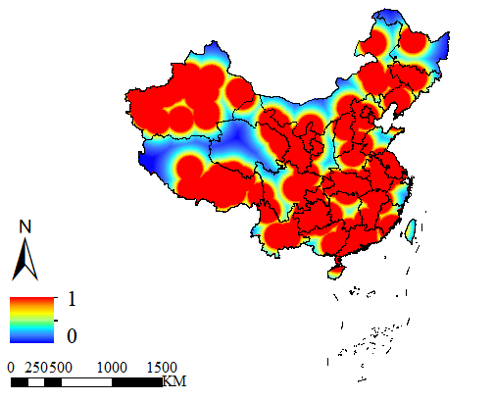
Fig 10. Map of distance to previous outbreak points with standardization.

