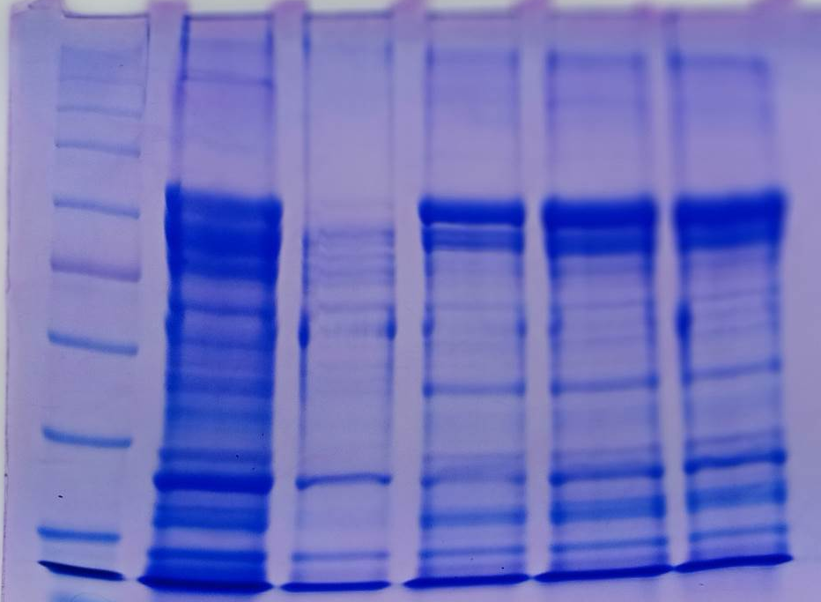
C
M

T₄
T₃
T₂
T₁
kDa
kDa
14

120
120

118
117
114

116
52
110
66
43
45
28
34
29

19

20
16

15
14

Fig. 1: SDS-PAGE pattern of muscle protein of M. rosenbergii PL fed with fishmeal replaced with diet C. roseus incorporated feeds. Lane M: Marker (120: Myosin; 116: β-galactosidase; 66: Bovine serum albumin; 45: Ovalbumin; 43: actin; 34: β-tropomyosin; 29: Carbonic anhydrase; 20: Soyabean trypsin inhibitor; 14: Lysozyme); Lane C: Control; Lane 1: 0.5 mg/g: Lane 2: 1.0 mg/g: Lane 3: 1.5 mg/g: Lane 4: 2.0 mg/g Fishmeal replaced diet C. roseus incorporated feeds PL)
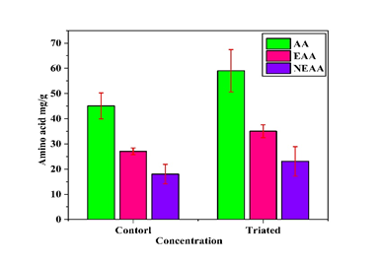

Fig. 2: Profiles of amino acids

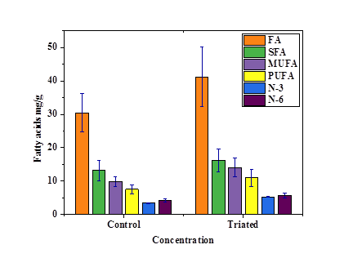

Fig. 3: Profiles of fatty acids

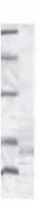
kDa

T
M
95
kDa
M
C
T
95
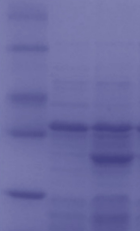
66
66

45
45
31
VP28
VP28
31
14
14
VP28

A
Fig. 4: SDS-PAGE gel expressed in the VP28 protein (A). SDS-PAGE arrow indicated the location of the purified VP28protein.

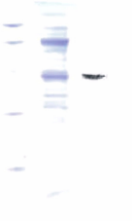
L₃
L₄
L₂

L₁
kDa
97
66
VP28
45
31

14

Fig.5: SDS-PAGE and Western blot analysis of the membrane proteins bound with the protein VP28. Western blotting was performed by the polyclonal mouse anti-His • tag and HRP-conjugated goat anti-mouse IgG. Lane 1 is a marker, lane 2 is the membrane proteins extracted from the cells after the VP28 binding assay. Lane 3 is the Western blot results of the binding assay, lane 4 is the control. The clear band in line 3 shows the VP28 binding to the shrimp cells.
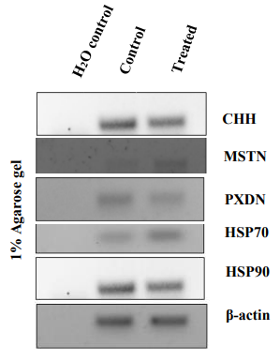
L₁
L₂
L₃
L₄
L₅
L₆

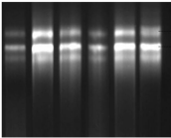

28 S

18 S

M
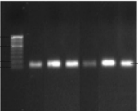
1000 bp

500 bp
150 bp
100 bp
200 bp

Fig.6: (A). Total RNA 1% agarose gel electrophoresis (B). 1% bands Agarose gel (C). cDNA bands (2 % AGE), Relative RNA expression levels of reared MrCHH, MrMSTN, MrPXDN, MrHSP70 and MrHSP90 genes in the muscle of M. rosenbergii PL control and PL fed with C. roseus (1.5 mg/g) supplemented diet. M, 100-bp ladder; L₁ -Control; L₂ -CHH; L₃ -MSTN; L₄ -PXDN; L₅ -HSP70; L₆ -HSP90 genes.
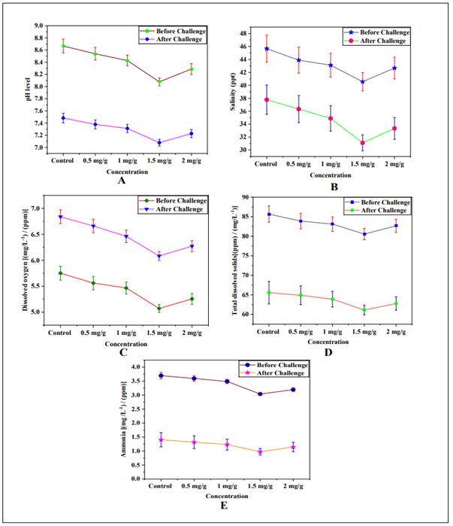
Fig.7: Water challenges of before and after physicochemical variables of M. rosenbergii PL control and PL fed with C. roseus (0.5-2.0 mg/g) supplemented diet. (A). pH, (B). salinity, (C). DO, (D). TDS, and (E). ammonia.

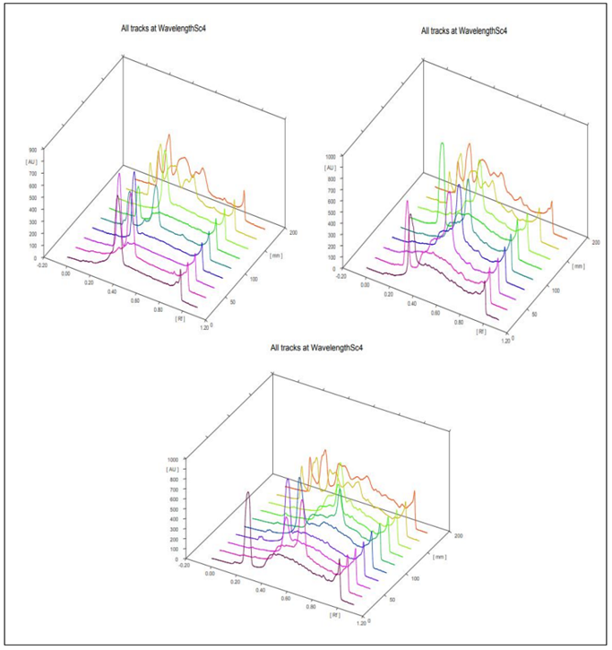
Fig.8: Profiles of amino acids muscle of M. rosenbergii PL control and PL fed with C. roseus (1.5 mg/g) supplemented diet. HPTLC All tracks at chromatogram. HPTLC, High-performance thin-layer chromatographic.

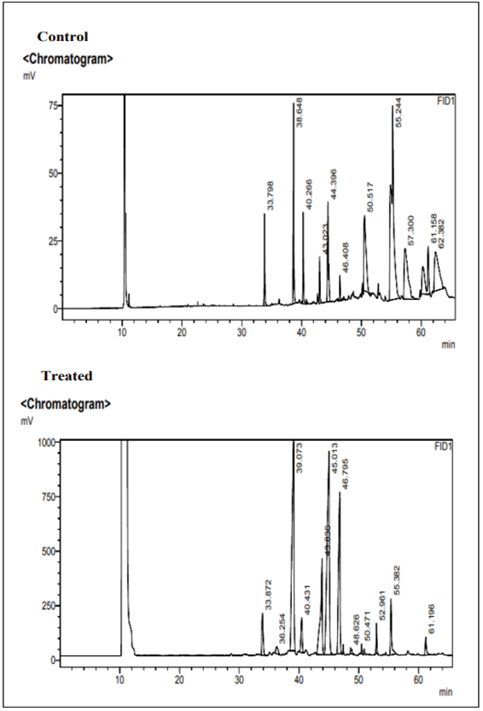
Fig.9: Profiles of fatty acids muscle of M. rosenbergii PL control and PL fed with C. roseus (1.5 mg/g) supplemented diet GC-FID - chromatogram. GC, Gas Chromatography.

