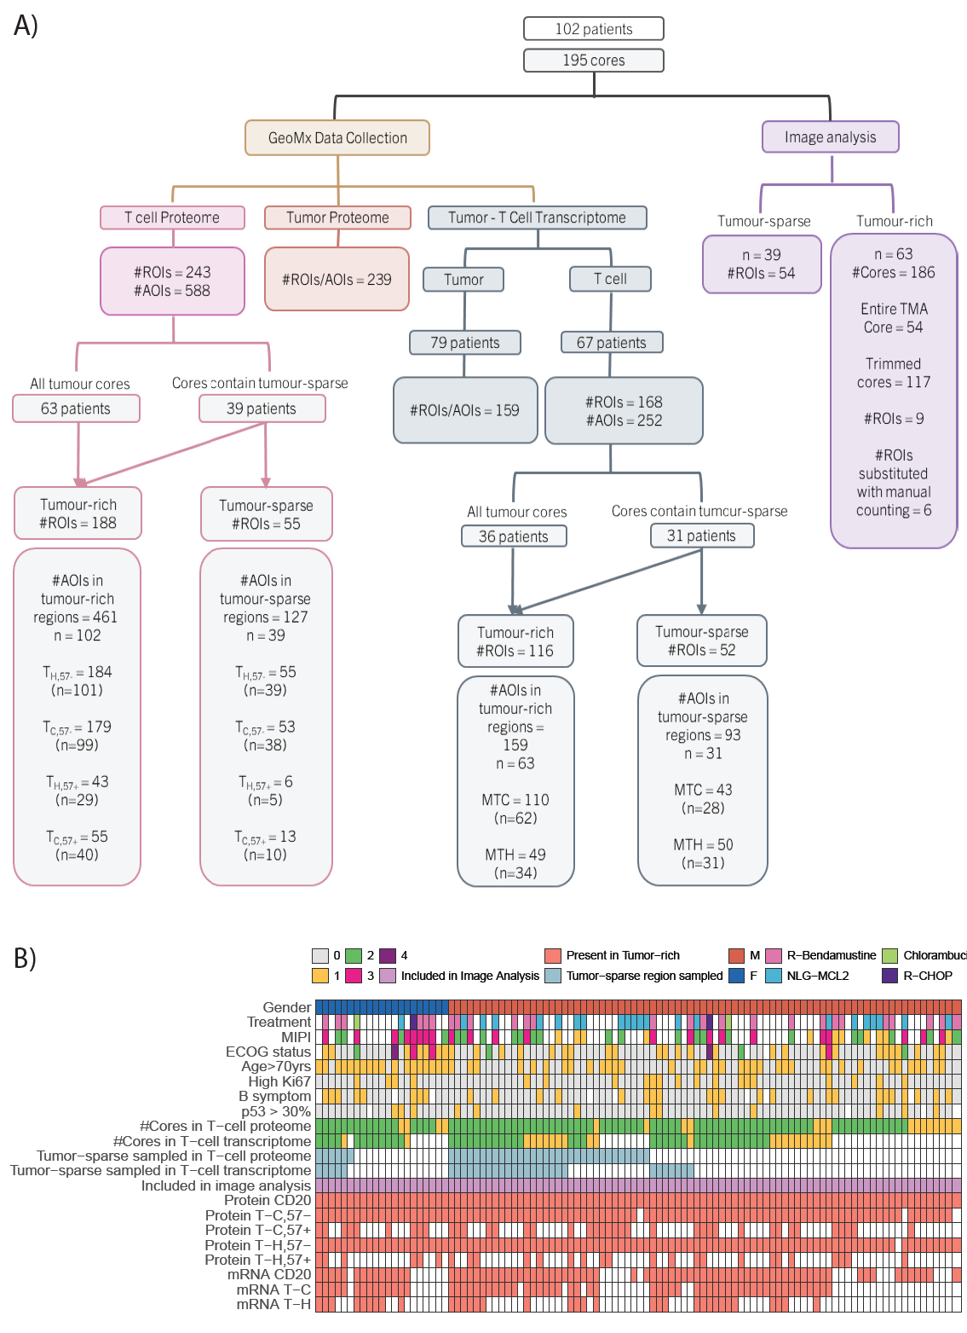

Figure S1: Overview of data collection: A) Summarized information of the number of patients, patient cores, spatially-guided region of interest (ROIs) and cell-specific segments collected by GeoMx™️ DSP. B) Tile plot showing the distribution of technical and clinical parameters across the studied patients (n=102). For most patients two cores were included in the study. In tumor sparse (TS) regions T-cell proteomic and transcriptomic data was collected from 39 and 31 patients, respectively.

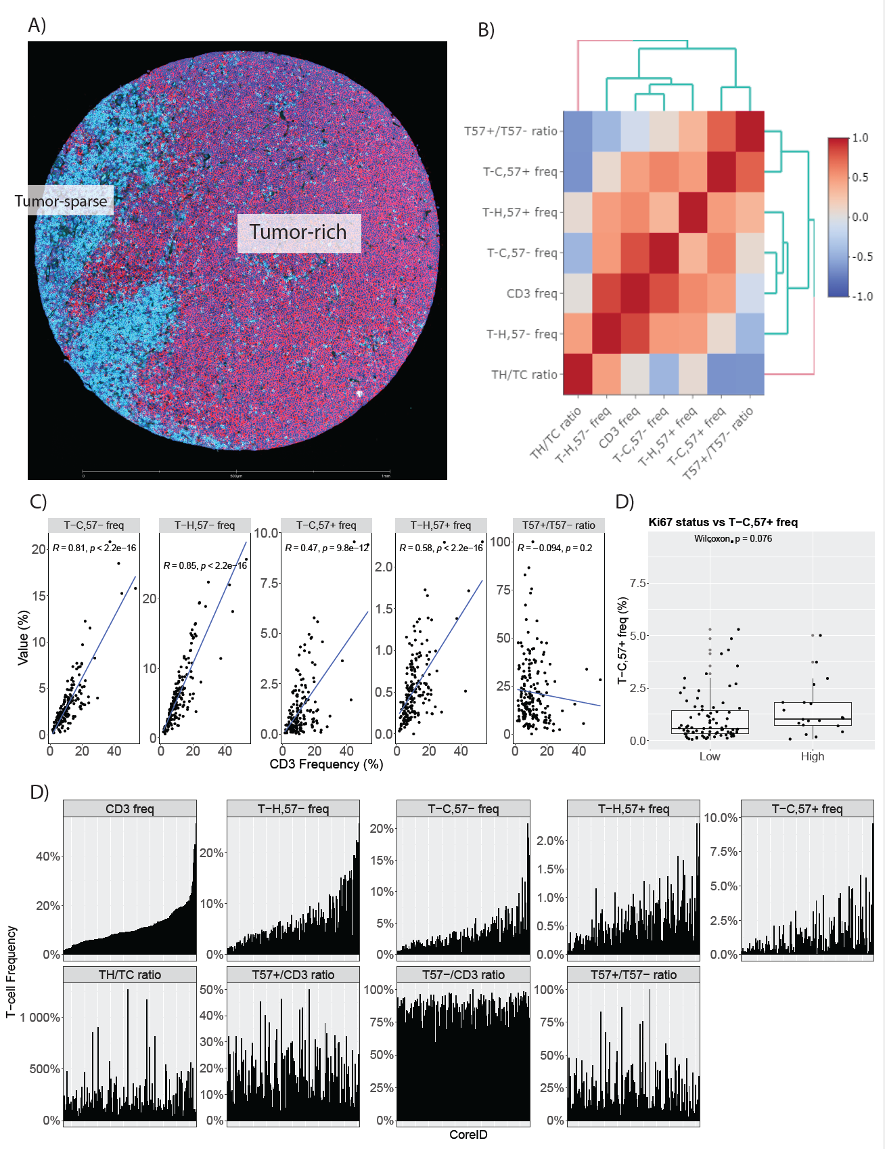

Figure S2: Composition of MCL TIME based on image analysis metrics: A) Example of a tissue micro array core containing both tumor-sparse and rich areas, stained with CD3, CD57, CD8 and Syto13. The segregation in the spatial compartment was made based on CD20 and CD3 staining in a consecutive tissue slide. B) Spearman correlation analysis between the T-cell infiltrating frequencies and ratios. C) Spearman correlation between infiltrating CD3 frequency vs T₅₇₋ and T₅₇₊ frequency as well as T₅₇₊/T₅₇₋ ratio. D) Boxplot analysis of T₅₇₊ frequency in Ki-67 high and low subgroups (based on IHC staining). E) Distribution of the various infiltrating frequencies and ratios with respect to each core. X-axis is ordered as per increasing CD3 infiltration shown in the first panel.

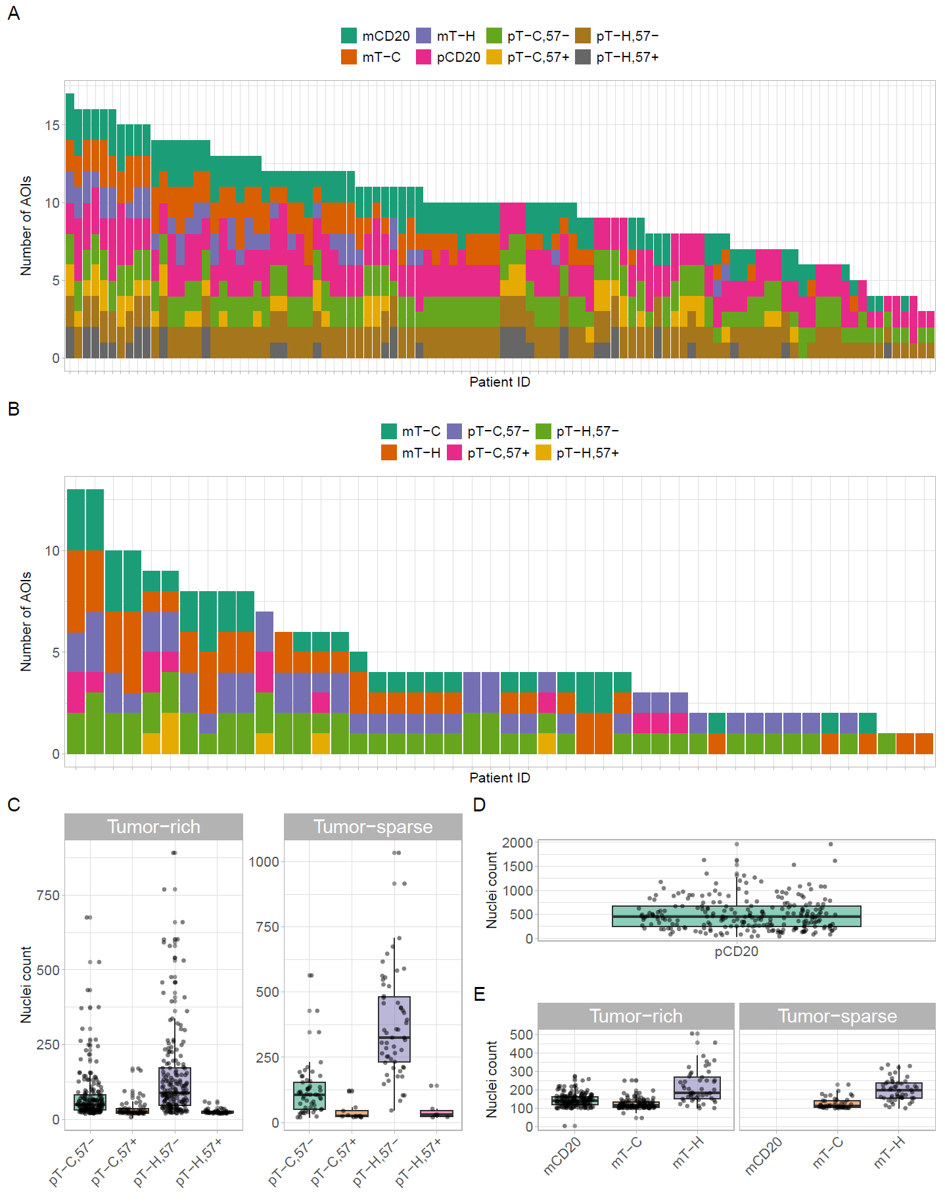
Figure S3: Distribution of segments and nuclei count as collected for each omic data set: A) Barplot of number of segments collected per patient per omic layer for the tumor-rich compartment. B) Barplot of number of segments collected per patient per omic data set for the tumor-sparse compartment. C) Boxplot distribution of the nuclei count for each type of omic data set.

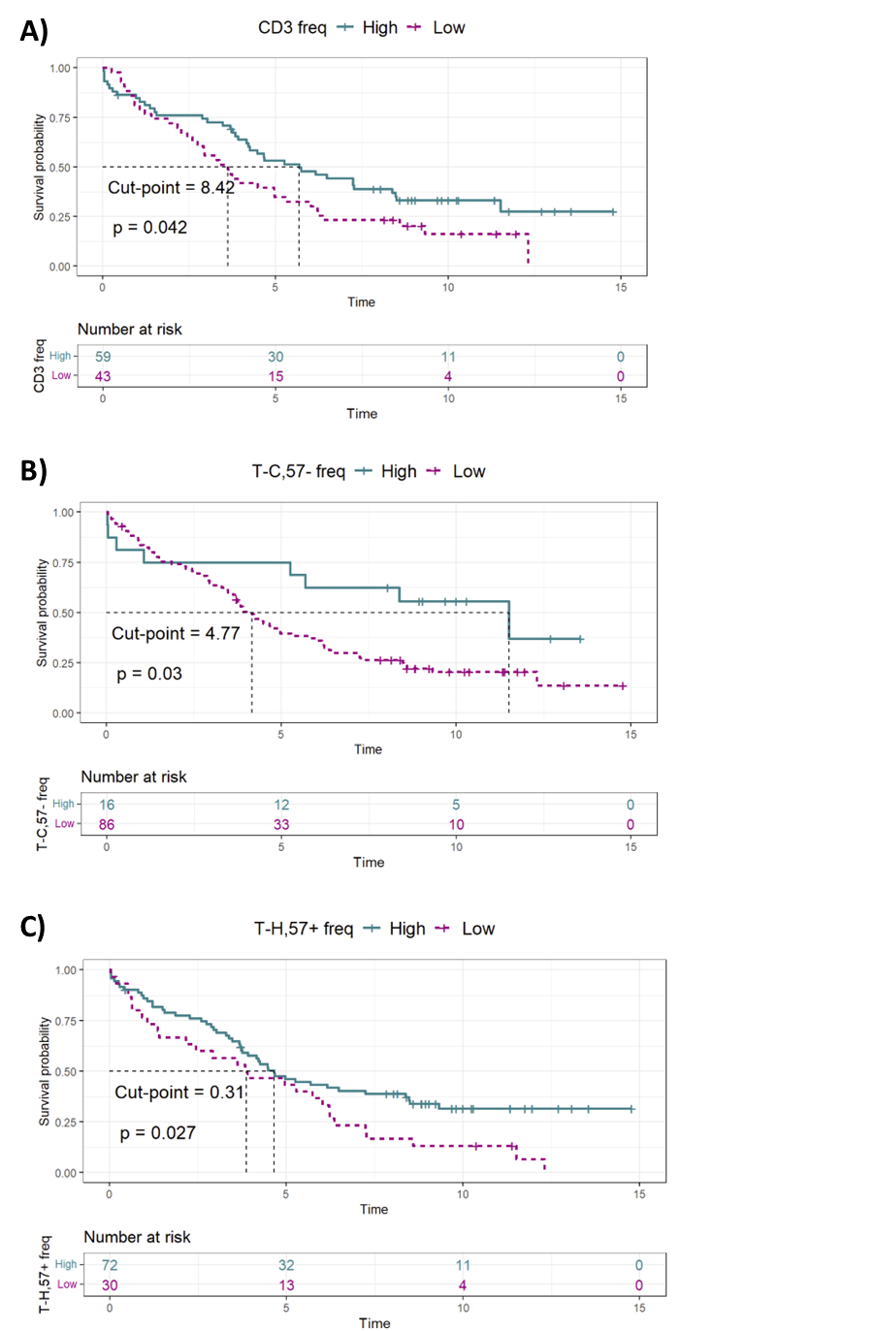
Figure S4: Outcome analysis based on infiltrating T-cell frequencies: A) Kaplan-Meier and log-rank analysis of A) CD3, B) T_{C,57-}, and C) T_{H,57+} frequencies with stated cut-off (%). The groups were defined by max-rank statistics with minimum population distribution set at 0.1 (10%).

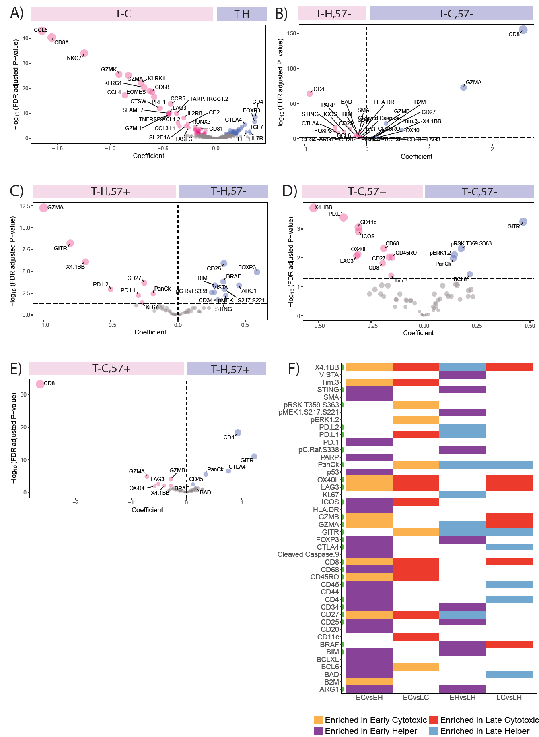

Figure S5: Differential expression analysis of infiltrating T-cell subsets: LMM analysis highlighting (A) differentially expressed transcripts in T_{H} vs T_{C} and differentially expressed proteins in B) T_{C,57-} vs T_{H,57-,} C) T_{H,57-} vs T_{H,57+,} D) T_{C,57-} vs T_{C,57+} and E) T_{H,57+} vs T_{C,57+} . F) Tile plot summarizing the differentially expressed proteins identified in B-F highlighting the direction of enrichment of proteins in the four subtypes. The green dots on the y-label highlight the proteins identified by ANOVA as shown in figure 6.

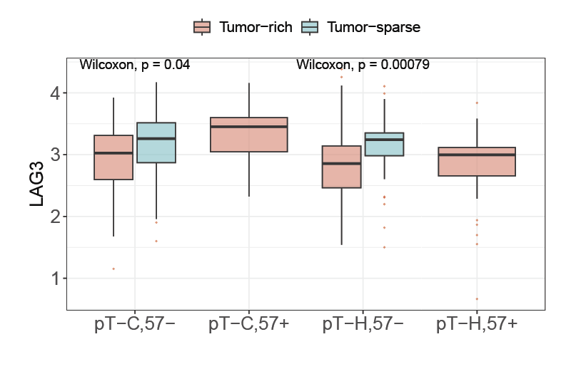
Figure S6: Boxplot analysis of LAG3 protein expression. Expression plotted for the tumor-sparse and -rich regions across the four T-cell subsets, indicating that T_{C,57+} T cells show the highest mean expression of LAG3 in tumor-rich microenvironment.

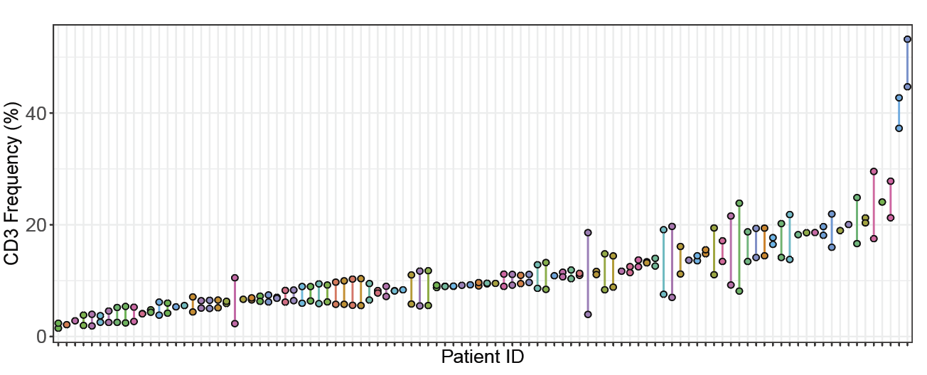
Figure S7: Exploration of CD3 infiltration between the duplicate cores per patient. Plot shows that the duplicate cores have acceptable variation to allow the use of aggregated means in subsequent analysis.

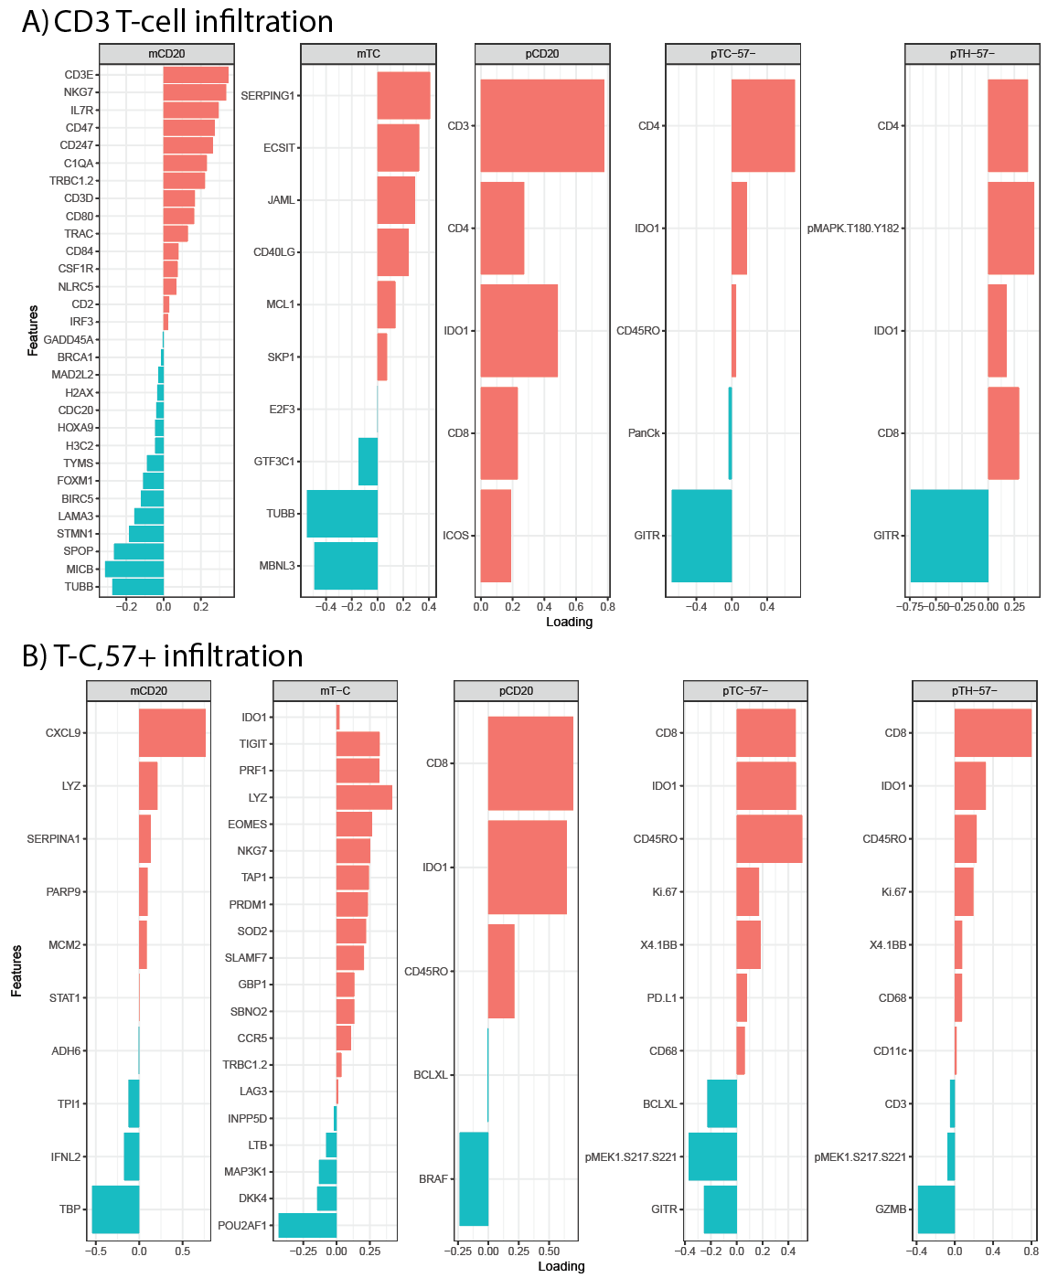
Figure S8: Multi-omics integration with respect to CD3 and T_{C,57+} infiltration. Bar plot of estimated loadings of omics-layer specific features for component-1 as identified by DIABLO data integration modelling for infiltration groups of A) CD3 frequency and B) T_{C,57+} infiltration.

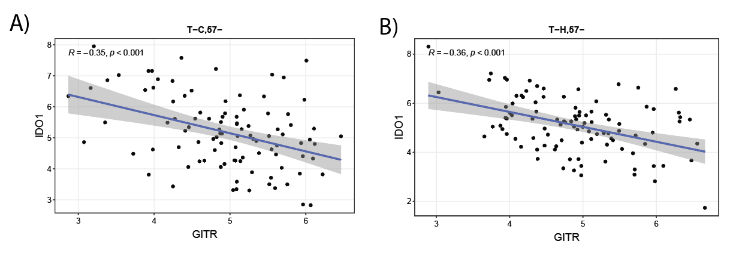
Figure S9: Spearman correlation of IDO1 -GITR. Analysis performed for infiltrating (tumor-rich) A) T_{C,57-} and B) T_{H,57-}, showing significant negative association between the two markers.

