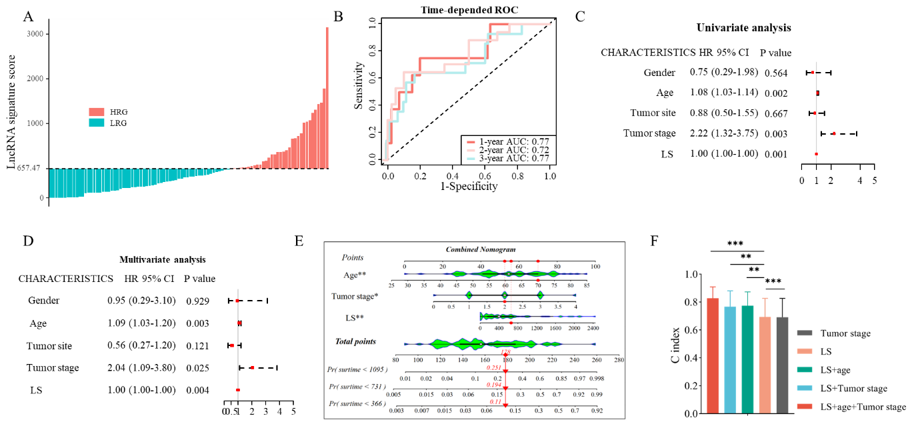
Figure S1. The lncRNA classifier performance and construction of nomogram
A. The lncRNA signature scores (LS scores) of the primary cohort. B. The time-depended ROC of LncRNA signature. C. The univariate analysis with clinical features. D. The multivariate analysis with clinical features. E. The nomogram based on age, lncRNA signature, and tumor stage. F. The C index of LS, age, and tumor stage.

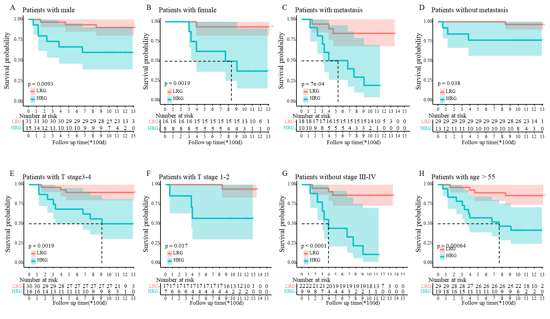
Figure S2. The survival differences between HRG and LRG with different clinical information.
A. The survival differences between HRG and LRG in male. B. The survival differences between HRG and LRG in female. C. The survival differences between HRG and LRG in patients with cancer metastasis. D. The survival differences between HRG and LRG in patients without cancer metastasis. E. The survival differences between HRG and LRG in patients with T stage 3-4. F. The survival differences between HRG and LRG in patients with T stage 1-2. G. The survival differences between HRG and LRG in patients without stage Ⅲ-Ⅳ. H. The survival differences between HRG and LRG in patients with age >55.

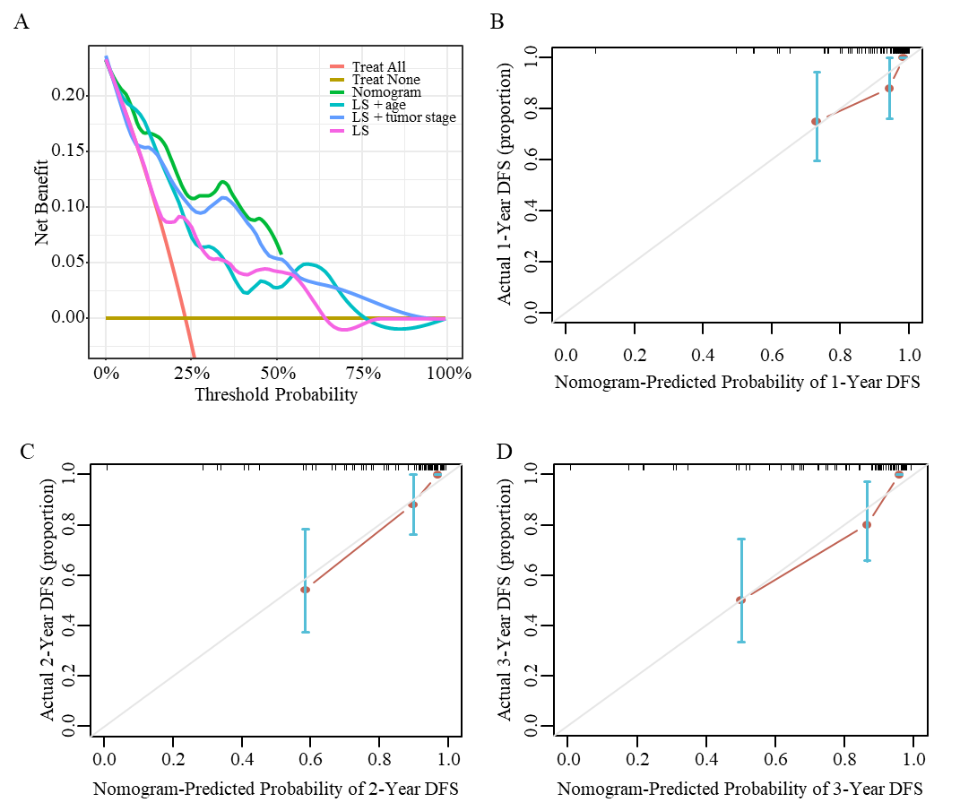
Figure S3. The performance of nomogram established by lncRNAs-related signature score, age and tumor stage.
A. The decision curve analysis of the nomogram. B-D. The calibration curve of 1-, 2-, 3-year of the nomogram.

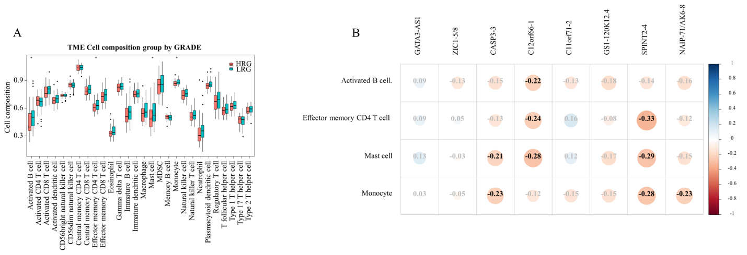
Figure S4. The immune analysis of lncRNAs-derived subtypes
A. The TME cell composition group by GRADE between LRG and HRG. B. The correlation between lncRNAs and immune cells.

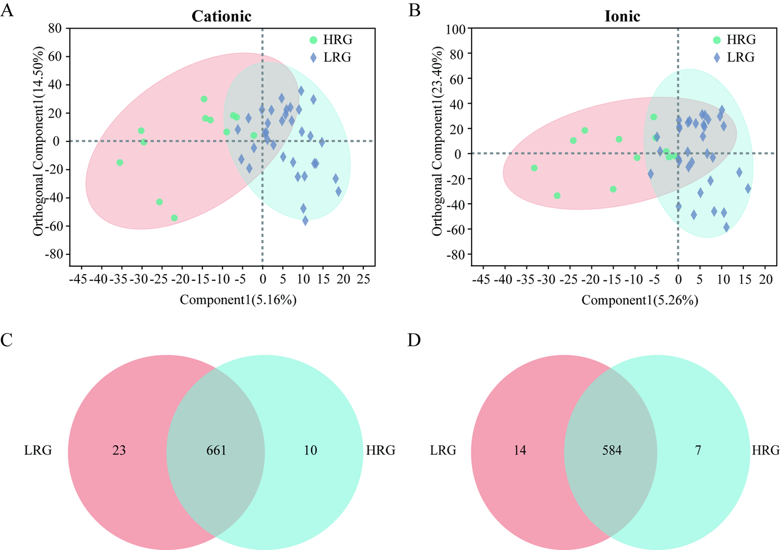
Figure S5. The differences of metabolomics between HRG group and LRG group.
A-B. The OPLS-DA between two groups using cationic and ionic metabolites, respectively. C-D. The Ven plot of two groups using cationic and ionic metabolites, respectively.

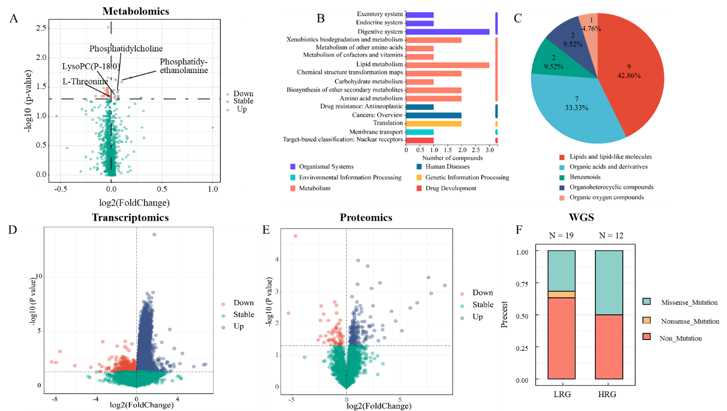
Figure S6. The different characteristics of multi-omics.
A. The volcano plot of significant different metabolites. B. The expression level of L-threonine, phosphatidylcholine, lysoPC and phosphatidylethanolamine. C. The compounds species (HMDB) of 23 metabolites. D. The volcano plot of significant different genes. E. The volcano plot of significant different proteins. F. The mutation precents of KRAS in LRG and HRG.

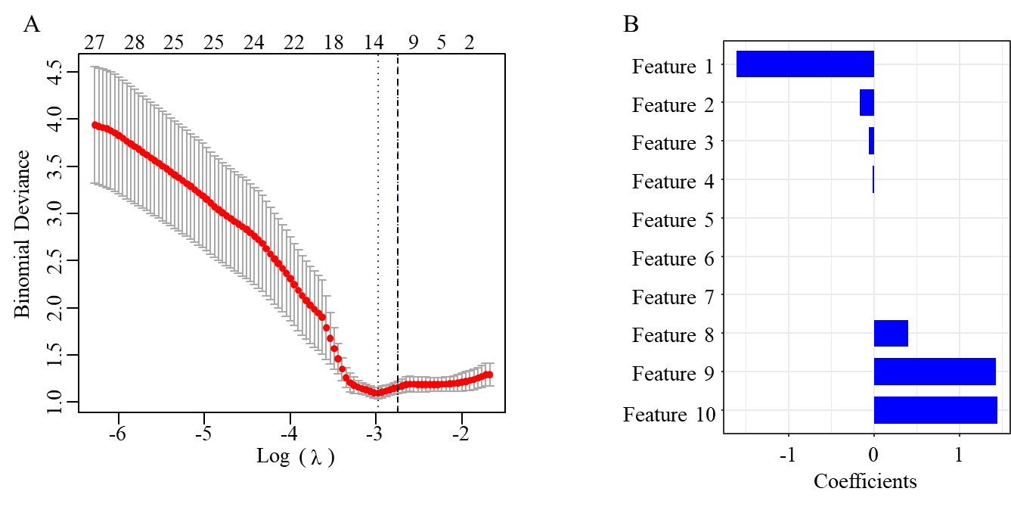
Figure S7. The variable screening process of radiomic prognosis modal based on LASSO analysis.
A. The coefficient of radiomic signature. B. The screening of radiomic signature.
Feature 1, wavelet.LLH_ngtdm_Strength. feature 2, wavelet.LLH_firstorder_Mean. feature 3, wavelet.LLH_firstorder_Median. feature 4, original_shape_Maximum2DDiameterColumn. feature 5, wavelet.LLH_glszm_LargeAreaLowGrayLevelEmphasis. feature 6, wavelet.HLL_glszm_LargeAreaLowGrayLevelEmphasis. feature 7, wavelet.HHH_glszm_LargeAreaHighGrayLevelEmphasis. feature 8, original_shape_Flatness. feature 9, wavelet.HHH_glszm_SmallAreaEmphasis. feature 10, wavelet.HLL_glcm_MCC. C. The AUC of radiomic prognosis modal.

Table S1. The characteristics of HRG and LRG
Characteristic | HRG  （N = 34） | LRG  （N = 62） | P
Age (y), mean±SD* | 60.91 ± 11.14 | 59.73 ± 12.06 | 0.6296
Gender |  |  | 1.0000
Male | 20 (58.82) | 37 (59.68)
Female | 14 (41.18) | 25 (40.32)
Tumor stages |  |  | 0.6262
0 | - | 4 (6.45)
Ⅰ | 9 (26.47) | 17 (27.42)
Ⅱ | 9 (26.47) | 17 (27.42)
Ⅲ | 13 (38.24) | 17 (27.42)
Ⅳ | 3 (8.82) | 7 (11.29)
Tumor sites |  |  | 0.0715
Rectum | 22 (64.71) | 43 (69.35)
Right colon | 9 (26.47) | 6 (9.68)
Left colon | 3 (8.82) | 5 (8.06)
Sigmoid colon | - | 6 (9.68)
Transverse colon | - | 2 (3.23)
The P of age: T test. The P of gender, tumor stage, tumor stage, metastatic: fisher’s exact test.

Table S2. The significant different metabolites in metabolomics
Metabolite | VIP_pred_OPLS-DA | VIP_PLS-DA | FC(HRG/LRG) | P (T test)
Aldosterone | 1.506936 | 2.099398 | 0.896087 | 0.04441
5-L-Glutamyl-taurine | 1.307565 | 1.525385 | 0.968463 | 0.04111
L-Methionine | 2.146008 | 1.387284 | 0.951062 | 0.04441
5,5-Dimethyl-2(5H)-furanone | 1.084752 | 1.56901 | 0.959557 | 0.03514
LysoPC(P-18:0) | 1.680635 | 1.209232 | 1.024859 | 0.04441
Tuberoside | 1.474175 | 1.653149 | 1.046343 | 0.04792
PE(15:0/18:1(11Z)) | 2.111489 | 2.783455 | 1.073296 | 0.02539
SM(d18:1/14:0) | 1.514235 | 1.459703 | 1.029234 | 0.02336
PC(14:0/20:4(5Z,8Z,11Z,14Z)) | 1.421839 | 1.22373 | 1.041509 | 0.03803
LysoPE(18:0/0:0) | 1.030498 | 1.158822 | 1.014955 | 0.03514
PGA1 | 1.47091 | 1.578497 | 0.967105 | 0.03245
Garcinia lactone dibutyl ester | 2.227115 | 2.530018 | 1.137123 | 0.02147
Stachyose | 2.21094 | 3.032409 | 1.225549 | 0.04792
L-Threonine | 1.241978 | 0.635114 | 0.988929 | 0.04792
Glutaminylproline | 1.337653 | 1.067345 | 0.971817 | 0.03803
P-cresol | 1.309935 | 0.7477 | 0.984327 | 0.04441
PC(18:3(9Z,12Z,15Z)/22:1(13Z)) | 1.785 | 1.561622 | 1.049161 | 0.04441
L-beta-aspartyl-L-threonine | 1.272961 | 0.69537 | 0.976718 | 0.03803
PG(18:0/22:4(7Z,10Z,13Z,16Z)) | 1.007626 | 1.089262 | 0.979278 | 0.02147
13(S)-HOTrE | 1.320072 | 1.025698 | 0.976473 | 0.03514
N-lactoyl-Leucine | 1.458551 | 0.990127 | 0.972041 | 0.04441
Benzaldehyde | 1.164843 | 0.709694 | 0.986883 | 0.04441
Kojic acid | 1.094916 | 1.096367 | 0.956052 | 0.04111

