The lung tissues from the young control group and the elderly model group were soft, butterfly-shaped, flexible, and pale red. However, the lung size of the elderly model macaques was larger than that of the young control visually.
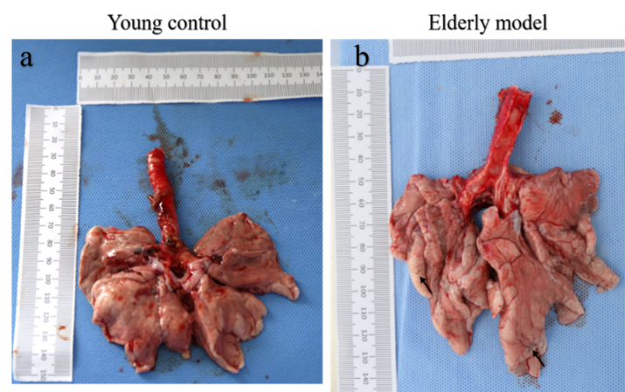
Fig Comparison of lung size between the young control group and the elderly model group. (a is the isolated lung of the macaques in the young control group, b is the isolated lung tissue of macaques of the elderly group)

