Examination of material from the lung tissue after 180 days of treatment, showed that the lung tissue appeared dark white and red without embolism. However, there were no significant changes observed in both the treatment group compared with the model group.
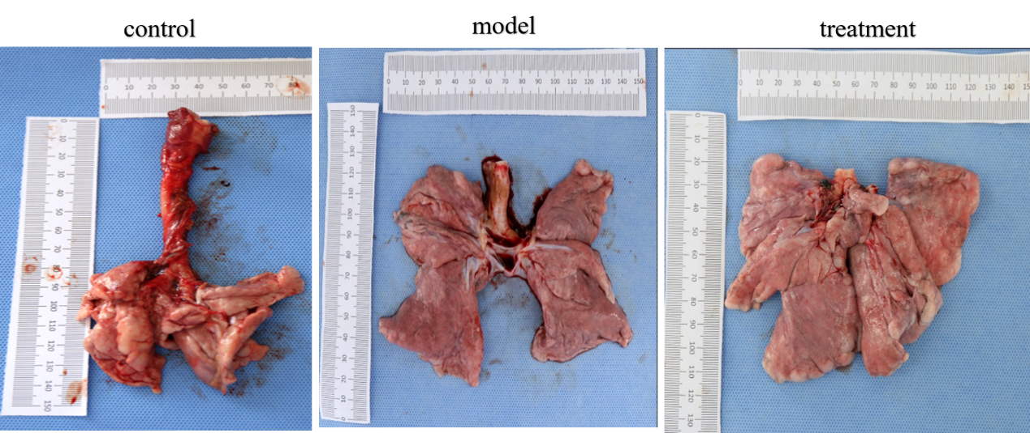
Fig Gross anatomical changes of lung tissue in elderly macaque after BMMSCS treatment

