The lung tissue of the young control group and the elderly model group were soft, butterfly-shaped, flexible, and pale red. However, when compared with the young control group, the lung size of the elderly model macaque was significantly larger than that of the young control.
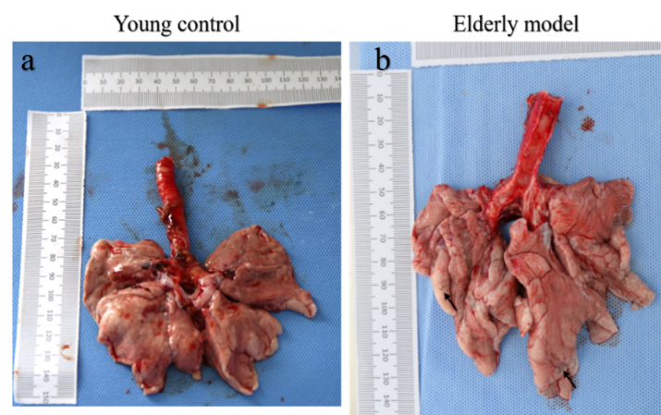
Fig Comparison of lung size between the young control group and the elderly model group.(a is the isolated lung of the macaques in young control group, b is the isolated lung tissue of the elderly group of macaque.)

