Supplementary material 2
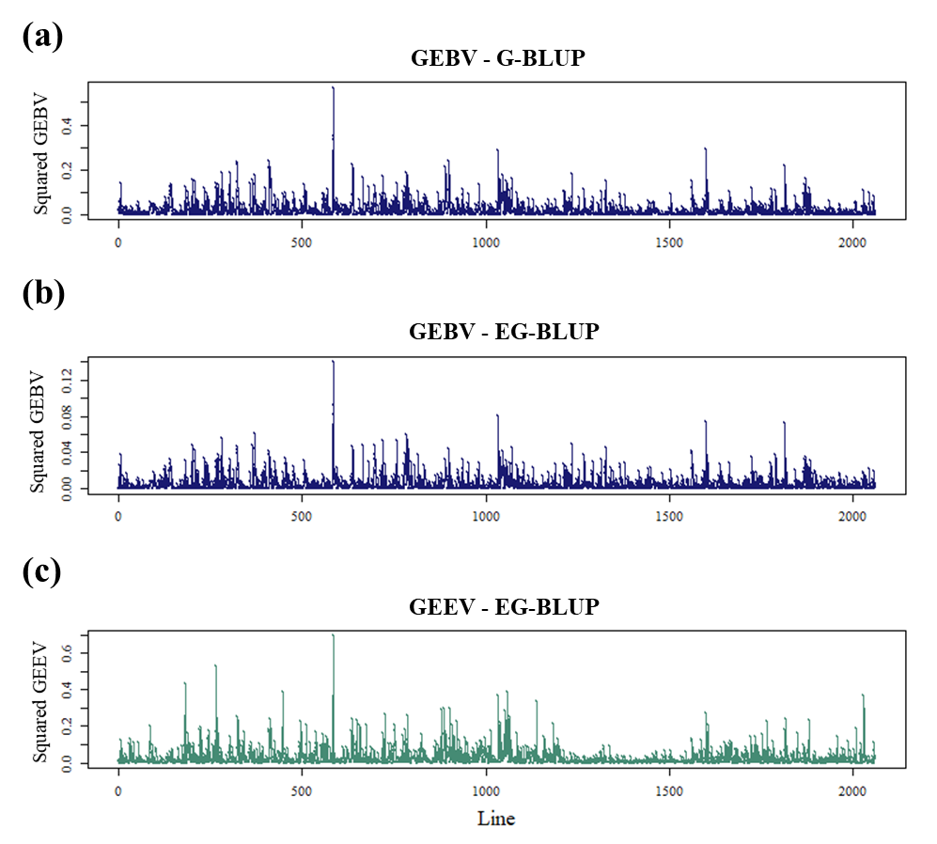
Figure S2. Squared estimated genomic values for genomic best linear unbiased prediction (G-BLUP) and extended genomic best linear unbiased prediction (EG-BLUP) models. (a) Squared Genomic Estimated Breeding Value (GEBVs) for G-BLUP model. (b) Squared Genomic Estimated Breeding Value (GEBVs) for EG-BLUP model. (c) Squared Genomic Estimated Breeding Epistatic (GEEVs) for EG-BLUP model.

