Tab.S1 Primer design in this paper
Name | Sequence (5’-3’)
ZT-F | GGATCTCCAGGCATCAAATAAAA
ZT-R | CGCTTGGACTCCTGTTGATAGAT
Str-F | TATCAACAGGAGTCCAAGCGGGTCTGACGCTCAGTGGAACG
Str-R | AAGCTTTCATGTGCAGCTCCATAAGCA
Tet-F | GGAGCTGCACATGAAAGCTTAAGACCCACTTTCACATTT
Tet-R | CCTGTTCCGCTCATCATATGTATATCTCCTTCTTACTCCTCTTTAG
MCR-F | CATATGATGAGCGGAACAGGACGACTG
MCR-R | TATTTGATGCCTGGAGATCCTTACACGGTAATCGCCCGTC
MCR-C-F | ACTAGTAAGGAGATATAATGAGCGCCACCACCGGCGCAC
MCR-N-R | TATATCTCCTTACTAGTTTAAATGTTGGCAGGGATGTTG
940-F | CGTGGTCAGTGGTGAGACATTCCACCC
940-R | TCTCACCACTGACCACGCGGTCGGCAAGGTAATAGA
1106-1114-F | TTGCCCTGAGTGATGGTGCCCGTCTCGCGCTGGTCACTCC
1106-1114-R | ACCATCACTCAGGGCAATCCAGCGCGCTACCCGGAAATG
pTargetF-ldhA-F | CTAGTCAACAGGTGAACGAGTCCTTGTTTTAGAGCTAGAAATAGC
pTargetF-ldhA-R | AAAACAAGGACTCGTTCACCTGTTGACTAGTATTATACCTAGGAC
pTargetF-poxB-F | CTAGTGGCAACCTGCACTTAATCAAGTTTTAGAGCTAGAAATAGC
pTargetF-poxB-R | AAAACTTGATTAAGTGCAGGTTGCCACTAGTATTATACCTAGGAC
pTargetF-pta-F | CTAGTCCTTGGCGTGATCCGTGCAAGTTTTAGAGCTAGAAATAGC
pTargetF-pta-R | AAAACTTGCACGGATCACGCCAAGGACTAGTATTATACCTAGGAC
ldhA up-F | GCATTACCCAACGGCAAACG
ldhA up-R | AGAAAGTCTTTCTTGCCGCTCCCCTGCAAC
ldhA down-F | AGCGGCAAGAAAGACTTTCTCCAGTGATGT
ldhA down-R | GTGTTAGGCAGCATGGACTG
ldhA test-F | GTAGTGAGCCTGTTCAGCAG
ldhA test-R | TTTCAAACGCGACGACATCC
poxB up-F | TTCAGTTCGCAGCCGTAAGC
poxB up-R | ATGGAGAACCAAAGGGTGGCATTTCCCGTC
poxB down-F | GCCACCCTTTGGTTCTCCATCTCCTGAATG
poxB down-R | TATCGCTGGTCGTCTCACTC
poxB test-F | GAATCCCGGACTGACGCATC
poxB test-R | CACGCCGATTATGTCGATGC
pta up-F | CGATCATCTTCCACCTGCAC
pta up-R | GATGACGAGAGGTTTATCCTCTTTCGTTAC
pta down-F | AGGATAAACCTCTCGTCATCATCCGCAGCT
pta down-R | CAATGGTTCCTGTACGCATC
pta test-F | GGCACCAGCCACTTCTATGT
pta test-R | CACCAGGACGGTGGTAATAC
ptazh-l-F | GCTATCCGCAACGGTAAATG
ptaP119-l-R | GCATTATACCTAGGACTGAGCTAGCTGTCAAGTTTATCCTCTTTCGTTACCG
accDA119-F | TCAGTCCTAGGTATAATGCTAGCCTTTAATAAGGAGATATACC
accDAzh-R | GATGACGAGAAATACGATTACTTTCTGTTCG
ptazh-r-F | TAATCGTATTTCTCGTCATCATCCGCAGCT
ptazh-r-R | GACGGCCTCTTCTCCCATAC
poxBzh-l-F-28 | GAACAAACAGCATATTAGTGTCCTGACG
poxB-CPA1-R | TTTTTGATAAAAAGGGTGGCATTTCCCGTC
CPA1-F-poxB | GCCACCCTTTTTATCAAAAAGAGTATTGAC
CPA1-R | TAAGATGGGGTATATCTCCTTCTTAAAAGATC
accBCCPA1-F | AGGAGATATACCCCATCTTAGTATATTAGTTAAG
accBC-R-poxBR | ATGGAGAACCATGCCTGGAGATCCTTACTC
poxB-r-F-accBC | CTCCAGGCATGGTTCTCCATCTCCTGAATG
poxBzh-r-R-29 | CTGCGACGATAAAGCAGAAGATAAATTCC

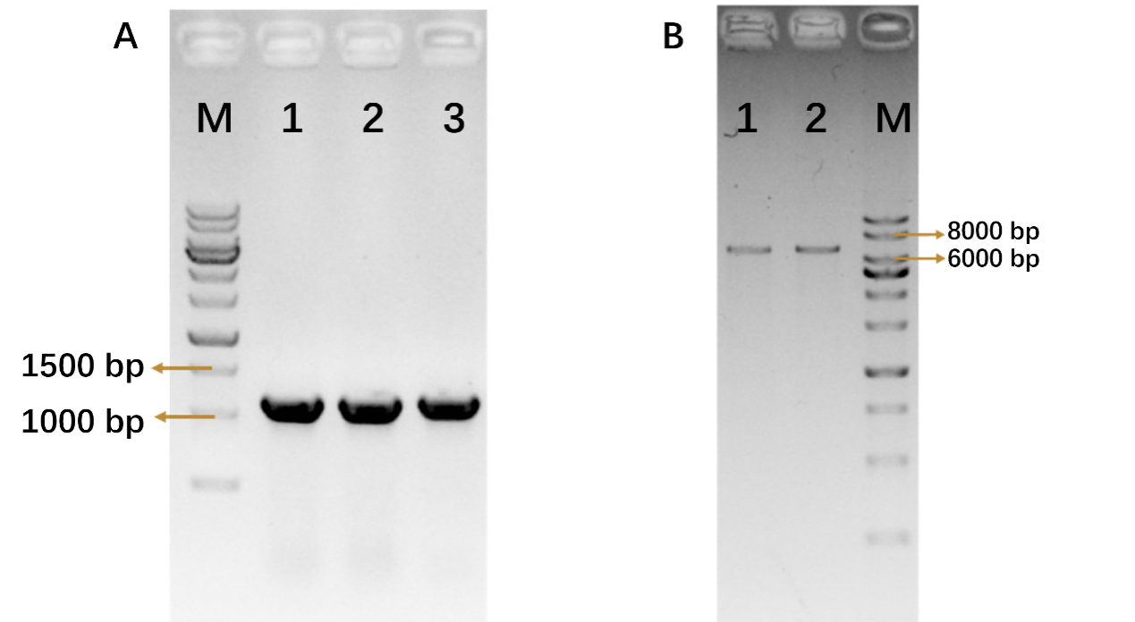
Fig.S1 Validation of plasmid pA2s-mcr by digestion and colony PCR. (A)PCR verification of single colony pA2s-mcr M: 1 kb ladder; 1/2/3: Str; (B) Digestion verification of recombinant plasmid pA2s-mcr. M: 1 kb ladder; 1: digest with HindIII; 2: digest with EcoRI

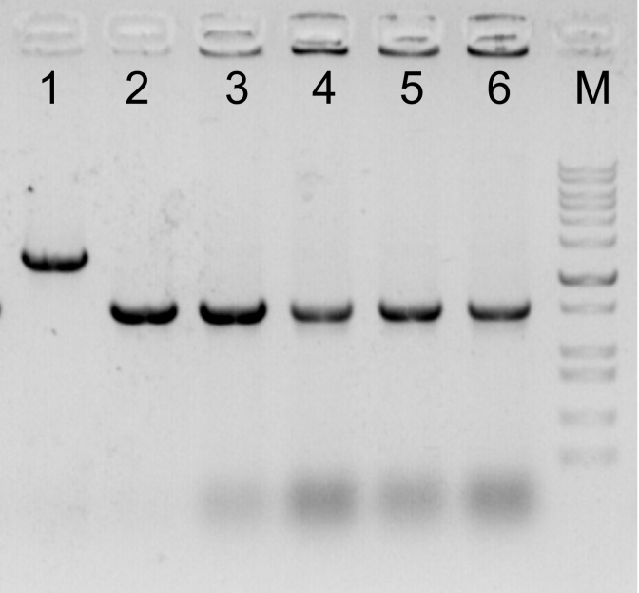
Fig.S2 Deletion of ldhA/pta/poxB sequences with CRISPR-Cas9 system. a PCR confirmation of the deletion of redundant sequences. The decrescent bands indicated the successful deletion of genes. M: DNA marker. 1: strain without deletion of ldhA. 2: colonies from the plate after deleting ldhA. 3,4: colonies from the plate after deleting pta. 5,6: colonies from the plate after deleting poxB.

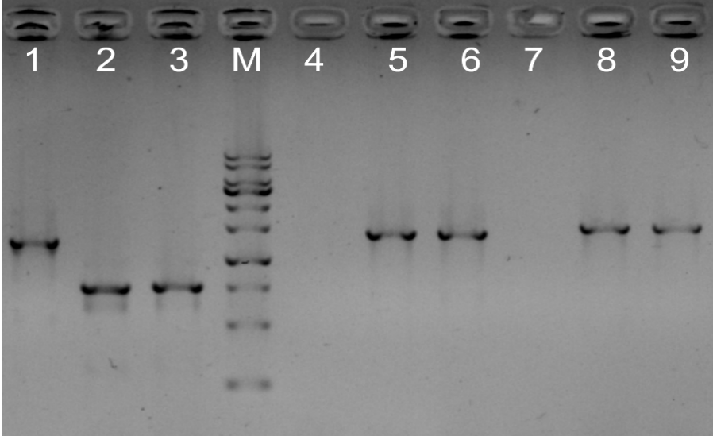
Fig.S3 Gel image of colony PCR results to check successfully edited strain Q1Z2. The same bands as the positive control or the decrescent bands indicated the successful edition of E. coli genome sequences. M: DNA marker. 1,4,7: strain without edition of genome sequences. 2,3:the sequence at ldhA site of strain Q1Z2. 5: positive control of pta integration site. 6: the sequence at pta site of strain Q1Z2. 8: positive control of poxB integration site. 9: the sequence at poxB site of strain Q1Z2.

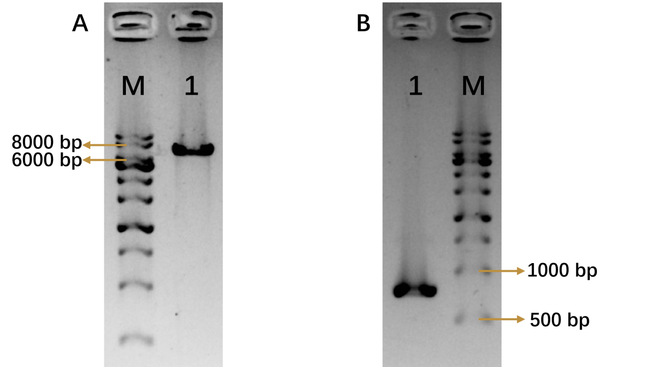
Fig. S4 Validation of plasmid pYB-0055-mcherry-CmR by digestion and colony PCR. (A) Digestion verification of recombinant plasmid pYB-0055-mcherry-CmR. M: 1 kb ladder; 1: digest with EcoRI; (B) PCR verification of single colony pYB-0055-mcherry-CmR. M: 1 kb ladder; 1: mcherry.

