Supporting information for

A novel fluorescent probe for nitroreductase detection and imaging of cancer cells under hypoxia conditions
Tong Sun¹, Lei Wu², Mengyuan Cui³, Guisen Zhao¹
¹ Department of Medicinal Chemistry, School of Pharmaceutical Sciences, Cheeloo College of Medicine, Shandong University, Jinan 250012, China
² Department of Biomedical Engineering, School of Engineering, China Pharmaceutical University, Nanjing 210009, China
³ School of Biological Science and Medical Engineering, Southeast University, Nanjing 210009, China
Corresponding email: guisenzhao@sdu.edu.cn

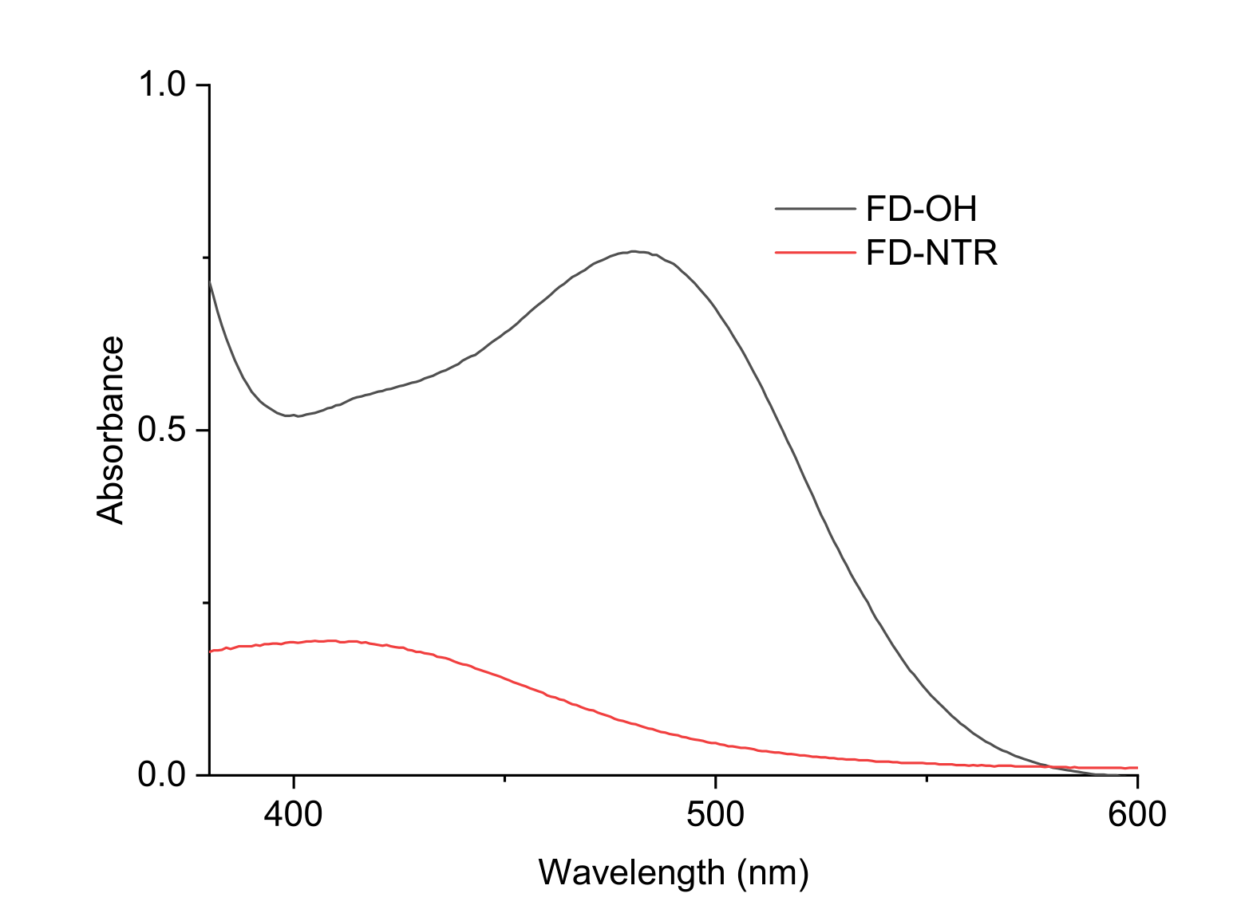
Figure S1. Absorption of probe FD-NTR (80 μM) and fluorophore FD-OH (80 μM) in DMSO/PBS solution.

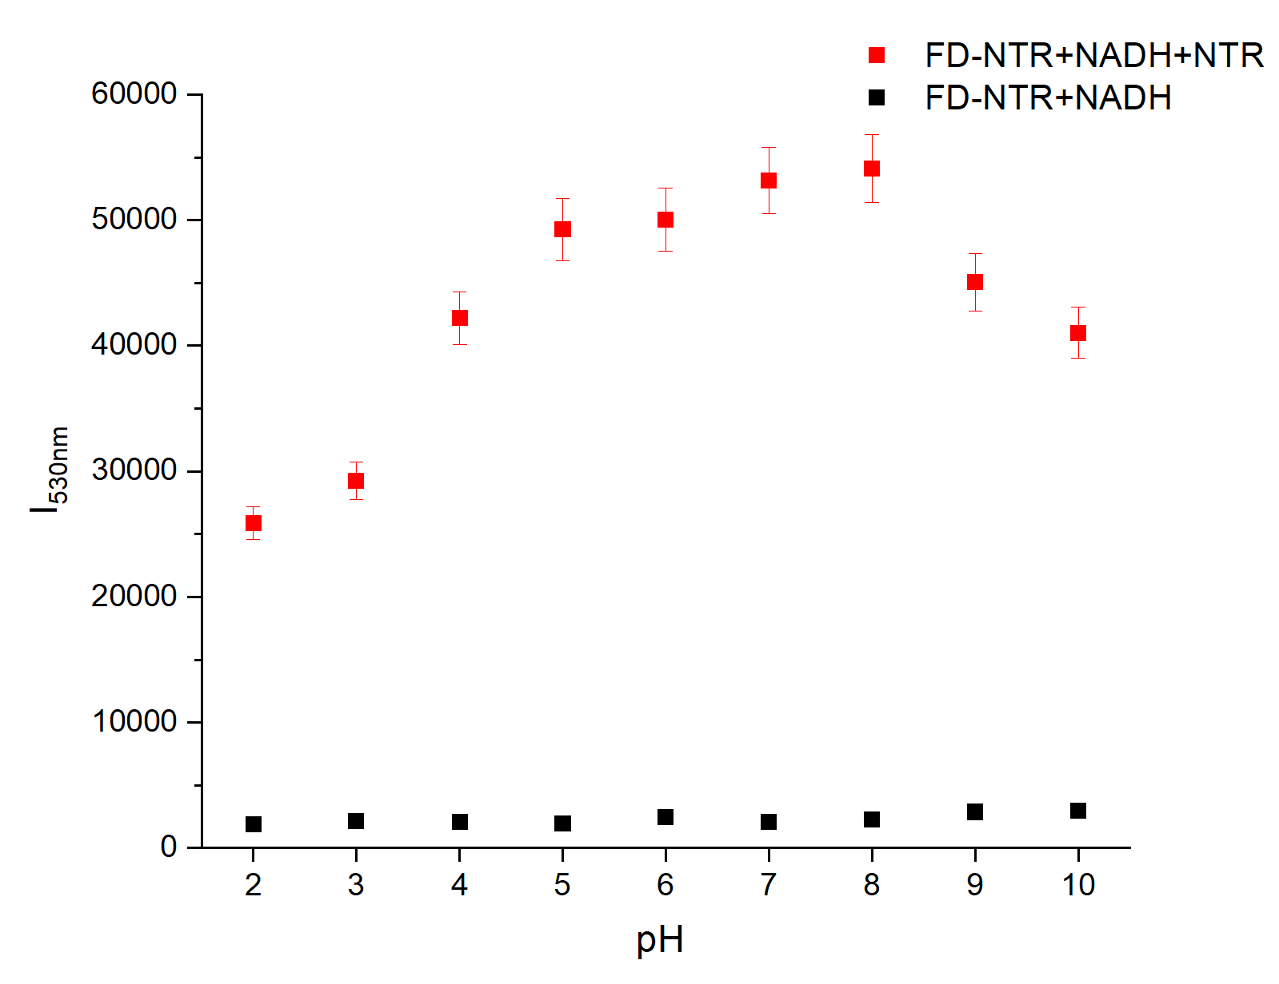
Figure S2 Fluorescence intensity of probe FD-NTR (10 μM) with/without NTR (5 μg/mL) at different pH. λ_{ex} =480 nm
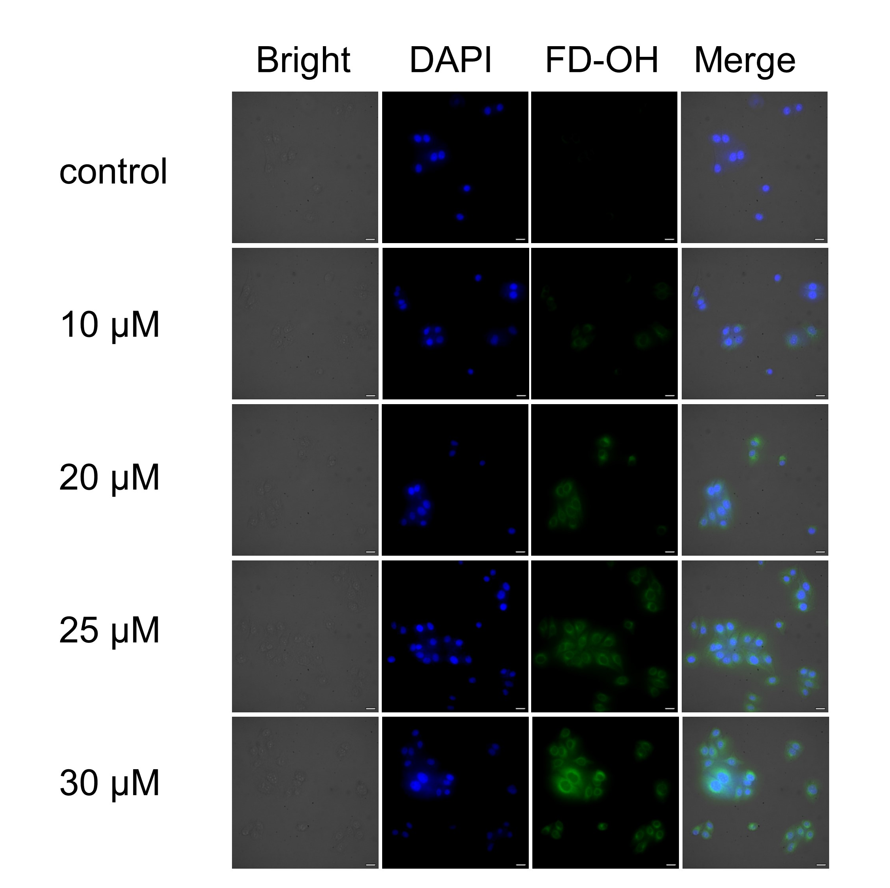
Figure S3. Fluorescence imaging of NTR in MCF-7 living cells incubated with different concentrations of FD-NTR.

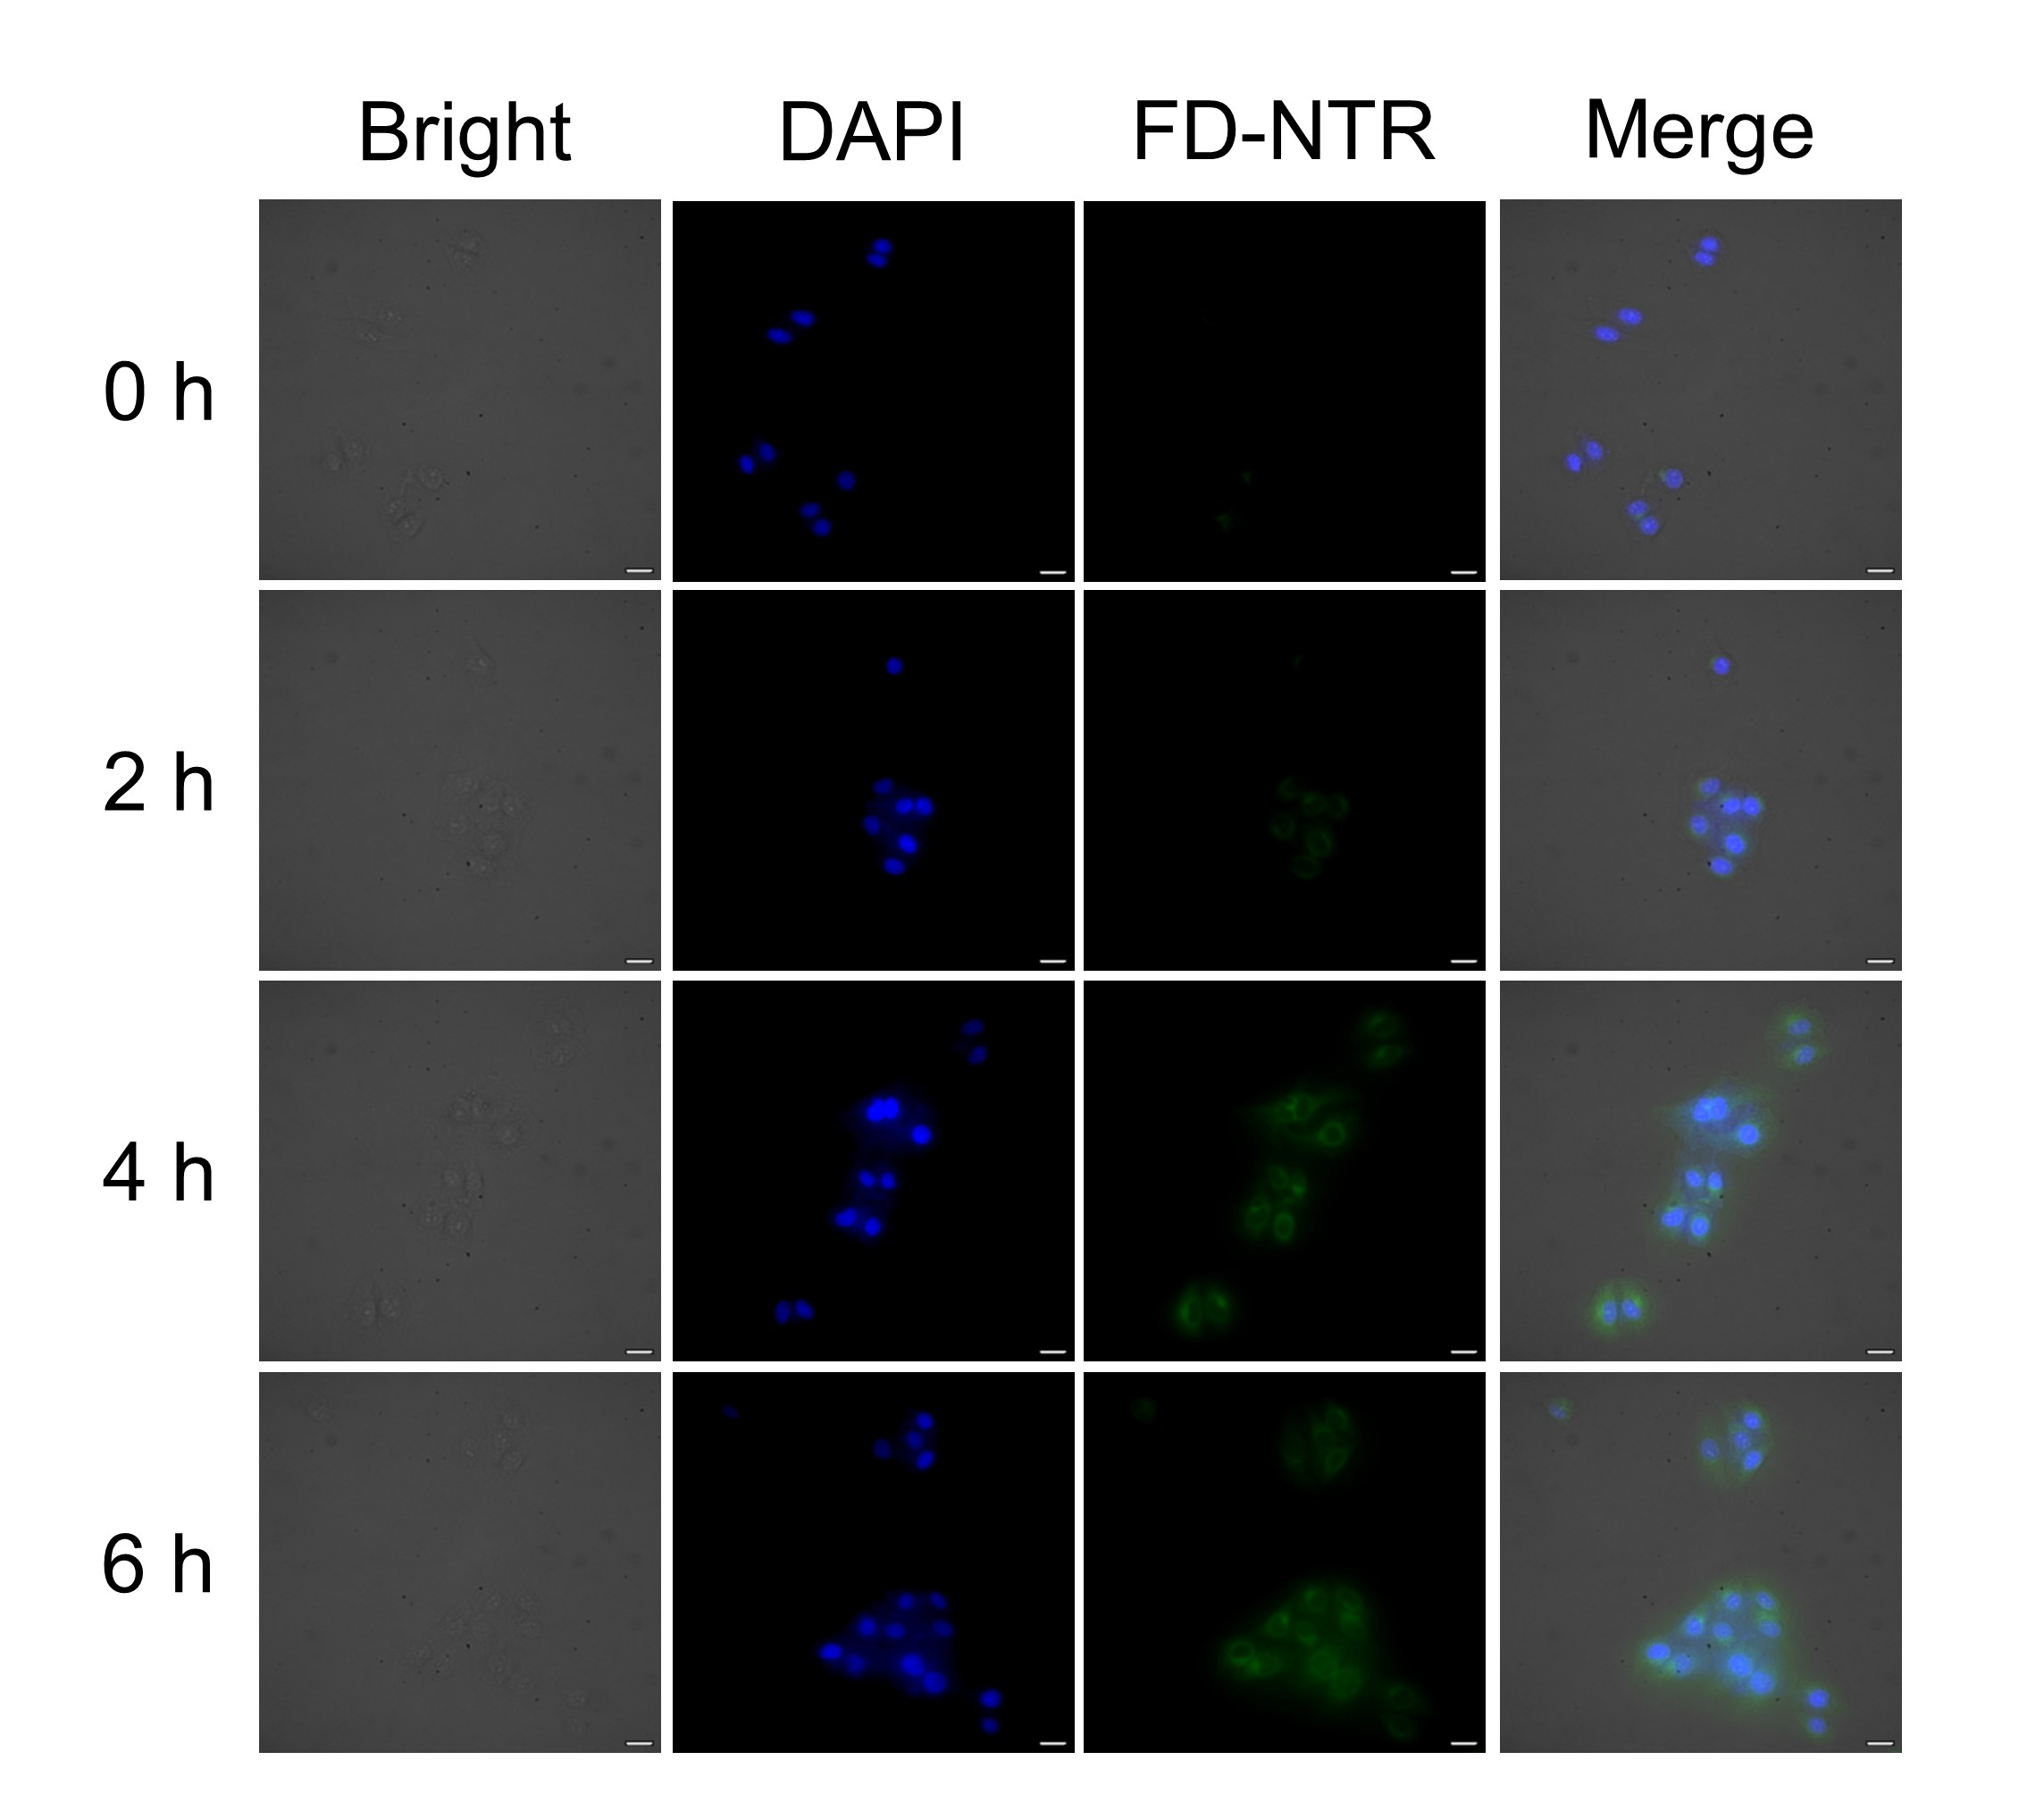
Figure S4. Fluorescence imaging of NTR in the living MCF-7 cells under different time conditions.
Figure S5. ¹H NMR spectrum of FD-OH

Figure S6. ¹³C NMR spectrum of FD-OH

Figure S7. ¹H NMR spectrum of FD-NTR

Figure S8. ¹³C NMR spectrum of FD-NTR

