Supplementary Material
A ratiometric fluorescence probe based on silver nanoclusters and CdSe/ZnS quantum dots for the detection of hydrogen peroxide by aggregation and etching

Yuanyuan Zhang#, Xin Zhang#, Hedan Xu#, Sitian Zhao, Zirui Yang, Zijie Pi, Xiaoling Yang, Xiaoling Liao*

Chongqing Engineering Laboratory of Nano/Micro Biomedical Detection, Chongqing Key Laboratory of Nano/Micro Composite Materials and Devices, Chongqing University of Science and Technology, No. 20 East road, University town, Chongqing 401331, P. R. China

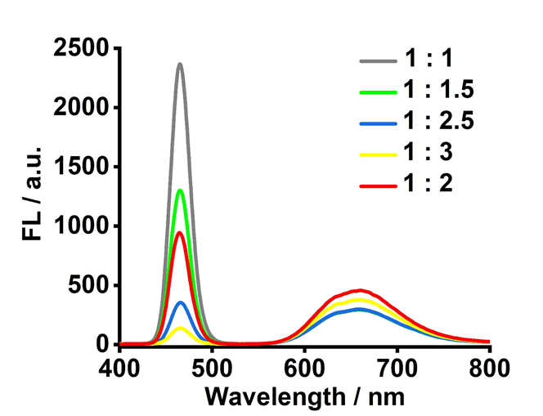
Fig. S1 Emission spectra of AgNCs-QDs at the volume ratios of CdSe/ZnS QDs to AgNCs is 1:3, 1:2.5, 1:2, 1:1.5, to 1:1.

Fig. S2 The stability of AgNCs-QDs in aqueous solution stored at low temperature (about 4 °C) for about 50 days.

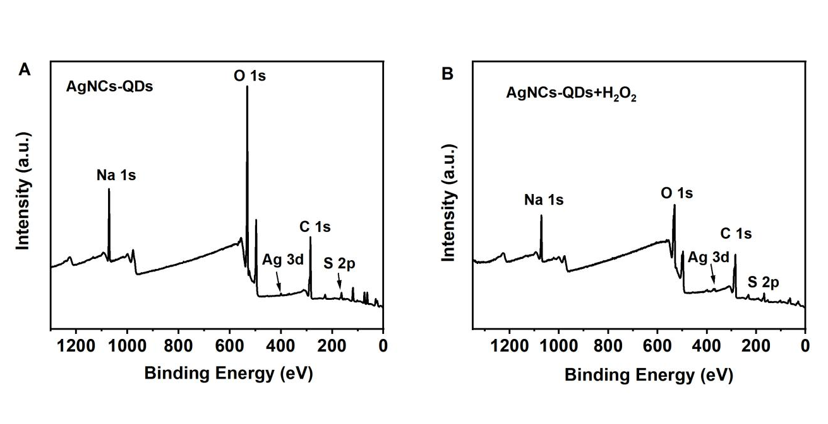
Fig. S3 XPS survey spectrum of AgNCs-QDs (A) and AgNCs-QDs + H₂O₂ (B).
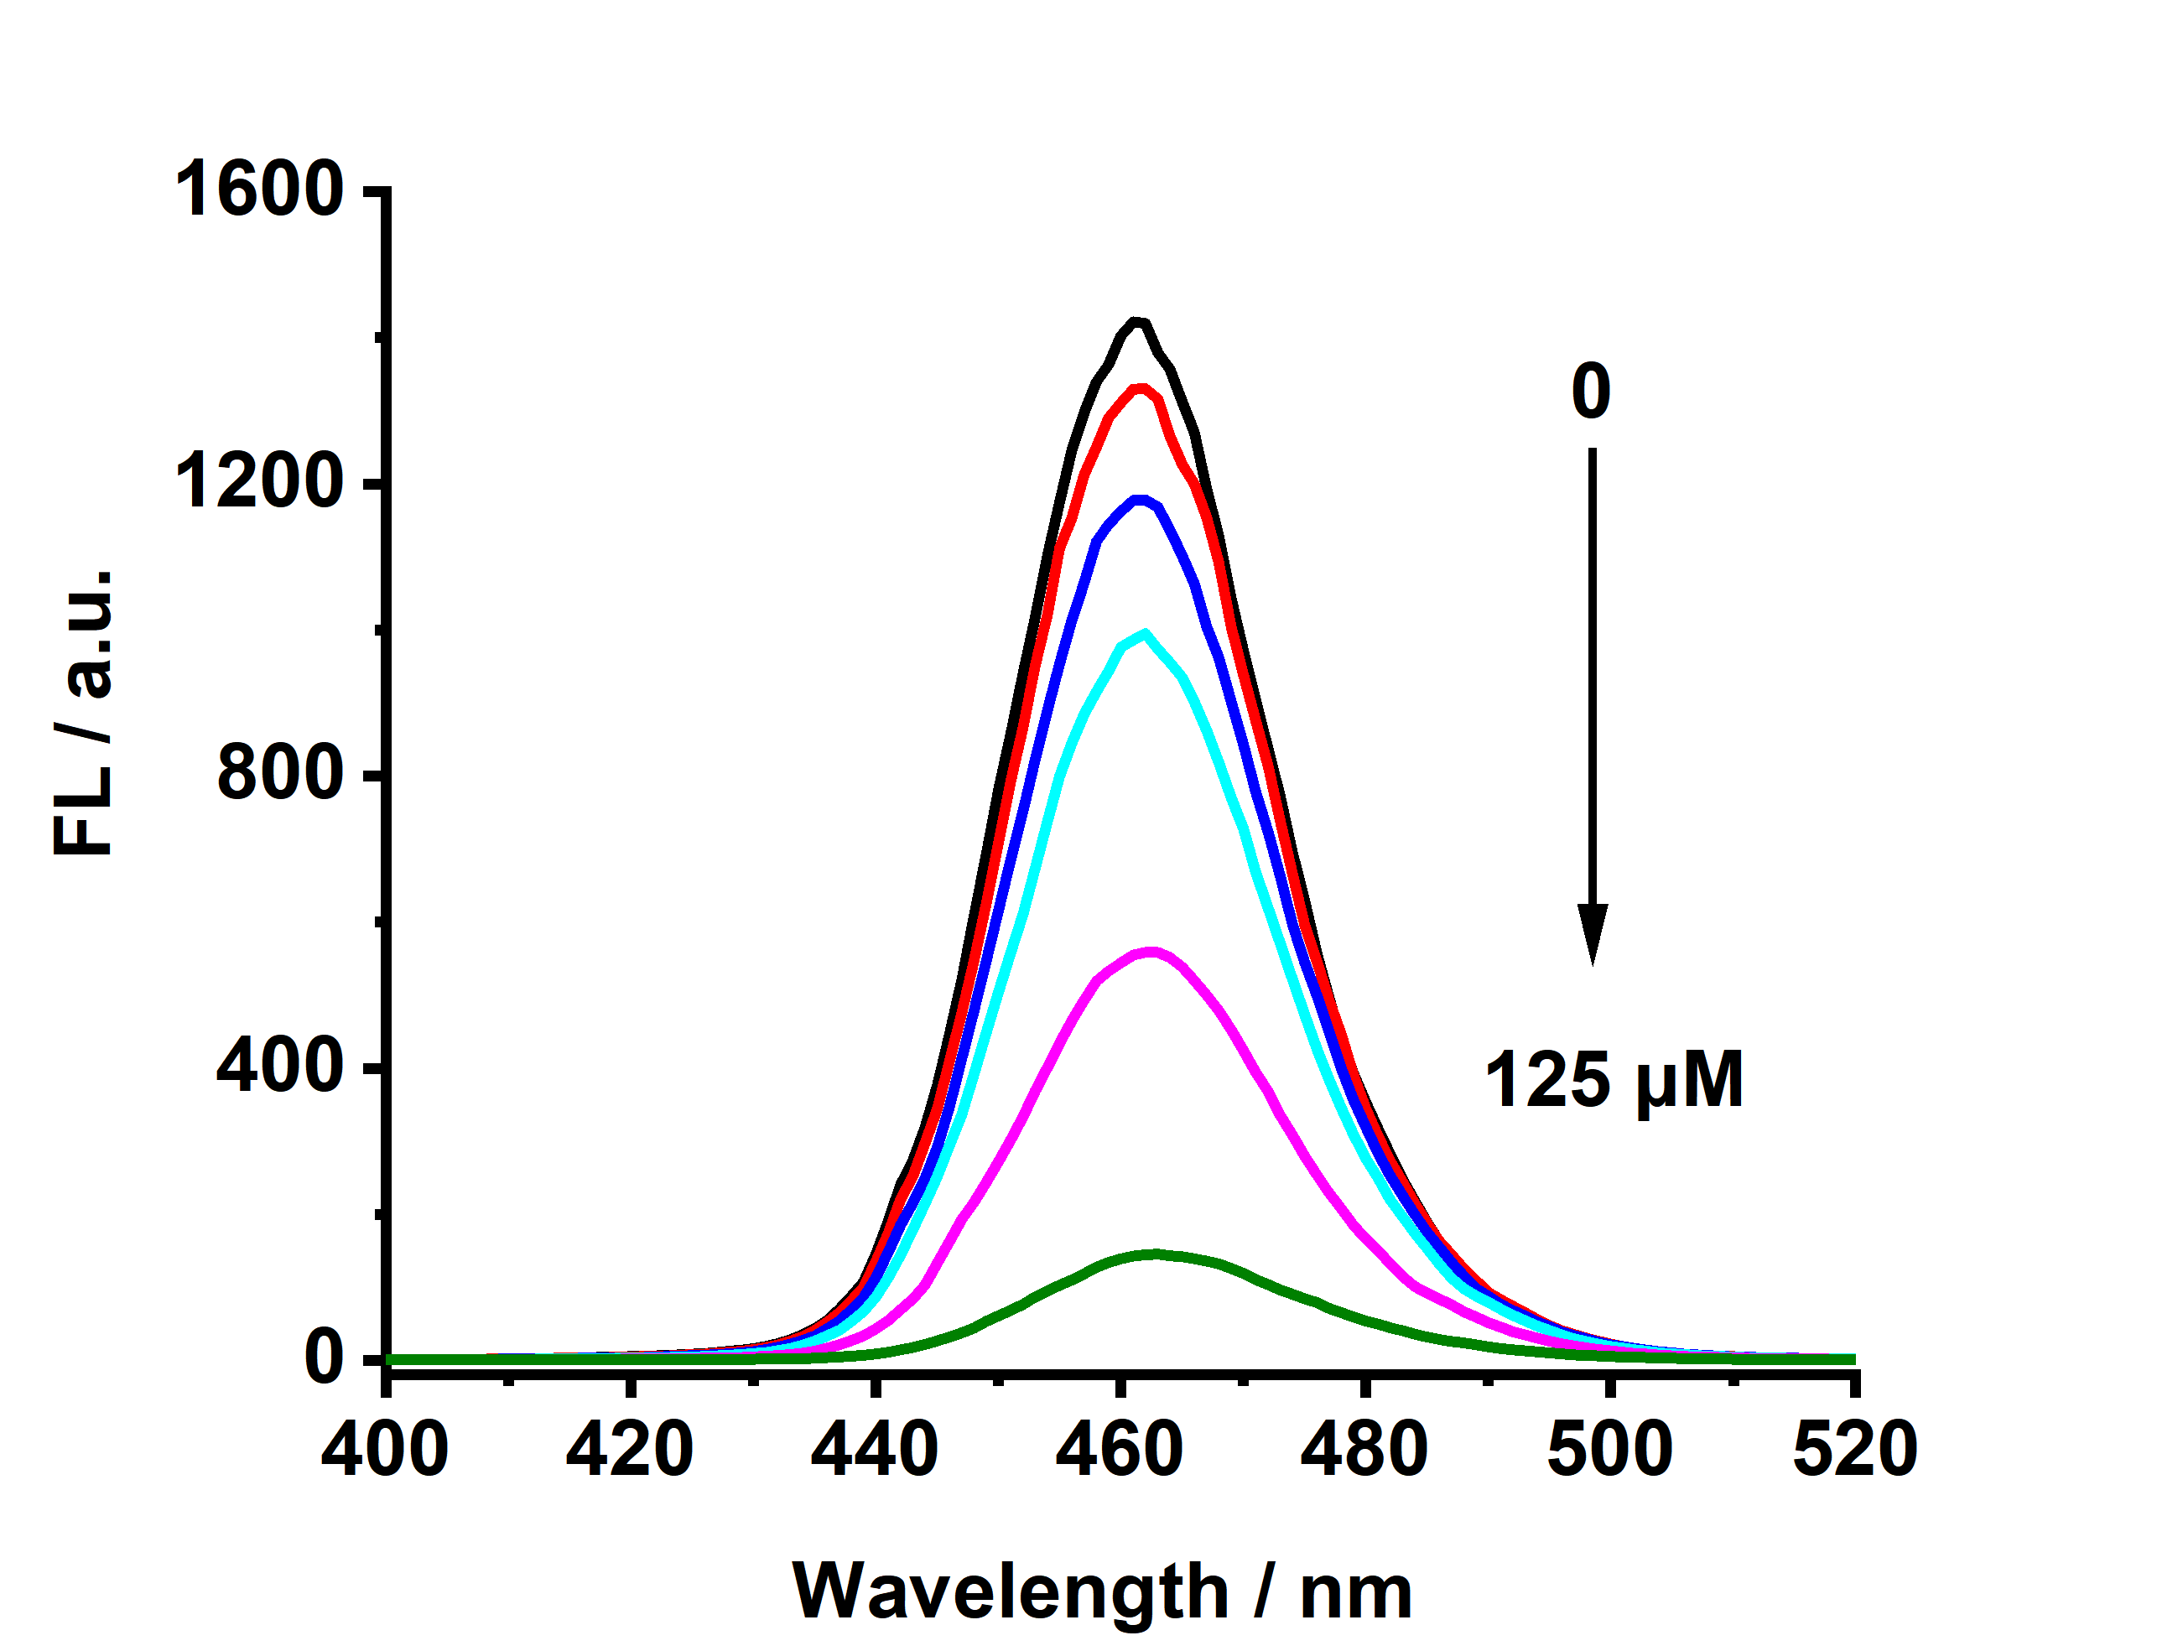
Fig. S4 Response of AgNCs-QDs to different concentrations of Ag⁺
Fig. S5 Fluorescence decay as a function of time of AgNCs-QDs and AgNCs-QDs + H₂O₂. (The concentration of H₂O₂ was 1.50 mM).

Table S1 The fluorescence lifetimes of AgNCs-QDs and AgNCs-QDs + H₂O₂
Sample | τ₁, B₁ | τ₂, B₂ | Lifetime (ns)
AgNCs-QDs | 0.8234, 36.75% | 3.9988, 63.25% | 2.83 ± 0.07
AgNCs-QDs + H₂O₂ | 0.9469, 34.86% | 4.3552, 65.14% | 3.17 ± 0.07
B₁, B₂ are the relative amplitude of τ₁, τ₂.

