Structural insights into the binding of nanobodies LaM2 and LaM4 to the red fluorescent protein mCherry
Ziying Wang¹, Long Li², Rongting Hu², Peiyu Zhong¹, Yiran Zhang¹, Shihao Cheng¹, Rui Liu¹, Yu Ding^{1#}

Supplementary data
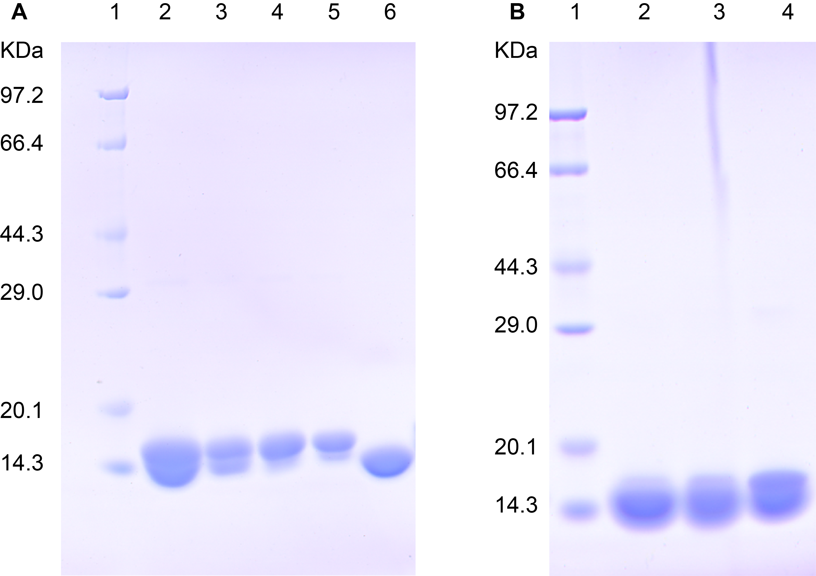
Figure S1 Expression and purification of LaM2, LaM4 and their mutants. A. Purification of LaM2 and corresponding mutants. 1. Marker, 2. LaM2, 3. LaM2_S44A, 4. LaM2_S68A, 5. LaM2_W119A/Y120A; B. Purification of LaM4 and corresponding mutants. 1. Marker, 2. LaM4, 3. LaM2_N104K, 4. LaM4_N109K.

Table S1.
The sequence of the primers used to generate LaM2 and LaM4 related mutants：
LaM2 variant | Sequence(5’3’) | Direction
S44A | cctttgccgattatgcaatgggttggtttcg | Forward
S44A | gtgcaaccagcggttttacctttgccgatta | Reverse
S68A | gttgcagcaattagctgggcaggtcatgttacc | Forward
S68A | gcaattagctgggcaggtcatgttaccgattat | Reverse
W109AY110A | gcaaaaagcggcacctgggcggctcagcgtagcgaa | Forward
W109AY110A | agcggcacctgggcggctcagcgtagcgaaaatgat | Reverse

LaM4 variant | Sequence(5’3’) | Direction
N104K | ggtaagtatattagcagcaatcagcgcctg | Forward
N104K | gtattattgtgcagccaatctgggtaagtatattagc | Reverse
N109K | gcagcaagcagcgcctgtatggttattg | Forward
N109K | ctgggtaactatattagcagcaagcagcgc | Reverse

Sequence alignment of LaM2 and the mutants:
LaM2S68A SAQVQLVESGGGLVQAGGSLRLSCATSGFTFSDYAMGWFRQAPGKEREFVAAISWAGHVT 72
LaM2 SAQVQLVESGGGLVQAGGSLRLSCATSGFTFSDYAMGWFRQAPGKEREFVAAISWSGHVT 72
LaM2S44A SAQVQLVESGGGLVQAGGSLRLSCATSGFTFADYAMGWFRQAPGKEREFVAAISWSGHVT 72
LaM2WY SAQVQLVESGGGLVQAGGSLRLSCATSGFTFSDYAMGWFRQAPGKEREFVAAISWSGHVT 72
LaM2S44AWY SAQVQLVESGGGLVQAGGSLRLSCATSGFTFADYAMGWFRQAPGKEREFVAAISWSGHVT 72
*******************************:***********************:****

LaM2S68A DYADSVKGRFTISRDNVKNTVYLQMNSLKPEDTAVYSCAAAKSGTWWYQRSENDFGSWGQ 132
LaM2 DYADSVKGRFTISRDNVKNTVYLQMNSLKPEDTAVYSCAAAKSGTWWYQRSENDFGSWGQ 132
LaM2S44A DYADSVKGRFTISRDNVKNTVYLQMNSLKPEDTAVYSCAAAKSGTWWYQRSENDFGSWGQ 132
LaM2WY DYADSVKGRFTISRDNVKNTVYLQMNSLKPEDTAVYSCAAAKSGTWAAQRSENDFGSWGQ 132
LaM2S44AWY DYADSVKGRFTISRDNVKNTVYLQMNSLKPEDTAVYSCAAAKSGTWAAQRSENDFGSWGQ 132
********************************************** ************

LaM2S68A GTQVTVS 139
LaM2 GTQVTVS 139
LaM2S44A GTQVTVS 139
LaM2WY GTQVTVS 139
LaM2S44AWY GTQVTVS 139
*******

Sequence alignment of LaM4 and the mutants:
LaM4N109K GAQVQLVESGGSLVQPGGSLRLSCAASGRFAESSSMGWFRQAPGKEREFVAAISWSGGAT 60
LaM4N104K GAQVQLVESGGSLVQPGGSLRLSCAASGRFAESSSMGWFRQAPGKEREFVAAISWSGGAT 60
LaM4 GAQVQLVESGGSLVQPGGSLRLSCAASGRFAESSSMGWFRQAPGKEREFVAAISWSGGAT 60
************************************************************

LaM4N109K NYADSAKGRFTLSRDNTKNTVYLQMNSLKPDDTAVYYCAANLGNYISSKQRLYGYWGQGT 120
LaM4N104K NYADSAKGRFTLSRDNTKNTVYLQMNSLKPDDTAVYYCAANLGKYISSNQRLYGYWGQGT 120
LaM4 NYADSAKGRFTLSRDNTKNTVYLQMNSLKPDDTAVYYCAANLGNYISSNQRLYGYWGQGT 120
*******************************************:****:***********

LaM4N109K QVTVSSPFTLE 131
LaM4N104K QVTVSSPFTLE 131
LaM4 QVTVSSPFTLE 131
***********

