 | GROUP 1 (N=96) | GROUP 2 (N=98)
Proportion of female:male students (%) | 69.5: 30.5 | 65.8:35.2
Proportion of 1st: 2nd: 3rd: 4th year students (%) | 1.7: 62.6: 10.4: 25.2 | 1.9: 60.8: 10.3: 26.2
Proportion of concentrations (%)  (undeclared: life science: physical science: humanities/social science) | 27.0: 54.8: 9.6: 8.7 | 29.3: 55.7: 9.4: 5.7
Table S1A. Demographic factors of groups 1 and 2.
Table S1A. Gender, year, and concentration proportions for groups 1 and 2.

Table S1B. Descriptive statistics for groups 1 and 2.
 | GROUP 1 (N=96) |  | GROUP 2 (N=98)
 | Mean | SD | Mean | SD | t | df | p
FCI pre-test score (0-30) | 13.3 | 6.8 | 15.2 | 8.7 | -1.09 | 188 | 0.28
Midterm Score (%) | 81.1 | 14.7 | 83.1 | 14.1 | -0.96 | 189 | 0.33
Table S1B. Pre-semester scores on the Force Concept Inventory and the first midterm exam for groups 1 and 2.

Table S2. Two-lesson crossover design.
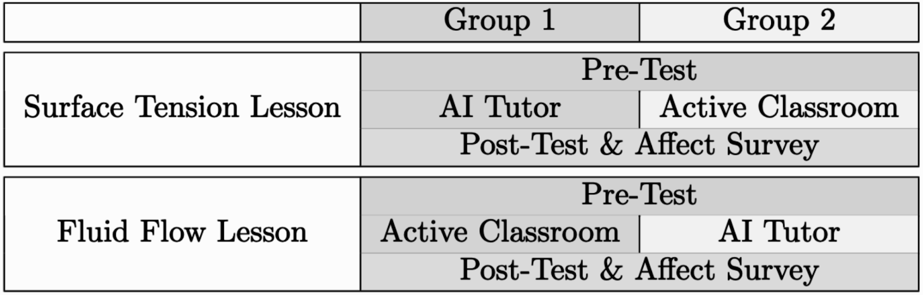
Table S2. Workflow for groups 1 and 2 during each of two lessons. Cross-over design ensures each student experiences both the experimental and control condition once.

Fig. S1. AI tutor system.
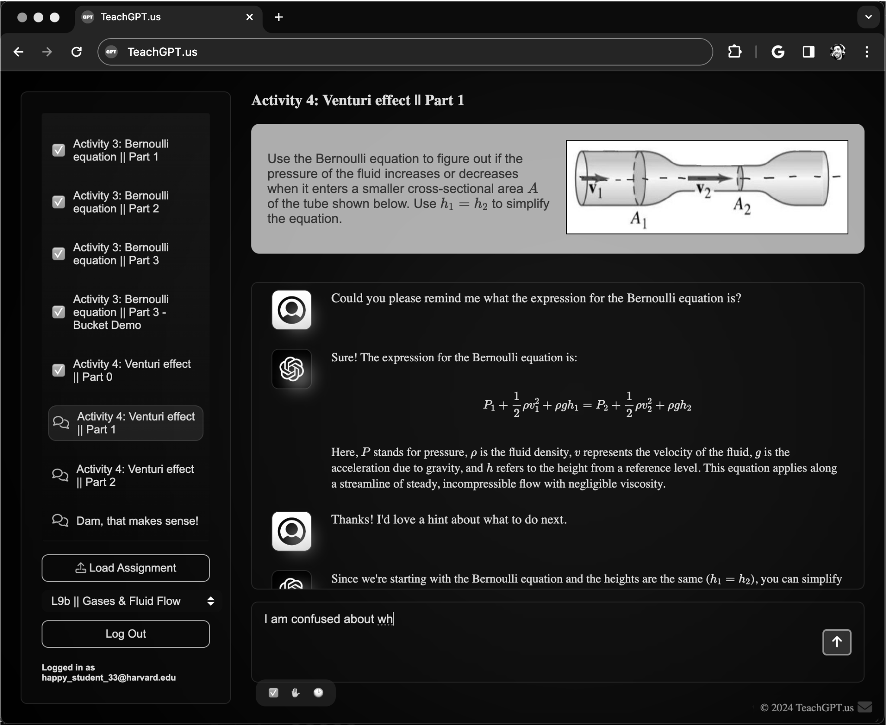
Fig. S1. The customized AI tutor system students used during the experimental condition. Question statement appears at the top. Student input and AI tutor feedback appear below.

