Supplementary tables
Supplementary Table S1. Taxonomic composition relative abundances in each of the sample type, gut region, and dietary regime. See https://github.com/marwa38/NP_intesParts_ampliseq to download.
Supplementary Table S2. Core microbiota taxa of gut across different gut regions and dietary regimes. Taxa were considered core when present in at least 80% of individuals at a minimum of 0.1% relative abundance and arranged taxonomically as Kingdom, Phylum, Class, Order, Family, Genus and where possible Species.
Group | Core taxa
Group | ASV | Kingdom | Phylum | Class | Order | Family | Genus | Species
Pyloric, middle, & distal (MMV & VMV) | ASV1  ASV13 | Bacteria  Bacteria | Firmicutes  Proteobacteria | Clostridia  Gammaproteobacteria | Oscillospirales  Pseudomonadales | Ruminococcaceae  Pseudomonadaceae | NA  Pseudomonas | NA  NA
MMV (all gut regions) | ASV1  ASV13 | Bacteria  Bacteria | Firmicutes  Proteobacteria | Clostridia  Gammaproteobacteria | Oscillospirales  Pseudomonadales | Ruminococcaceae  Pseudomonadaceae | NA  Pseudomonas | NA  NA
VMV (all gut regions) | ASV1 | Bacteria | Firmicutes | Clostridia | Oscillospirales | Ruminococcaceae | NA | NA
Pyloric MMV & VMV | ASV1  ASV9  ASV13 | Bacteria  Bacteria  Bacteria | Firmicutes  Proteobacteria  Proteobacteria | Clostridia  Gammaproteobacteria  Gammaproteobacteria | Oscillospirales  Enterobacterales  Pseudomonadales | Ruminococcaceae  Enterobacteriaceae  Pseudomonadaceae | NA  Escherichia-Shigella  Pseudomonas | NA  NA  NA
Pyloric MMV | ASV1  ASV13 | Bacteria  Bacteria | Firmicutes  Proteobacteria | Clostridia  Gammaproteobacteria | Oscillospirales  Pseudomonadales | Ruminococcaceae  Pseudomonadaceae | NA  Pseudomonas | NA  NA
Pyloric VMV | ASV1  ASV9  ASV13  ASV78  ASV94 | Bacteria  Bacteria  Bacteria  Bacteria  Bacteria | Firmicutes  Proteobacteria  Proteobacteria  Proteobacteria  Proteobacteria | Clostridia  Gammaproteobacteria  Gammaproteobacteria  Gammaproteobacteria  Gammaproteobacteria | Oscillospirales  Enterobacterales  Pseudomonadales  Enterobacterales  Pseudomonadales | Ruminococcaceae  Enterobacteriaceae  Pseudomonadaceae  Yersiniaceae  Pseudomonadaceae | NA  Escherichia-Shigella  Pseudomonas  Yersinia  Pseudomonas | NA  NA  NA  NA  NA
Middle MMV &/or VMV | ASV1  ASV13 | Bacteria  Bacteria | Firmicutes  Proteobacteria | Clostridia  Gammaproteobacteria | Oscillospirales  Pseudomonadales | Ruminococcaceae  Pseudomonadaceae | NA  Pseudomonas | NA  NA
Distal MMV & VMV | ASV1 | Bacteria | Firmicutes | Clostridia | Oscillospirales | Ruminococcaceae | NA | NA
Distal MMV | ASV1  ASV13 | Bacteria  Bacteria | Firmicutes  Proteobacteria | Clostridia  Gammaproteobacteria | Oscillospirales  Pseudomonadales | Ruminococcaceae  Pseudomonadaceae | NA  Pseudomonas | NA  NA
Distal VMV | ASV1 | Bacteria | Firmicutes | Clostridia | Oscillospirales | Ruminococcaceae | NA | NA
Pyloric & middle (MMV or VMV) | ASV1  ASV13 | Bacteria  Bacteria | Firmicutes  Proteobacteria | Clostridia  Gammaproteobacteria | Oscillospirales  Pseudomonadales | Ruminococcaceae  Pseudomonadaceae | NA  Pseudomonas | NA  NA
MMV middle & distal | ASV1  ASV13 | Bacteria  Bacteria | Firmicutes  Proteobacteria | Clostridia  Gammaproteobacteria | Oscillospirales  Pseudomonadales | Ruminococcaceae  Pseudomonadaceae | NA  Pseudomonas | NA  NA
VMV middle & distal | ASV1 | Bacteria | Firmicutes | Clostridia | Oscillospirales | Ruminococcaceae | NA | NA
MMV distal & pyloric | ASV1  ASV13 | Bacteria  Bacteria | Firmicutes  Proteobacteria | Clostridia  Gammaproteobacteria | Oscillospirales  Pseudomonadales | Ruminococcaceae  Pseudomonadaceae | NA  Pseudomonas | NA  NA
VMV distal & pyloric | ASV1 | Bacteria | Firmicutes | Clostridia | Oscillospirales | Ruminococcaceae | NA | NA

Supplementary Table S3. Relative abundance (in %) of top 15 microbiota in pyloric caeca at the genus level mapped up to phylum level and grouped by dietary regimes where the table is divided into two by the double borders between MMV and VMV. Error! Reference source not found. shows complete list of microbiota. Proteo: Protobacteria, Actino: Actinobacteriota, Firm: Firmicutes, and Bactero: Bacteroidota.
Phylum | Class | Family | Genus | MMV | VMV | Genus | Family | Class | Phylum
Firm | Clostridia | Ruminococcaceae | NA | 49 | 48 | NA | Ruminococcaceae | Clostridia | Firm
Proteo | Gammaproteobacteria | Pseudomonadaceae | Pseudomonas | 24 | 21.1 | Pseudomonas | Pseudomonadaceae | Gammaproteobacteria | Proteo
Proteo | Gammaproteobacteria | Moraxellaceae | Acinetobacter | 3.5 | 3.27 | Enterobacter | Enterobacteriaceae | Gammaproteobacteria | Proteo
Actino | Actinobacteria | Micrococcaceae | Kocuria | 2.6 | 3.07 | Acinetobacter | Moraxellaceae | Gammaproteobacteria | Proteo
Proteo | Gammaproteobacteria | Yersiniaceae | Yersinia | 2.3 | 2.27 | Stenotrophomonas | Xanthomonadaceae | Gammaproteobacteria | Proteo
Proteo | Alphaproteobacteria | Sphingomonadaceae | Sphingomonas | 1.8 | 1.4 | Yersinia | Yersiniaceae | Gammaproteobacteria | Proteo
Proteo | Gammaproteobacteria | Xanthomonadaceae | Stenotrophomonas | 1.7 | 1.27 | Paeniclostridium | Peptostreptococcaceae | Clostridia | Firm
Proteo | Gammaproteobacteria | Enterobacteriaceae | Escherichia-Shigella | 1.7 | 1.25 | Staphylococcus | Staphylococcaceae | Bacilli | Firm
Firm | Bacilli | Staphylococcaceae | Staphylococcus | 1 | 1.21 | Sphingomonas | Sphingomonadaceae | Alphaproteobacteria | Proteo
Proteo | Gammaproteobacteria | Yersiniaceae | NA | 0.8 | 1.2 | Cutibacterium | Propionibacteriaceae | Actinobacteria | Actino
Proteo | Gammaproteobacteria | Enterobacteriaceae | Enterobacter | 0.8 | 1.16 | NA | Enterobacteriaceae | Gammaproteobacteria | Proteo
Bactero | Bacteroidia | Weeksellaceae | Chryseobacterium | 0.7 | 1.09 | Escherichia-Shigella | Enterobacteriaceae | Gammaproteobacteria | Proteo
Firm | Bacilli | Carnobacteriaceae | Carnobacterium | 0.6 | 0.75 | Streptococcus | Streptococcaceae | Bacilli | Firm
Proteo | Gammaproteobacteria | Comamonadaceae | Comamonas | 0.6 | 0.62 | Carnobacterium | Carnobacteriaceae | Bacilli | Firm
Proteo | Gammaproteobacteria | Enterobacteriaceae | NA | 0.5 | 0.62 | Flavobacterium | Flavobacteriaceae | Bacteroidia | Bactero

Supplementary Table S4. Relative abundance (in %) of top 15 microbiota in middle intestine at the genus level mapped up to phylum level and grouped by dietary regimes where the table is divided into two by the double borders between MMV and VMV. Error! Reference source not found. shows complete list of microbiota. Proteo: Protobacteria, Actino: Actinobacteriota, Firm: Firmicutes, and Bactero: Bacteroidota.
Phylum | Class | Family | Genus | MMV | VMV | Genus | Family | Class | Phylum
Firm | Clostridia | Ruminococcaceae | NA | 59.7 | 57.2 | NA | Ruminococcaceae | Clostridia | Firm
Proteo | Gammaproteobacteria | Pseudomonadaceae | Pseudomonas | 14.3 | 17.3 | Pseudomonas | Pseudomonadaceae | Gammaproteobacteria | Proteo
Firm | Bacilli | Lactobacillaceae | Lactobacillus | 3.77 | 7.2 | Enterococcus | Enterococcaceae | Bacilli | Firm
Firm | Bacilli | Enterococcaceae | Enterococcus | 3.08 | 1.51 | Yersinia | Yersiniaceae | Gammaproteobacteria | Proteo
Actino | Actinobacteria | Micrococcaceae | Kocuria | 1.86 | 1.05 | Lactobacillus | Lactobacillaceae | Bacilli | Firm
Actino | Actinobacteria | Corynebacteriaceae | Corynebacterium | 1.19 | 0.88 | Escherichia-Shigella | Enterobacteriaceae | Gammaproteobacteria | Proteo
Proteo | Gammaproteobacteria | Yersiniaceae | Yersinia | 1.07 | 0.86 | Flavobacterium | Flavobacteriaceae | Bacteroidia | Bactero
Bacter | Bacteroidia | Weeksellaceae | NA | 0.82 | 0.83 | Cutibacterium | Propionibacteriaceae | Actinobacteria | Actino
Proteo | Gammaproteobacteria | Moraxellaceae | Enhydrobacter | 0.71 | 0.79 | Staphylococcus | Staphylococcaceae | Bacilli | Firm
Proteo | Gammaproteobacteria | Enterobacteriaceae | Escherichia-Shigella | 0.69 | 0.76 | Corynebacterium | Corynebacteriaceae | Actinobacteria | Actino
Actino | Actinobacteria | Propionibacteriaceae | Cutibacterium | 0.65 | 0.56 | Pseudorhodobacter | Rhodobacteraceae | Alphaproteobacteria | Proteo
Firm | Bacilli | Staphylococcaceae | Staphylococcus | 0.61 | 0.34 | Sphingomonas | Sphingomonadaceae | Alphaproteobacteria | Proteo
Actino | Actinobacteria | Microbacteriaceae | NA | 0.58 | 0.33 | NA | Microtrichaceae | Acidimicrobiia | Actino
Proteo | Alphaproteobacteria | Sphingomonadaceae | Sphingomonas | 0.5 | 0.33 | Serratia | Yersiniaceae | Gammaproteobacteria | Proteo
Firm | Bacilli | Carnobacteriaceae | Carnobacterium | 0.45 | 0.3 | Reyranella | Reyranellaceae | Alphaproteobacteria | Proteo

Supplementary Table S5. Relative abundance (in %) of top 15 microbiota in distal intestine at the genus level mapped up to phylum level and grouped by dietary regimes where the table is divided into two by the double borders between MMV and VMV. Error! Reference source not found. shows complete list of microbiota. Proteo: Protobacteria, Actino: Actinobacteriota, Firm: Firmicutes, and Bactero: Bacteroidota.
Phylum | Order | Family | Genus | MMV | VMV | Genus | Family | Order | Phylum
Firm | Oscillospirales | Ruminococcaceae | NA | 64.3 | 66.5 | NA | Ruminococcaceae | Oscillospirales | Firm
Proteo | Pseudomonadales | Pseudomonadaceae | Pseudomonas | 12.4 | 8.23 | Pseudomonas | Pseudomonadaceae | Pseudomonadales | Proteo
Firm | Lactobacillales | Lactobacillaceae | Lactobacillus | 6.74 | 5.86 | Aeromonas | Aeromonadaceae | Aeromonadales | Proteo
Proteo | Aeromonadales | Aeromonadaceae | Aeromonas | 5.77 | 5.39 | Lactobacillus | Lactobacillaceae | Lactobacillales | Firm
Firm | Lactobacillales | Enterococcaceae | Enterococcus | 3.61 | 3.46 | Enterococcus | Enterococcaceae | Lactobacillales | Firm
Proteo | Enterobacterales | Yersiniaceae | Yersinia | 0.71 | 1 | Arthrobacter | Micrococcaceae | Micrococcales | Actino
Actino | Micrococcales | Micrococcaceae | Kocuria | 0.53 | 0.85 | NA | Weeksellaceae | Flavobacteriales | Bactero
Firm | Lactobacillales | Leuconostocaceae | Leuconostoc | 0.47 | 0.73 | Yersinia | Yersiniaceae | Enterobacterales | Proteo
Proteo | Enterobacterales | Enterobacteriaceae | Escherichia-Shigella | 0.42 | 0.54 | Corynebacterium | Corynebacteriaceae | Corynebacteriales | Actino
Proteo | Sphingomonadales | Sphingomonadaceae | Sphingomonas | 0.38 | 0.4 | Escherichia-Shigella | Enterobacteriaceae | Enterobacterales | Proteo
Firm | Staphylococcales | Staphylococcaceae | Staphylococcus | 0.38 | 0.35 | Massilia | Oxalobacteraceae | Burkholderiales | Proteo
Actino | Propionibacteriales | Propionibacteriaceae | Cutibacterium | 0.25 | 0.31 | Staphylococcus | Staphylococcaceae | Staphylococcales | Firm
Firm | Lactobacillales | Streptococcaceae | Lactococcus | 0.24 | 0.31 | Bacillus | Bacillaceae | Bacillales | Firm
Actino | Micrococcales | Micrococcaceae | Pseudarthrobacter | 0.18 | 0.29 | Veillonella | Veillonellaceae | Veillonellales-Selenomonadales | Firm
Proteo | Enterobacterales | Yersiniaceae | NA | 0.15 | 0.26 | Leuconostoc | Leuconostocaceae | Lactobacillales | Firm

Supplementary Table S6. Relative abundance of significantly different (MWW-tested and BH-corrected) taxa between gut regions. RA: relative abundance, p.adj: adjusted p-values. Statistical significance strength is represented by * (p<0.05), ** (p<0.01) and *** (p<0.001) on pairwise comparisons.
taxa | RA | group1 | group2 | RA | p.adj
Pseudomonadaceae | 21.1 | pyloric.VMV | distal.VMV | 8.23 | *
Enterobacteriaceae | 5.58 | pyloric.VMV | distal.VMV | 0.41 | **
Acinetobacter | 3.07 | pyloric.VMV | distal.VMV | 0.12 | ***
Acinetobacter | 3.07 | pyloric.VMV | middle.VMV | 0.22 | **

Supplementary Table S7. Relative abundance (in %) of top 15 microbiota in feed at the genus level mapped up to Phylum level and grouped by dietary regimes where the table is divided into two by the double borders between M and V. Error! Reference source not found. shows complete list of microbiota. Proteo: Protobacteria, Actino: Actinobacteriota, Firm: Firmicutes, and Bactero: Bacteroidota, Fuso: Fusobacteriota.
Phylum | Class | Family | Genus | M | V | Genus | Family | Class | Phylum
Firm | Bacilli | Lactobacillaceae | Lactobacillus | 43.3 | 64 | Lactobacillus | Lactobacillaceae | Bacilli | Firm
Proteo | Gammaproteobacteria | Vibrionaceae | Photobacterium | 19.3 | 8.2 | NA | Bifidobacteriaceae | Actinobacteria | Actino
Actino | Actinobacteria | Bifidobacteriaceae | NA | 4.14 | 7.3 | Lactococcus | Streptococcaceae | Bacilli | Firm
Firm | Bacilli | Streptococcaceae | Lactococcus | 4.03 | 6.8 | Leuconostoc | Leuconostocaceae | Bacilli | Firm
Firm | Bacilli | Lactobacillaceae | Pediococcus | 3.8 | 5.7 | Pediococcus | Lactobacillaceae | Bacilli | Firm
Firm | Bacilli | Leuconostocaceae | Leuconostoc | 3.51 | 1.2 | Weissella | Leuconostocaceae | Bacilli | Firm
Fuso | Fusobacteriia | Fusobacteriaceae | Fusobacterium | 1.79 | 1 | Photobacterium | Vibrionaceae | Gammaproteobacteria | Proteo
Firm | Bacilli | Streptococcaceae | Streptococcus | 1.59 | 0.6 | Streptococcus | Streptococcaceae | Bacilli | Firm
Firm | Bacilli | Leuconostocaceae | Weissella | 1.55 | 0.5 | Janthinobacterium | Oxalobacteraceae | Gammaproteobacteria | Proteo
Firm | Clostridia | Clostridiaceae | NA | 1.08 | 0.4 | Acinetobacter | Moraxellaceae | Gammaproteobacteria | Proteo
Proteo | Gammaproteobacteria | Shewanellaceae | Shewanella | 1.05 | 0.3 | Pseudomonas | Pseudomonadaceae | Gammaproteobacteria | Proteo
Fuso | Fusobacteriia | Fusobacteriaceae | Psychrilyobacter | 0.94 | 0.3 | NA | Ruminococcaceae | Clostridia | Firm
Firm | Clostridia | Clostridiaceae | Clostridium sensu stricto 7 | 0.9 | 0.2 | Prevotella | Prevotellaceae | Bacteroidia | Bactero
Firm | Clostridia | Tepidimicrobium | NA | 0.85 | 0.2 | Chryseobacterium | Weeksellaceae | Bacteroidia | Bactero
Fuso | Fusobacteriia | Fusobacteriaceae | Cetobacterium | 0.78 | 0.1 | Megasphaera | Veillonellaceae | Negativicutes | Firm

Supplementary Table S8. Relative abundance (in %) of top 15 microbiota in water at the genus level mapped up to Phylum level and grouped by dietary regimes where the table is divided into two by the double borders between MMV and VMV. Error! Reference source not found. shows complete list of microbiota. Proteo: Protobacteria, Actino: Actinobacteriota, Firm: Firmicutes, and Bactero: Bacteroidota.
Phylum | Class | Family | Genus | MMV | VMV | Genus | Family | Class | Phylum
Proteo | Alphaproteobacteria | Rhodobacteraceae | Pseudorhodobacter | 8.8 | 11 | Arsenicibacter | Spirosomaceae | Bacteroidia | Bactero
Bactero | Bacteroidia | Spirosomaceae | Arsenicibacter | 6.1 | 11 | Pseudorhodobacter | Rhodobacteraceae | Alphaproteobacteria | Proteo
Verru | Verrucomicrobiae | Rubritaleaceae | Luteolibacter | 5.6 | 7.1 | Luteolibacter | Rubritaleaceae | Verrucomicrobiae | Verru
Proteo | Gammaproteobacteria | Comamonadaceae | Polaromonas | 5.1 | 6.3 | NA | Microtrichaceae | Acidimicrobiia | Actino
Proteo | Alphaproteobacteria | Rhodobacteraceae | Rhodobacter | 4.7 | 5.4 | Polaromonas | Comamonadaceae | Gammaproteobacteria | Proteo
Proteo | Gammaproteobacteria | Comamonadaceae | Rhodoferax | 4.7 | 4.6 | AAP99 | Sutterellaceae | Gammaproteobacteria | Proteo
Bactero | Bacteroidia | Sphingobacteriaceae | Pedobacter | 4.6 | 4.3 | Pedobacter | Sphingobacteriaceae | Bacteroidia | Bactero
Bactero | Bacteroidia | Flavobacteriaceae | Flavobacterium | 3.9 | 4.2 | Rhodobacter | Rhodobacteraceae | Alphaproteobacteria | Proteo
Bactero | Bacteroidia | NS11-12 marine group | NA | 3.8 | 3 | Rhodoferax | Comamonadaceae | Gammaproteobacteria | Proteo
Actino | Acidimicrobiia | Microtrichaceae | NA | 3.8 | 2.8 | NA | Sphingomonadaceae | Alphaproteobacteria | Proteo
Proteo | Gammaproteobacteria | Sutterellaceae | AAP99 | 3.6 | 2.5 | Novosphingobium | Sphingomonadaceae | Alphaproteobacteria | Proteo
Proteo | Gammaproteobacteria | Comamonadaceae | Sphaerotilus | 2.5 | 2 | NA | Fimbriimonadaceae | Fimbriimonadia | Armat
Armat | Fimbriimonadia | Fimbriimonadaceae | NA | 2.3 | 1.6 | Sphaerotilus | Comamonadaceae | Gammaproteobacteria | Proteo
Proteo | Alphaproteobacteria | Sphingomonadaceae | Novosphingobium | 2.2 | 1.3 | Flavobacterium | Flavobacteriaceae | Bacteroidia | Bactero
Proteo | Alphaproteobacteria | Sphingomonadaceae | NA | 2.1 | 1.1 | Gemmatimonas | Gemmatimonadaceae | Gemmatimonadetes | Gemma

Supplementary Figures
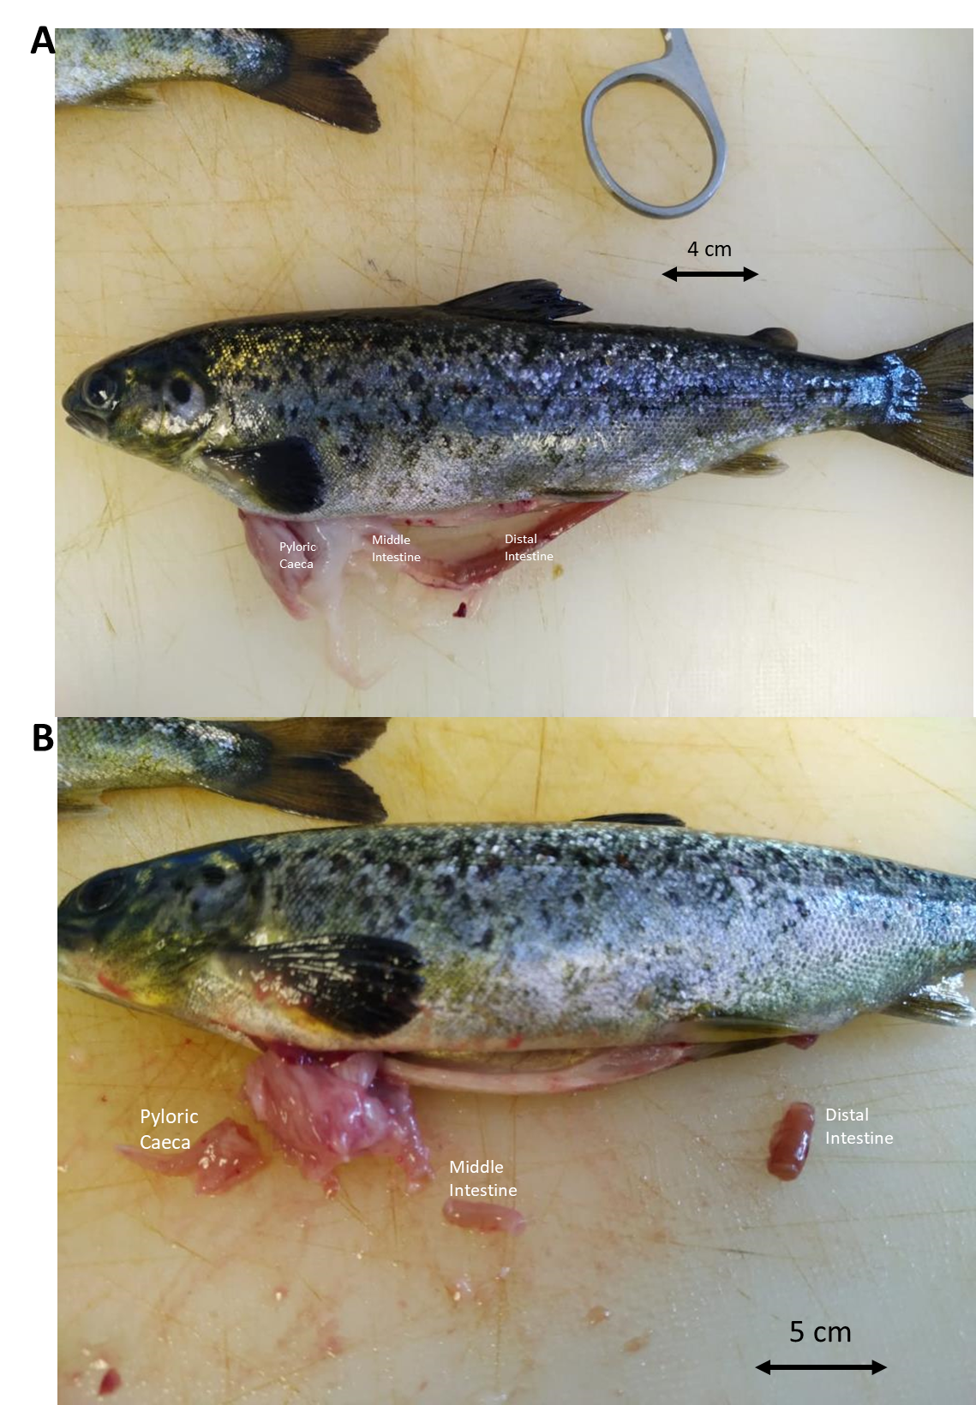
Supplementary Fig. S1. Atlantic salmon fish and intestine (A) before and (B) after sampling different gut regions (pyloric caeca, middle, and distal intestines).
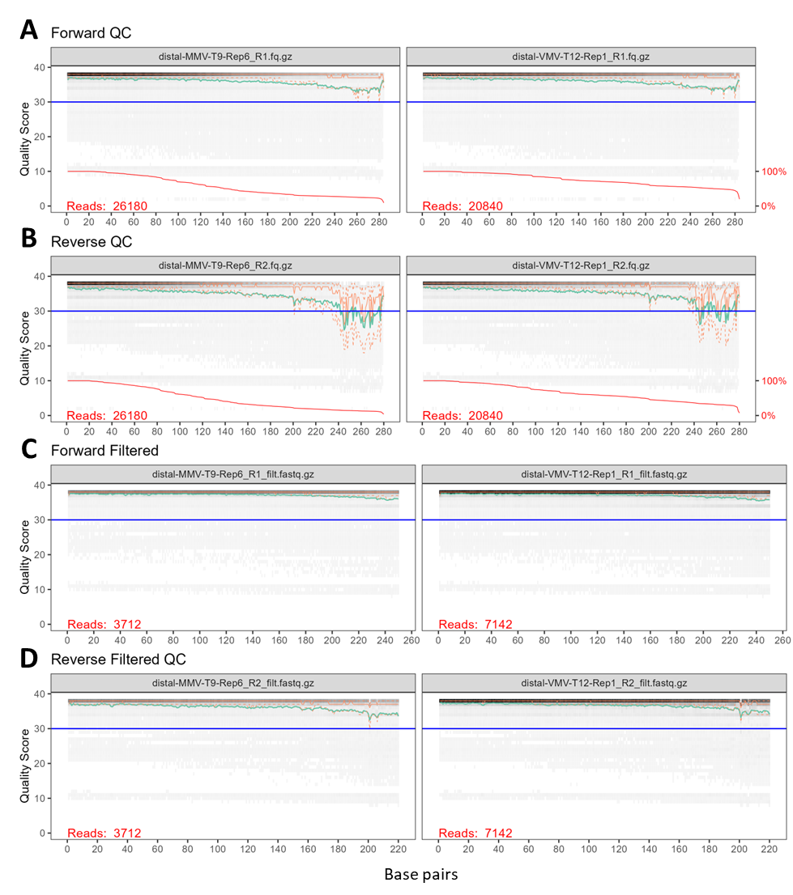
Supplementary Fig. S2. Quality control for forward (F) and reverse (R) reads per sample (two samples used as example) using the DADA2 package before (A & B) and after filtration (C & D). The green line shows the mean quality score at each position, and the orange lines show the quartiles of the quality score distribution. The blue y-intercept line shows a quality score (Q) above 30, the higher the score the better the base call. Filtration at Q>30 showed up to 250 base pairs (bps) for F reads and 220 bps for R reads thus filtered in. All other samples were checked and the same filtration criteria (Q>30, 250 bps F, and 220 bps R) were applied. M – marine-based diet fed group (for two weeks at Stim): T – tank number: Rep – replicate number: R1 the sequencer label for a forward read while R2 label for a reverse read. Sequence data output from the sequencer is saved as FASTQ files which are compressed and created with the extension *.fq.gz or *.fastq.gz

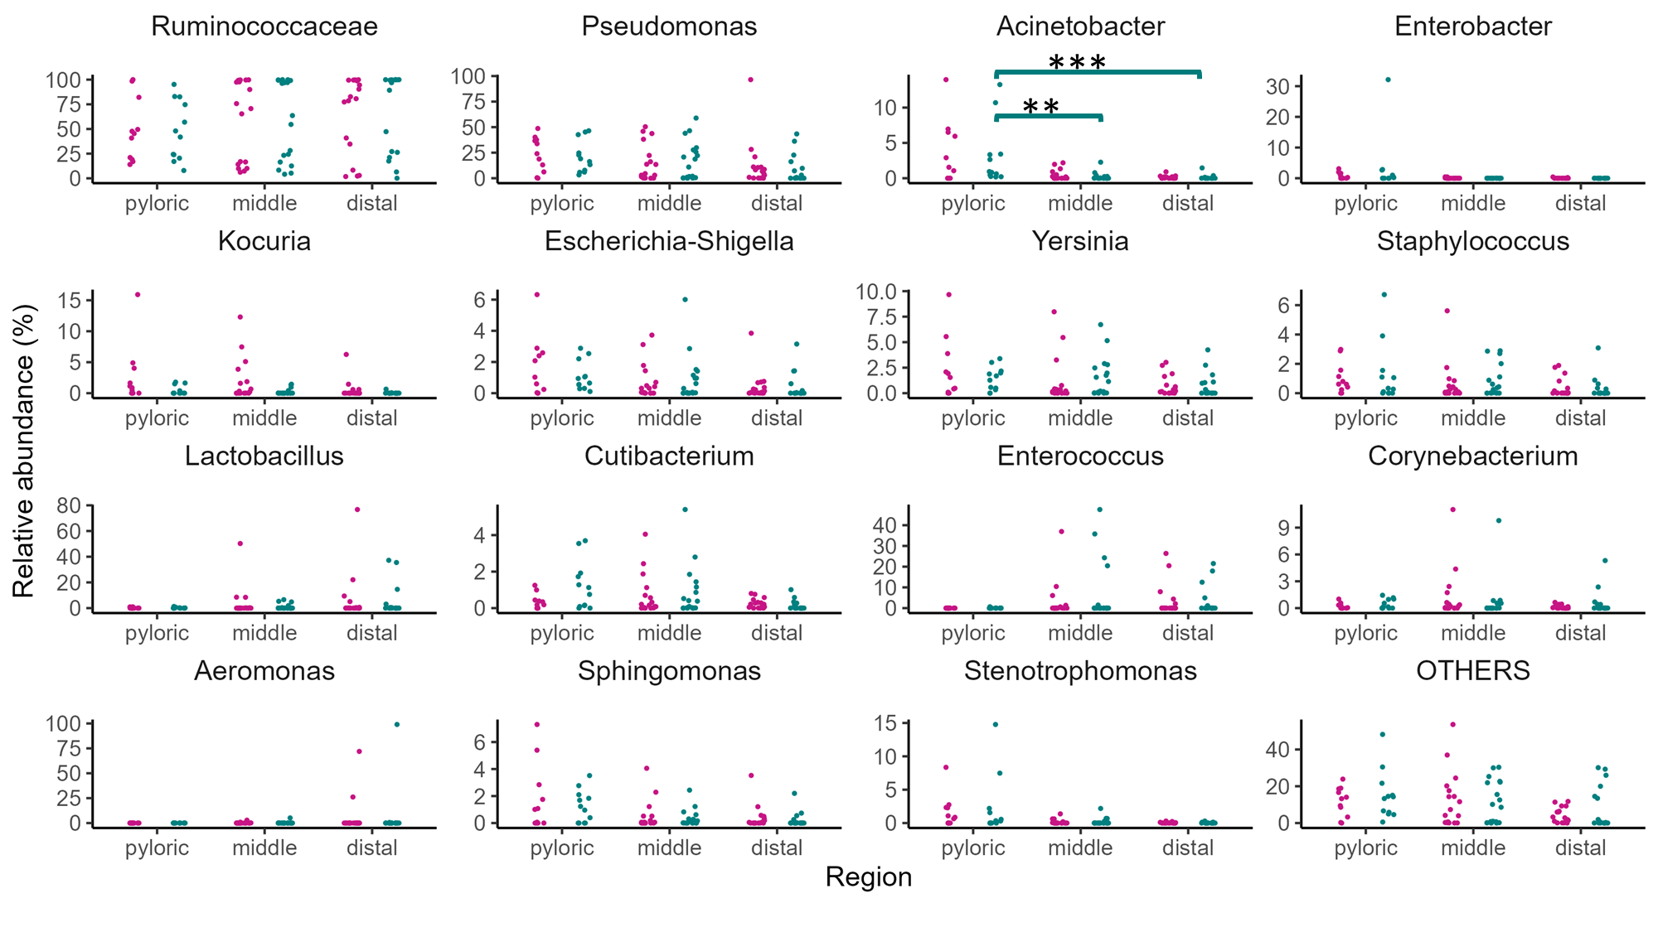
Supplementary Fig. S3. Relative abundance of the top 15 most abundant taxa (at genus or lowest taxonomic rank) in the gut of Atlantic salmon fed the experimental diets. The samples are grouped by gut regions and coloured by dietary regimes. Statistical significance difference of pairwise comparisons was tested by MWW and BH-corrected is presented by stars (**: p<0.01, ***: p<0.001) on the top of the comparison, otherwise it is non-significant.
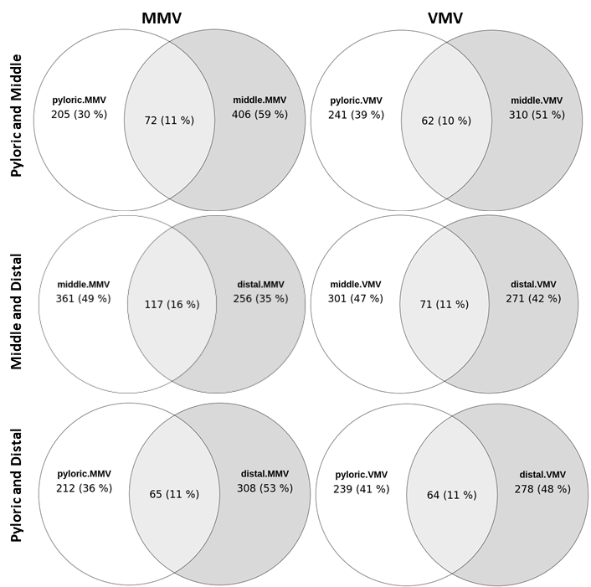
Supplementary Fig. S4. Venn diagram showing unique and shared ASVs in gut region comparisons: pyloric caeca and middle, middle, and distal, and pyloric caeca and distal microbiota.

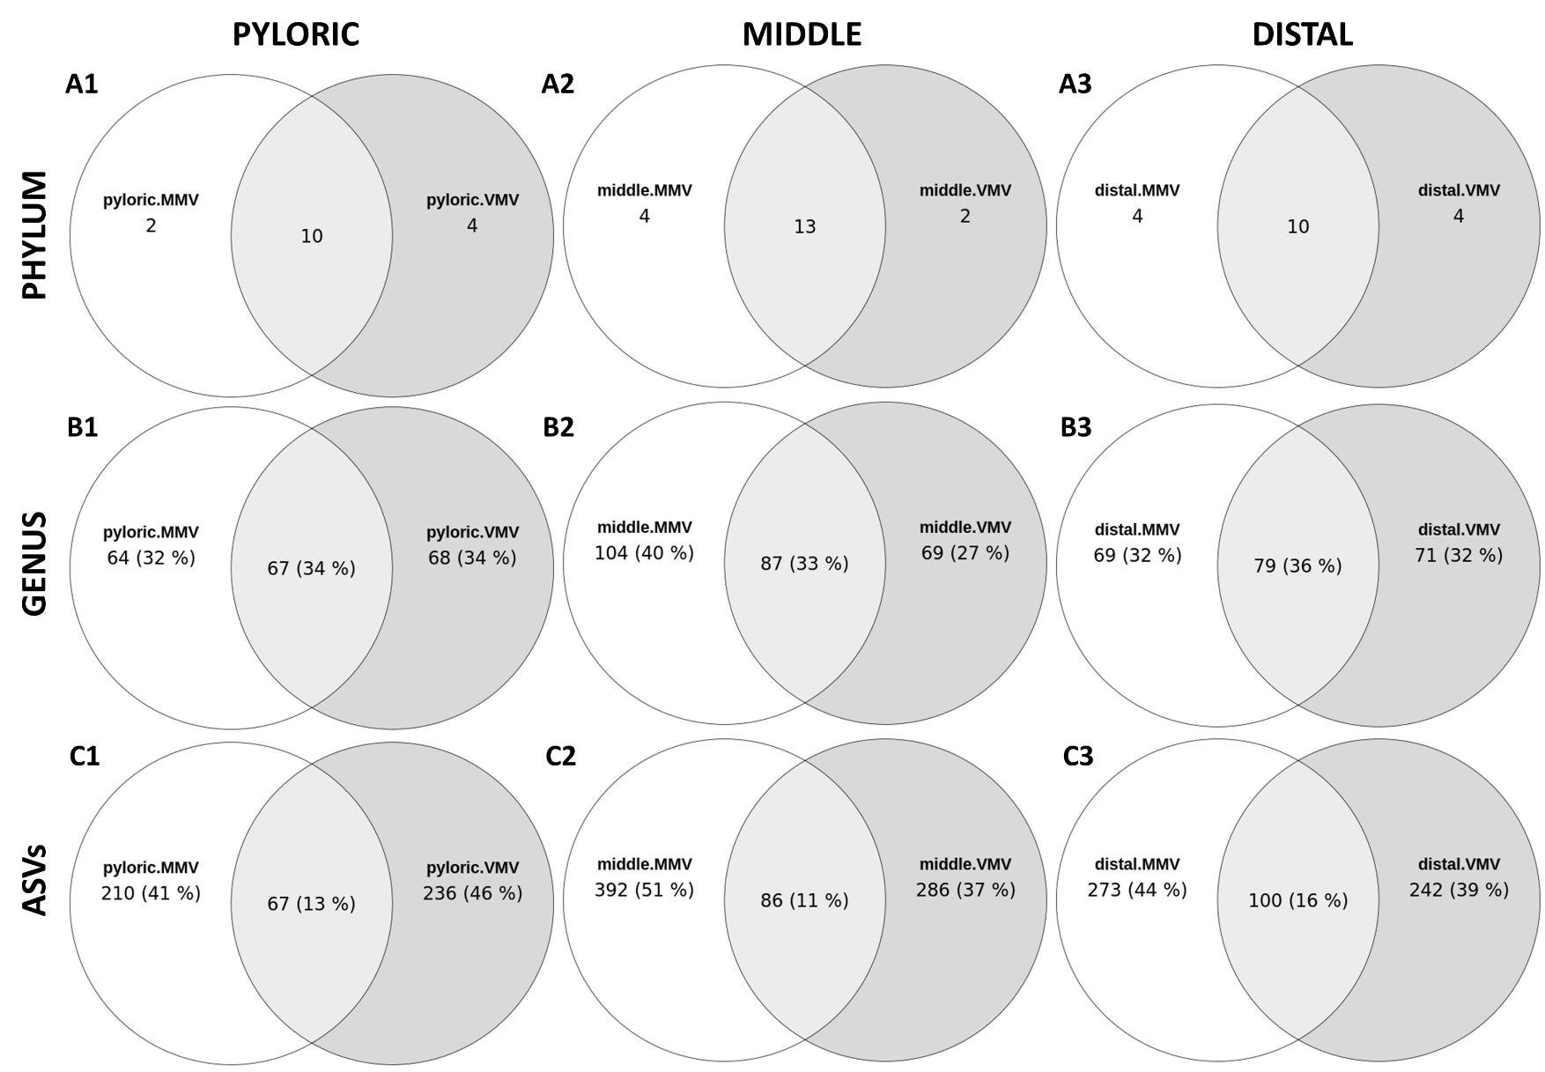
Supplementary Fig. S5. Venn diagram showing unique and shared (A) phyla: (B) genera, and (C) ASVs in gut microbiota grouped by gut regions: (1) pyloric caeca, (2) middle, and (3) distal intestines.

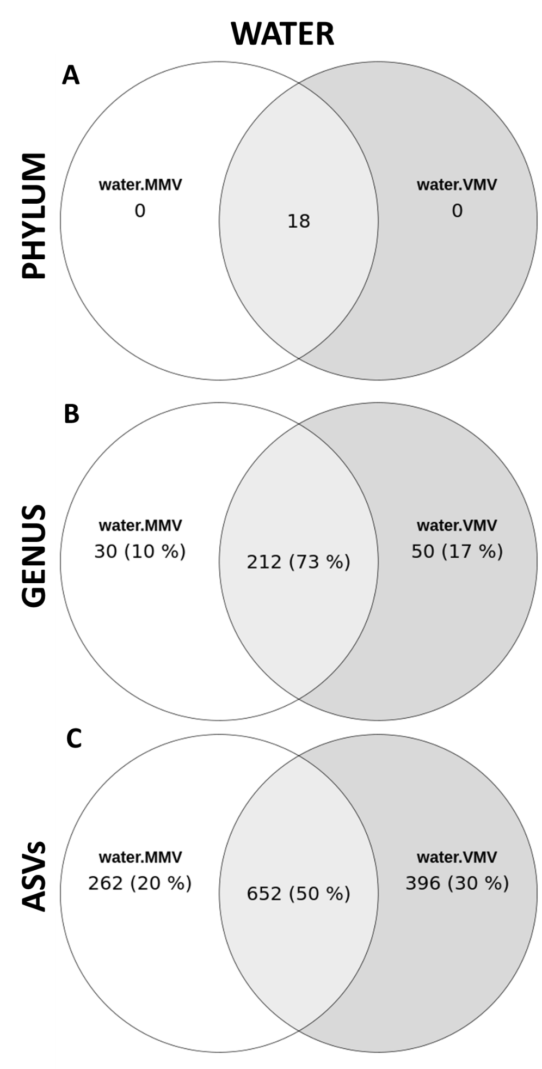
Supplementary Fig. S6. Venn diagram showing unique and shared (A) phyla: (B) genera: and (C) ASVs in water microbiota.

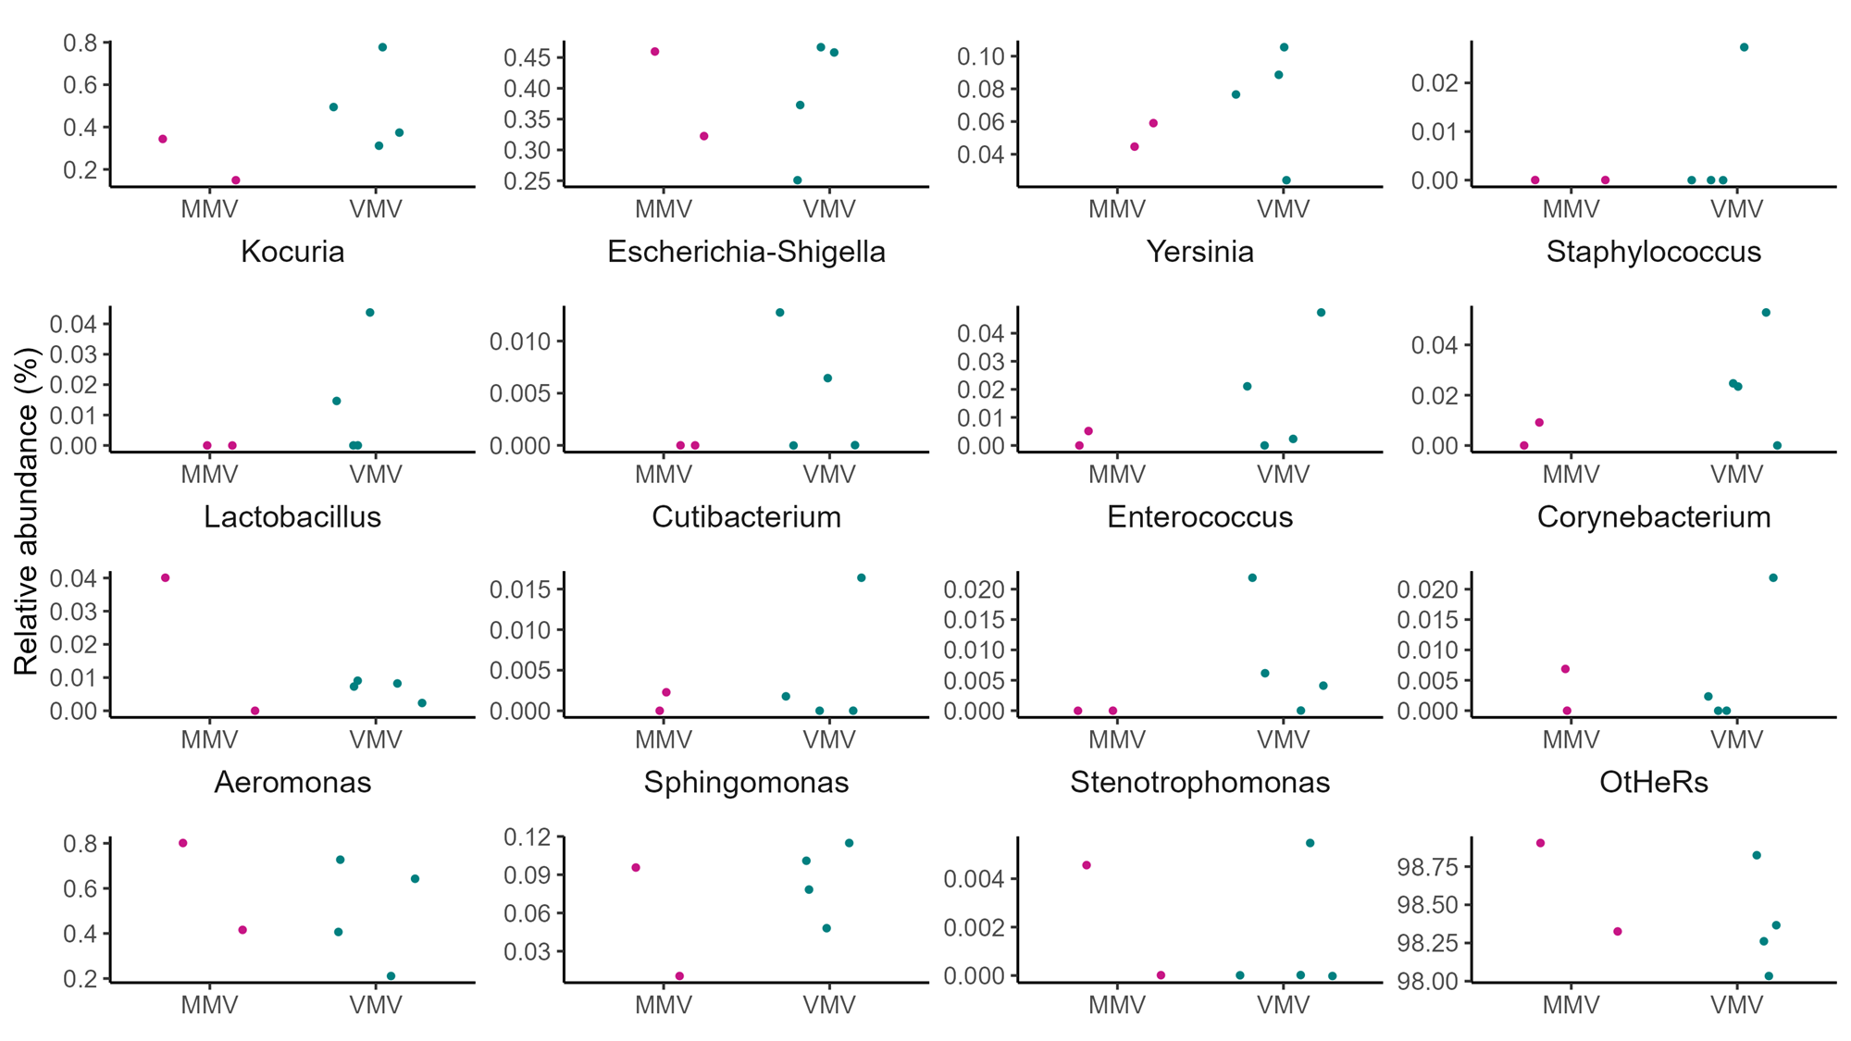
Supplementary Fig. S7. Relative abundance of the top 15 most abundant gut taxa (at genus or lowest taxonomic rank) in the tank water samples in which Atlantic salmon fed the experimental diets are kept. The samples are grouped and coloured by dietary regimes. No statistically significant difference of was shown between MMV vs VMV (tested by MWW and BH-corrected).

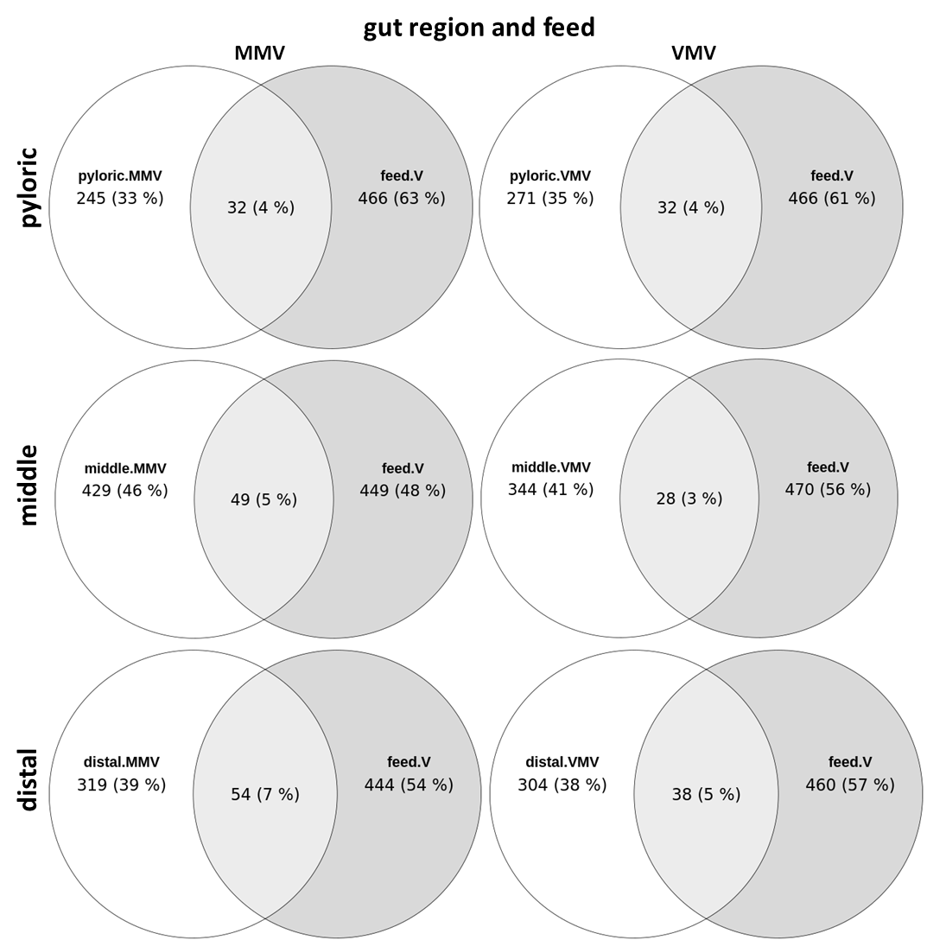
Supplementary Fig. S8. Venn diagram showing unique and shared ASVs between gut region and feed.

