Supplementary Information
Impact of cinnamaldehyde thiosemicarbazone on the corrosion of mild steel in an acidic medium
Varsha Choudharyª, Sachin Dua^{b,c}, Nishtha Arora^{b,c}, R C Saxena^{a,b*}, B G Prakashaiah^{a,b*}, T Senthilkumar^{b,c*}, Mansi Mani Singh^{d}, Tuhin Suvra Khan^{b,d}
ªCorrosion Area, Chemical and Material Sciences Division, CSIR-Indian Institute of Petroleum, Dehradun 248005, India
^{b}Academy of Scientific and Innovative Research (AcSIR), Ghaziabad 201002, India
^{C}Polymeric Materials Area, Chemical and Material Sciences Division, CSIR-Indian Institute of Petroleum, Dehradun 248005, India
^{d}Climate changes and Data Science Division, CSIR-Indian Institute of Petroleum, Mohkampur, Dehradun -248005, India
rcsaxena@iip.res.in, prakashaiah.bg@iip.res.in, t.senthilkumar@iip.res.in

Fig. S1.¹H NMR spectrum of CT.

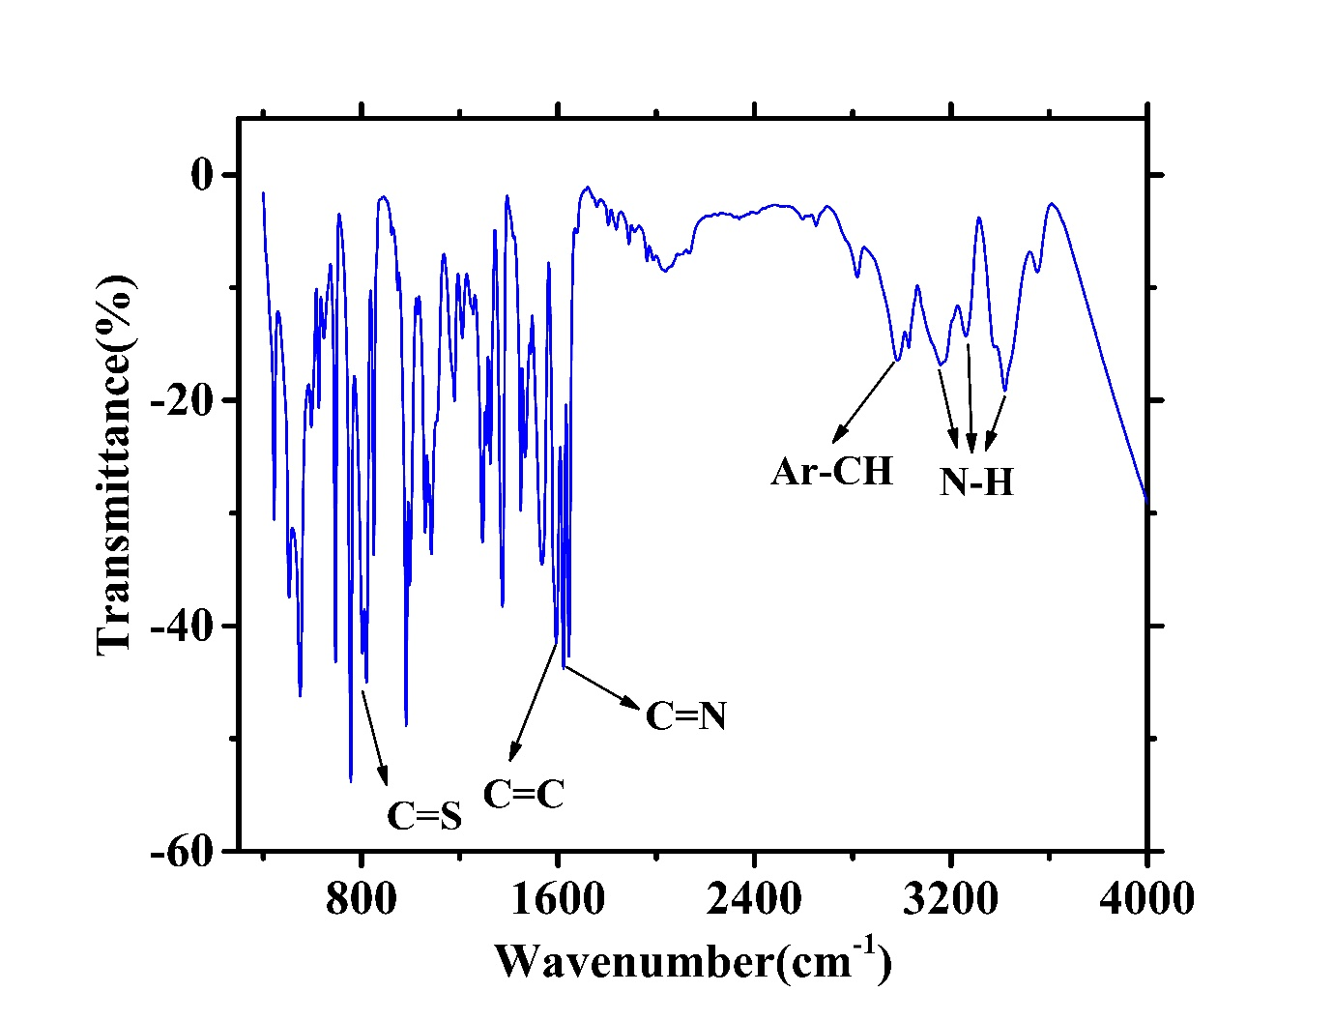
Fig. S2. FTIR spectrum of CT.

Fig. S3. EDAX analysis of MS obtained after 4 hours of immersion in (a) 1M HCl, (b) 1M HCl + CT, (c) 15% HCl, and (d) 15% HCl + CT.

