Online Resources for

Genetic analysis in aid of delineation of Management Units for a wide-ranging marine mammal, the grey seal (Halichoerus grypus), in European waters

Kristina Steinmetz¹*, Sinéad Murphy¹, Oliver Ó Cadhla², Joseph Ivan Hoffman^{3,4}, Jean-Luc Jung⁵, James Barnett⁶, Michelle Cronin⁷, Anders Galatius⁸, Sami Hassani⁹, Mark Jessopp^{7,10}, Paddy Pomeroy¹¹, Luca Mirimin¹

- Marine and Freshwater Research Centre, Department of Natural Resources & the Environment, Atlantic Technological University, Dublin Road, Galway, Ireland
- Marine Environment Section, Department of Housing, Local Government and Heritage, Cork, Ireland.
- Department of Animal Behaviour, Bielefeld University, 33501 Bielefeld, Germany
- British Antarctic Survey, High Cross, Madingley Road, Cambridge CB3 OET, UK
- Université de Brest & Institut de Systématique, Evolution, Biodiversité (ISYEB), Muséum national d'Histoire naturelle, CNRS, Sorbonne Université, EPHE, Université des Antilles France
- Cornwall Marine Pathology Team, Fishers Well, Higher Brill, Falmouth TR11 5QG U.K.
- MaREI Centre, Environmental Research Institute, University College Cork
- Section for Marine Mammal Research, Department of Ecoscience, Aarhus University, Frederiksborgvej 399, 4000 Roskilde, Denmark
- Conservation des Mammifères et Oiseaux Marins de Bretagne, Direction scientifique, Océanopolis, port de plaisance, BP 91039, 29210 Brest Cedex 1, France
- School of Biological, Earth & Environmental Sciences, University College Cork
- Sea Mammal Research Unit, School of Biology, University of St Andrews, Fife, KY16 8LB, UK

* Corresponding author: ksteinmetz.research@gmail.com

Online Resource 1

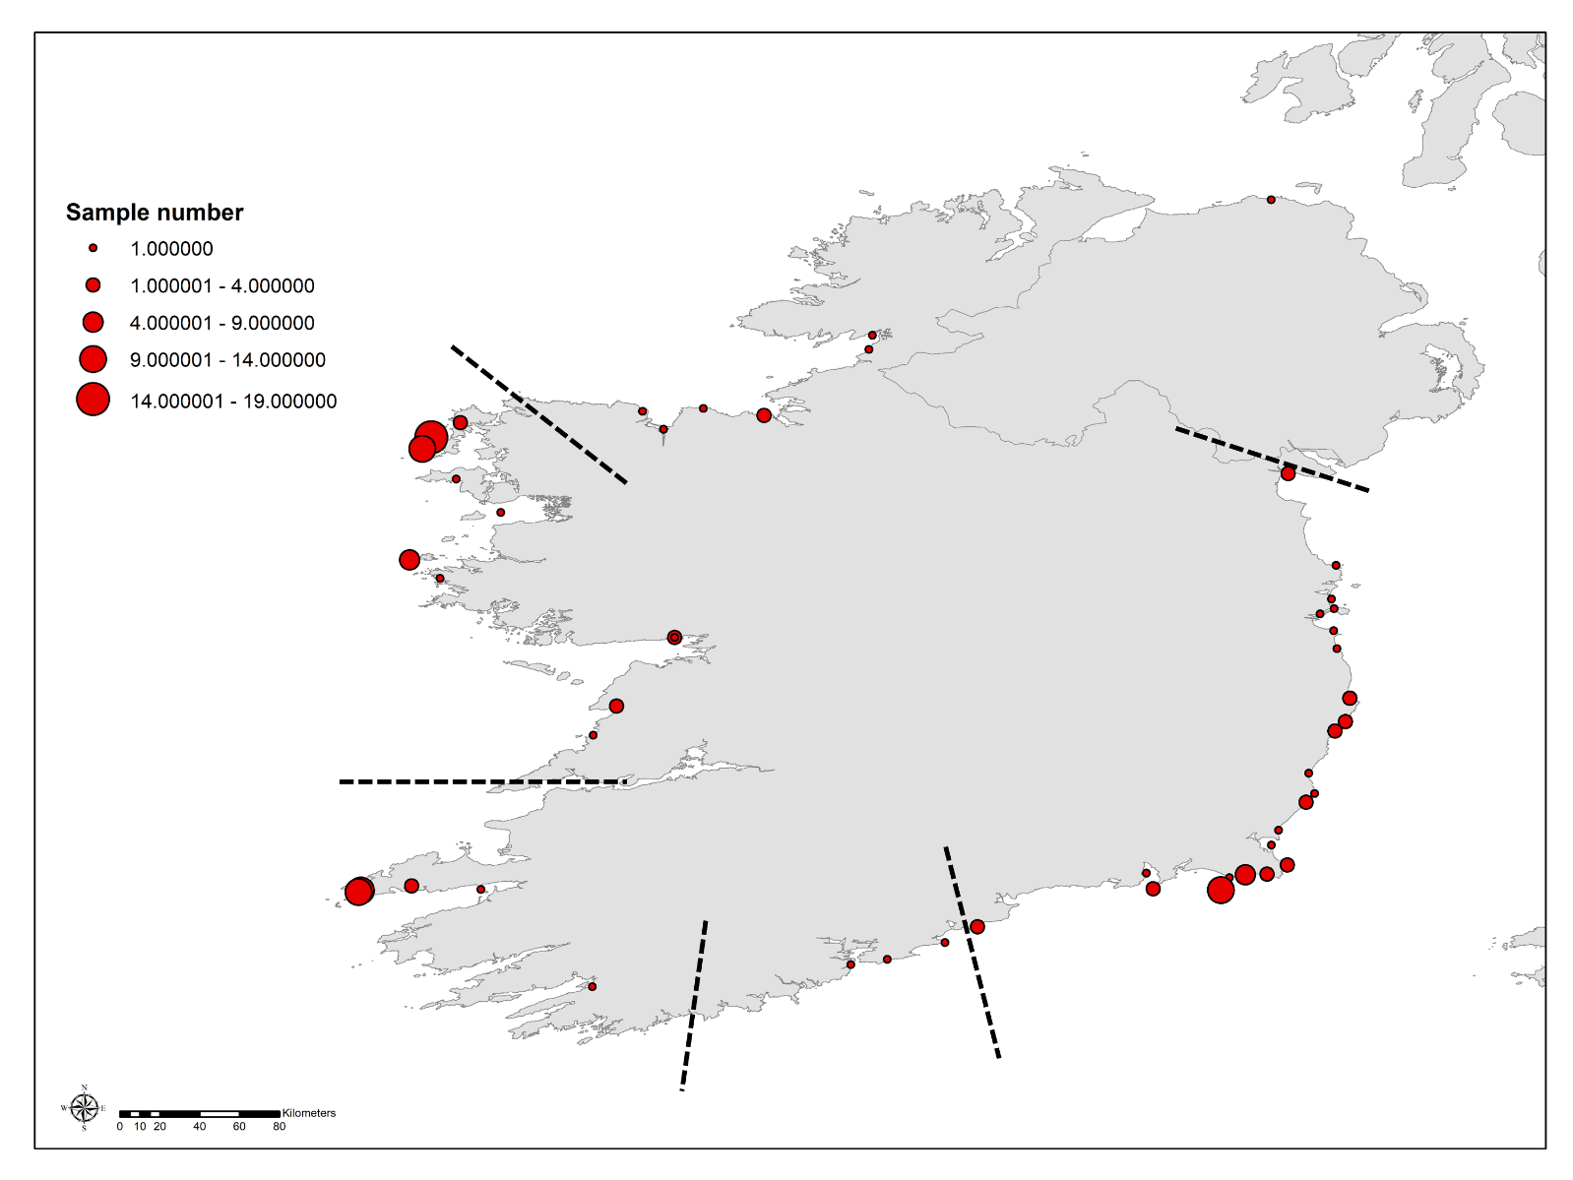
Figure S1. Geographic areas (separated by dashed lines) indicating sample size and distribution across the island of Ireland. These geographics areas were used for the assessment of genetic differentiation within the island of Ireland.

Online Resource 2

Supplementary material 2 provides further details corresponding to the mitochondrial analysis of data that exclude any samples known to originate from moulted pups due to their high dispersal rates.
Table 1-A. Samples collected from pups that were fully moulted and excluded from this analysis.
 | n(before_exclusion) | n(moulted_pups) | n(after_exclusion)
IRL & NI | 138 | 10 | 128
GDNS | 32 | 13 (1 DK, 12 GER) | 19
SWE | 28 | 9 | 19

Table 2-A. Genetic diversity based on a 317bp fragment of the mitochondrial d-loop of grey seals, excluding moulted pups, for the affected sub-regions. Shown are the sample number (N), number of haplotypes, the nucleotide (π) and haplotype (h) diversities with standard deviation in brackets and the number of polymorphic sites. Acronyms are shown in Table 1.
Sub-region | N | No. haplotypes | π (SD) | h (SD) | No. polymorphic sites
IRL & NI | 128 | 31 | 0.015 (0.008) | 0.925 (0.011) | 31
SWE | 19 | 8 | 0.015 (0.009) | 0.866 (0.046) | 16
GDNS | 19 | 7 | 0.012 (0.007) | 0.842 (0.051) | 14
 | Remained the same
 | Decreased
 | Increased

Table 4-A. Pairwise genetic differentiation between grey seal putative populations based on mtDNA where samples from moulted pups were excluded due to higher dispersal probabilities. Acronyms are shown in Table 1. Asterix indicates a significant p value after sequential Bonferroni correction (*p < 0.0007). Data gained by the present study is highlighted in bold.
 | NWS | IRL & NI | SWE | NEE | ESC | ORK | FO | FR | DWS | GDNS | BAL | SIC
NWS | 0
IRL & NI | 0.037* | 0
SWE | 0.051 | 0.013 | 0
NEE | 0.029 | 0.037* | 0.073* | 0
ESC | 0.059* | 0.063* | 0.127* | -0.010 | 0
ORK | 0.006 | 0.032* | 0.039 | 0.023* | 0.047* | 0
FO | -0.001 | 0.060 | 0.054 | 0.072* | 0.128* | 0.012 | 0
FR | 0.023* | 0.008 | 0.037 | 0.022 | 0.043* | 0.017* | 0.051* | 0
DWS | -0.000 | 0.023 | 0.036 | -0.009 | 0.027 | -0.009 | 0.024 | 0.014 | 0
GDNS | 0.042 | 0.028 | 0.109* | 0.066* | 0.100* | 0.060* | 0.089* | 0.043 | 0.053 | 0
BAL | 0.072* | 0.071* | 0.072* | 0.111* | 0.151* | 0.095* | 0.059* | 0.105* | 0.061* | 0.070* | 0
SIC | 0.277* | 0.313* | 0.319* | 0.353* | 0.409* | 0.275* | 0.255* | 0.342* | 0.265* | 0.345* | 0.189* | 0
 | Was significant when including moulted pups
 | Was significant and higher (min 0.01 difference) when including moulted pups
 | Was higher when including moulted pups (min 0.01 difference)
 | Was not significant when including moulted pups
 | Was not significant and lower (min 0.01 difference) when including moulted pups
 | Was lower when including moulted pups (min 0.01 difference)
Table 6-A. Tajima’s D and Fu’s Fs for each grey seal sub-region based on the 317bp fragment of the mitochondrial d-loop for the mitochondrial assessment of genetic bottlenecks where samples from moulted pups were excluded due to higher dispersal probabilities. Cells shaded in blue indicate a different interpretation compared to the dataset including moulted pups. Significance is indicated by an Asterix.
 | Tajima’s D | p | Fu’s Fs | p
NWS | -0.897 | 0.192 | -6.251 | 0.022*
IRL & NI | -0.519 | 0.370 | -9.879 | 0.012*
SWE | 0.189 | 0.641 | 0.475 | 0.595
NEE | -1.406 | 0.072 | -3.493 | 0.104
ESC | -0.778 | 0.233 | -1.687 | 0.246
ORK | -1.495 | 0.021* | -24.682 | 0.002*
FO | -0.207 | 0.484 | -1.257 | 0.310
FR | -0.761 | 0.265 | -12.676 | 0.005*
DWS | -0.427 | 0.377 | -4.624 | 0.016*
GDNS | -0.157 | 0.471 | 0.631 | 0.672
BAL | -0.081 | 0.555 | -19.404 | 0.000*
SIC | -0.654 | 0.295 | -4.401 | 0.083

Online Resource 3

Table S3. Pairwise genetic differentiation between grey seal geographic areas. Mitochondrial data shown below the diagonal and microsatellite data shown above the diagonal. No differentiation was significant after sequential Bonferroni correction. Note that no microsatellite data were available from the South of Ireland as indicated by ‘na’ within the table. Area boundaries are shown in supplementary Figure S1.
 | North | West | Southwest | South | Southeast & East
North |  | 0.023 | 0.038 | na | 0.000
West | 0.049 |  | -0.006 | na | 0.008
Southwest | -0.005 | -0.014 |  | na | 0.002
South | -0.213 | -0.003 | -0.036 |  | na
Southeast & East | -0.022 | 0.034 | 0.014 | -0.146

Online Resource 4

Supplementary Material 4 shows haplotype details in a separate excel table S4 including full sequences, their occurrence and GenBank accession numbers of newly identified haplotypes.

Online Resource 5

Table S5 Genetic diversity of grey seals based on 11 microsatellite loci showing the number of alleles (Na), allelic richness (Ar), expected and observed heterozygosity (He, Ho) and the inbreeding coefficient (FIS). Acronyms for putative populations/sub-regions are shown in Table 1 of the main manuscript.
Locus | Parameter | IRL (n = 108) | SWE (n = 15) | GDNS (n = 37) | All (mean)
Sgpv9 | N_{a} | 9 | 6 | 7 | 7.333
Sgpv9 | A_{r} | 6.242 | 5.751 | 5.883 | 5.959
Sgpv9 | H_{e} | 0.799 | 0.625 | 0.805 | 0.743
Sgpv9 | H_{o} | 0.86 | 0.667 | 0.919 | 0.815
Sgpv9 | F_{IS} | -0.076 | -0.069 | -0.143 | -0.096
Hgdii | N_{a} | 7 | 5 | 8 | 6.667
Hgdii | A_{r} | 4.656 | 4.968 | 5.706 | 5.110
Hgdii | H_{e} | 0.689 | 0.717 | 0.714 | 0.707
Hgdii | H_{o} | 0.647 | 0.714 | 0.892 | 0.751
Hgdii | F_{IS} | 0.062 | 0.004 | -0.253 | -0.062
Hg6.1 | N_{a} | 8 | 5 | 5 | 6
Hg6.1 | A_{r} | 4.992 | 4.999 | 4.459 | 4.817
Hg6.1 | H_{e} | 0.668 | 0.816 | 0.678 | 0.721
Hg6.1 | H_{o} | 0.705 | 0.933 | 0.969 | 0.869
Hg6.1 | F_{IS} | -0.056 | -0.15 | -0.439 | -0.215
Hg8.10 | N_{a} | 14 | 7 | 10 | 10.333
Hg8.10 | A_{r} | 7.448 | 7 | 7.886 | 7.445
Hg8.10 | H_{e} | 0.812 | 0.754 | 0.83 | 0.799
Hg8.10 | H_{o} | 0.935 | 0.917 | 0.892 | 0.915
Hg8.10 | F_{IS} | -0.152 | -0.228 | -0.076 | -0.152
Hg8.9 | N_{a} | 12 | 8 | 9 | 9.667
Hg8.9 | A_{r} | 8.443 | 7.555 | 7.369 | 7.789
Hg8.9 | H_{e} | 0.846 | 0.821 | 0.805 | 0.824
Hg8.9 | H_{o} | 0.968 | 0.933 | 0.919 | 0.94
Hg8.9 | F_{IS} | -0.146 | -0.143 | -0.1444 | -0.144
Hg6.3 | N_{a} | 8 | 6 | 7 | 7
Hg6.3 | A_{r} | 6.241 | 5.951 | 6.057 | 6.083
Hg6.3 | H_{e} | 0.812 | 0.763 | 0.809 | 0.795
Hg6.3 | H_{o} | 0.924 | 0.867 | 0.861 | 0.884
Hg6.3 | F_{IS} | -0.138 | -0.141 | -0.065 | -0.115
Sgpv10 | N_{a} | 4 | 4 | 4 | 4
Sgpv10 | A_{r} | 3.127 | 3.4 | 2.887 | 3.138
Sgpv10 | H_{e} | 0.262 | 0.193 | 0.28 | 0.245
Sgpv10 | H_{o} | 0.25 | 0.2 | 0.286 | 0.245
Sgpv10 | F_{IS} | 0.045 | -0.037 | -0.023 | -0.005
Sgpv11 | N_{a} | 9 | 5 | 7 | 7
Sgpv11 | A_{r} | 5.994 | 4.765 | 5.51 | 5.423
Sgpv11 | H_{e} | 0.769 | 0.692 | 0.735 | 0.732
Sgpv11 | H_{o} | 0.913 | 0.733 | 0.73 | 0.792
Sgpv11 | F_{IS} | -0.189 | -0.062 | 0.007 | -0.081
Tbpv2 | N_{a} | 12 | 5 | 6 | 7.667
Tbpv2 | A_{r} | 6.21 | 4.99 | 5.499 | 5.566
Tbpv2 | H_{e} | 0.784 | 0.786 | 0.796 | 0.789
Tbpv2 | H_{o} | 0.871 | 0.8 | 0.919 | 0.863
Tbpv2 | F_{IS} | -0.111 | -0.018 | -0.157 | -0.095
Pvc19 | N_{a} | 6 | 5 | 6 | 5.667
Pvc19 | A_{r} | 5.062 | 4.566 | 5.368 | 4.999
Pvc19 | H_{e} | 0.708 | 0.63 | 0.704 | 0.681
Pvc19 | H_{o} | 0.821 | 0.933 | 0.811 | 0.855
Pvc19 | F_{IS} | -0.161 | -0.508 | -0.154 | -0.274
Pvc78 | N_{a} | 6 | 2 | 3 | 3.667
Pvc78 | A_{r} | 3.243 | 1.995 | 2.683 | 2.640
Pvc78 | H_{e} | 0.303 | 0.186 | 0.305 | 0.265
Pvc78 | H_{o} | 0.304 | 0.2 | 0.351 | 0.285
Pvc78 | F_{IS} | -0.004 | -0.077 | -0.156 | -0.079
N_{a} (mean ±SD) |  | 8.636±3.009 | 5.273±1.555 | 6.545±2.067
A_{r} (mean) |  | 5.605 | 5.085 | 5.392
H_{e} (mean ± SD) |  | 0.677±0.203 | 0.635±0.230 | 0.678±0.197
H_{o} (mean ± SD) |  | 0.745±0.251 | 0.718±0.273 | 0.777±0.236
F_{IS} (mean) |  | -0.084 | -0.13 | -0.146

