Supplementary file

Title | Geo_accession
GSM1369756 | Monocytes from a postmenopausal high BMD woman (H-GE-01M.CEL)
GSM1369757 | Monocytes from a postmenopausal high BMD woman (H-GE-04M.CEL)
GSM1369758 | Monocytes from a postmenopausal high BMD woman (H-GE-06M.CEL)
GSM1369759 | Monocytes from a postmenopausal high BMD woman (H-GE-07M.CEL)
GSM1369760 | Monocytes from a postmenopausal high BMD woman (H-GE-10M.CEL)
GSM1369761 | Monocytes from a postmenopausal high BMD woman (H-GE-11M.CEL)
GSM1369762 | Monocytes from a postmenopausal high BMD woman (H-GE-13M.CEL)
GSM1369763 | Monocytes from a premenopausal high BMD woman (H-GE-15M.CEL)
GSM1369764 | Monocytes from a premenopausal high BMD woman (H-GE-17M.CEL)
GSM1369765 | Monocytes from a postmenopausal high BMD woman (H-GE-18M.CEL)
GSM1369766 | Monocytes from a premenopausal high BMD woman (H-GE-19M.CEL)
GSM1369767 | Monocytes from a postmenopausal high BMD woman (H-GE-20M.CEL)
GSM1369768 | Monocytes from a premenopausal high BMD woman (H-GE-22M.CEL)
GSM1369769 | Monocytes from a postmenopausal high BMD woman (H-GE-23M.CEL)
GSM1369770 | Monocytes from a premenopausal high BMD woman (H-GE-24M.CEL)
GSM1369771 | Monocytes from a postmenopausal high BMD woman (H-GE-26M.CEL)
GSM1369772 | Monocytes from a premenopausal high BMD woman (H-GE-27M.CEL)
GSM1369773 | Monocytes from a premenopausal high BMD woman (H-GE-28M.CEL)
GSM1369774 | Monocytes from a premenopausal high BMD woman (H-GE-29M.CEL)
GSM1369775 | Monocytes from a premenopausal high BMD woman (H-GE-30M.CEL)
GSM1369776 | Monocytes from a premenopausal high BMD woman (H-GE-33M.CEL)
GSM1369777 | Monocytes from a postmenopausal high BMD woman (H-GE-34M.CEL)
GSM1369778 | Monocytes from a postmenopausal high BMD woman (H-GE-42M.CEL)
GSM1369779 | Monocytes from a postmenopausal high BMD woman (H-GE-45M.CEL)
GSM1369780 | Monocytes from a postmenopausal high BMD woman (H-GE-47M.CEL)
GSM1369781 | Monocytes from a postmenopausal high BMD woman (H-GE-53M.CEL)
GSM1369782 | Monocytes from a postmenopausal high BMD woman (H-GE-55M.CEL)
GSM1369783 | Monocytes from a postmenopausal high BMD woman (H-GE-59M.CEL)
GSM1369784 | Monocytes from a postmenopausal high BMD woman (H-GE-65M.CEL)
GSM1369785 | Monocytes from a premenopausal high BMD woman (H-GE-68M.CEL)
GSM1369786 | Monocytes from a premenopausal high BMD woman (H-GE-71M.CEL)
GSM1369787 | Monocytes from a premenopausal high BMD woman (H-GE-73M.CEL)
GSM1369788 | Monocytes from a premenopausal high BMD woman (H-GE-74M.CEL)
GSM1369789 | Monocytes from a premenopausal high BMD woman (H-GE-77M.CEL)
GSM1369790 | Monocytes from a premenopausal high BMD woman (H-GE-78M.CEL)
GSM1369791 | Monocytes from a premenopausal high BMD woman (H-GE-79M.CEL)
GSM1369792 | Monocytes from a postmenopausal high BMD woman (H-GE-80M.CEL)
GSM1369793 | Monocytes from a premenopausal high BMD woman (H-GE-81M.CEL)
GSM1369794 | Monocytes from a premenopausal high BMD woman (H-GE-82M.CEL)
GSM1369795 | Monocytes from a premenopausal high BMD woman (H-GE-85M.CEL)
GSM1369796 | Monocytes from a premenopausal low BMD woman (L-GE-21M.CEL)
GSM1369797 | Monocytes from a postmenopausal low BMD woman (L-GE-25M.CEL)
GSM1369798 | Monocytes from a postmenopausal low BMD woman (L-GE-31M.CEL)
GSM1369799 | Monocytes from a postmenopausal low BMD woman (L-GE-32M.CEL)
GSM1369800 | Monocytes from a postmenopausal low BMD woman (L-GE-35M.CEL)
GSM1369801 | Monocytes from a premenopausal low BMD woman (L-GE-36M.CEL)
GSM1369802 | Monocytes from a postmenopausal low BMD woman (L-GE-37M.CEL)
GSM1369803 | Monocytes from a postmenopausal low BMD woman (L-GE-38M.CEL)
GSM1369804 | Monocytes from a premenopausal low BMD woman (L-GE-39M.CEL)
GSM1369805 | Monocytes from a postmenopausal low BMD woman (L-GE-40M.CEL)
GSM1369806 | Monocytes from a premenopausal low BMD woman (L-GE-41M.CEL)
GSM1369807 | Monocytes from a postmenopausal low BMD woman (L-GE-43M.CEL)
GSM1369808 | Monocytes from a premenopausal low BMD woman (L-GE-44M.CEL)
GSM1369809 | Monocytes from a premenopausal low BMD woman (L-GE-46M.CEL)
GSM1369810 | Monocytes from a postmenopausal low BMD woman (L-GE-48M.CEL)
GSM1369811 | Monocytes from a premenopausal low BMD woman (L-GE-49M.CEL)
GSM1369812 | Monocytes from a postmenopausal low BMD woman (L-GE-50M.CEL)
GSM1369813 | Monocytes from a postmenopausal low BMD woman (L-GE-51M.CEL)
GSM1369814 | Monocytes from a postmenopausal low BMD woman (L-GE-52M.CEL)
GSM1369815 | Monocytes from a premenopausal low BMD woman (L-GE-54M.CEL)
GSM1369816 | Monocytes from a postmenopausal low BMD woman (L-GE-56M.CEL)
GSM1369817 | Monocytes from a premenopausal low BMD woman (L-GE-57M.CEL)
GSM1369818 | Monocytes from a premenopausal low BMD woman (L-GE-58M.CEL)
GSM1369819 | Monocytes from a premenopausal low BMD woman (L-GE-60M.CEL)
GSM1369820 | Monocytes from a premenopausal low BMD woman (L-GE-61M.CEL)
GSM1369821 | Monocytes from a postmenopausal low BMD woman (L-GE-62M.CEL)
GSM1369822 | Monocytes from a postmenopausal low BMD woman (L-GE-63M.CEL)
GSM1369823 | Monocytes from a postmenopausal low BMD woman (L-GE-64M.CEL)
GSM1369824 | Monocytes from a postmenopausal low BMD woman (L-GE-66M.CEL)
GSM1369825 | Monocytes from a postmenopausal low BMD woman (L-GE-67M.CEL)
GSM1369826 | Monocytes from a postmenopausal low BMD woman (L-GE-69M.CEL)
GSM1369827 | Monocytes from a premenopausal low BMD woman (L-GE-70M.CEL)
GSM1369828 | Monocytes from a postmenopausal low BMD woman (L-GE-72M.CEL)
GSM1369829 | Monocytes from a premenopausal low BMD woman (L-GE-75M.CEL)
GSM1369830 | Monocytes from a premenopausal low BMD woman (L-GE-76M.CEL)
GSM1369831 | Monocytes from a premenopausal low BMD woman (L-GE-83M.CEL)
GSM1369832 | Monocytes from a premenopausal low BMD woman (L-GE-84M.CEL)
GSM1369833 | Monocytes from a premenopausal low BMD woman (L-GE-86M.CEL)
GSM1369834 | Monocytes from a premenopausal low BMD woman (L-GE-88M.CEL)
GSM1369835 | Monocytes from a premenopausal low BMD woman (L-GE-89M.CEL)
GSM7658073 | Synovium cells from a frozen shoulder patient(rep1)
GSM7658074 | Synovium cells from a frozen shoulder patient(rep2)
GSM7658075 | Synovium cells from a frozen shoulder patient(rep3)
GSM7658076 | Synovium cells from a frozen shoulder patient(rep4)
GSM7658077 | Synovium cells from a control patient(rep1)
GSM7658078 | Synovium cells from a control patient(rep2)
GSM7658079 | Synovium cells from a control patient(rep3)
GSM7658080 | Synovium cells from a control patient(rep4)
Supplementary Table1. The detailed clinical information about the GSE56815 and GSE228053 used in this research.
Gene symbol
ZEB2
TRPM6
FLNC
BCL11A
SMAGP
ACTN1
PYGM
DMTF1
BCAT1
SLC6A12
GSAP
ANGPT1
TSNAX
NFKB2
TNR
S100A8
MAN2A1
GPRC5B
ELN
NES
HMOX1
GRIP2
FCGR2C
SOCS3
TPP2
PGRMC2
NBPF1
PHF3
CP
ACTN2
IER2
SRP72
SEMA3F
SSTR2
ADAMTS5
PHLDA3
PHKG1
FHOD3
SLCO4A1
PRKCZ
OGFRL1
FAM110D
IRF8
PCDH17
GPR4
FIG4
LIPE
DLG4
GJA4
CTSS
STC1
ENO3
PDLIM7
FST
TAOK3
CLCN6
SLC30A3
TUBA8
ATP1A2
EGFR
JUN
R3HDM4
CEP57
CROCCP2
ADCY8
SDHA
JUNB
NT5DC3
SLC4A3
HP
SCAF11
ALPK3
NUPR1
APBB2
MYH14
EHBP1
AFTPH
ERAP1
MMP3
TDRD3
HPD
CD180
N4BP3
HIST1H4H
TGFBR3
AOC3
LPP
AKR1C1
TTF2
ACTN3
CIDEA
POSTN
AVPR1A
IGKC
HLA-DRB6
GLRX
ANKRD2
RAMP1
MYOM1

Supplementary Table2. The crosstalk genes linking FS dataset (GSE238053) and OP dataset (GSE56815)

ID | Description | GeneRatio |  | BgRatio | Pvalue | P.adjust | qvalue | Count
hsa05215 | Prostate cancer |  | 0.029661 | 97/8577 | 0.000799 | 0.253343 | 0.228821 | 14
hsa04152 | AMPK signaling pathway |  | 0.03178 | 121/8577 | 0.002541 | 0.261494 | 0.236182 | 15
hsa05208 | Chemical carcinogenesis - reactive oxygen species |  | 0.048729 | 223/8577 | 0.00265 | 0.261494 | 0.236182 | 23
hsa04936 | Alcoholic liver disease |  | 0.033898 | 142/8577 | 0.004873 | 0.261494 | 0.236182 | 16
hsa04932 | Non-alcoholic fatty liver disease |  | 0.036017 | 155/8577 | 0.004966 | 0.261494 | 0.236182 | 17
hsa05166 | Human T-cell leukemia virus 1 infection |  | 0.04661 | 222/8577 | 0.005259 | 0.261494 | 0.236182 | 22
hsa00590 | Arachidonic acid metabolism |  | 0.019068 | 61/8577 | 0.005774 | 0.261494 | 0.236182 | 9
hsa03060 | Protein export |  | 0.010593 | 23/8577 | 0.007283 | 0.28857 | 0.260638 | 5
hsa04120 | Ubiquitin mediated proteolysis |  | 0.03178 | 142/8577 | 0.011233 | 0.306927 | 0.277218 | 15
hsa04068 | FoxO signaling pathway |  | 0.029661 | 131/8577 | 0.012758 | 0.306927 | 0.277218 | 14
hsa05213 | Endometrial cancer |  | 0.016949 | 58/8577 | 0.013445 | 0.306927 | 0.277218 | 8
hsa04922 | Glucagon signaling pathway |  | 0.025424 | 107/8577 | 0.014273 | 0.306927 | 0.277218 | 12
hsa04931 | Insulin resistance |  | 0.025424 | 108/8577 | 0.015286 | 0.306927 | 0.277218 | 12
hsa00290 | Valine, leucine and isoleucine biosynthesis |  | 0.004237 | 4/8577 | 0.016836 | 0.306927 | 0.277218 | 2
hsa03267 | Virion - Adenovirus |  | 0.004237 | 4/8577 | 0.016836 | 0.306927 | 0.277218 | 2
hsa04210 | Apoptosis |  | 0.029661 | 136/8577 | 0.017281 | 0.306927 | 0.277218 | 14
hsa04910 | Insulin signaling pathway |  | 0.029661 | 137/8577 | 0.018316 | 0.306927 | 0.277218 | 14
hsa05210 | Colorectal cancer |  | 0.021186 | 86/8577 | 0.019202 | 0.306927 | 0.277218 | 10
hsa04024 | cAMP signaling pathway |  | 0.042373 | 225/8577 | 0.022949 | 0.306927 | 0.277218 | 20
hsa04380 | Osteoclast differentiation |  | 0.027542 | 128/8577 | 0.023553 | 0.306927 | 0.277218 | 13
hsa04010 | MAPK signaling pathway |  | 0.052966 | 301/8577 | 0.025537 | 0.306927 | 0.277218 | 25
hsa05017 | Spinocerebellar ataxia |  | 0.029661 | 143/8577 | 0.025547 | 0.306927 | 0.277218 | 14
hsa03018 | RNA degradation |  | 0.019068 | 79/8577 | 0.028819 | 0.306927 | 0.277218 | 9
hsa05221 | Acute myeloid leukemia |  | 0.016949 | 67/8577 | 0.029854 | 0.306927 | 0.277218 | 8
hsa04722 | Neurotrophin signaling pathway |  | 0.025424 | 119/8577 | 0.030333 | 0.306927 | 0.277218 | 12
hsa05171 | Coronavirus disease - COVID-19 |  | 0.042373 | 232/8577 | 0.030577 | 0.306927 | 0.277218 | 20
hsa05022 | Pathways of neurodegeneration - multiple diseases |  | 0.076271 | 476/8577 | 0.031301 | 0.306927 | 0.277218 | 36
hsa05224 | Breast cancer |  | 0.029661 | 147/8577 | 0.031425 | 0.306927 | 0.277218 | 14
hsa04935 | Growth hormone synthesis, secretion and action |  | 0.025424 | 120/8577 | 0.032096 | 0.306927 | 0.277218 | 12
hsa05010 | Alzheimer disease |  | 0.063559 | 384/8577 | 0.032356 | 0.306927 | 0.277218 | 30
hsa04270 | Vascular smooth muscle contraction |  | 0.027542 | 134/8577 | 0.032748 | 0.306927 | 0.277218 | 13
hsa04072 | Phospholipase D signaling pathway |  | 0.029661 | 148/8577 | 0.033036 | 0.306927 | 0.277218 | 14
hsa05161 | Hepatitis B |  | 0.03178 | 162/8577 | 0.03304 | 0.306927 | 0.277218 | 15
hsa04919 | Thyroid hormone signaling pathway |  | 0.025424 | 121/8577 | 0.033932 | 0.306927 | 0.277218 | 12
hsa04144 | Endocytosis |  | 0.044492 | 250/8577 | 0.034689 | 0.306927 | 0.277218 | 21
hsa05012 | Parkinson disease |  | 0.04661 | 266/8577 | 0.036145 | 0.306927 | 0.277218 | 22
hsa04066 | HIF-1 signaling pathway |  | 0.023305 | 109/8577 | 0.036969 | 0.306927 | 0.277218 | 11
hsa05230 | Central carbon metabolism in cancer |  | 0.016949 | 70/8577 | 0.03751 | 0.306927 | 0.277218 | 8
hsa05150 | Staphylococcus aureus infection |  | 0.021186 | 96/8577 | 0.037761 | 0.306927 | 0.277218 | 10
hsa04923 | Regulation of lipolysis in adipocytes |  | 0.014831 | 58/8577 | 0.038834 | 0.30721 | 0.277473 | 7
hsa04630 | JAK-STAT signaling pathway |  | 0.03178 | 166/8577 | 0.039734 | 0.30721 | 0.277473 | 15
hsa04015 | Rap1 signaling pathway |  | 0.038136 | 210/8577 | 0.040743 | 0.30751 | 0.277745 | 18
hsa05218 | Melanoma |  | 0.016949 | 72/8577 | 0.043288 | 0.319123 | 0.288233 | 8
hsa04668 | TNF signaling pathway |  | 0.023305 | 114/8577 | 0.048681 | 0.326825 | 0.29519 | 11
hsa05016 | Huntington disease |  | 0.050847 | 306/8577 | 0.04991 | 0.326825 | 0.29519 | 24
hsa04916 | Melanogenesis |  | 0.021186 | 101/8577 | 0.050603 | 0.326825 | 0.29519 | 10
hsa04540 | Gap junction |  | 0.019068 | 88/8577 | 0.052135 | 0.326825 | 0.29519 | 9
hsa05160 | Hepatitis C |  | 0.029661 | 158/8577 | 0.052575 | 0.326825 | 0.29519 | 14
hsa05169 | Epstein-Barr virus infection |  | 0.036017 | 202/8577 | 0.052871 | 0.326825 | 0.29519 | 17
hsa05214 | Glioma |  | 0.016949 | 75/8577 | 0.053007 | 0.326825 | 0.29519 | 8
Supplementary table3. TOP50 KEGG pathways in OP dataset (GSE56815).

Gene | Forward | Reverse
GADPH | 5'-GGAGCGAGATCCCTCCAAAAT-3' | 5'GGCTGTTGTCATACTTCTCATGG-3'
COL1A1 | 5'-GTGCGATGACGTGATCTGTGA-3' | 5'-CGGTGGTTTCTTGGTCGGT-3'
COL3A3 | 5'-GCCAAATATGTGTCTGTGACTCA-3' | 5'-GGGCGAGTAGGAGCAGTTG-3'
FN | 5'-CGGTGGCTGTCAGTCAAAG-3' | 5'-AAACCTCGGCTTCCTCCATAA-3'
Supplementary Table4.Forward and reverse primers for each gene in this article.
GAPDH: glyceraldehyde-3-phosphate dehydrogenase; COL1A1: collagen type I alpha 1 chain; COL3A1: collagen type III alpha 1 chain; FN: Fibronectin 1.
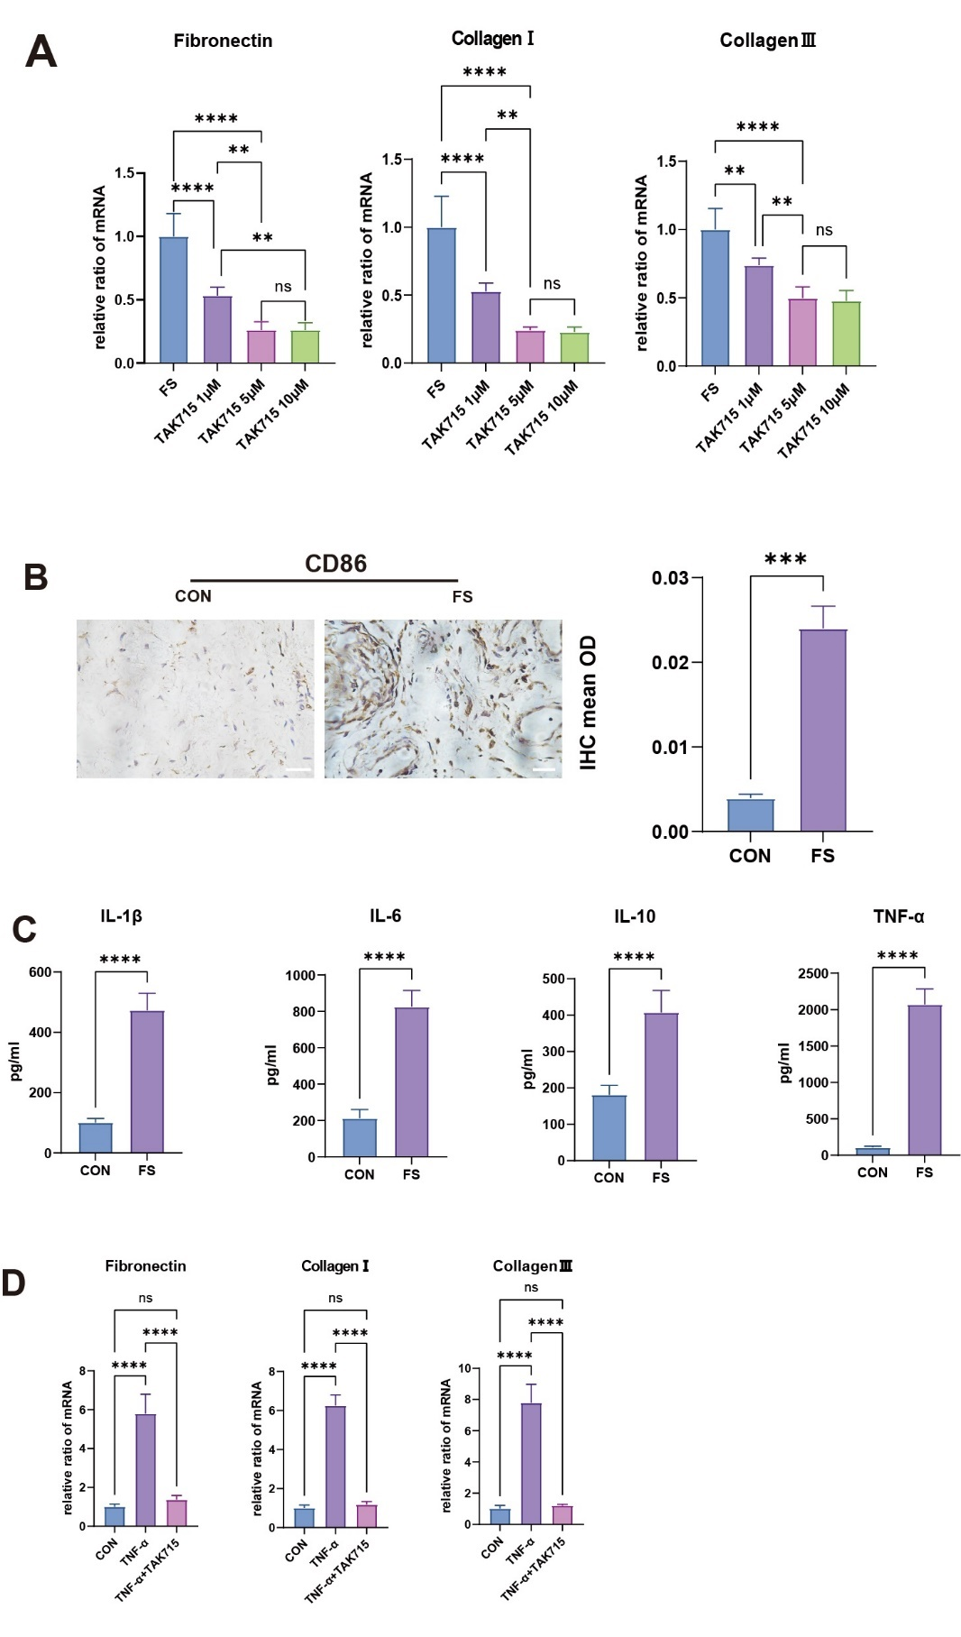

Supplementary figure 1.
(A) The statistic results(n=6) of qRT-PCR analysis of the TAK715 effect on reversing the fibrotic process of FS synovium fibroblasts. *P< 0.05; **P < 0.01; *** P < 0.001; **** P < 0.0001.
(B)The representative IHC results of CD86(+) macrophage infiltration in control and FS tissues. FS tissue. Scale Bar: 50μm.The statistics analysis of the IHC was also performed on the right. the mean optical density (mean OD) of CD86 in the control and FS tissues(n=3). *P< 0.05; **P < 0.01; *** P < 0.001; **** P < 0.0001.
(C)The ELISA results of IL-1β, IL-6，IL-10 and TNF-α concentrations in the glenohumeral joint fluid(n=6). *P< 0.05; **P < 0.01; *** P < 0.001; **** P < 0.0001.
(D)The statistic results(n=6) of qRT-PCR analysis of TNF-α stimulating the control synovium fibroblasts into the fibrotic process and the TAK715 could inhibit this stimulation on synovium fibroblasts. *P< 0.05; **P < 0.01; *** P < 0.001; **** P < 0.0001.

Supplementary Figure 2. the osteoporosis rats were successfully constructed. (A) (B)The micro-CT scan of femur distal end in control and OVX group. The micro-CT images showed that the OVX group had a more scattered trabecular. (C) The statistic results(n=6) of Bone Volume/Total Volume, Trabecular number, Trabecular spacing, Trabecular thickness and Bone surface area/ Bone Volume in figure(A)(B).
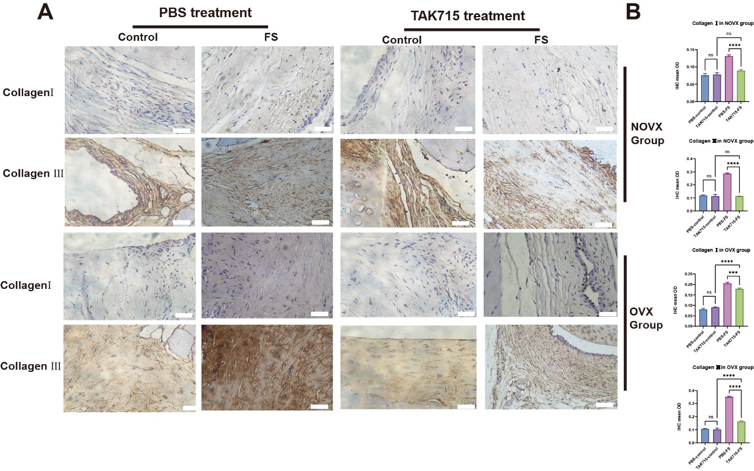
Figure3. IHC analysis of Collagen Ⅰ and Collagen Ⅲ of FS shoulder joint.
(A)Representative Collagen Ⅰ and Collagen Ⅲ immuno-stained tissue sections in rat shoulder joint. Scale Bar: 50μM
(B)The statistics analysis of (A): the mean optical density (mean OD) of Collagen Ⅰ and Collagen Ⅲ in rat shoulder joint. (n=6). *P< 0.05; **P < 0.01; *** P < 0.001; **** P < 0.0001.

