Supporting Information
Reversible in-situ assembly of PROTACs using iminoboronate conjugation
Ce Yang,ª Yayun Xie,ª Xiaoxiao Yang,ª Jun Yin,^{a,}* and Binghe Wang^{a,}*
Corresponding Authors Dr. J. Yin and Prof. Dr. B. Wang.
ª Department of Chemistry and Center for Diagnostics and Therapeutics, Georgia State University, Atlanta, GA 30303 United State

E-mail: wang@gsu.edu or junyin@gsu.edu

Table of Contents

1. Experimental methods and Data………………………….………………………………………...2
1.1 Biology………………………………………………………………………………………..….2
1.2 Chemistry………………………………………………………………………………………..4
2. NMR spectra…………………………………………………………………….…………….………8

- Experimental methods
  - Biology
    - Construction of the pcDNA5-Aurora B-EGFP-HaloTag2 expression plasmids
The Aurora B gene was PCR amplified from the plasmid pHAGE-P-CMVt-N-HA-GAW-AURKB (Addgene #100142) and digested by restriction enzymes NheI and HindIII. The digested fragment was cloned into the plasmid pCDNA5-HA-EGFP-HaloTag2 (Addgene #41742)4 between the two restriction sites to afford the pcDNA5-Aurora B-EGFP-HaloTag2 plasmid.

    - Cell culture and immunoblotting
HEK293-T cells were cultured using standard protocols at 37 °C and 5% CO₂ in DMEM and supplemented with 10% FBS, 100 U mL⁻¹ penicillin, and 100 μg mL⁻¹ streptomycin. The pCDNA5-HA-EGFP-HaloTag2 plasmid was acquired from Addgene (#41742). 2 µg of the plasmid was used to transfect HEK293-T cells cultured in a 6-well plate following a general transfection protocol. Various concentrations of compounds were dissolved in DMSO and added to 6-well plates of HEK293-T cells expressing EGFP-HaloTag2 at a uniformed DMSO concentration of 0.1% (v/v). After incubating 24 hours with PROTAC compounds, cells were then lysed with 150 µL of lysis buffer (1% Triton X-100, 0.1% SDS, 0.5% sodium deoxycholate, 150 mM NaCl, 25 mM Tris pH 8). Lysates were clarified by centrifugation at 16,000g for 10 min at 4 °C. The protein concentrations in the cell lysates were measured with a BSA assay, and lysates containing 4.5 µg of protein were loaded on a 4-20% Bis-Tris gel for SDS-PAGE analysis. Proteins on the PAGE gel were transferred onto a nitrocellulose membrane, which was blocked with 5% milk in TBST (25 mM Tris, pH 7.5, 150 mM NaCl, and 0.1% Triton X-100) and probed with anti-EGFP (1:2000) antibody and an anti-mouse IgG conjugated to horseradish peroxidase. The chemiluminescence signals from the blots were detected using a ChemiDoc MP Imaging System and quantified with the ImageJ software. The remaining levels of EGFP-HaloTag2 fusion in the cell after the treatment of compounds were quantified based on the band intensities on the Western blots and plotted against the compound concentrations with the Prism software.
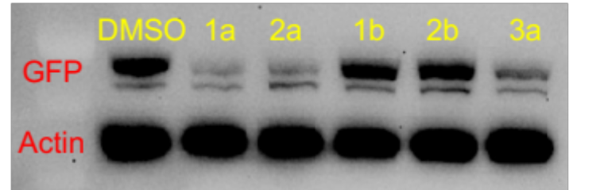
Figure S1. Activities of iminoboronate PROTAC precursors in inducing the degradation of GFP-HaloTag fusion in HEK293 cells. Cells expressing HaloTag GFP were treated with iminoboronate precursors 1a, 2a, 1b, 2b, or 3a for 24 h at 12.5 µM. The level of HaloTag GFP in cells was analyzed by western blotting the cell lysate probed with anti-GFP antibody. Anti-actin antibody probed western blots of the cell lysate were used as loading control.

    - Flow cytometry
HEK 293 FlpIn cells expressing GFP-HaloTag2 were treated with compounds for 24 hr. Treated cells were harvested by trypsinization and resuspended in serum-free DMEM followed by quantification of intracellular EGFP fluorescence on the FL1 channel of a FACSCalibur (BD Biosciences). The resulting data was quantified in terms of mean fluorescence intensity using CellQuest™ (BD Biosciences).
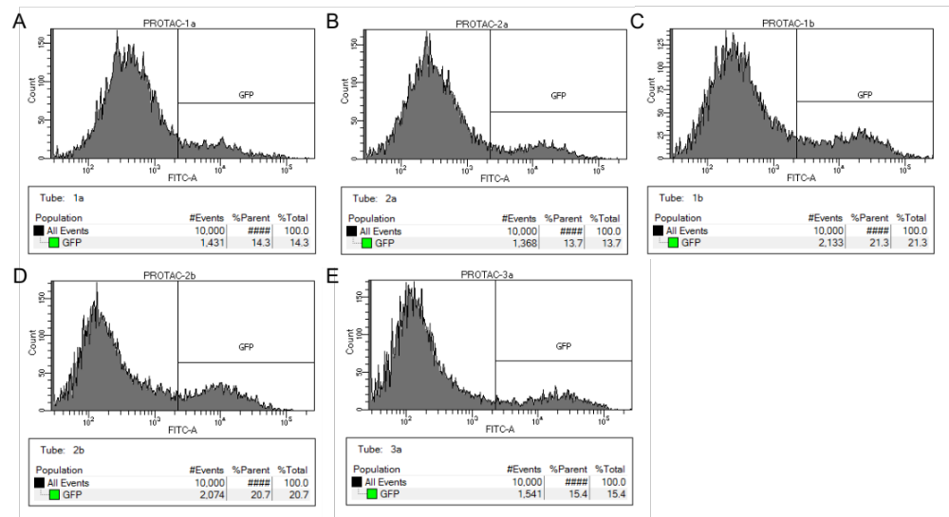
Figure S2. Analysis of GFP-HaloTag fusion protein levels by flow cytometry. HEK 293 cells expressing GFP-HaloTag were treated with (A) 12.5 μM 1a, (B) 12.5 μM 2a, (C) 12.5 μM 1b, (D) 12.5 μM 2b, or (E) 12.5 μM 3a for 24 h.

    - Cell viability MTT Assay
Cell viability in the presence of compound was assayed using the MTT assay with a CCK-8 dye. HEK293 cells were seeded into a 96-well plate incubated for 18-24 hrs at 37 °C with 5% CO₂. Cells were then treated with a range of concentrations of compounds dissolved in DMSO with the DMSO concentration maintained at 1% per volume in each well. Additionally, control cells were treated with DMSO in which the DMSO concentration was 1% per volume in each well. Cells were incubated for 20-22 hours with compounds or DMSO control before adding CCK-8 dye. 10 μL of CCK-8 dye was added to each well and incubated for 2 hrs before obtaining absorbance values using an H-1 synergy plate reader. All data for compound was standardized relative to the DMSO control, and all data generated represents the mean of at least 3 assays.

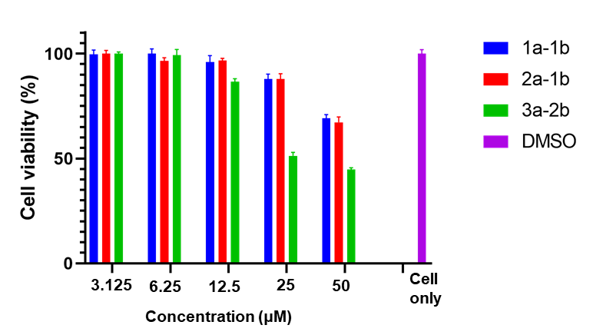
Figure S3. Cytotoxicity studies of iminoboronate conjugate pairs.

  - Chemistry
General information: Chemicals were purchased from commercial sources (Sigma Aldrich and Oakwood Chemicals). Analytical-grade solvents were used for all reactions. TLC analyses were conducted on silica gel plates. Column chromatography was carried out on flash silica gel (Sorbent 200–300 mesh). NMR spectra were recorded at 400 MHz for ¹H and 100 MHz for ¹³C on a Bruker Advance NMR spectrometer with TMS as the internal reference. High-resolution mass spectrometry (HRMS) and LCMS were performed using electrospray ionization (ESI) by the GSU Mass Spectrometry Facilities.
Synthesis of intermediate 5
Compound 4 (3 mmol, 1.0 equiv) was dissolved in DCM (5.5 mL) at room temperature. TEA (9 mmol, 3.0 equiv) and MsCl (4.5 mmol, 1.5 equiv) were added and the mixture was stirred overnight at room temperature. Then the mixture diluted with 10% critic acid aqueous solution (5 mL) and extracted with DCM (3 × 10 mL). Combined organic layers were dried over Na₂SO₄. The solvent was evaporated to afford intermediate 5 as a colourless oil. The product was directly used for the next step without purification.
Synthesis of intermediate 7a/7b
A mixture of compound 5 (3 mmol, 1 equiv), 6a/b (3 mmol, 1 equiv), K₂CO₃ (3 mmol, 1 equiv), and DMF (10 mL) was stirred at room temperature for overnight. Then the reaction mixture was diluted in ethyl acetate (15 mL). After water (10 mL) was added, the aqueous layer was extracted with ethyl acetate (2 × 12 mL). The combined organic layers were dried over Na₂SO₄ and concentrated. The residue was dried under vacuum. Then the residue was purified by flash chromatography by using hexane and EA as eluent to afford intermediate 7a/b as white solid.
Intermediate 7a. Isolated overall yield for four steps: 88%. ¹H NMR (CDCl₃): δ 7.58 (d, J = 8.7 Hz, 1H), 7.13 (d, J = 2.4 Hz, 1H), 6.85 (m, 1H), 3.98 (m, 2H), 3.55 (m, 2H), 2.61 (s, 3H), 1.80 (m, 4H), 1.60 – 1.37 (m, 4H). ¹³C NMR (CDCl₃): δ 199.1, 161.4, 132.4, 131.7, 121.3, 120.0, 113.5, 68.3, 45.0, 32.4, 30.0, 28.9, 26.6, 25.3.
Intermediate 7b. Isolated overall yield for four steps: 94%. ¹H NMR (CDCl₃): δ 10.21 (s, 1H), 7.88 (d, J = 8.7 Hz, 1H), 7.12 (d, J = 2.4 Hz, 1H), 6.91 (m, 1H), 4.03 (m, 2H), 3.55 (m, 2H), 1.81 (m, 4H), 1.52 (m, 4H). ¹³C NMR (CDCl_{3:}) δ 190.6, 164.1, 131.4, 128.8, 126.9, 118.9, 114.5, 68.6, 44.9, 32.4, 28.8, 26.5, 25.3.

Synthesis of 8a/b
A mixture of compound 7a/b (3 mmol, 1 equiv), B₂Pin₂ (3.6 mmol, 1.2 equiv), KOAc (9 mmol, 3 equiv), and PdCl₂(dppf) (0.09 mmol 0.03 equiv) in dioxane (10 mL) was purged three times with argon gas. Then the reaction mixture was stirred at 80 ºC for 8 hours. Then the crude mixture was diluted with ethyl acetate (12 mL) followed by the addition of water (12 mL). The organic layer was separated, and the aqueous layer was extracted with ethyl acetate (2 ×12 mL). The combined organic layers were dried over anhydrous Na₂SO₄. The solvent was evaporated and the residue was purified by flash column chromatography by using hexane and EA to afford 8a/b as white solid.
8a. Isolated overall yield for four steps: 53%. ¹H NMR (CDCl₃): δ 7.81 – 7.72 (m, 1H), 6.95 (d, J = 2.4 Hz, 1H), 6.84 (m, 1H), 4.01 (m, 2H), 3.54 (m, 2H), 2.54 (s, 3H), 1.88 – 1.73 (m, 4H), 1.56 – 1.46 (m, 4H), 1.43 (s, 12H). ¹³C NMR (CDCl₃): δ 198.4, 162.8, 133.3, 130.7, 117.9, 113.9, 83.6, 67.8, 45.0, 32.4, 28.9, 26.5, 25.3, 25.0, 24.9, 24.8. HRMS (ESI) m/z: Calculated for C₁₆H₂₁O₂ [M+H]⁺ 245.1542; Found 245.1541.
8b. Isolated overall yield for four steps: 57%. ¹H NMR (CDCl₃):δ 10.34 (s, 1H), 8.02 – 7.80 (m, 1H), 7.28 – 7.25 (m, 1H), 6.99 (m, 1H), 4.04 (m, 2H), 3.54 (m, 2H), 1.80 (s, 5H), 1.50 (s, 4H), 1.38 (s, 12H). ¹³C NMR (CDCl_{3:}) δ 192.9, 162.9, 134.4, 130.7, 120.6, 116.3, 84.4, 67.9, 44.9, 32.4, 28.9, 26.6, 25.3, 25.0, 24.8. HRMS (ESI) m/z: Calculated for C₁₇H₁₉O₃ [M-H]⁻ 271.1334; Found 271.1345.
Synthesis of 1a or 2a
Compound 8a/b (3 mmol, 1 equiv) was dissolved in 5 mL of THF/H₂O (4:1). To this solution, NaIO₄ (9 mmol, 3 equiv) was added to it and stirred for about 30 min at room temperature. After that 5 mL of 1N HCl solution was added and stirred for another 2 h at room temperature. After completion of the reaction (confirmed by TLC), THF was evaporated under vacuum and the aqueous solution was extracted with ethyl acetate (2 ×12 mL). The combined organic layers were dried over anhydrous Na₂SO₄. The solvent was evaporated and the residue was purified by flash column chromatography by using hexane and EA to afford 1a or 2a as white solid.
1a. Isolated overall yield for four steps: 51%. ¹H NMR (400 MHz, Methanol-d4) δ 7.99 (d, J = 8.6 Hz, 1H), 6.98 (d, J = 11.0 Hz, 1H), 6.91 (s, 1H), 4.09 (t, J = 6.3 Hz, 2H), 3.57 (t, J = 6.6 Hz, 2H), 2.60 (s, 3H), 1.95 – 1.70 (m, 4H), 1.61 – 1.39 (m, 4H). ¹³C NMR (101 MHz, Methanol-d4) δ 201.9, 165.2, 133.8, 132.6, 117.5, 114.9, 69.2, 45.6, 33.7, 30.0, 27.6, 26.4, 24.1. HRMS (ESI) m/z: Calculated for C₁₄H₁₉O₄ClB [M-H]⁻ 297.1065; Found 297.1077.
2a. Isolated overall yield for four steps: 49%. ¹H NMR (CDCl₃):δ 9.67 (s, 1H), 8.01 (d, J = 8.7 Hz, 1H), 7.05 (m, 1H), 6.80 (d, J = 2.5 Hz, 1H), 4.05 (t, J = 6.4 Hz, 2H), 3.55 (t, J = 6.6 Hz, 2H), 1.94 – 1.72 (m, 4H), 1.57 – 1.40 (m, 4H). ¹³C NMR (CDCl_{3:})δ 189.7, 162.9, 143.7, 130.5, 128.1, 116.7, 114.9, 68.3, 44.9, 32.4, 28.9, 26.5, 25.3. HRMS (ESI) m/z: Calculated for C₁₃H₁₇O₄ClB [M-H]⁻ 283.0908; Found 283.0937.

Synthesis of intermediate 9
BocNHNH₂ (5 mmol, 5 equiv) was added to a solution of compound 5 (1 mmol, 1 equiv) in anhydrous DMF (10 mL) at room temperature. After stirring for overnight, water (10 mL) was added in the reaction mixture. The aqueous layer was extracted twice with DCM (15 mL). The combined organic layers were dried by anhydrous Na₂SO₄. After concentration, the residue was purified by silica gel flash column (EtOAc/n-hexane) chromatography to afford intermediate 9 as a colourless oil.
Intermediate 9. Isolated overall yield for four steps: 89%. ¹H NMR (CDCl₃): δ 6.44 (s, 1H), 3.70 (s, 1H), 3.47 (m, 2H), 2.77 (m, 2H), 1.71 (m, 2H), 1.40 (s, 9H), 1.37 (s, 4H), 1.31 (m, 2H). ¹³C NMR (CDCl₃): δ 156.8, 80.3, 51.8, 44.9, 32.4, 28.3, 27.6, 26.7, 26.3.
Synthesis of 3a
To a mixture of intermediate 8 (1 mmol, 1 equiv) in DCM (5 ml) in a dry round-bottom flask was added TFA (5 ml). The reaction mixture was stirred at room temperature for 1 hour. Upon the complete consumption of the starting material as indicated by TLC, the mixture was evaporated to afford 3a as a colorless oil.
3a. Isolated yield: 99%. ¹H NMR (400 MHz, Methanol-d4) δ 3.56 (m, 2H), 3.15 – 2.96 (m, 2H), 1.78 (m, 2H), 1.67 (m, 2H), 1.57 – 1.34 (m, 4H). ¹³C NMR (101 MHz, Methanol-d4) δ 51.1, 48.2, 48.0, 47.8, 47.6, 47.4, 47.2, 44.1, 32.0, 26.0, 25.4, 24.4. HRMS (ESI) m/z: Calculated for C₆H₁₆N₂Cl [M+H]⁺ 151.1002; Found 151.1005.
Synthesis of intermediate 12
Compound 10 (3 mmol, 3 equiv) was added into a solution of compound 11 (1 mmol, 1 equiv) in dry DCM (10 mL). Then, DBU (0.9 mmol, 0.9 equiv) was added into the mixture and the mixture was stirred at room temperature for overnight. After stirring for overnight, the reaction was quenched by addition of water (10 mL). The aqueous layer was extracted twice with DCM (15 mL). The combined organic layers were dried by anhydrous Na₂SO₄. After concentration, the residue was purified by silica gel flash column (EtOAc/n-hexane) chromatography to afford intermediate 12 as a colourless oil.
12. Isolated overall yield for four steps: 89%. ¹H NMR (CDCl₃): δ 7.46 (s, 1H), 3.80 (t, J = 6.2 Hz, 2H), 3.39 (t, J = 6.6 Hz, 2H), 1.92 (m, 2H), 1.78 – 1.64 (m, 2H), 1.41 (s, 9H). ¹³C NMR (CDCl₃): δ 156.9, 81.5, 75.4, 33.6, 29.2, 28.2, 28.1, 26.5.

Synthetic procedure for 14
Compound 13 (1 mmol, 1 equiv) was dissolved in 1 mL of DMF followed by the addition of compound 12 (1 mmol, 1 equiv.) and Na₂HCO₃. The mixture was at 70 ºC for 4 hours. Then, the reaction mixture was concentrated under vacuum and the crude product was purified by silica gel column chromatography (EtOAc/DCM) to yield the desired product as a white solid.
14. Isolated yield: 64%. ¹H NMR (400 MHz, DMSO-d6) δ 11.11 (s, 1H), 9.95 (s, 1H), 7.95 (s, 1H), 7.81 (m, 1H), 7.53 (m, 1H), 7.45 (m, 1H), 5.08 (m, 1H), 4.24 (m, 2H), 3.76 (m, 2H), 2.89 (s, 3H), 2.73 (s, 2H), 2.08 – 1.93 (m, 1H), 1.90 – 1.77 (m, 2H), 1.77 – 1.62 (m, 2H), 1.40 (s, 9H). ¹³C NMR (101 MHz, DMSO-d6) δ 196.8, 173.2, 165.7, 162.7, 156.6, 156.4, 137.5, 133.7, 120.2, 116.6, 115.6, 79.95 , 75.2, 68.9, 49.1, 36.2, 31.4, 28.5, 25.6, 24.4, 22.4.
Synthesis of 1b
To a mixture of intermediate 13 (1 mmol, 1 equiv) in DCM (5 ml) in a dry round-bottom flask was added TFA (5 ml). The reaction mixture was stirred at room temperature for 1 hour. Upon the complete consumption of the starting material as indicated by TLC, the mixture was evaporated to afford 1b as a white solid.
Intermediate 1b. Isolated yield: 98%. ¹H NMR (400 MHz, DMSO-d6) δ 11.11 (s, 1H), 7.82 (m, 1H), 7.52 (d, J = 8.5 Hz, 1H), 7.46 (d, J = 7.3 Hz, 1H), 5.08 (d, J = 17.9 Hz, 1H), 4.25 (s, 2H), 4.01 (s, 2H), 2.89 (s, 2H), 2.73 (s, 1H), 2.66 – 2.54 (m, 1H), 2.04 (s, 1H), 1.81 (s, 4H).¹³C NMR (101 MHz, DMSO-d6) δ 173.2, 170.4, 167.2, 156.3, 137.5, 133.7, 120.2, 115.7, 74.2, 68.6, 49.2, 31.4, 25.2, 24.2, 22.4. HRMS (ESI) m/z: Calculated for C₁₇H₂₀N₃O₆ [M+H]⁺ 362.1352; Found 362.1350.

- NMR spectra
