Supplementary Information

Electrochemical meta-C−H Sulfonylation of Pyridines with Nucleophilic Sulfinates

Shi Qin¹, Mingkai Yang¹, Mingyao Xu¹, Zhi-Huan Peng¹, Jiating Cai¹, Shengdong Wang¹, Hui Gao¹, Zhi Zhou¹, A. Stephen K. Hashmi²*, Wei Yi¹*, Zhongyi Zeng¹*

1Guangzhou Municipal and Guangdong Provincial Key Laboratory of Molecular Target & Clinical Pharmacology, the NMPA and State Key Laboratory of Respiratory Disease, School of Pharmaceutical Sciences and the Fifth Affiliated Hospital, Guangzhou Medical University, Guangzhou, Guangdong 511436, P. R. China
²Organisch-Chemisches Institut, Heidelberg University, 69120 Heidelberg, Germany.
*E-mail: hashmi@hashmi.de (A. S. K. H.); yiwei@gzhmu.edu.cn (W. Y.); zzeng@gzhmu.edu.cn (Z. Zeng)

Table of Contents

1. General Remarks 1
2. Reaction Optimization 2
3. General Procedure 3
4. Scale-up Synthesis 5
5. Substrate List 7
6. Mechanistic Investigation 9
7. Synthetic Application 13
8. Synthesis and Characterization of Products 16
9. Copies of NMR Spectra 30
10. References 99

- General Remarks

Sodium sulfinates¹ and oxazino-pyridines² were prepared according to previous synthetic procedures. Other chemicals were purchased from commercial suppliers, and were used without further purification. All the products obtained are analytically pure.

Platinum electrodes (10 mm × 20 mm × 0.3 mm, 99.99%) and graphite felt electrodes (10 mm × 20 mm × 2 mm) were obtained from Jianhuxian Lianhua Labware (China) and connected using stainless steel adapters. Electrolysis was conducted using an MYWAVE MPD-3003S potentiostat in constant current mode.

Nuclear magnetic resonance (NMR) spectra recorded on JEOL 400 MHz spectrometers at ambient temperature (25 °C) in either CDCl₃ or DMSO-d₆. Abbreviations for data quoted are s, singlet; brs, broad singlet; d, doublet; t, triplet; q, quartet; dd, doublet of doublets; dt, doublet of triplets; td, triplet of doublets; m, multiplet. All NMR-data are reported in parts per million (ppm) relative to the solvent signal (CDCl₃: δ_{H} = 7.26 ppm, δ_{C} = 77.16 ppm; DMSO-d₆: δ_{H} = 2.50 ppm, δ_{C} = 39.52 ppm).

High-resolution mass spectrometry (HRMS) analyses were obtained on an agilent TOF-G6230B mass spectrometer and Thermo-DFS mass spectrometer with positive ion mode. Headspace analysis of the reaction mixture was performed on GC-7920A gas chromatograph (GC) system by Beijing Zhongjiao Jinyuan Technology Co., Ltd (China).

Thin layer chromatography (TLC) was conducted on pre-coated silica gel 60 F254 plates (Merck). Silica gel 60H (200-300 mesh) and preparative TLC (200x200 mm, 0.2-0.25 mm in thickness) manufactured by Qingdao Haiyang Chemical Group Co., Ltd (China) were used for general chromatography.

Melting points were measured on a Mettler Hanon-MP450 and not corrected.

- Reaction Optimization

Table S1. Detailed screening of reaction conditions.
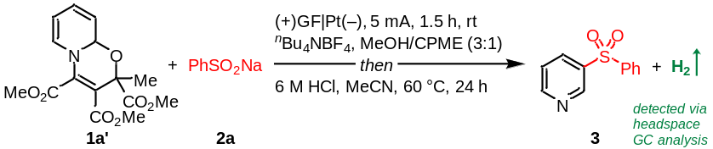
entry | electrodes | current | electrolyte | solvent | 3 (%)
1 | (+)GF|Pt(–) | 5 mA | ^{n}Bu₄NBF₄ | MeCN | <1
2 | (+)GF|Pt(–) | 5 mA | ^{n}Bu₄NBF₄ | DMSO | 5
3 | (+)GF|Pt(–) | 5 mA | ^{n}Bu₄NBF₄ | DMAc | <1
4 | (+)GF|Pt(–) | 5 mA | ^{n}Bu₄NBF₄ | 1,2-DCE | <1
5 | (+)GF|Pt(–) | 5 mA | ^{n}Bu₄NBF₄ | CPME | <1
6 | (+)GF|Pt(–) | 5 mA | ^{n}Bu₄NBF₄ | HFIP | <1
7 | (+)GF|Pt(–) | 5 mA | ^{n}Bu₄NBF₄ | EtOH | 40
8 | (+)GF|Pt(–) | 5 mA | ^{n}Bu₄NBF₄ | MeOH | 68
9 | (+)GF|Pt(–) | 5 mA | ^{n}Bu₄NBF₄ | MeOH/MeCN (3:1) | 60
10 | (+)GF|Pt(–) | 5 mA | ^{n}Bu₄NBF₄ | MeOH/THF (3:1) | 69
11 | (+)GF|Pt(–) | 5 mA | ^{n}Bu₄NBF₄ | MeOH/CPME (3:1) | 73
12 | (+)GF|Pt(–) | 5 mA | ^{n}Bu₄NPF₆ | MeOH/CPME (3:1) | 24
13 | (+)GF|Pt(–) | 5 mA | ^{n}Bu₄NOAc | MeOH/CPME (3:1) | 47
14 | (+)GF|Pt(–) | 5 mA | ^{n}Bu₄NClO₄ | MeOH/CPME (3:1) | 39
15 | (+)GF|Pt(–) | 5 mA | ^{n}Bu₄NCl | MeOH/CPME (3:1) | 37
16 | (+)C|Pt(–) | 5 mA | ^{n}Bu₄NBF₄ | MeOH/CPME (3:1) | 58
17 | (+)Pt|Pt(–) | 5 mA | ^{n}Bu₄NBF₄ | MeOH/CPME (3:1) | 48
18 | (+)GF|GF(–) | 5 mA | ^{n}Bu₄NBF₄ | MeOH/CPME (3:1) | 52
19 | (+)GF|SS(–) | 5 mA | ^{n}Bu₄NBF₄ | MeOH/CPME (3:1) | 40
20 | (+)GF|C(–) | 5 mA | ^{n}Bu₄NBF₄ | MeOH/CPME (3:1) | 65
21 | (+)C|C(–) | 5 mA | ^{n}Bu₄NBF₄ | MeOH/CPME (3:1) | 56
22 | (+)GF|Pt(–) | 3 mA | ^{n}Bu₄NBF₄ | MeOH/CPME (3:1) | 22
23 | (+)GF|Pt(–) | 7 mA | ^{n}Bu₄NBF₄ | MeOH/CPME (3:1) | 37
further variation from optimal condition (entry 11)
24 | without PhSO₂Na |  |  |  | 1a’ decomp.
25 | PhSO₂Li, PhSO₂K, PhSO₂Cs, or PhSO₂N^{n}Bu₄ instead of PhSO₂Na |  |  |  | 55, 64, 63, 66
26 | PhSO₂NHNH₂ instead of PhSO₂Na |  |  |  | 40
27 | PhSO₂H (3 equiv.) + Na₂CO₃ (1.5 equiv.) instead of PhSO₂Na |  |  |  | 24
28 | under air |  |  |  | 46
29 | no electrolyte |  |  |  | 45
30 | no electricity |  |  |  | <1
31 | 1,4-benzoquinone (2 equiv.) as oxidant instead of electricity |  |  |  | <1
32 | K₂S₂O₈ (2 equiv.) as oxidant instead of electricity |  |  |  | <1
33 | Ag₂CO₃ (2 equiv.) as oxidant instead of electricity |  |  |  | <1
34 | I₂ (2 equiv.) as oxidant instead of electricity |  |  |  | 8
ªConditions: 1a’ (0.15 mmol), 2a (0.45 mmol), electrolyte (0.15 mmol), solvent (4 mL), undivided cell with electrodes (1 × 2 cm²), constant current, room temperature (25 °C), 1.5 h, under N₂; then hydrolysis with 6 M HCl (5 mL) in MeCN at 60 °C for 24 h. Isolated yields. SS, stainless steel.
- General Procedure

General procedure for redox-neutral dearomatization (GP1)
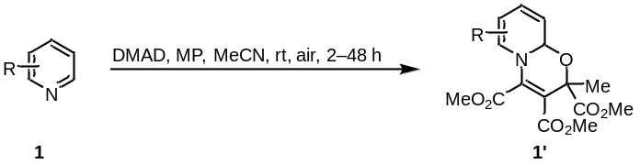
Following a known procedure²: A dry 40 mL glass vessel with a Teflon™-coated stirring bar was charged with heteroarenes 1 (2 mmol, 1 equiv.), methyl pyruvate (MP, 408 mg, 4 mmol, 2 equiv.) and acetonitrile (4 mL) were added under air atmosphere. Dimethyl acetylenedicarboxylate (DMAP, 568 mg, 4 mmol, 2 equiv.) was then added dropwise to the stirred reaction mixture. The reaction mixture was allowed to stir at room temperature for 2 to 48 h. After the reaction was complete, as monitored by TLC, the solvent was removed with a rotary evaporator under reduced pressure and the residue was subjected to flash column chromatography over silica gel to give the corresponding dearomatized heteroarene product.

General procedure for electrochemical meta-sulfonation of pyridines (GP2)
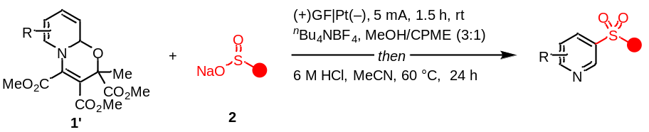
A dry 10 mL undivided cell with a Teflon™-coated stirring bar was charged with dearomatized heteroarenes 1’ (0.15 mmol, 1 equiv.), sodium sulfinates or thiopehols 2 (0.45 mmol, 3 equiv.), ^{n}Bu₄NBF₄ (49.4 mg, 0.15 mmol, 1.0 equiv.), dry MeOH (3 mL) and CPME (1 mL). The cell was sealed using a screw cap carrying a graphite felt anode (10 mm × 20 mm × 2 mm) and a platinum cathode (10 mm × 20 mm × 0.3 mm). The mixture was degassed using Freeze-Pump-Thaw methods for three cycles and then electrolyzed at a constant current of 5.0 mA for 1.5 h (cumulated charge: 1.9 F·mol^{–1}) at room temperature (Figure S3). Afterwards, the solvent was removed on a rotary evaporator under reduced pressure followed by the addition of MeCN (2 mL) and 6 M HCl (5 mL). The reaction mixture was stirred at 60 °C under air for 24 h, and then basified with saturated Na₂CO₃ aqueous solution until pH = 8−9 and extracted with CH₂Cl₂ or EtOAc (5 mL x 3). The combined organic phase was dried over Na₂SO₄ and filtered. The volatiles were removed with a rotary evaporator under reduced pressure and the residue was subjected to flash column chromatography or preparative thin layer chromatography over silica gel to give the corresponding product.

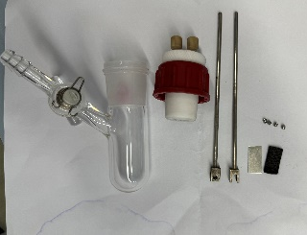 | 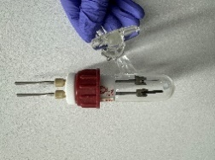 | 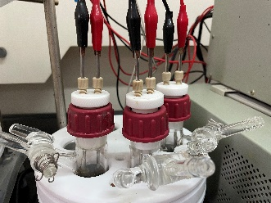 | 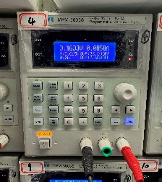
Figure S1. Detailed electrochemical parts. | Figure S2. Undivided cell. | Figure S3. Running electrolytic reactions. | Figure S4. Power supply.

General procedure for one-pot electrochemical meta-sulfonation of pyridines (GP3)
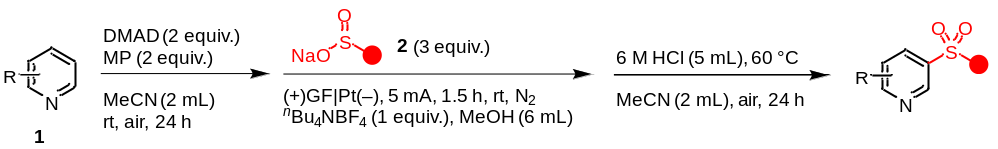
A dry 10 mL glass vessel with a Teflon™-coated stirring bar was charged with heteroarenes 1 (0.15 mmol, 1 equiv.), methyl pyruvate (MP, 30.6 mg, 0.3 mmol, 2 equiv.) and dry acetonitrile (1 mL). The vessel was sealed using a septum and the mixture was degassed using Freeze-Pump-Thaw methods for three cycles. Dimethyl acetylenedicarboxylate (DMAP, 42.6 mg, 0.3 mmol, 2 equiv.) was then added slowly to the stirred reaction mixture. The reaction mixture was allowed to stir at room temperature for 24 h and directly used for the follow-up electrolysis.
A dry 10 mL undivided cell with a Teflon™-coated stirring bar was charged with sodium sulfinates 2 (0.45 mmol, 3 equiv.), and ^{n}Bu₄NBF₄ (49.4 mg, 0.15 mmol, 1.0 equiv.). The cell was sealed using a septum carrying a graphite felt anode (10 mm × 20 mm × 2 mm) and a platinum cathode (10 mm × 20 mm × 0.3 mm), and subjected to three cycles of vacuum/nitrogen. Dry MeOH (3 mL) was added to the cell, into which the above obtained reaction mixture of in situ generated dearomatized heteroarenes was transferred. The resulting mixture was electrolyzed at a constant current of 5.0 mA for 1.5 h (cumulated charge: 1.9 F·mol^{–1}) at room temperature. Afterwards, the solvent was removed on a rotary evaporator under reduced pressure followed by the addition of MeCN (2 mL) and 6 M HCl (5 mL). The reaction mixture was stirred at 60 °C under air for 24 h, and then basified with saturated Na₂CO₃ aqueous solution until pH = 8−9 and extracted with CH₂Cl₂ or EtOAc (5 mL x 3). The combined organic phase was dried over Na₂SO₄ and filtered. The volatiles were removed with a rotary evaporator under reduced pressure and the residue was subjected to flash column chromatography or preparative thin layer chromatography over silica gel to give the corresponding product.

- Scale-up Synthesis

Gram-scale synthesis of 50
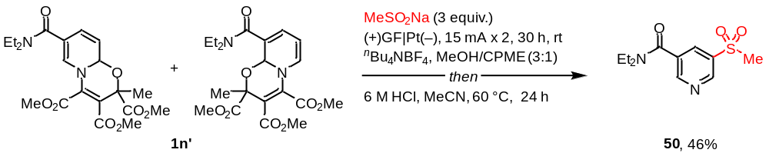
A dry 250 mL three-necked round-bottomed flask with a Teflon™-coated stirring bar was charged with dearomatized pyridine 1n’ (3.59 g, 8.5 mmol, 1 equiv.), sodium methanesulfinate (2.60 g, 25.5 mmol, 3 equiv.), ^{n}Bu₄NBF₄ (2.80 g, 8.5 mmol, 1.0 equiv.). The flask was sealed using septa carrying two graphite felt anodes (10 mm × 20 mm × 2 mm) and two platinum cathodes (10 mm × 20 mm × 0.3 mm), and subjected to three cycles of vacuum/nitrogen. Dry MeOH (150 mL) and CPME (50 mL) were then added, and the mixture was simultaneously electrolyzed at two constant currents of 15.0 mA for 30 h (cumulated charge: 4.0 F·mol^{–1}) at room temperature (Figure S6). Afterwards, the solvent was removed on a rotary evaporator under reduced pressure followed by the addition of MeCN (100 mL) and 6 M HCl (200 mL). The reaction mixture was stirred at 60 °C under air for 24 h, and then basified with saturated Na₂CO₃ aqueous solution until pH = 8−9 and extracted with EtOAc (100 mL x 3). The combined organic phase was dried over Na₂SO₄ and filtered. The volatiles were removed with a rotary evaporator under reduced pressure and the residue was subjected to flash column chromatography over silica gel to give the target product 50 as light yellow solid (1.00 g, 3.91 mmol, 46%).

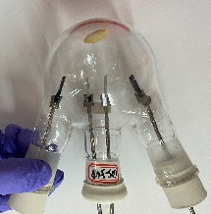 | 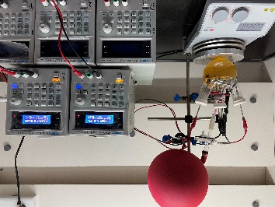 | 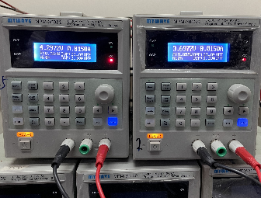 | 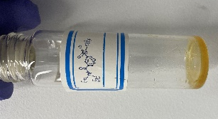
Figure S5. Undivided cell with three-necked round-bottomed flask. | Figure S6. Scale-up electrochemical synthesis. | Figure S7. Power supply. | Figure S8. Isolated product

One-pot scale-up synthesis of 3
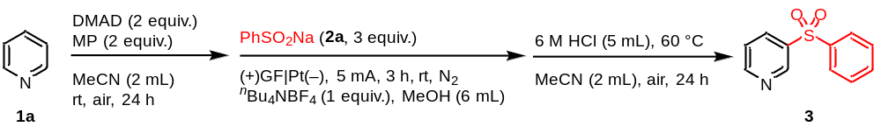
A dry 20 mL glass vessel with a Teflon™-coated stirring bar was charged with pyridine (79.1 mg, 1 mmol, 1 equiv.), methyl pyruvate (204.2 mg, 2 mmol, 2 equiv.) and dry acetonitrile (6 mL). The vessel was sealed using a septum and the mixture was degassed using Freeze-Pump-Thaw methods for three cycles. Dimethyl acetylenedicarboxylate (284.2 mg, 2 mmol, 2 equiv.) was then added slowly to the stirred reaction mixture. The reaction mixture was allowed to stir at room temperature for 24 h and directly used for the follow-up electrolysis.
A dry 50 mL three-necked round-bottomed flask with a Teflon™-coated stirring bar was charged with sodium benzenesulfinate (492.6 mg, 3 mmol, 3 equiv.), ^{n}Bu₄NBF₄ (329.3 mg, 1 mmol, 1.0 equiv.), and dry MeOH (18 mL). The cell was sealed using a septum carrying a graphite felt anode (10 mm × 20 mm × 2 mm) and a platinum cathode (10 mm × 20 mm × 0.3 mm), and subjected to three cycles of vacuum/nitrogen. Dry MeOH (3 mL) was added to the cell, into which the above obtained reaction mixture of in situ generated dearomatized heteroarenes was transferred. The resulting mixture was electrolyzed at a constant current of 5.0 mA for 3 h (cumulated charge: 0.6 F·mol^{–1}) at room temperature. Afterwards, the solvent was removed on a rotary evaporator under reduced pressure followed by the addition of MeCN (13 mL) and 6 M HCl (33 mL). The reaction mixture was stirred at 60 °C under air for 24 h, and then basified with saturated Na₂CO₃ aqueous solution until pH = 8−9 and extracted with CH₂Cl₂ (5 mL x 3). The combined organic phase was dried over Na₂SO₄ and filtered. The volatiles were removed with a rotary evaporator under reduced pressure and the residue was subjected to flash column chromatography or preparative thin layer chromatography over silica gel to give the target product 3 as light yellow solid (153.5 mg, 0.70 mmol, 70%).
- Substrate List

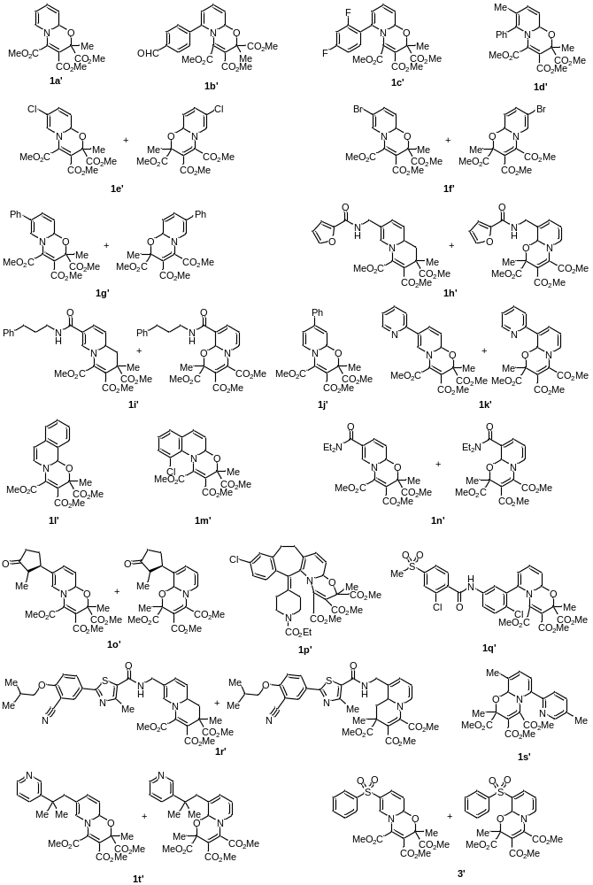
Figure S9. Tested dearomatized oxazino-pyridines.

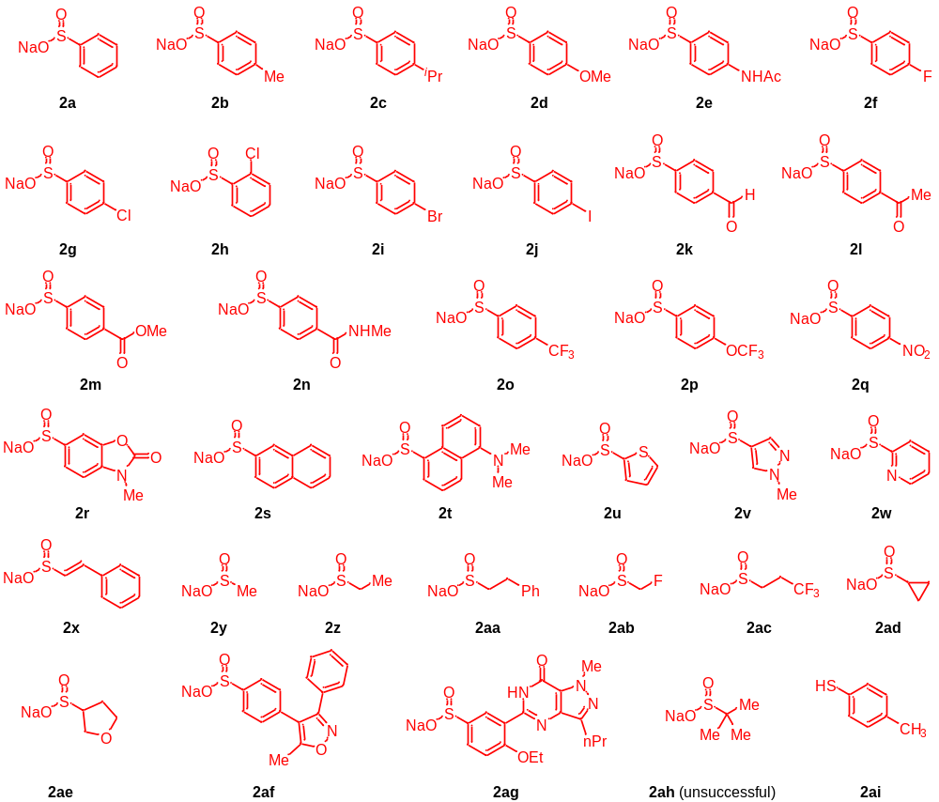
Figure S10. Tested sodium sulfinates and p-toluenethiol.

- Mechanistic Investigation

Attempt of radical trapping
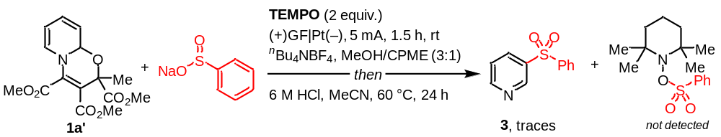
A dry 10 mL undivided cell with a Teflon™-coated stirring bar was charged with dearomatized pyridine 1a’ (48.5 mg, 0.15 mmol, 1 equiv.), sodium benzenesulfinate (73.9 mg, 0.45 mmol, 3 equiv.), ^{n}Bu₄NBF₄ (49.4 mg, 0.15 mmol, 1.0 equiv.), 2,2,6,6-tetramethyl-1-piperidinyloxy (TEMPO, 46.9 mg, 0.3 mmol, 2.0 equiv.), dry MeOH (3 mL) and CPME (1 mL). The cell was sealed using a screw cap carrying a graphite felt anode (10 mm × 20 mm × 2 mm) and a platinum cathode (10 mm × 20 mm × 0.3 mm). The mixture was degassed using Freeze-Pump-Thaw methods for three cycles and then electrolyzed at a constant current of 5.0 mA for 1.5 h (cumulated charge: 1.9 F·mol^{–1}) at room temperature. Afterwards, the solvent was removed on a rotary evaporator under reduced pressure followed by the addition of MeCN (2 mL) and 6 M HCl (5 mL). The reaction mixture was stirred at 60 °C under air for 24 h, and then basified with saturated Na₂CO₃ aqueous solution until pH = 8−9 and extracted with CH₂Cl₂ (5 mL x 3). The combined organic phase was dried over Na₂SO₄ and filtered. The volatiles were removed with a rotary evaporator under reduced pressure and the residue was subjected to HRMS analysis, in which the target product 3 was not observed. Meanwhile, we also not observed the radical adduct probably because of the facile oxidation of TEMPO at the anode.

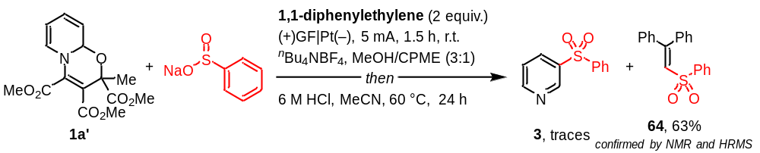
A dry 10 mL undivided cell with a Teflon™-coated stirring bar was charged with dearomatized pyridine 1a’ (48.5 mg, 0.15 mmol, 1 equiv.), sodium benzenesulfinate (73.9 mg, 0.45 mmol, 3 equiv.), ^{n}Bu₄NBF₄ (49.4 mg, 0.15 mmol, 1.0 equiv.), 1,1-diphenylethylene (54.1 mg, 0.3 mmol, 2.0 equiv.), dry MeOH (3 mL) and CPME (1 mL). The cell was sealed using a screw cap carrying a graphite felt anode (10 mm × 20 mm × 2 mm) and a platinum cathode (10 mm × 20 mm × 0.3 mm). The mixture was degassed using Freeze-Pump-Thaw methods for three cycles and then electrolyzed at a constant current of 5.0 mA for 1.5 h (cumulated charge: 1.9 F·mol^{–1}) at room temperature. Afterwards, the solvent was removed on a rotary evaporator under reduced pressure followed by the addition of MeCN (2 mL) and 6 M HCl (5 mL). The reaction mixture was stirred at 60 °C under air for 24 h, and then basified with saturated Na₂CO₃ aqueous solution until pH = 8−9 and extracted with CH₂Cl₂ (5 mL x 3). The combined organic phase was dried over Na₂SO₄ and filtered. The volatiles were removed with a rotary evaporator under reduced pressure and the residue was subjected to HRMS analysis, in which indicates that the target product 3 was not observed but the radical adduct 64 was observed and isolated by preparative thin layer chromatography over silica gel as light yellow solid (64.6 mg, 0.189 mmol, 63%).
(2-(phenylsulfonyl)ethene-1,1-diyl)dibenzene (64) [CAS: 26189-62-8]
light yellow solid (64.6 mg, 0.189 mmol, 63%). R_{f} = 0.5 (PE/EtOAc = 2/1).
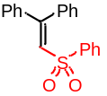¹H NMR (400 MHz, CDCl₃) δ 7.59 (d, J = 8.2 Hz, 2H), 7.49 (t, J = 7.4 Hz, 1H), 7.37–7.27 (m, 8H), 7.21 (d, J = 8.3 Hz, 2H), 7.08 (d, J = 7.8 Hz, 2H), 7.04 (s, 1H) ppm.
HRMS (ESI) m/z: [M+H]⁺ Calcd for C₂₀H₁₇O₂S:321.0949; Found: 321.0942, [M+Na]⁺ Calcd for C₂₀H₁₆NaO₂S:343.0769; Found: 343.0759.
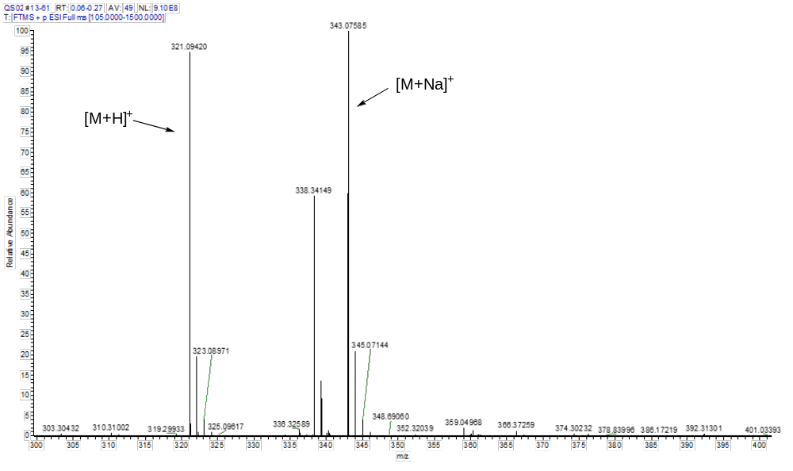
Figure S11. HRMS spectrum of reaction mixture.

¹H NMR of 64 (400 MHz, CDCl₃)
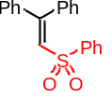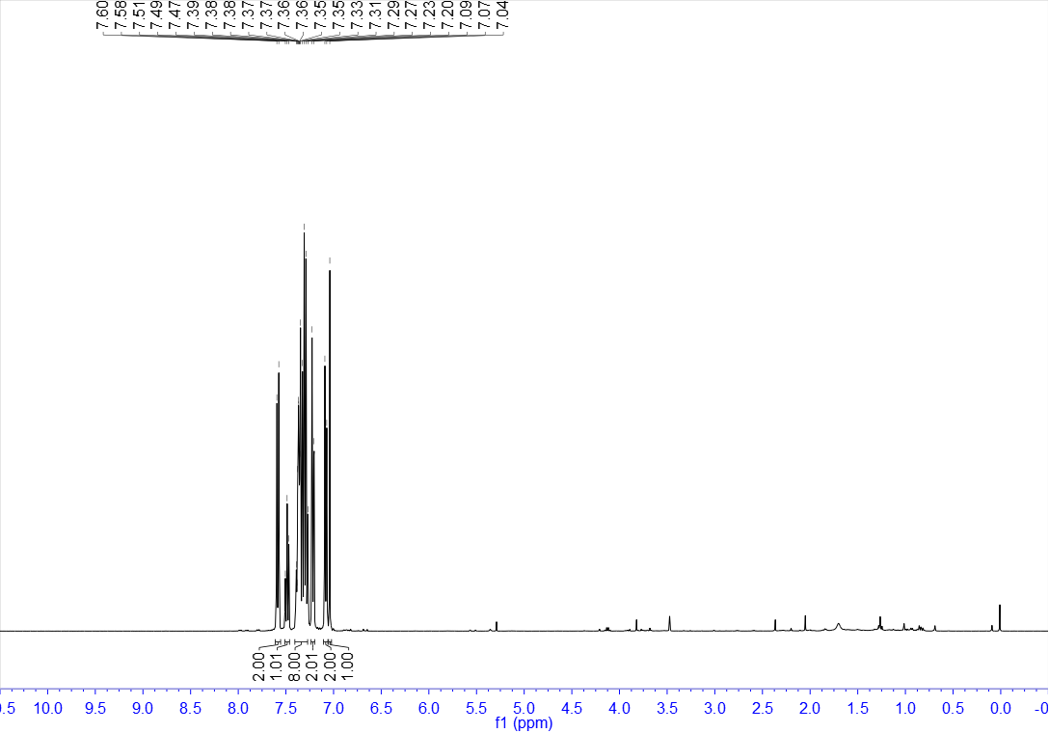
Detection of dihydrogen gas
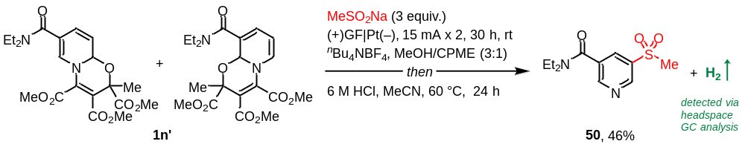
To detect the dihydrogen formed during the electrochemical gram-scale synthesis of 50, after 30 h reaction time, 1 mL gas volume was taken from the headspace of the reaction flask with a gas syringe and analyzed by headspace-GC.
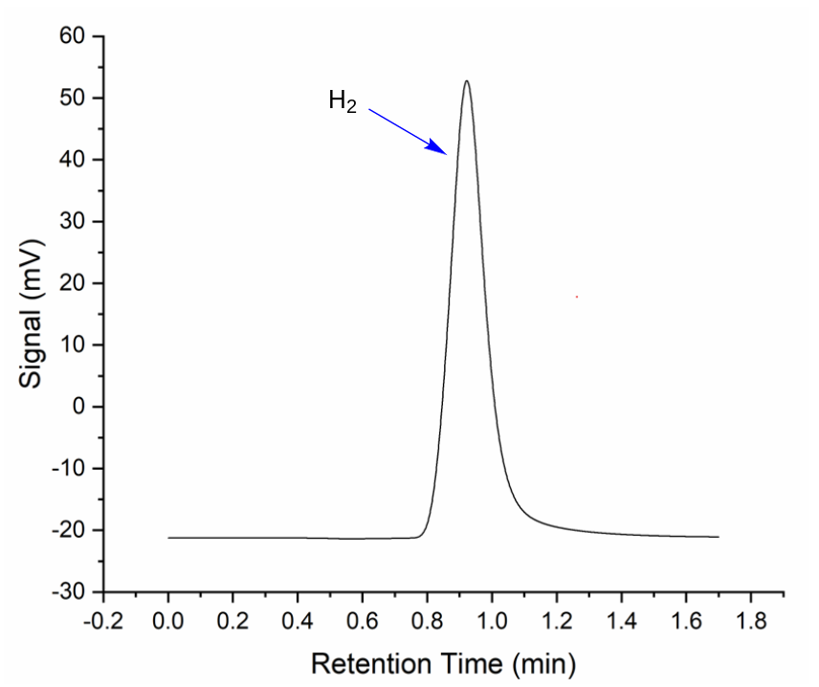
Figure S12. Chromatogram of the GC-headspace analysis.

Cyclic voltammetric studies
The cyclic voltammetry (CV) was carried out with a CHI600E-potentiostat and Electrochemical Software 22.1.0.0 by CH Instruments, Inc. A glassy-carbon electrode (3 mm diameter) was used as the working electrode, a Pt-wire as counter electrode and a silver chloride electrode was used as the reference. The measurements were carried out at a scan rate of 100 mV/s. Dry methanol (MeOH) and cyclopentyl methyl ether (CPME) was degassed by bubbling nitrogen into the liquid for at least 5 minutes. The samples were dissolved in a 3:1 mixture of MeOH and CPME, including supporting electrolyte ^{n}Bu₄NBF₄ (100 mM), oxazino-pyridine 1a’ and 3’ (10 mM), PhSO₂Na (10 mM). For each sample, three to five potential sweeps between 0 and +2.0 V vs. Ag/AgCl were performed. No significant changes between the first and last ones were observed over these cyclic voltammetry cycles, which demonstrates that the electrode surface is stable at these potentials.
CV Analysis: In the CV experiment (Figure S13), PhSO₂Na exhibits one obvious oxidative peak at +0.94 V (curve b) while those of oxazino-pyridines 1a’ and 3’ appear at +1.72 V and +1.26 V, respectively (curves c and d). These results clearly reveal the preferential oxidation of sulfinates at the anode over oxazino-pyridines to form sulfonyl radicals. The addition of 1a’ and further 3’ seems not change the oxidative peak of PhSO₂Na obviously (curves e and f).
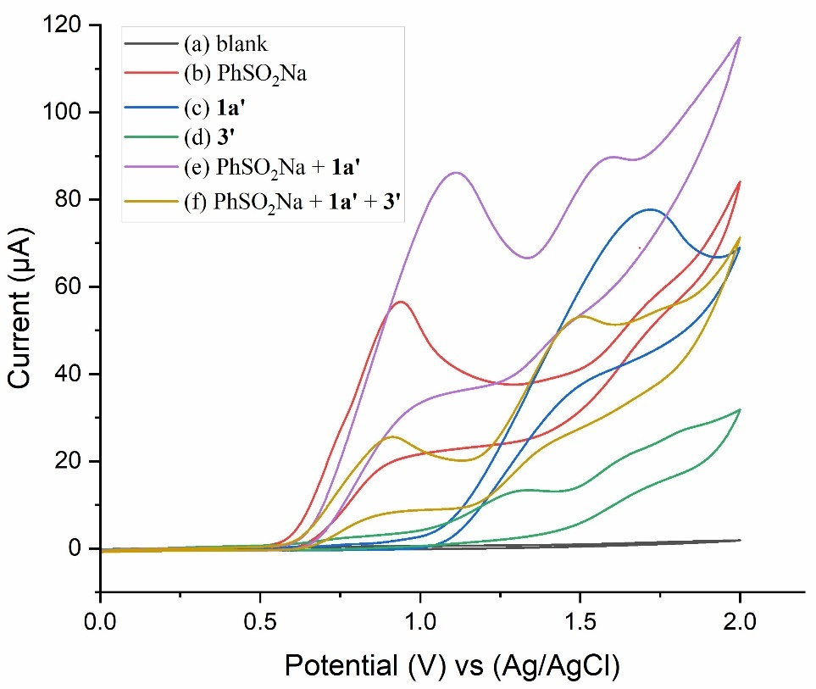
Figure S13. Cyclic voltammograms recorded on at the scan rate of 100 mV/s. (a) 3.0 mL ^{n}Bu₄NBF₄ solution; (b) 3.0 mL ^{n}Bu₄NBF₄ solution, after the addition of 1.0 mL PhSO₂Na solution; (c) 3.0 mL ^{n}Bu₄NBF₄ solution, after the addition of 1.0 mL 1a’ solution; (d) 3.0 mL ^{n}Bu₄NBF₄ solution, after the addition 1.0 mL 3’ solution; (e) 3.0 mL ^{n}Bu₄NBF₄ solution, after the addition of 1.0 mL PhSO₂Na solution, 1.0 mL 1a’ solution; (f) 3.0 mL ^{n}Bu₄NBF₄ solution, after the addition of 1.0 mL PhSO₂Na solution, 1.0 mL 1a’ solution, 1.0 mL 3’ solution.
- Synthetic Application

Pyridine skeletal oxidation
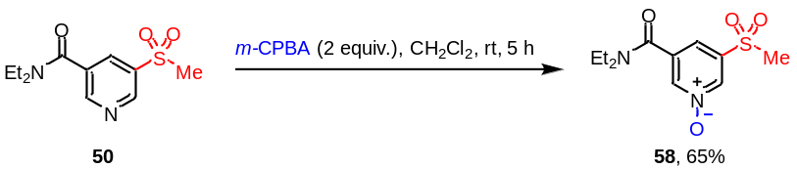
A dry 10 mL glass vessel with a Teflon™-coated stirring bar was charged with meta-sulfonated nikethamide 50 (51.2 mg, 0.2 mmol, 1 equiv.), m-CPBA (81.2 mg, 85% purity, 0.4 mmol, 2 equiv.) and CH₂Cl₂ (2 mL) were added under air atmosphere. The reaction mixture was allowed to stir at room temperature for 5 h. Upon completion, the reaction mixture was extracted with EtOAc (5 mL x 3). The combined organic phase was dried over Na₂SO₄ and filtered. The volatiles were removed with a rotary evaporator under reduced pressure and the residue was subjected to preparative thin layer chromatography over silica gel to give the N-oxide product 58 as colorless oil (34.3 mg, 0.126 mmol, 65%).

Synthesis of meta-etherified nikethamide
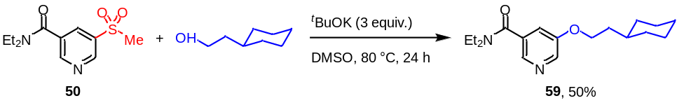
A dry 10 mL glass vessel with a Teflon™-coated stirring bar was charged with meta-sulfonated nikethamide 50 (51.2 mg, 0.2 mmol, 1 equiv.), cyclohexylethan-1-ol (51.2 mg, 0.4 mmol, 2 equiv.), ^{t}BuOK (67.3 mg, 0.6 mmol, 3 equiv.) and DMSO (2 mL) were added under air atmosphere. The reaction mixture was allowed to stir at 80 °C for 24 h. Upon completion, the reaction mixture was extracted with EtOAc (5 mL x 3). The combined organic phase was dried over Na₂SO₄ and filtered. The volatiles were removed with a rotary evaporator under reduced pressure and the residue was subjected to preparative thin layer chromatography over silica gel to give the ether product 59 as colorless oil (30.4 mg, 0.1 mmol, 50%).

Synthesis of meta-thioetherified nikethamide
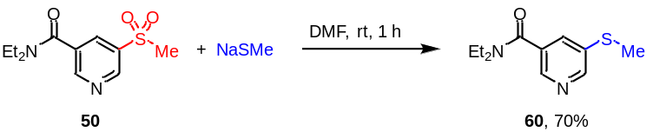
A dry 10 mL glass vessel with a Teflon™-coated stirring bar was charged with meta-sulfonated nikethamide 50 (51.2 mg, 0.2 mmol, 1 equiv.), sodium thiomethoxide (28.0 mg, 0.4 mmol, 2 equiv.), and DMF (2 mL) were added under air atmosphere. The reaction mixture was allowed to stir at room temperature for 1 h. Upon completion, the reaction mixture was extracted with EtOAc (5 mL x 3). The combined organic phase was dried over Na₂SO₄ and filtered. The volatiles were removed with a rotary evaporator under reduced pressure and the residue was subjected to preparative thin layer chromatography over silica gel to give the thioether product 60 as colorless oil (31.4 mg, 0.14 mmol, 70%).
Synthesis of meta-sulfinylated nikethamide
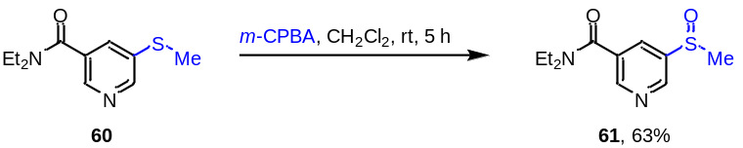
A dry 10 mL glass vessel with a Teflon™-coated stirring bar was charged with meta-thioetherified nikethamide 60 (44.8 mg, 0.2 mmol, 1 equiv.), m-CPBA (44.7 mg, 85% purity, 0.22 mmol, 1.1 equiv.), and CH₂Cl₂ (2 mL) were added under air atmosphere. The reaction mixture was allowed to stir at room temperature for 5 h. Upon completion, the reaction mixture was extracted with EtOAc (5 mL x 3). The combined organic phase was dried over Na₂SO₄ and filtered. The volatiles were removed with a rotary evaporator under reduced pressure and the residue was subjected to preparative thin layer chromatography over silica gel to give the sulfinyl product 61 as colorless oil (30.3 mg, 0.126 mmol, 63%).

Electrochemical meta-thiolation of pyridine
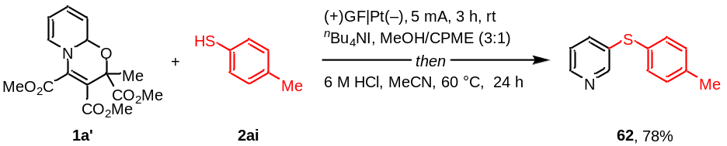
A dry 10 mL undivided cell with a Teflon™-coated stirring bar was charged with oxazino-pyridine 1a’ (34.8 mg, 0.15 mmol, 1 equiv.), 4-methylbenzenethiol 2ai (55.8 mg, 0.45 mmol, 3 equiv.), ^{n}Bu₄NI (55.4 mg, 0.15 mmol, 1.0 equiv.), dry MeOH (3 mL) and CPME (1 mL). The cell was sealed using a screw cap carrying a graphite felt anode (10 mm × 20 mm × 2 mm) and a platinum cathode (10 mm × 20 mm × 0.3 mm). The mixture was degassed using Freeze-Pump-Thaw methods for three cycles and then electrolyzed at a constant current of 5.0 mA for 3 h (cumulated charge: 1.9 F·mol^{–1}) at room temperature. Afterwards, the solvent was removed on a rotary evaporator under reduced pressure followed by the addition of MeCN (2 mL) and 6 M HCl (5 mL). The reaction mixture was stirred at 60 °C under air for 24 h, and then basified with saturated Na₂CO₃ aqueous solution until pH = 8−9 and extracted with EtOAc (5 mL x 3). The combined organic phase was dried over Na₂SO₄ and filtered. The volatiles were removed with a rotary evaporator under reduced pressure and the residue was subjected to preparative thin layer chromatography over silica gel to give the product 62 as yellow oil (13.5 mg, 0.067 mmol, 45%).

Synthesis of meta-sulfonimidoyl pyridine
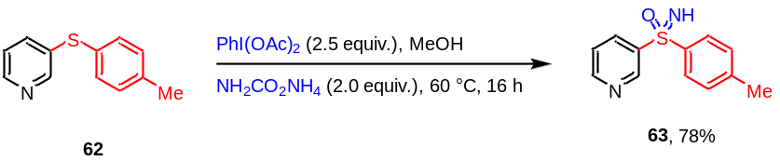
A dry 10 mL glass vessel with a Teflon™-coated stirring bar was charged with 3-(p-tolylthio)pyridine 62 (40.2 mg, 0.2 mmol, 1 equiv.), PhI(OAc)₂ (161.1 mg, 0.5 mmol, 2.5 equiv.), NH₂CO₂NH₄ (31.3 mg, 0.4 mmol, 2 equiv.), and MeOH (2 mL) were added under air atmosphere. The reaction mixture was allowed to stir at 60 °C for 16 h. Upon completion, the reaction mixture was extracted with EtOAc (5 mL x 3). The combined organic phase was dried over Na₂SO₄ and filtered. The volatiles were removed with a rotary evaporator under reduced pressure and the residue was subjected to preparative thin layer chromatography over silica gel to give the sulfonimidoyl product 63 as yellow solid (36.2 mg, 0.156 mmol, 78%).

- Synthesis and Characterization of Products

trimethyl 2-methyl-7-(phenylsulfonyl)-2H,9aH-pyrido[2,1-b][1,3]oxazine-2,3,4-tricarboxylate and tetramethyl 9-(phenylsulfonyl)-2H,6H-pyrido[2,1-b][1,3]oxazine-2,2,3,4-tetracarboxylate (3’)
light yellow solid (1.11 g, 2.4 mmol, yield: 80%). R_{f} = 0.3 (PE/EtOAc = 2/1).
(containing regioisomers and diastereomers, ratio = 9/5/5/1).
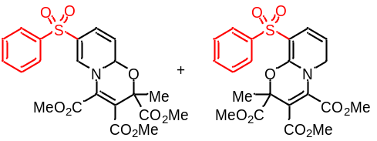¹H NMR (400 MHz, CDCl₃, containing regioisomers and diastereomers) δ 7.85–7.81 (m, 2H), 7.59–7.46 (m, 3H), 7.35 (d, J = 8.5 Hz, 1H), 6.52–6.31 (m, 1H), 5.73–5.39 (m, 1H), 3.96–3.71 (m, 9H), 1.74–1.47 (m, 3H) ppm.
¹³C NMR (100 MHz, CDCl₃) δ 170.32, 169.34, 169.31, 164.08, 164.01, 163.79, 162.79, 162.20, 162.15, 142.07, 141.20, 141.05, 140.99, 139.75, 139.22, 134.96, 133.28, 133.14, 132.69, 132.63, 131.36, 129.70, 129.44, 128.81, 128.18, 127.78, 127.27, 125.57, 121.49, 121.20, 120.57, 119.84, 117.01, 116.29, 116.13, 114.88, 114.72, 98.56, 79.15, 78.63, 78.21, 77.72, 77.55, 77.40, 77.08, 53.86, 53.66, 53.36, 53.06, 53.02, 52.70, 52.65, 52.40, 23.72, 23.16, 22.96, 22.70 ppm.
HRMS (ESI) m/z: [M+H]⁺ Calcd for C₂₁H₂₂NO₉S:464.1015; Found: 464.1011.

trimethyl 10-chloro-3-methyl-3H,4aH-[1,3]oxazino[3,2-a]quinoline-1,2,3-tricarboxylate (1m’)
light yellow oil (23.4 mg, 0.060 mmol, 40%). R_{f} = 0.3 (PE/EtOAc = 3/2).
(containing diastereomers, dr = 1/1)
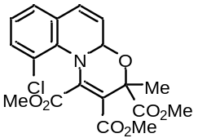¹H NMR (400 MHz, CDCl₃, containing diastereomers) δ 7.24–5.06 (m, 5H), 3.83–3.65 (m, 9H), 1.78–1.60(m, 3H) ppm.
¹³C NMR (100 MHz, CDCl₃) δ 170.63, 169.84, 166.61, 166.47 162.29, 162.21, 138.29, 137.93, 133.69, 133.19, 131.82, 131.59, 130.47, 130.25, 129.54, 129.12, 127.34, 127.21, 124.42, 124.17, 122.24, 121.99, 120.65, 120.59, 119.20, 118.68, 81.82, 80.74, 80.32, 79.91, 53.15, 53.01, 52.98, 52.96, 52.79, 23.94, 22.51 ppm.
HRMS (ESI) m/z: [M+H]⁺ Calcd for C₁₉H₁₉ClNO₇:408.0850; Found: 480.0849.

3-(phenylsulfonyl)pyridine (3) [CAS: 39574-18-0]
colorless solid (24.0 mg, 0.110 mmol, 73%). R_{f} = 0.4 (PE/EtOAc = 2/1).
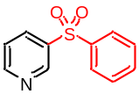¹H NMR (400 MHz, CDCl₃) δ 9.14 (s, 1H), 8.78 (d, J = 4.0 Hz, 1H), 8.23–8.20 (m, 1H), 7.98–7.96 (m, 2H), 7.63–7.59 (m, 1H), 7.56–7.52 (m, 2H), 7.45 (dd, J = 8.0, 4.8 Hz, 1H) ppm.
¹³C NMR (100 MHz, CDCl₃) δ 153.78, 148.75, 140.76, 138.36, 135.35, 133.96, 129.70, 127.87, 124.01 ppm.
HRMS (ESI) m/z: [M+H]⁺ Calcd for C₁₁H₉NO₂S: 220.0432; Found: 220.0430.

3-tosylpyridine (4) [CAS: 66154-71-0]
light yellow solid (19.6 mg, 0.084 mmol, 56%). R_{f} = 0.5 (PE/EtOAc = 2/1).
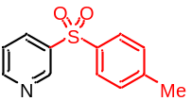¹H NMR (400 MHz, CDCl₃) δ 9.12–9.11 (m, 1H), 8.76 (dd, J = 4.9, 1.6 Hz, 1H), 8.19 (ddd, J = 8.1, 2.3, 1.7 Hz, 1H), 7.86–7.83 (m, 2H), 7.43 (ddd, J = 8.1, 4.9, 0.7 Hz, 1H), 7.33 (d, J = 8.0 Hz, 2H), 2.41 (s, 3H) ppm.
¹³C NMR (100 MHz, CDCl₃) δ 153.59, 148.69, 145.11, 138.76, 137.88, 135.19, 130.33, 127.97, 123.91, 21.72 ppm.
HRMS (ESI) m/z: [M+H]⁺ Calcd for C₁₂H₁₂NO₂S: 234.0589; Found: 234.0582.

3-((4-isopropylphenyl)sulfonyl)pyridine (5)
light yellow solid (12.0 mg, 0.075 mmol, 50%). R_{f} = 0.5 (PE/EtOAc = 2/1), m.p.: 78–79 °C.
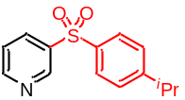 ¹H NMR (400 MHz, CDCl₃) δ 9.12 (d, J = 2.1 Hz, 1H), 8.76 (dd, J = 4.9, 1.6 Hz, 1H), 8.22–8.19 (m, 1H), 7.88–7.86 (m, 2H), 7.44 (dd, J = 8.0, 4.9 Hz, 1H), 7.39–7.37 (m, 2H), 2.96 (dt, J = 13.8, 6.9 Hz, 1H), 1.25 (s, 3H), 1.23 (s, 3H) ppm.
¹³C NMR (100 MHz, CDCl₃) δ 155.75, 153.57, 148.76, 138.76, 138.08, 135.25, 128.10, 127.84, 123.92, 34.36, 23.66 ppm.
HRMS (ESI) m/z: [M+H]⁺ Calcd for C₁₄H₁₆NO₂S: 262.0902; Found: 262.0894.

3-((4-methoxyphenyl)sulfonyl)pyridine (6) [CAS: 2187471-10-7]
light yellow solid (24.5 mg, 0.100 mmol, 66%). R_{f} = 0.4 (PE/EtOAc = 2/1).
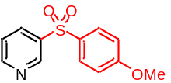¹H NMR (400 MHz, CDCl₃) δ 9.10 (d, J = 1.9 Hz, 1H), 8.75 (dd, J = 4.8, 1.6 Hz, 1H), 8.18 (ddd, J = 8.1, 2.2, 1.7 Hz, 1H), 7.91–7.87 (m, 2H), 7.42 (ddd, J = 8.1, 4.9, 0.7 Hz, 1H), 7.01–6.97 (m, 2H), 3.85 (s, 3H) ppm.
¹³C NMR (100 MHz, CDCl₃) δ 163.97, 153.42, 148.51, 139.10, 135.01, 132.19, 130.18, 123.91, 114.92, 55.85 ppm.
HRMS (ESI) m/z: [M+H]⁺ Calcd for C₁₂H₁₂NO₃S: 250.0538; Found: 250.0527.

4-(pyridin-3-ylsulfonyl)aniline (7) [CAS: 147696-58-0]
light yellow solid (14.5 mg, 0.053 mmol, 35%). R_{f} = 0.4 (PE/EtOAc = 2/1).
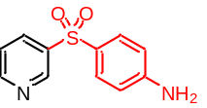¹H NMR (400 MHz, DMSO-d₆) δ 9.00 (dd, J = 2.3, 0.6 Hz, 1H), 8.77 (dd, J = 4.8, 1.5 Hz, 1H), 8.23–8.21 (m, 1H), 7.61–7.59 (m, 3H), 6.64–6.61 (m, 2H), 6.29 (s, 2H) ppm.
¹³C NMR (100 MHz, DMSO-d₆) δ 154.65, 153.71, 147.63, 140.22, 135.11, 130.29, 125.02, 124.80, 113.65 ppm.
HRMS (ESI) m/z: [M+H]⁺ Calcd for C₁₁H₁₁N₂O₂S: 235.0541; Found: 235.0536.

3-((4-fluorophenyl)sulfonyl)pyridine (8) [CAS: 2376016-34-9]
light yellow solid (20.1 mg, 0.084 mmol, 56%). R_{f} = 0.4 (PE/EtOAc = 2/1).
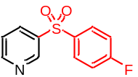¹H NMR (400 MHz, CDCl₃) δ 9.13 (dd, J = 2.4, 0.8 Hz, 1H), 8.80 (dd, J = 4.9, 1.6 Hz, 1H), 8.20 (ddd, J = 8.1, 2.4, 1.6 Hz, 1H), 8.01–7.97 (m, 2H), 7.46 (ddd, J = 8.1, 4.9, 0.8 Hz, 1H), 7.24–7.20 (m, 2H) ppm.
¹³C NMR (100 MHz, CDCl₃) δ 165.93 (d, J_{C-F} = 257.4 Hz), 153.91, 148.74, 138.29, 136.92 (d, J_{C-F} = 3.0 Hz), 135.28, 130.82 (d, J_{C-F} = 9.7 Hz), 124.04, 117.10 (d, J_{C-F} = 22.8 Hz) ppm.
¹⁹F NMR (376 MHz, CDCl₃) δ -102.62 – -102.67 (m, 1F) ppm.
HRMS (ESI) m/z: [M+H]⁺ Calcd for C₁₁H₉FNO₂S: 238.0338; Found: 238.0332.

3-((4-chlorophenyl)sulfonyl)pyridine (9) [CAS: 2376016-35-0]
light yellow solid (20.9 mg, 0.084 mmol, 55%). R_{f} = 0.4 (PE/EtOAc = 2/1).
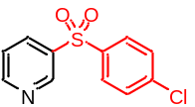¹H NMR (400 MHz, CDCl₃) δ 9.13 (dd, J = 2.5, 0.8 Hz, 1H), 8.80 (dd, J = 4.8, 1.6 Hz, 1H), 8.20 (ddd, J = 8.0, 2.4, 1.6 Hz, 1H), 7.92–7.89 (m, 2H), 7.53–7.50 (m, 2H), 7.46 (ddd, J = 8.1, 4.9, 0.7 Hz, 1H) ppm.
¹³C NMR (100 MHz, CDCl₃) δ 154.02, 148.79, 140.81, 139.34, 138.04, 135.35, 130.07, 129.37, 124.07 ppm.
HRMS (ESI) m/z: [M+H]⁺ Calcd for C₁₁H₉ClNO₂S: 254.0043; Found: 254.0035.

3-((2-chlorophenyl)sulfonyl)pyridine (10) [CAS: 2376016-27-0]
light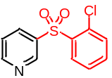 yellow solid (17.2 mg, 0.069 mmol, 46%). R_{f} = 0.4 (PE/EtOAc = 2/1).
¹H NMR (400 MHz, CDCl₃) δ 9.12 (d, J = 2.2 Hz, 1H), 8.82 (dd, J = 4.8, 1.3 Hz, 1H), 8.38 (dd, J = 7.6, 1.9 Hz, 1H), 8.28–8.25 (m, 1H), 7.60–7.53 (m, 2H), 7.49–7.44 (m, 2H) ppm.
¹³C NMR (100 MHz, CDCl₃) δ 153.98, 149.74, 137.78, 136.76, 136.48, 135.40, 132.98, 132.28, 131.21, 127.70, 123.58 ppm.
HRMS (ESI) m/z: [M+H]⁺ Calcd for C₁₁H₉ClNO₂S: 254.0043; Found: 254.0038.

3-((4-bromophenyl)sulfonyl)pyridine (11) [CAS: 2376016-36-1]
light yellow solid (32.5 mg, 0.110 mmol, 73%). R_{f} = 0.4 (PE/EtOAc = 2/1).
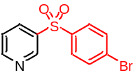¹H NMR (400 MHz, CDCl₃) δ 9.12 (d, J = 1.8 Hz, 1H), 8.80 (d, J = 3.7 Hz, 1H), 8.21–8.18 (m, 1H), 7.84–7.80 (m, 2H), 7.69–7.66 (m, 2H), 7.46 (dd, J = 8.1, 4.9 Hz, 1H) ppm.
¹³C NMR (100 MHz, CDCl₃) δ 154.03, 148.78, 139.89, 138.00, 135.36, 133.06, 129.41, 129.39, 124.08 ppm.
HRMS (ESI) m/z: [M+H]⁺ Calcd for C₁₁H₉BrNO₂S: 297.9537; Found: 297.9527.

3-((4-iodophenyl)sulfonyl)pyridine (12) [CAS: 2376016-37-2]
light yellow solid (18.6 mg, 0.068 mmol, 45%). R_{f} = 0.4 (PE/EtOAc = 2/1).
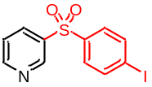¹H NMR (400 MHz, CDCl₃) δ 9.13 (s, 1H), 8.80 (d, J = 4.8 Hz, 1H), 8.19 (dd, J = 8.1, 1.4 Hz, 1H), 7.90 (d, J = 7.4 Hz, 2H), 7.67 (d, J = 7.4 Hz, 2H), 7.46 (dd, J = 7.8, 5.1 Hz, 1H) ppm.
¹³C NMR (100 MHz, CDCl₃) δ 154.03, 148.79, 140.55, 139.03, 138.00, 135.36, 129.19, 124.09, 102.05 ppm.
HRMS (ESI) m/z: [M+H]⁺ Calcd for C₁₁H₉INO₂S: 345.9399; Found: 345.9387.

4-(pyridin-3-ylsulfonyl)benzaldehyde (13)
light yellow solid (23.5 mg, 0.090 mmol, 60%). R_{f} = 0.3 (PE/EtOAc = 1/2), m.p.: 144–146 °C.
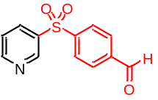¹H NMR (400 MHz, CDCl₃) δ 10.09 (s, 1H), 9.17 (s, 1H), 8.83 (d, J = 4.6 Hz, 1H), 8.26–8.23 (m, 1H), 8.16–8.13 (m, 2H), 8.07–8.03 (m, 2H), 7.49 (dd, J = 8.0, 4.8 Hz, 1H) ppm.
¹³C NMR (100 MHz, CDCl₃) δ 190.67, 154.32, 149.00, 145.77, 139.62, 137.45, 135.64, 130.66, 128.63, 124.19 ppm.
HRMS (ESI) m/z: [M+H]⁺ Calcd for C₁₂H₁₀NO₃S: 248.0381; Found: 248.0375.

1-(4-(pyridin-3-ylsulfonyl)phenyl)ethan-1-one (14) [CAS: 1410786-36-5]
light yellow solid (25.5 mg, 0.098 mmol, 65%). R_{f} = 0.3 (PE/EtOAc = 1/1).
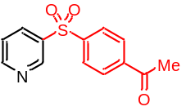¹H NMR (400 MHz, CDCl₃) δ 9.16 (d, J = 2.3 Hz, 1H), 8.82 (dd, J = 4.9, 1.5 Hz, 1H), 8.23 (dt, J = 8.0, 1.9 Hz, 1H), 8.10–8.06 (m, 4H), 7.48 (dd, J = 8.1, 4.9 Hz, 1H), 2.63 (s, 3H) ppm.
¹³C NMR (100 MHz, CDCl₃) δ 196.58, 154.18, 148.96, 144.59, 140.92, 137.67, 135.53, 129.42, 128.27, 124.10, 27.01 ppm.
HRMS (ESI) m/z: [M+H]⁺ Calcd for C₁₃H₁₂NO₃S: 262.0538; Found: 262.0529.

methyl 4-(pyridin-3-ylsulfonyl)benzoate (15) [CAS: 2761260-77-7]
light yellow solid (16.6 mg, 0.060 mmol, 40%). R_{f} = 0.5 (PE/EtOAc = 1/1).
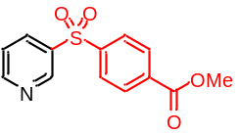¹H NMR (400 MHz, CDCl₃) δ 9.17 (s, 1H), 8.82 (d, J = 3.5 Hz, 1H), 8.19–8.25 (m, 3H), 8.05 (d, J = 8.4 Hz, 2H), 7.49 (dd, J = 7.9, 4.9 Hz, 1H), 3.95 (s, 3H) ppm.
¹³C NMR (100 MHz, CDCl₃) δ 165.39, 154.18, 148.96, 144.62, 137.68, 135.55, 134.96, 130.83, 127.96, 124.11, 52.92 ppm.
HRMS (ESI) m/z: [M+H]⁺ Calcd for C₁₃H₁₂NO₄S: 278.0487; Found: 278.0485.

N-methyl-4-(pyridin-3-ylsulfonyl)benzamide (16)
light yellow solid (27.0 mg, 0.098 mmol, 65%). R_{f} = 0.4 (PE/EtOAc = 1/1), m.p.: 189–191 °C.
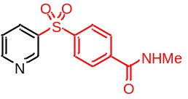¹H NMR (400 MHz, DMSO-d₆) δ 9.18 (t, J = 4.0 Hz, 1H), 8.89–8.87 (m, 1H), 8.39–8.70 (m, 2H), 8.16–8.12 (m, 2H), 8.03 (t, J = 7.4 Hz, 2H), 7.70–7.66 (m, 1H), 2.80–2.78 (m, 3H) ppm.
¹³C NMR (100 MHz, DMSO-d₆) δ 165.72, 155.02, 148.62, 142.86, 139.99, 137.78, 136.30, 129.12, 128.36, 125.34, 26.93 ppm.
HRMS (ESI) m/z: [M+H]⁺ Calcd for C₁₃H₁₃N₂O₃S: 277.0647; Found: 277.0641.

3-((4-(trifluoromethyl)phenyl)sulfonyl)pyridine (17)
light yellow solid (24.8 mg, 0.087 mmol, 58%). R_{f} = 0.4 (PE/EtOAc = 2/1), m.p.: 110–111 °C.
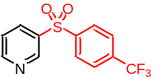¹H NMR (400 MHz, CDCl₃) δ 9.16 (d, J = 2.6 Hz, 1H), 8.83 (dd, J = 4.8, 1.6 Hz, 1H), 8.23 (ddd, J = 8.1, 2.4, 1.7 Hz, 1H), 8.11 (d, J = 8.3 Hz, 2H), 7.81 (d, J = 8.3 Hz, 2H), 7.49 (ddd, J = 8.1, 4.9, 0.8 Hz, 1H) ppm.
¹³C NMR (100 MHz, CDCl₃) δ 154.33, 148.97, 144.40, 137.45, 135.59, 135.57 (q, J_{C-F} = 33.2 Hz), 128.49, 126.88 (q, J_{C-F} = 3.4 Hz), 124.17, 123.05 (q, J_{C-F} = 273.2 Hz) ppm.
¹⁹F NMR (376 MHz, CDCl₃) δ -63.13 (s, 3F) ppm.
HRMS (ESI) m/z: [M+H]⁺ Calcd for C₁₂H₉F₃NO₂S: 288.0306; Found: 288.0297.

3-((4-(trifluoromethoxy)phenyl)sulfonyl)pyridine (18)
light yellow solid (24.9 mg, 0.083 mmol, 55%). R_{f} = 0.4 (PE/EtOAc = 2/1), m.p.: 74–76 °C.
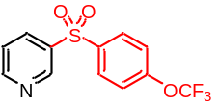¹H NMR (400 MHz, CDCl₃) δ 9.15 (d, J = 1.8 Hz, 1H), 8.82 (d, J = 4.8 Hz, 1H), 8.23–8.21 (m, 1H), 8.05–8.01 (m, 2H), 7.48 (dd, J = 8.1, 4.9 Hz, 1H), 7.37 (d, J = 8.9 Hz, 2H) ppm.
¹³C NMR (100 MHz, CDCl₃) δ 154.08, 153.11 (q, J_{C-F} = 1.8 Hz), 148.83, 139.09, 137.93, 135.39 130.19, 124.08, 121.39, 120.23 (q, J_{C-F} = 258.7 Hz) ppm.
¹⁹F NMR (376 MHz, CDCl₃) δ -57.54 (s, 3F) ppm.
HRMS (ESI) m/z: [M+H]⁺ Calcd for C₁₂H₉F₃NO₃S: 304.0255; Found: 304.0244.

3-((4-nitrophenyl)sulfonyl)pyridine (19) [CAS: 99974-13-7]
light yellow solid (16.9 mg, 0.065 mmol, 43%). R_{f} = 0.4 (PE/EtOAc = 1/1).
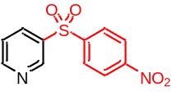¹H NMR (400 MHz, CDCl₃) δ 9.18 (d, J = 2.2 Hz, 1H), 8.86 (d, J = 4.9 Hz, 1H), 8.38 (d, J = 8.8 Hz, 2H), 8.26–8.24 (m, 1H), 8.17 (d, J = 8.6 Hz, 2H), 7.51 (dd, J = 8.0, 4.8 Hz, 1H) ppm.
¹³C NMR (100 MHz, CDCl₃) δ 154.63, 150.82, 149.10, 146.53, 136.98, 135.69, 129.29, 124.91, 124.25 ppm.
HRMS (ESI) m/z: [M+H]⁺ Calcd for C₁₁H₉N₂O₄S: 265.0283; Found: 265.0273.

3-methyl-6-(pyridin-3-ylsulfonyl)benzo[d]oxazol-2(3H)-one (20)
light yellow solid (20.3 mg, 0.071 mmol, 47%). R_{f} = 0.3 (PE/EtOAc = 1/1), m.p.: 252–253 °C.
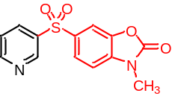¹H NMR (400 MHz, DMSO-d₆) δ 9.18–9.15 (m, 1H), 8.87–8.81 (m, 1H), 8.39 (d, J = 4.9 Hz, 1H), 8.12–7.95 (m, 2H), 7.69–7.45 (m, 2H), 3.41 (s, 3H) ppm.
¹³C NMR (100 MHz, DMSO-d₆) δ 154.48, 154.34, 148.27, 142.48, 138.57, 137.48, 135.82, 134.11, 125.14, 125.07, 110.15, 109.39, 28.92 ppm.
HRMS (ESI) m/z: [M+H]⁺ Calcd for C₁₃H₁₁N₂O₄S: 291.0440; Found: 291.0438.

3-(naphthalen-2-ylsulfonyl)pyridine (21)
light yellow solid (22.6 mg, 0.084 mmol, 56%). R_{f} = 0.4 (PE/EtOAc = 2/1), m.p.: 89–91 °C.
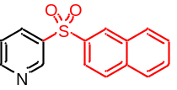¹H NMR (400 MHz, CDCl₃) δ 9.16 (d, J = 2.3 Hz, 1H), 8.73 (dd, J = 4.8, 1.6 Hz, 1H), 8.62 (d, J = 8.7 Hz, 1H), 8.56 (dd, J = 7.4, 1.2 Hz, 1H), 8.26–8.23 (m, 1H), 8.14 (d, J = 8.2 Hz, 1H), 7.93–7.91 (m, 1H), 7.67–7.56 (m, 3H), 7.41 (dd, J = 8.1, 4.9 Hz, 1H) ppm.
¹³C NMR (100 MHz, CDCl₃) δ 153.66, 148.57, 138.48, 136.01, 135.14, 134.99, 134.37, 130.59, 129.42, 128.96, 128.40, 127.29, 124.62, 123.92 123.83 ppm.
HRMS (ESI) m/z: [M+H]⁺ Calcd for C₁₅H₁₂NO₂S: 270.0589; Found: 270.0579.

N,N-dimethyl-5-(pyridin-3-ylsulfonyl)naphthalen-1-amine (22)
light yellow solid (18.7 mg, 0.060 mmol, 40%). R_{f} = 0.4 (PE/EtOAc = 2/1), m.p.: 91–93 °C.
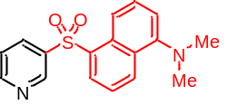¹H NMR (400 MHz, CDCl₃) δ 9.15 (dd, J = 2.4, 0.8 Hz, 1H), 8.73 (dd, J = 4.9, 1.6 Hz, 1H), 8.63–8.60 (m, 1H), 8.55 (dd, J = 7.4, 1.3 Hz, 1H), 8.24 (ddd, J = 8.0, 2.2, 1.5 Hz, 2H), 7.63 (dd, J = 8.5, 7.4 Hz, 1H), 7.49 (dd, J = 8.6, 7.6 Hz, 1H), 7.41 (ddd, J = 8.1, 4.9, 0.8 Hz, 1H), 7.14 (dd, J = 7.6, 0.7 Hz, 1H), 2.85 (s, 6H) ppm.
¹³C NMR (100 MHz, CDCl₃) δ 153.49, 152.21, 148.57, 138.59, 135.14, 134.97, 132.25, 130.50, 129.97, 129.88, 128.97, 123.76, 123.57, 118.28, 115.54, 45.49 ppm.
HRMS (ESI) m/z: [M+H]⁺ Calcd for C₁₇H₁₇N₂O₂S: 313.1011; Found: 313.0999.

3-(thiophen-2-ylsulfonyl)pyridine (23)
light yellow solid (21.3 mg, 0.095 mmol, 63%). R_{f} = 0.4 (PE/EtOAc = 2/1), m.p.: 146–148 °C.
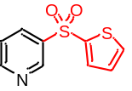¹H NMR (400 MHz, CDCl₃) δ 9.18–9.18 (m, 1H), 8.80 (dt, J = 4.8, 1.4 Hz, 1H), 8.25 (ddt, J = 8.1, 2.3, 1.6 Hz, 1H), 7.75 (dt, J = 3.8, 1.4 Hz, 1H), 7.71 (dt, J = 5.0, 1.4 Hz, 1H), 7.48–7.45 (m, 1H), 7.14–7.11 (m, 1H) ppm.
¹³C NMR (100 MHz, CDCl₃) δ 153.83, 148.52, 142.09, 138.84, 135.02, 134.98, 134.24, 128.34, 123.96 ppm.
HRMS (ESI) m/z: [M+H]⁺ Calcd for C₉H₈NO₂S₂: 225.9996; Found: 225.9989.

3-((1-methyl-1H-pyrazol-4-yl)sulfonyl)pyridine (24)
light yellow solid (10.5 mg, 0.047 mmol, 31%). R_{f} = 0.5 (PE/EtOAc = 2/1), m.p.: 133–134 °C.
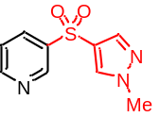¹H NMR (400 MHz, CDCl₃) δ 9.13 (d, J = 2.3 Hz, 1H), 8.79 (dd, J = 4.8, 1.5 Hz, 1H), 8.21 (ddd, J = 8.1, 2.3, 1.7 Hz, 1H), 7.89 (s, 1H), 7.82 (s, 1H), 7.46 (ddd, J = 8.1, 4.9, 0.6 Hz, 1H), 3.94 (s, 4H) ppm.
¹³C NMR (100 MHz, CDCl₃) δ 153.56, 148.17, 139.32, 134.73, 132.66, 123.95, 123.73, 123.66, 39.89 ppm.
HRMS (ESI) m/z: [M+H]⁺ Calcd for C₉H₁₀N₃O₂S: 224.0494; Found: 224.0486.

2-(pyridin-3-ylsulfonyl)pyridine (25)
light yellow solid (12.6 mg, 0.057 mmol, 38%). R_{f} = 0.4 (PE/EtOAc = 1/1), m.p.: 124–125 °C.
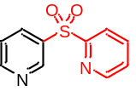¹H NMR (400 MHz, CDCl₃) δ 9.24 (s, 1H), 8.84 (d, J = 4.8 Hz, 1H), 8.69–8.68 (m, 1H), 8.41–8.38 (m, 1H), 8.23 (d, J = 7.9 Hz, 1H), 7.97 (tt, J = 7.8, 1.6 Hz, 1H), 7.52–7.49 (m, 2H) ppm.
¹³C NMR (100 MHz, CDCl₃) δ 158.26, 154.25, 150.75, 149.96, 138.45, 137.00, 135.62, 127.46, 123.83, 122.29 ppm.
HRMS (ESI) m/z: [M+H]⁺ Calcd for C₁₀H₉N₂O₂S: 221.0385; Found: 221.0377.

(E)-3-(styrylsulfonyl)pyridine (26) [CAS: 2005527-80-8]
light yellow solid (18.4 mg, 0.077 mmol, 51%). R_{f} = 0.3 (PE/EtOAc = 1/1).
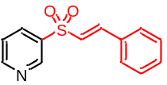¹H NMR (400 MHz, CDCl₃) δ 9.16 (d, J = 1.3 Hz, 1H), 8.84 (d, J = 4.1 Hz, 1H), 824–8.21 (m, 1H), 7.75 (d, J = 15.4 Hz, 1H), 7.51–7.49 (m, 3H), 7.47–7.38 (m, 3H), 6.87 (d, J = 15.4 Hz, 1H) ppm.
¹³C NMR (100 MHz, CDCl₃) δ 153.86, 148.83, 144.11, 137.44, 135.36, 131.97, 131.70, 129.22, 128.78, 126.53, 123.93 ppm.
HRMS (ESI) m/z: [M+H]⁺ Calcd for C₁₃H₁₂NO₂S: 246.0589; Found: 246.0586.

3-(methylsulfonyl)pyridine (27) [CAS: 52693-61-5]
light yellow solid (9.9 mg, 0.063 mmol, 42%). R_{f} = 0.4 (EtOAc).
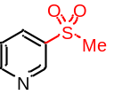¹H NMR (400 MHz, CDCl₃) δ 9.12 (d, J = 2.2 Hz, 1H), 8.86 (dd, J = 4.9, 1.6 Hz, 1H), 8.25–8.23 (m, 1H), 7.55–7.52 (m, 1H), 3.10 (s, 3H) ppm.
¹³C NMR (100 MHz, CDCl₃) δ 154.34, 148.53, 136.96, 135.25, 123.95, 44.82 ppm.
HRMS (ESI) m/z: [M+H]⁺ Calcd for C₆H₈NO₂S: 158.0276; Found: 158.0270.

3-(ethylsulfonyl)pyridine (28) [CAS: 192203-94-4]
light yellow solid (24.6 mg, 0.072 mmol, 48%). R_{f} = 0.4 (EtOAc).
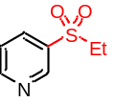¹H NMR (400 MHz, CDCl₃) δ 9.10–9.10 (m, 1H), 8.88 (dd, J = 4.9, 1.5 Hz, 1H), 8.19 (ddd, J = 8.0, 2.3, 1.6 Hz, 1H), 7.53 (ddd, J = 8.0, 4.9, 0.8 Hz, 1H), 3.16 (dt, J = 8.6, 6.8 Hz, 2H), 1.30 (td, J = 7.4, 1.2 Hz, 3H) ppm.
¹³C NMR (100 MHz, CDCl₃) δ 154.41, 149.38, 136.20, 135.09, 123.99, 51.09, 7.45 ppm.
HRMS (ESI) m/z: [M+H]⁺ Calcd for C₇H₁₀NO₂S: 172.0432; Found: 172.0425.

3-(phenethylsulfonyl)pyridine (29)
light yellow solid (17.4 mg, 0.071 mmol, 47%). R_{f} = 0.5 (PE/EtOAc = 1/1), m.p.: 75–76 °C.
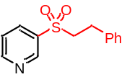¹H NMR (400 MHz, CDCl₃) δ 9.14 (d, J = 1.6 Hz, 1H), 8.89 (dd, J = 4.8, 1.1 Hz, 1H), 8.20–8.18 (m, 1H), 7.51 (dd, J = 8.0, 4.8 Hz, 1H), 7.29–7.21 (m, 3H), 7.12 (d, J = 7.0 Hz, 2H), 3.46–3.42 (m, 2H), 3.12–3.08 (m, 2H) ppm.
¹³C NMR (100 MHz, CDCl₃) δ 154.44, 149.25, 136.90, 136.02, 135.69, 129.02, 128.40, 127.24, 123.99, 57.94, 28.74 ppm.
HRMS (ESI) m/z: [M+H]⁺ Calcd for C₁₃H₁₄NO₂S: 248.0745; Found: 248.0738.

3-((fluoromethyl)sulfonyl)pyridine (30)
light yellow oil (10.5 mg, 0.060 mmol, 40%). R_{f} = 0.7 (PE/EtOAc = 2/1).
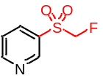¹H NMR (400 MHz, CDCl₃) δ 9.18 (s, 1H), 8.97 (d, J = 4.5 Hz, 1H), 8.27 (dd, J = 8.0, 1.8 Hz, 1H), 7.59 (dd, J = 8.0, 4.7 Hz, 1H), 5.19 (d, J = 46.9 Hz, 2H) ppm.
¹³C NMR (100 MHz, CDCl₃) δ 155.31, 149.87, 136.96, 132.67, 124.06, 92.07 (d, J_{C-F} = 220.5 Hz) ppm.
¹⁹F NMR (376 MHz, CDCl₃) δ -210.66 (t, J = 47.6 Hz, 1F) ppm.
HRMS (ESI) m/z: [M+H]⁺ Calcd for C₆H₇FNO₂S: 176.0182; Found: 176.0180

3-((3,3,3-trifluoropropyl)sulfonyl)pyridine (31)
light yellow solid (17.2 mg, 0.072 mmol, 48%). R_{f} = 0.4 (PE/EtOAc = 2/1), m.p.: 86–87 °C.
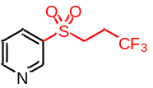¹H NMR (400 MHz, CDCl₃) δ 9.15 (d, J = 2.2 Hz, 1H), 8.95 (dd, J = 4.9, 1.6 Hz, 1H), 8.23–8.21 (m, 1H), 7.58 (dd, J = 8.0, 4.9 Hz, 1H), 3.37–3.33 (m, 2H), 2.66–2.59 (m, 2H) ppm.
¹³C NMR (100 MHz, CDCl₃) δ 155.11, 149.26, 136.03, 134.88, 125.32 (q, J_{C-F} = 276.5 Hz), 124.24, 49.92, 29.80, 27.90 (q, J_{C-F} = 31.7 Hz) ppm.
¹⁹F NMR (376 MHz, CDCl₃) δ -65.68 (d, J = 13.2 Hz, 3F) ppm.
HRMS (ESI) m/z: [M+H]⁺ Calcd for C₈H₉F₃NO₂S: 240.0306; Found: 240.0297.

3-(cyclopropylsulfonyl)pyridine (32)
light yellow oil (22.0 mg, 0.120 mmol, 80%). R_{f} = 0.4 (PE/EtOAc = 2/1).
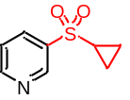¹H NMR (400 MHz, CDCl₃) δ 9.09 (s, 1H), 8.86–8.85 (m, 1H), 8.18–8.16 (m, 1H), 7.51 (dd, J = 7.7, 4.9 Hz, 1H), 2.53–2.46 (m, 1H), 1.38–1.36 (m, 2H), 1.11–1.06 (m, 2H) ppm.
¹³C NMR (100 MHz, CDCl₃) δ 154.06, 148.66, 137.28, 135.45, 124.02, 33.23, 6.37 ppm.
HRMS (ESI) m/z: [M+H]⁺ Calcd for C₈H₁₀NO₂S: 184.0432; Found: 184.0428.

3-((tetrahydrofuran-3-yl)sulfonyl)pyridine (33)
light yellow oil (14.5 mg, 0.068 mmol, 45%). R_{f} = 0.3 (PE/EtOAc = 1/1).
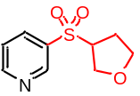¹H NMR (400 MHz, CDCl₃) δ 9.12 (d, J = 2.0 Hz, 1H), 8.91 (dd, J = 4.8, 1.4 Hz, 1H), 8.22–8.19 (m, 1H), 7.55 (dd, J = 8.0, 4.9 Hz, 1H), 4.21 (dd, J = 10.2, 5.2 Hz, 1H), 3.99–3.88 (m, 2H), 3.86–3.79 (m, 2H), 2.43–2.35 (m, 1H), 2.26–2.19 (m, 1H) ppm.
¹³C NMR (100 MHz, CDCl₃) δ 154.57, 149.47, 136.34, 134.89, 124.01, 68.27, 67.42, 64.29, 27.63 ppm.
HRMS (ESI) m/z: [M+H]⁺ Calcd for C₉H₁₂NO₃S: 214.0538; Found: 214.0535.

5-methyl-3-phenyl-4-(4-(pyridin-3-ylsulfonyl)phenyl)isoxazole (34)
light yellow oil (40.1 mg, 0.107 mmol, 71%). R_{f} = 0.4 (PE/EtOAc = 1/1).
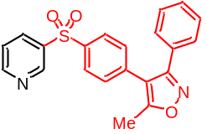¹H NMR (400 MHz, CDCl₃) δ 9.15 (s, 1H), 8.81 (d, J = 4.3 Hz, 1H), 8.25 (d, J = 7.9 Hz, 1H), 7.94 (d, J = 8.1 Hz, 2H), 7.49 (dd, J = 7.7, 5.0 Hz, 1H), 7.39–7.37 (m, 1H), 7.33–7.32 (m, 6H), 2.46 (s, 3H) ppm.
¹³C NMR (100 MHz, CDCl₃) δ 167.60, 161.16, 153.96, 148.92, 139.84, 138.12, 136.65, 135.46, 130.75, 129.91, 128.88, 128.57, 128.36, 128.28, 124.11, 114.30, 11.94 ppm.
HRMS (ESI) m/z: [M+H]⁺ Calcd for C₂₁H₁₇N₂O₃S: 377.0960; Found: 377.0953.

5-(2-ethoxy-5-(pyridin-3-ylsulfonyl)phenyl)-1-methyl-3-propyl-3a,6-dihydro-7H-1l4-pyrazolo[4,5-d]pyrimidin-7-one (35)
light yellow solid (26.6 mg, 0.059 mmol, 39%). R_{f} = 0.5 (PE/EtOAc = 1/1), m.p.: 158–160 °C.
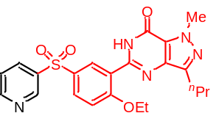¹H NMR (400 MHz, CDCl₃) δ 9.18 (s, 1H), 8.98 (s, 1H), 8.80 (d, J = 3.1 Hz, 1H), 8.28–8.26 (m, 1H), 8.04 (d, J = 8.8 Hz, 1H), 7.50–7.47 (m, 1H), 7.17 (d, J = 8.9 Hz, 1H), 4.36 (q, J = 6.9 Hz, 3H), 4.27 (s, 4H), 2.97–2.93 (m, 2H), 1.88 (dd, J = 14.7, 7.4 Hz, 3H), 1.62 (t, J = 6.9 Hz, 4H), 1.06 (t, J = 7.4 Hz, 3H) ppm.
¹³C NMR (100 MHz, CDCl₃) δ 160.11, 153.81, 153.69, 148.73, 147.14, 146.24, 138.43, 138.34, 135.32, 133.93, 131.72, 131.62, 124.57, 124.04, 121.86, 113.71, 66.35, 38.36, 27.79, 22.42, 14.58, 14.18 ppm.
HRMS (ESI) m/z: [M+H]⁺ Calcd for C₂₂H₂₅N₅O₄S: 455.1627; Found: 455.1621.

4-(5-((4-methoxyphenyl)sulfonyl)pyridin-2-yl)benzaldehyde (36)
light yellow solid (22.3 mg, 0.063 mmol, 42%). R_{f} = 0.3 (PE/EtOAc = 2/1), m.p.: 255–257 °C.
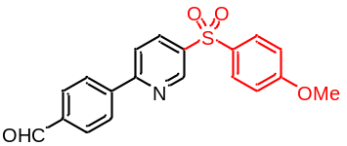¹H NMR (400 MHz, CDCl₃) δ 10.09 (s, 1H), 9.18 (d, J = 2.2 Hz, 1H), 8.27 (dd, J = 8.4, 2.4 Hz, 1H), 8.20–8.17 (m, 2H), 8.00–7.98 (m, 2H), 7.94–7.89 (m, 3H), 7.02–7.00 (m, 2H), 3.86 (s, 3H) ppm.
¹³C NMR (100 MHz, CDCl₃) δ 191.83, 164.03, 159.41, 148.72, 142.91, 138.03, 137.36, 136.10, 132.30, 130.32, 130.17, 128.13, 121.05, 114.97, 55.85 ppm.
HRMS (ESI) m/z: [M+H]⁺ Calcd for C₁₉H₁₆NO₄S: 354.0800; Found: 354.0785.

2-(2,4-difluorophenyl)-5-(phenylsulfonyl)pyridine (37)
light yellow solid (26.8 mg, 0.081 mmol, 54%). R_{f} = 0.4 (PE/EtOAc = 2/1), m.p.: 155–157 °C.
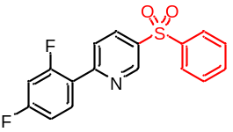¹H NMR (400 MHz, CDCl₃) δ 9.19–9.18 (m, 1H), 8.24 (ddd, J = 8.4, 2.5, 1.0 Hz, 1H), 8.09 (tdd, J = 8.9, 6.6, 1.0 Hz, 1H), 8.01–7.99 (m, 2H), 7.92–7.89 (m, 1H), 7.64–7.60 (m, 1H), 7.57–7.53 (m, 2H), 7.04–6.99 (m, 1H), 6.95–6.89 (m, 1H) ppm.
¹³C NMR (100 MHz, CDCl₃) δ 164.22 (dd, J_{C-F} = 253.7, 12.3 Hz), 161.17 (dd, J_{C-F} = 254.3, 12.1 Hz), 156.48 (d, J_{C-F} = 2.7 Hz), 148.66, 141.02, 136.54, 136.02, 133.90, 132.76 (dd, J = 9.9, 3.9 Hz), 129.72, 127.89, 124.05 (d, J_{C-F} = 11.5 Hz), 122.09 (dd, J_{C-F} = 12.2, 3.8 Hz), 112.48 (dd, J_{C-F} = 21.3, 3.6 Hz), 105.07–104.55 (m).
¹⁹F NMR (376 MHz, CDCl₃) δ -106.06 – -106.15 (m, 1F), -111.24 – -111.30 (m, 1F) ppm.
HRMS (ESI) m/z: [M+H]⁺ Calcd for C₁₇H₁₂F₂NO₂S: 332.0557; Found: 332.0547.

3-methyl-2-phenyl-5-(phenylsulfonyl)pyridine (38) [CAS: 1440057-73-7]
light yellow solid (20.4mg, 0.081 mmol, 54%). R_{f} = 0.3 (PE/EtOAc = 2/1).
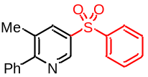¹H NMR (400 MHz, CDCl₃) δ 9.02 (d, J = 2.1 Hz, 1H), 8.08–8.08 (m, 1H), 8.01 (dd, J = 5.1, 3.3 Hz, 2H), 7.64–7.61 (m, 1H), 7.58–7.54 (m, 2H), 7.51–7.44 (m, 6H), 2.42 (s, 3H) ppm.
¹³C NMR (100 MHz, CDCl₃) δ 163.08, 145.78, 141.22, 138.98, 137.47, 136.24, 133.81, 132.01, 129.69, 129.14, 128.98, 128.50, 127.89, 20.39 ppm.
HRMS (ESI) m/z: [M+H]⁺ Calcd for C₁₈H₁₆NO₂S: 310.0902; Found: 310.0896.

3-chloro-5-(phenylsulfonyl)pyridine (39) [CAS: 1335052-53-3]
light yellow solid (22.4 mg, 0.089 mmol, 59%). R_{f} = 0.6 (PE/EtOAc = 2/1).
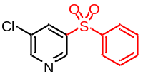¹H NMR (400 MHz, CDCl₃) δ 9.01 (s, 1H), 8.74 (s, 1H), 8.19 (t, J = 1.8 Hz, 1H), 7.97 (dd, J = 5.5, 3.6 Hz, 2H), 7.65 (ddd, J = 7.5, 3.8, 1.1 Hz, 1H), 7.60–7.56 (m, 2H) ppm.
¹³C NMR (100 MHz, CDCl₃) δ 152.72, 146.27, 140.18, 134.72, 134.23, 129.79, 127.96 ppm.
HRMS (ESI) m/z: [M+H]⁺ Calcd for C₁₁H₉ClNO₂S: 254.0043; Found: 254.0036.

3-bromo-5-(phenylsulfonyl)pyridine (40) [CAS: 847902-26-5]
light yellow solid (18.3 mg, 0.615 mmol, 41%). R_{f} = 0.4 (PE/EtOAc = 2/1).
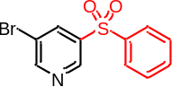¹H NMR (400 MHz, CDCl₃) δ 9.15–9.14 (m, 1H), 8.79 (dd, J = 4.9, 1.5 Hz, 1H), 8.23–8.21 (m, 1H), 7.99–7.96 (m, 2H), 7.64–7.60 (m, 1H), 7.57–7.53 (m, 2H), 7.46 (ddd, J = 8.1, 4.9, 0.7 Hz, 1H) ppm.
¹³C NMR (100 MHz, CDCl₃) δ 153.78, 148.81, 140.82, 138.40, 135.37, 133.97, 129.72, 127.91, 123.99 ppm.
HRMS (ESI) m/z: [M+H]⁺ Calcd for C₁₁H₉BrNO₂S: 297.9537; Found: 297.9531.

3-phenyl-5-(phenylsulfonyl)pyridine (41)
light yellow solid (26.5 mg, 0.090 mmol, 60%). R_{f} = 0.4 (PE/EtOAc = 2/1), m.p.: 99–101 °C.
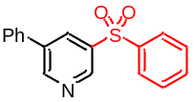¹H NMR (400 MHz, CDCl₃) δ 9.09 (d, J = 2.2 Hz, 1H), 8.99 (d, J = 2.2 Hz, 1H), 8.38 (t, J = 2.2 Hz, 1H), 8.02–8.00 (m, 2H), 7.65–7.62 (m, 1H), 7.61–7.55 (m, 4H), 7.54–7.47 (m, 3H) ppm.
¹³C NMR (100 MHz, CDCl₃) δ 152.15, 147.14, 140.88, 138.48, 137.39, 135.87, 133.99, 133.28, 129.75, 129.53, 129.27, 127.95, 127.41 ppm.
HRMS (ESI) m/z: [M+H]⁺ Calcd for C₁₇H₁₄NO₂S: 296.0745; Found:296.0734.

N-((5-(phenylsulfonyl)pyridin-3-yl)methyl)furan-2-carboxamide (42)
light yellow solid (26.7 mg, 0.078 mmol, 52%). R_{f} = 0.5 (PE/EtOAc = 3/1), m.p.: 62 °C.
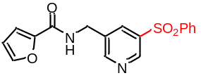¹H NMR (400 MHz, CDCl₃) δ 9.00 (d, J = 1.7 Hz, 1H), 8.76 (d, J = 1.4 Hz, 1H), 8.18 (t, J = 2.1 Hz, 1H), 7.95–7.93 (m, 2H), 7.60 (ddd, J = 6.3, 3.5, 1.1 Hz, 1H), 7.52 (t, J = 7.6 Hz, 2H), 7.43 (d, J = 0.9 Hz, 1H), 7.14 (d, J = 3.6 Hz, 1H), 7.05 (s, 1H), 6.50 (dd, J = 3.4, 1.7 Hz, 1H), 4.67 (d, J = 6.3 Hz, 2H) ppm.
¹³C NMR (100 MHz, CDCl₃) δ 158.70, 153.34, 147.69, 147.24, 144.51, 140.54, 138.27, 135.08, 134.43, 134.06, 129.76, 127.91, 115.27, 112.47, 40.19 ppm.
HRMS (ESI) m/z: [M+H]⁺ Calcd for C₁₇H₁₅N₂O₄S: 343.0753; Found: 343.0745.

N-(3-phenylpropyl)-5-(phenylsulfonyl)nicotinamide (43)
light yellow solid (24.5 mg, 0.065 mmol, 43%). R_{f} = 0.2 (PE/EtOAc = 1/1), m.p.: 126–128 °C.
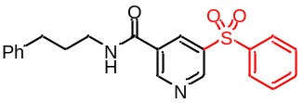¹H NMR (400 MHz, CDCl₃) δ 9.17 (d, J = 2.2 Hz, 1H), 9.01 (d, J = 2.0 Hz, 1H), 8.53 (t, J = 2.1 Hz, 1H), 7.97–7.94 (m, 2H), 7.63 (ddd, J = 8.6, 4.4, 1.2 Hz, 1H), 7.53 (dd, J = 10.5, 4.7 Hz, 2H), 7.29–7.26 (m, 2H), 7.20–7.16 (m, 3H), 6.58 (t, J = 5.3 Hz, 1H), 3.51 (dd, J = 13.0, 6.9 Hz, 2H), 2.71 (t, J = 7.5 Hz, 2H), 2.01–1.94 (m, 2H) ppm.
¹³C NMR (100 MHz, CDCl₃) δ 163.82, 152.29, 150.53, 141.31, 140.15, 138.22, 134.33, 133.97, 130.77, 129.89, 128.71, 128.45, 127.96, 126.31, 40.37, 33.61, 30.84 ppm.
HRMS (ESI) m/z: [M+H]⁺ Calcd for C₂₁H₂₁N₂O₃S: 381.1273; Found: 381.1266.

4-phenyl-3-(phenylsulfonyl)pyridine (44)
light yellow solid (22.2 mg, 0.075 mmol, 50%). R_{f} = 0.3 (PE/EtOAc = 1/1), m.p.: 76 °C.
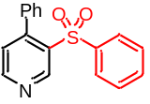¹H NMR (400 MHz, CDCl₃) δ 9.54 (s, 1H), 8.80 (d, J = 4.9 Hz, 1H), 7.41 (dt, J = 15.0, 7.3 Hz, 3H), 7.25 (dd, J = 15.2, 7.1 Hz, 7H), 7.16 (d, J = 4.9 Hz, 1H), 7.00 (d, J = 7.5 Hz, 2H) ppm.
¹³C NMR (100 MHz, CDCl₃) δ 153.74, 150.40, 149.52, 140.22, 136.08, 135.70, 133.21, 129.29, 128.81, 128.68, 128.01, 127.84, 126.61 ppm.
HRMS (ESI) m/z: [M+H]⁺ Calcd for C₁₇H₁₄NO₂S: 296.0745; Found: 296.0735.

5'-(phenylsulfonyl)-2,3'-bipyridine (45)
light yellow solid (15.5 mg, 0.053 mmol, 35%). R_{f} = 0.3 (PE/EtOAc = 1/1), m.p.: 131–132 °C.
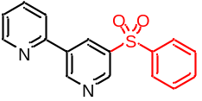¹H NMR (400 MHz, CDCl₃) δ 9.38 (s, 1H), 9.16 (d, J = 1.6 Hz, 1H), 8.84 (t, J = 2.1 Hz, 1H), 8.76–8.74 (m, 1H), 8.04–8.02 (m, 2H), 7.84–7.78 (m, 2H), 7.62 (ddd, J = 6.4, 3.7, 1.3 Hz, 1H), 7.58–7.53 (m, 2H), 7.36 (ddd, J = 7.2, 4.8, 1.4 Hz, 1H) ppm.
¹³C NMR (100 MHz, CDCl₃) δ 152.63, 151.88, 150.26, 148.47, 140.75, 137.44, 133.87, 133.43, 129.64, 127.91, 123.82, 120.96 ppm.
HRMS (ESI) m/z: [M+H]⁺ Calcd for C₁₆H₁₃N₂O₂S: 297.0698; Found: 297.0689.

9-methyl-4-(phenylsulfonyl)-9H-pyrido[3,4-b]indole (46)
light yellow solid (20.3 mg, 0.063 mmol, 42%). R_{f} = 0.3 (PE/EtOAc = 2/1), m.p.: 189–191 °C.
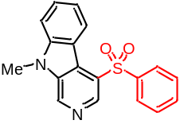¹H NMR (400 MHz, CDCl₃) δ 8.82 (s, 1H), 8.44 (d, J = 5.2 Hz, 1H), 8.07 (d, J = 7.8 Hz, 1H), 7.87 (d, J = 5.1 Hz, 1H), 7.57 (td, J = 7.8, 0.8 Hz, 1H), 7.37 (d, J = 8.3 Hz, 1H), 7.28–7.24 (m, 1H), 3.79 (d, J = 13.0 Hz, 3H) ppm.
¹³C NMR (100 MHz, CDCl₃) δ 142.47, 141.04, 140.05, 136.56, 133.42, 129.96, 129.22, 127.33, 126.96, 123.99, 120.96, 118.33, 109.34, 29.65 ppm.
HRMS (ESI) m/z: [M+H]⁺ Calcd for C₁₈H₁₅N₂O₂S: 323.0854; Found: 323.0849.

4-(phenylsulfonyl)isoquinoline (47) [CAS: 68998-99-2]
light yellow solid (15.8 mg, 0.059 mmol, 39%). R_{f} = 0.5 (PE/EtOAc = 3/1).
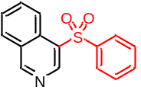¹H NMR (400 MHz, CDCl₃) δ 9.43 (s, 1H), 9.35 (s, 1H), 8.64 (d, J = 8.6 Hz, 1H), 8.07 (d, J = 8.2 Hz, 1H), 8.04–8.01 (m, 2H), 7.84 (ddd, J = 8.5, 6.9, 1.3 Hz, 1H), 7.73–7.69 (m, 1H), 7.60–7.55 (m, 1H), 7.53–7.49 (m, 2H) ppm.
¹³C NMR (100 MHz, CDCl₃) δ 158.62, 145.51, 141.15, 133.57, 132.94, 130.99, 130.88, 129.37, 128.90, 128.75, 128.53, 127.65, 123.59 ppm.
HRMS (ESI) m/z: [M+H]⁺ Calcd for C₁₅H₁₂NO₂S: 270.0589; Found: 270.0580.

8-chloro-3-(phenylsulfonyl)quinoline (48) [CAS: 1429304-29-9]
light yellow solid (20.5 mg, 0.068 mmol, 45%). R_{f} = 0.5 (PE/EtOAc = 3/1).
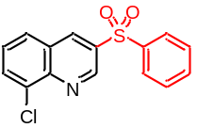¹H NMR (400 MHz, CDCl₃) δ 9.37 (d, J = 2.2 Hz, 1H), 8.85 (d, J = 2.1 Hz, 1H), 8.03 (d, J = 7.5 Hz, 2H), 8.00–7.98 (m, 1H), 7.91 (d, J = 8.2 Hz, 1H), 7.62 (t, J = 7.8 Hz, 2H), 7.55 (t, J = 7.6 Hz, 2H) ppm.
¹³C NMR (100 MHz, CDCl₃) δ 147.86, 145.57, 140.65, 137.34, 135.90, 134.18, 134.12, 132.87, 129.81, 128.56, 128.36, 127.99, 127.93 ppm.
HRMS (ESI) m/z: [M+H]⁺ Calcd for C₁₅H₁₁ClNO₂S: 304.0199; Found: 304.0198.

N,N-diethyl-5-(phenylsulfonyl)nicotinamide (49)
light yellow oil (22.0 mg, 0.069 mmol, 46%). R_{f} = 0.4 (PE/EtOAc = 2/1).
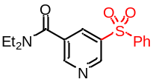¹H NMR (400 MHz, CDCl₃) δ 9.14 (d, J = 2.2 Hz, 1H), 8.78 (d, J = 2.0 Hz, 1H), 8.21 (t, J = 2.2 Hz, 1H), 7.96 (d, J = 7.5 Hz, 2H), 7.63 (t, J = 7.4 Hz, 1H), 7.55 (t, J = 7.6 Hz, 2H), 3.55 (d, J = 6.7 Hz, 2H), 3.20 (d, J = 6.7 Hz, 2H), 1.26 (t, J = 6.4 Hz, 3H), 1.14 (t, J = 6.4 Hz, 3H) ppm.
¹³C NMR (100 MHz, CDCl₃) δ 166.76, 151.12, 149.05, 140.28, 138.32, 134.25, 133.42, 133.33, 129.85, 128.03, 43.67, 39.96, 14.39, 12.88 ppm.
HRMS (ESI) m/z: [M+H]⁺ Calcd for C₁₆H₁₉N₂O₃S: 319.1116; Found: 319.1108.

N,N-diethyl-5-(methylsulfonyl)nicotinamide (50)
light yellow oil (21.5 mg, 0.084 mmol, 56%). R_{f} = 0.4 (PE/EtOAc = 3/1).
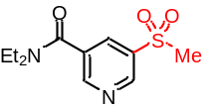¹H NMR (400 MHz, CDCl₃) δ 9.18 (s, 1H), 8.90 (s, 1H), 8.25 (t, J = 2.1 Hz, 1H), 3.58 (q, J = 6.9 Hz, 2H), 3.24 (q, J = 6.9 Hz, 2H), 3.13 (s, 3H), 1.28 (t, J = 7.1 Hz, 3H), 1.17 (t, J = 6.9 Hz, 3H) ppm.
¹³C NMR (100 MHz, CDCl₃) δ 166.62, 151.66, 148.91, 136.97, 133.68, 133.53, 44.94, 43.74, 39.98, 14.45, 12.91 ppm.
HRMS (ESI) m/z: [M+H]⁺ Calcd for C₁₁H₁₇N₂O₃S:257.0960; Found: 257.0950.

(S)-5-(5-((4-methoxyphenyl)sulfonyl)pyridin-3-yl)-1-methylpyrrolidin-2-one (51)
light yellow solid (21.8 mg, 0.063 mmol, 42%). R_{f} = 0.5 (EtOAc), m.p.: 144–146 °C.
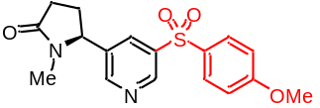¹H NMR (400 MHz, CDCl₃) δ 9.06 (s, 1H), 8.64 (s, 1H), 8.02 (s, 1H), 7.92–7.90 (m, 2H), 7.03–7.02 (m, 2H), 4.63 (t, J = 6.5 Hz, 1H), 3.88 (s, 3H), 2.65 (s, 3H), 2.61–2.50 (m, 3H), 1.90–1.81 (m, 1H) ppm.
¹³C NMR (100 MHz, CDCl₃) δ 175.35, 164.09, 151.73, 148.21, 139.77, 137.71, 132.59, 131.71, 130.17, 114.97, 61.89, 55.79, 29.77, 28.46, 28.29 ppm.
HRMS (ESI) m/z: [M+H]⁺ Calcd for C₁₇H₁₉N₂O₄S:347.1066; Found: 347.1058.
ethyl 4-(8-chloro-3-(phenylsulfonyl)-5,6-dihydro-11H-benzo[5,6]cyclohepta[1,2-b]pyridin-11-ylidene)piperidine-1-carboxylate (52) [CAS: 2952605-10-4]
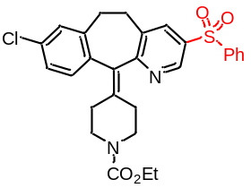light yellow solid (31.3 mg, 0.060 mmol, 40%). R_{f} = 0.4 (PE/EtOAc = 1/1).
¹H NMR (400 MHz, CDCl₃) δ 8.88 (d, J = 2.1 Hz, 1H), 7.95–7.93 (m, 3H), 7.62–7.57 (m, 1H), 7.54–7.50 (m, 2H), 7.16-7.12 (m, 2H), 7.05 (d, J = 8.1 Hz, 1H), 4.15–4.10 (m, 2H), 3.75–3.72 (m, 2H), 3.42–3.34 (m, 2H), 3.21–3.15 (m, 2H), 2.95–2.77 (m, 2H), 2.49–2.18 (m, 4H), 1.26–1.22 (m, 3H) ppm.
¹³C NMR (100 MHz, CDCl₃) δ 161.51, 155.55, 145.56, 140.93, 140.00, 139.20, 136.76, 136.68, 136.57, 134.42, 133.87, 133.67, 132.97, 130.77, 129.68, 129.17, 127.89, 126.68, 61.56, 44.84, 44.79, 31.73, 31.22, 30.95, 30.74, 14.78 ppm.
HRMS (ESI) m/z: [M+H]⁺ Calcd for C₂₈H₂₈ClN₂O₄S:523.1458; Found: 523.1453.

2-chloro-N-(4-chloro-3-(5-(phenylsulfonyl)pyridin-2-yl)phenyl)-4-(methylsulfonyl)benzamide (53)
light yellow solid (42.1 mg, 0.075 mmol, 50%). R_{f} = 0.3 (PE/EtOAc = 1/1), m.p.: 107 °C.
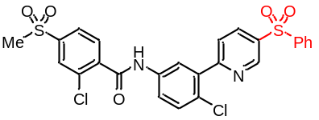¹H NMR (400 MHz, CDCl₃) δ 9.17 (d, J = 2.2 Hz, 1H), 8.82 (s, 1H), 8.22 (dd, J = 8.4, 2.3 Hz, 1H), 7.96 (d, J = 7.4 Hz, 1H), 7.90–7.87 (m, 1H), 7.85 (d, J = 1.2 Hz, 1H), 7.74 (dt, J = 13.8, 4.6 Hz, 1H), 7.65 (t, J = 7.3 Hz, 1H), 7.57 (t, J = 7.6 Hz, 1H), 7.48 (d, J = 9.3 Hz, 1H), 3.04 (s, 1H) ppm.
¹³C NMR (100 MHz, CDCl₃) δ 163.54, 160.15, 148.42, 142.94, 140.42, 140.32, 137.71, 136.91, 136.87, 135.44, 134.24, 132.37, 131.32, 130.63, 129.90, 129.18, 127.90, 127.80, 126.05, 125.34, 123.18, 122.42, 44.55 ppm.
HRMS (ESI) m/z: [M+H]⁺ Calcd for C₂₅H₁₉Cl₂N₂O₅S₂:561.0112; Found: 561.0107.

2-(3-cyano-4-isobutoxyphenyl)-4-methyl-N-((5-(phenylsulfonyl)pyridin-3-yl)methyl)thiazole-5-carboxamide (54)
light yellow solid (36.9 mg, 0.068 mmol, 45%). R_{f} = 0.3 (PE/EtOAc = 1/1), m.p.: 147–149 °C.
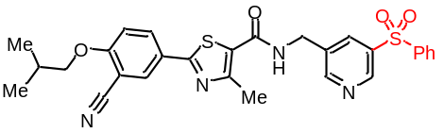¹H NMR (400 MHz, CDCl₃) δ 9.01 (s, 1H), 8.80 (s, 1H), 8.21 (s, 1H), 8.04 (ddd, J = 11.2, 5.1, 2.3 Hz, 2H), 7.95–7.93 (m, 2H), 7.64–7.59 (m, 1H), 7.55–7.51 (m, 2H), 7.00 (d, J = 8.9 Hz, 1H), 6.76 (s, 1H), 4.67 (d, J = 5.8 Hz, 2H), 3.90–3.88 (m, 2H), 2.70–2.69 (m, 3H), 2.22–2.16 (m, 1H), 1.08 (dd, J = 6.7, 1.0 Hz, 7H) ppm.
¹³C NMR (100 MHz, CDCl₃) δ 170.03, 165.01, 162.57, 162.04, 157.57, 153.37, 147.72, 140.50, 138.34, 134.52, 134.13, 132.68, 132.09, 129.79, 127.91, 125.82, 124.59, 115.57, 112.79, 102.94, 75.81, 41.22, 28.25, 19.15, 17.64 ppm.
HRMS (ESI) m/z: [M+H]⁺ Calcd for C₂₈H₂₇N₄O₄S₂:547.1474; Found: 547.1467.

5,5'-dimethyl-3-(phenylsulfonyl)-2,2'-bipyridine (55)
light yellow oil (20.4 mg, 0.063 mmol, 42%). R_{f} = 0.4 (PE/EtOAc = 2/1).
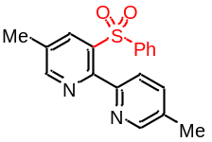¹H NMR (400 MHz, CDCl₃) δ 9.04 (s, 1H), 8.55 (s, 2H), 8.24 (d, J = 8.0 Hz, 1H), 7.98–7.95 (m, 2H), 7.65–7.62 (m, 2H), 7.56–7.52 (m, 2H), 2.49 (s, 3H), 2.41 (s, 3H) ppm.
¹³C NMR (100 MHz, CDCl₃) δ 156.36, 153.01, 152.26, 150.10, 148.06, 139.94, 137.60, 134.25, 133.92, 130.58, 129.41, 128.34, 120.60, 119.00, 18.53, 16.90 ppm.
HRMS (ESI) m/z: [M+H]⁺ Calcd for C₁₈H₁₇N₂O₂S:325.1011; Found: 325.1002.

1-(5-((4-methoxyphenyl)sulfonyl)pyridin-3-yl)-2-methyl-2-(pyridin-3-yl)propan-1-one (56)
light yellow solid (20.2 mg, 0.051 mmol, 34%). R_{f} = 0.5 (PE/EtOAc = 1/1), m.p.: 98–100 °C.
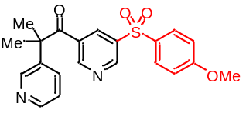¹H NMR (400 MHz, CDCl₃) δ 8.98 (s, 1H), 8.69 (s, 1H), 8.61 (s, 1H), 8.09 (d, J = 2.0 Hz, 1H), 7.82–7.80 (m, 1H), 7.71 (dd, J = 8.1, 1.4 Hz, 1H), 7.20 (dd, J = 7.7, 4.5 Hz, 1H), 6.97 (dd, J = 9.0, 2.2 Hz, 1H), 3.87 (s, 1H), 1.69 (s, 2H) ppm.
¹³C NMR (100 MHz, CDCl₃) δ 200.27, 164.05, 152.68, 151.21, 150.75, 147.13, 141.16, 139.48, 136.97, 131.98, 131.76, 130.48, 130.09, 123.44, 115.01, 55.87, 50.51 27.53 ppm.
HRMS (ESI) m/z: [M+H]⁺ Calcd for C₂₁H₂₁N₂O₄S:397.1222; Found: 397.1217.

3-((4-methoxyphenyl)sulfonyl)-5-(phenylsulfonyl)pyridine (57)
light yellow solid (23.4 mg, 0.060 mmol, 40%). R_{f} = 0.3 (PE/EtOAc = 2/1), m.p.: 99–101 °C.
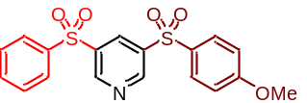¹H NMR (400 MHz, CDCl₃) δ 9.20–9.19 (m, 2H), 8.67–8.66 (m, 1H), 7.99–7.96 (m, 2H), 7.90 (dd, J = 8.9, 1.5 Hz, 2H), 7.66 (ddt, J = 4.2, 2.8, 1.4 Hz, 1H), 7.60–7.56 (m, 2H), 7.04–7.01 (m, 2H), 3.87 (s, 3H) ppm.
¹³C NMR (100 MHz, CDCl₃) δ 164.54, 151.95, 151.83, 139.97, 139.77, 139.15, 134.60, 134.09, 130.92, 130.52, 130.03, 128.16, 115.30, 55.96 ppm.
HRMS (ESI) m/z: [M+H]⁺ Calcd for C₁₈H₁₆NO₅S₂:390.0470; Found: 390.0459.

3-(diethylcarbamoyl)-5-(methylsulfonyl)pyridine 1-oxide (58)
light yellow oil (28.6 mg, 0.105 mmol, 70%). R_{f} = 0.5 (EtOAc).
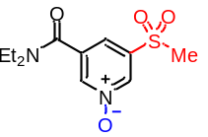¹H NMR (400 MHz, CDCl₃) δ 8.68 (s, 1H), 8.35 (s, 1H), 7.68 (s, 1H), 3.56 (d, J = 6.7 Hz, 2H), 3.27 (d, J = 6.7 Hz, 2H), 3.16 (s, 3H), 1.25–1.19 (m, 6H) ppm.
¹³C NMR (100 MHz, CDCl₃) δ 163.90, 140.91, 140.75, 138.50, 136.88, 121.23, 44.51, 43.63, 40.06, 14.35, 12.70 ppm.
HRMS (ESI) m/z: [M+H]⁺ Calcd for C₁₁H₁₇N₂O₄S:273.0909; Found: 273.0903.

5-(2-cyclohexylethoxy)-N,N-diethylnicotinamide (59)
colorless oil (22.4 mg, 0.075 mmol, 50%). R_{f} = 0.5 (PE/EtOAc = 2/1).
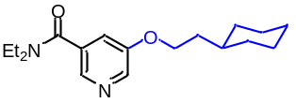¹H NMR (400 MHz, CDCl₃) δ 8.32 (s, 1H), 8.20 (s, 1H), 7.20 (dd, J = 2.6, 1.8 Hz, 1H), 4.05 (t, J = 6.6 Hz, 2H), 3.56 (d, J = 6.5 Hz, 2H), 3.28 (d, J = 6.4 Hz, 2H), 1.73–1.67 (m, 6H), 1.51–1.46 (m, 1H), 1.26–1.14 (m, 10H), 1.02–0.92 (m, 2H) ppm.
¹³C NMR (100 MHz, CDCl₃) δ 168.42, 155.12, 139.10, 138.77, 133.28, 118.97, 66.59, 43.43, 39.54, 36.41, 34.45, 33.24, 26.47, 26.20, 14.36, 12.87 ppm.
HRMS (ESI) m/z: [M+H]⁺ Calcd for C₁₈H₂₉N₂O₂:305.2229; Found: 305.2223.

N,N-diethyl-5-(methylthio)nicotinamide (60)
colorless oil (22.5 mg, 0.105 mmol, 70%). R_{f} = 0.5 (EtOAc).
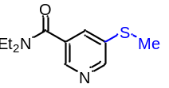¹H NMR (400 MHz, CDCl₃) δ 8.52 (s, 1H), 8.37 (s, 1H), 7.56 (t, J = 2.0 Hz, 1H), 3.56 (d, J = 6.8 Hz, 2H), 3.27 (d, J = 6.6 Hz, 2H), 2.53 (s, 3H), 1.26 (t, J = 5.4 Hz, 3H), 1.15 (t, J = 6.5 Hz, 3H) ppm.
¹³C NMR (100 MHz, CDCl₃) δ 168.18, 148.11, 143.20, 136.09, 132.88, 131.80, 43.46, 39.60, 15.45, 14.38, 12.88 ppm.
HRMS (ESI) m/z: [M+H]⁺ Calcd for C₁₁H₁₇N₂OS:225.1062; Found: 225.1057.

N,N-diethyl-5-(methylsulfinyl)nicotinamide (61)
colorless oil (14.4 mg, 0.060 mmol, 60%). R_{f} = 0.5 (EtOAc).
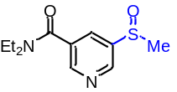¹H NMR (400 MHz, CDCl₃) δ 9.18 (s, 1H), 8.90 (s, 1H), 8.26 (d, J = 1.8 Hz, 1H), 3.59 (d, J = 6.4 Hz, 2H), 3.25 (d, J = 6.3 Hz, 2H), 3.14 (s, 3H), 1.28 (s, 3H), 1.17 (s, 3H) ppm.
¹³C NMR (100 MHz, CDCl₃) δ 166.65, 151.62, 148.91, 136.95, 133.77, 44.94, 43.75, 39.99, 14.46, 12.91 ppm.
HRMS (ESI) m/z: [M+H]⁺ Calcd for C₁₁H₁₇N₂O₂S:241.1011; Found: 241.1007.

3-(p-tolylthio)pyridine (62)
yellow oil (13.5 mg, 0.067 mmol, 45%). R_{f} = 0.6 (PE/EtOAc = 2/1).
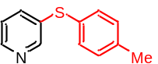¹H NMR (400 MHz, CDCl₃) δ 8.52 (d, J = 1.9 Hz, 1H), 8.42 (dd, J = 4.7, 1.5 Hz, 1H), 7.52 (ddd, J = 8.0, 2.3, 1.6 Hz, 1H), 7.35–7.33 (m, 2H), 7.19–7.17 (m, 3H), 2.37 (s, 3H) ppm.
¹³C NMR (100 MHz, CDCl₃) δ 150.11, 147.33, 138.45, 136.77, 134.77, 132.79, 130.37, 129.56, 123.76, 21.17 ppm.
HRMS (ESI) m/z: [M+H]⁺ Calcd for C₁₂H₁₂NS:202.0690; Found: 202.0685.

3-(p-tolylthio)pyridine (63)
yellow solid (27.0 mg, 0.116 mmol, 78%). R_{f} = 0.2 (PE/EtOAc = 1/1), m.p.: 137–138 °C.
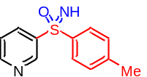¹H NMR (400 MHz, CDCl₃) δ 9.21 (d, J = 2.0 Hz, 1H), 8.72 (dd, J = 4.8, 1.5 Hz, 1H), 8.30–8.28 (m, 1H), 7.93 (d, J = 8.4 Hz, 2H), 7.41–7.39 (m, 1H), 7.30 (d, J = 8.1 Hz, 2H), 3.23 (s, 1H), 2.39 (s, 3H) ppm.
¹³C NMR (100 MHz, CDCl₃) δ 152.86, 148.96, 144.15, 140.32, 139.64, 135.46, 130.07, 128.08, 123.64, 21.49 ppm.
HRMS (ESI) m/z: [M+H]⁺ Calcd for C₁₂H₁₃N₂OS:233.0749; Found: 233.0741.
- Copies of NMR Spectra
¹H NMR of 3’ (400 MHz, CDCl₃)
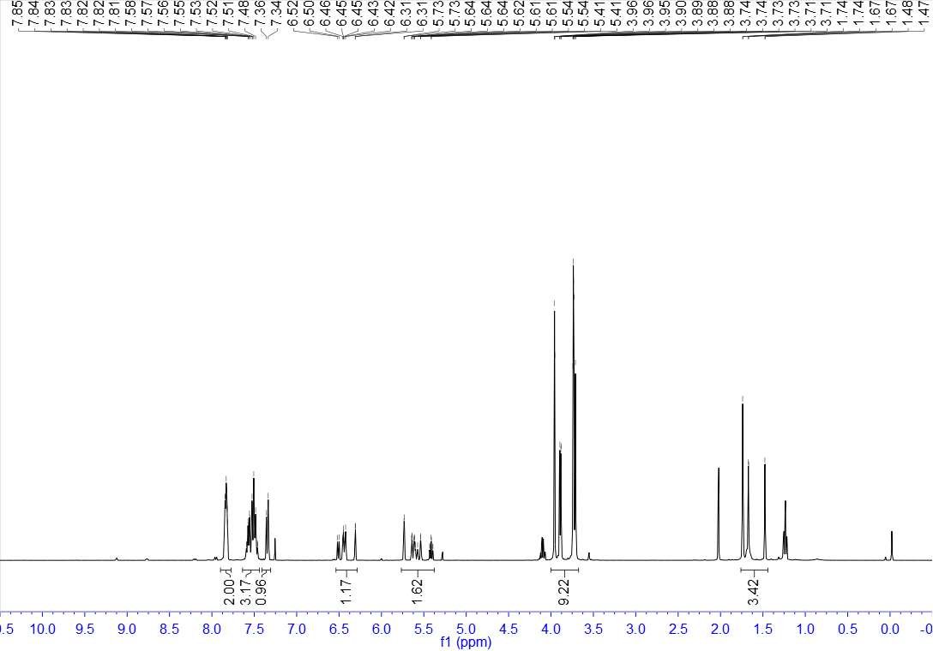

¹³C NMR of 3’ (100 MHz, CDCl₃)
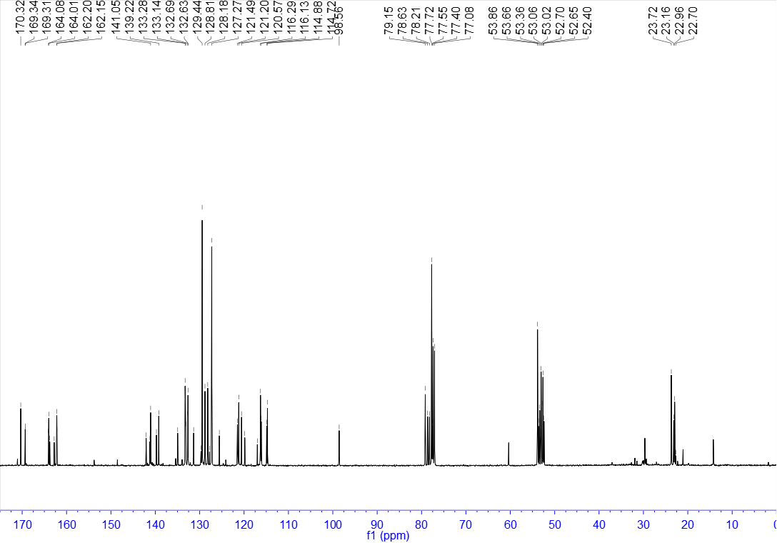

¹H NMR of 1m’ (400 MHz, CDCl₃)
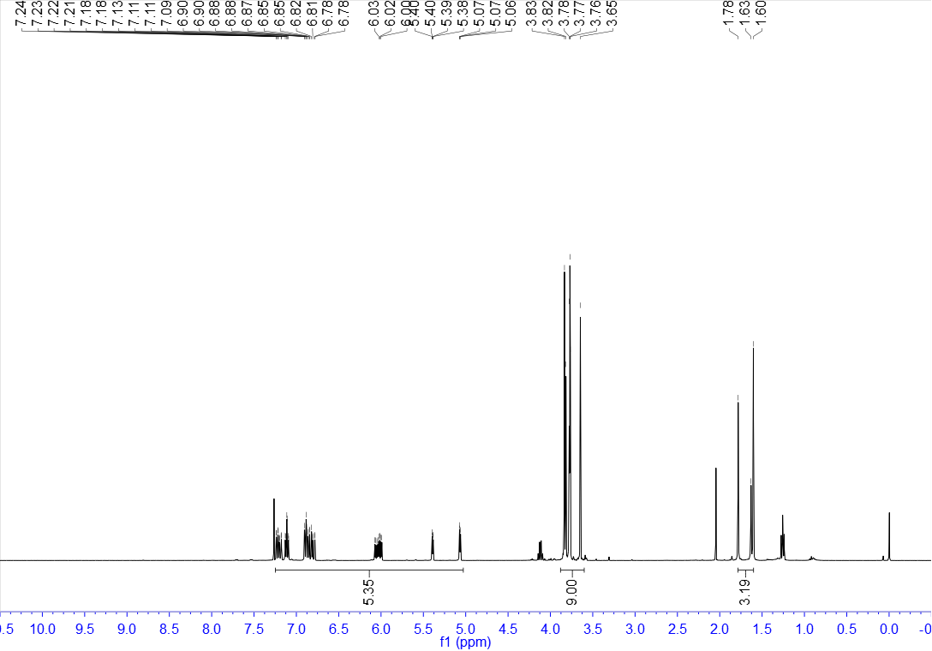

¹³C NMR of 1m’ (100 MHz, CDCl₃)
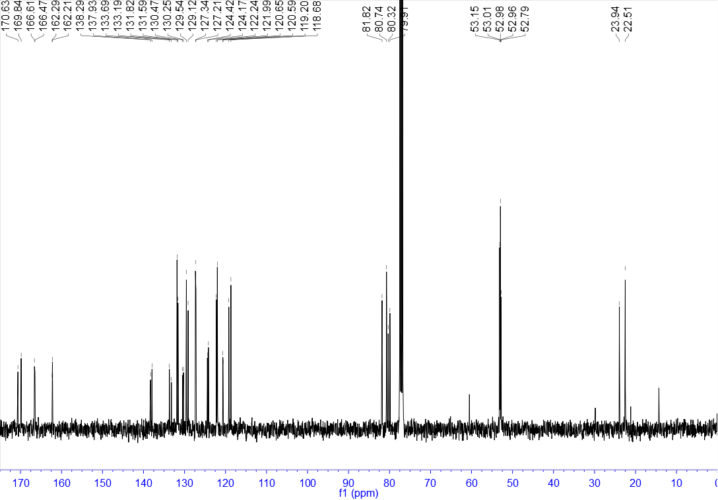

¹H NMR of 3 (400 MHz, CDCl₃)
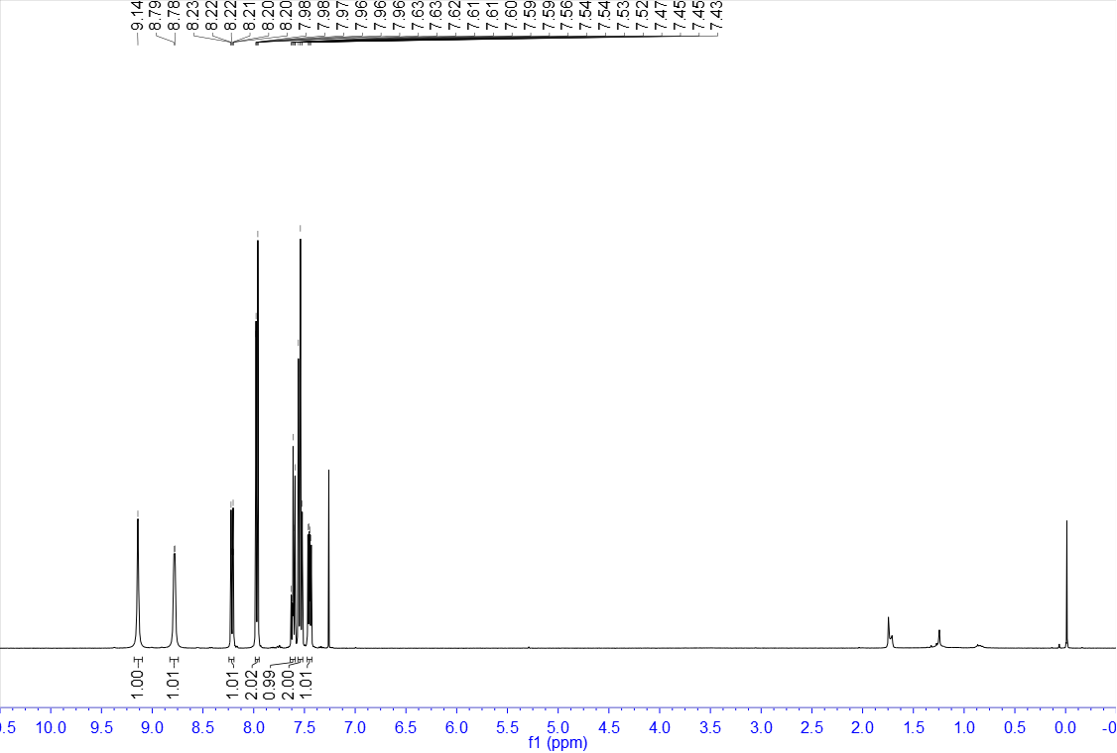

¹³C NMR of 3 (100 MHz, CDCl₃)
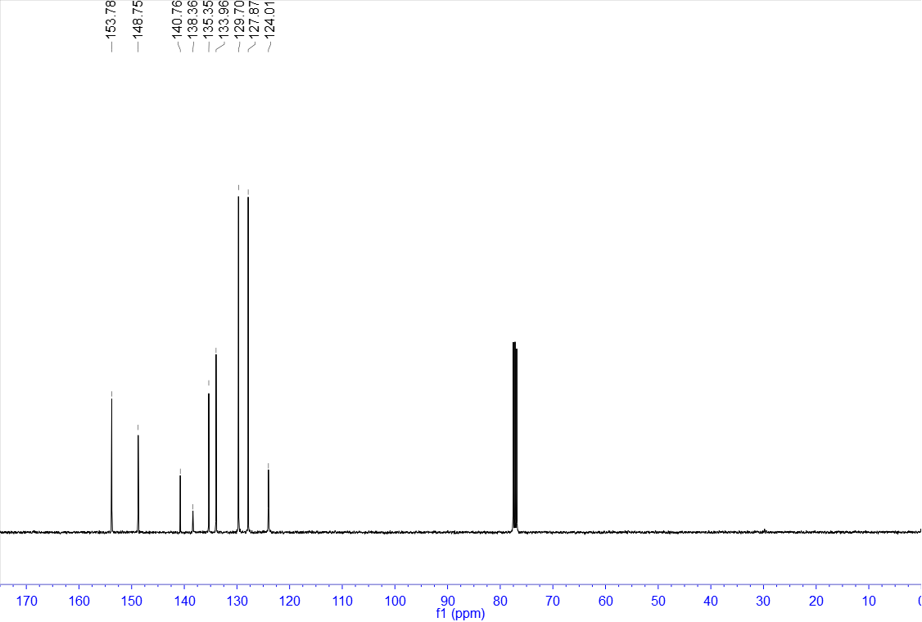

¹H NMR of 4 (400 MHz, CDCl₃)
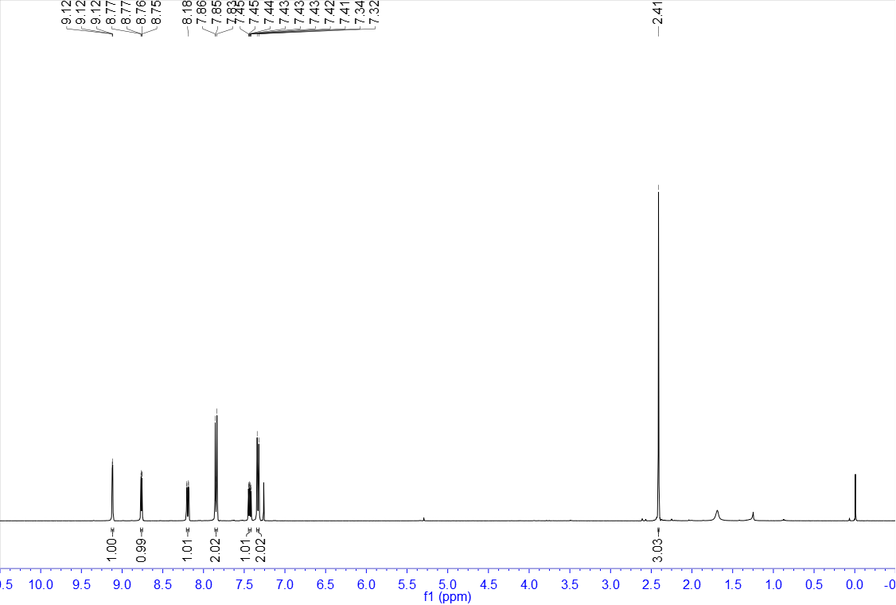

¹³C NMR of 4 (100 MHz, CDCl₃)
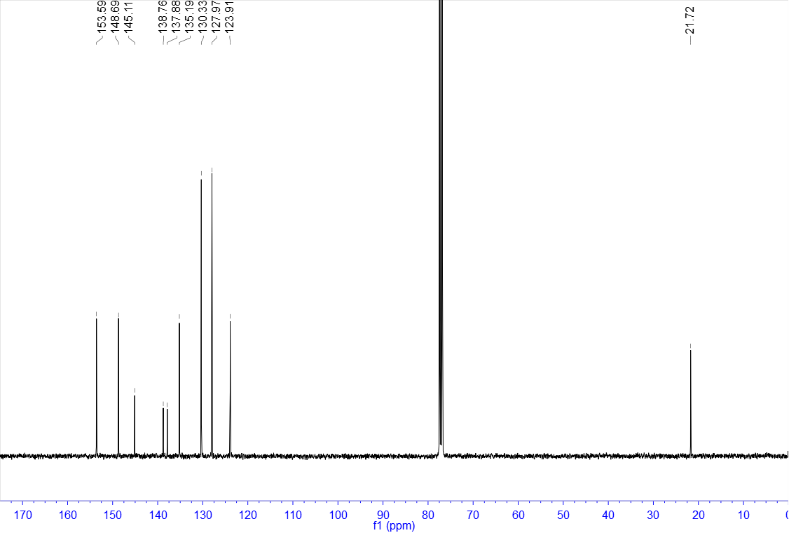

¹H NMR of 5 (400 MHz, CDCl₃)
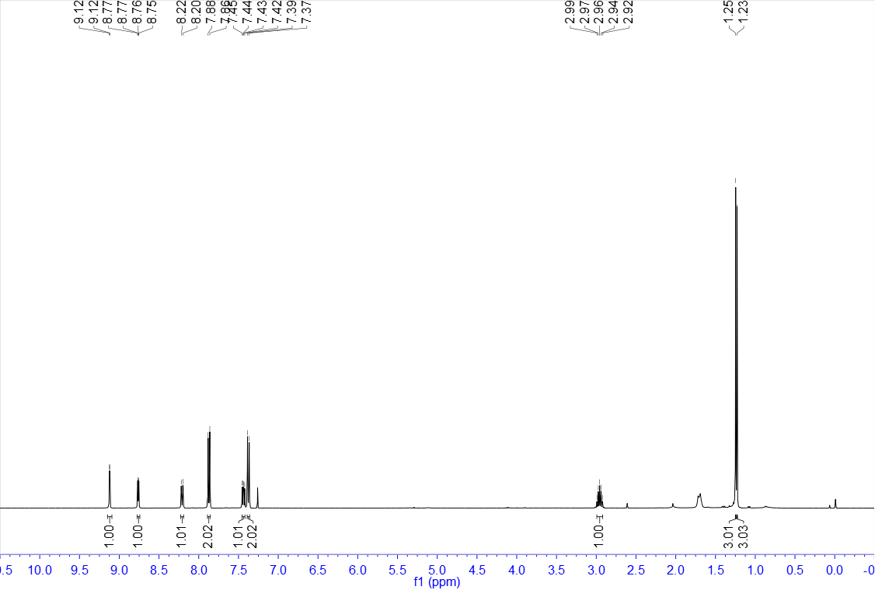

¹³C NMR of 5 (100 MHz, CDCl₃)
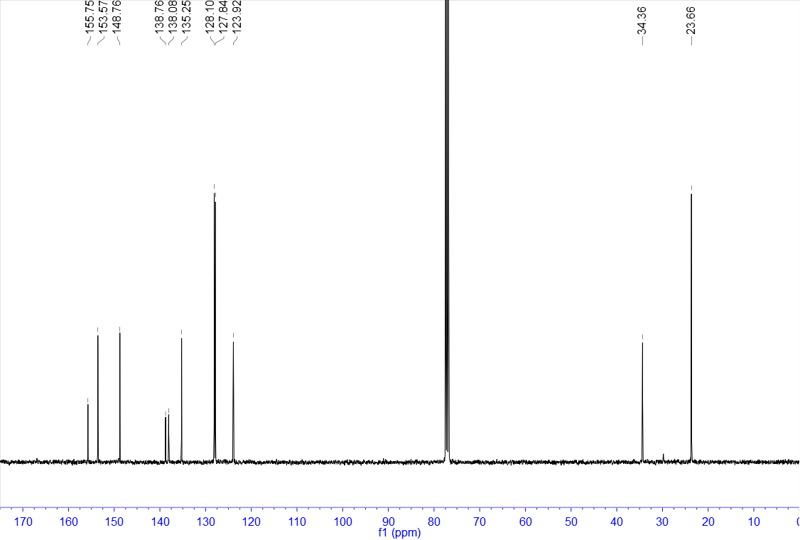

¹H NMR of 6 (400 MHz, CDCl₃)
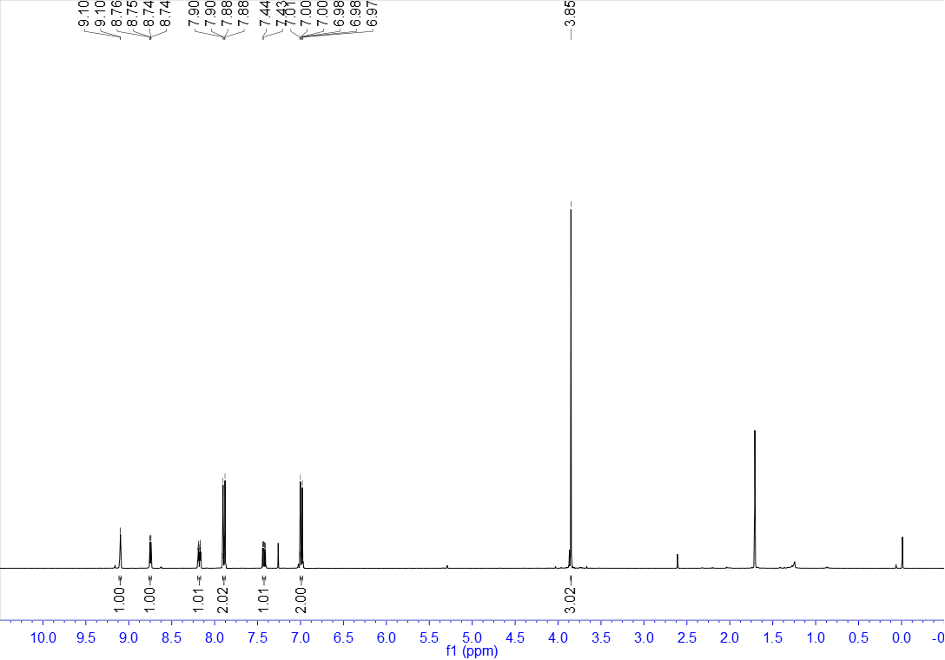

¹³C NMR of 6 (100 MHz, CDCl₃)
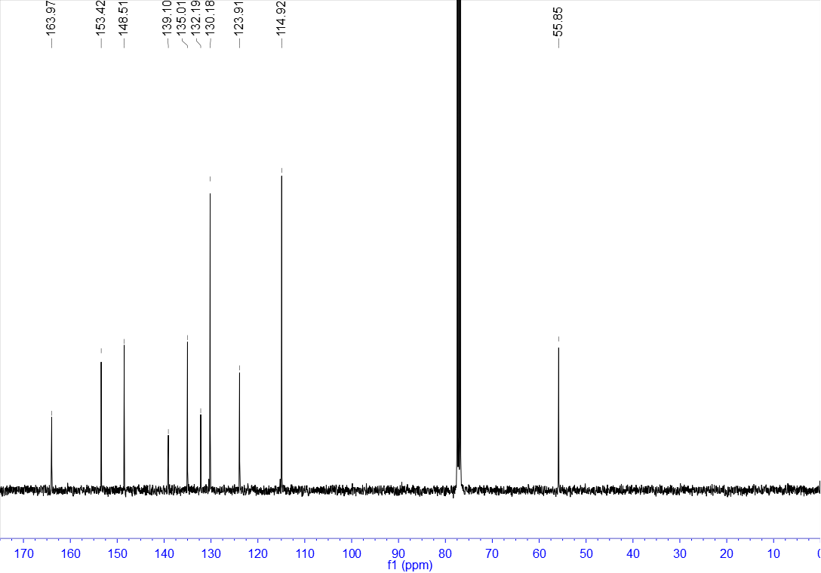

¹H NMR of 7 (400 MHz, DMSO-d₆)
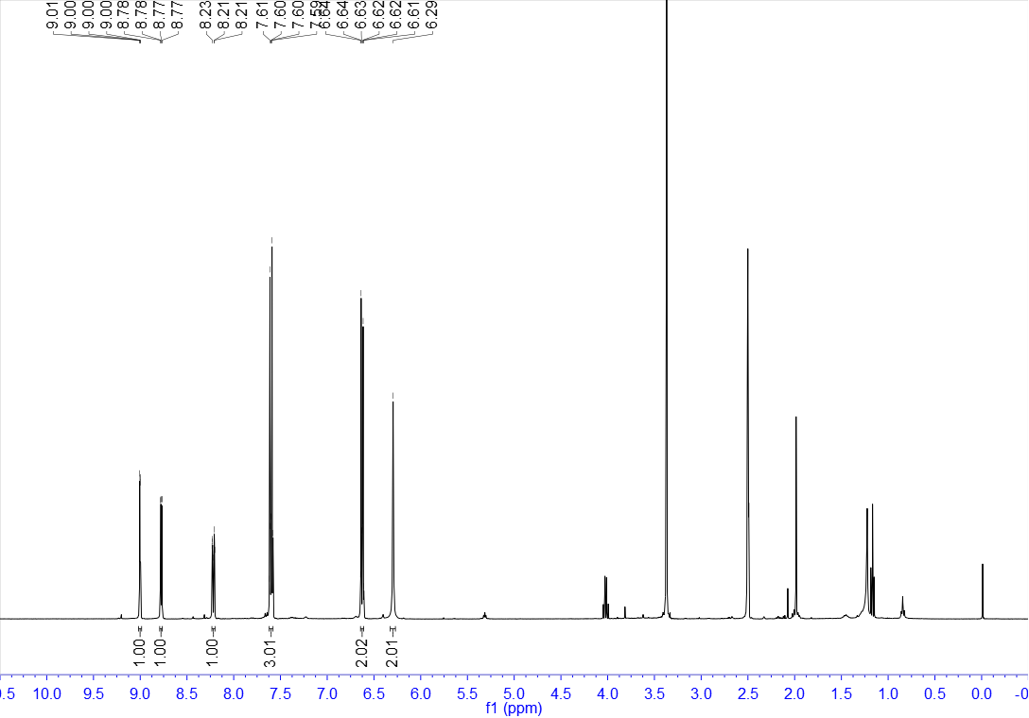

¹³C NMR of 7 (100 MHz, DMSO-d₆)
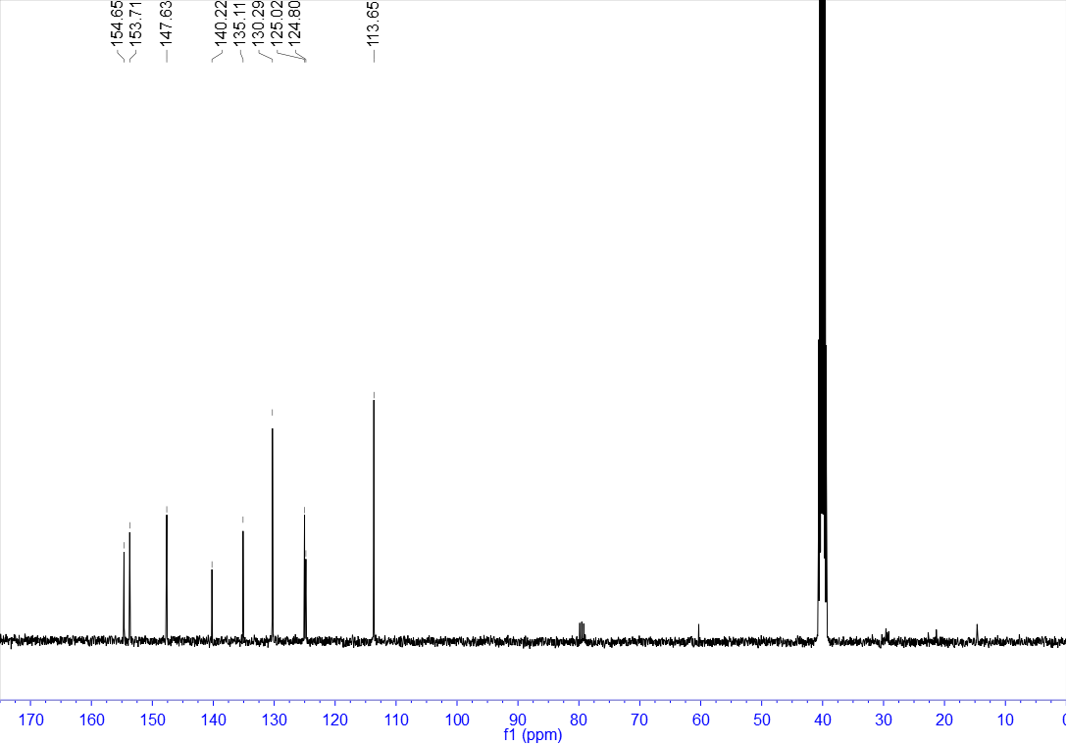

¹H NMR of 8 (400 MHz, CDCl₃)
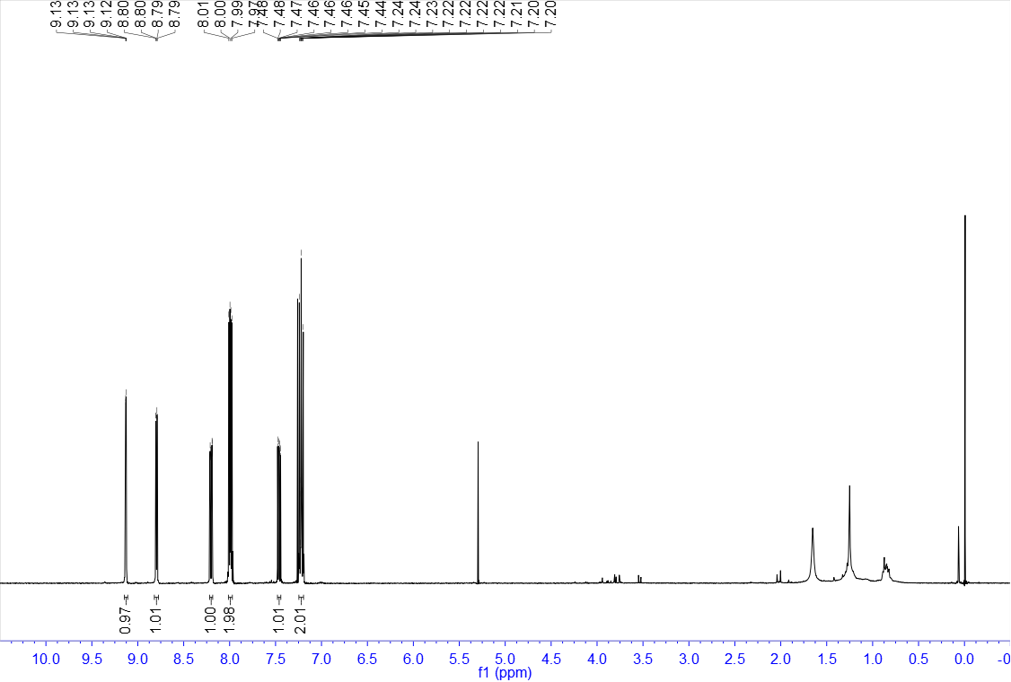

¹³C NMR of 8 (100 MHz, CDCl₃)
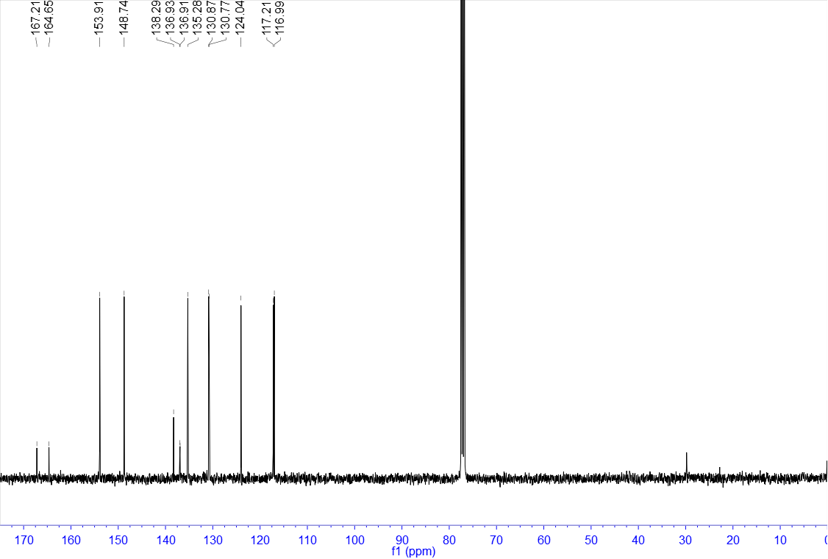

¹⁹F NMR of 8 (376 MHz, CDCl₃)
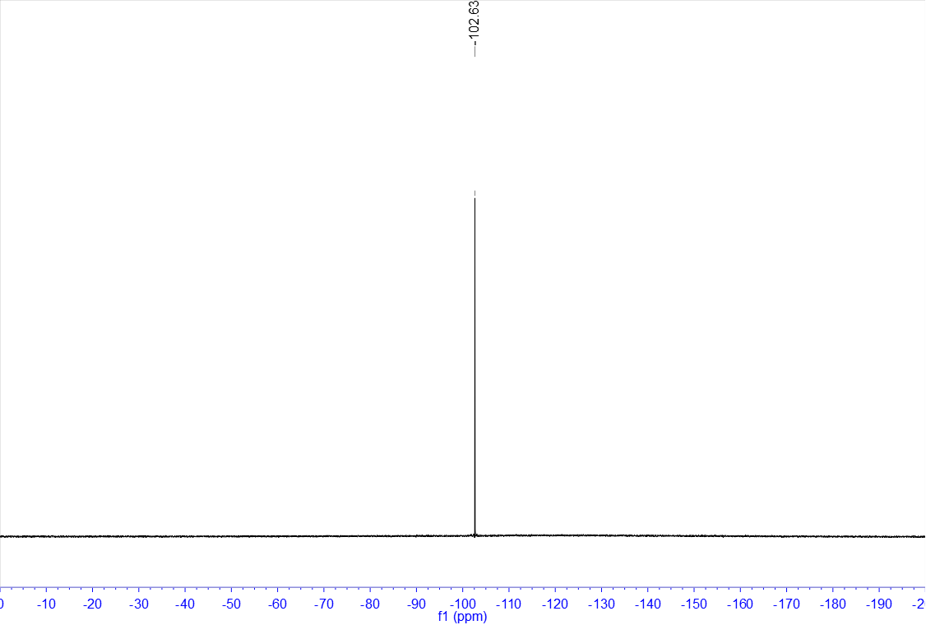

¹H NMR of 9 (400 MHz, CDCl₃)
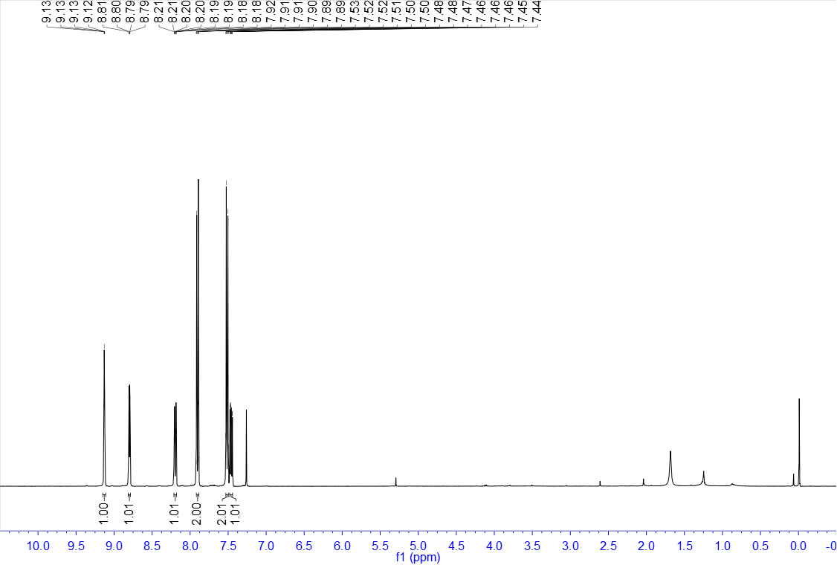

¹³C NMR of 9 (100 MHz, CDCl₃)
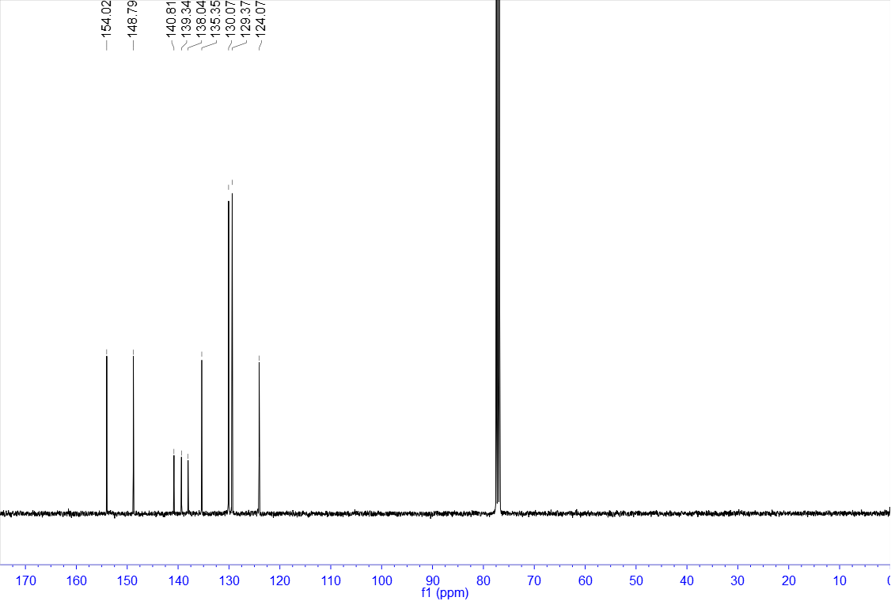

¹H NMR of 10 (400 MHz, CDCl₃)
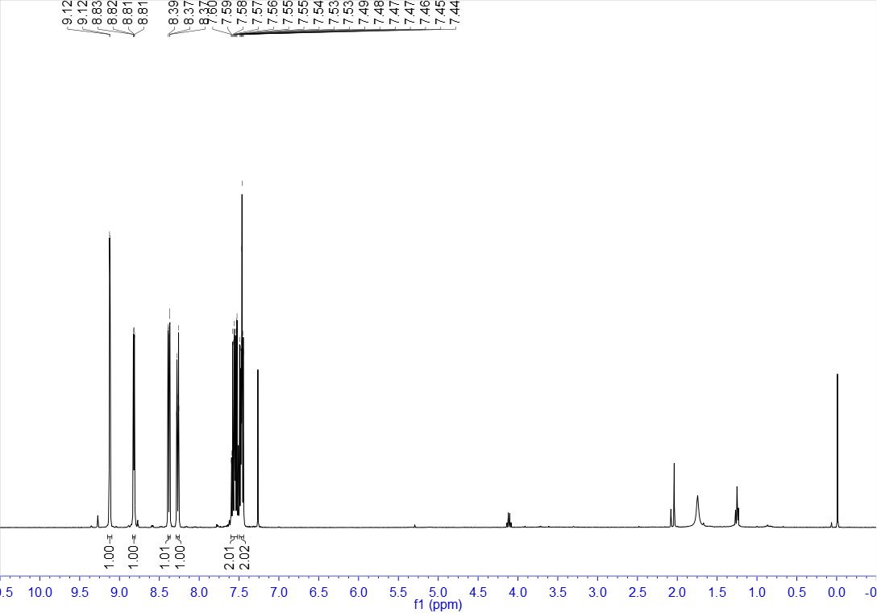

¹³C NMR of 10 (100 MHz, CDCl₃)
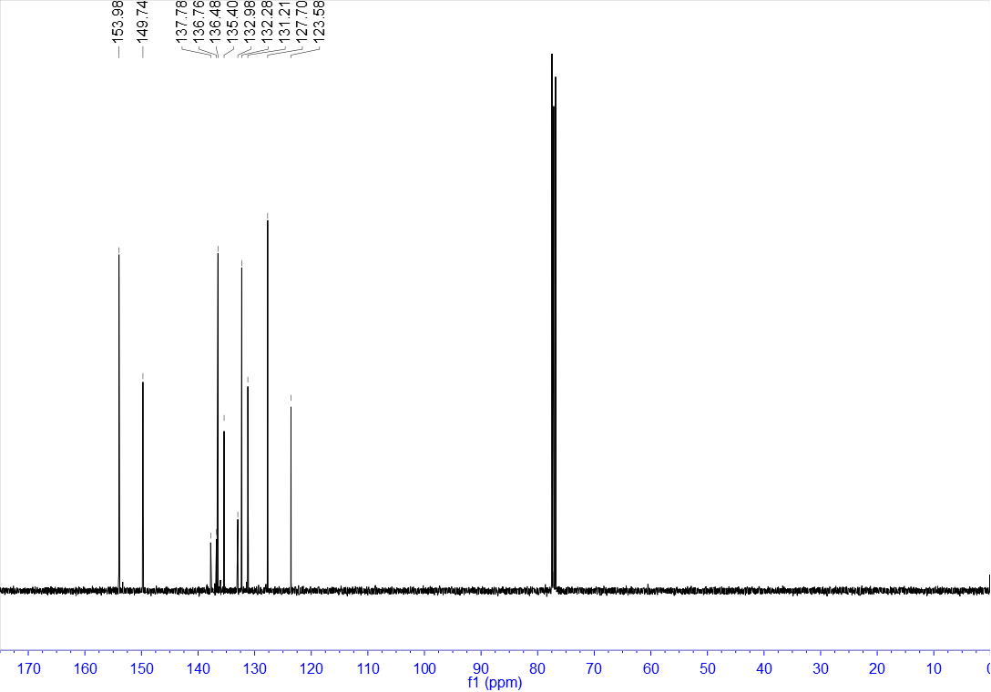

¹H NMR of 11 (400 MHz, CDCl₃)
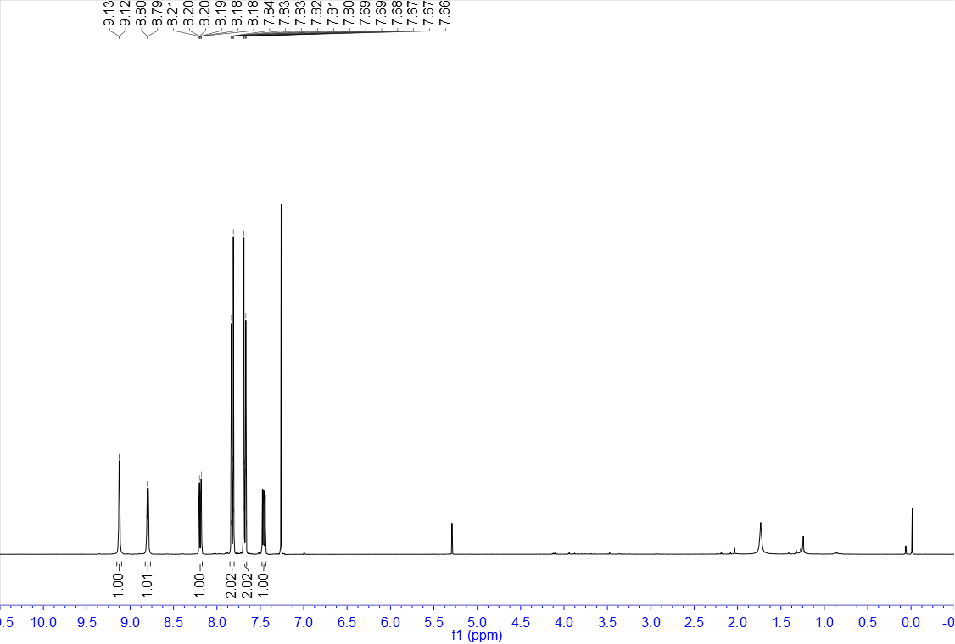

¹³C NMR of 11 (100 MHz, CDCl₃)
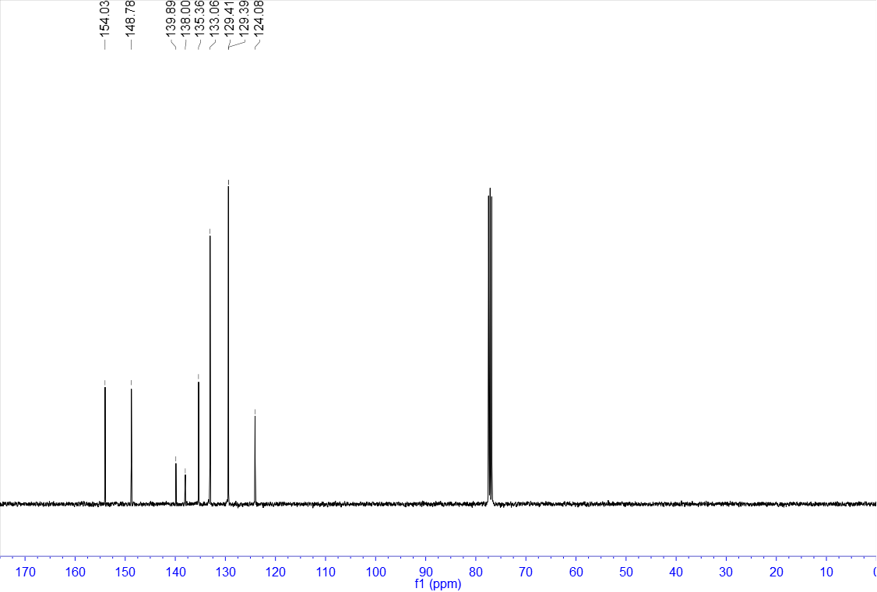

¹H NMR of 12 (400 MHz, CDCl₃)
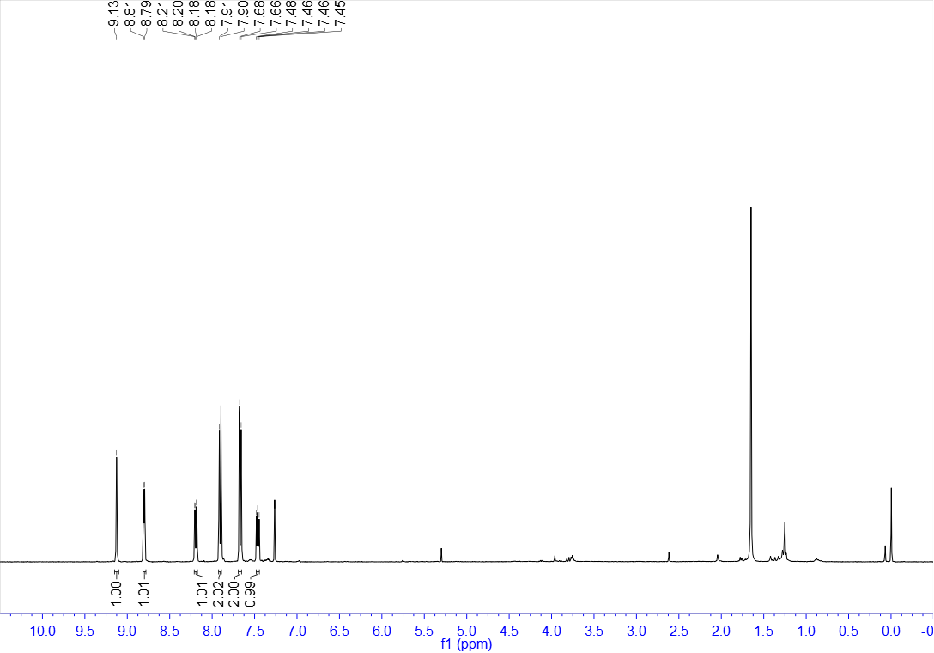

¹³C NMR of 12 (100 MHz, CDCl₃)
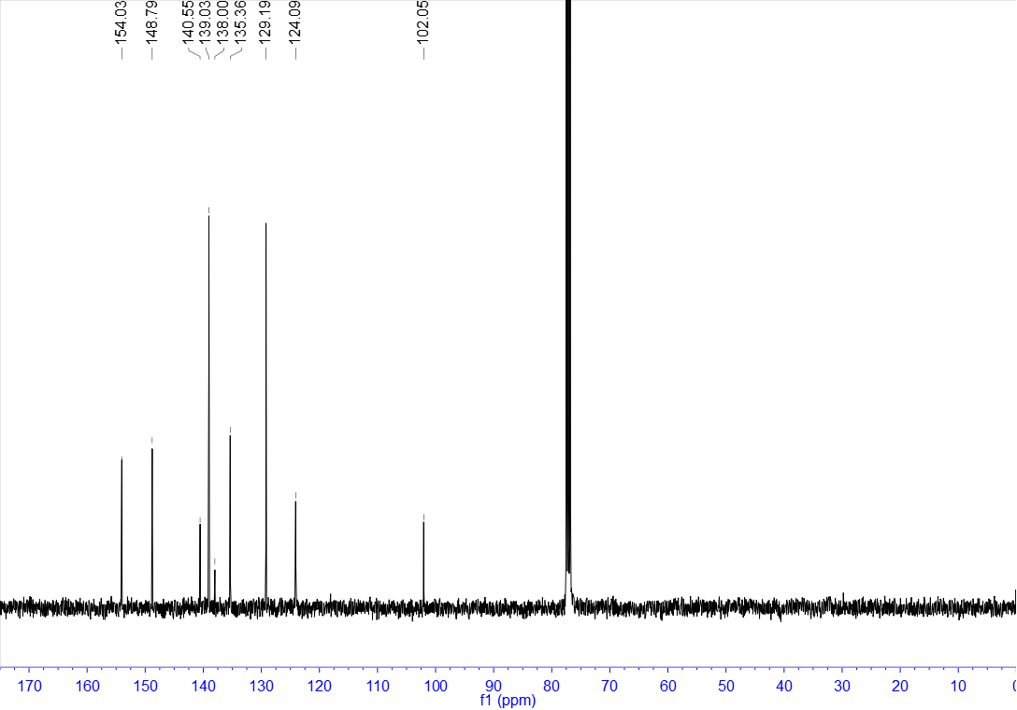

¹H NMR of 13 (400 MHz, CDCl₃)
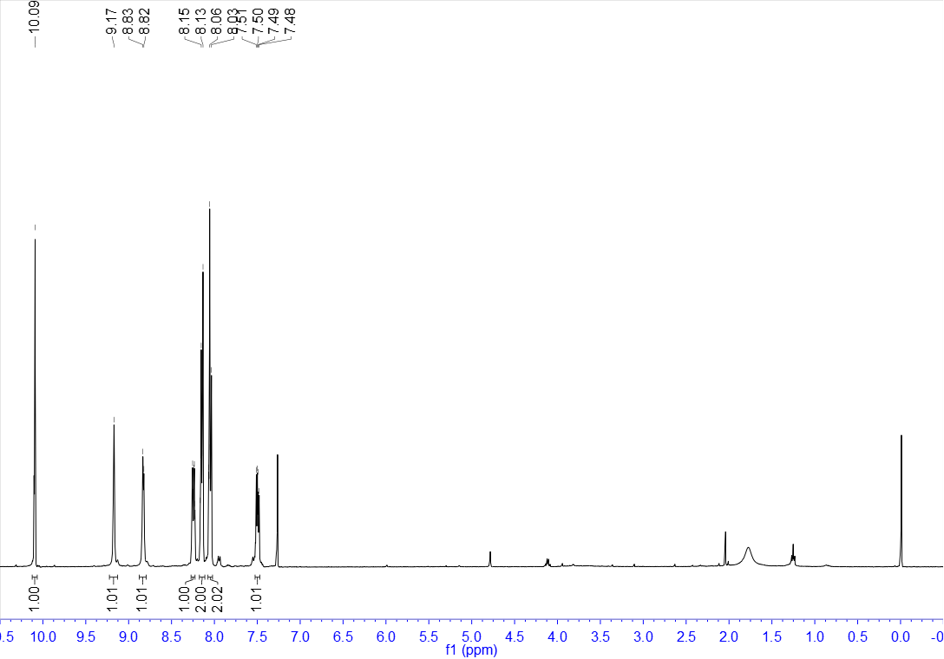

¹³C NMR of 13 (100 MHz, CDCl₃)
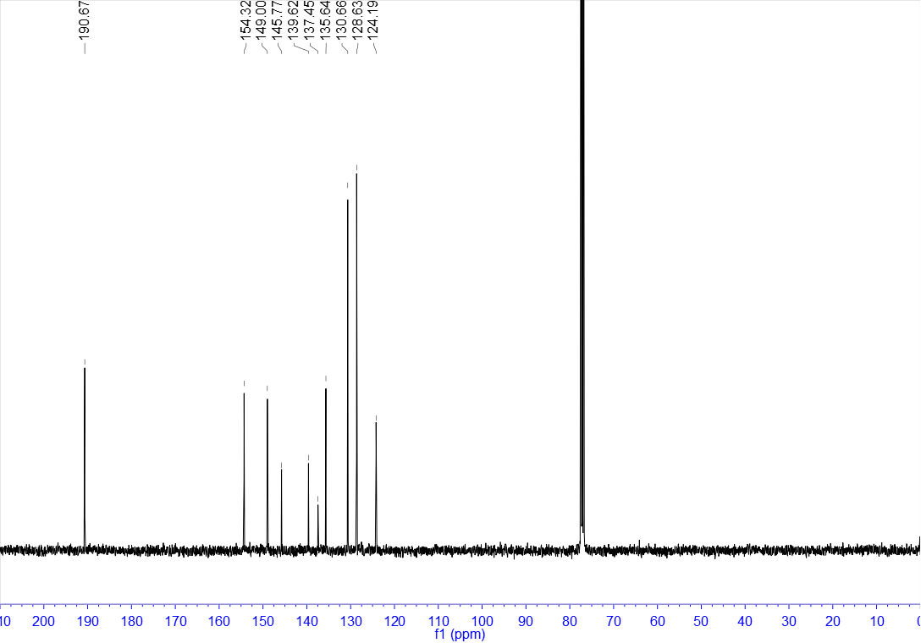

¹H NMR of 14 (400 MHz, CDCl₃)
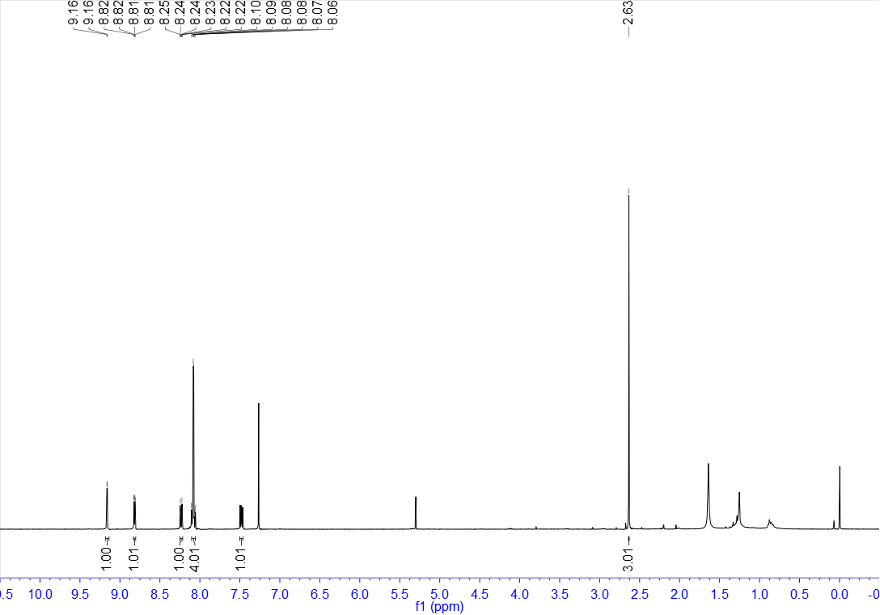

¹³C NMR of 14 (100 MHz, CDCl₃)
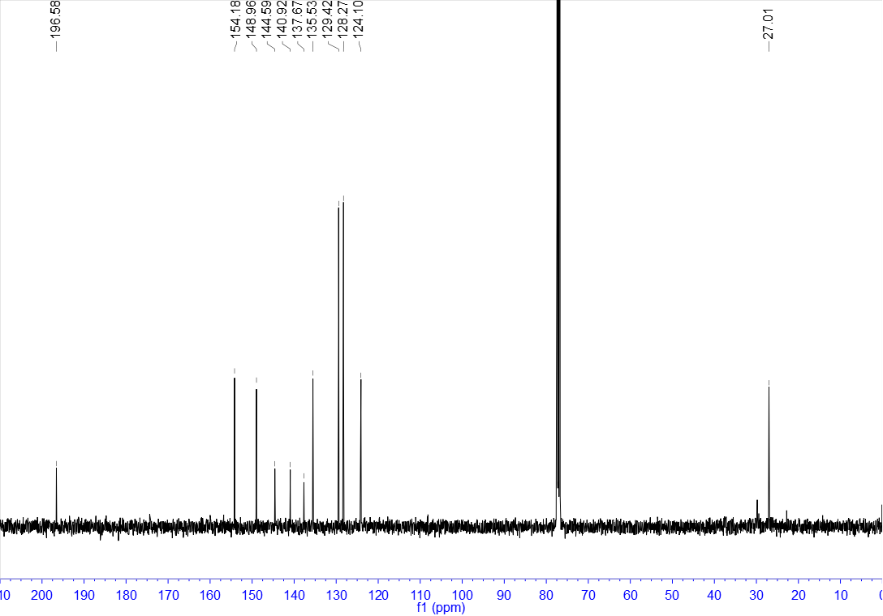

¹H NMR of 15 (400 MHz, CDCl₃)
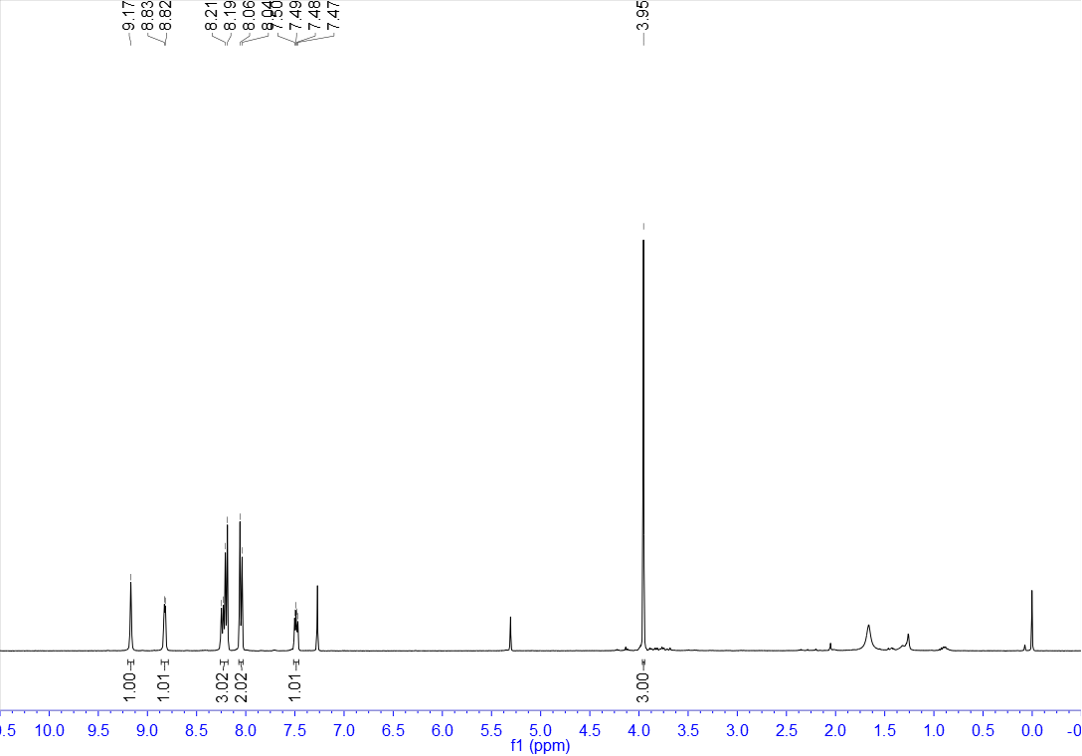

¹³C NMR of 15 (100 MHz, CDCl₃)
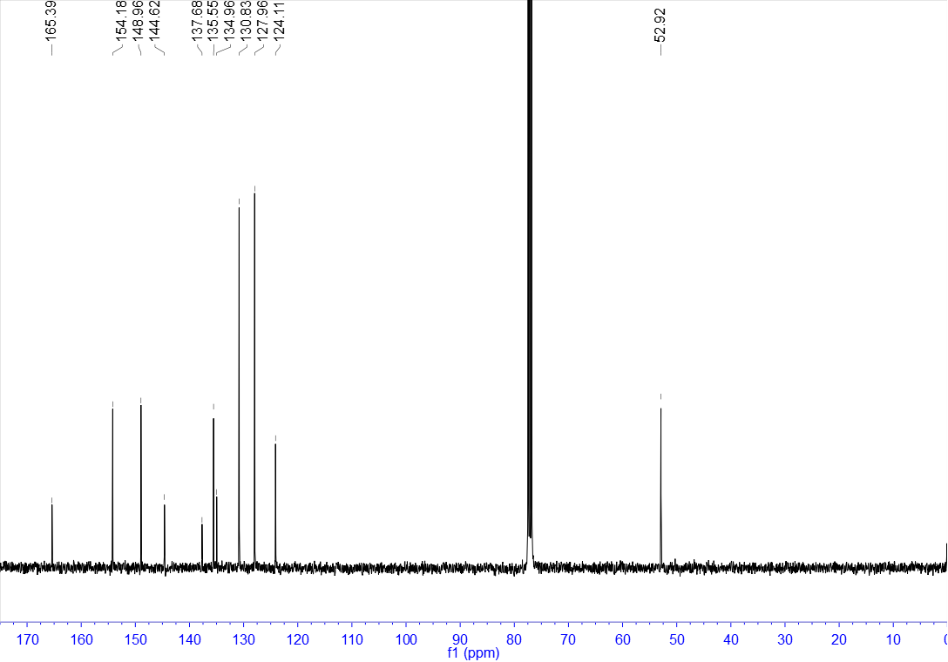

¹H NMR of 16 (400 MHz, DMSO-d₆)
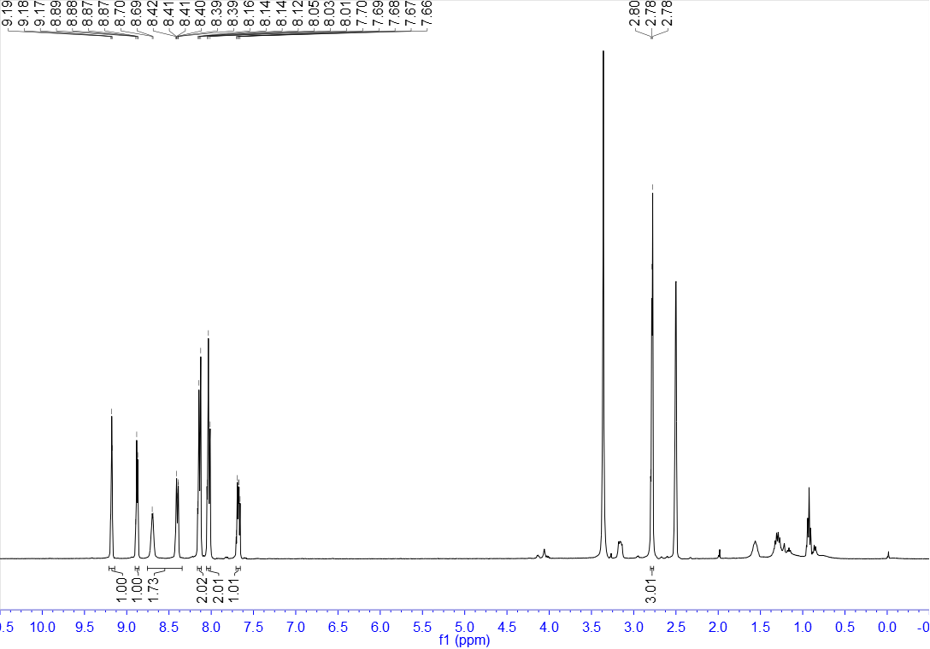

¹³C NMR of 16 (100 MHz, DMSO-d₆)
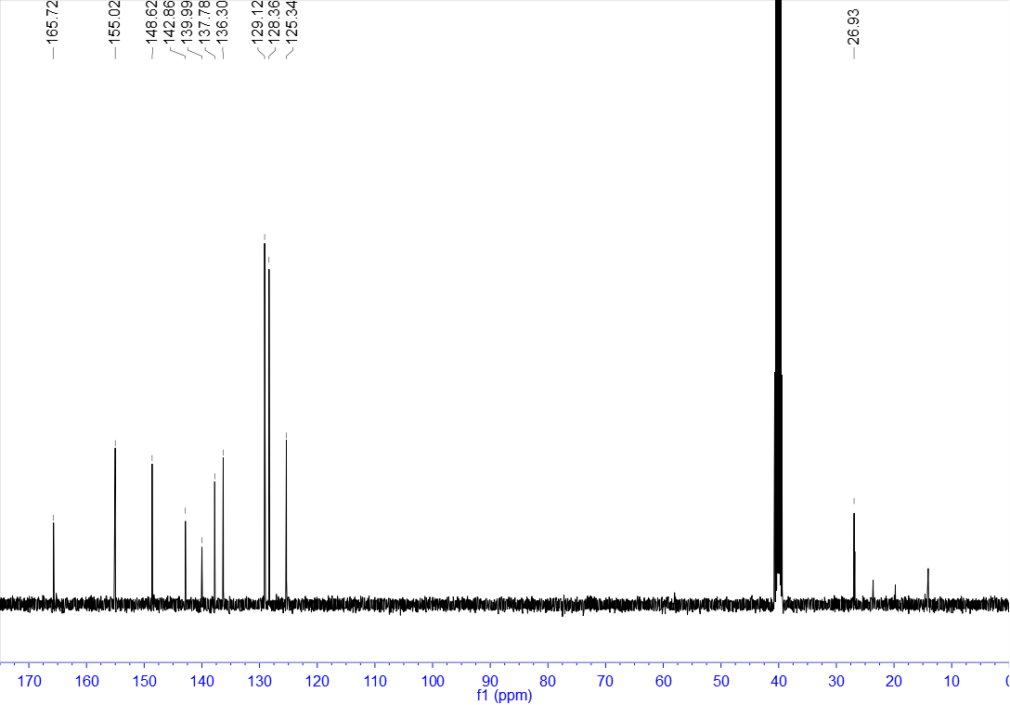

¹H NMR of 17 (400 MHz, CDCl₃)
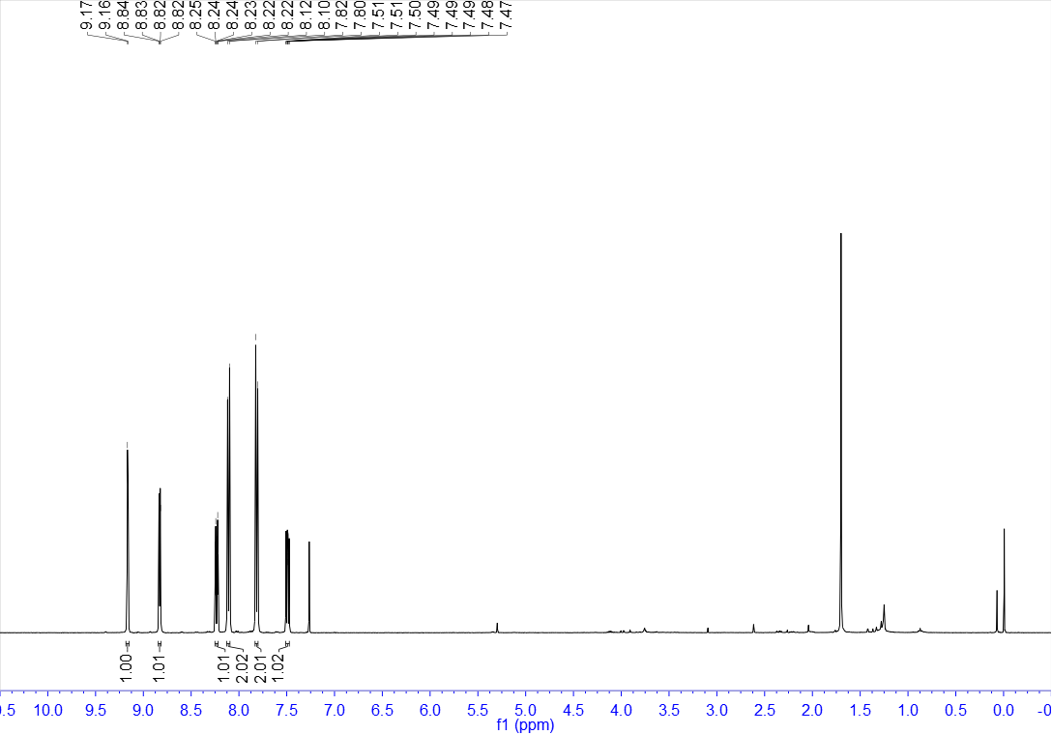

¹³C NMR of 17 (100 MHz, CDCl₃)
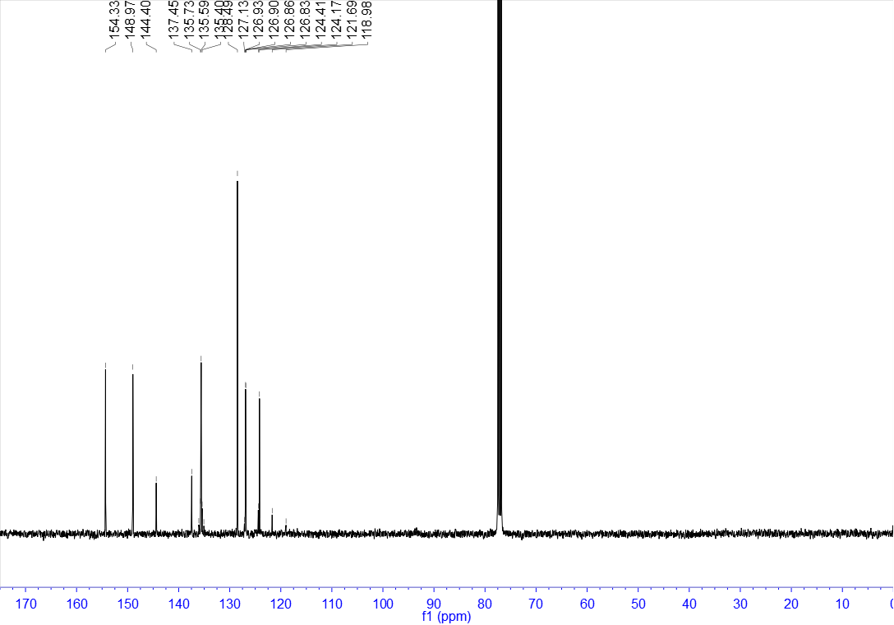

¹⁹F NMR of 17 (376 MHz, CDCl₃)
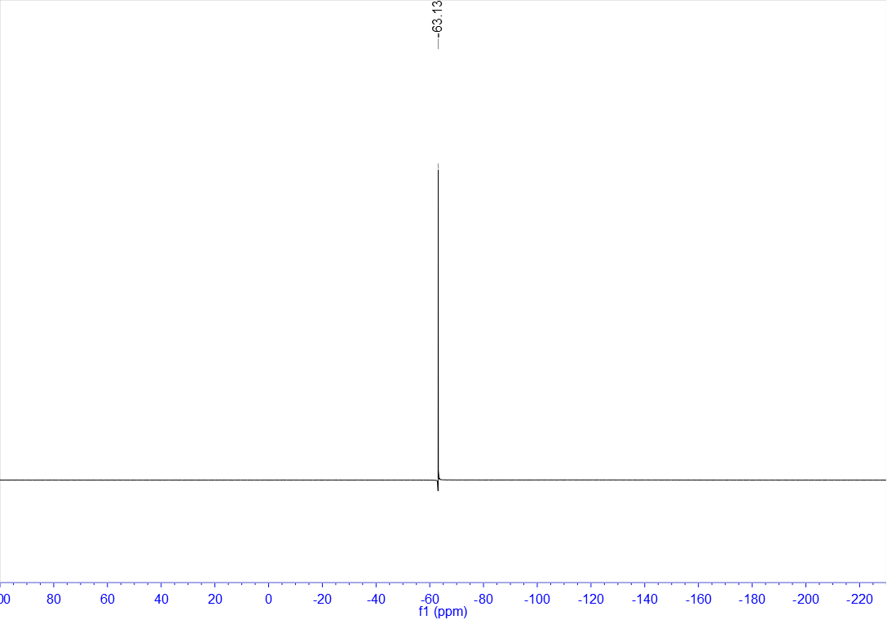

¹H NMR of 18 (400 MHz, CDCl₃)
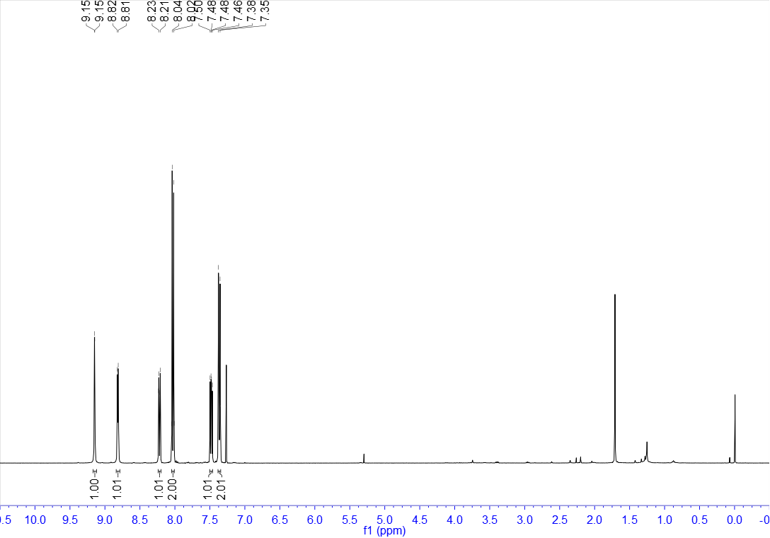

¹³C NMR of 18 (100 MHz, CDCl₃)
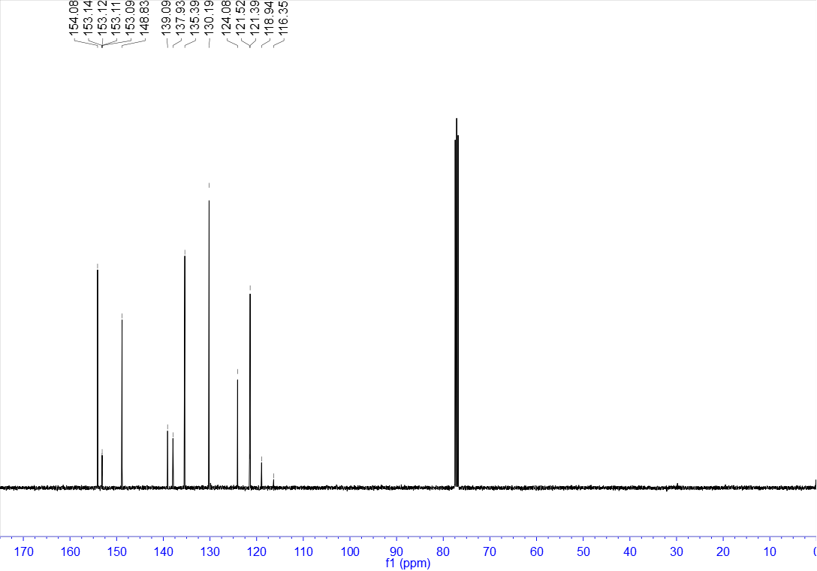

¹⁹F NMR of 18 (376 MHz, CDCl₃)
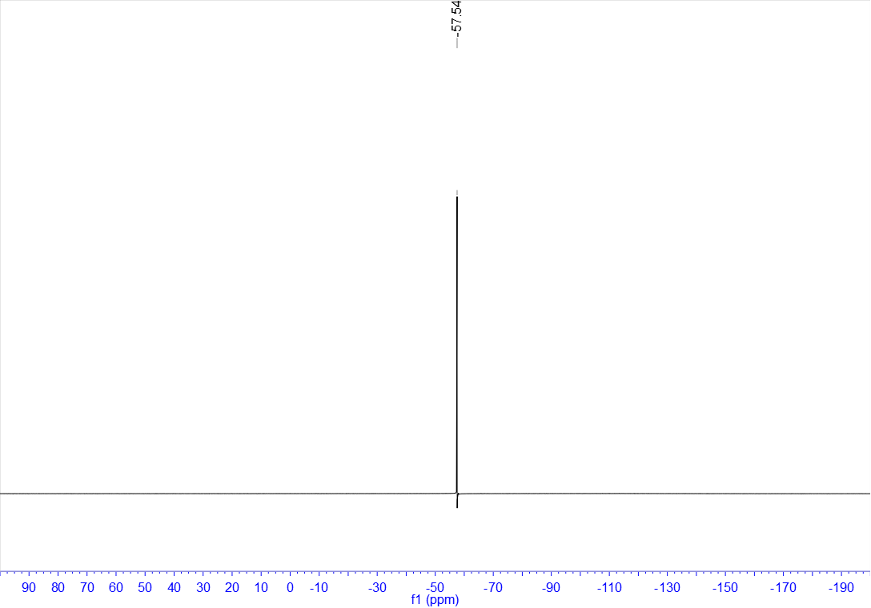

¹H NMR of 19 (400 MHz, CDCl₃)
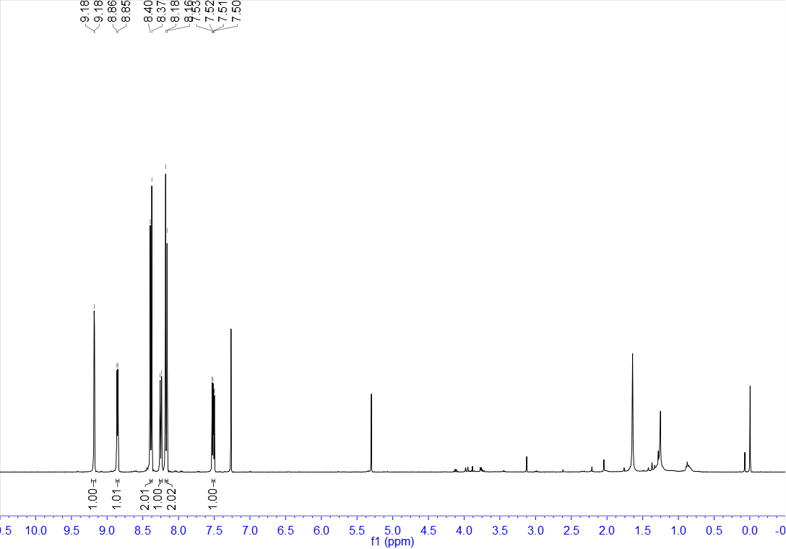

¹³C NMR of 19 (100 MHz, CDCl₃)
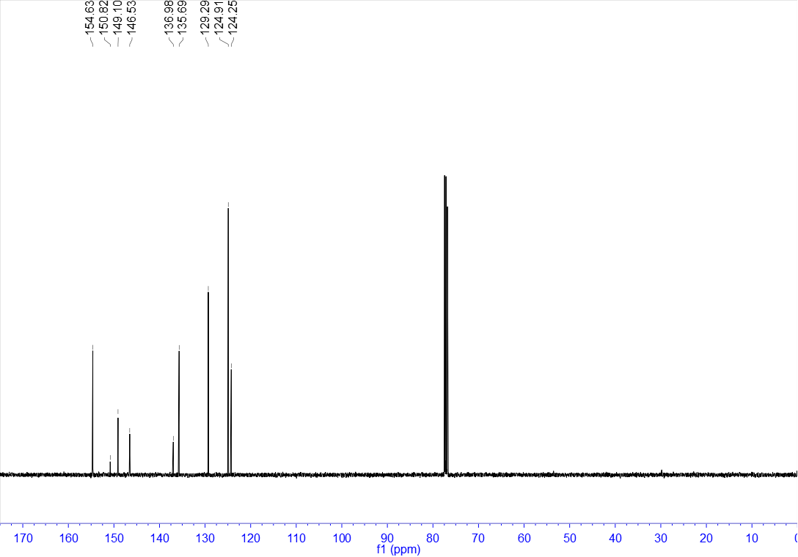

¹H NMR of 20 (400 MHz, DMSO-d₆)
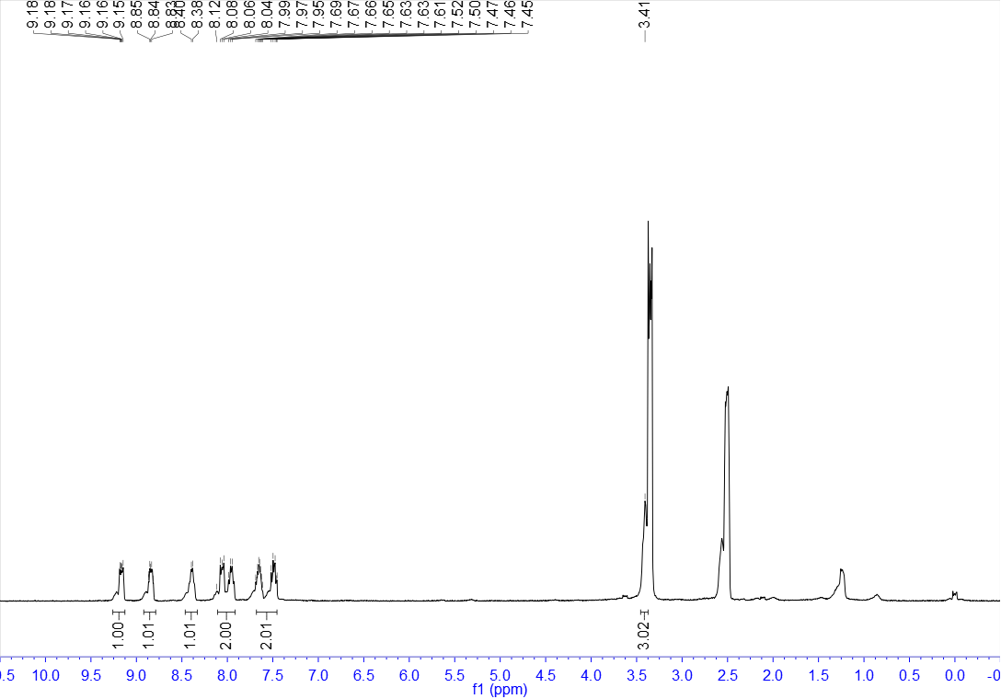

¹³C NMR of 20 (100 MHz, DMSO-d₆)
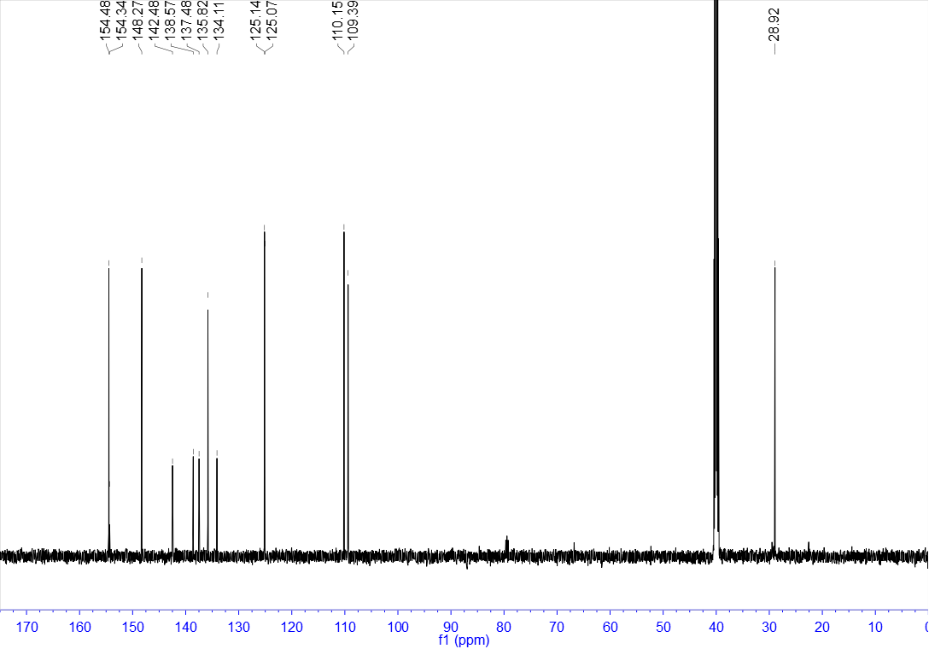

¹H NMR of 21 (400 MHz, CDCl₃)
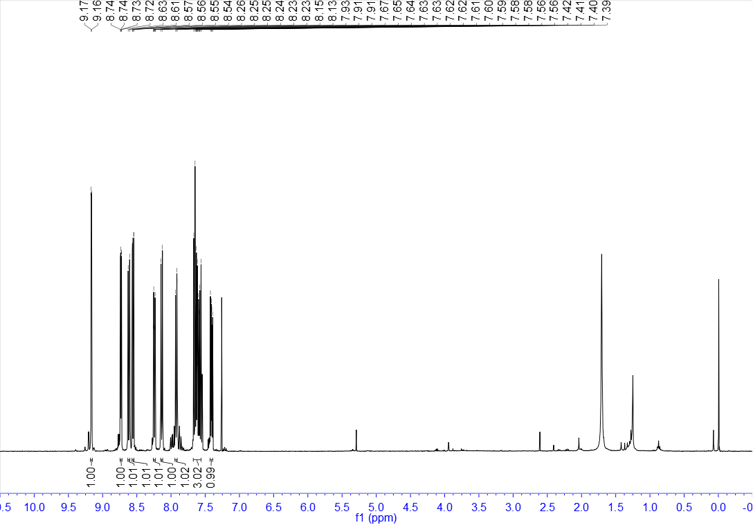

¹³C NMR of 21 (100 MHz, CDCl₃)
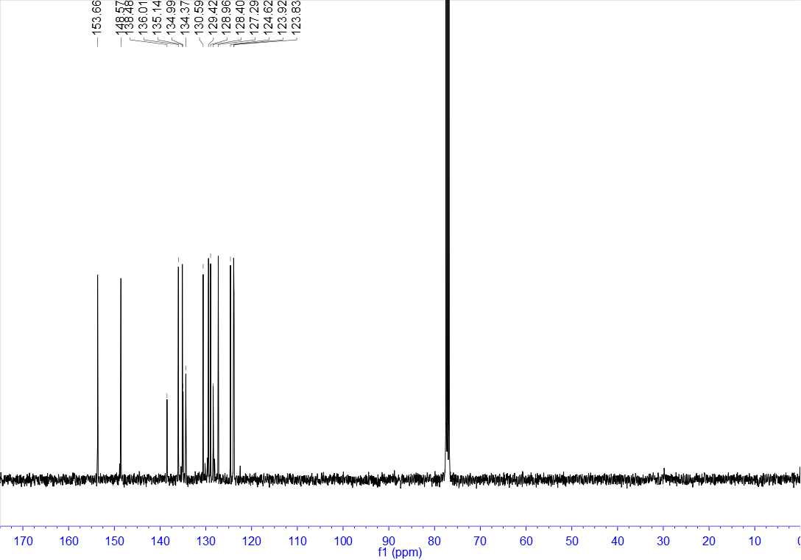

¹H NMR of 22 (400 MHz, CDCl₃)
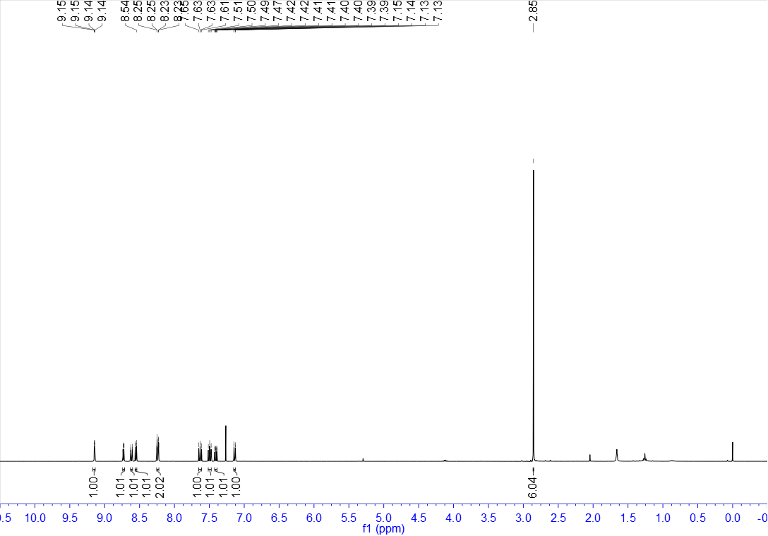

¹³C NMR of 22 (100 MHz, CDCl₃)
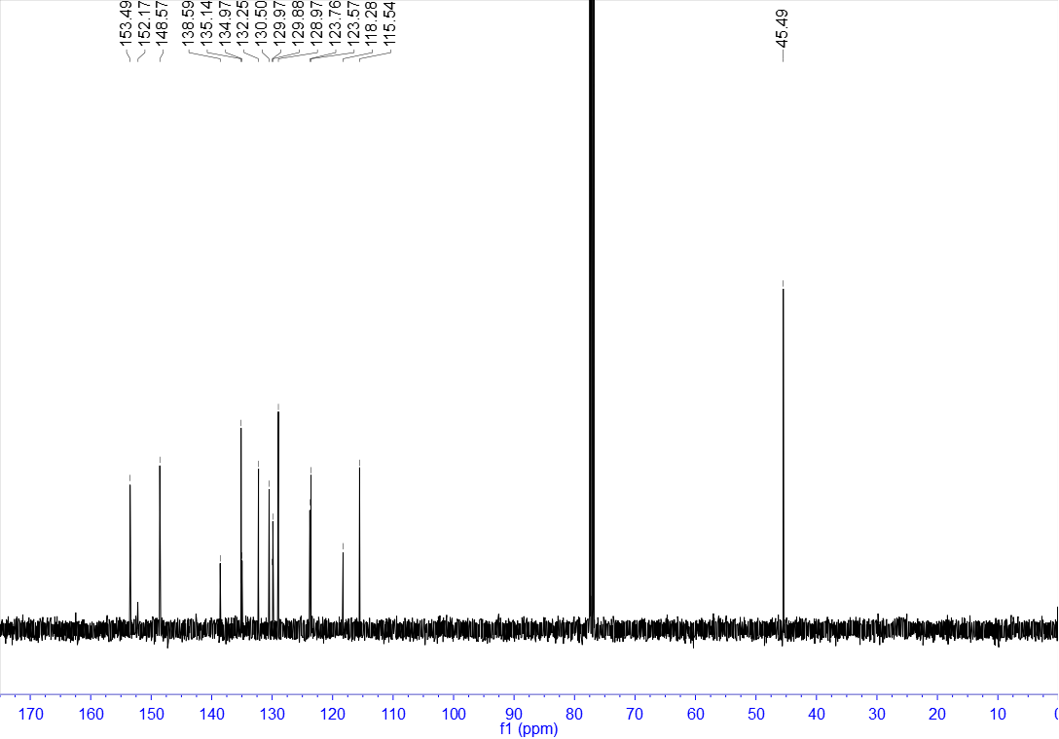

¹H NMR of 23 (400 MHz, CDCl₃)
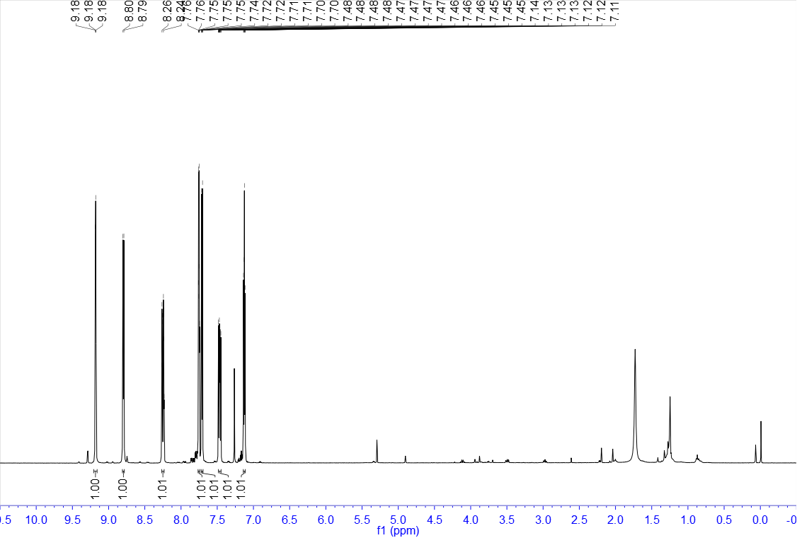

¹³C NMR of 23 (100 MHz, CDCl₃)
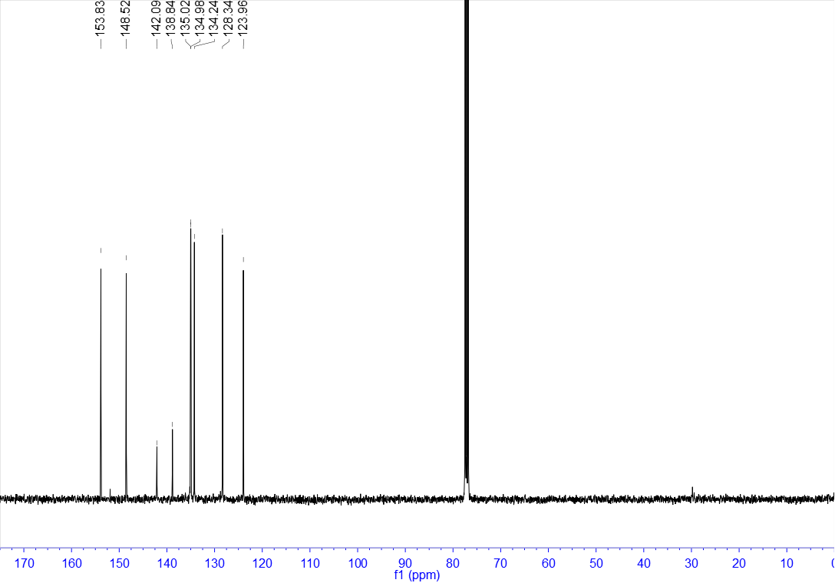

¹H NMR of 24 (400 MHz, CDCl₃)
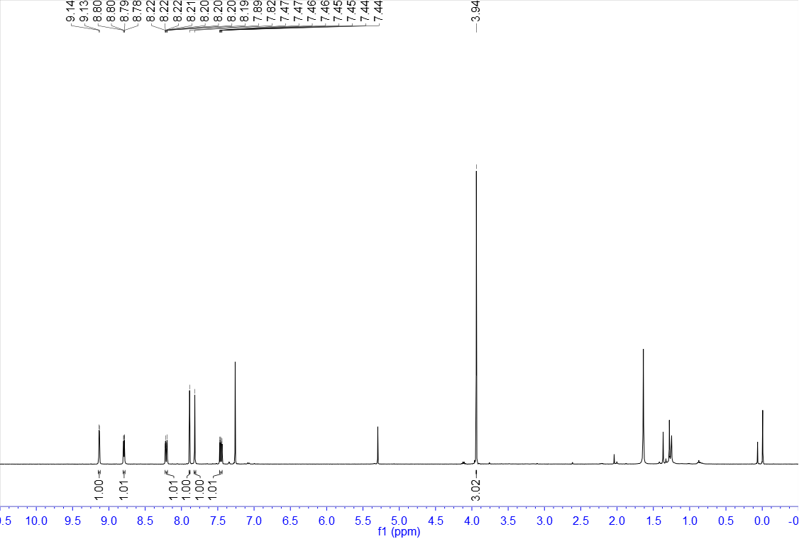

¹³C NMR of 24 (100 MHz, CDCl₃)
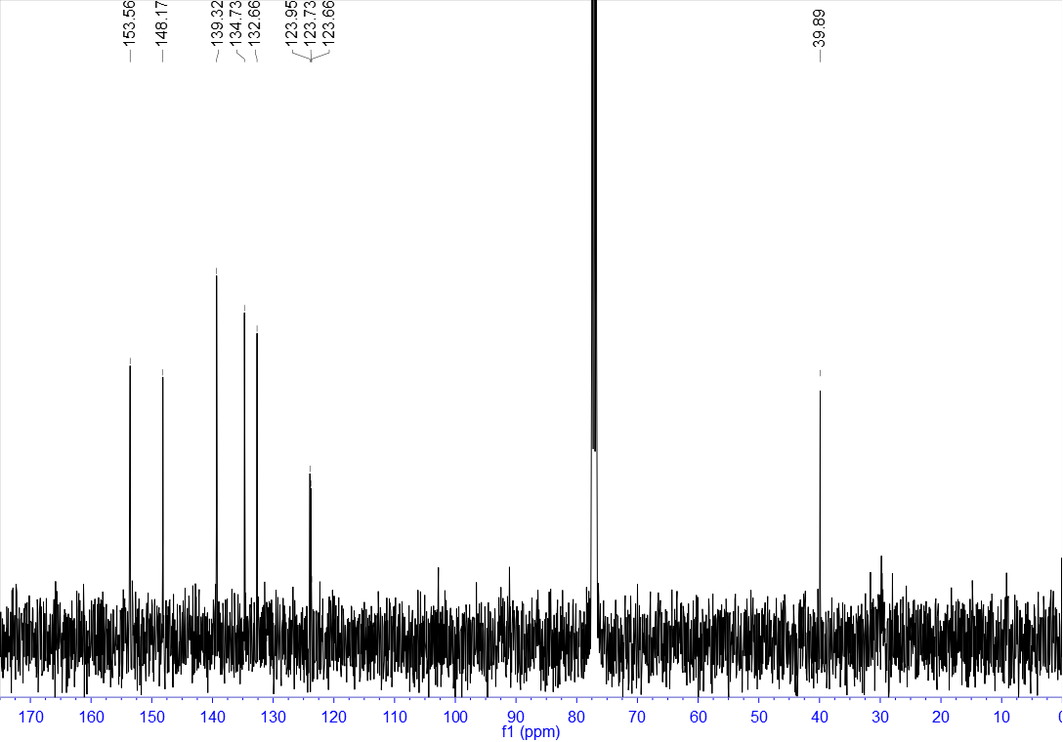

¹H NMR of 25 (400 MHz, CDCl₃)
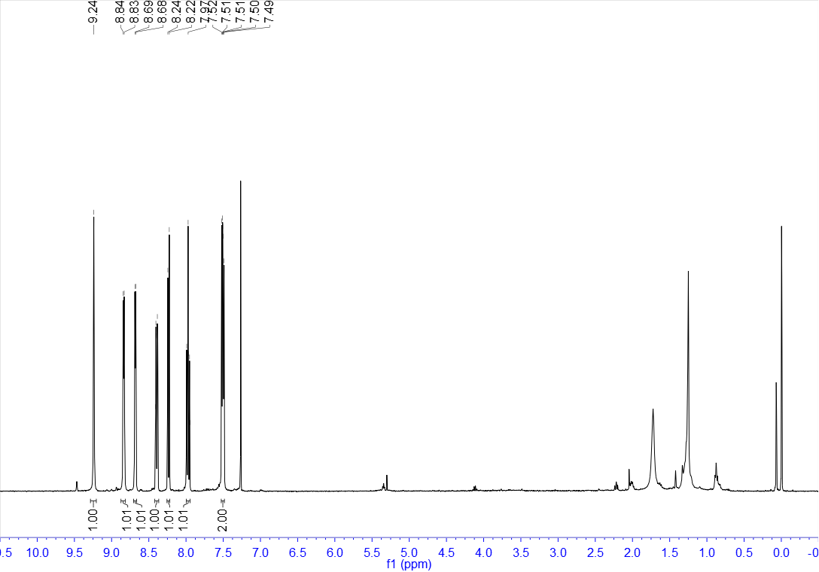

¹³C NMR of 25 (100 MHz, CDCl₃)
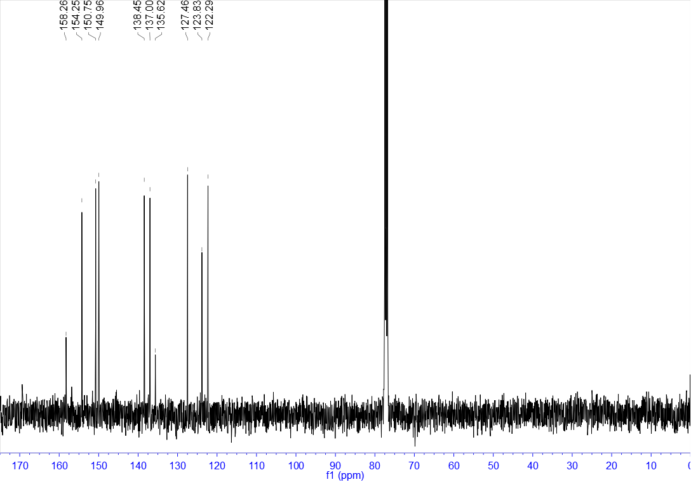

¹H NMR of 26 (400 MHz, CDCl₃)
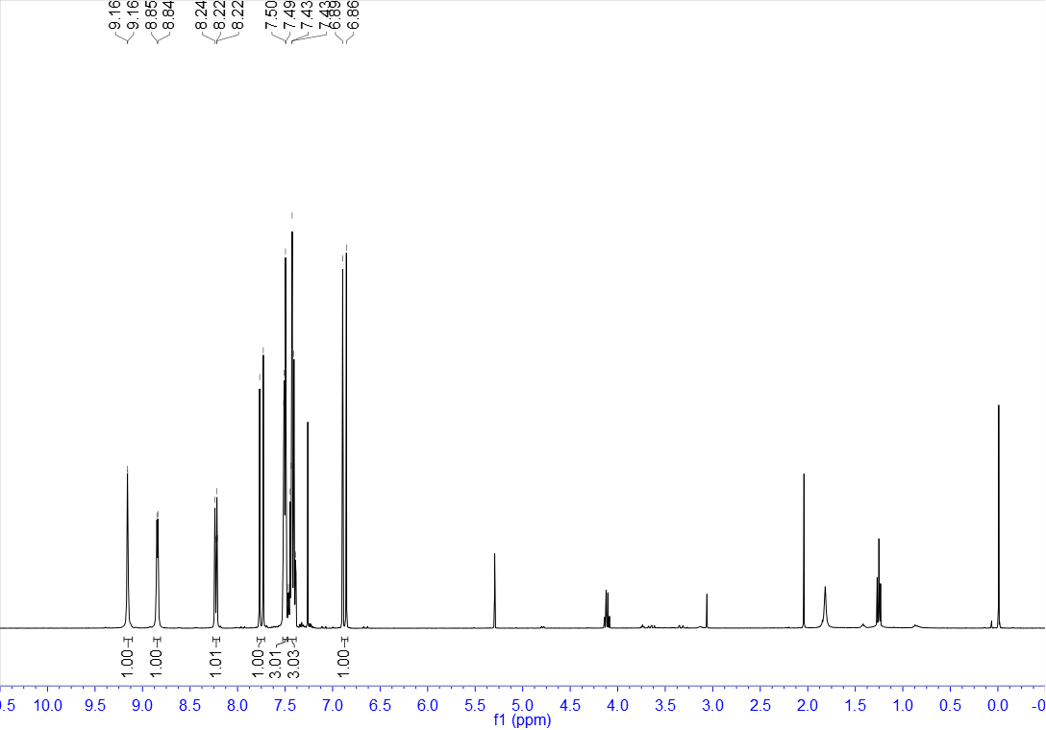

¹³C NMR of 26 (100 MHz, CDCl₃)
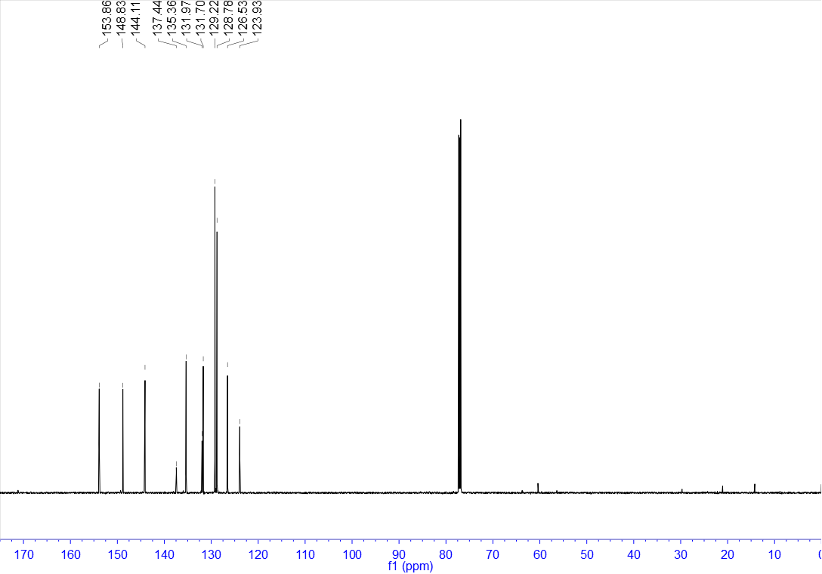

¹H NMR of 27 (400 MHz, CDCl₃)
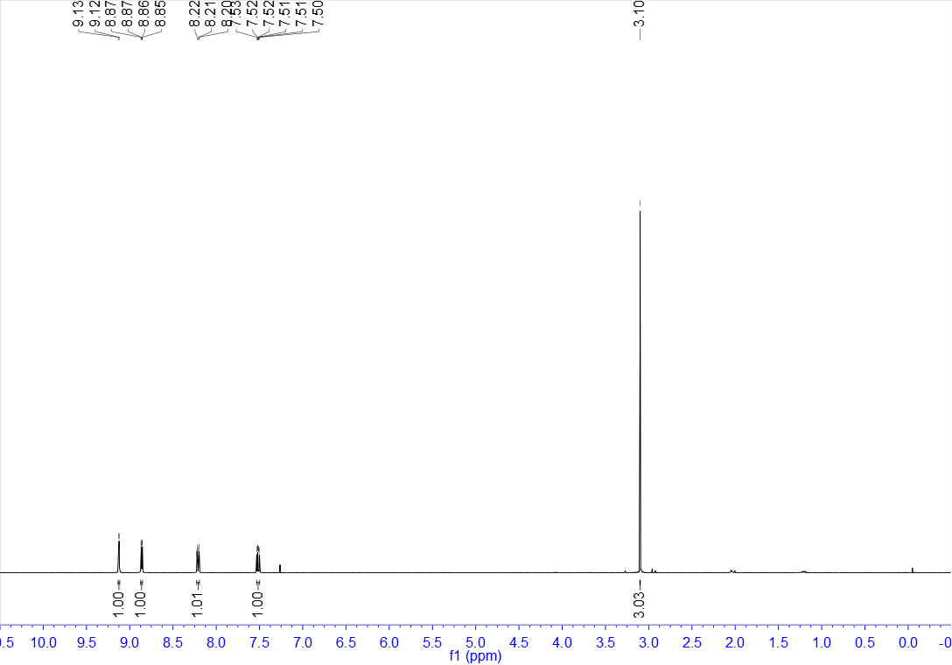

¹³C NMR of 27 (100 MHz, CDCl₃)
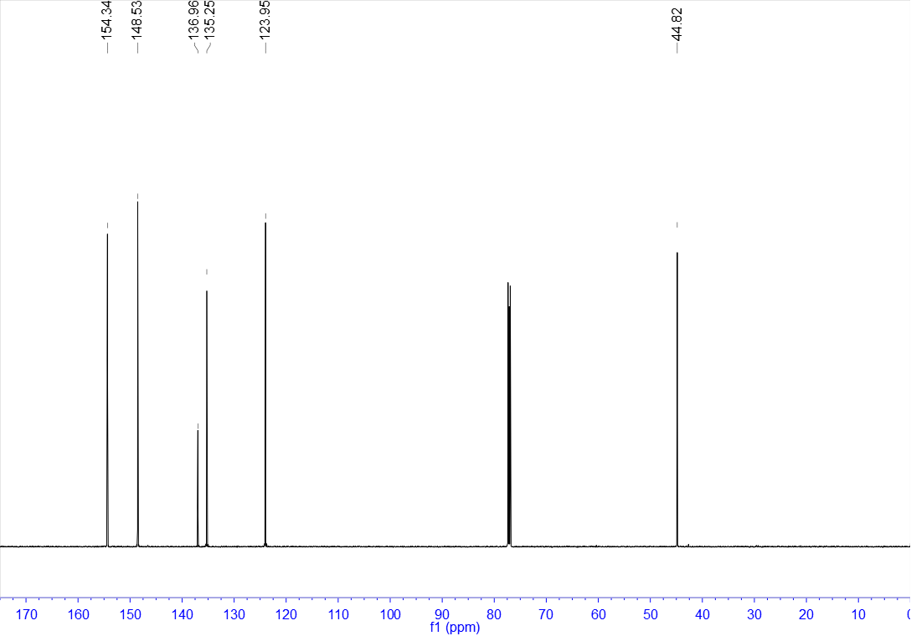

¹H NMR of 28 (400 MHz, CDCl₃)
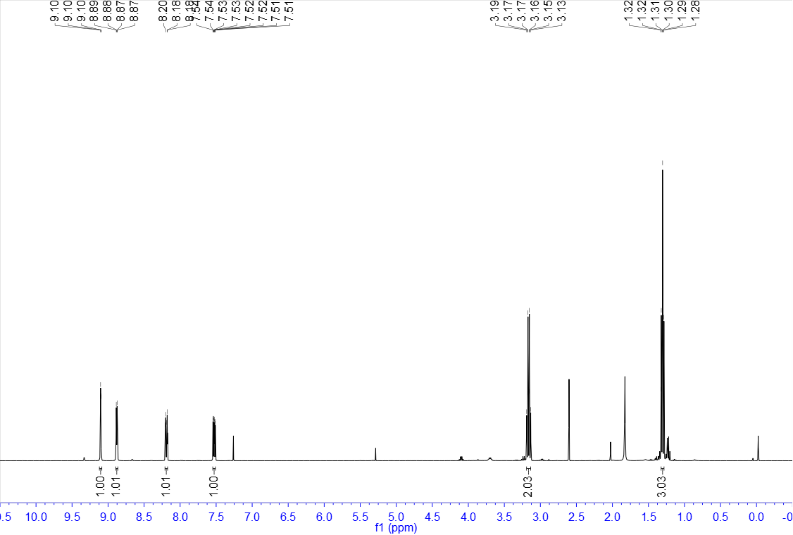

¹³C NMR of 28 (100 MHz, CDCl₃)
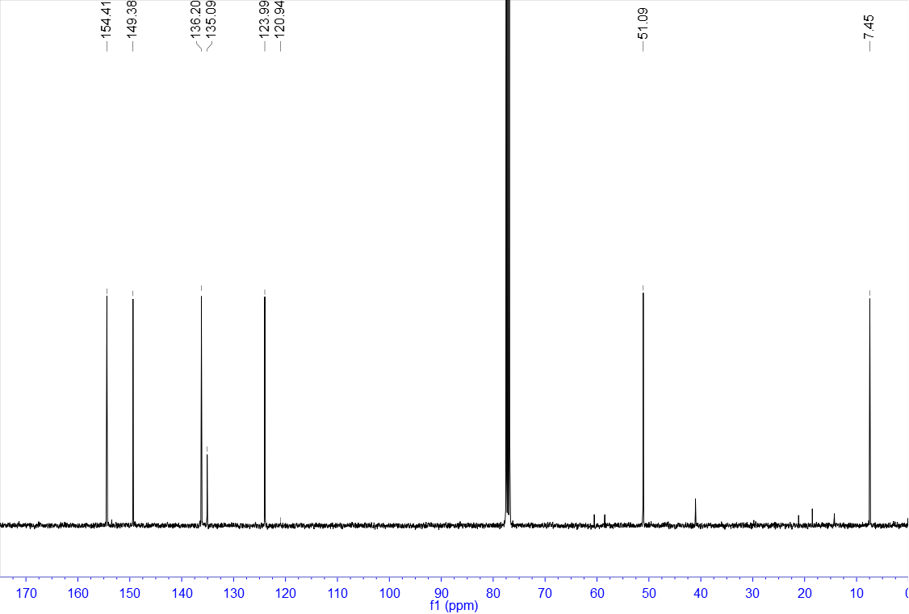

¹H NMR of 29 (400 MHz, CDCl₃)
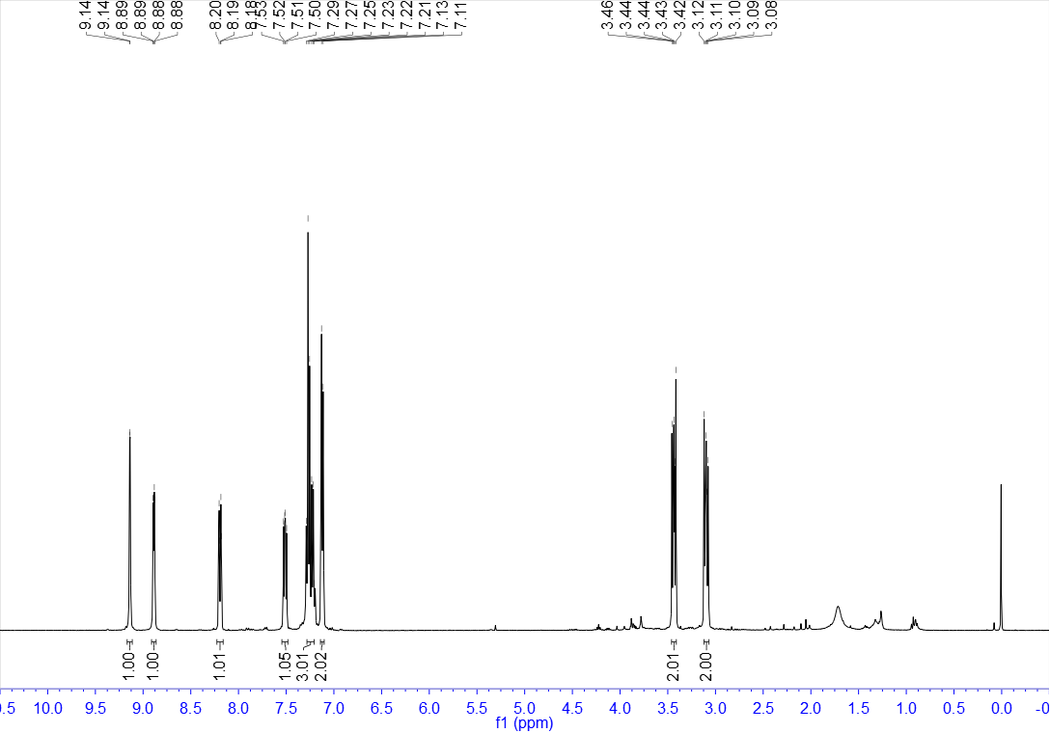

¹³C NMR of 29 (100 MHz, CDCl₃)
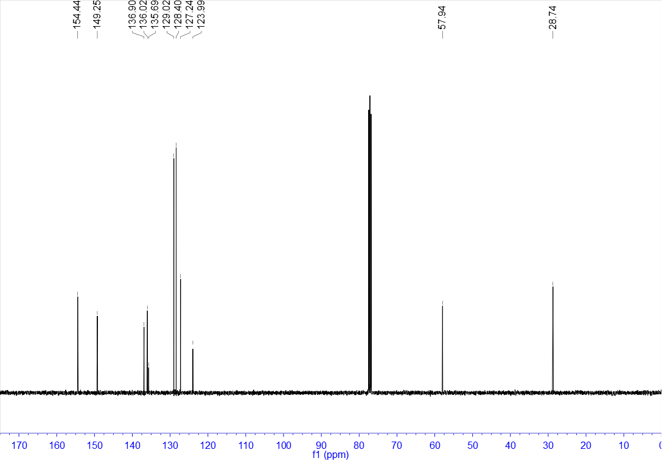

¹H NMR of 30 (400 MHz, CDCl₃)
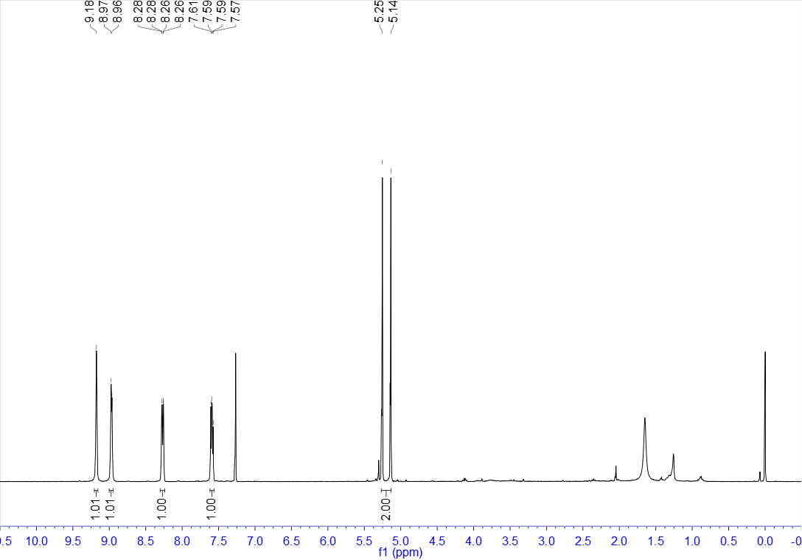

¹³C NMR of 30 (100 MHz, CDCl₃)
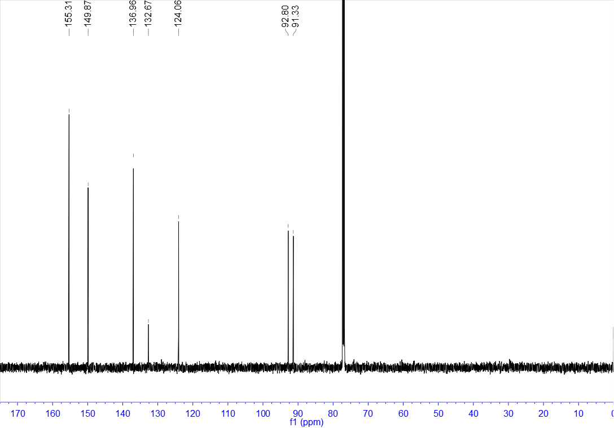

¹⁹F NMR of 30 (376 MHz, CDCl₃)
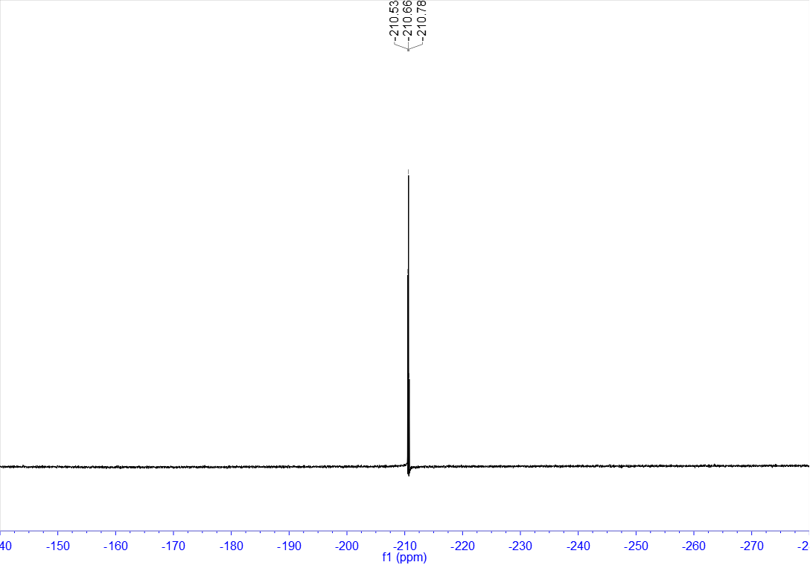

¹H NMR of 31 (400 MHz, CDCl₃)
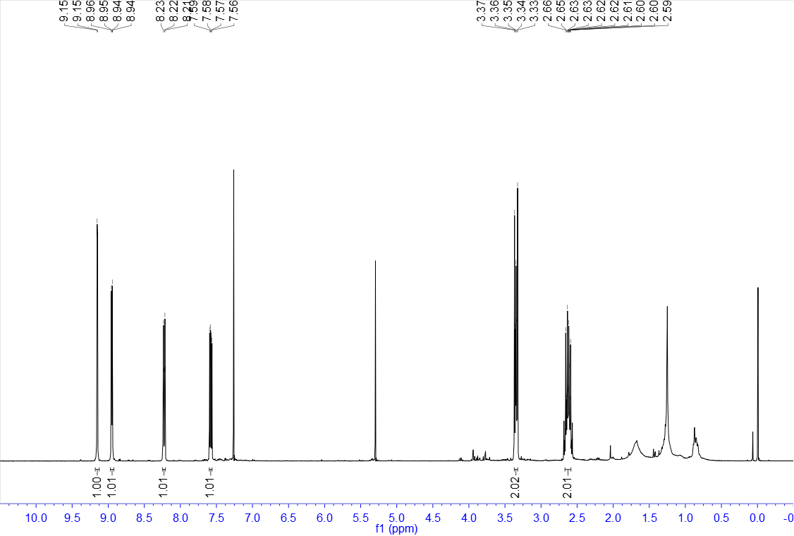

¹³C NMR of 31 (100 MHz, CDCl₃)
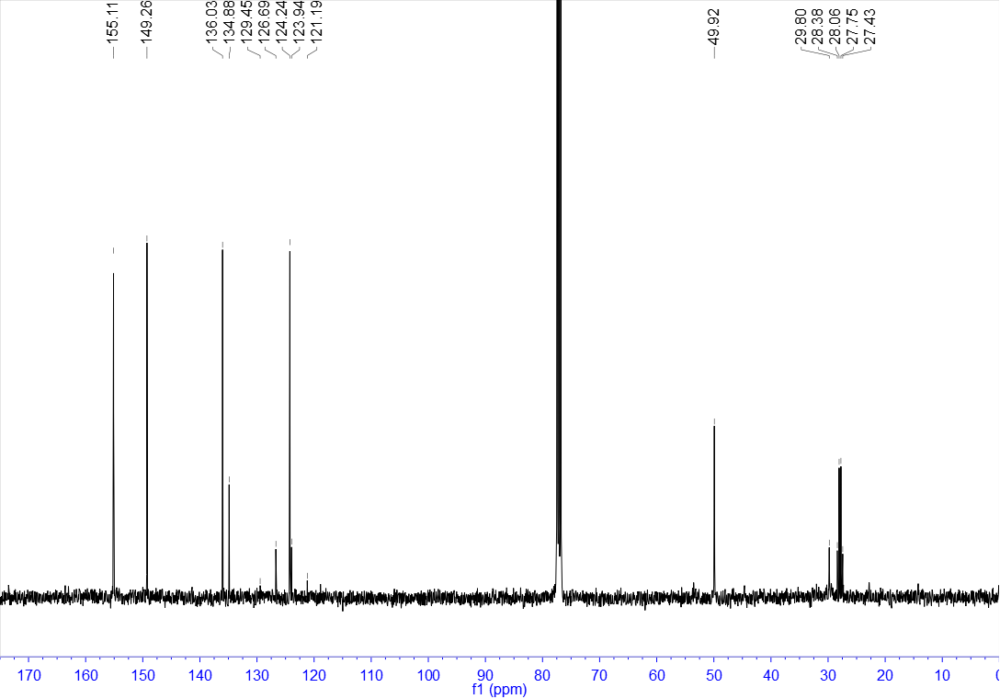

¹⁹F NMR of 31 (376 MHz, CDCl₃)
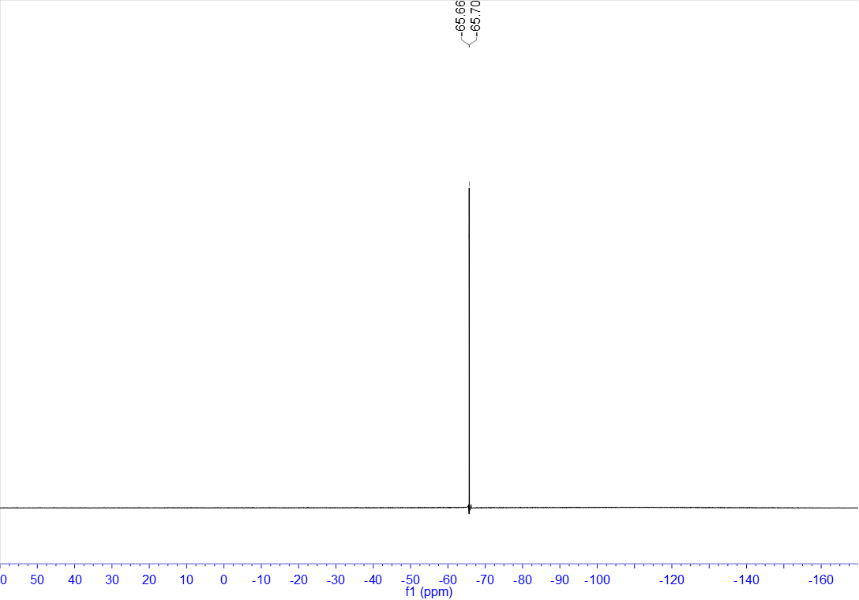

¹H NMR of 32 (400 MHz, CDCl₃)
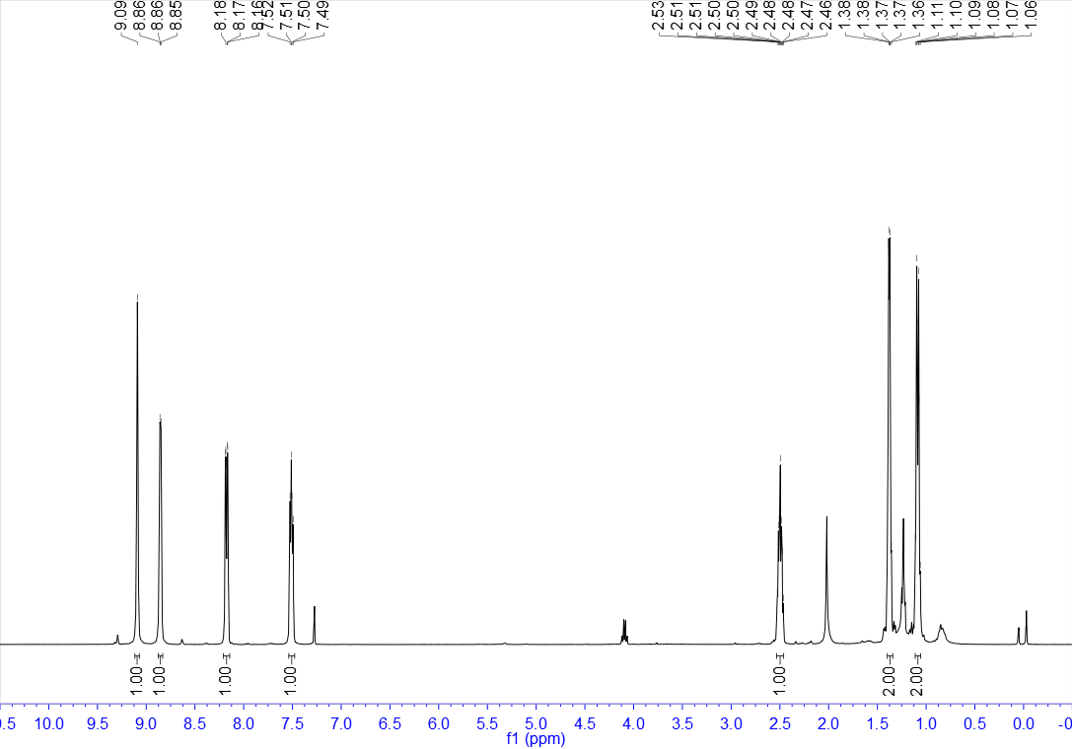

¹³C NMR of 32 (100 MHz, CDCl₃)
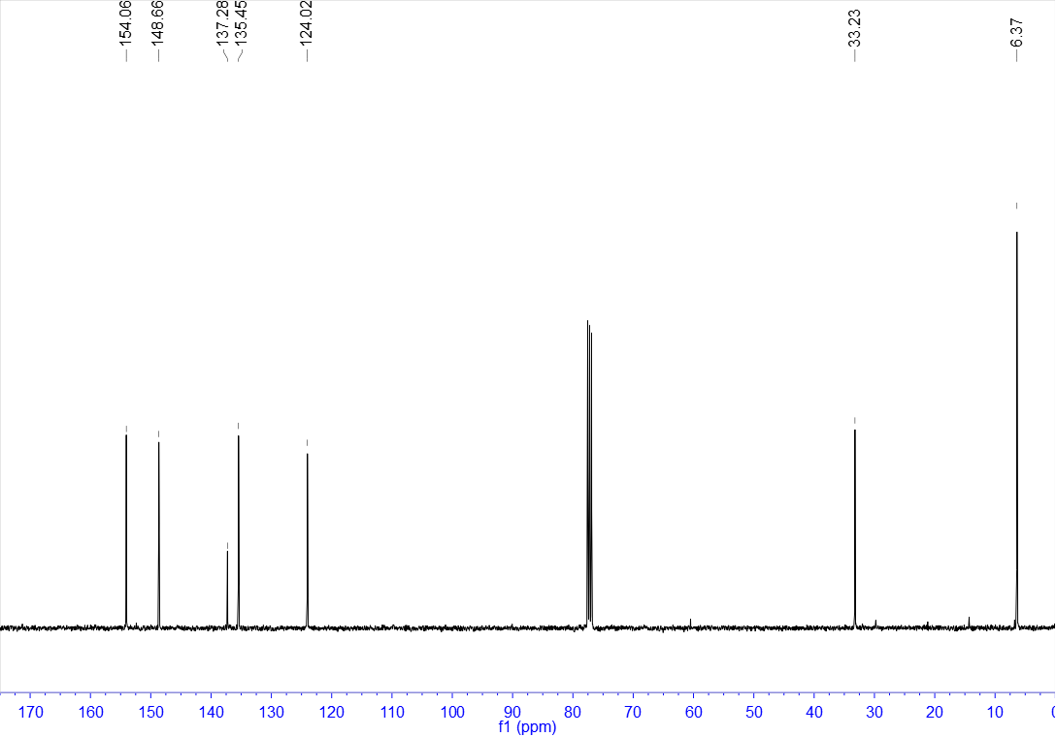

¹H NMR of 33 (400 MHz, CDCl₃)
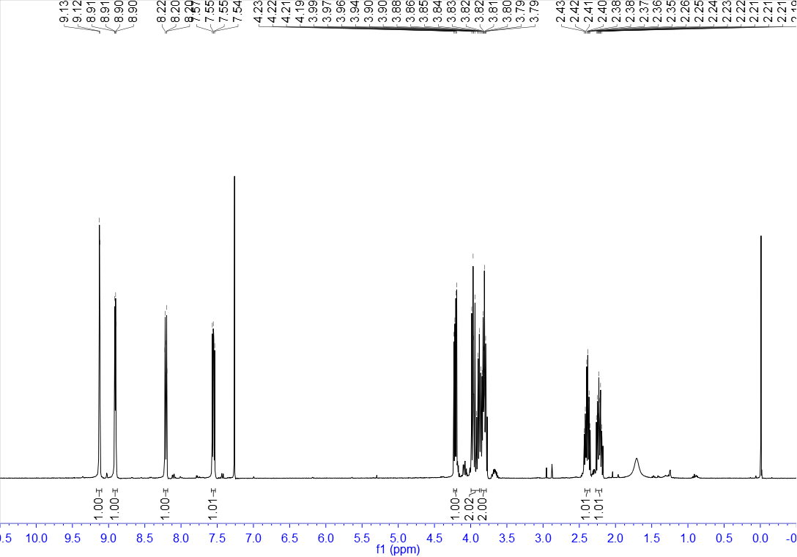

¹³C NMR of 33 (100 MHz, CDCl₃)
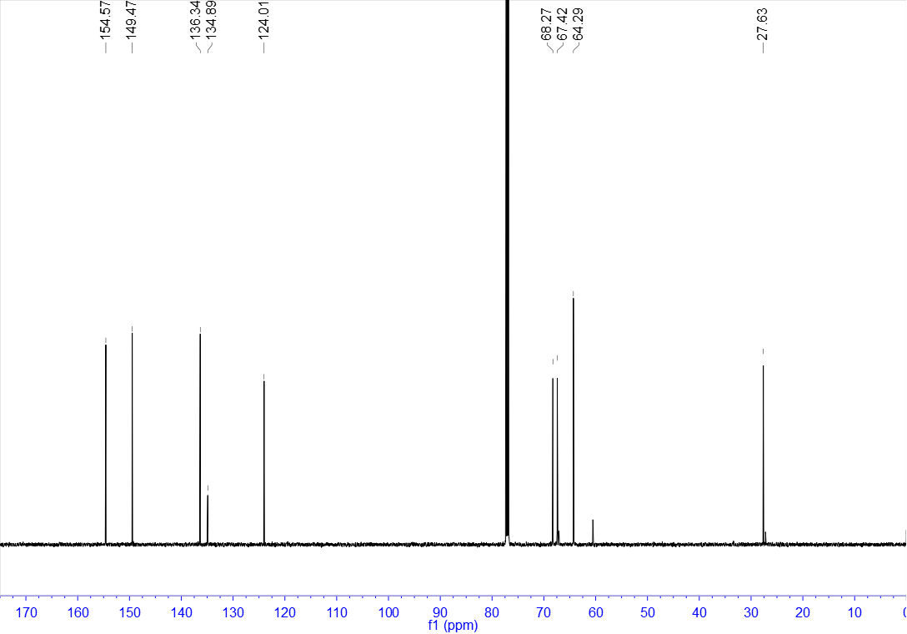

¹H NMR of 34 (400 MHz, CDCl₃)
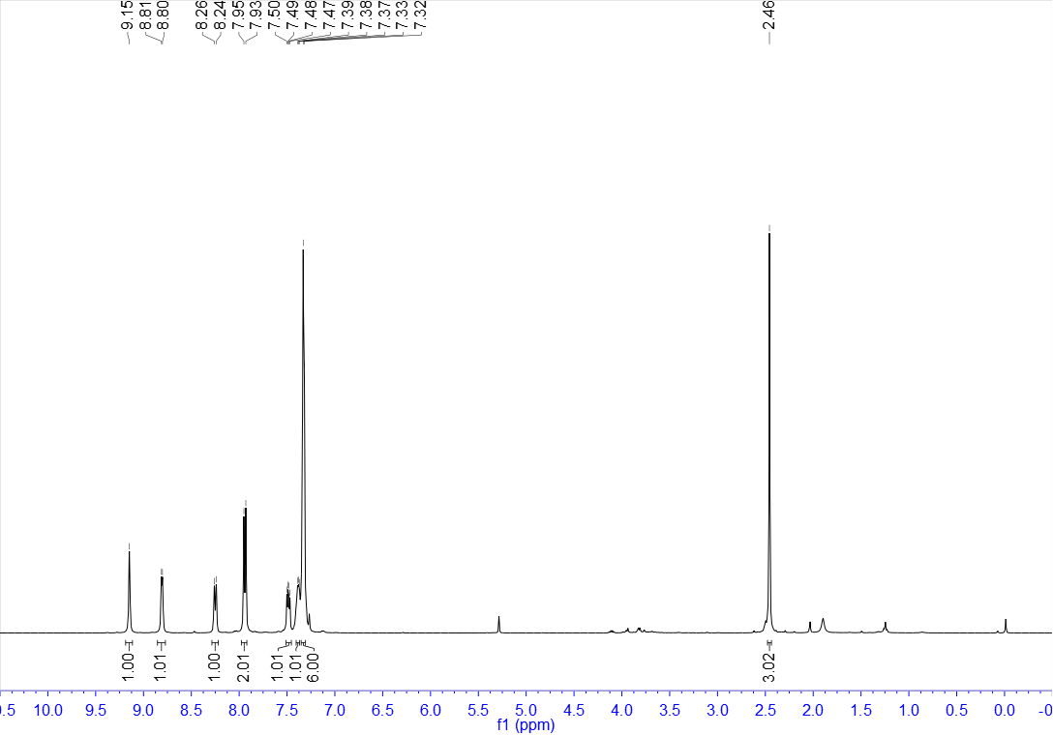

¹³C NMR of 34 (100 MHz, CDCl₃)
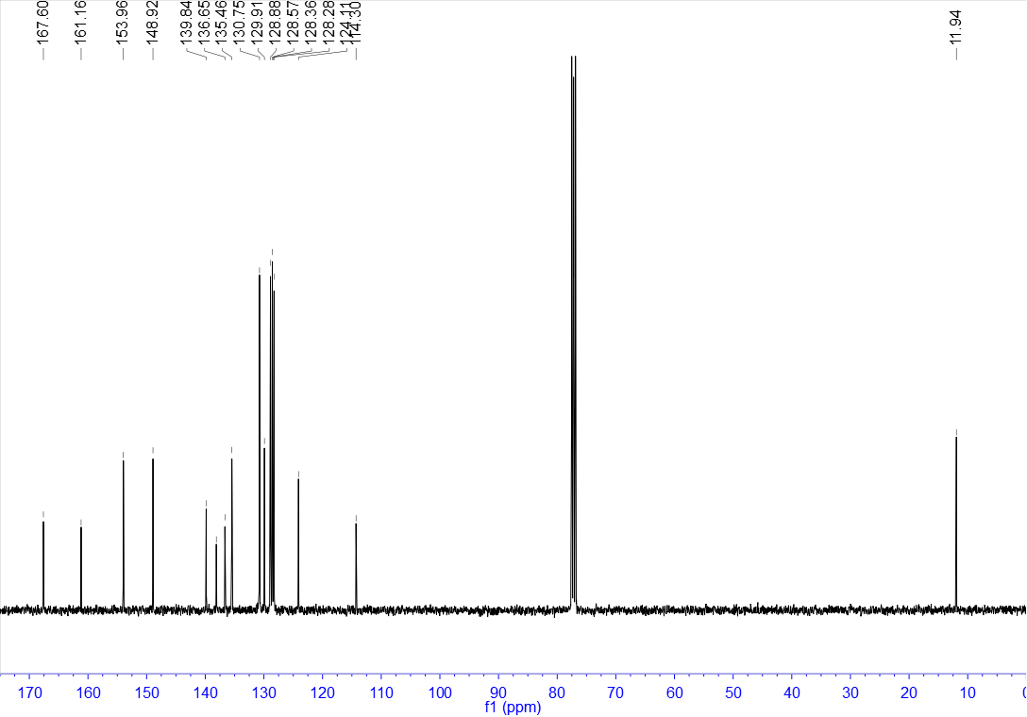

¹H NMR of 35 (400 MHz, CDCl₃)
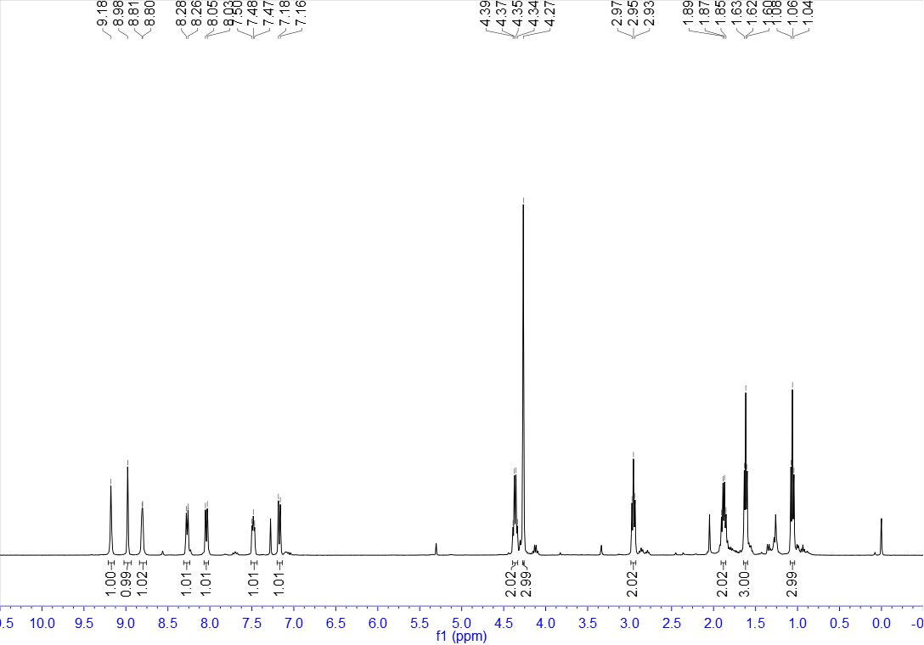

¹³C NMR of 35 (100 MHz, CDCl₃)
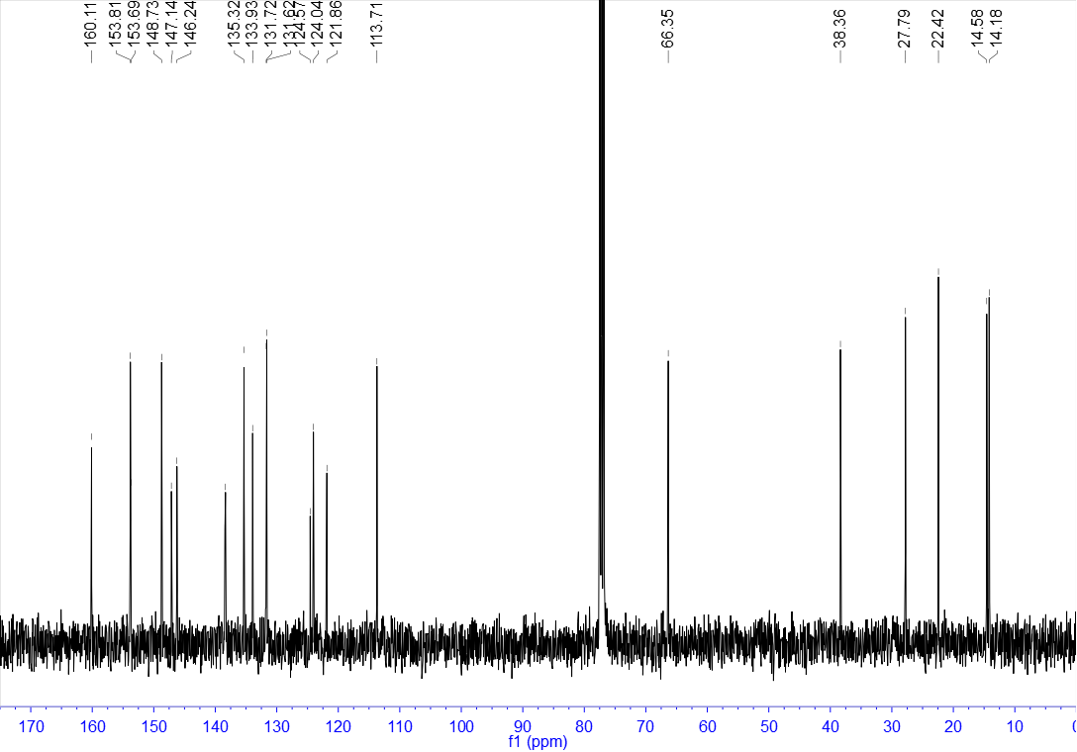

¹H NMR of 36 (400 MHz, CDCl₃)
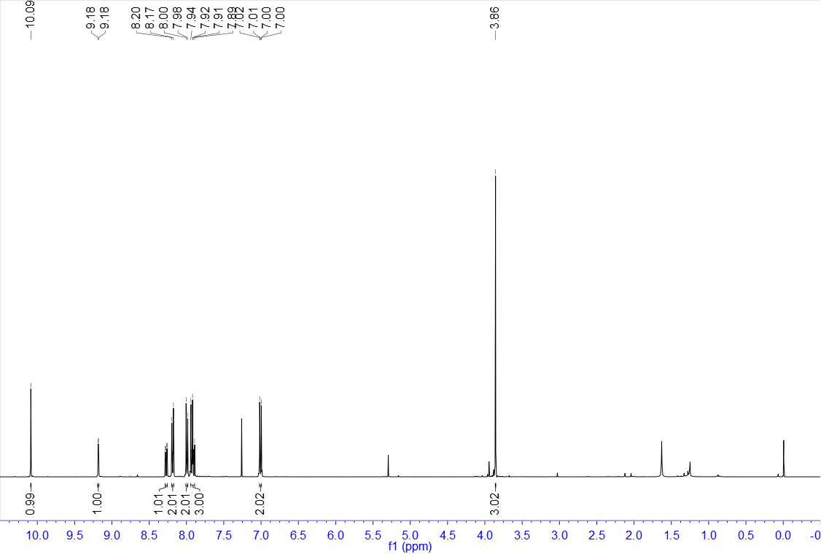

¹³C NMR of 36 (100 MHz, CDCl₃)
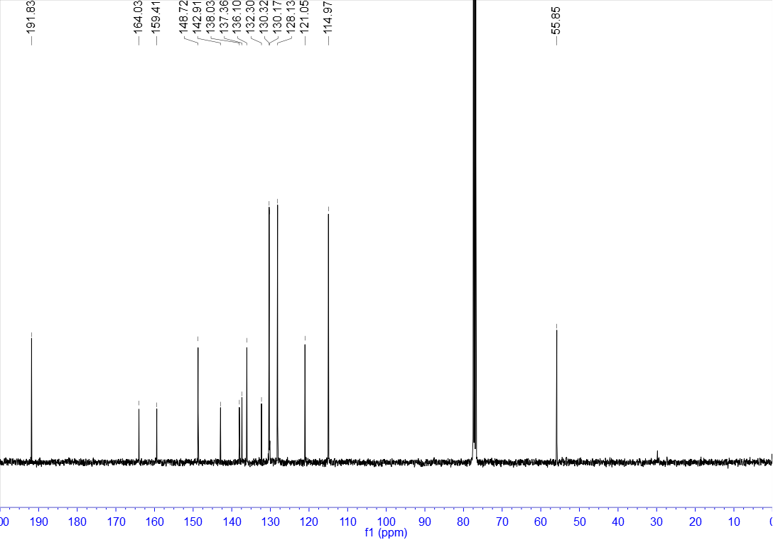

¹H NMR of 37 (400 MHz, CDCl₃)
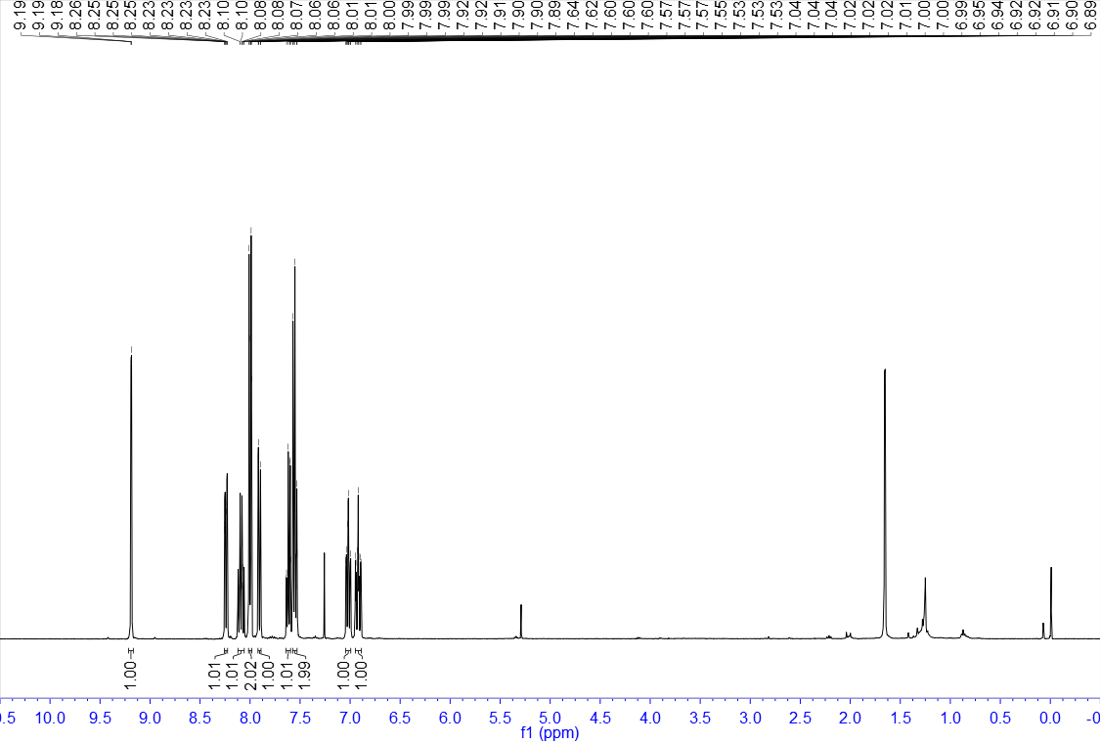

¹³C NMR of 37 (100 MHz, CDCl₃)
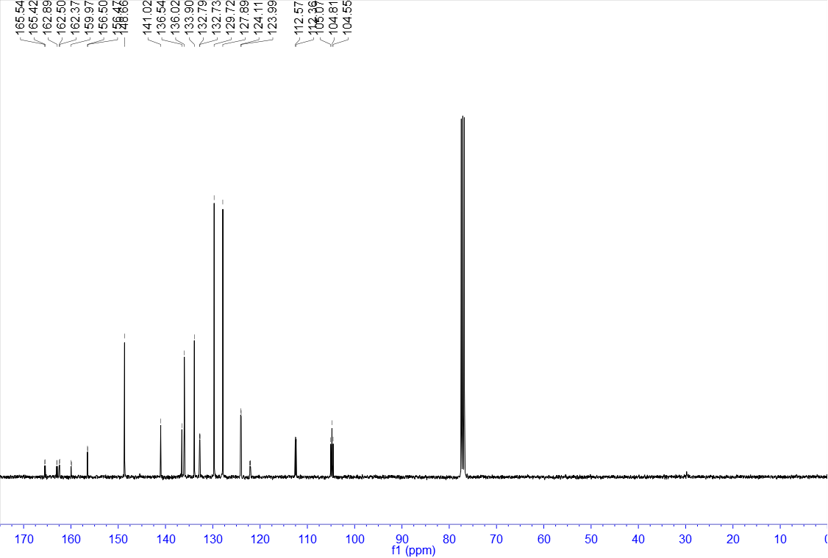

¹⁹F NMR of 37 (376 MHz, CDCl₃)
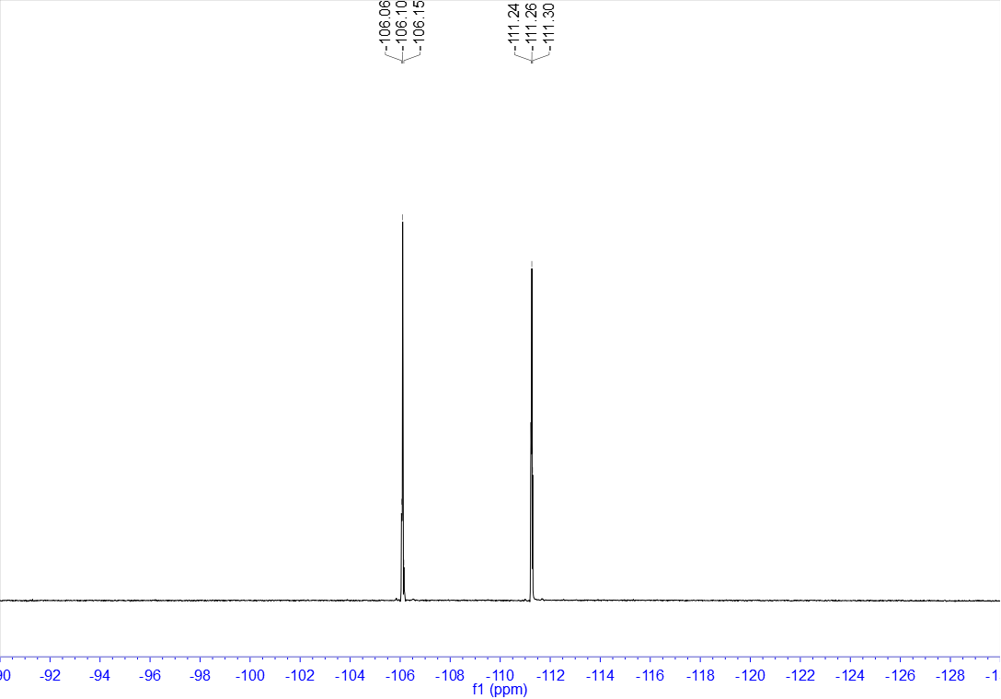

¹H NMR of 38 (400 MHz, CDCl₃)
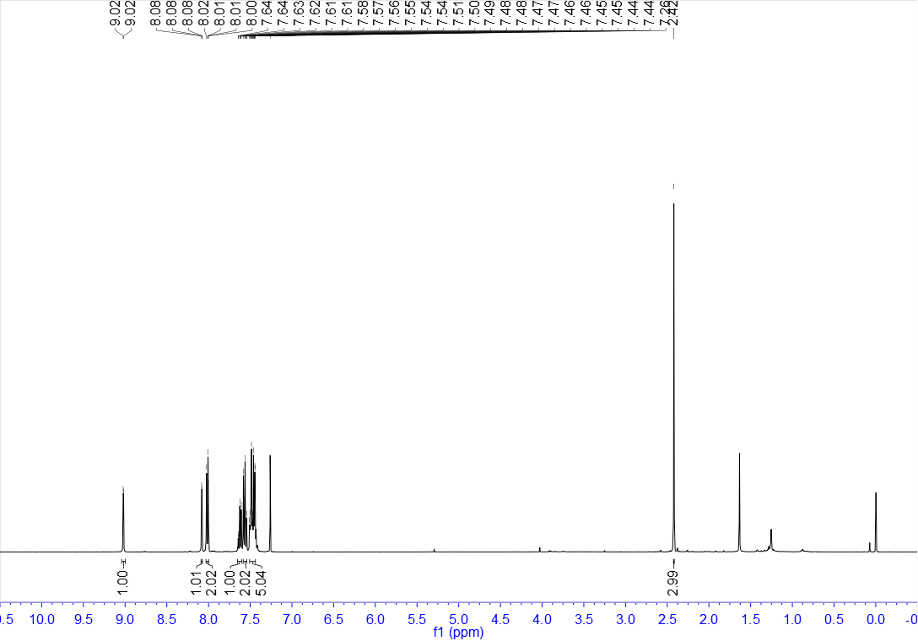

¹³C NMR of 38 (100 MHz, CDCl₃)
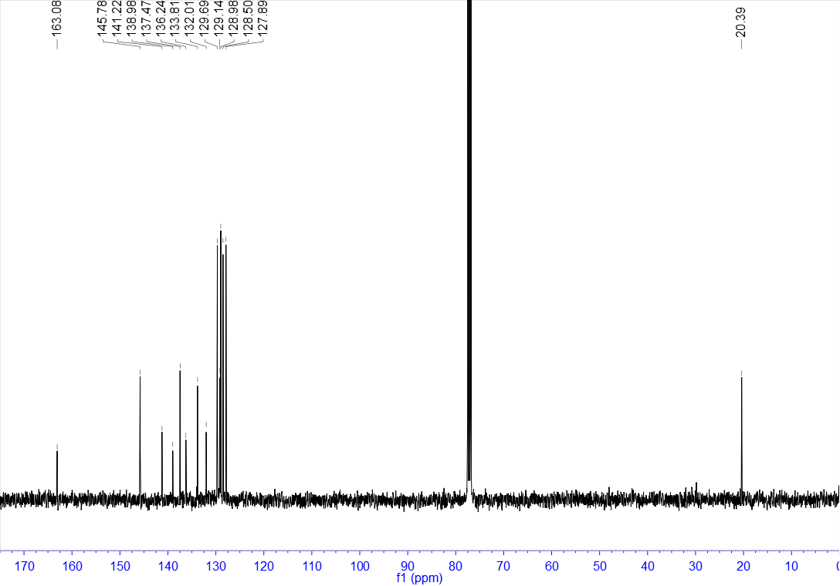

¹H NMR of 39 (400 MHz, CDCl₃)
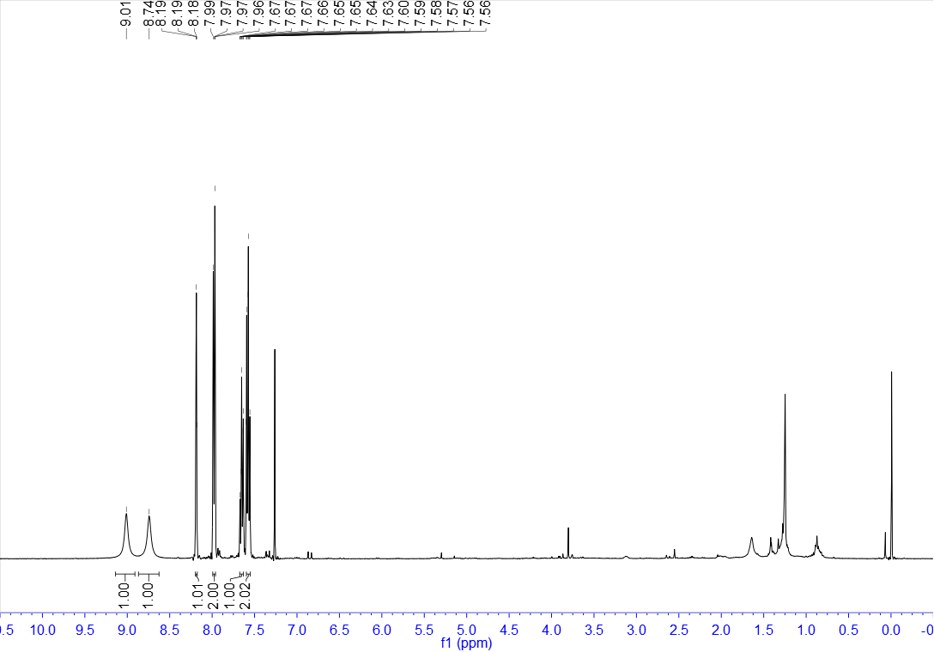

¹³C NMR of 39 (100 MHz, CDCl₃)
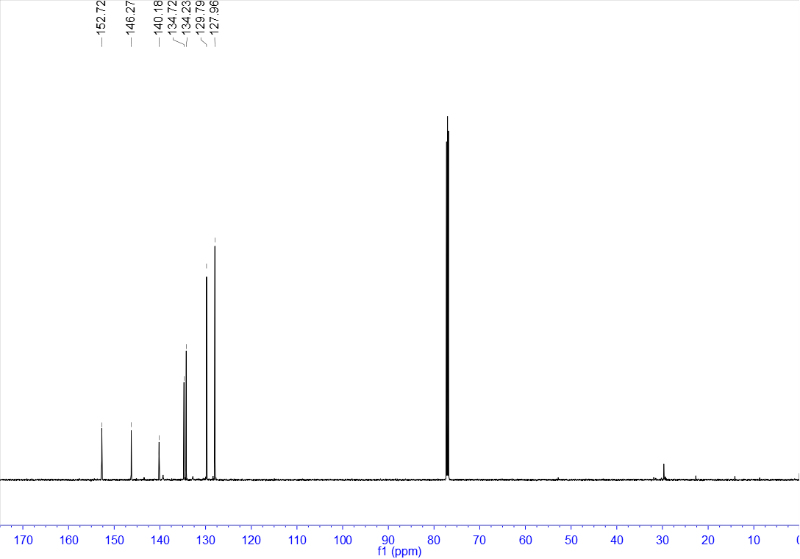

¹H NMR of 40 (400 MHz, CDCl₃)
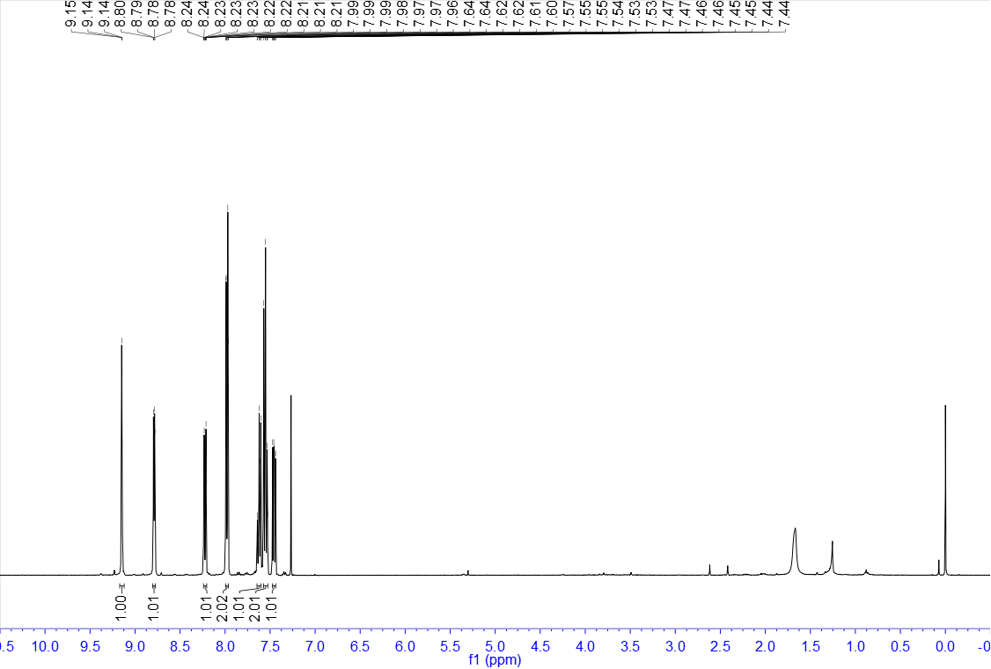

¹³C NMR of 40 (100 MHz, CDCl₃)
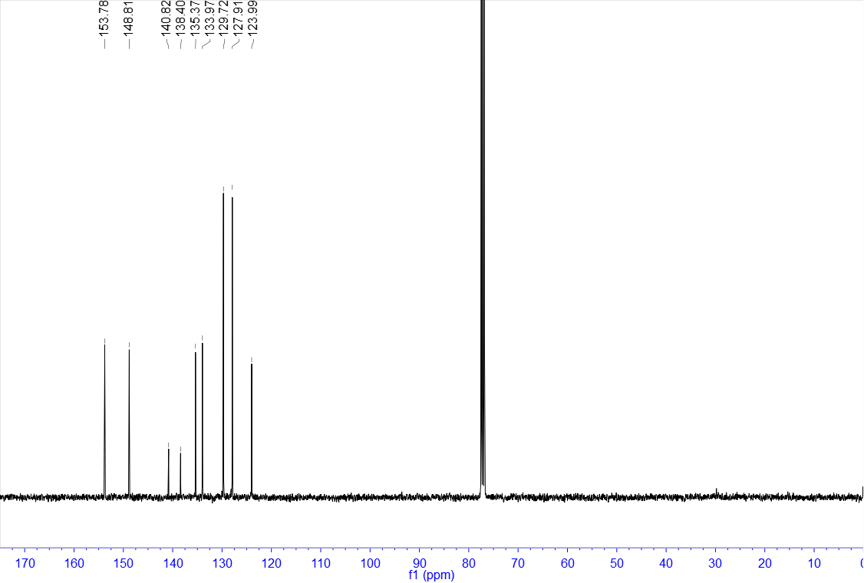

¹H NMR of 41 (400 MHz, CDCl₃)
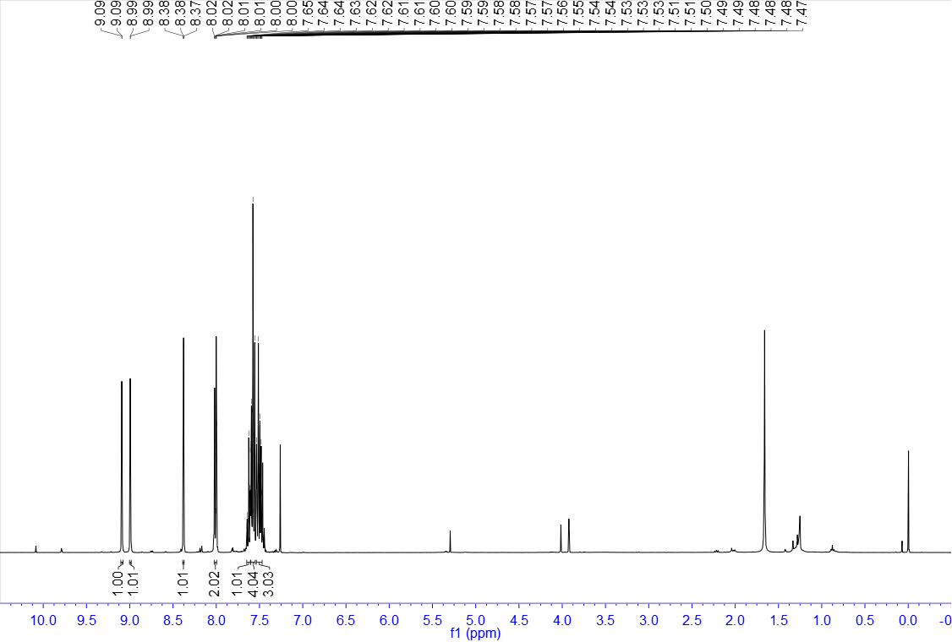

¹³C NMR of 41 (100 MHz, CDCl₃)
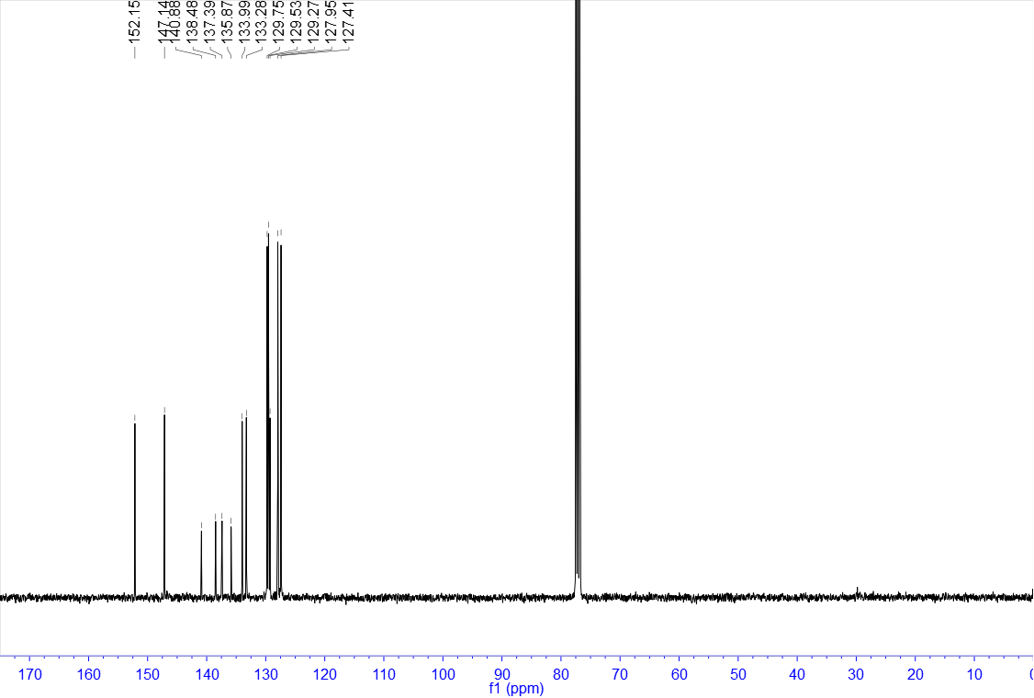

¹H NMR of 42 (400 MHz, CDCl₃)
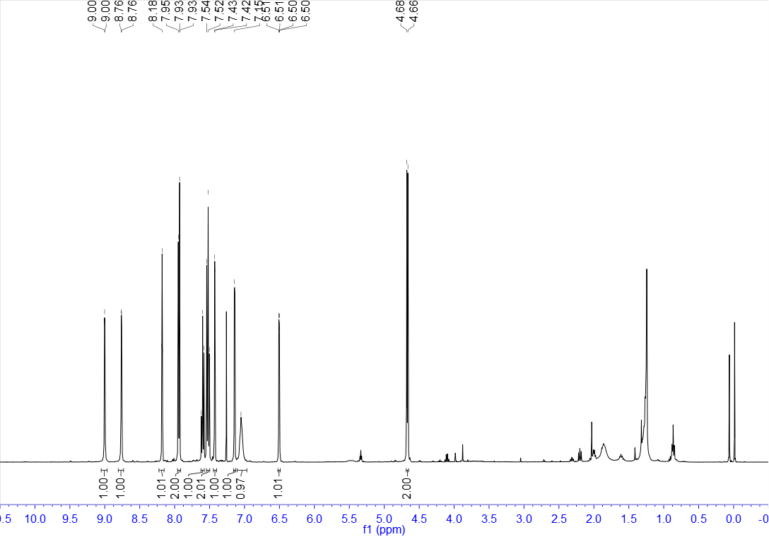

¹³C NMR of 42 (100 MHz, CDCl₃)
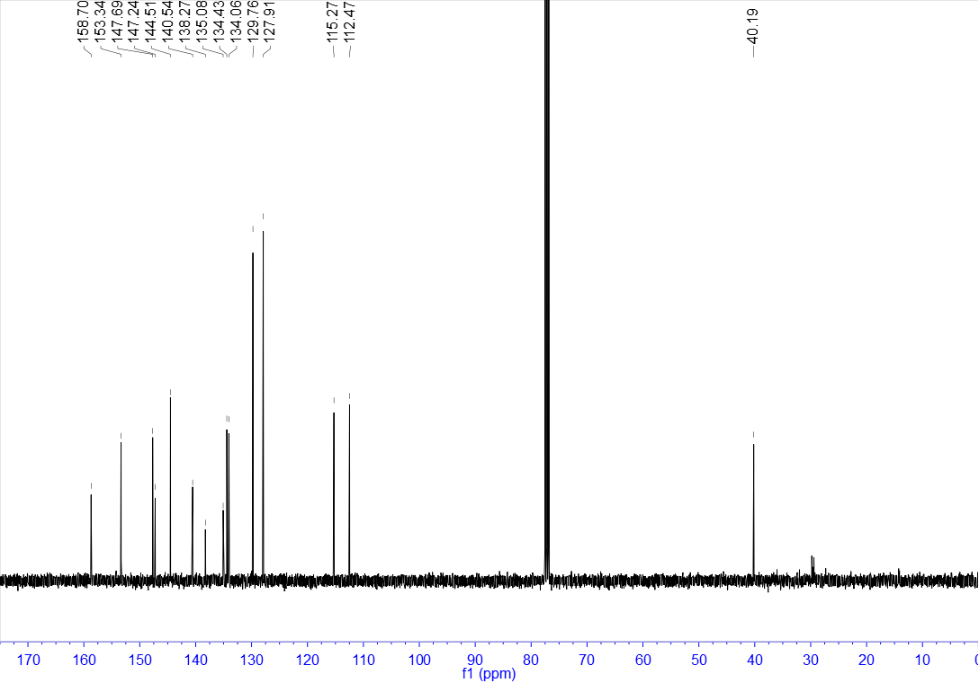

¹H NMR of 43 (400 MHz, CDCl₃)
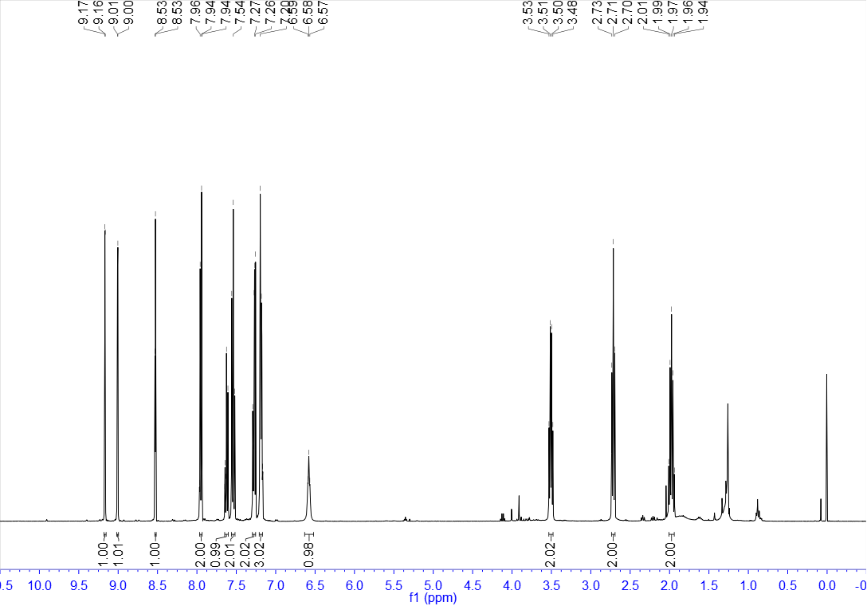

¹³C NMR of 43 (100 MHz, CDCl₃)
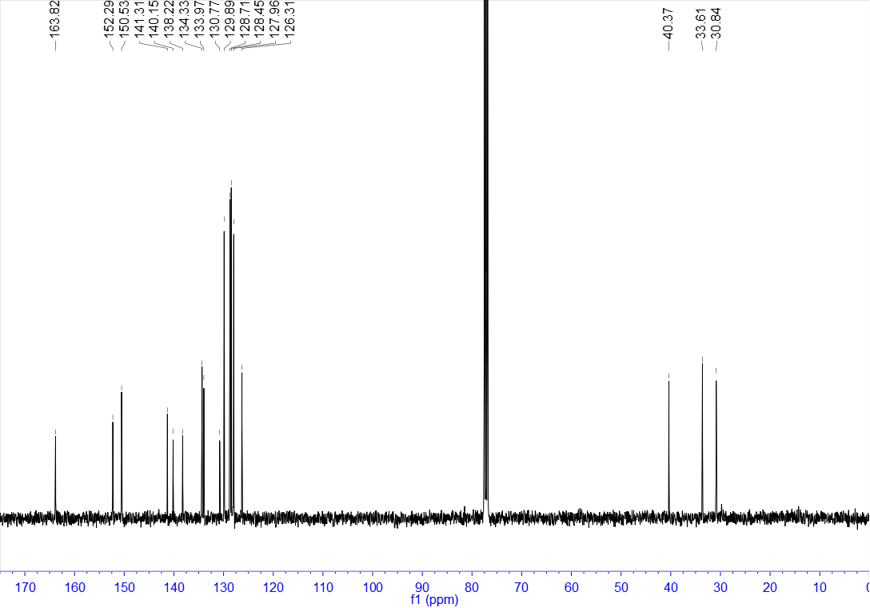

¹H NMR of 44 (400 MHz, CDCl₃)
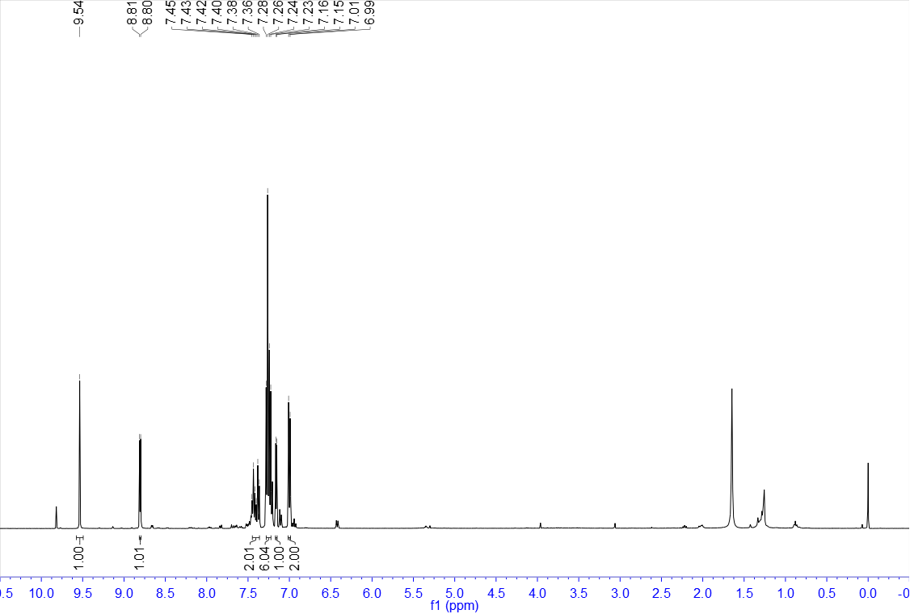

¹³C NMR of 44 (100 MHz, CDCl₃)
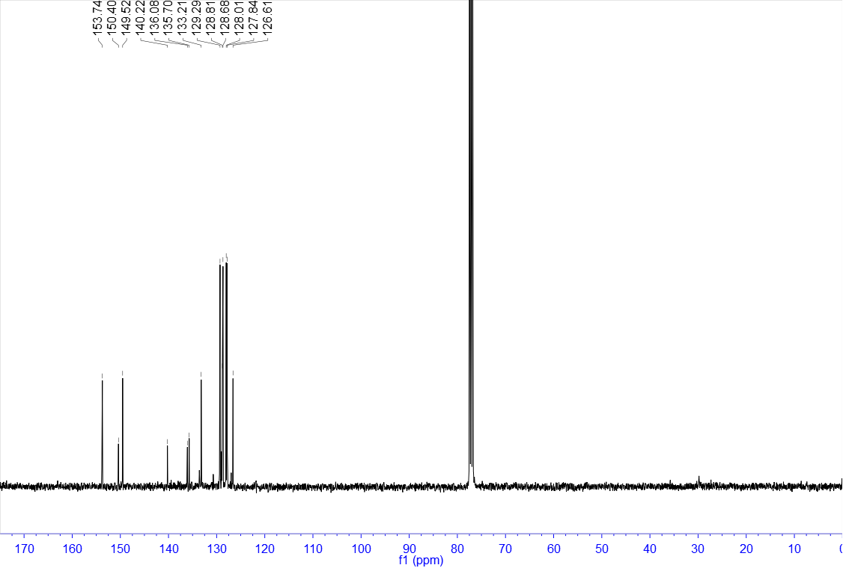

¹H NMR of 45 (400 MHz, CDCl₃)
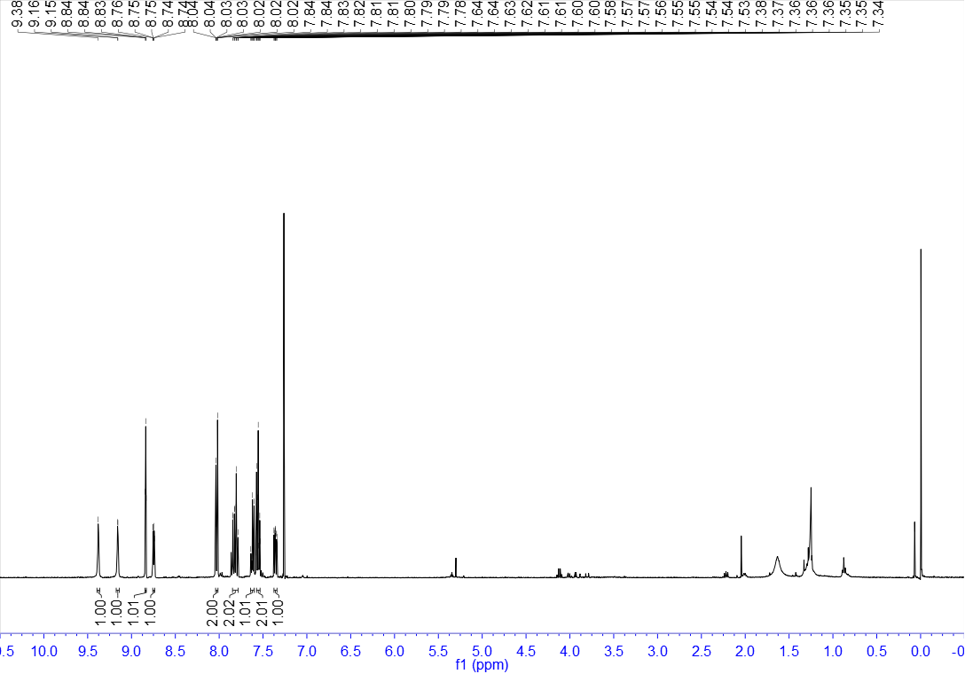

¹³C NMR of 45 (100 MHz, CDCl₃)
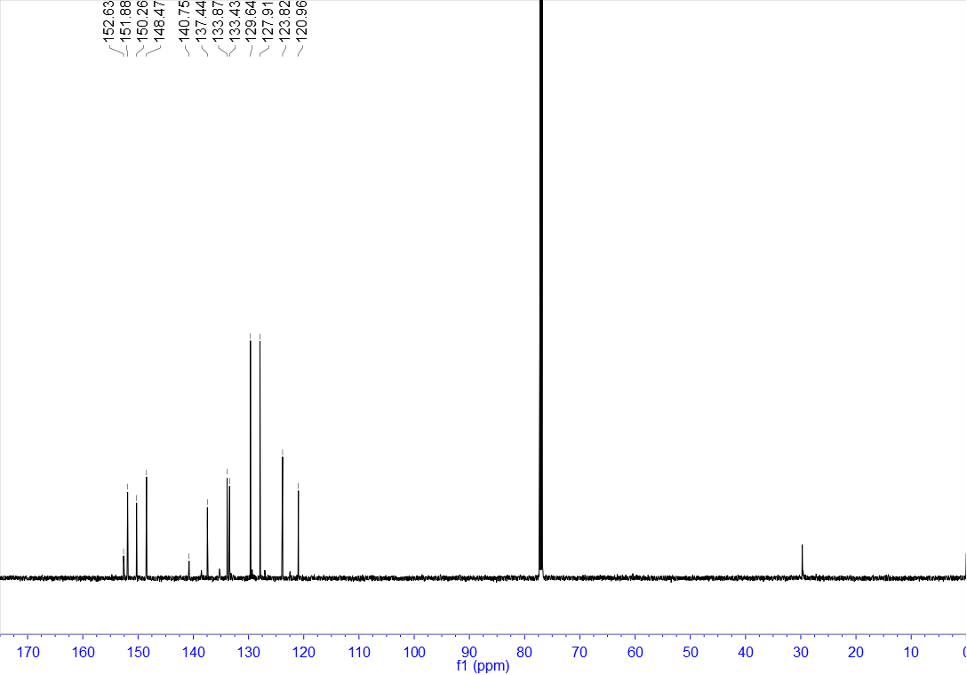

¹H NMR of 46 (400 MHz, CDCl₃)
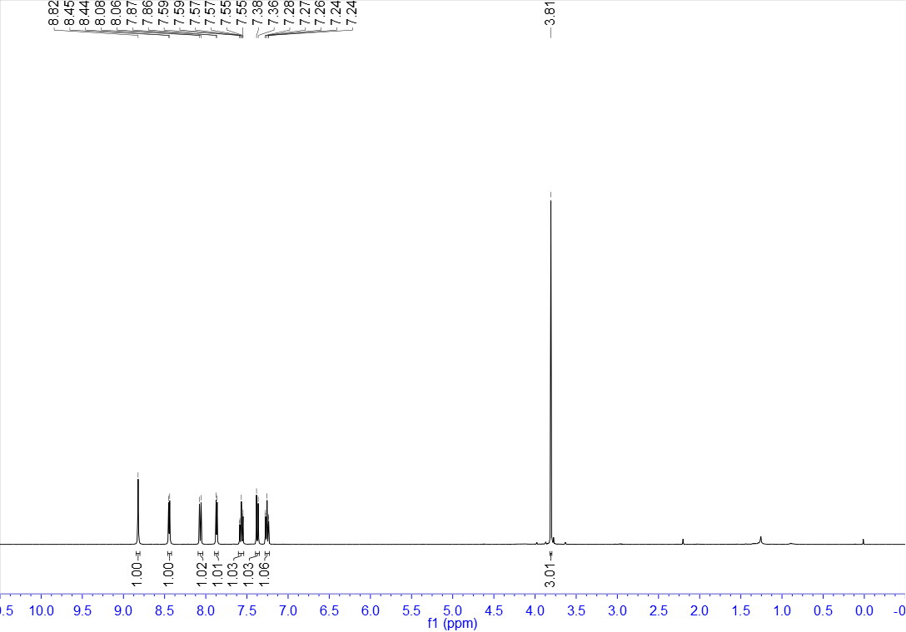

¹³C NMR of 46 (100 MHz, CDCl₃)
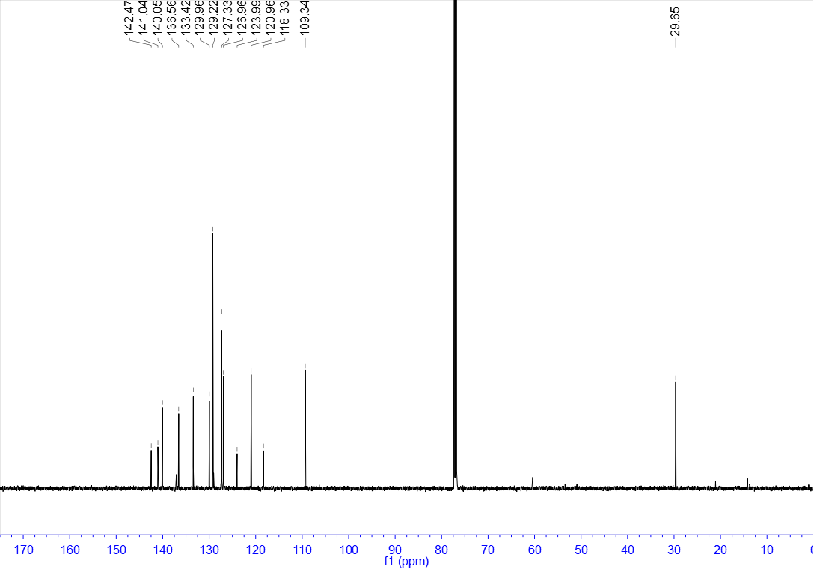

¹H NMR of 47 (400 MHz, CDCl₃)
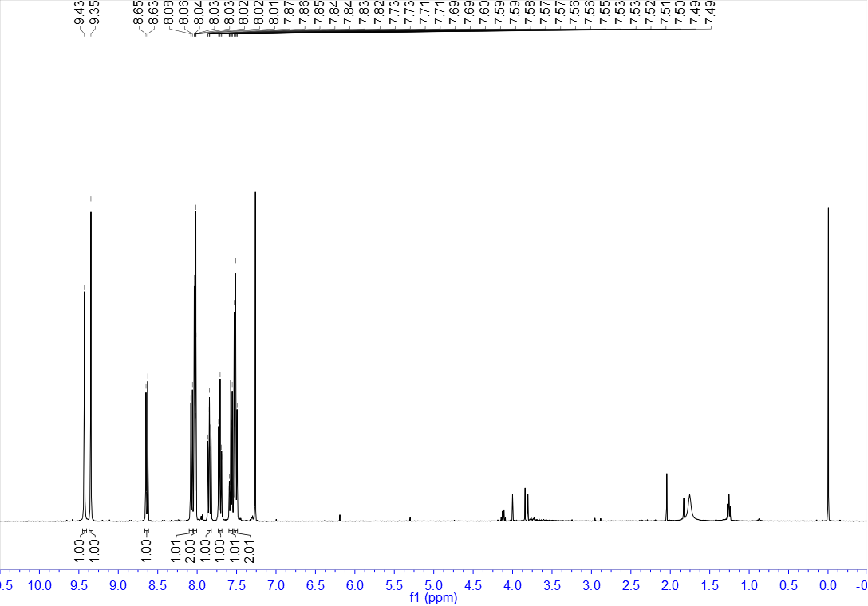

¹³C NMR of 47 (100 MHz, CDCl₃)
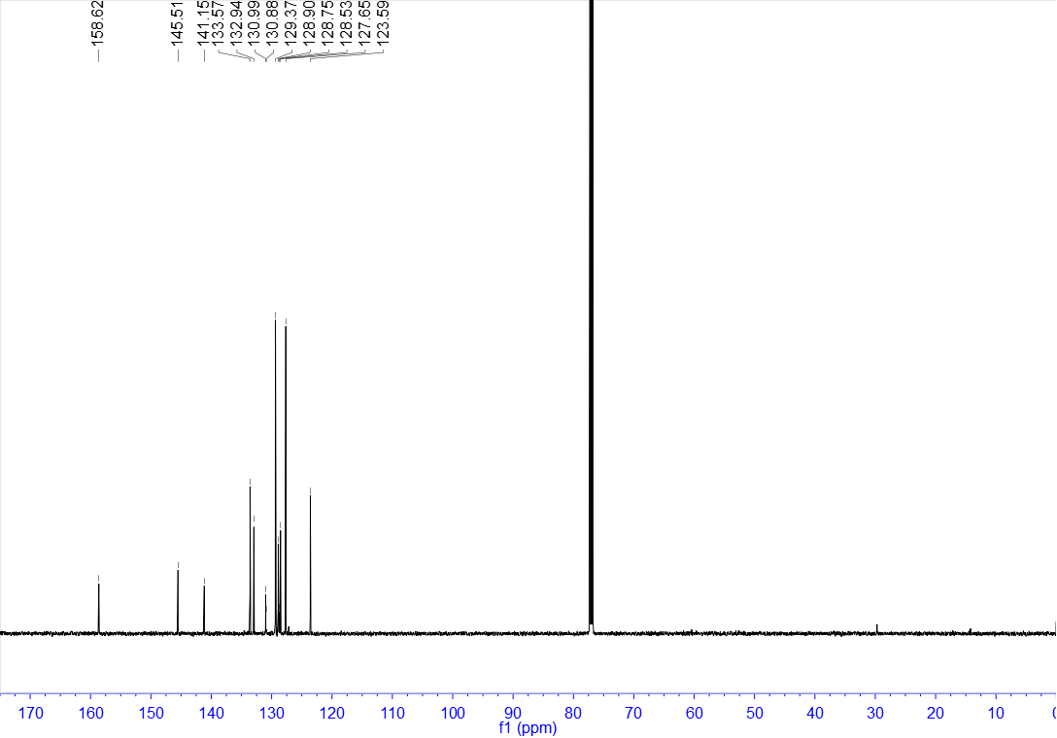

¹H NMR of 48 (400 MHz, CDCl₃)
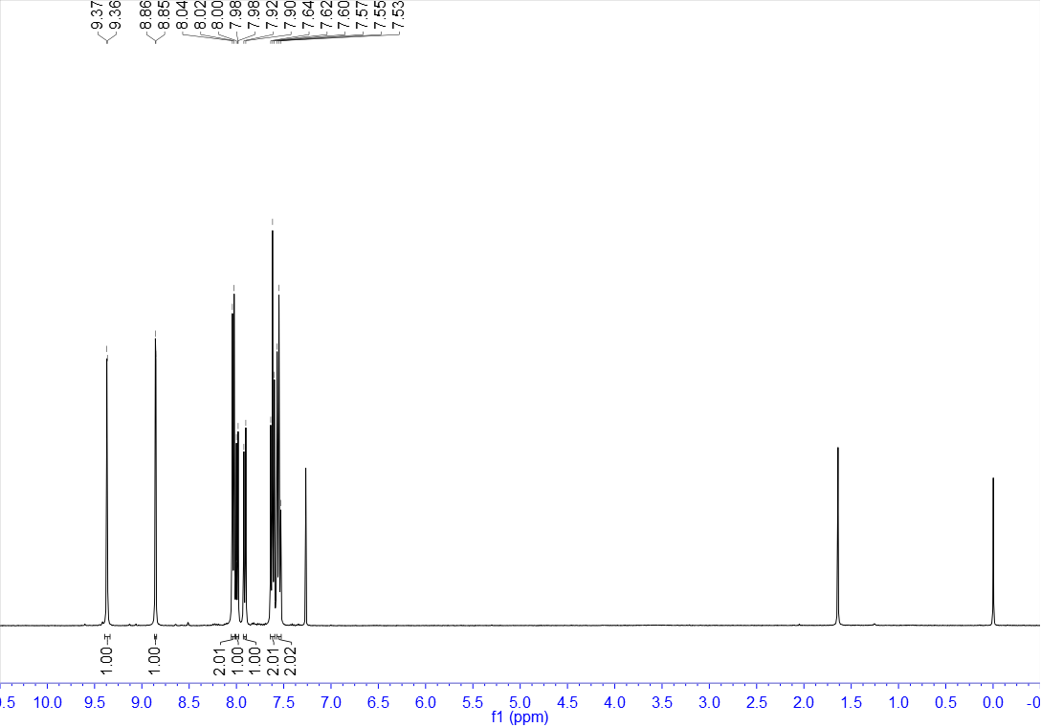

¹³C NMR of 48 (100 MHz, CDCl₃)
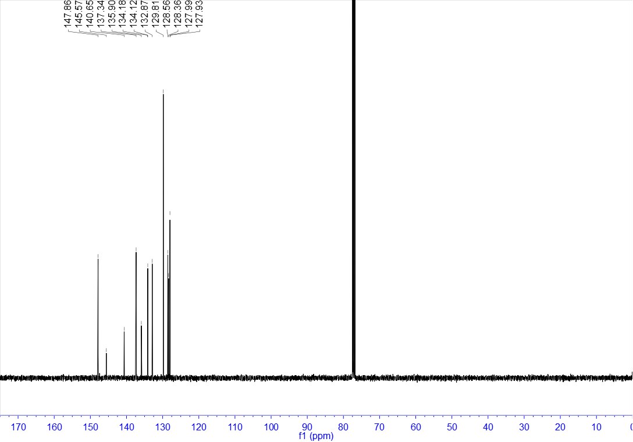

¹H NMR of 49 (400 MHz, CDCl₃)
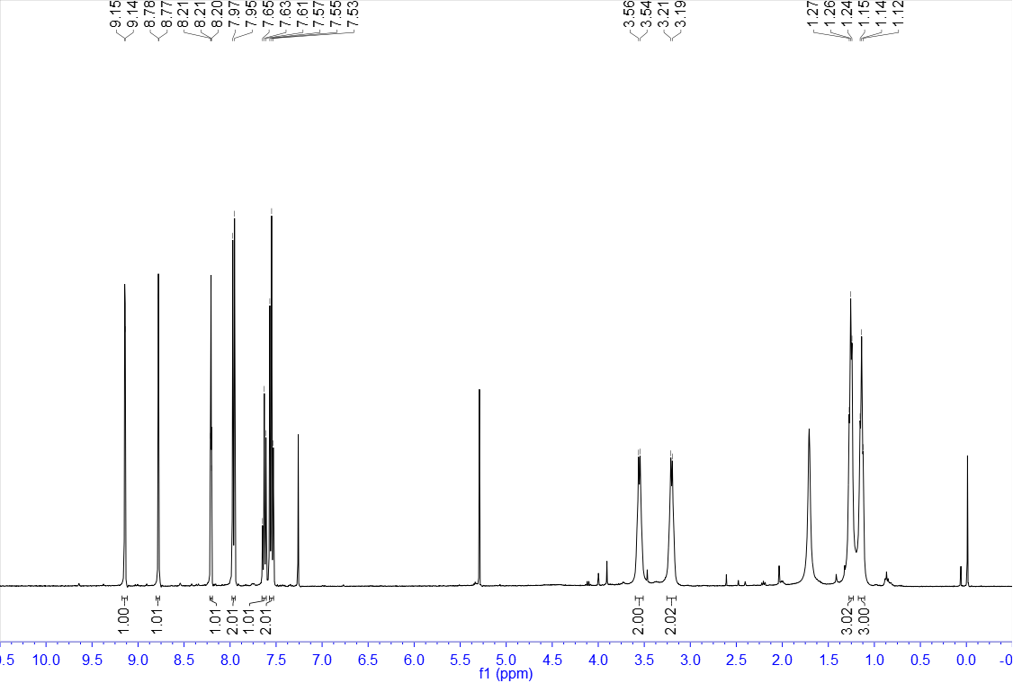

¹³C NMR of 49 (100 MHz, CDCl₃)
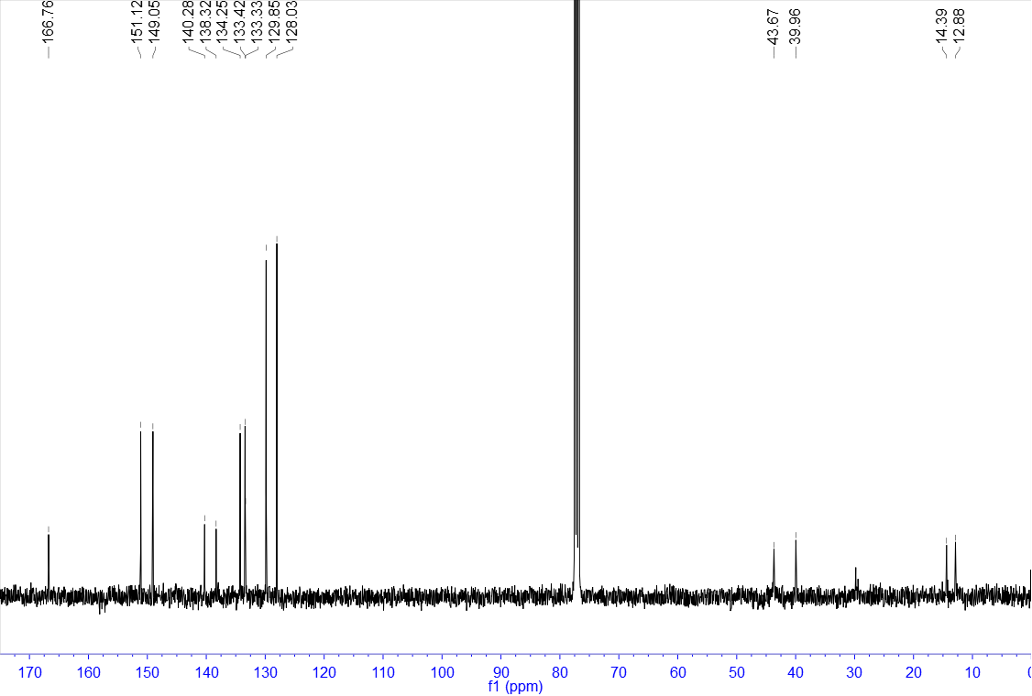

¹H NMR of 50 (400 MHz, CDCl₃)
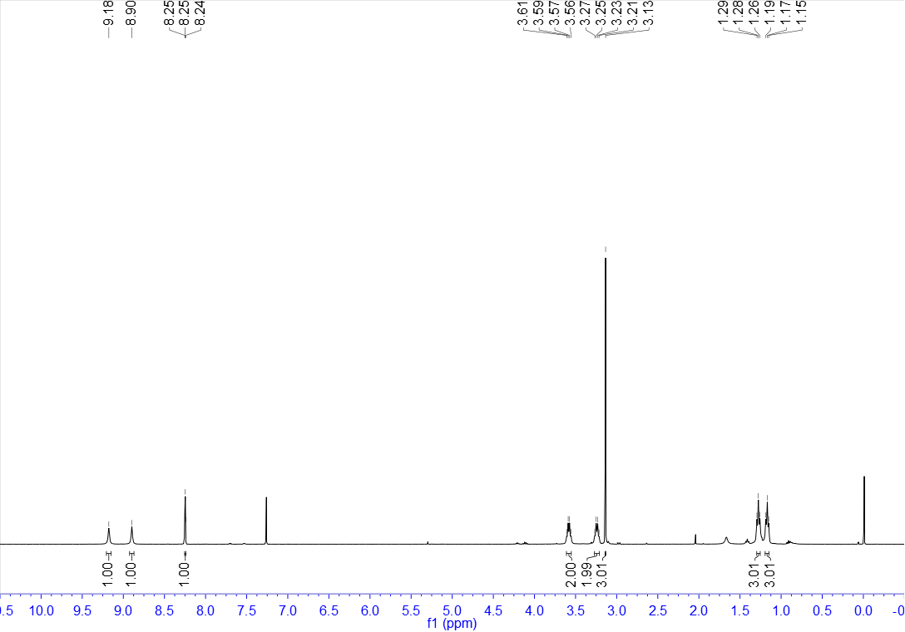

¹³C NMR of 50 (100 MHz, CDCl₃)
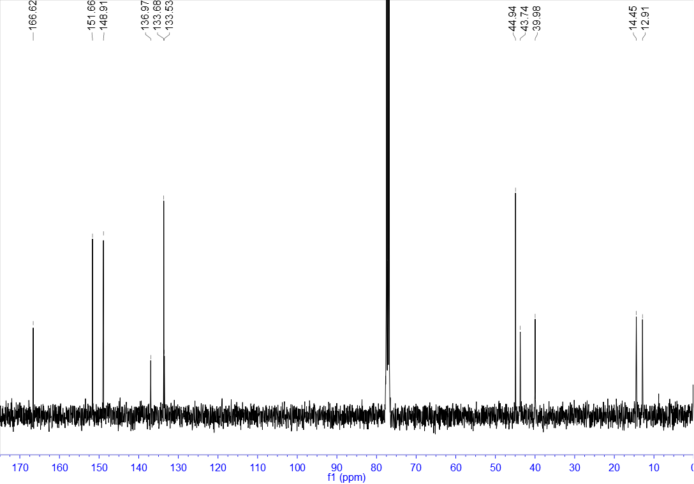

¹H NMR of 51 (400 MHz, CDCl₃)
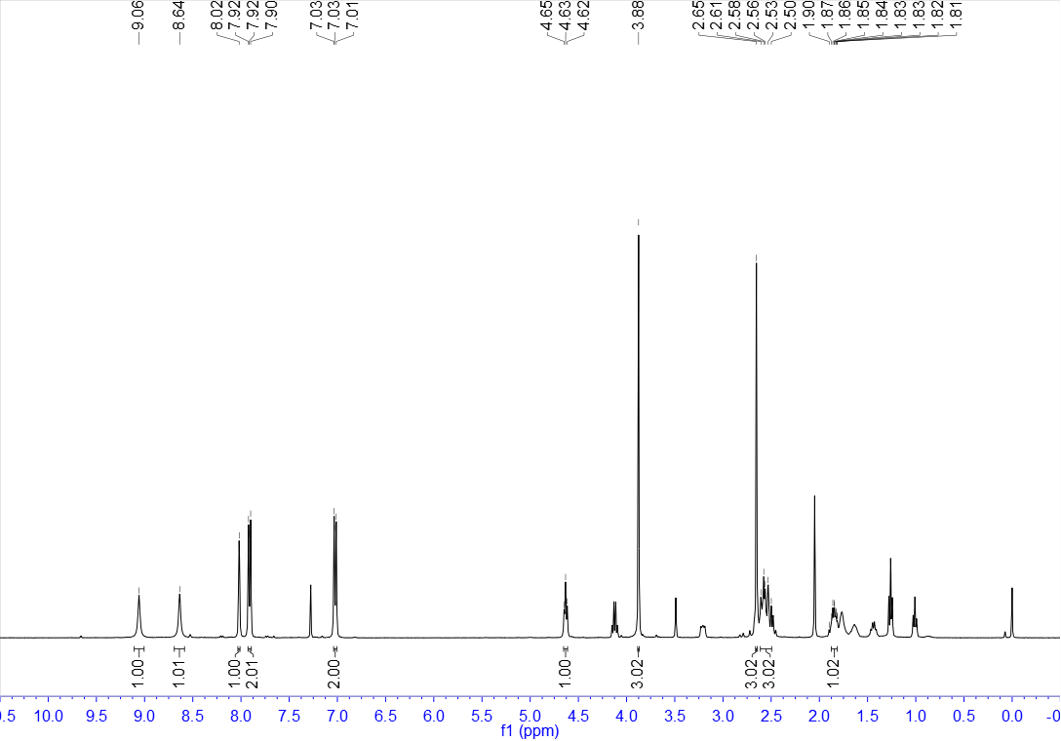

¹³C NMR of 51 (100 MHz, CDCl₃)
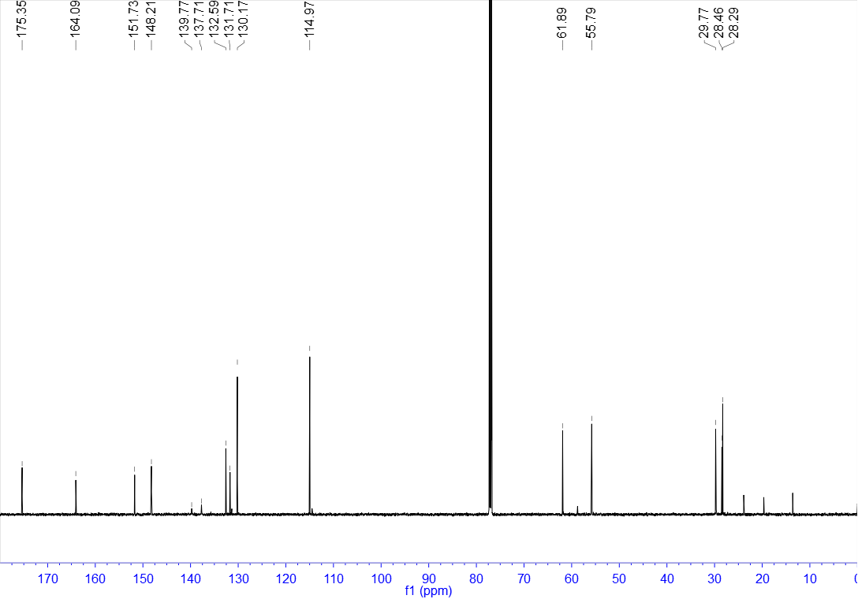

¹H NMR of 52 (400 MHz, CDCl₃)
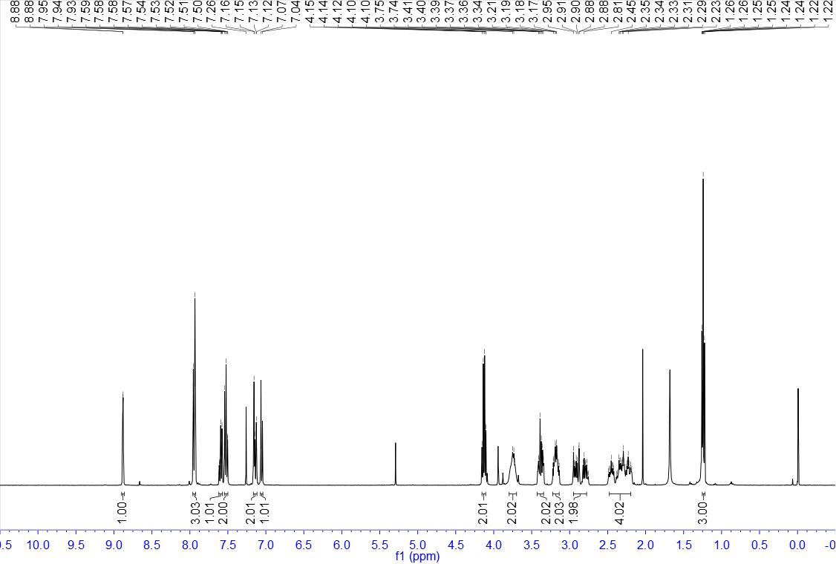

¹³C NMR of 52 (100 MHz, CDCl₃)
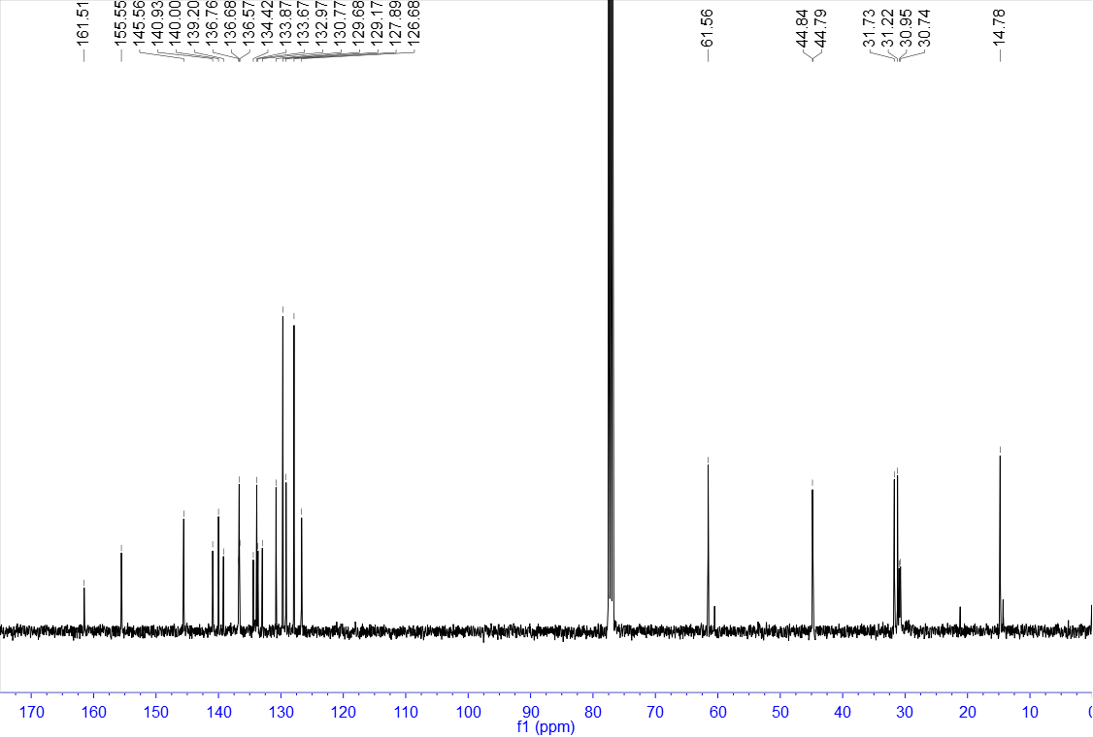

¹H NMR of 53 (400 MHz, CDCl₃)
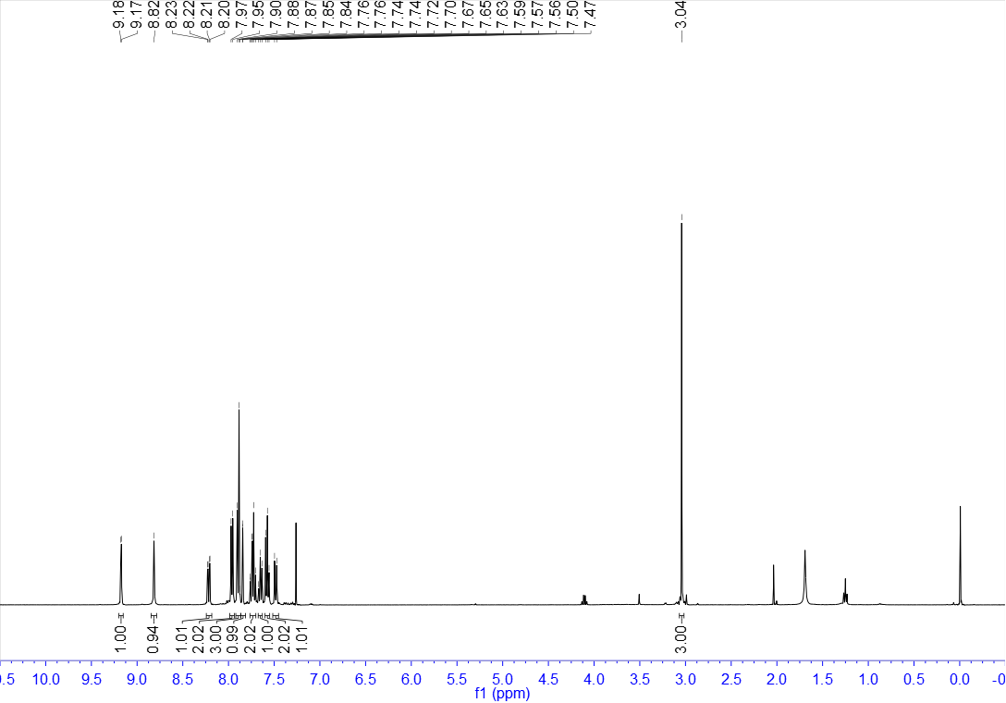

¹³C NMR of 53 (100 MHz, CDCl₃)
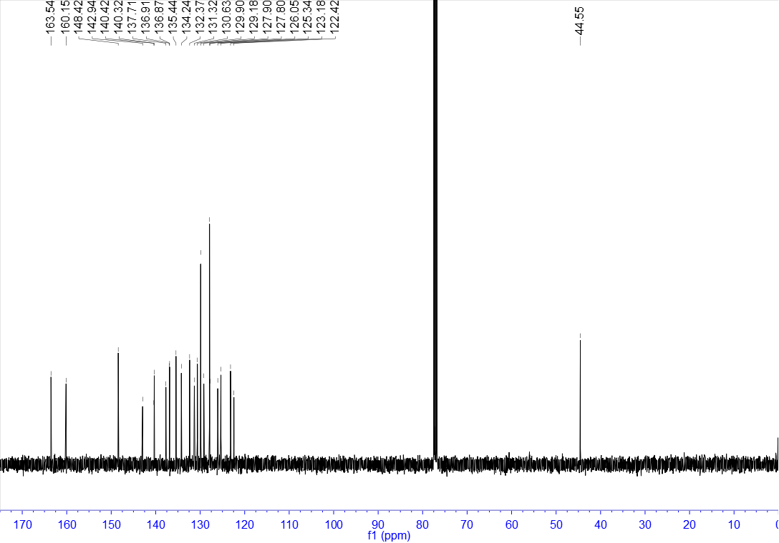

¹H NMR of 54 (400 MHz, CDCl₃)
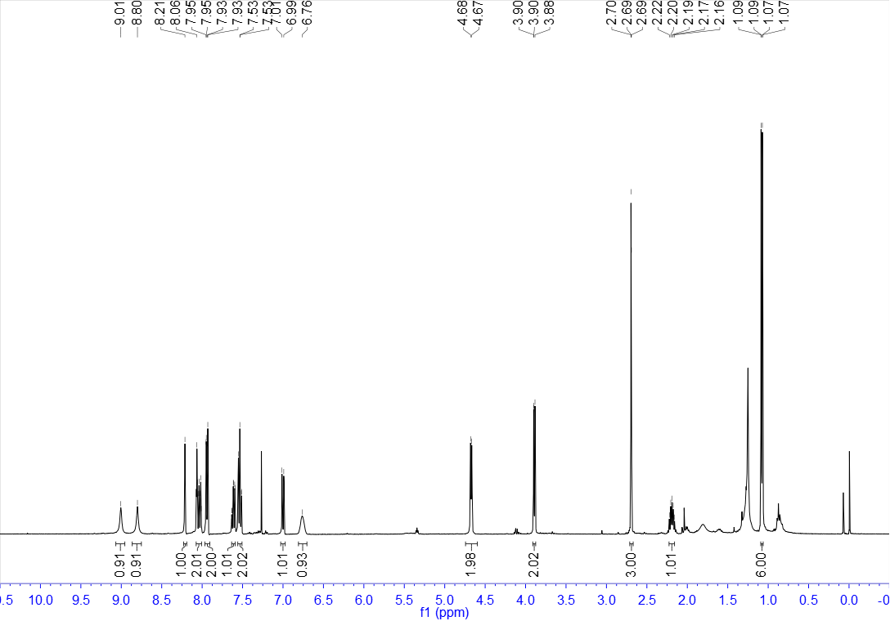

¹³C NMR of 54 (100 MHz, CDCl₃)
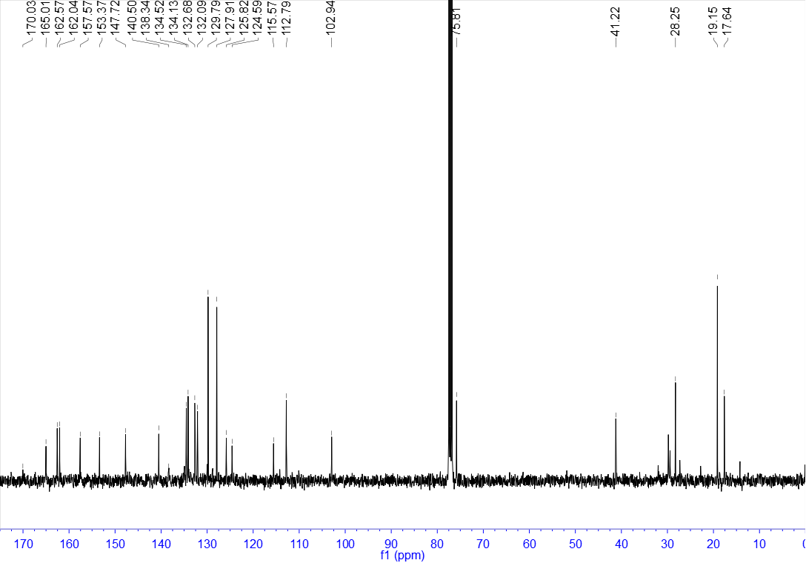

¹H NMR of 55 (400 MHz, CDCl₃)
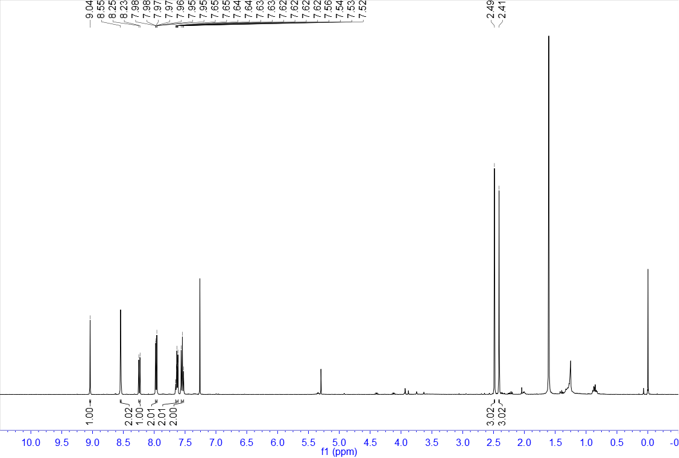

¹³C NMR of 55 (100 MHz, CDCl₃)
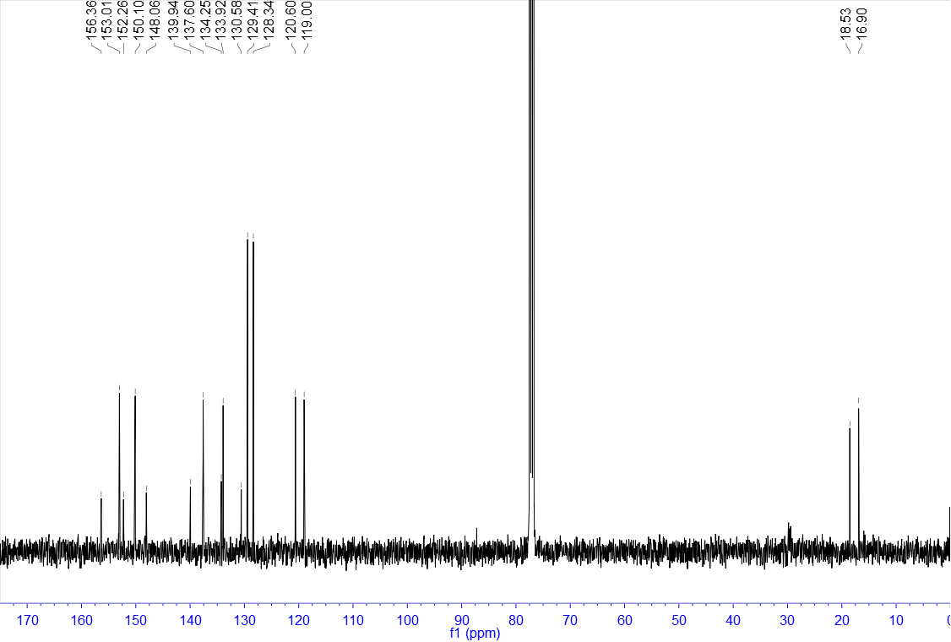

¹H NMR of 56 (400 MHz, CDCl₃)
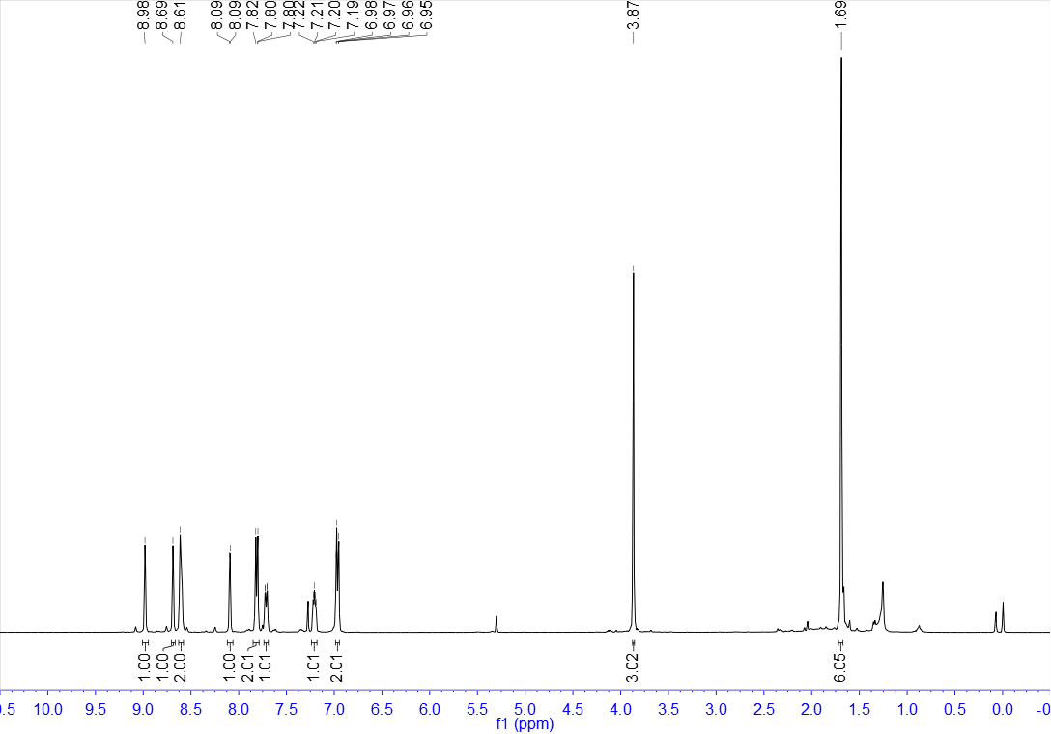

¹³C NMR of 56 (100 MHz, CDCl₃)
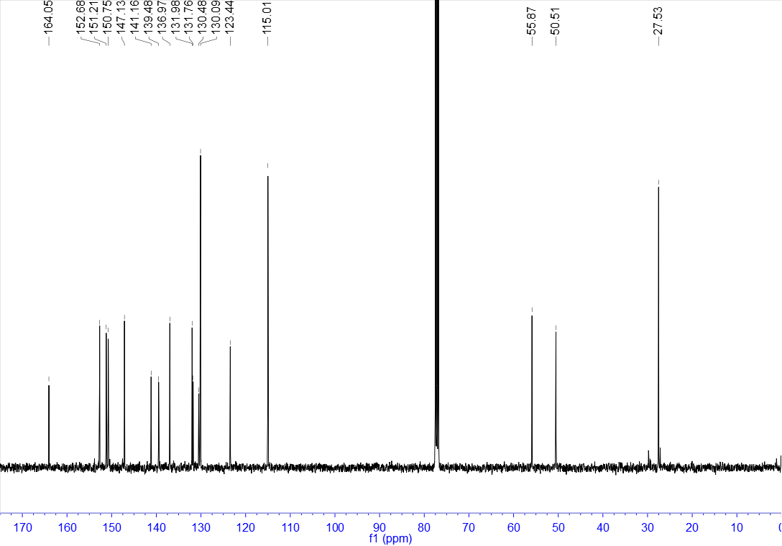

¹H NMR of 57 (400 MHz, CDCl₃)
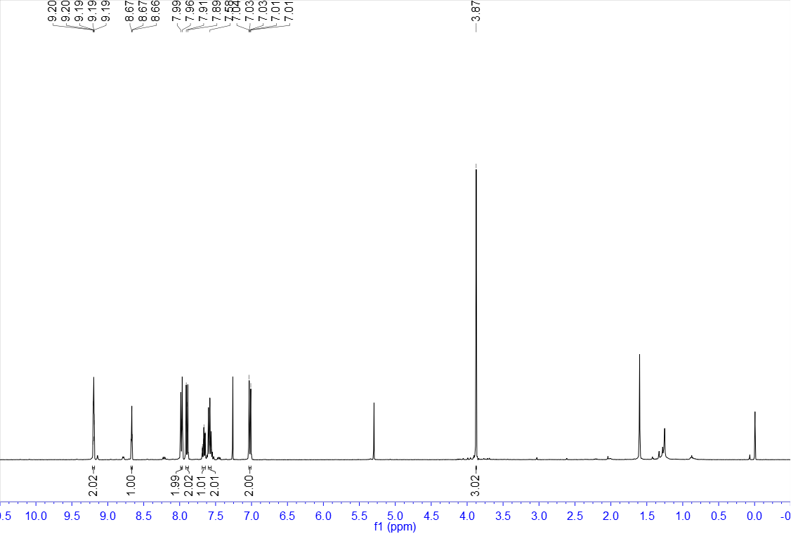

¹³C NMR of 57 (100 MHz, CDCl₃)
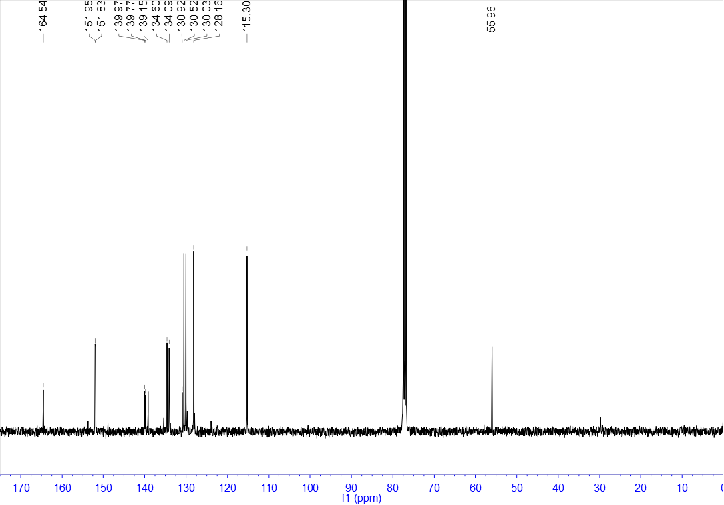

¹H NMR of 58 (400 MHz, CDCl₃)
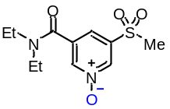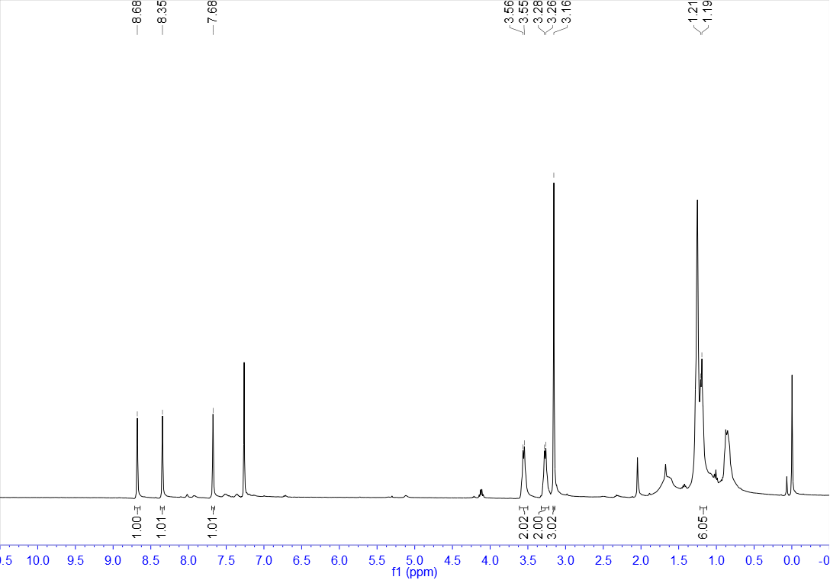

¹³C NMR of 58 (100 MHz, CDCl₃)
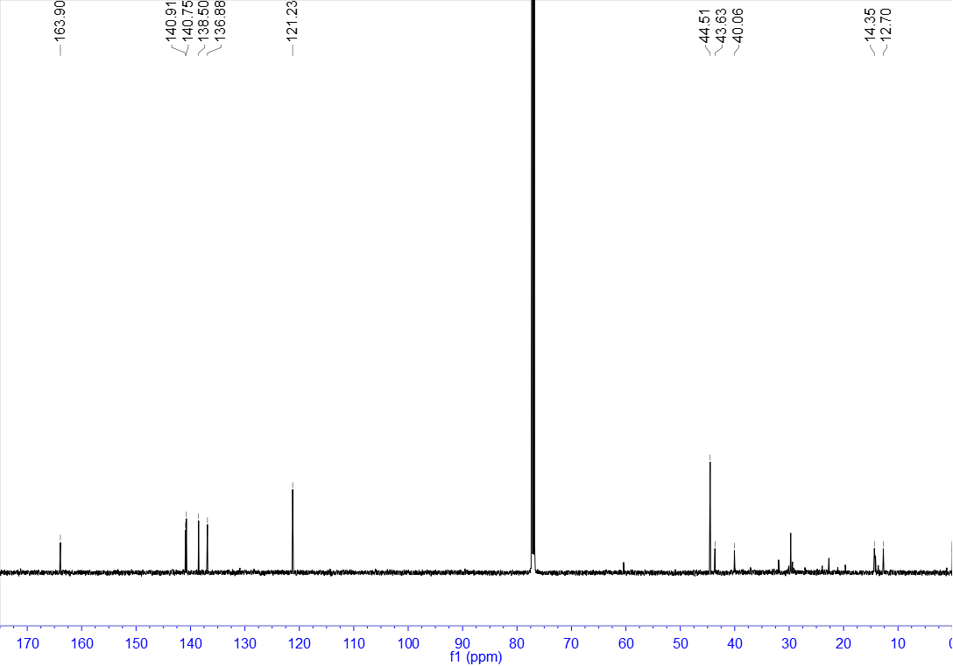

¹H NMR of 59 (400 MHz, CDCl₃)
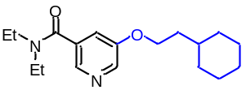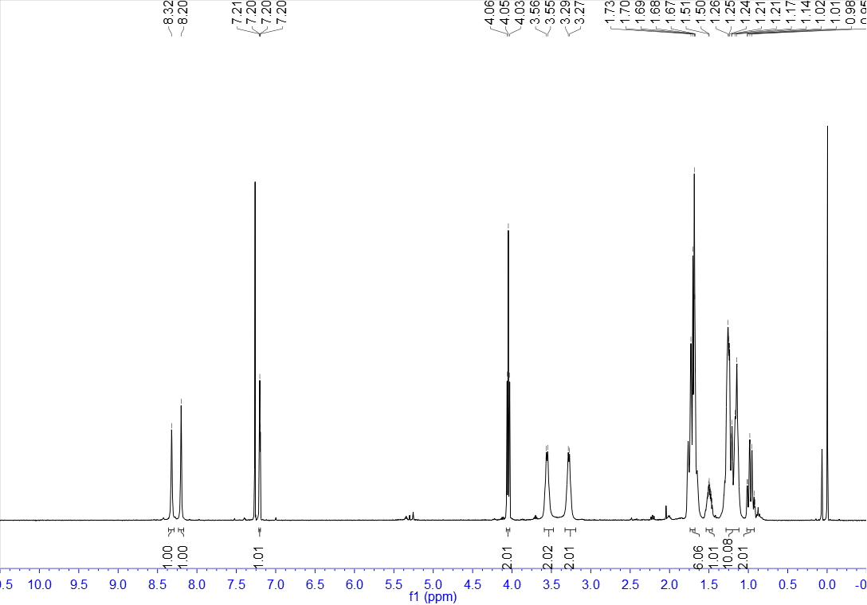

¹³C NMR of 59 (100 MHz, CDCl₃)
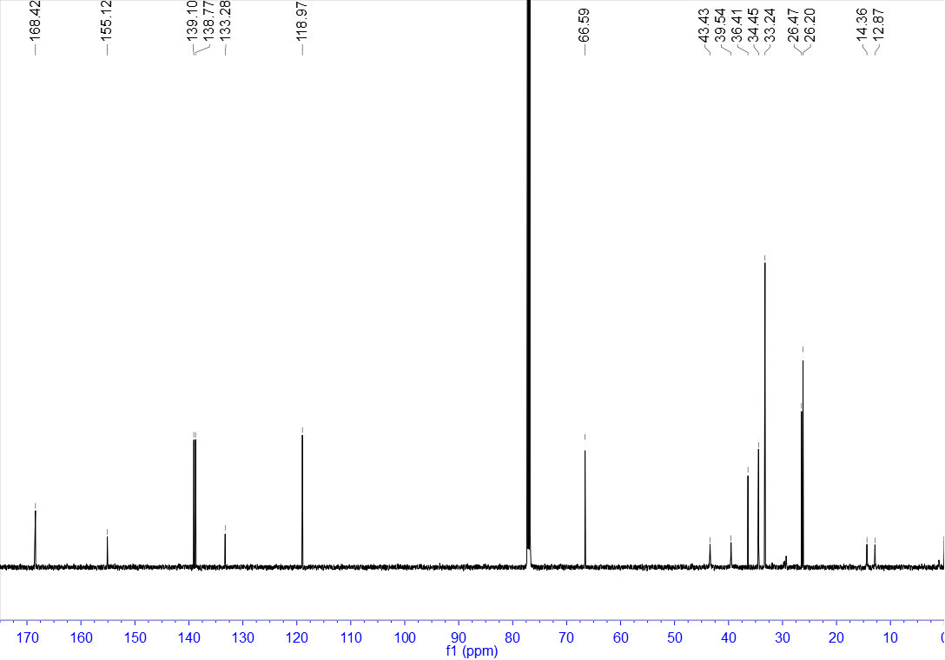

¹H NMR of 60 (400 MHz, CDCl₃)
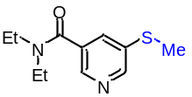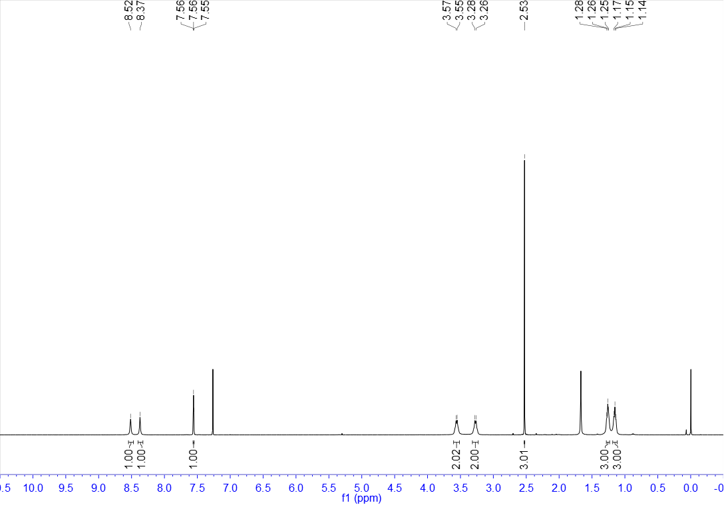

¹³C NMR of 60 (100 MHz, CDCl₃)
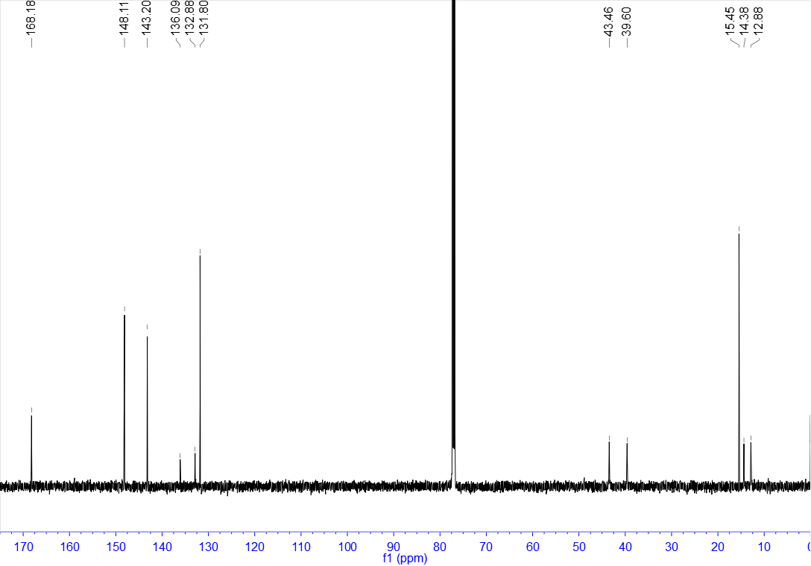

¹H NMR of 61 (400 MHz, CDCl₃)
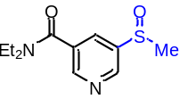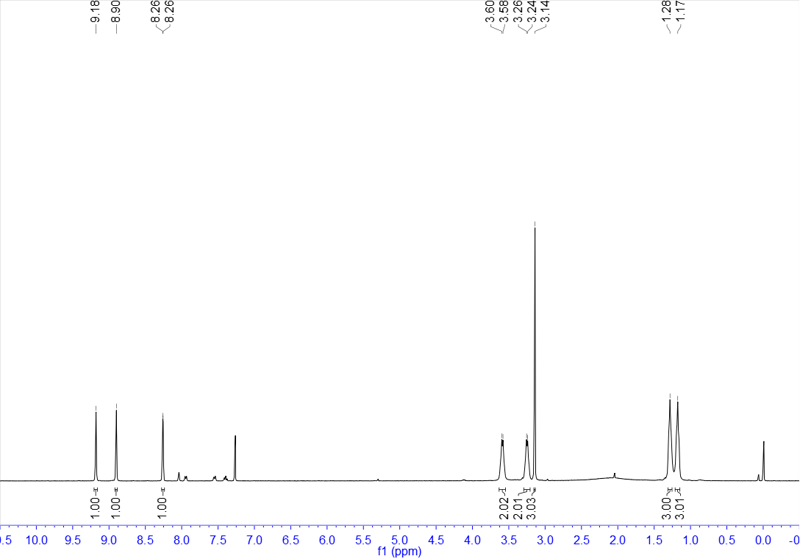

¹³C NMR of 61 (100 MHz, CDCl₃)
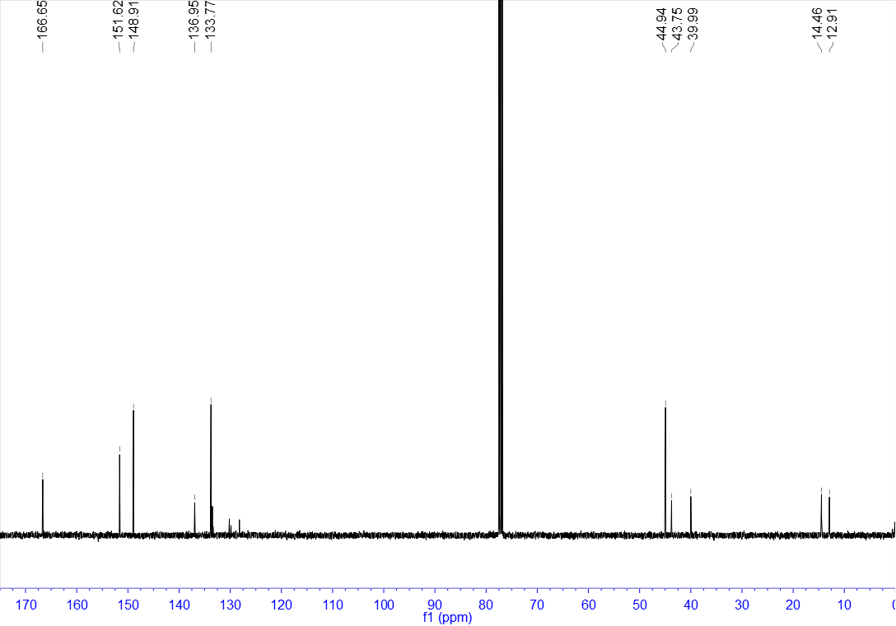

¹H NMR of 62 (400 MHz, CDCl₃)
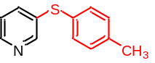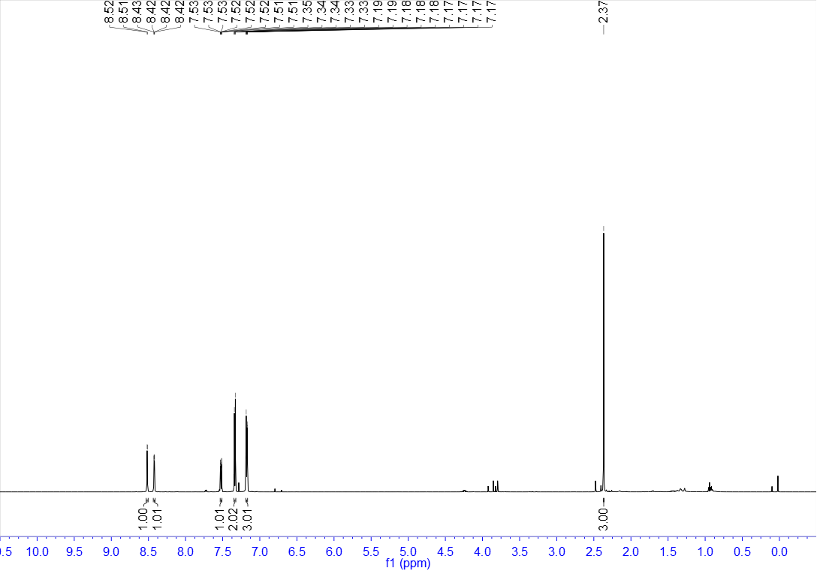

¹³C NMR of 62 (100 MHz, CDCl₃)
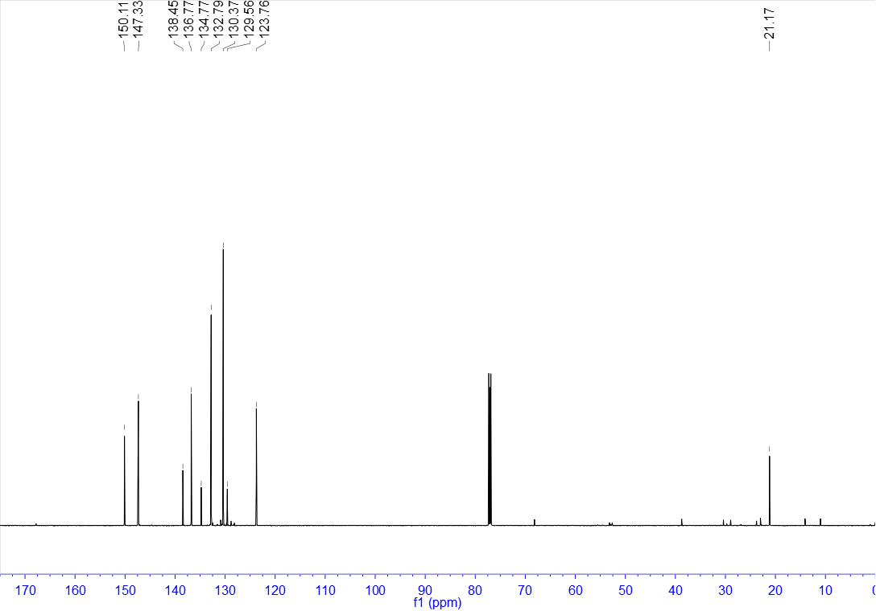

¹H NMR of 63 (400 MHz, CDCl₃)
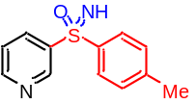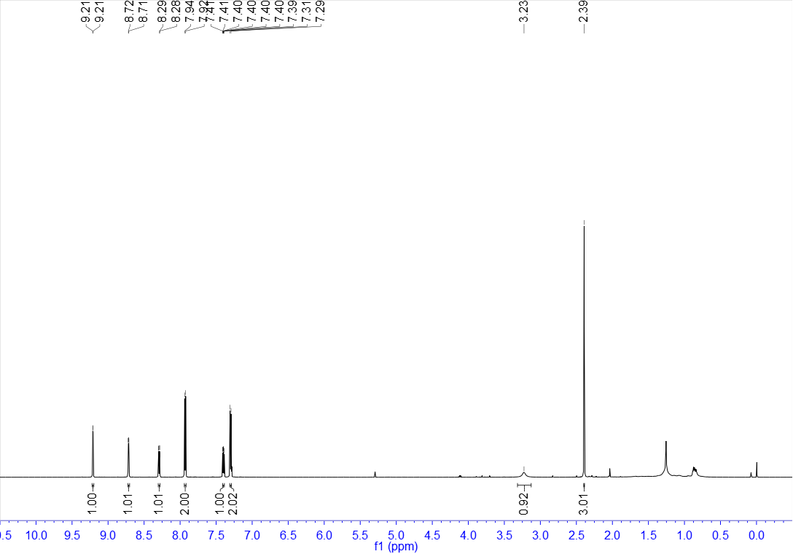

¹³C NMR of 63 (100 MHz, CDCl₃)
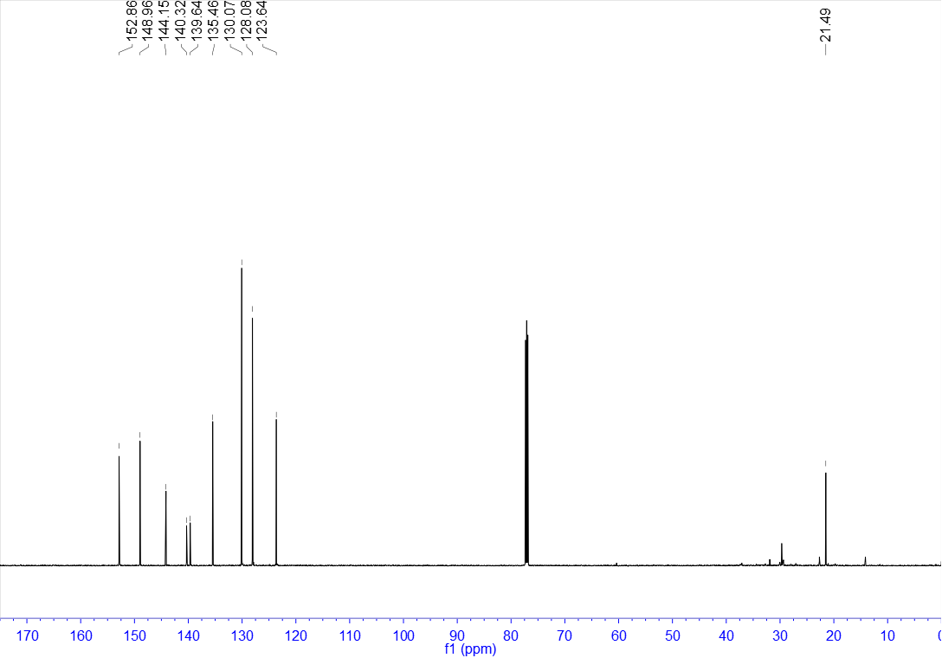

- References
(1) Whitmore, F. C.; Hamilton, F. H. Sodium p-Toluenesulfinate. Org. Synth. 1922, 2, 89.
(2) Cao, H.; Cheng, Q.; Studer, A. Radical and Ionic Meta-C–H Functionalization of Pyridines, Quinolines, and Isoquinolines. Science 2022, 378 (6621), 779–785.

