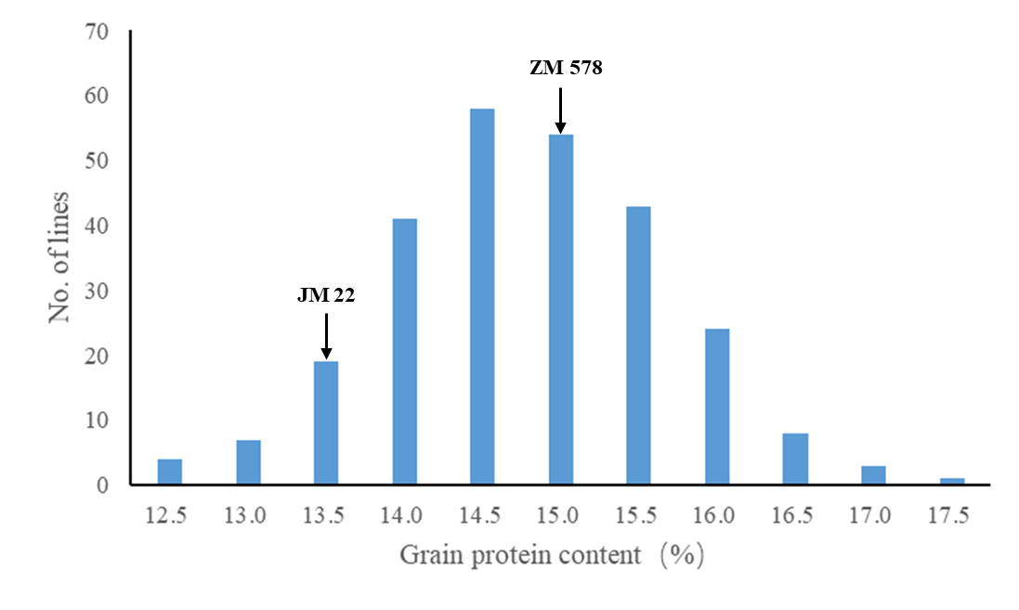
Fig. S1 Frequency distribution for the best linear unbiased estimate (BLUE) of grain protein content across four environments in the Zhongmai 578/Jimai 22 RIL population.

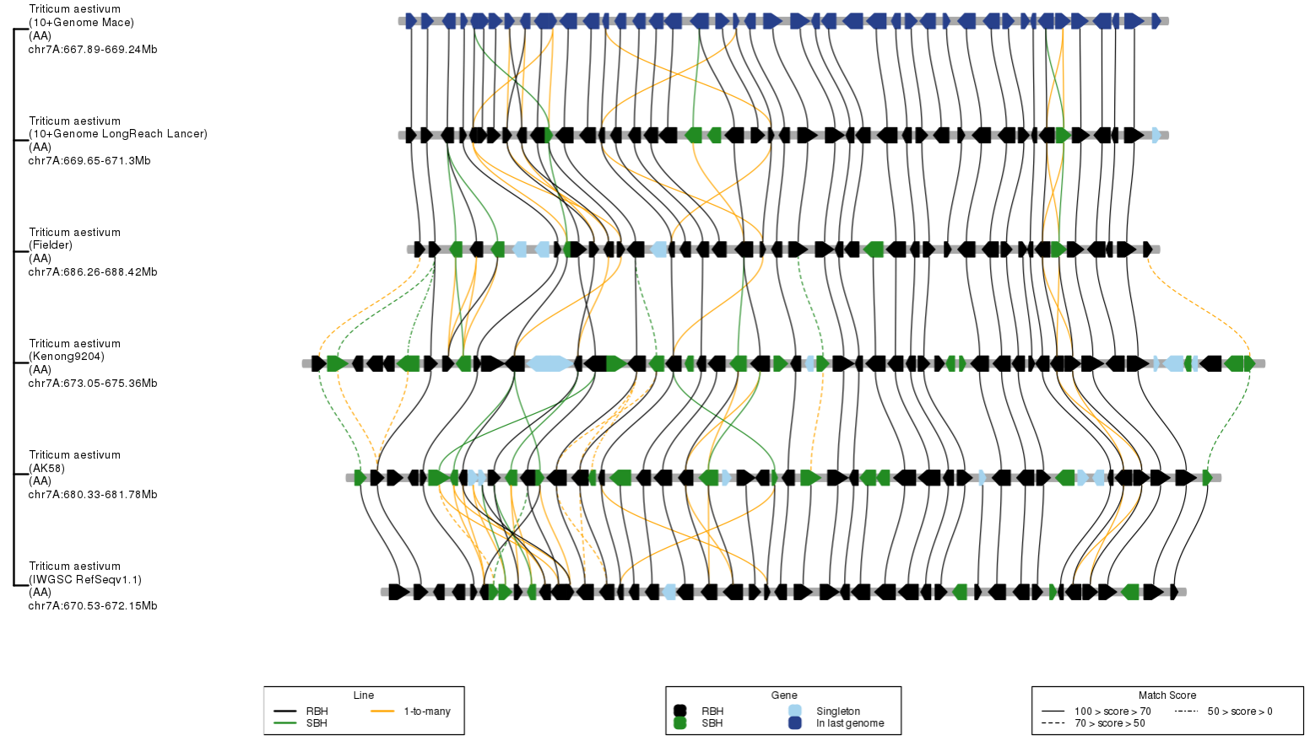
Fig. S2 Schematic diagrams of gene syntenies between markers KASP_7A1 and KASP_7A3 among Triticum aestivum (IWGSC RefSeq v1.1), Triticum aestivum (AK 58), Triticum aestivum (Kenong 9204), Triticum aestivum (Fielder), and Triticum aestivum (10+ Genome, Mace and LongReach Lancer). RBH, reciprocal best hit. SBH, single-side best hit.

