Table S1. Seed genotypes and their places of origin
S/N | Genotype | Place of Origin | S/N | Genotype | Place of Origin
1 | G37 | Afghanistan | 67 | G9 | Indonesia
2 | G15 | Australia | 68 | G38 | Korea, South
3 | G16 | Australia | 69 | G39 | Korea, South
4 | G46 | Australia | 70 | G40 | Korea, South
5 | G47 | Australia | 71 | G41 | Korea, South
6 | G48 | Australia | 72 | G42 | Korea, South
7 | G12 | China | 73 | G1 | Pakistan
8 | G32 | Colombia | 74 | G13 | Philippines
9 | G2 | India | 75 | G5 | Taiwan
10 | G3 | India | 76 | G6 | Taiwan
11 | G4 | India | 77 | G7 | Taiwan
12 | G14 | India | 78 | G8 | Taiwan
13 | G31 | India | 79 | G10 | Taiwan
14 | G33 | India | 80 | G11 | Taiwan
15 | G34 | India | 81 | G17 | Taiwan
16 | G35 | India | 82 | G18 | Taiwan
17 | G36 | India | 83 | G19 | Taiwan
18 | G45 | India | 84 | G20 | Taiwan
19 | G51 | India | 85 | G21 | Taiwan
20 | G52 | India | 86 | G43 | Taiwan
21 | G53 | India | 87 | G44 | Taiwan
22 | G54 | India | 88 | G101 | Taiwan
23 | G55 | India | 89 | G102 | Taiwan
24 | G56 | India | 90 | G103 | Taiwan
25 | G57 | India | 91 | G104 | Taiwan
26 | G58 | India | 92 | G105 | Taiwan
27 | G59 | India | 93 | G106 | Taiwan
28 | G60 | India | 94 | G107 | Taiwan
29 | G61 | India | 95 | G108 | Taiwan
30 | G62 | India | 96 | G109 | Taiwan
31 | G63 | India | 97 | G110 | Taiwan
32 | G64 | India | 98 | G111 | Taiwan
33 | G65 | India | 99 | G112 | Taiwan
34 | G66 | India | 100 | G113 | Taiwan
35 | G67 | India | 101 | G114 | Taiwan
36 | G68 | India | 102 | G115 | Taiwan
37 | G69 | India | 103 | G116 | Taiwan
38 | G70 | India | 104 | G117 | Taiwan
39 | G71 | India | 105 | G118 | Taiwan
40 | G72 | India | 106 | G119 | Taiwan
41 | G73 | India | 107 | 131 | India
42 | G74 | India | 108 | 132 | India
43 | G75 | India | 109 | G120 | Taiwan
44 | G76 | India | 110 | G121 | Taiwan
45 | G77 | India | 111 | G122 | Taiwan
46 | G78 | India | 112 | G123 | Taiwan
47 | G79 | India | 113 | G124 | Taiwan
48 | G80 | India | 114 | G125 | Taiwan
49 | G81 | India | 115 | G126 | Taiwan
50 | G82 | India | 116 | G127 | Taiwan
51 | G83 | India | 117 | G128 | Taiwan
52 | G84 | India | 118 | G99 | Tanzania
53 | G85 | India | 119 | G100 | Tanzania
54 | G86 | India | 120 | G129 | Tanzania
55 | G87 | India | 121 | G130 | Tanzania
56 | G88 | India | 122 | G22 | Unknown
57 | G89 | India | 123 | G23 | Unknown
58 | G90 | India | 124 | G24 | Unknown
59 | G91 | India | 125 | G25 | Unknown
60 | G92 | India | 126 | G26 | Unknown
61 | G93 | India | 127 | G27 | Unknown
62 | G94 | India | 128 | G28 | Unknown
63 | G95 | India | 129 | G29 | Unknown
64 | G96 | India | 130 | G30 | Unknown
65 | G97 | India | 131 | G49 | Vietnam
66 | G98 | India | 132 | G50 | Vietnam
 |  |  | 1 | Mum-2 | India
 |  |  | 2 | Sweta | India
 |  |  | 3 | Rice bean (R200) | India

Table S2. Mung bean descriptor sheet
SN | Traits | Crop stage for recording data | Score | Classified as
1 | Hypocotyl colour | At the time of germination | 1 | Green
1 | Hypocotyl colour | At the time of germination | 2 | Greenish purple
1 | Hypocotyl colour | At the time of germination | 3 | Purple
1 | Hypocotyl colour | At the time of germination | 4 | mixed
1 | Hypocotyl colour | At the time of germination | 5 | Others (specify)
2 | Seedling Vigour | At the time of germination | 1 | Poor
2 | Seedling Vigour | At the time of germination | 5 | Medium
2 | Seedling Vigour | At the time of germination | 9 | Vigorous
1 | Pod colour at immature stage | At the time of pod  filling | 1 | Light green
1 | Pod colour at immature stage | At the time of pod  filling | 2 | Deep green
1 | Pod colour at immature stage | At the time of pod  filling | 3 | Other (specify)
2 | Colour of Ventral Suture of immature pod | At the time of pod  filling | 1 | Dark green
2 | Colour of Ventral Suture of immature pod | At the time of pod  filling | 2 | Deep green
2 | Colour of Ventral Suture of immature pod | At the time of pod  filling | 3 | Purple
2 | Colour of Ventral Suture of immature pod | At the time of pod  filling | 4 | Other (specify)
3 | Pod colour at mature stage | At the time of pod  filling | 1 | Straw
3 | Pod colour at mature stage | At the time of pod  filling | 2 | Tan
3 | Pod colour at mature stage | At the time of pod  filling | 3 | Brown
3 | Pod colour at mature stage | At the time of pod  filling | 4 | Black
3 | Pod colour at mature stage | At the time of pod  filling | 5 | Other (specify)
4 | Shape of the ripe pod | At the time of pod  filling | 1 | Semi-flat
4 | Shape of the ripe pod | At the time of pod  filling | 2 | Round
5 | Attachment of mature pod peduncle | At the time of pod  filling | 1 | Pendant
5 | Attachment of mature pod peduncle | At the time of pod  filling | 2 | Intermediate
5 | Attachment of mature pod peduncle | At the time of pod  filling | 3 | Angle of around 90°
6 | Pod pubescence | At the time of pod  filling | 1 | Glabrous
6 | Pod pubescence | At the time of pod  filling | 5 | Intermediate
6 | Pod pubescence | At the time of pod  filling | 9 | Heavily Pubescent
7 | Constriction of pod between seeds | At the time of pod  filling | 0 | Absent
7 | Constriction of pod between seeds | At the time of pod  filling | + | Present
1 | Length of peduncle | At the time of  flowering | 1 | Short (<14cm)
1 | Length of peduncle | At the time of  flowering | 2 | Medium (14-18cm)
1 | Length of peduncle | At the time of  flowering | 3 | Long (>18 cm)
2 | Raceme position | At the time of  flowering | 1 | Mostly above canopy
2 | Raceme position | At the time of  flowering | 2 | Intermediate
2 | Raceme position | At the time of  flowering | 3 | No pods visible above the canopy
3 | Calyx colour | At the time of  flowering | 1 | Green
3 | Calyx colour | At the time of  flowering | 2 | Greenish purple
3 | Calyx colour | At the time of  flowering | 3 | Other specify
4 | Corolla colour (Wings and standard) | At the time of  flowering | 1 | Light yellow
4 | Corolla colour (Wings and standard) | At the time of  flowering | 2 | Deep yellow
4 | Corolla colour (Wings and standard) | At the time of  flowering | 3 | Greenish yellow
4 | Corolla colour (Wings and standard) | At the time of  flowering | 4 | Other (specify)
5 | Leafiness | At the time of  flowering | 1 | Sparse (main stem easily visible)
5 | Leafiness | At the time of  flowering | 5 | Medium
5 | Leafiness | At the time of  flowering | 9 | Abundant (very leafy)
6 | Flowering period | At the time of  flowering | 1 | Asynchronous
6 | Flowering period | At the time of  flowering | 2 | Intermediate
6 | Flowering period | At the time of  flowering | 3 | Synchronous
1 | Terminal leaf let shape | At the time of  flowering | 1 | Deltoid
1 | Terminal leaf let shape | At the time of  flowering | 2 | Ovate
1 | Terminal leaf let shape | At the time of  flowering | 3 | Acute
1 | Terminal leaf let shape | At the time of  flowering | 4 | Ovate-lanceolate
1 | Terminal leaf let shape | At the time of  flowering | 5 | Cuneate
1 | Terminal leaf let shape | At the time of  flowering | 6 | Lobed
1 | Terminal leaf let shape | At the time of  flowering |  | Other (specify)
2 | Terminal leaflet length |  | 1 | Small (<10 cm)
2 | Terminal leaflet length |  | 2 | Medium (10-13cm)
2 | Terminal leaflet length |  | 3 | Large (>13cm)
3 | Leaf colour | At the time of  flowering | 1 | Light green
3 | Leaf colour | At the time of  flowering | 2 | Green
3 | Leaf colour | At the time of  flowering | 3 | Dark green
3 | Leaf colour | At the time of  flowering | 4 | Other (specify)
4 | Petiole colour | At the time of  flowering | 1 | Green
4 | Petiole colour | At the time of  flowering | 2 | Greenish purple
4 | Petiole colour | At the time of  flowering | 3 | Purple
4 | Petiole colour | At the time of  flowering | 4 | Dark purple
5 | Petiole length | At the time of  flowering | 1 | Short (<12 cm)
5 | Petiole length | At the time of  flowering | 2 | Medium (12-18 cm)
5 | Petiole length | At the time of  flowering | 3 | Long (> 18 cm)
6 | Leaf senescence | At the time of  flowering | 1 | Not visibly senescent
6 | Leaf senescence | At the time of  flowering | 5 | Intermediate
6 | Leaf senescence | At the time of  flowering | 9 | Conspicuously concurrent
7 | Growth habit | At the time of  flowering | 1 | Erect
7 | Growth habit | At the time of  flowering | 2 | Semi-erect
7 | Growth habit | At the time of  flowering | 3 | Spreading
8 | Leaf pubescence | At the time of  flowering | 1 | Glabrous
8 | Leaf pubescence | At the time of  flowering | 2 | Pubescent
1 | Lodging | At the time of harvesting | 1 | None
1 | Lodging | At the time of harvesting | 5 | Intermediate
1 | Lodging | At the time of harvesting | 9 | Heavy
2 | Shattering in the field | At the time of harvesting | 1 | No
2 | Shattering in the field | At the time of harvesting | 2 | Yes
 | Growth pattern | At the time of harvesting | 1 | Indeterminate
 | Growth pattern | At the time of harvesting | 2 | Determinate
1 | Seed colour | At the time of harvesting | 1 | Yellow
1 | Seed colour | At the time of harvesting | 2 | Greenish yellow
1 | Seed colour | At the time of harvesting | 3 | Light green
1 | Seed colour | At the time of harvesting | 4 | Dark green
1 | Seed colour | At the time of harvesting | 5 | Brown
1 | Seed colour | At the time of harvesting | 6 | Mixed
1 | Seed colour | At the time of harvesting | 7 | Other (Specify)
2 | Mottling on seed | At the time of harvesting | 1 | Absent
2 | Mottling on seed | At the time of harvesting | 2 | Light
2 | Mottling on seed | At the time of harvesting | 3 | Medium
2 | Mottling on seed | At the time of harvesting | 4 | Heavy
3 | Lustre on seed surface | At the time of harvesting | 1 | Dull
3 | Lustre on seed surface | At the time of harvesting | 2 | Shiny
4 | Seed shape | At the time of harvesting | 1 | Round
4 | Seed shape | At the time of harvesting | 2 | Oval
4 | Seed shape | At the time of harvesting | 3 | Drum shaped
4 | Seed shape | At the time of harvesting | 4 | Other (Specify)
5 | Hilum | At the time of harvesting | 1 | Concave
5 | Hilum | At the time of harvesting | 2 | Non concave

Disease scale | Percentage leaf area coverage | Description | Reaction
0 | 0 | Plant free from infection | Highly resistant (HR)
1 | 1.0-10.0 | Plants showing up 10% infection on leaves, stem free from infection | Resistant (R)
2 | 10.1-25.0 | Slight infection with a thin coating of powdery mildew growth on leaves covering 10.1-25% leaf area slight infection on stem and pods usually free | Moderately resistant (MR)
3 | 25.1-50.0 | Dense powdery coating covering 25.1-50% leaf area, slight infection on pods, moderate infection on pods | Moderately susceptible (MS)
4 | 50.1-75.0 | Dense powdery coating covering 50.1-75% leaf area, pods moderately, stem heavily infected. Infected area turns greying | Susceptible (S)
5 | Above 75.0 | Severe infection with dense powdery growth covering 75% of whole plant including pods, plant resulting in premature defoliation and dying | Highly susceptible (HS)
Table S3. Powdery mildew scale of 0-5 in mung bean
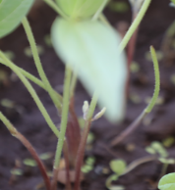  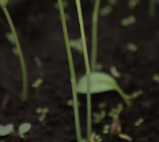  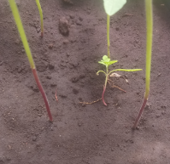  a  b  Hypocotyl color: a) green purple; b) green; c) purple  c | 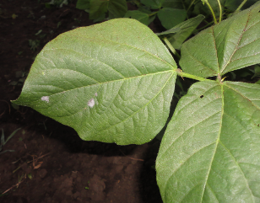  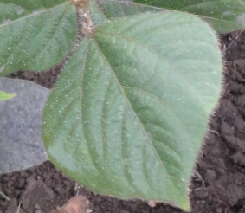  b  a  Terminal leaflet shape: a) Ovate; b) Cuneate |  | 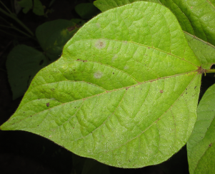  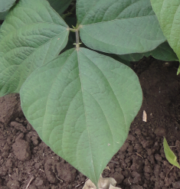  b  a  Leaf color: a) light green; b) green
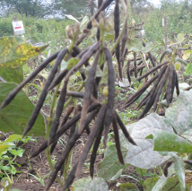  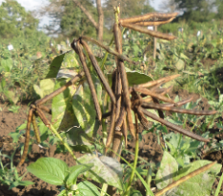  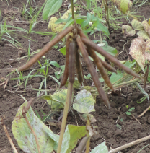  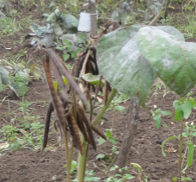  d  a  b  c  Pod color at mature stage: a) tan; b) brown; c) straw; d) black |  | 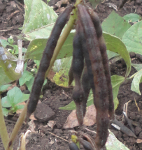  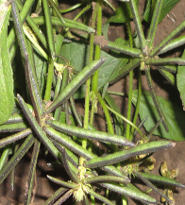  Pod constriction: a) present; b) absent  a  b |  | 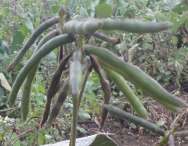  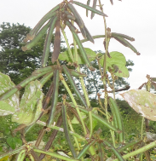  Shape of the ripe pods: a) semi flat; b) round  b  a
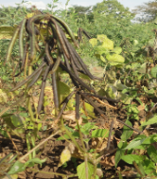  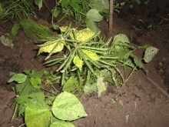  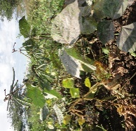  a  c  b  Pod attachment: a) angle around 90°; b) intermediate; c) pendant | 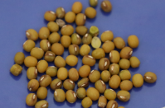  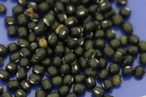  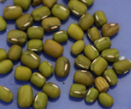  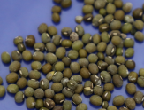  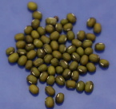  Seed color: a) Yellow; b) Greenish yellow; c) Dark green; d) Light green; e) Mixed  c  d  e  b  a |  |  |  | 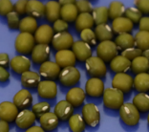  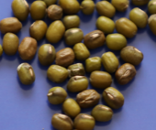  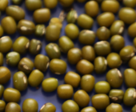  Seed shape: a) Drum shaped; b) Round; c) Oval  b  c  a
Plate S1. Morphological variations observed in different traits of mung bean

