Supplementary Information
Discovery of Conformationally Constrained Dihydro Benzo-Indole Derivatives as Pan-Metallo-β-Lactamase Inhibitors to tackle Multidrug-Resistant Bacterial Infection
Pulkit Dhiman^{1,2}, Satyajeet Das³, Vikas Pathania^{2,4}, Suraj Rawat³, Hemraj S. Nandanwar^{2,4}*, Krishan G. Thakur^{2,3}*, Vinod D. Chaudhari^{1,2}*
¹Division of Medicinal Chemistry, CSIR-Institute of Microbial Technology, Chandigarh, India
²Academy of Scientific and Innovative Research (AcSIR), Ghaziabad, India
³Structural Biology Lab, CSIR- Institute of Microbial Technology, Chandigarh, India
⁴Clinical Microbiology & Antimicrobial Research Laboratory, CSIR-Institute of Microbial Technology, Chandigarh, India
*Corresponding author. Email: hemraj@imtech.res.in, krishang@imtech.res.in, vinod.chaudhari@imtech.res.in

Table of contents
1. Supplementary Figures .........................................................................................................3
2. Supplementary Tables...........................................................................................................7
3. Supplementary Methods – Experimental Section.................................................................11
4. General Procedures for the Synthesis and Characterization of dBIs and Intermediates.......16
5. NMR Spectra.........................................................................................................................30
6. HRMS Data...........................................................................................................................78
7. HPLC Data.............................................................................................................................94

Figure S1. SDS-PAGE gels of purified proteins and MS profile. A) SDS-PAGE gel of purified NDM-1; B) SDS-PAGE gel of purified IMP-1; C) SDS-PAGE gel of purified VIM-I. Abbreviations used: M (Protein standard molecular weight marker), P (Pellet), F (Flow-through fraction), W (Wash fraction), 30, 300 & 500 (30, 300 & 500 mM imidazole elution fractions respectively).
Figure S2 | Protein-ligand interaction diagrams of compounds 17m, 17s, 17u, 8 and 17ad. 2D protein-ligand interaction diagrams were generated using the Ligand Interaction script in Maestro. The protein-ligand interactions for the best-docked poses for VIM-1, IMP-1, and NDM-1 with 17m, 17s, 17u, 17ad, and reference compound 8 are shown. The carboxyl group in all the molecules shows binding interactions with both the Zn²⁺ ions in the active site of NDM-1 and IMP-1 (Binding mode 1). However, molecules adopt different binding poses in VIM-1 active site. Binding interaction of the carboxyl group of only 17u was observed with Zn²⁺ ion in the active site. The lowest docking score of -9.878 Kcal/mol was observed for 17u for NDM-1 followed by 17m, 17s, and 8 with docking scores of -9.557, -9.536 and -4.805 Kcal/mol, respectively. For IMP-1, the lowest docking score observed was -10.67 Kcal/mol for 17ad followed by 17s, 17m, 17u, and 8 with docking scores of -9.467, -8.685, -8.591, and -8.101 Kcal/mol respectively. 17s, 17m, 17u, and 8 interact with the binding site by forming covalent bonds with zinc, hydrogen bonds with Asn167, and several non-bonding interactions. For VIM-1, the lowest docking score observed was -5.298 Kcal/mol for 8 followed by 17ad, 17u, 17s, and 17m with docking scores of -4.939, -4.458, -4.452, and -3.744 Kcal/mol respectively. 8 interacts with the binding site by forming a covalent bond with zinc and hydrogen bond with Asn210. While 17ad and 17u interacts covalently with zinc, 17s interacts with Ser205, Thr206, and Ser207 by forming H-bonds while 17m interacts with Glu202, Ser205, Thr206 and Ser207 by forming H-bonds. Moreover, several top best compounds in the docking results also showed potent inhibitory activity. The compounds are stabilized by binding to two Zn²⁺ metal ions, also form hydrogen bonds with Asp223, and several non-bonded interactions.
Figure S3. Cell cytotoxicity

Table S1. Structures and inhibitory activities of dBIs derivatives against three MBLs
Compound | Structure | IC₅₀ (μM) |  |  | ClogP
Compound | Structure | NDM-1 | IMP-1 | VIM-1 | ClogP
17ae | 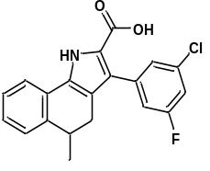 | 0.290 ± 0.034 | 22 ± 9 | 7.7 ± 2 | 5.79
17af | 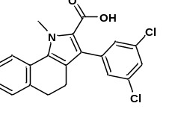 | 10 | 17 | 17.9 ± 5 | 6.20
16m | 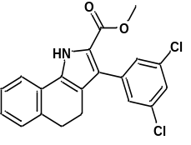 | 5.3 | 18 ± 2 | 15.3 ± 5 | 5.79

Table S2. Synergistic effect of compounds on MIC of imipenem and meropenem against strain of Klebsiella pneumoniae ATCC BAA-2146
Comp | IntrinsicMIC  (μg/mL) | Fold Modulation against  meropenem |  |  |  | Intrinsic MIC (μg/mL) | Fold Modulation against  imipenem
Comp | IntrinsicMIC  (μg/mL) | 32  µg/mL | 16  µg/mL | 8  µg/mL | 4  µg/mL | Intrinsic MIC (μg/mL) | 32  µg/mL | 16  µg/mL | 8  µg/mL | 4  µg/mL
17b | >128 | 4 | ND | ND | ND | >128 | 8 | 8 | 4 | 4
17c | >128 | 8 | 4 | 4 | 4 | >128 | 8 | 8 | 4 | 4
17d | >128 | 8 | 4 | 4 | 4 | >128 | 8 | 8 | 4 | 4
17e | >128 | 4 | 4 | 4 | 4 | >128 | 8 | 4 | 4 | 4
17f | >128 | 8 | 4 | 4 | 2 | >128 | 8 | 8 | 4 | 2
17g | >128 | 4 | 4 | 4 | 4 | >128 | 8 | 4 | 4 | 4
17h | >128 | 4 | 4 | 4 | 2 | >128 | 8 | 4 | 4 | 2
17i | >64 | 4 | 4 | 4 | 2 | >64 | 4 | 2 | 2 | 2
17j | >64 | 4 | 4 | 4 | 4 | >64 | 4 | 4 | 4 | 2
17k | >128 | 4 | 4 | 2 | 2 | >128 | 4 | 4 | 2 | 2
17l | >128 | 16 | 8 | 4 | 4 | >128 | 16 | 8 | 4 | 4
17m | >128 | 8 | 8 | 8 | 4 | >128 | 16 | 16 | 8 | 8
17n | >128 | 4 | 4 | 4 | 2 | >128 | 8 | 4 | 4 | 2
17o | >64 | 4 | 4 | 4 | 4 | >64 | 4 | 4 | 2 | 2
17p | >64 | 4 | 4 | 4 | 4 | >128 | 8 | 8 | 4 | 4
17q | >128 | 8 | 8 | 4 | 4 | >128 | 8 | 8 | 8 | 4
17r | >128 | 8 | 4 | 4 | 4 | >128 | 8 | 8 | 4 | 4
17s | >128 | 4 | 4 | 2 | 2 | >128 | 8 | 4 | 2 | 2
17t | >128 | 8 | 8 | 4 | 4 | >128 | 16 | 8 | 8 | 4
17u | >128 | 8 | 4 | 4 | 2 | >128 | 16 | 8 | 4 | 4
17v | >128 | 8 | 8 | 4 | 4 | >128 | 16 | 8 | 8 | 4
17w | >128 | 8 | 8 | 4 | 2 | >128 | 2 | ND | ND | ND
17x | >128 | 4 | ND | ND | ND | >128 | 8 | 8 | 4 | 4
17y | >128 | 16 | 8 | 8 | 4 | >128 | 16 | 8 | 4 | 4
17z | >128 | 4 | 4 | 2 | 2 | >128 | 2 | ND | ND | ND
17aa | >128 | 8 | 8 | 8 | 4 | >128 | 16 | 8 | 8 | 4
17ab | >128 | 8 | 4 | 4 | 4 | >128 | 8 | 8 | 4 | 4
17ac | >128 | 4 | 4 | 2 | ND | >128 | 8 | 4 | 4 | 4
17ad | >128 | 8 | 4 | 4 | 4 | >128 | 8 | 8 | 4 | 4
17ae | >128 | 8 | ND | ND | ND | >128 | 8 | 8 | 4 | 4

Table S3. List of top hits with their respective docking scores

S. No. | Protein (PDB ID) | Ligand | Docking Score  (Kcal/mol)
1 | NDM-1 (6LJ4) | 17u | -9.878
2 | NDM-1 (6LJ4) | 17m | -9.557
3 | NDM-1 (6LJ4) | 17s | -9.536
4 | NDM-1 (6LJ4) | 8 | -4.805

S. No. | Protein (PDB ID) | Ligand | Docking Score  (Kcal/mol)
1 | IMP-1 (1JJT) | 17ad | -10.67
2 | IMP-1 (1JJT) | 17s | -9.467
3 | IMP-1 (1JJT) | 17m | -8.685
4 | IMP-1 (1JJT) | 17u | -8.591
5 | IMP-1 (1JJT) | 8 | -8.101

S. No. | Protein (PDB ID) | Ligand | Docking Score  (Kcal/mol)
1 | VIM-1 (7AYJ) | 8 | -5.298
2 | VIM-1 (7AYJ) | 17ad | -4.939
3 | VIM-1 (7AYJ) | 17u | -4.458
4 | VIM-1 (7AYJ) | 17s | -4.452
5 | VIM-1 (7AYJ) | 17m | -3.744

Table S4. Synergistic effect of compounds on MIC of imipenem and meropenem against carbapenem resistant strains.

Table S5. Synergistic effect of compounds on MIC of imipenem and meropenem against MBL-producing clinical strains.
Isolate code | Organism | NDM-1 | MIC of IMP (μg/mL) | MIC of IMP with 17u at indicated concentration
 |  |  |  | 4 μg/mL | 8 μg/mL | 16 μg/mL | 32 μg/mL
541588 | E. coli | 1 | 8 | 1 | 1 | 1 | ≤ 0.5
538961 | K. pneumoniae | 1 | 64 | 32 | 2 | 2 | ≤ 0.5
552439 | K. pneumoniae | 1 | 32 | 4 | 2 | 1 | ≤ 0.5
565988 | E. coli | 1 | 8 | 1 | ≤ 0.5 | ≤ 0.5 | ≤ 0.5
567975 | E. coli | 1 | 16 | 8 | 1 | 1 | ≤ 0.5
571307 | E. coli | 1 | 32 | 4 | 4 | 2 | 2
565345 | K. pneumoniae | 1 | 32 | 32 | 16 | 8 | 8
571278 | K. pneumoniae | 1 | 16 | 8 | 8 | 4 | 2

Isolate code | Organism | NDM-1 | MIC of MEM (μg/mL) | MIC of MEM 17u at indicated concentration
 |  |  |  | 4 μg/mL | 8 μg/mL | 16 μg/mL | 32 μg/mL
541588 | E. coli | 1 | 64 | 8 | 1 | 1 | ≤ 0.5
538961 | K. pneumoniae | 1 | >64 | 16 | 8 | 4 | 2
552439 | K. pneumoniae | 1 | >64 | 16 | 8 | 4 | 4
565988 | E. coli | 1 | 64 | 1 | 1 | ≤ 0.5 | ≤ 0.5
567975 | E. coli | 1 | 64 | 2 | 2 | ≤ 0.5 | ≤ 0.5
571307 | E. coli | 1 | 64 | 4 | 2 | 1 | 1
565345 | K. pneumoniae | 1 | 64 | 64 | 32 | 32 | 16
571278 | K. pneumoniae | 1 | 64 | 32 | 32 | 16 | 16

Methods
Cloning and expression of IMP-1, VIM-1 and NDM-1
Constructs of IMP-1 and VIM-1 in pUC57 vector were designed and synthesized by GenScript. These constructs were digested with NcoI and XhoI and gel extracted products were further cloned between NcoI and XhoI sites of pET28c vector. Whereas, NDM gene was amplified from genomic DNA of K. pneumoniae. Further, N-term truncation was made by deleting first 49 residues and NDM-trnct version (NDM_{∆1-49N}) was developed and cloned in pET28c vector in between NcoI and XhoI sites. Ligated products were transformed in Top 10 cells (Novagen) and the clones were confirmed by DNA sequencing. Plasmids containing desired gene were transformed in BL21 (DE3) cells (Novagen) and plated on Nutrient Agar plate containing 30 µg/mL Kanamycin and were incubated at 37 °C. A single colony was used to inoculate primary culture of 10 mL Luria Bertani Broth (LB) containing 30 µg/mL Kanamycin, which was incubated at 37 °C for overnight. This inoculum was further used to inoculate secondary culture of 1 litre LB broth and grown at 37 °C. 0.3 mM IPTG was used to induce the culture once it obtained an OD600 of 0.6 and incubated at 16 °C for 16 hours in shaker incubator. The cells were harvested at 10,000 g for 10 min and the pellet was resuspended in lysis buffer (20 mM HEPES, pH-7.5; 300 mM NaCl and 10% Glycerol) along with 0.1% phenylmethylsulfonyl fluoride (PMSF) and protease inhibitor cocktail (Roche). Further it was purified using nickel affinity and size exclusion chromatography. Quality of protein was checked using SDS-PAGE and mass spectrophotometry. The purified protein was flash frozen and stored at -80 °C.
Inhibition assay. The Class B beta-lactamases activities were measured in the presence of the test inhibitors in a fluorescence assay against an in-house synthesized fluorescent cephalosporin substrate FC5. The enzymes (NDM-1, IMP-1) and the substrate were diluted in 20 mM HEPES, pH 7.4, supplemented with 300 mM NaCl and 10 μM ZnSO₄. In the assay, the final concentration of the enzyme was 150 pM, for NDM-1 and VIM-1, and 100pm for IMP-1, and the final concentration of FC5 was 1.5 µΜ for NDM-1 and VIM-1, and 3 µΜ for IMP-1. The test inhibitors/compounds were dissolved in dimethyl sulfoxide (DMSO) and diluted in the assay with assay buffer (20 mM HEPES, pH 7.4, supplemented with 5% DMSO, 300 mM NaCl, and 10 μM ZnSO₄), resulting in a final concentration range of 0 to 25 μM. The assays were performed in a 96-well microplate (flat bottom, black). The test inhibitors were incubated with the MBLs enzyme for 10 min at room temperature, followed by the addition of the substrate, and the fluorescence was recorded immediately (λ_{ex} 380 nm, λ_{em} 460 nm) on a microplate reader. Using the initial velocity data plotted against the inhibitor concentration, the half-maximal inhibitory concentrations were calculated by an IC₅₀ curve-fitting model in GraphPad Prism 9 software. Representative compounds of the present invention exhibit inhibition of Class B β-lactamases in this assay.
In-house developed small molecule library preparation. All in-house developed small molecules were then prepared for docking studies using the LigPrep module of Schrödinger Suite, 2019 to produce energy-minimized 3D molecular structures. The compound databases contain only 2D molecular structures in SDF format. LigPrep efficiently and accurately performed the 3D conversion of these compounds. Now, this 3D structure compound library will be used for docking studies.
Molecular docking. NDM-1, VIM-1 and IMP-1 crystal structures were downloaded from Protein Data Bank with PDB IDs: 6LJ4, 7AYJ and 1JJT respectively, and were used as receptors for the molecular docking studies. The Protein Preparation wizard of the Schrödinger software suite was used to prepare NDM-1, VIM-1 and IMP-1 structures suitable for docking using default settings. i.e., adding hydrogens, adding missing side chains using Prime, removing surrounding waters, adjusting charges, assigning disulfide bonds, and capping termini. The final restrained minimization of the system was carried out using OPLS3e force field to optimize the geometry and minimize the energy of the protein. 0.30 Å maximum root mean square deviation cut-off from the initial position for the heavy atoms was used during minimization. The grid for docking was generated around the selected active site residues using GLIDE. The Receptor Grid Generation module was used to generate the docking grid. The molecules were docked using Xtra-precision (XP) mode in the Glide module.
Structure-based in silico screening and scoring. In this study, NDM-1, VIM-1 and IMP-1 structures were downloaded from RCSB Protein Data Bank with PDB IDs: 6LJ4, 7AYJ and 1JJT respectively, and were used as receptors for docking. The protein preparation wizard module of the Schrödinger software suite was used to prepare the NDM-1, VIM-1 and IMP-1 structures. The prepared receptor structure was further analyzed by the SiteMap module of the Schrödinger software suite to identify potential binding sites. The predicted binding site with highest site map score (>0.9) was further selected for grid generation. The Receptor Grid Generation module was used to generate the docking grid. The molecules were docked using Xtra- precision (XP) mode in the Glide module.
Minimum inhibitory concentration (MIC). MIC values were identified through broth-microdilution in sterilized 96-well polystyrene flat-bottom microtitre plates (Cole-Parmer®) according to the guideline of the Clinical and Laboratory Standards Institute (CLSI) (CLSI; Methods for dilution antimicrobial susceptibility tests for bacteria that grow aerobically; Clinical Laboratory Standards Institute, M07-A09, 2012). This method involves the use of BBLTM Cation-adjusted Mueller-Hinton II Broth (Ca-MHB; BD) and the strain (Klebsiella pneumoniae ATCC BAA-2146) concentration was adjusted to 5 × 10⁵ CFU/mL. After 16-18 h of incubation at various concentrations of imipenem, meropenem (Alfa Aesar), or test compounds at 37 ºC, MIC was defined as the lowest concentration of antibiotic and test compound with no visible growth.
Checkerboard synergy assay. The fold modulation activity of test compounds, in combination with imipenem or meropenem, was checked against Klebsiella pneumoniae ATCC BAA-2146 strain by the broth-microdilution checkerboard synergy assay. The plates contained 5 × 10⁵ CFU/mL bacterial inocula and 2-fold serial dilutions of the antibiotics (128-2 μg/mL) as well as test compounds (32-4 μg/mL) in a total volume of 200 μL of Ca-MHB. Dimethyl sulfoxide (DMSO, ≤2.5%) was included as vehicle control. Following 16-18 h of incubation at 37 ºC, the MICs of antibiotics as well as drug combinations were spectrophotometrically measured.
Neutropenic murine thigh infection model. Female BALB/c mice (6-8 weeks old, 18-20 g, n = 6) were rendered neutropenic via two intraperitoneal cyclophosphamide injections four days and one day prior to infection. 0.05 mL of bacterial suspension (~5 × 105 CFU per mouse) was injected into the left thighs of each mouse. After two hours post-infection, mice were treated with three doses at eight-hour intervals with either DMSO, Imipenem + Cilastatin (10 + 84 mg/kg), IMT VC 120 (50 mg/kg), or a combination of antibiotic and inhibitory compound (10 + 20 mg/kg) by subcutaneous injection. At 26 h post-infection, mice were euthanized. The left thighs were aseptically removed, homogenized in 1 mL PBS, serially diluted, and plated on MHA to count bacterial numbers after incubating for 12 h at 37 °C.
The strain used to infect the mice in a murine thigh infection model, K. pneumoniae ATCC BAA 2146, which produces NDM-1 and displays high-level imipenem and meropenem resistance both in vitro and in vivo. The MIC of imipenem as well as meropenem alone against this ATCC strain is 64 μg/mL, and in the presence of 32 μg/mL of IMT VC 120, it reduces to 4 μg/mL. In the mouse thigh infection model, the combination of imipenem and IMT VC 120 (10 + 20 mg/kg) reduced ~2.2 log10 CFU/mL/thigh as compared to the vehicle control, whereas the Imipenem alone at the same concentration reduced ~1.15 log10 CFU/mL/thigh.
Kinetic solubility. Kinetic solubility was estimated by spiking compounds with a saturated concentration of up to 500 μM in potassium phosphate buffer (pH 7.4) using a 50 mM DMSO stock solution. The final DMSO concentration was limited to 1%. The spiked samples were then incubated at the physiological temperature of 37 °C for 24 hours in a thermo-mixer at 300 rpm. After the experiments, the samples were centrifuged, and the supernatants were analyzed using HPLC to estimate the solubility fraction. The compounds' solubility was determined against DMSO standards.
Metabolic stability. To assess metabolic stability, test compound stock solutions were spiked at a concentration of 1 μM into 1 mg/mL liver microsomes (both mouse and human). After a 5-minute pre-incubation at 37 °C, the reaction was initiated by adding NADPH in a 100 mM potassium phosphate buffer (pH 7.4). Reactions were stopped with 100 μL of acetonitrile at 0, 5, 15, 30, and 60 minutes. A positive control reaction was conducted similarly using Verapamil (1 μM) with a microsomal protein concentration of 1 mg/mL. A NADPH negative control was performed similarly, except NADPH was omitted, and samples were collected at 0 and 60 minutes. LC-MS/MS was used to analyze all samples. The percentage of parent compound remaining at 60 minutes was quantified.
% remaining of the test substance = ([C]t) / [C]0) x 100, where, [C]t - Concentration of compound at t min; [C]0 - Concentration of compound at 0 min
Plasma protein binding (PPB). Plasma protein binding was assessed using the equilibrium dialysis method in a Rapid Equilibrium Dialysis (RED) device (Thermo; Cat. No. 89809) containing a dialysis membrane with an 8k molecular weight cutoff. Plasma was spiked with test compounds or reference controls to achieve a final concentration of 10 μM in the reaction mixture, with a final DMSO concentration of 0.5%. For the protein binding study, 300 μL of the test item-spiked plasma was added to a plasma chamber, and 500 μL of buffer was added to the buffer chamber of the RED device. Dialysis was conducted in a thermo-mixer (100 rpm) at 37 °C for 5 hours. After dialysis, 100 μL aliquots were taken from both the plasma and buffer sides, diluted with an equal volume of the opposite matrix to neutralize matrix effects, and subjected to LC-MS/MS analysis. Warfarin at 10 μM was used as a reference standard under the same experimental conditions. Sample extraction followed the protein precipitation method. Cross-matrixed samples were terminated with ice-cold acetonitrile containing telmisartan (0.05 μM) as an internal standard. After vortexing and centrifugation, supernatants were separated and submitted for bioanalysis using a fit-for-purpose LC-MS/MS method for the quantification of test compounds and warfarin. The percentage of plasma bound/unbound fraction was calculated by the following equations:
% Unbound = 100 *FC / T_{C}
% Recovery = 100 * (FC + T_{C}) / T₀, where T_{C} = Total compound concentration as determined by the calculated concentration on the plasma side of the membrane; FC = Free compound concentration as determined by the calculated concentration on the buffer side of the membrane; T₀ = Total compound concentration as determined before dialysis
PAMPA permeability. The PAMPA method was employed to determine compound permeability in a high-throughput format. The study utilized the BD Gentest™ Pre-coated PAMPA Plate System (Cat. No. 353015), which consists of a 96-well filter plate pre-coated with lipids (permeation acceptor) and a matching 96-well receiver plate (permeation donor). Compounds in duplicate, stocked as 10 mM DMSO solutions, were diluted to 0.1 mM in PBS (pH 7.4) and added to the receiver plate (final DMSO concentration < 0.5%), while PBS (pH 7.4) was used in the filter plate wells. The filter plate was coupled with the receiver plate and incubated at room temperature without agitation for five hours. After incubation, the plates were separated, and 150 µL solutions from each well of both the filter plate and the donor plate were collected. These solutions were centrifuged at 4000 rpm for 20 minutes, and the supernatants were analyzed using LC-MS/MS for the quantification of test compounds.
Cytotoxicity assay. Mammalian cell cytotoxicity was determined using two different cell lines, i.e., the HepG2 and HEK 293T using MTT as the indicator of cell viability. In brief, 8000 cells/well were seeded and incubated at 37 °C with 5% CO₂. After 24 h of incubation, compounds were added to the cells at 3-fold increasing concentration from 100 nM up to 218.7 µM. 24 h post-treatment, media was exchanged with fresh media containing 0.5 mg/mL MTT and incubated further for 4 h. 100 µL of DMSO was added to each well, mixed, and spectrophotometrically analyzed at 570 nm. The half-maximal cytotoxic concentration (CC₅₀) of the compound was found >200 µM in case of HEK 293T and >400 in case of HepG2 cell line.
General methods, reagents, and materials. All of the chemicals used in the synthesis were acquired commercially and utilized without additional purification. Chemicals were obtained from Sigma-Aldrich, Acros, Alfa Aesar, TCI, AVRA, Combi-Blocks, and GLR Innovations. All solvents were either purified by aerobic distillation or acquired in analytical and HPLC grade quality. Reactions were performed under argon or nitrogen using dried glassware and solvents. Reactions were conducted at room temperature unless otherwise stated and monitored by standard thin-layer chromatography or liquid chromatography-mass spectrometry (LC-MS) techniques. Components were visualized by UV light (λ = 254 and 366 nm), iodine vapours, and ninhydrin solution. Chromatography was performed on flash chromatography instrument (Biotage Sr. No. SEL20190055H) using standard silica columns packed with silica gel (100-200 mesh) or a C18 (40−60 μm, 100 Å) column and eluting with solvent combinations as described. The ¹H and ¹³C NMR spectra were obtained using a Brüker 500 MHz Fourier transform NMR spectrophotometer. Chemical shifts (δ) are reported in parts per million downfield from tetramethylsilane or alternatively using the residual solvent peak as an internal standard. Multiplicity is given as s, singlet; d, doublet; t, triplet; q, quartet; m, multiplet; bs, broad; dd, doublet of doublets, etc. Coupling constants (J) are reported in Hertz (Hz). The purity (>90%) of all of the compounds was established using the high-pressure liquid chromatography method with 5 μm particle size C18 columns. High-resolution mass spectra (ESI) were recorded on an ESI source QTOF (Agilent 1290- G6545XT) in positive and negative ion modes. High-resolution mass values are calculated to four decimal places from the molecular formula, with the found values in a tolerance of 4 ppm.
1,2,3,4-Tetrahydronaphthalen-1-ol (11a).
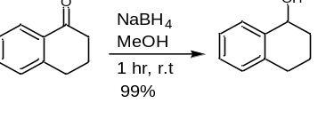
To a stirred solution of 1-tetralone (15 g, 102.61 mmol) in methanol (250 mL), was added NaBH₄ (3.88 g, 102.61 mmol). The reaction mixture was stirred for one hour and then concentrated to about 35 mL under reduced pressure. To this reaction mixture, deionized water (75 mL) was added and extracted with ethyl acetate (2 x 100 mL). The organic phase was washed with brine solution (40 mL), dried over Na₂SO₄ and filtered. The organic layer was concentrated to get crude compound. The crude compound was purified by flash column chromatography using eluent (1:9, ethyl acetate: n-hexane) to get the titled compound (15.1 g, 99.3% yield) as a pale-yellow oil. LCMS (ESI): m/z = 148.2 (M)⁺.
3,4-Dihydronaphthalene-2-carbaldehyde (12a).
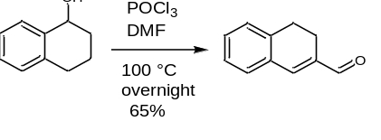
To a stirred solution of 1,2,3,4-tetrahydronaphthalen-1-ol (15.4 g, 97.5 mmol) in DMF (39.22 mL), POCl₃ (22.66 mL) was added dropwise at 0 °C and stirred for one hour. The reaction mixture was allowed to rise at room temperature and stirred for another one hour. Further, the stirred solution was heated at 100 °C for overnight. The reaction mixture was quenched at room temperature with water and basified with 3M NaOH. The reaction mixture was extracted with ethyl acetate (3 x 550 mL), washed with brine solution, dried over Na₂SO₄, and concentrated to get the crude compound. The crude compound was purified by flash column chromatography using eluent (1:9, ethyl acetate: n-hexane) to get the 3,4-dihydronaphthalene-2-carbaldehyde (8.5 g, 52% yield) as a pale-yellow oil. ¹H NMR (301 MHz, DMSO-D6) δ 9.65 (bs, 1H), 7.54 (s, 1H), 7.46 – 7.22 (m, 4H), 2.83 (t, J = 8.3 Hz, 2H), 2.42 (t, J = 8.3 Hz, 2H).
Methyl (Z)-2-azido-3-(3,4-dihydronaphthalen-2-yl) acrylate (13a).
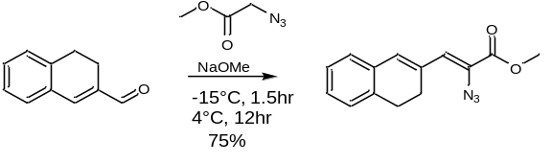
To a round-bottomed flask purged and maintained with an inert atmosphere was added 3,4-dihydronaphthalene-2-carbaldehyde (8.5 g, 53.95 mmol), methyl azidoacetate (15.5 g, 134.19 mmol) in dry MeOH (175 mL) at -15 °C. After 15 minutes to the stirred mixture, a solution of NaOMe (26.3 mL) in MeOH (44 mL) was added dropwise over 20 min and stirred at -15 °C for 90 min. Further, slowly warmed to 4 °C and stirred for 12 h. The reaction mixture was then poured into ice-cold saturated aqueous NH₄Cl (215 mL). The resulting precipitate was isolated on a fritted funnel and washed with deionized water until the filtrate came through clear. The solid was dissolved in DCM and dried over Na₂SO₄. The organic phase was filtered and evaporated in vacuo to get crude compound. The crude compound was purified by flash column chromatography using eluent (1:9, ethyl acetate: n-hexane) to get the methyl (Z)-2-azido-3-(3,4-dihydronaphthalen-2-yl) acrylate (9.65 g, 70% yield) as an oil with trace cyclized compound, which was further taken for next reaction.
Methyl 4,5-dihydro-1H-benzo[g]indole-2-carboxylate (14a).
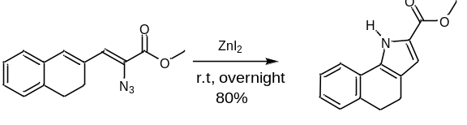
To a stirred solution of methyl 4,5-dihydro-1H-benzo[g]indole-2-carboxylate (9.654 g, 37.82 mmol) in DCM (55 mL), ZnI₂ (0.6 g, 1.89 mmol ) was added slowly and stirred overnight at room temperature. The resulting solution was filtered through a pad of celite and concentrated under vacuum to get the crude compound. The crude compound was purified by flash column chromatography using eluent (2:8, ethyl acetate: n-hexane) to get the methyl 4,5-dihydro-1H-benzo[g]indole-2-carboxylate (5.864 g, 68% yield) as a pale yellow solid. ¹H NMR (301 MHz, DMSO-D6) δ 12.10 (bs, 1H), 7.86 (d, J = 7.6 Hz, 1H), 7.21 (t, J = 7.5 Hz, 2H), 7.16 – 7.09 (m, 1H), 6.71 – 6.66 (m, 1H), 3.78 (s, 3H), 2.85 (t, J = 7.5 Hz, 2H), 2.64 (t, J = 7.5 Hz, 2H).
Methyl 5-methyl-4,5-dihydro-1H-benzo[g]indole-2-carboxylate (14af).
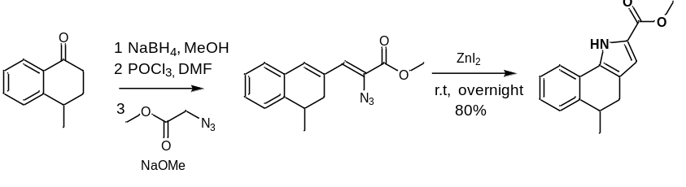
Procedure same as for compounds 11a-14a. ¹H NMR (500 MHz, CDCl₃) δ 9.25 (s, 1H), 7.36 (d, J = 7.3 Hz, 1H), 7.29 – 7.27 (m, 1H), 7.25 – 7.18 (m, 2H), 6.78 (d, J = 2.2 Hz, 1H), 3.88 (s, 3H), 3.11 – 3.06 (m, 1H), 2.91 (dd, J = 15.4, 6.2 Hz, 1H), 2.55 (dd, J = 15.4, 6.2 Hz, 1H), 1.26 (d, J = 7.0 Hz, 4H).
Methyl 3-iodo-4,5-dihydro-1H-benzo[g]indole-2-carboxylate (15a).
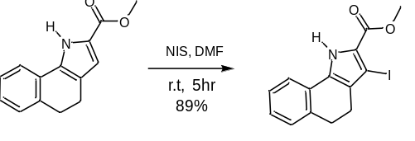
To a stirred solution of methyl 3-iodo-4,5-dihydro-1H-benzo[g]indole-2-carboxylate (5.86 g, 25.8 mmol) in DMF (60 mL) was added N-iodosuccinamide (6.38 g, 28.34 mmol). The resulting mixture was stirred at room temperature for 3 h and then concentrated in vacuo. The crude mixture was dissolved in DCM and washed with sat. NaHCO₃. The organic extracts were dried over Na₂SO₄, filtered and concentrated in vacuo. The crude compound was purified by column chromatography using eluent (2:8, ethyl acetate: n-hexane) to get the methyl 3-iodo-4,5-dihydro-1H-benzo[g]indole-2-carboxylate (8.01 g, 88% yield) as a brown solid. ¹H NMR (301 MHz, DMSO-D6) δ 12.45 (bs, 1H), 7.92 (d, J = 7.5 Hz, 1H), 7.23 (t, J = 7.0 Hz, 2H), 7.19 – 7.12 (m, 1H), 3.82 (s, 3H), 2.89 (t, J = 7.6 Hz, 2H), 2.61 – 2.51 (m, 2H); LCMS (ESI): m/z = 354.1 (M+1)⁺.
General procedure for compounds (16b-16ae). To a solution of methyl 3-iodo-4,5-dihydro-1H-benzo[g]indole-2-carboxylate (200 mg, 0.57 mmol), suitable boronic acid (0.68 mmol) in 1,4-dioxane (5.5 mL), aqueous Na₂CO₃ (120.82 mg, 1.14 mmol in 1.5 mL H₂O) was added at 25 °C in a sealed tube and nitrogen gas was bubbled through the reaction mixture for 15 minutes. To this [1,1′-Bis(diphenylphosphino)ferrocene]dichloropalladium(II) was added, packed tightly and the reaction mixture was heated at 80 °C overnight under stirring. The progress of the reaction was monitored by TLC. The reaction mixture was cooled to 25 °C and filtered through celite. The filtrate was concentrated under reduced pressure to obtain a crude product. The crude compound so obtained was purified by column chromatography using eluent (2:8, ethyl acetate: n-hexane) to get the desired compound.
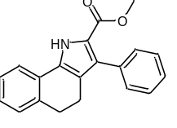Methyl 3-phenyl-4,5-dihydro-1H-benzo[g]indole-2-carboxylate (16b). LCMS (ESI): m/z = 304.1 (M+H)⁺.

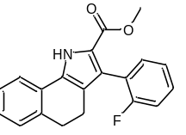Methyl 3-(2-fluorophenyl)-4,5-dihydro-1H-benzo[g]indole-2-carboxylate (16c). ¹H NMR (500 MHz, DMSO) δ 12.26 (s, 1H), 7.96 (d, J = 7.2 Hz, 1H), 7.40 – 7.33 (m, 2H), 7.28 – 7.19 (m, 4H), 7.18 – 7.13 (m, 1H), 3.64 (s, 3H), 2.84 (t, J = 7.5 Hz, 2H), 2.48 – 2.44 (m, 2H); LCMS (ESI): m/z = 322.1 (M+H)⁺.
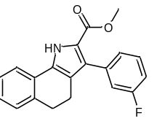Methyl 3-(3-fluorophenyl)-4,5-dihydro-1H-benzo[g]indole-2-carboxylate (16d). ¹H NMR (500 MHz, DMSO) δ 12.18 (bs, 1H), 7.97 (d, J = 8.3 Hz, 1H), 7.44 – 7.38 (m, 1H), 7.27 – 7.22 (m, 2H), 7.20 – 7.11 (m, 4H), 3.68 (s, 3H), 2.84 (t, J = 7.5 Hz, 2H), 2.56 (t, J = 7.5 Hz, 2H); LCMS (ESI): m/z = 322.1 (M+H)⁺.
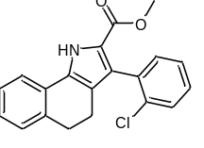Methyl 3-(2-chlorophenyl)-4,5-dihydro-1H-benzo[g]indole-2-carboxylate (16e). ¹H NMR (500 MHz, DMSO) δ 12.24 (bs, 1H), 7.95 (d, J = 7.7 Hz, 1H), 7.52 – 7.48 (m, 1H), 7.39 – 7.30 (m, 3H), 7.24 (t, J = 7.6 Hz, 2H), 7.18 – 7.12 (m, 1H), 3.60 (s, 3H), 2.84 (t, J = 7.5 Hz, 2H), 2.42 - 2.36 (m, 2H); LCMS (ESI): m/z = 338.1 (M+H)⁺.
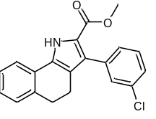Methyl 3-(3-chlorophenyl)-4,5-dihydro-1H-benzo[g]indole-2-carboxylate (16f). ¹H NMR (500 MHz, DMSO) δ 12.20 (bs, 1H), 8.00 – 7.94 (m, 1H), 7.41 (t, J = 7.7 Hz, 2H), 7.39 - 7.35 (m, 1H), 7.33 – 7.29 (m, 1H), 7.27 – 7.22 (m, 2H), 7.16 (td, J = 7.5, 1.2 Hz, 1H), 3.69 (s, 3H), 2.85 (t, J = 7.5 Hz, 2H), 2.55 (t, J = 7.5 Hz, 2H); LCMS (ESI): m/z = 338.1 (M+H)⁺.
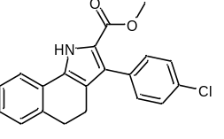Methyl 3-(4-chlorophenyl)-4,5-dihydro-1H-benzo[g]indole-2-carboxylate (16g). ¹H NMR (500 MHz, DMSO) δ 12.17 (bs, 1H), 8.01 - 7.93 (m, 1H), 7.46 – 7.41 (m, 2H), 7.39 - 7.35 (m, 2H), 7.28 – 7.21 (m, 2H), 7.16 (td, J = 7.5, 1.2 Hz, 1H), 3.68 (s, 3H), 2.84 (t, J = 7.5 Hz, 2H), 2.54 (t, J = 7.5 Hz, 2H); LCMS (ESI): m/z = 338.1 (M+H)⁺.
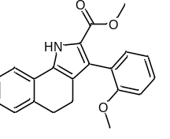Methyl 3-(2-methoxyphenyl)-4,5-dihydro-1H-benzo[g]indole-2-carboxylate (16h). ¹H NMR (500 MHz, CDCl₃) δ 9.38 (bs, 1H), 7.40 (d, J = 7.6 Hz, 1H), 7.36 – 7.30 (m, 1H), 7.28 (dd, J = 7.5, 1.7 Hz, 1H), 7.25 – 7.21 (m, 2H), 7.18-7.15 (m, 1H), 7.05 – 6.95 (m, 2H), 3.79 (s, 3H), 3.71 (s, 3H), 2.91 (t, J = 7.5 Hz, 2H), 2.61-2.54 (m, 2H); LCMS (ESI): m/z = 334.1 (M+H)⁺.
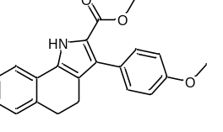Methyl 3-(4-methoxyphenyl)-4,5-dihydro-1H-benzo[g]indole-2-carboxylate (16i). ¹H NMR (500 MHz, CDCl₃) δ 9.21 (bs, 1H), 7.41 – 7.34 (m, 3H), 7.25-7.23 (m, 2H), 7.19 (t, J = 7.3 Hz, 1H), 6.95 (d, J = 8.5 Hz, 2H), 3.86 (s, 3H), 3.77 (s, 3H), 2.92 (t, J = 7.5 Hz, 2H), 2.69 (t, J = 7.5 Hz, 2H); LCMS (ESI): m/z = 334.1 (M+H)⁺.
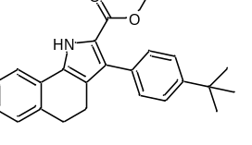Methyl 3-(4-(tert-butyl) phenyl)-4,5-dihydro-1H-benzo[g]indole-2-carboxylate (16j). ¹H NMR (500 MHz, CDCl3) δ 9.22 (bs, 1H), 7.44 – 7.41 (m, 2H), 7.40 – 7.35 (m, 3H), 7.27 (m, 1H), 7.24 (m, 1H), 7.18 (td, J = 7.4, 1.2 Hz, 1H), 3.78 (s, 3H), 2.91 (t, J = 7.5 Hz, 2H), 2.72 (t, J = 7.5 Hz, 2H), 1.37 (s, 9H); LCMS (ESI): m/z = 360.2 (M+H)⁺.
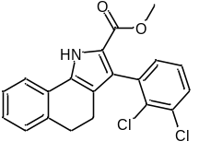Methyl 3-(2,3-dichlorophenyl)-4,5-dihydro-1H-benzo[g]indole-2-carboxylate (16k). ¹H NMR (500 MHz, DMSO) δ 12.31 (bs, 1H), 7.96 (d, J = 7.6 Hz, 1H), 7.61 (dd, J = 7.9, 1.6 Hz, 1H), 7.37 (t, J = 7.8 Hz, 1H), 7.32 (dd, J = 7.6, 1.6 Hz, 1H), 7.28 – 7.22 (m, 2H), 7.19 – 7.13 (m, 1H), 3.62 (s, 3H), 2.84 (t, J = 7.5 Hz, 2H), 2.41 – 2.35 (m, 2H); LCMS (ESI): m/z = 372.0(M+H)⁺.
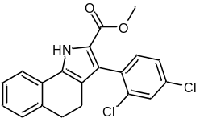Methyl 3-(2,4-dichlorophenyl)-4,5-dihydro-1H-benzo[g]indole-2-carboxylate (16l). ¹H NMR (500 MHz, DMSO) δ 12.31 (bs, 1H), 7.95 (d, J = 7.6 Hz, 1H), 7.67 (d, J = 2.1 Hz, 1H), 7.43 (dd, J = 8.3, 2.1 Hz, 1H), 7.37 (d, J = 8.3 Hz, 1H), 7.24 (d, J = 7.4 Hz, 2H), 7.16 (dd, J = 11.2, 4.9 Hz, 1H), 3.63 (s, 3H), 2.84 (t, J = 7.5 Hz, 2H), 2.42 – 2.37 (m, 2H); LCMS (ESI): m/z = 374.0 (M+H)⁺.
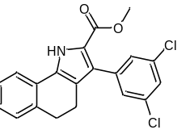Methyl 3-(3,5-dichlorophenyl)-4,5-dihydro-1H-benzo[g]indole-2-carboxylate (16m). ¹H NMR (500 MHz, CDCl₃) δ 9.33 (bs, 1H), 7.39 (d, J = 7.4 Hz, 1H), 7.33 (t, J = 1.8 Hz, 1H), 7.29 (d, J = 1.8 Hz, 2H), 7.28 (s, 1H), 7.25 (s, 1H), 7.21 (td, J = 7.4, 0.9 Hz, 1H), 3.79 (s, 3H), 2.94 (t, J = 7.5 Hz, 2H), 2.66 (t, J = 7.5 Hz, 2H); LCMS (ESI): m/z = 369.9 (M-H)⁻.
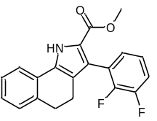Methyl 3-(2,3-difluorophenyl)-4,5-dihydro-1H-benzo[g]indole-2-carboxylate (16n). LCMS (ESI): m/z = 340.0 (M+H)⁺.

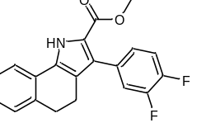Methyl 3-(3,4-difluorophenyl)-4,5-dihydro-1H-benzo[g]indole-2-carboxylate (16o). ¹H NMR (500 MHz, CDCl₃) δ 9.33 (bs, 1H), 7.40 (dd, J = 7.5, 0.6 Hz, 1H), 7.28 (dd, J = 7.4, 1.4 Hz, 1H), 7.25 (s, 1H), 7.23 – 7.18 (m, 1H), 6.96 – 6.91 (m, 2H), 6.78 (tt, J = 9.1, 2.4 Hz, 1H), 3.79 (s, 3H), 2.94 (t, J = 7.5 Hz, 2H), 2.67 (t, J = 7.5 Hz, 2H); LCMS (ESI): m/z = 338.1 (M-H)⁻.
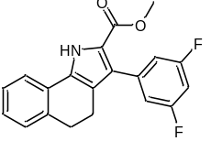Methyl 3-(3,5-difluorophenyl)-4,5-dihydro-1H-benzo[g]indole-2-carboxylate (16p). ¹H NMR (500 MHz, CDCl₃) δ 9.34 (bs, 1H), 7.40 (d, J = 7.2 Hz, 1H), 7.28 (d, J = 7.4 Hz, 2H), 7.23 – 7.19 (m, 1H), 6.97 – 6.90 (m, 2H), 6.78 (tt, J = 9.1, 2.4 Hz, 1H), 3.79 (s, 3H), 2.94 (t, J = 7.5 Hz, 2H), 2.67 (t, J = 7.5 Hz, 2H); LCMS (ESI) m/z: 340.0 [M+H]⁺.
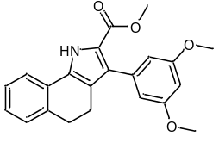Methyl 3-(3,5-dimethoxyphenyl)-4,5-dihydro-1H-benzo[g]indole-2-carboxylate (16q). ¹H NMR (500 MHz, CDCl₃) δ 9.29 (bs, 1H), 7.39 (d, J = 7.4 Hz, 1H), 7.28 (s, 1H), 7.25 – 7.23 (m, 1H), 7.19 (td, J = 7.5, 0.9 Hz, 1H), 6.58 (d, J = 2.3 Hz, 2H), 6.46 (t, J = 2.3 Hz, 1H), 3.82 (s, 6H), 3.78 (s, 3H), 2.92 (t, J = 7.5 Hz, 2H), 2.71 (t, J = 7.5 Hz, 2H); LCMS (ESI) m/z: 364.1[M+H]⁺.
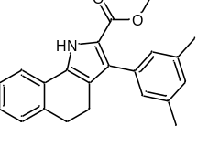Methyl 3-(3,5-dimethylphenyl)-4,5-dihydro-1H-benzo[g]indole-2-carboxylate (16r). ¹H NMR (500 MHz, DMSO) δ 12.03 (bs, 1H), 7.99 – 7.91 (m, 1H), 7.23 (t, J = 6.6 Hz, 2H), 7.17 – 7.12 (m, 1H), 6.94 – 6.91 (m, 3H), 3.66 (s, 3H), 2.83 (t, J = 7.5 Hz, 2H), 2.55 – 2.51 (m, 2H), 2.29 (s, 6H); LCMS (ESI): m/z = 332.1 (M+H)⁺.
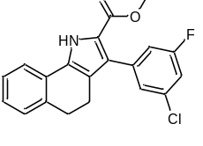Methyl 3-(3-chloro-5-fluorophenyl)-4,5-dihydro-1H-benzo[g]indole-2-carboxylate (16s). ¹H NMR (500 MHz, CDCl₃) δ 9.31 (bs, 1H), 7.39 (d, J = 7.6 Hz, 1H), 7.30 – 7.26 (m, 2H), 7.23 – 7.18 (m, 2H), 7.09 – 7.01 (m, 2H), 3.79 (s, 3H), 2.94 (t, J = 7.5 Hz, 2H), 2.67 (t, J = 7.5 Hz, 2H); LCMS (ESI) m/z = 354.1 [M-H]⁻.
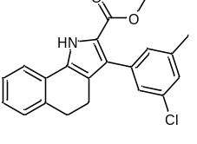Methyl 3-(3-chloro-5-methylphenyl)-4,5-dihydro-1H-benzo[g]indole-2-carboxylate (16t). LCMS (ESI) m/z = 353.1 [M-H]⁻.

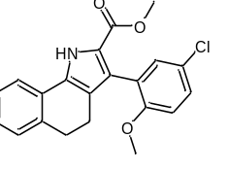Methyl 3-(5-chloro-2-methoxyphenyl)-4,5-dihydro-1H-benzo[g]indole-2-carboxylate (16u). ¹H NMR (500 MHz, CDCl₃) δ 9.46 (bs, 1H), 7.41 (d, J = 7.1 Hz, 1H), 7.29 – 7.22 (m, 4H), 7.17 (td, J = 7.4, 1.2 Hz, 1H), 6.88 (d, J = 8.7 Hz, 1H), 3.76 (s, 6H), 3.73 (s, 3H), 2.91 (t, J = 7.6 Hz, 2H), 2.62 – 2.51 (m, 2H); LCMS (ESI): m/z = 368.0 (M+H)⁺.
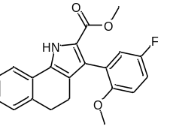Methyl 3-(5-fluoro-2-methoxyphenyl)-4,5-dihydro-1H-benzo[g]indole-2-carboxylate (16v). ¹H NMR (500 MHz, CDCl₃) δ 9.42 (bs, 1H), 7.40 (d, J = 7.4 Hz, 1H), 7.25 – 7.21 (m, 2H), 7.19 – 7.15 (m, 1H), 7.04 – 6.98 (m, 2H), 6.90 – 6.56 (m, 1H), 3.75 (s, 3H), 3.73 (s, 3H), 2.91 (t, J = 7.5 Hz, 2H), 2.63 – 2.50 (m, 2H); LCMS (ESI): m/z = 352.1 (M+H)⁺.
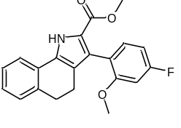Methyl 3-(4-fluoro-2-methoxyphenyl)-4,5-dihydro-1H-benzo[g]indole-2-carboxylate (16w). ¹H NMR (500 MHz, CDCl₃) δ 9.32 (bs, 1H), 7.63 – 7.33 (m, 3H), 7.32-7.27 (m, 2H), 7.18 (td, J = 7.4, 1.1 Hz, 1H), 6.88 (d, J = 8.7 Hz, 1H), 3.76 (s, 3H), 3.73 (s, 3H), 2.91 (t, J = 7.6 Hz, 2H), 2.65 – 2.50 (m, 2H); LCMS (ESI) m/z = 350.1 [M+H]⁻.
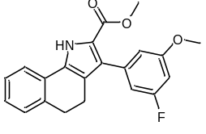Methyl 3-(3-fluoro-5-methoxyphenyl)-4,5-dihydro-1H-benzo[g]indole-2-carboxylate (16x). ¹H NMR (500 MHz, CDCl₃) δ 9.31 (bs, 1H), 7.40 (d, J = 7.2 Hz, 1H), 7.24 (s, 1H), 7.20 (td, J = 7.4, 1.1 Hz, 1H), 6.75 (d, J = 1.9 Hz, 1H), 6.74 – 6.71 (m, 1H), 6.61 (dt, J = 10.7, 2.3 Hz, 1H), 3.83 (s, 3H), 3.78 (s, 3H), 2.93 (t, J = 7.5 Hz, 2H), 2.68 (t, J = 7.5 Hz, 2H); LCMS (ESI) m/z: 350.1 [M-H]⁻.
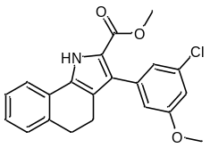Methyl 3-(3-chloro-5-methoxyphenyl)-4,5-dihydro-1H-benzo[g]indole-2-carboxylate (16y). ¹H NMR (500 MHz, CDCl₃) δ 9.29 (bs, 1H), 7.39 (d, J = 7.4 Hz, 1H), 7.29 (s, 1H), 7.24 (s, 1H), 7.20 (td, J = 7.4, 1.1 Hz, 1H), 7.00 (t, J = 1.5 Hz, 1H), 6.88 (t, J = 2.1 Hz, 1H), 6.86 – 6.84 (m, 1H), 3.83 (s, 3H), 3.78 (s, 3H), 2.93 (t, J = 7.5 Hz, 2H), 2.68 (t, J = 7.5 Hz, 2H); LCMS (ESI) m/z = 368.0 [M+H]⁺.
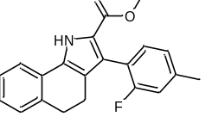Methyl 3-(2-fluoro-4-methylphenyl)-4,5-dihydro-1H-benzo[g]indole-2-carboxylate (16z). ¹H NMR (500 MHz, DMSO) δ 12.21 (bs, 1H), 7.97 – 7.93 (m, 1H), 7.26 – 7.19 (m, 3H), 7.17 – 7.12 (m, 1H), 7.04 (t, J = 10.2 Hz, 2H), 3.65 (s, 3H), 2.84 (t, J = 7.5 Hz, 2H), 2.49 – 2.43 (m, 2H), 2.36 (s, 3H); LCMS (ESI): m/z = 336.1 (M+H)⁺.
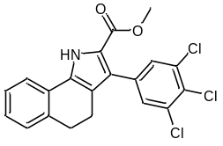Methyl 3-(3,4,5-trichlorophenyl)-4,5-dihydro-1H-benzo[g]indole-2-carboxylate (16aa). ¹H NMR (500 MHz, CDCl₃) δ 9.32 (bs, 1H), 7.44 (s, 2H), 7.39 (d, J = 7.5 Hz, 1H), 7.29 (d, J = 7.3 Hz, 2H), 7.21 (td, J = 7.5, 1.0 Hz, 1H), 3.80 (s, 3H), 2.94 (t, J = 7.5 Hz, 2H), 2.66 (t, J = 7.5 Hz, 2H); LCMS (ESI) m/z: 405.9 [M-H]⁻.
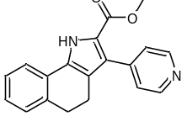Methyl 3-(pyridin-4-yl)-4,5-dihydro-1H-benzo[g]indole-2-carboxylate (16ab). ¹H NMR (500 MHz, MeOD) δ 8.54 (d, J = 5.7 Hz, 2H), 7.73 (d, J = 7.6 Hz, 1H), 7.50 (d, J = 4.7 Hz, 2H), 7.30 – 7.22 (m, 2H), 7.18 (td, J = 7.5, 1.2 Hz, 1H), 3.77 (s, 3H), 2.92 (t, J = 7.5 Hz, 2H), 2.69 – 2.64 (m, 2H).
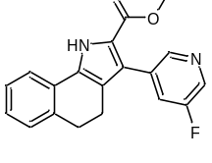Methyl 3-(5-fluoropyridin-3-yl)-4,5-dihydro-1H-benzo[g]indole-2-carboxylate (16ac). ¹H NMR (500 MHz, DMSO) δ 12.34 (bs, 1H), 8.51 (d, J = 2.8 Hz, 1H), 8.44 (t, J = 1.7 Hz, 1H), 7.99 – 7.96 (m, 1H), 7.79 – 7.74 (m, 1H), 7.28-7.23 (m, 2H), 7.20 – 7.14 (m, 1H), 3.70 (s, 3H), 2.86 (t, J = 7.5 Hz, 2H), 2.61 – 2.57 (m, 2H); LCMS (ESI) m/z: 323.0 [M+H]⁺.
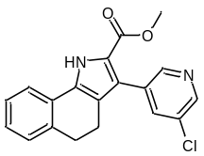Methyl 3-(5-chloropyridin-3-yl)-4,5-dihydro-1H-benzo[g]indole-2-carboxylate (16ad). ¹H NMR (500 MHz, DMSO) δ 12.37 (bs, 1H), 8.54 (dd, J = 22.7, 2.1 Hz, 2H), 7.99 – 7.96 (m, 1H), 7.96 – 7.94 (m, 1H), 7.25 (t, J = 6.7 Hz, 2H), 7.21 – 7.14 (m, 1H), 3.70 (s, 3H), 2.86 (t, J = 7.5 Hz, 2H), 2.61 – 2.57 (m, 3H); LCMS (ESI) m/z: 339.0 [M+H]⁺.
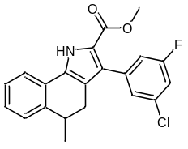Methyl 3-(3-chloro-5-fluorophenyl)-5-methyl-4,5-dihydro-1H-benzo[g]indole-2-carboxylate (16ae). LCMS (ESI) m/z: 369.2 [M-H]⁻.

General procedure for compounds (17a-17ae). To a stirred solution of methyl 3-(3,5-dichlorophenyl)-4,5-dihydro-1H-benzo[g]indole-2-carboxylate (188 mg, 0.57 mmol) in THF (2.5 mL), MeOH (1.1 mL) and H₂0 (1.1 mL) was added LiOH.H₂O (120 mg, 2.87 mmol). The resultant mixture was stirred at room temperature for 48 h. The reaction mixture was acidified to pH 2 with 2 M HCI and extracted with EtOAc (2 x 25 mL). The organic extracts were dried over Na₂SO₄, filtered, and concentrated in vacuo. The crude compound so obtained was purified by column chromatography (Biotage) using eluent (2:8, ethyl acetate: n-hexane) to get the desired product as a solid.
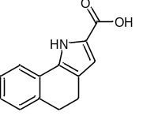4,5-dihydro-1H-benzo[g]indole-2-carboxylic acid (17a). ¹H NMR (500 MHz, MeOD) δ 7.62 – 7.57 (m, 1H), 7.24 – 7.17 (m, 2H), 7.12 (td, J = 7.6, 1.1 Hz, 1H), 6.73 (s, 1H), 2.90 (t, J = 7.5 Hz, 2H), 2.70 (t, J = 7.5 Hz, 2H); ¹³C NMR (126 MHz, MeOD) δ 164.58, 137.47, 134.40, 129.85, 129.27, 127.77, 127.72, 123.74, 122.50, 121.99, 115.54, 49.00, 30.93, 22.56; HRMS (ESI⁻) m/z: [M-H]⁻ calcd for C₁₃H₁₁NO₂ 212.0712; found 212.0711; HPLC purity, 98.41%.
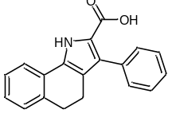3-Phenyl-4,5-dihydro-1H-benzo[g]indole-2-carboxylic acid (17b). ¹H NMR (500 MHz, MeOD) δ 7.68 (d, J = 7.6 Hz, 1H), 7.38– 7.32 (m, 4H), 7.29 – 7.20 (m, 4H), 7.14 (t, J = 7.3 Hz, 1H), 2.88 (t, J = 7.2 Hz, 2H), 2.60 (t, J = 7.1 Hz, 2H); ¹³C NMR (126 MHz, DMSO) δ 162.06, 135.72, 134.55, 130.97, 130.10, 130.10, 128.47, 128.26, 128.06, 127.36, 127.36, 126.57, 126.53, 126.29, 121.77, 120.31, 119.00, 29.22, 20.02; HRMS (ESI⁻) m/z: [M-H]⁻ calcd for C₁₉H₁₄NO₂ 288.1025; found 288.1059; HPLC purity, 96%.
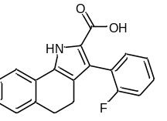3-(2-Fluorophenyl)-4,5-dihydro-1H-benzo[g]indole-2-carboxylic acid (17c). ¹H NMR (500 MHz, MeOD) δ 7.68 (d, J = 7.4 Hz, 1H), 7.36 – 7.27 (m, 2H), 7.24 – 7.19 (m, 7.4 Hz, 2H), 7.16 – 7.07 (m, 3H), 2.87 (t, J = 7.1 Hz, 2H), 2.51 (t, J = 7.0 Hz, 2H); ¹³C NMR (126 MHz, MeOD) δ 164.19, 162.57, 160.62, 137.60, 133.60, 133.58, 133.17, 129.84, 129.78, 129.62, 129.29, 127.93, 127.81, 124.39, 124.37, 124.32, 124.17, 124.04, 122.81, 122.22, 120.99, 116.15, 115.97, 30.72, 21.32; HRMS (ESI⁻) m/z: [M-H]⁻ calcd for C₁₉H₁₅FNO₂ 306.0936; found 306.0916; HPLC purity, 97.19%.
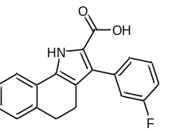3-(3-Fluorophenyl)-4,5-dihydro-1H-benzo[g]indole-2-carboxylic acid (17d). ¹H NMR (500 MHz, MeOD) δ 7.68 (d, J = 7.5 Hz, 1H), 7.36 – 7.32 (m, 1H), 7.25-7.10 (m, 5H), 7.00 (t, J = 7.5 Hz, 1H), 2.87 (t, J = 7.4 Hz, 2H), 2.59 (t, J = 7.4 Hz, 2H); ¹³C NMR (126 MHz, MeOD) δ 164.66, 164.16, 162.73, 138.64, 138.57, 137.65, 133.29, 130.07, 130.01, 129.53, 129.28, 128.02, 127.81, 127.20, 122.33, 122.11, 119.95, 118.17, 118.00, 114.25, 114.08, 30.82, 21.41; HRMS (ESI⁻) m/z: [M-H]⁻ calcd for C₁₉H₁₅FNO₂ 306.0936; found 306.0925; HPLC purity, 93.04%.
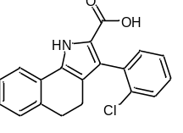3-(2-Chlorophenyl)-4,5-dihydro-1H-benzo[g]indole-2-carboxylic acid (17e). ¹H NMR (500 MHz, MeOD) δ 7.63 (d, J = 7.5 Hz, 1H), 7.41 – 7.36 (m, 1H), 7.26 – 7.16 (m, 4H), 7.13 (d, J = 7.3 Hz, 1H), 7.07 (t, J = 7.3 Hz, 1H), 2.80 (t, J = 7.1 Hz, 2H), 2.46 – 2.31 (m, 2H); ¹³C NMR (126 MHz, MeOD) δ 164.24, 137.59, 135.90, 135.28, 133.41, 133.01, 130.04, 129.73, 129.41, 129.31, 128.36, 127.90, 127.83, 127.18, 122.79, 122.22, 120.95, 30.68, 21.37; HRMS (ESI⁻) m/z: [M-H]⁻ calcd for C₁₉H₁₅ClNO₂ 322.0640; found 322.0616; HPLC purity, 99.22%.
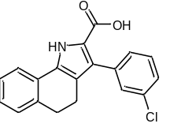3-(3-Chlorophenyl)-4,5-dihydro-1H-benzo[g]indole-2-carboxylic acid (17f). ¹H NMR (500 MHz, MeOD) δ 7.68 (d, J = 7.5 Hz, 1H), 7.38 (s, 1H), 7.33 –7.18 (m, 5H), 7.13 (t, J = 7.2 Hz, 1H), 2.86 (t, J = 7.1 Hz, 2H), 2.57 (t, J = 7.1 Hz, 2H); ¹³C NMR (126 MHz, MeOD) δ 164.14, 138.28, 137.63, 134.29, 133.32, 131.27, 129.96, 129.80, 129.70, 129.50, 129.28, 128.03, 127.81, 127.53, 122.33, 122.10, 120.00, 30.79, 21.36; HRMS (ESI⁻) m/z: [M-H]⁻ calcd for C₁₉H₁₅ClNO₂ 322.0640; found 322.0622; HPLC purity, 97.08%.
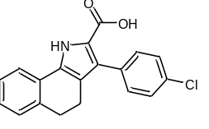3-(4-Chlorophenyl)-4,5-dihydro-1H-benzo[g]indole-2-carboxylic acid (17g). ¹H NMR (500 MHz, DMSO) δ 12.21 (bs, 1H), 12.04 (bs, 1H), 7.94 (d, J = 7.5 Hz, 2H), 7.39 – 7.34 (m, 4H), 7.21 – 7.18 (m, 2H), 7.11 (t, J = 7.5 Hz, 1H), 2.80 (t, J = 7.3 Hz, 2H), 2.50 (t, J = 7.3 Hz, 2H); ¹³C NMR (126 MHz, DMSO) δ 161.89, 135.72, 133.45, 131.89, 131.13, 128.15, 128.09, 127.50, 127.41, 127.20, 126.64, 126.60, 121.83, 120.29, 120.25, 119.06, 118.92, 29.16, 19.88; HRMS (ESI⁻) m/z: [M-H]⁻ calcd for C₁₉H₁₅ClNO₂ 322.0640; found 322.0623; HPLC purity, 91.22%.
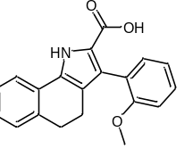3-(2-Methoxyphenyl)-4,5-dihydro-1H-benzo[g]indole-2-carboxylic acid (17h). ¹H NMR (500 MHz, MeOD) δ 7.66 (d, J = 7.4 Hz, 1H), 7.30 – 7.19 (m, 4H), 7.12 (t, J = 7.2 Hz, 1H), 7.00 (d, J = 8.1 Hz, 1H), 6.94 (t, J = 7.2 Hz, 1H), 3.75 (s, 3H), 2.86 (t, J = 7.1 Hz, 2H), 2.46 (t, J = 7.1 Hz, 2H); ¹³C NMR (126 MHz, MeOD) δ 164.57, 158.74, 137.69, 132.98, 129.91, 129.39, 129.26, 127.76, 127.72, 125.45, 123.17, 122.09, 120.99, 111.97, 55.91, 30.83, 21.54; HRMS (ESI⁻) m/z: [M-H]⁻ calcd for C₂₀H₁₆NO₃ 318.1136; found 318.1132; HPLC purity, 91.81%.
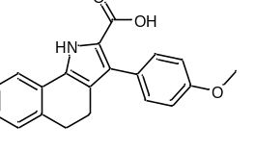3-(4-Methoxyphenyl)-4,5-dihydro-1H-benzo[g]indole-2-carboxylic acid (17i). ¹H NMR (500 MHz, MeOD) δ 7.66 (d, J = 6.1 Hz, 1H), 7.30 (d, J = 8.3 Hz, 2H), 7.24 – 7.19 (m, 2H), 7.15 – 7.11 (m, 1H), 6.91 (d, J = 8.3 Hz, 2H), 3.82 (s, 3H), 2.87 (t, J = 7.2 Hz, 2H), 2.60 (t, J = 7.2 Hz, 2H); HRMS (ESI⁻) m/z: [M-H]⁻ calcd for C₂₀H₁₆NO₃ 318.1130; found, 318.1157; HPLC purity, 92.98%.
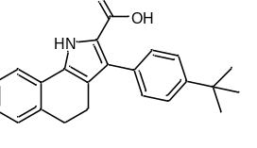3-(4-(tert-Butyl)phenyl)-4,5-dihydro-1H-benzo[g]indole-2-carboxylic acid (17j). ¹H NMR (301 MHz, CHLOROFORM-D) δ 9.42 (bs, 1H), 7.47 – 7.36 (m, 5H), 7.25 – 7.16 (m, 3H), 2.92 (t, J = 7.3 Hz, 2H), 2.71 (t, J = 7.3 Hz, 2H), 1.37 (s, 9H); ¹³C NMR (76 MHz, CHLOROFORM-D) δ 150.34, 137.15, 132.92, 131.68, 130.85, 130.84, 130.11, 128.97, 127.93, 127.88, 127.21, 125.18, 122.25, 120.69, 77.36, 34.96, 31.73, 30.07, 20.74; HRMS (ESI⁻) m/z: [M-H]⁻ calcd for C₂₃H₂₄NO₂ 344.1656; found 344.1657; HPLC purity, 93.99%.
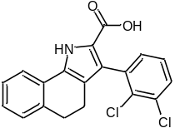3-(2,3-Dichlorophenyl)-4,5-dihydro-1H-benzo[g]indole-2-carboxylic acid (17k). ¹H NMR (500 MHz, MeOD) δ 7.69 (d, J = 7.6 Hz, 1H), 7.48 – 7.46 (m, 1H), 7.27 – 7.20 (m, 4H), 7.14 (t, J = 7.2 Hz, 1H), 2.88 (t, J = 7.6 Hz, 2H), 2.45 – 2.42 (m, 2H); ¹³C NMR (126 MHz, MeOD) δ 163.94, 138.46, 137.54, 133.69, 133.55, 133.17, 131.69, 130.15, 129.60, 129.33, 128.00, 127.90, 127.85, 122.54, 122.27, 30.60, 21.27; HRMS (ESI⁻) m/z: [M-H]⁻calcd for C₁₉H₁₄Cl₂NO₂ 356.0251; found 356.0224; HPLC purity, 93.86%.
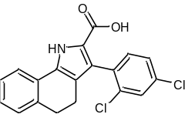3-(2,4-Dichlorophenyl)-4,5-dihydro-1H-benzo[g]indole-2-carboxylic acid (17l). ¹H NMR (500 MHz, MeOD) δ 7.68 (d, J = 7.6 Hz, 1H), 7.49 (d J = 1.6 Hz, 1H), 7.33 – 7.29 (m, 2H), 7.23 (dd, J = 15.5, 7.6 Hz, 2H), 7.14 (td, J = 7.4, 1.2 Hz, 1H), 2.88 (t, J = 7.6 Hz, 2H), 2.51-2.40 (m, 2H); ¹³C NMR (126 MHz, MeOD) δ 163.95, 137.56, 136.19, 134.83, 134.45, 134.39, 133.19, 129.72, 129.60, 129.33, 128.01, 127.86, 127.51, 127.05, 122.70, 122.28, 121.04, 30.63, 21.32; HRMS (ESI⁻) m/z: [M-H]⁻ calcd for C₁₉H₁₄Cl₂NO₂, 356.0251; found 356.0228; HPLC purity, 97.58%.
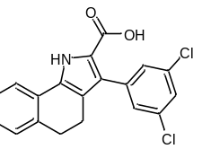3-(3,5-Dichlorophenyl)-4,5-dihydro-1H-benzo[g]indole-2-carboxylic acid (17m). ¹H NMR (500 MHz, MeOD) δ 7.70 (d, J = 7.4 Hz, 1H), 7.35 – 7.33 (m, 3H), 7.26 – 7.18 (m, 2H), 7.17 – 7.14 (m, 1H), 2.91 (t, J = 6.6 Hz, 2H), 2.61 (t, J = 6.6 Hz, 2H); ¹³C NMR (126 MHz, DMSO) δ 161.69, 138.32, 135.73, 133.02, 131.22, 128.72, 128.12, 127.98, 126.76, 126.62, 125.94, 125.49, 121.86, 120.38, 119.43, 29.03, 19.72; HRMS (ESI⁻) m/z: [M-H]⁻ calcd for C₁₉H₁₂Cl₂NO₂ 356.0251; found 356.0247; HPLC purity, 99.16%.
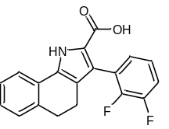3-(2,3-Difluorophenyl)-4,5-dihydro-1H-benzo[g]indole-2-carboxylic acid (17n). ¹H NMR (500 MHz, MeOD) δ 7.69 (d, J = 7.6 Hz, 1H), 7.26-7.22 (m, 2H), 7.20 – 7.09 (m, 4H), 2.90 (t, J = 7.0 Hz, 2H), 2.54 (t, J = 7.1 Hz, 2H); ¹³C NMR (126 MHz, DMSO) δ 171.20, 160.40, 160.30, 158.47, 158.36, 155.96, 155.87, 145.09, 140.69, 137.62, 137.55, 136.80, 136.16, 136.13, 134.69, 134.59, 133.25, 133.20, 131.20, 130.23, 125.29, 125.16, 38.46, 29.17; HRMS (ESI⁻) m/z: [M-H]⁻ calcd for C₁₉H₁₃F₂NO₂ 324.0842; found 324.0828; HPLC purity, 96.96%.
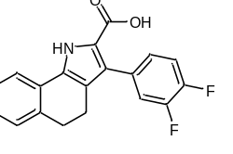3-(3,4-Difluorophenyl)-4,5-dihydro-1H-benzo[g]indole-2-carboxylic acid (17o). ¹H NMR (500 MHz, MeOD) δ 7.69 (d, J = 7.6 Hz, 1H), 7.27 – 7.20 (m, 2H), 7.15 (td, J = 7.5, 1.1 Hz, 1H), 7.01 – 6.94 (m, 2H), 6.85 (tt, J = 9.3, 2.3 Hz, 1H), 2.90 (t, J = 7.5 Hz, 2H), 2.62 (t, J = 7.5 Hz, 2H); ¹³C NMR (126 MHz, MeOD) δ 164.85, 164.75, 163.94, 162.90, 162.80, 137.62, 133.35, 129.42, 129.30, 128.13, 127.85, 122.39, 122.00, 114.30, 114.25, 114.14, 114.09, 102.75, 102.55, 102.34, 30.76, 21.36; HRMS (ESI⁻) m/z: [M-H]⁻ calcd for C₁₉H₁₂F₂NO₂ 324.0842; found 324.0863; HPLC purity, 91.10%.
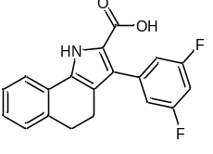3-(3,5-Difluorophenyl)-4,5-dihydro-1H-benzo[g]indole-2-carboxylic acid (17p). ¹H NMR (500 MHz, MeOD) δ 7.69 (d, J = 7.7 Hz, 1H), 7.27 – 7.21 (m, 2H), 7.16 (t, J = 7.3 Hz, 1H), 6.98 – 6.96 (m, 2H), 6.87 – 6.82 (m, 1H), 2.90 (t, J = 7.5 Hz, 2H), 2.62 (t, J = 7.5 Hz, 2H); ¹³C NMR (126 MHz, MeOD) δ 163.92, 162.91, 162.80, 137.63, 133.37, 129.42, 129.31, 128.14, 127.86, 122.40, 122.01, 120.15, 114.30, 114.25, 114.14, 114.10, 102.76, 102.56, 102.35, 49.00, 30.76, 21.35; HRMS (ESI⁻) m/z: [M-H]⁻ calcd for C₁₉H₁₄FNO₂ 324.0842; found 324.0826; HPLC purity, 97.52%.
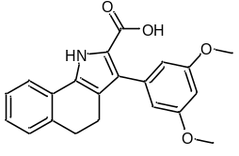3-(3,5-Dimethoxyphenyl)-4,5-dihydro-1H-benzo[g]indole-2-carboxylic acid (17q). ¹H NMR (500 MHz, DMSO) δ 11.90 (bs, 1H), 7.88 (s, 1H), 7.13 – 7.10 (m, 3H), 6.43 – 6.36 (m, 3H), 3.67 (s, 6H), 2.80 – 2.70 (m, 2H), 2.53 – 2.40 (m, 2H); ¹³C NMR (126 MHz, DMSO) δ 162.05, 159.56, 136.46, 135.74, 130.95, 128.44, 128.25, 128.07, 126.57, 121.78, 120.37, 119.10, 108.40, 108.40, 98.41, 55.08, 29.23, 20.12; HRMS (ESI⁻) m/z: [M-H]⁻ calcd for C₂₁H₁₈NO₄ 348.1236; found 348.1270; HPLC purity, 94.79%.
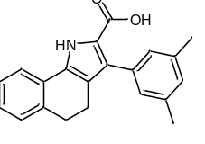3-(3,5-Dimethylphenyl)-4,5-dihydro-1H-benzo[g]indole-2-carboxylic acid (17r). ¹H NMR (500 MHz, MeOD) δ 7.67 (d, J = 7.5 Hz, 1H), 7.25 – 7.17 (m, 2H), 7.12 (t, J = 7.3 Hz, 1H), 6.96 (s, 2H), 6.91 (s, 1H), 2.85 (t, J = 7.2 Hz, 2H), 2.56 (t, J = 7.2 Hz, 2H), 2.31 (s, 6H); ¹³C NMR (126 MHz, MeOD) δ 164.45, 137.87, 137.71, 135.95, 133.12, 131.93, 129.72, 129.25, 129.06, 129.03, 127.87, 127.76, 122.24, 119.73, 30.91, 21.50, 21.43; HRMS (ESI⁻) m/z: [M-H]⁻ calcd for C₂₁H₂₀NO₂ 316.1343; found 316.1323; HPLC purity, 98.14%.
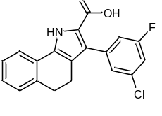3-(3-Chloro-5-fluorophenyl)-4,5-dihydro-1H-benzo[g]indole-2-carboxylic acid (17s). ¹H NMR (500 MHz, MeOD) δ 7.68 (d, J = 7.5 Hz, 1H), 7.26 – 7.18 (m, 3H), 7.14 (t, J = 7.3 Hz, 1H), 7.12 – 7.04 (m, 2H), 2.87 (t, J = 7.2 Hz, 2H), 2.58 (t, J = 7.2 Hz, 2H); ¹³C NMR (126 MHz, MeOD) δ 164.50, 163.95, 162.54, 139.97, 139.90, 137.59, 135.00, 134.91, 133.41, 129.30, 128.53, 128.16, 127.84, 127.40, 127.38, 122.36, 121.99, 116.91, 116.74, 115.02, 114.82, 30.70, 21.28; HRMS (ESI⁻) m/z: [M-H]⁻ calcd for C₁₉H₁₃ClFNO₂ 340.0546; found 340.0533; HPLC purity, 96.14%.
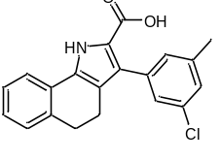3-(3-Chloro-5-methylphenyl)-4,5-dihydro-1H-benzo[g]indole-2-carboxylic acid (17t). ¹H NMR (500 MHz, MeOD) δ 7.68 (d, J = 7.5 Hz, 1H), 7.24 – 7.20 (m, 2H), 7.16 – 7.08 (m, 4H), 2.88 (t, J = 7.2 Hz, 2H), 2.58 (t, J = 7.2 Hz, 2H), 2.35 (s, 3H); ¹³C NMR (126 MHz, MeOD) δ 164.16, 140.24, 138.00, 137.65, 134.06, 133.27, 130.43, 130.03, 129.55, 129.28, 128.30, 128.07, 128.02, 127.81, 122.33, 122.11, 120.00, 30.82, 21.39, 21.20; HRMS (ESI⁻) m/z: [M-H]⁻ calcd for C₂₀H₁₆ClNO₂ 336.0797; found 336.0764; HPLC purity, 95.83%.
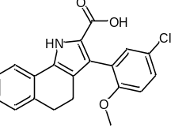3-(5-Chloro-2-methoxyphenyl)-4,5-dihydro-1H-benzo[g]indole-2-carboxylic acid (17u). ¹H NMR (500 MHz, MeOD) δ 7.66 (d, J = 7.4 Hz, 1H), 7.27 – 7.24 (m, 1H), 7.24 – 7.19 (m, 2H), 7.19 – 7.17 (m, 1H), 7.14 – 7.11 (m, 1H), 6.98 (d, J = 8.8 Hz, 1H), 3.74 (s, 3H), 2.87 (t, J = 7.3 Hz, 2H), 2.46 (t, J = 7.3 Hz, 2H); ¹³C NMR (126 MHz, MeOD) δ 164.18, 157.59, 137.64, 132.98, 132.54, 129.75, 129.28, 128.90, 127.84, 127.79, 127.35, 126.08, 125.68, 123.06, 122.16, 120.84, 113.27, 56.25, 30.74, 21.47; HRMS (ESI⁻) m/z: [M-H]⁻ calcd for C₁₂₀H₁₇ClNO₃ 352.0746; found 352.0748; HPLC purity, 99.82%.
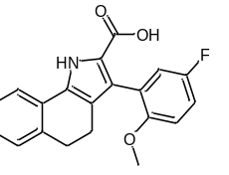3-(5-Fluoro-2-methoxyphenyl)-4,5-dihydro-1H-benzo[g]indole-2-carboxylic acid (17v). ¹H NMR (500 MHz, MeOD) δ 7.66 (d, J = 7.6 Hz, 1H), 7.22 (dd, J = 14.9, 7.4 Hz, 2H), 7.13 (td, J = 7.4, 1.2 Hz, 1H), 7.02 – 6.93 (m, 3H), 3.72 (s, 3H), 2.87 (t, J = 7.5 Hz, 2H), 2.47 (t, J = 7.5 Hz, 2H); ¹³C NMR (126 MHz, MeOD) δ 164.32, 157.04, 155.09, 137.65, 132.92, 129.79, 129.27, 127.81, 127.78, 123.08, 122.16, 119.53, 119.35, 115.04, 114.86, 113.05, 112.98, 56.57,30.76, 21.50; HRMS (ESI⁻) m/z: [M-H]⁻ calcd for C₂₀H₁₅FNO₂ 336.1041; found 336.1043; HPLC purity, 94.34%.
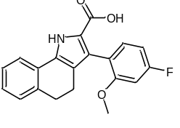3-(4-Fluoro-2-methoxyphenyl)-4,5-dihydro-1H-benzo[g]indole-2-carboxylic acid (17w). ¹H NMR (500 MHz, MeOD) δ 7.65 (d, J = 7.5 Hz, 1H), 7.23 – 7.15 (m, 3H), 7.12 (t, J = 7.3 Hz, 1H), 6.78 (dd, J = 11.2, 2.2 Hz, 1H), 6.67 (td, J = 8.4, 2.3 Hz, 1H), 3.74 (s, 3H), 2.85 (t, J = 7.4 Hz, 2H), 2.45 (t, J = 7.4 Hz, 2H); ¹³C NMR (126 MHz, MeOD) δ 165.46, 164.42, 163.52, 160.03, 159.95, 137.65, 133.69, 133.61, 132.89, 129.83, 129.26, 127.76, 126.58, 123.16, 122.11, 121.34, 120.85, 107.03, 106.86, 100.02, 99.81, 56.14, 30.78, 21.47; HRMS (ESI⁻) m/z: [M-H]⁻ calcd for C₂₀H₁₃FNO₃ 336.1041; found 336.1; HPLC purity, 90.89%.
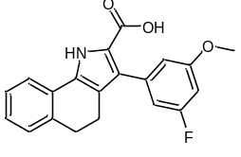3-(3-Fluoro-5-methoxyphenyl)-4,5-dihydro-1H-benzo[g]indole-2-carboxylic acid (17x). ¹H NMR (500 MHz, MeOD) δ 7.68 (d, J = 7.5 Hz, 1H), 7.24 – 7.19 (m, 2H), 7.13 (td, J = 7.4, 4.2 Hz, 1H), 6.75 (s, 1H), 6.72 – 6.66 (m, 1H), 6.60 (dt, J = 10.9, 2.3 Hz, 1H), 3.80 (s, 3H), 2.87 (t, J = 7.5 Hz, 2H), 2.54 (t, J = 7.5 Hz, 2H); ¹³C NMR (126 MHz, MeOD) δ 165.30, 164.15, 163.38, 161.75, 161.65, 138.94, 138.86, 137.63, 133.21, 130.18, 129.52, 129.27, 128.02, 127.80, 122.32, 122.07, 113.01, 110.39, 110.22, 100.85, 100.65, 56.03, 30.81, 21.46; HRMS (ESI⁻) m/z: [M-H]⁻ calcd for C₂₀H₁₅FNO₃ 336.1036; found 336.1070; HPLC purity, 97.99%.
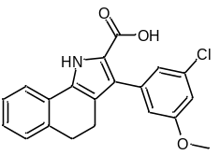3-(3-Chloro-5-methoxyphenyl)-4,5-dihydro-1H-benzo[g]indole-2-carboxylic acid (17y). ¹H NMR (500 MHz, MeOD) δ 7.67 (d, J = 7.5 Hz, 1H), 7.23 – 7.19 (m, 2H), 7.13 (t, J = 7.4 Hz, 1H), 6.94 (t, J = 1.5 Hz, 1H), 6.86 (d, J = 1.5 Hz, 2H), 3.79 (s, 3H), 2.87 (t, J = 7.5 Hz, 2H), 2.58 (t, J = 7.5 Hz, 2H); ¹³C NMR (126 MHz, MeOD) δ 164.12, 161.21, 138.91, 137.63, 134.78, 133.27, 129.84, 129.48, 129.28, 128.04, 127.81, 123.62, 122.32, 122.08, 120.01, 115.73, 113.51, 56.01, 30.79, 21.41; HRMS (ESI⁻) m/z: [M-H]⁻ calcd for C₂₀H₁₅ClNO₃ 352.0741; found, 352.0772; HPLC purity, 94.83%.
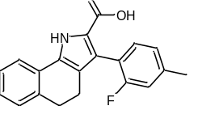3-(2-Fluoro-4-methylphenyl)-4,5-dihydro-1H-benzo[g]indole-2-carboxylic acid (17z). ¹H NMR (500 MHz, MeOD) δ 7.67 (d, J = 7.6 Hz, 1H), 7.23 (d, J = 7.4 Hz, 1H), 7.21 – 7.16 (m, 2H), 7.12 (td, J = 7.4, 1.1 Hz, 1H), 6.96 (d, J = 8.4 Hz, 1H), 6.92 (d, J = 10.9 Hz, 1H), 2.86 (t, J = 7.5 Hz, 2H), 2.50 (t, J = 7.5 Hz, 2H), 2.36 (s, 3H); ¹³C NMR (126 MHz, MeOD) δ 164.32, 162.36, 160.42, 140.43, 140.37, 137.61, 133.24, 133.21, 133.09, 129.67, 129.28, 127.87, 127.79, 125.07, 125.04, 124.44, 122.84, 122.18, 120.99, 120.85, 116.64, 116.4, 30.74, 21.34, 21.12; HRMS (ESI⁻) m/z: [M-H]⁻ calcd for C₂₀H₁₇FNO₂ 320.1092; found 320.1075; HPLC purity, 97.24%.
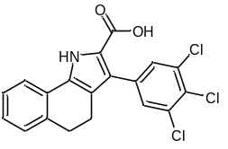3-(3,4,5-Trichlorophenyl)-4,5-dihydro-1H-benzo[g]indole-2-carboxylic acid (17aa). ¹H NMR (500 MHz, MeOD) δ 7.69 (d, J = 7.4 Hz, 1H), 7.51 (s, 2H), 7.27 – 7.21 (m, 2H), 7.16 (t, J = 7.4 Hz, 1H), 2.91 (t, J = 7.2 Hz, 2H), 2.62 (t, J = 7.2 Hz, 2H); ¹³C NMR (126 MHz, MeOD) δ 163.83, 137.61, 137.18, 134.01, 133.51, 131.77, 129.89, 129.34, 129.32, 128.23, 127.88, 122.43, 121.98, 120.40, 117.39, 30.70, 21.25; HRMS (ESI⁻) m/z: [M-H]⁻ calcd for C₂₀H₁₁Cl₃NO₂ 389.9856; found 389.9885; HPLC purity, 97.76%.
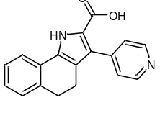3-(Pyridin-4-yl)-4,5-dihydro-1H-benzo[g]indole-2-carboxylic acid (17ab). ¹H NMR (500 MHz, DMSO) δ 12.16 (bs, 1H), 8.55 – 8.54 (d, J = 5.0 Hz, 2H), 7.96 (d, J = 7.5 Hz, 1H), 7.38 (d, J = 5.0 Hz, 2H), 7.22 (t, J = 7.5 Hz, 2H), 7.14 (t, J = 7.5 Hz, 1H), 2.84 (t, J = 7.4 Hz, 2H), 2.57 (t, J = 7.5 Hz, 2H); ¹³C NMR (126 MHz, DMSO) δ 162.05, 148.90, 148.70, 142.61, 135.63, 131.07, 128.08, 128.06, 126.64, 126.61, 125.16, 121.77, 120.24, 118.98, 39.52, 29.09, 19.88; HRMS (ESI⁻) m/z: [M-H]⁻ calcd for C₁₈H₁₅N₂O₂ 289.0983; found 289.0957; HPLC purity, 90.73%.
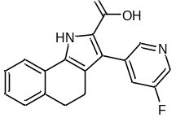3-(5-Fluoropyridin-3-yl)-4,5-dihydro-1H-benzo[g]indole-2-carboxylic acid (17ac). ¹H NMR (500 MHz, MeOD) δ 8.42 (s, 1H), 8.37 (s, 1H), 7.71 (t, J = 7.3 Hz, 2H), 7.24 (d, J = 7.6 Hz, 2H), 7.18 – 7.17 (m, 1H), 2.9 (t, J = 6.8 Hz, 2H), 2.65 (t, J = 6.8 Hz, 2H); ¹³C NMR (126 MHz, MeOD) δ 147.63, 137.61, 136.05, 136.05, 135.86, 129.35, 129.29, 128.27, 127.91, 126.43, 126.28, 122.47, 122.22, 120.74, 30.70, 21.23; HRMS (ESI⁻) m/z: [M-H]⁻ calcd for C₁₈H₁₃FN₂O₂ 307.0888; found 307.0863; HPLC purity, 93.59%.
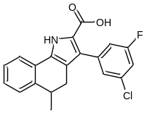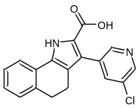3-(5-Chloropyridin-3-yl)-4,5-dihydro-1H-benzo[g]indole-2-carboxylic acid (17ad). ¹H NMR (500 MHz, DMSO) δ 12.43 (bs, 1H), 12.25 (bs, 1H), 8.52 (dd, J = 7.5, 2 Hz, 2H), 7.97 (d, J = 7.5 Hz, 1H), 7.93 (s, 1H), 7.23 (t, J = 7.5 Hz, 2H), 7.15 (t, J = 7.3 Hz, 1H), 2.86 (t, J = 7.4 Hz, 2H), 2.57 (t, J = 7.4 Hz, 2H); ¹³C NMR (126 MHz, DMSO) δ 161.69, 148.79, 145.73, 136.80, 135.74, 132.02, 131.43, 130.07, 128.14, 127.94, 126.81, 126.64, 123.09, 121.86, 120.61, 119.76, 29.01, 19.62; HRMS (ESI⁻) m/z: [M-H]⁻ calcd for C₁₈H₁₂ClN₂O₂ 323.0588; found 323.0619; HPLC purity, 97.99%.
3-(3-Chloro-5-fluorophenyl)-5-methyl-4,5-dihydro-1H-benzo[g]indole-2-carboxylic acid (17ae). ¹H NMR (500 MHz, MeOD) δ 7.70 (d, J = 7.7 Hz, 1H), 7.28 – 7.22 (m, 2H), 7.22 – 7.17 (m, 2H), 7.12 – 7.09 (m, 1H), 7.08-7.05 (M, 1H), 3.07-3.03 (m, 1H), 2.79 (dd, J = 15.4, 6.1 Hz, 1H), 2.41 (dd, J = 15.4, 5.8 Hz, 1H), 1.19 (d, J = 7.0 Hz, 3H); ¹³C NMR (126 MHz, DMSO) δ 162.46, 161.67, 160.51, 140.56, 138.46, 138.39, 132.80, 132.70, 130.63, 127.07, 127.04, 126.85, 126.50, 126.23, 122.01, 119.45, 118.89, 115.99, 115.82, 113.95, 113.75, 33.16, 27.52, 20.72; HRMS (ESI⁻) m/z: [M-H]⁻ calcd for C₂₀H₁₄ClFNO₂ 354.0697; found 354.0735; HPLC purity, 95.97%.
3-(3,5-Dichlorophenyl)-1-methyl-4,5-dihydro-1H-benzo[g]indole-2-carboxylic acid (17af).
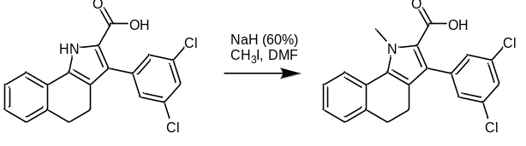
To a round-bottomed flask purged and maintained with an inert atmosphere was added 3-(3,5-dichlorophenyl)-4,5-dihydro-1H-benzo[g]indole-2-carboxylic acid in DCM. The resulting solution was cooled to 0 °C, NaH was added and stirred for half an hour. The reaction mixture was allowed to rise at room temperature, methyl iodide was added dropwise and stirred overnight. The reaction was quenched with ammonium chloride and extracted with ethyl acetate. The organic layers were collected and dried over sodium sulphate. ¹H NMR (500 MHz, DMSO) δ 12.29 (bs, 1H), 7.97 (d, J = 7.6 Hz, 1H), 7.53 (s, 1H), 7.42 – 7.38 (m, 2H), 7.27 – 7.21 (m, 2H), 7.16 (t, J = 7.4 Hz, 1H), 3.71 (s, 3H), 2.85 (t, J = 7.2 Hz, 2H), 2.56 (t, J = 7.2 Hz, 2H); ¹³C NMR (126 MHz, DMSO) δ 160.50, 137.93, 135.87, 133.11, 131.77, 128.60, 128.18, 127.78, 126.98, 126.62, 126.12, 126.08, 121.95, 120.49, 118.29, 50.99, 28.95, 19.64; HRMS (ESI⁻) m/z: [M-H]⁻ calcd for C₂₀H₁₄Cl₂NO₂ 370.0402; found 370.0422; HPLC purity, 97.34%.
NMR DATA
¹H NMR of 9 (500 MHz, MeOD)
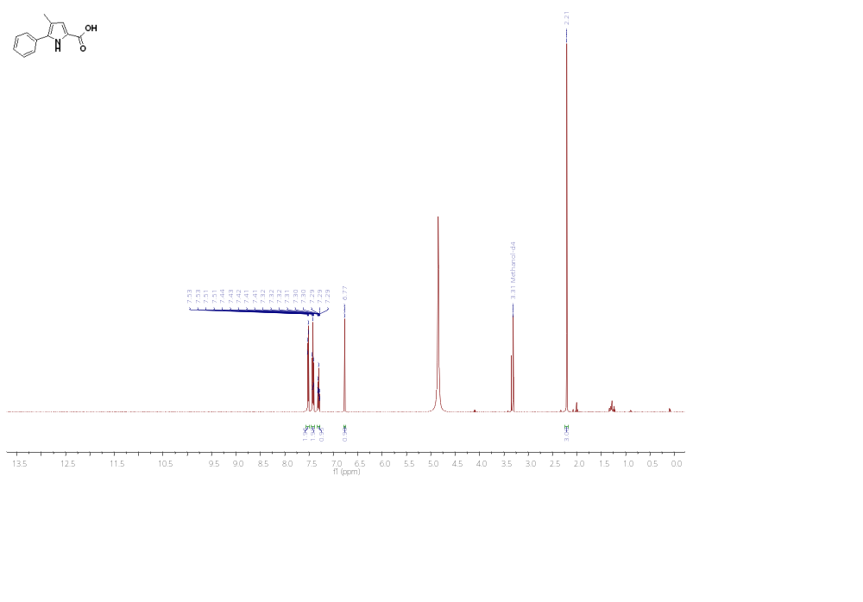

¹H NMR of 12 (301 MHz, DMSO)
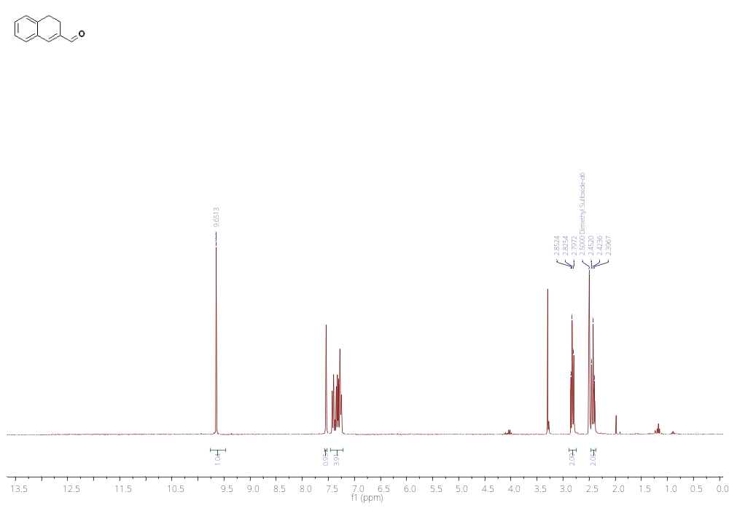
¹H NMR of 14 (301 MHz, DMSO)
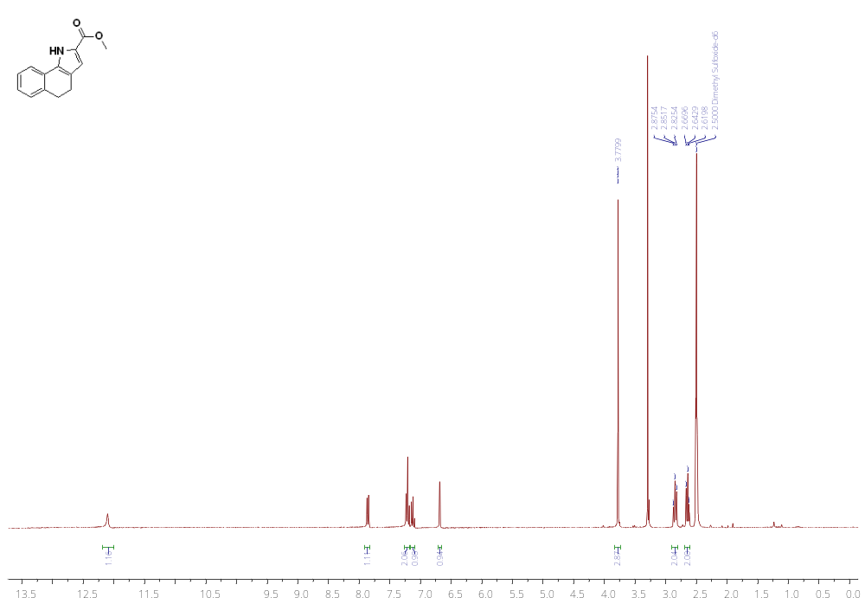
¹H NMR of 14af (500 MHz, CDCl₃)
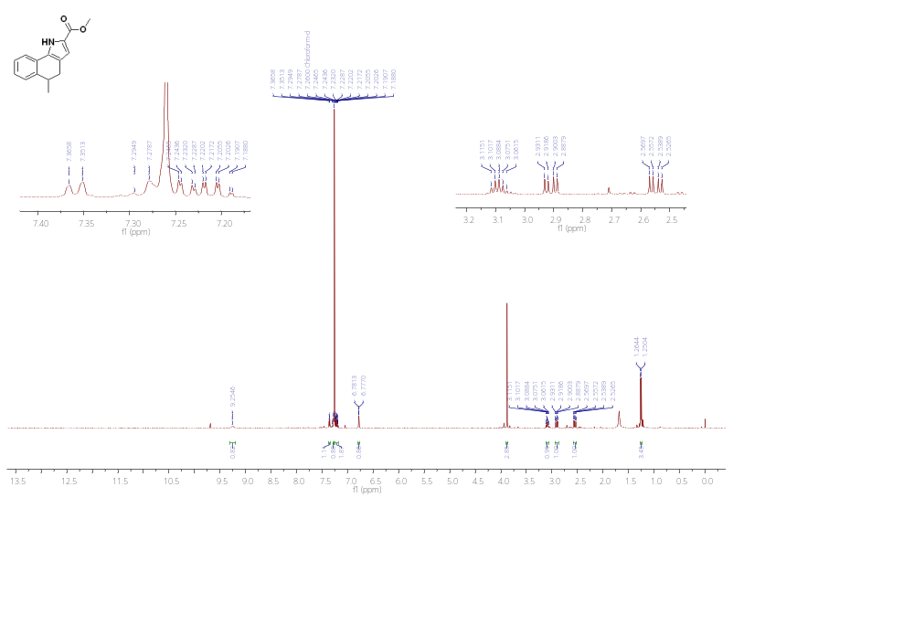
¹H NMR of 15 (301 MHz, DMSO)
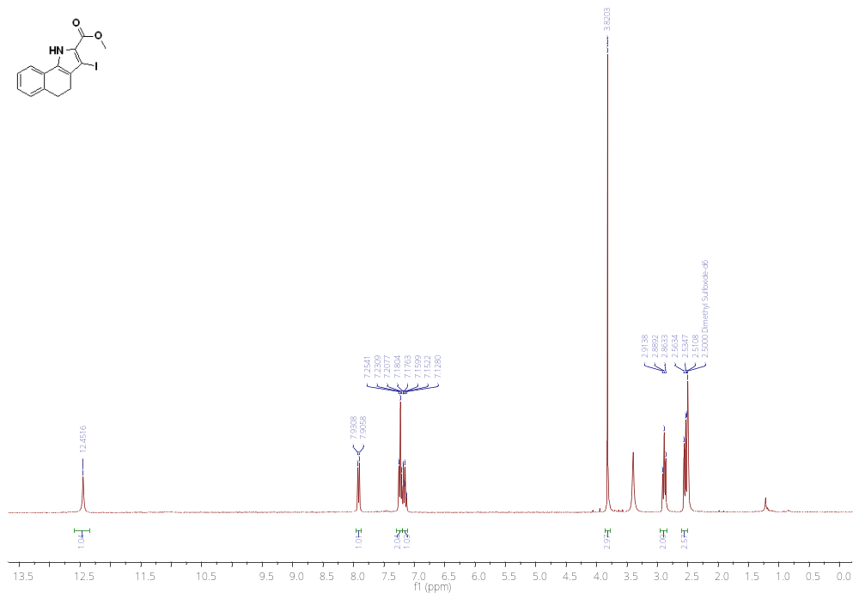
¹H NMR of 16c (500 MHz, DMSO)
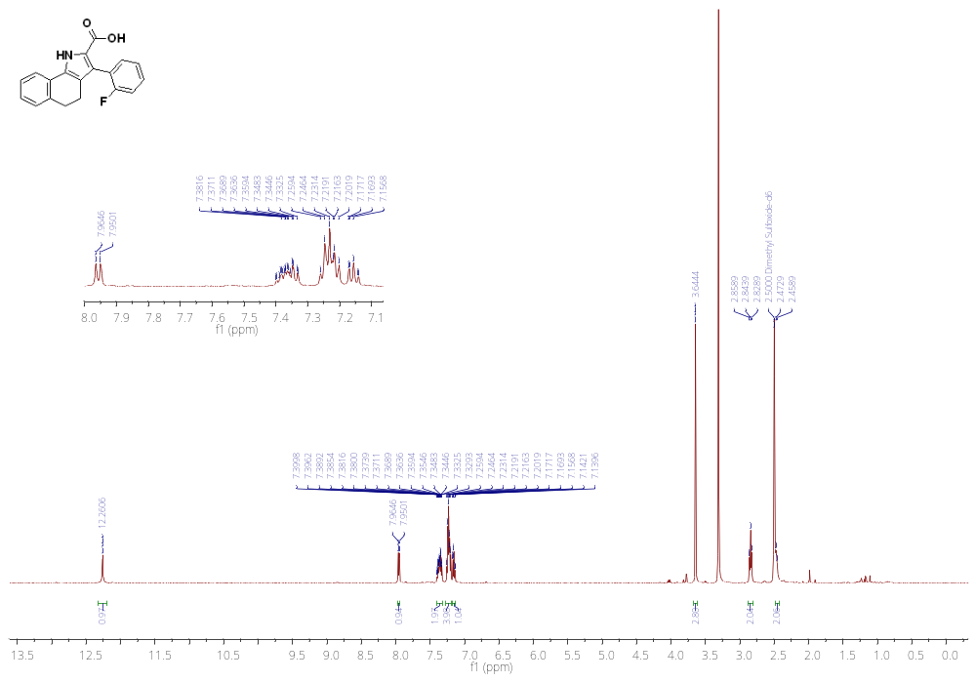
¹H NMR of 16d (500 MHz, DMSO)
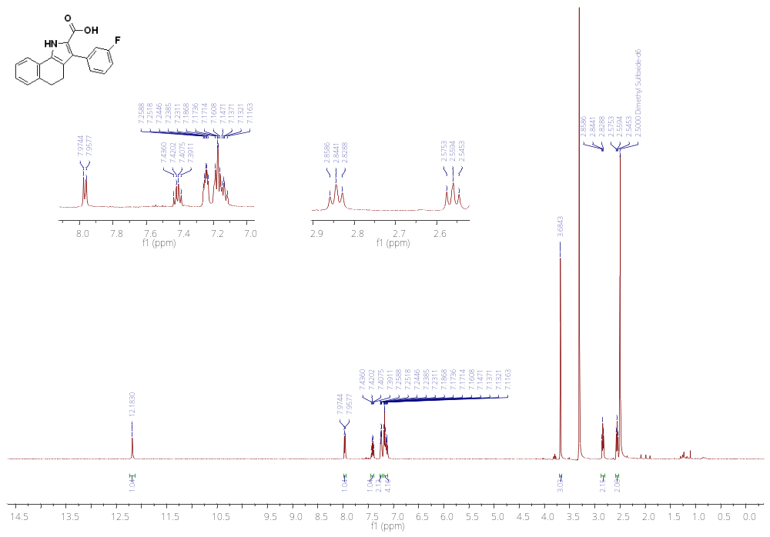
¹H NMR of 16e (500 MHz, DMSO)
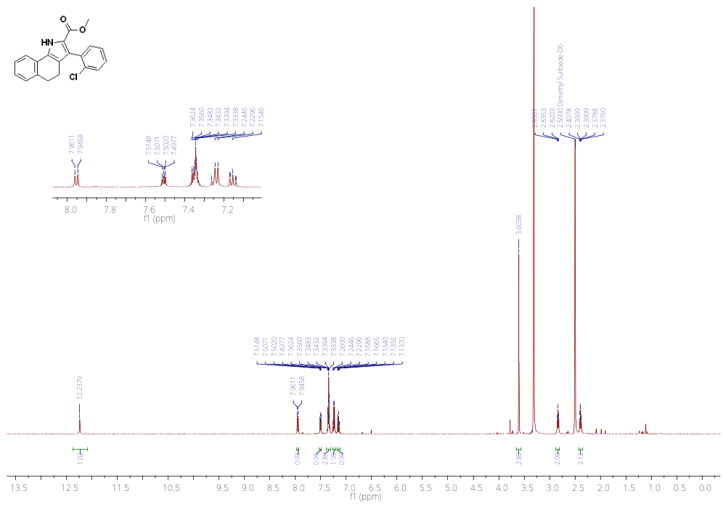
¹H NMR of 16f (500 MHz, DMSO)
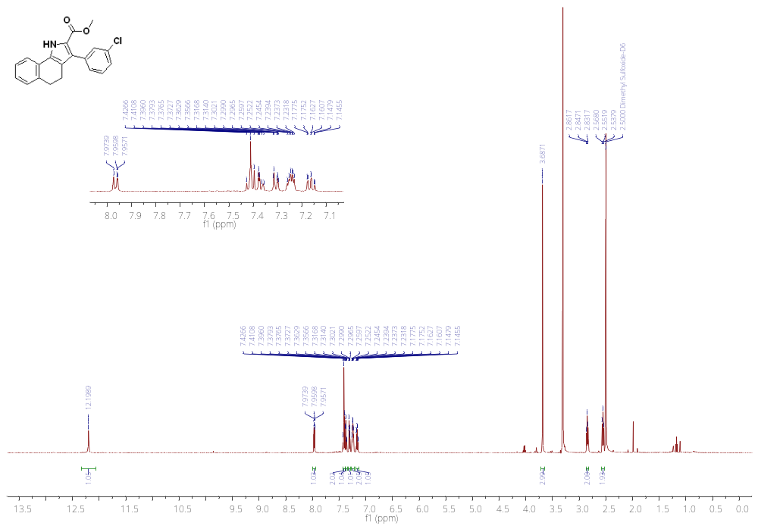
¹H NMR of 16g (500 MHz, DMSO)
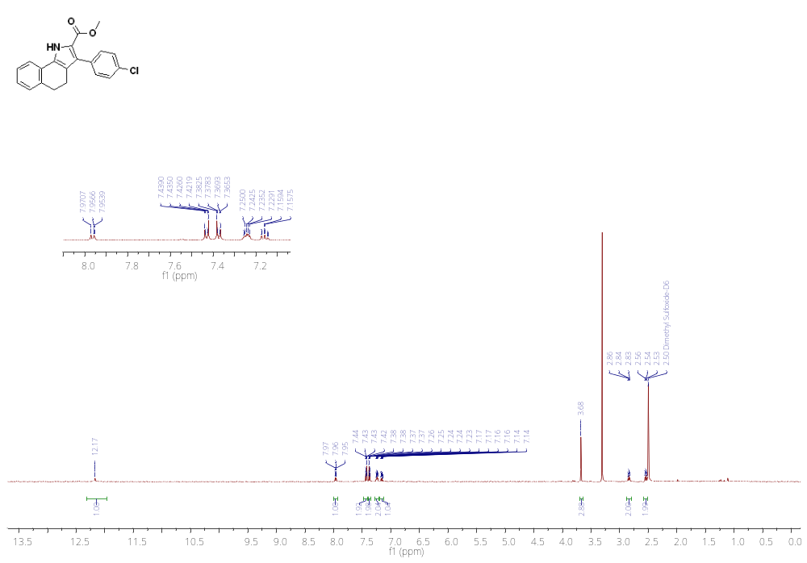
¹H NMR of 16h (500 MHz, CDCl₃)
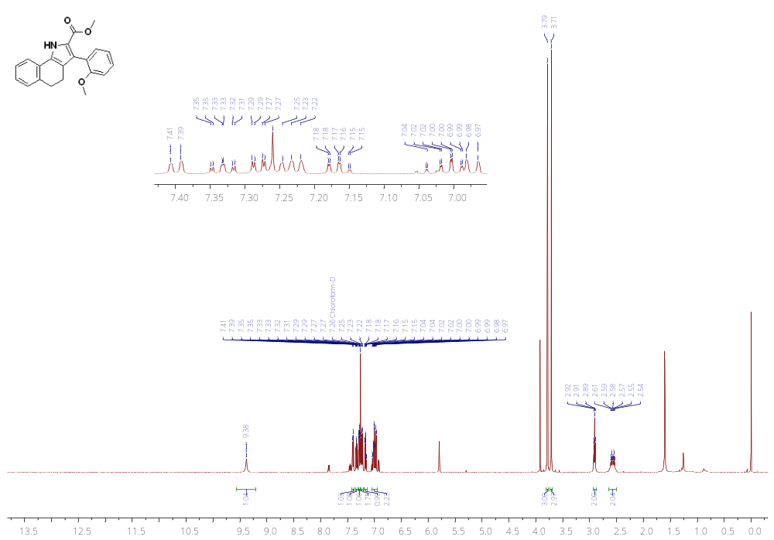
¹H NMR of 16i (500 MHz, CDCl₃)
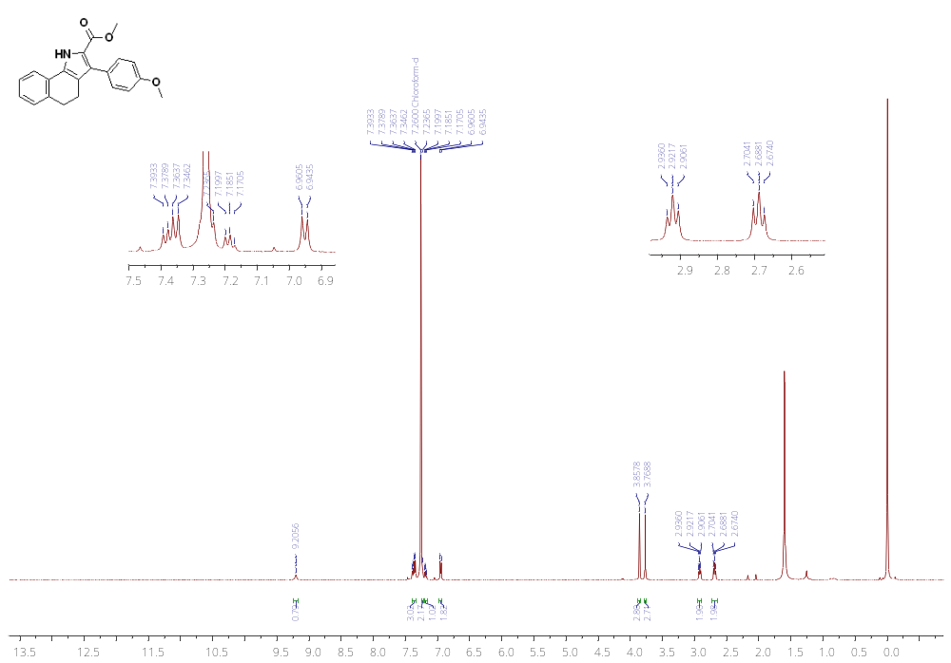
¹H NMR of 16j (500 MHz, CDCl₃)
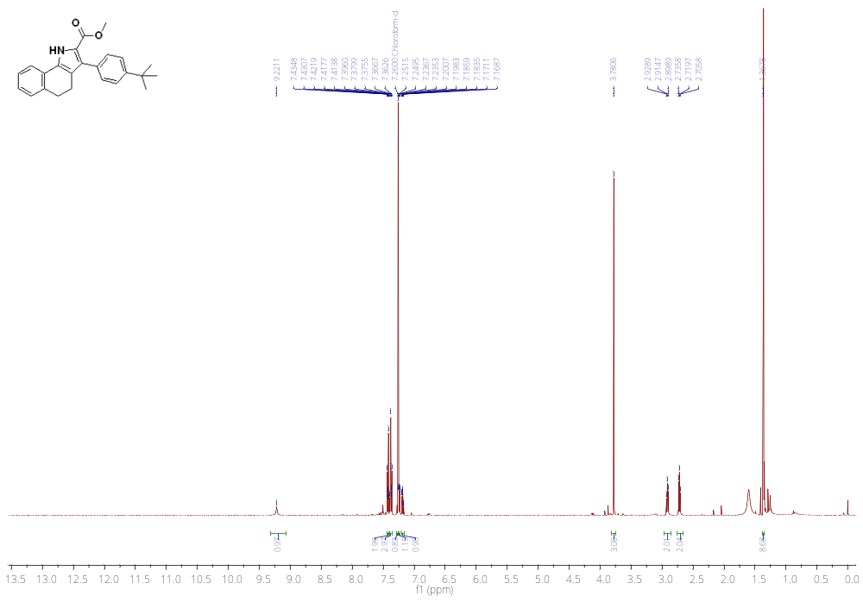
¹H NMR of 16k (500 MHz, DMSO)
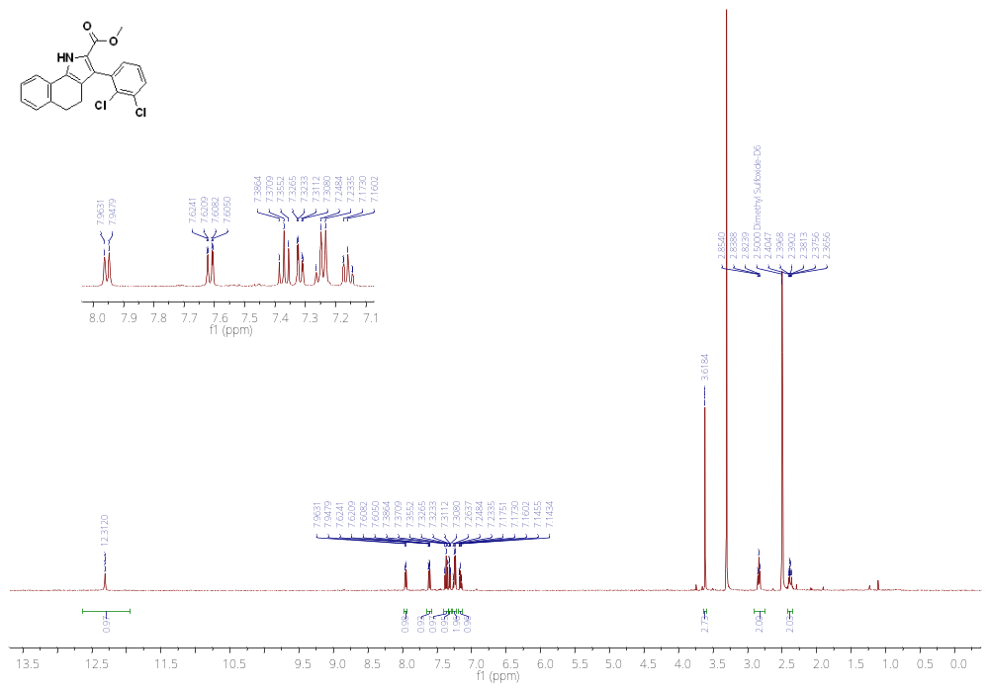
¹H NMR of 16l (500 MHz, DMSO)
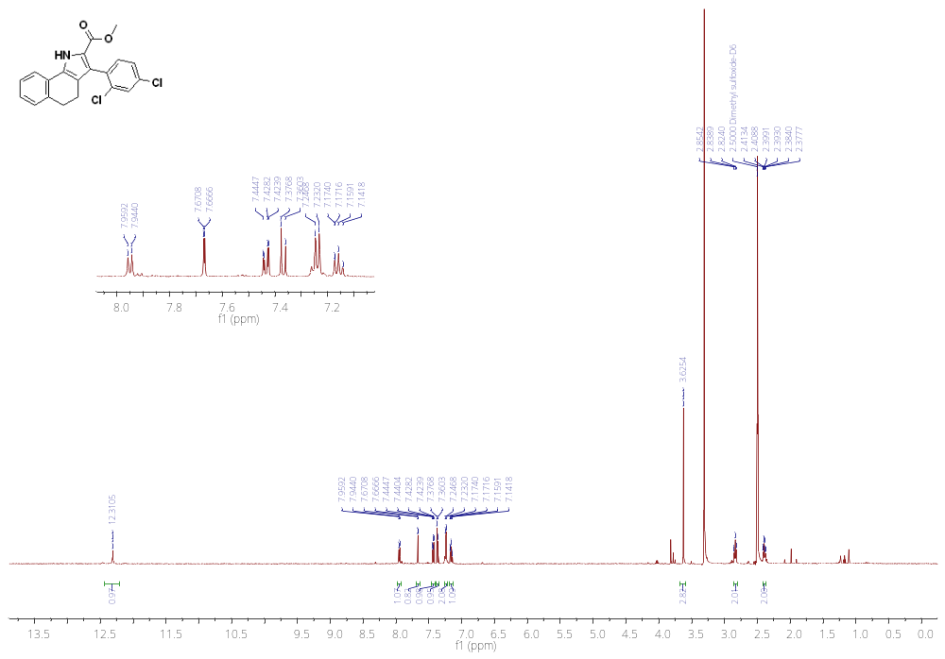
¹H NMR of 16m (500 MHz, CDCl₃)
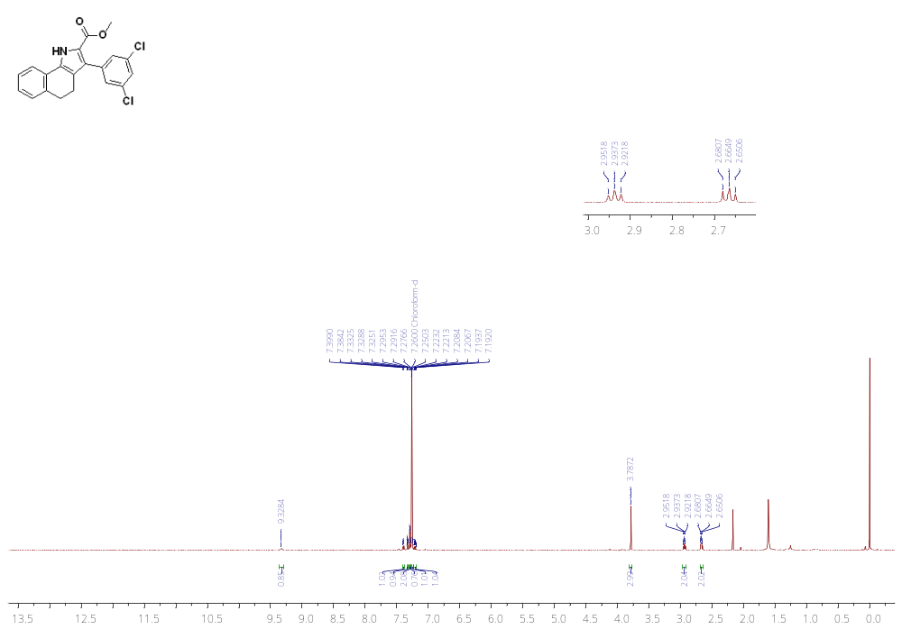
¹H NMR of 16o (500 MHz, CDCl₃)
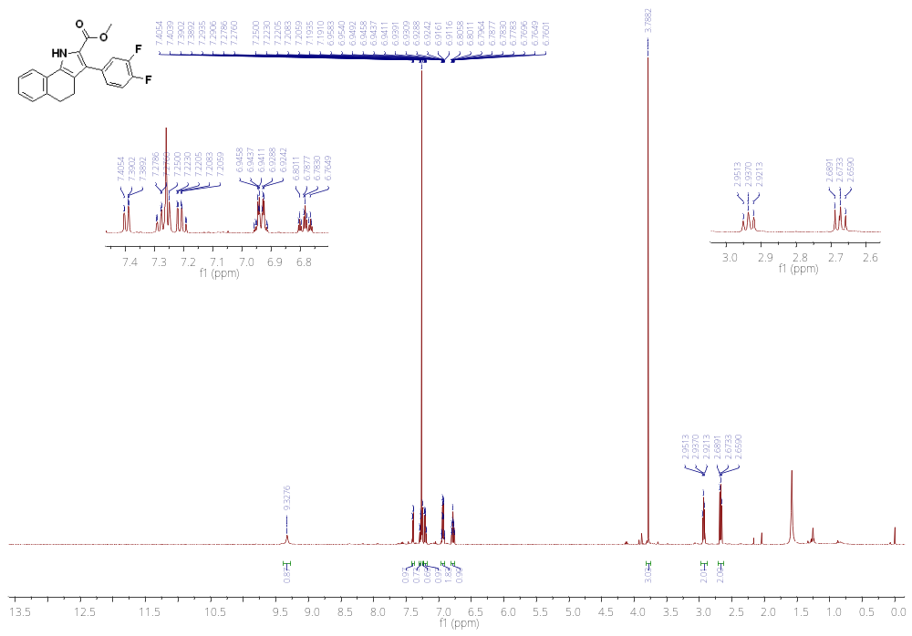
¹H NMR of 16p (500 MHz, CDCl₃)
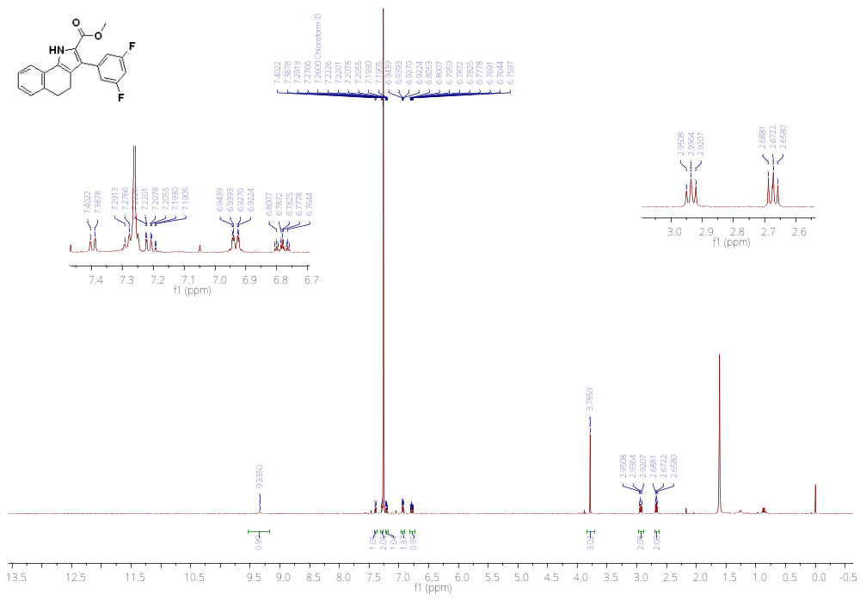
¹H NMR of 16q (500 MHz, CDCl₃)
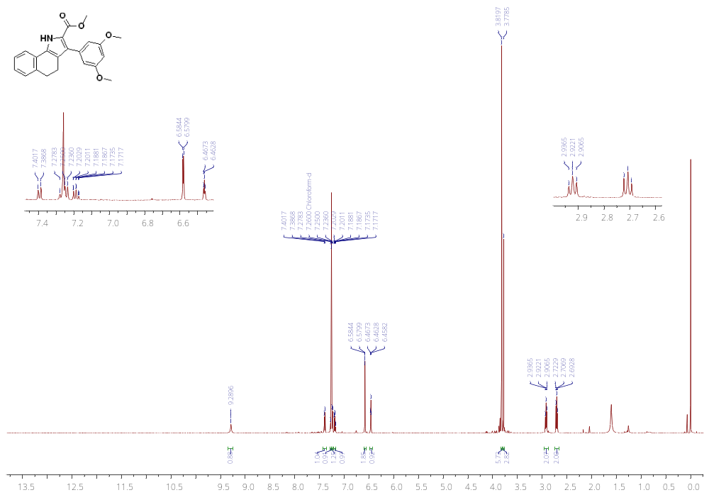
¹H NMR of 16r (500 MHz, DMSO)
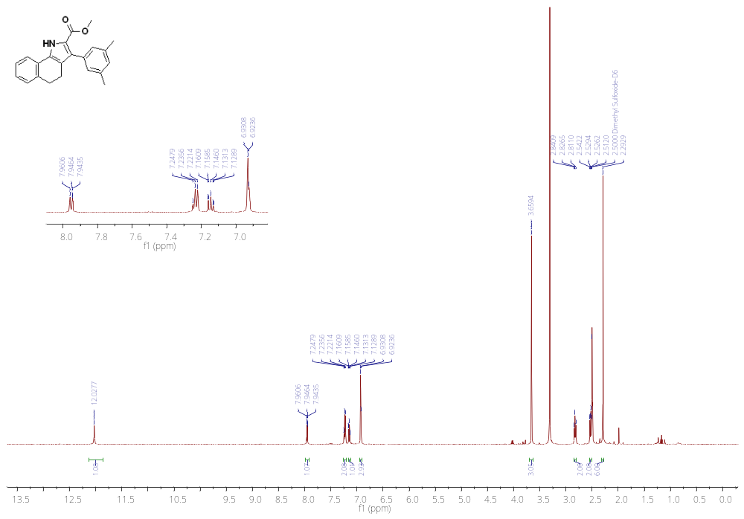
¹H NMR of 16s (500 MHz, CDCl₃)
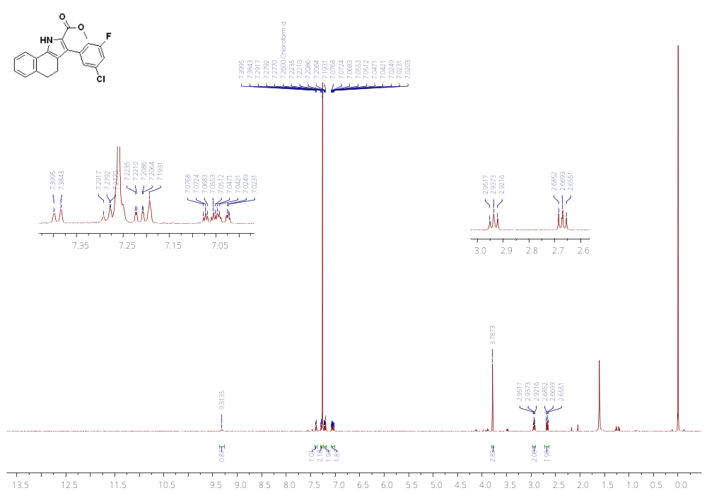
¹H NMR of 16u (500 MHz, CDCl₃)
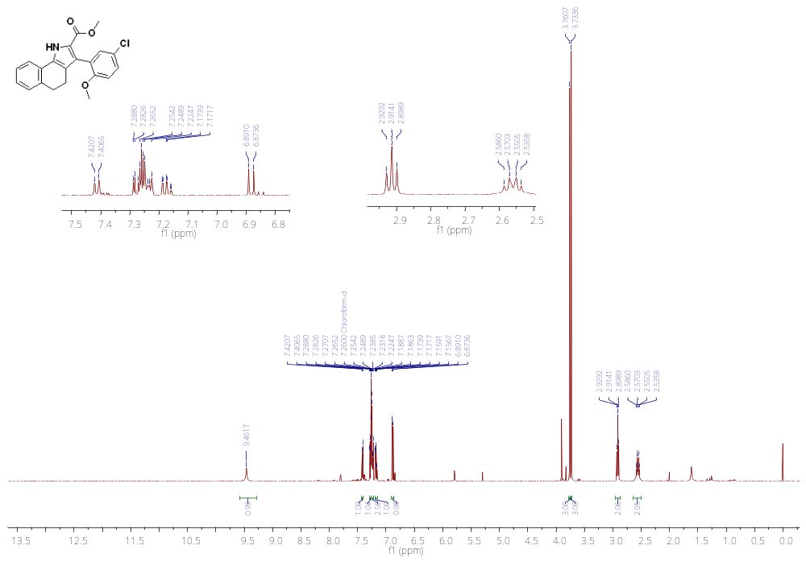
¹H NMR of 16v (500 MHz, CDCl₃)
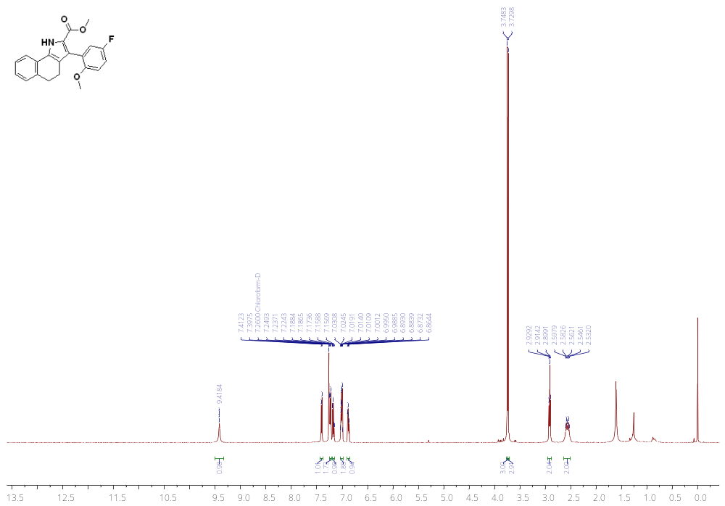
¹H NMR of 16w (500 MHz, CDCl₃)
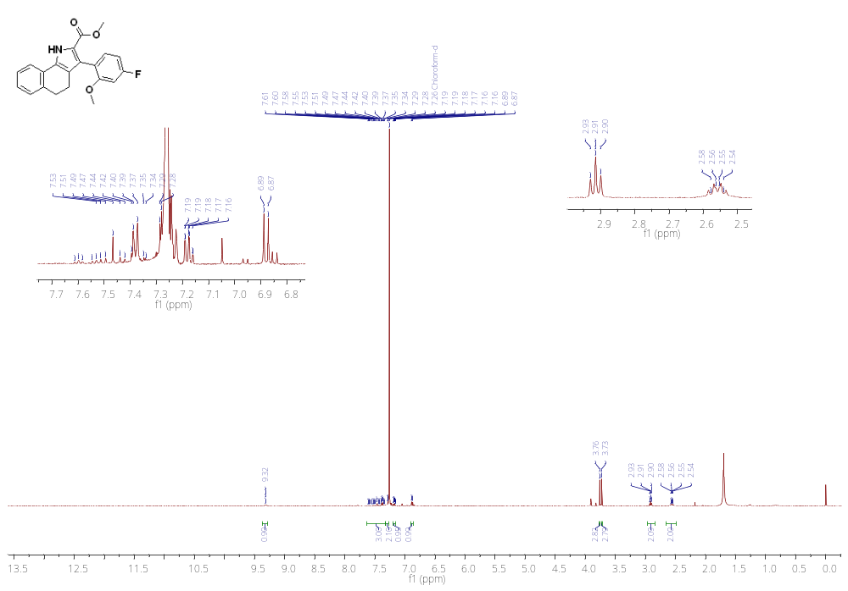
¹H NMR of 16x (500 MHz, CDCl₃)
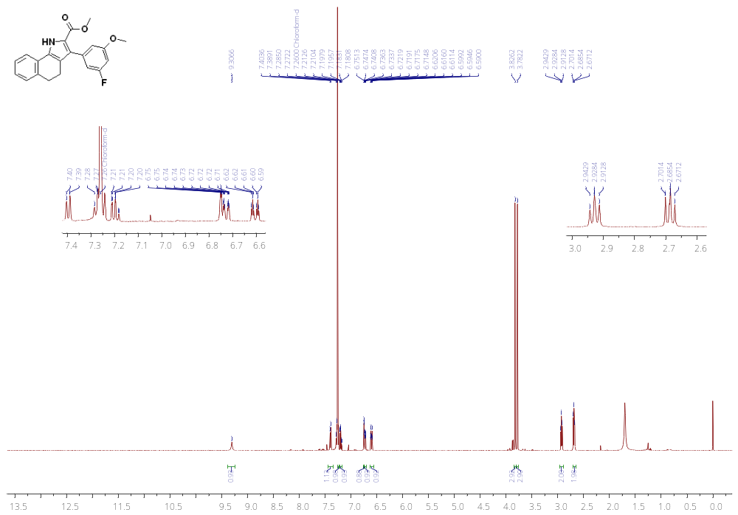
¹H NMR of 16y (500 MHz, CDCl₃)
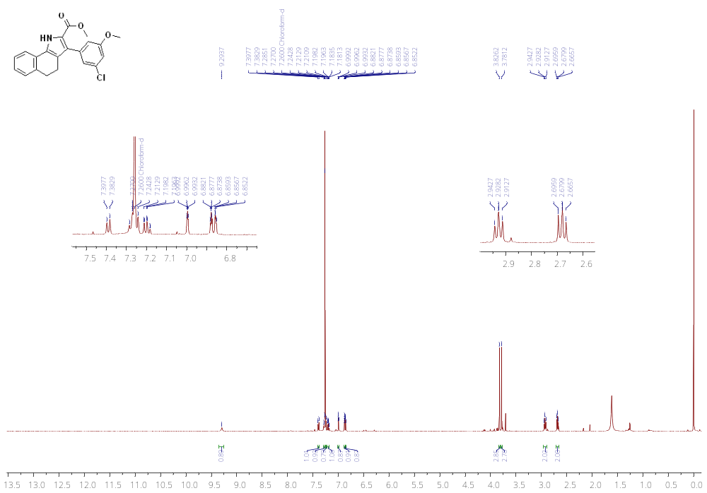
¹H NMR of 16z (500 MHz, DMSO)
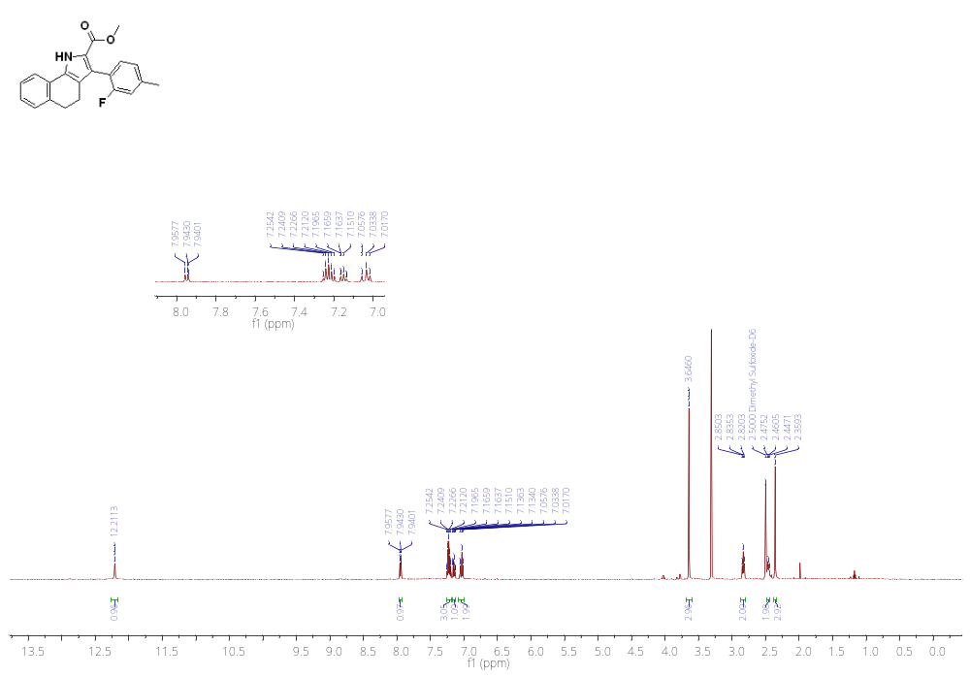
¹H NMR of 16aa (500 MHz, CDCl₃)
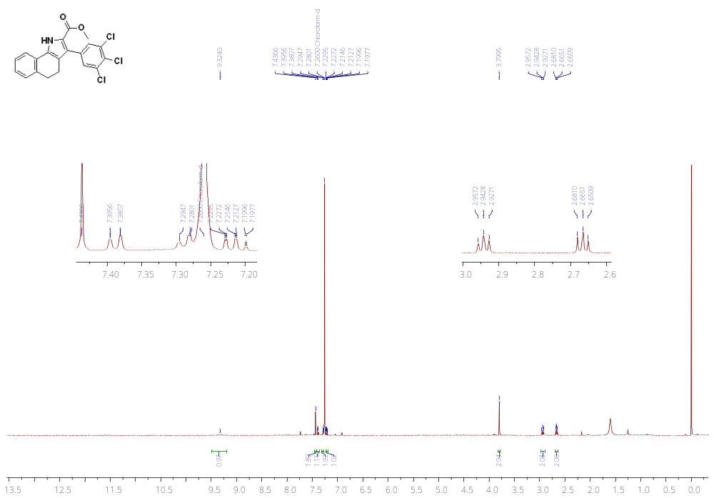
¹H NMR of 16ab (500 MHz, MeOD)
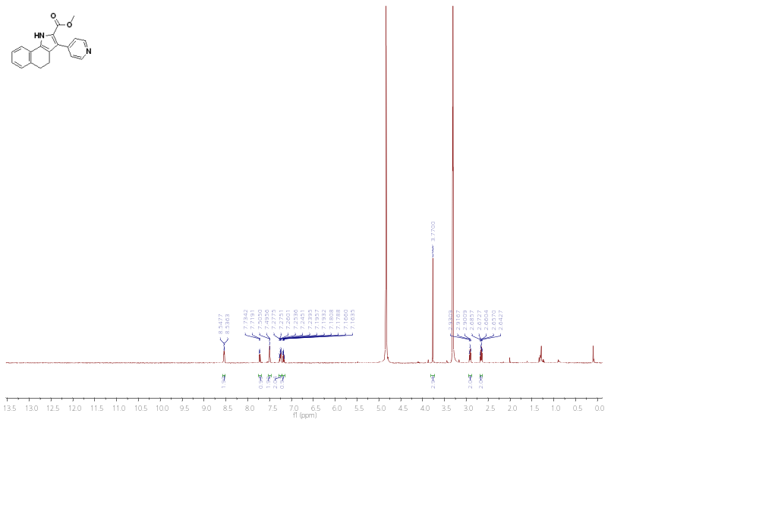
¹H NMR of 16ac (500 MHz, DMSO)
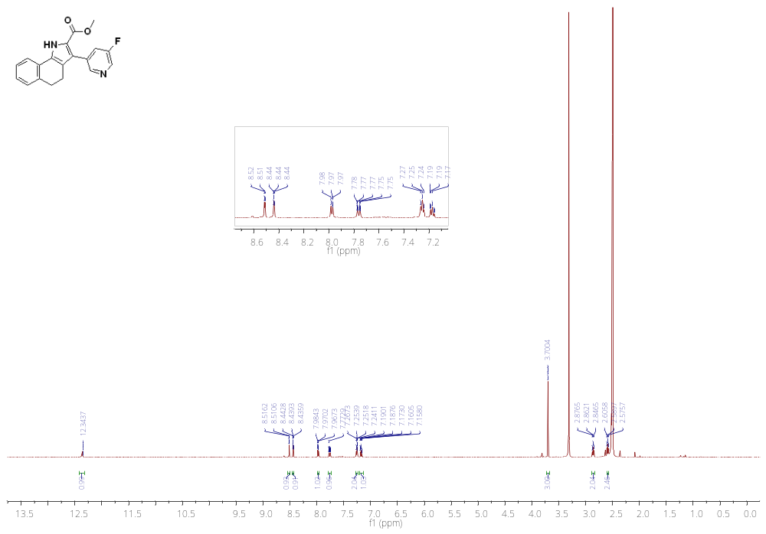
¹H NMR of 16ad (500 MHz, DMSO)
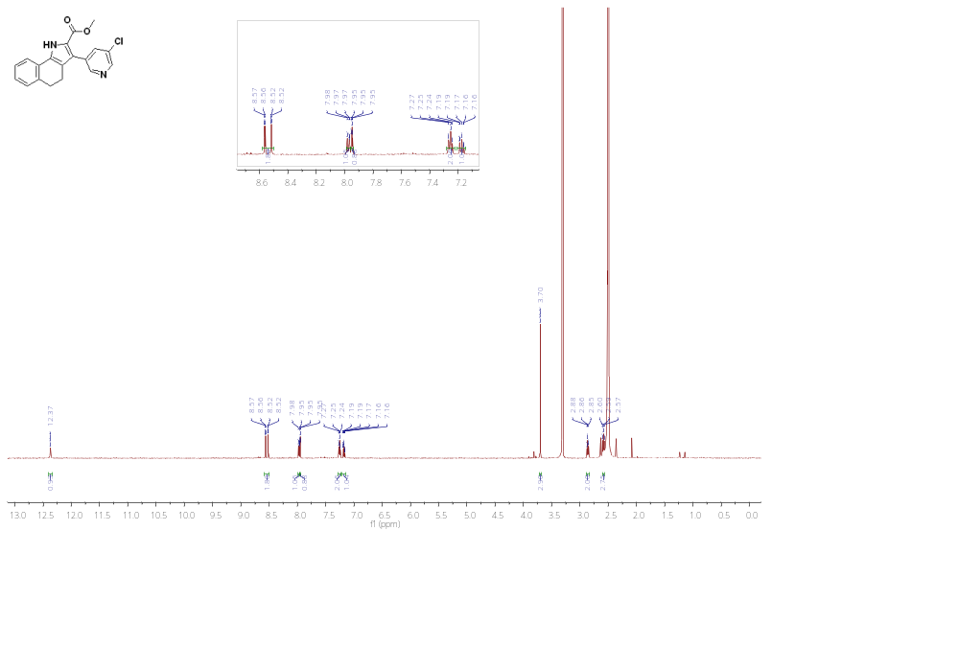
¹H NMR of 17a (500 MHz, MeOD)
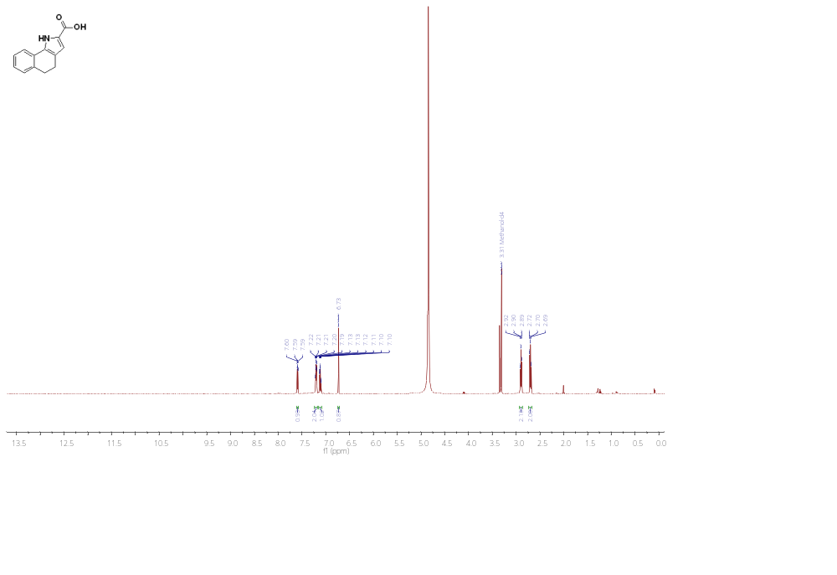
¹³C NMR of 17a (126 MHz, MeOD)
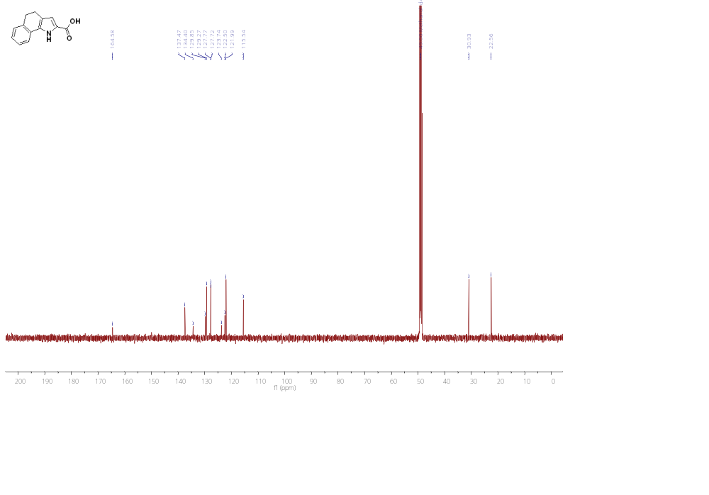

¹H NMR of 17b (500 MHz, MeOD)
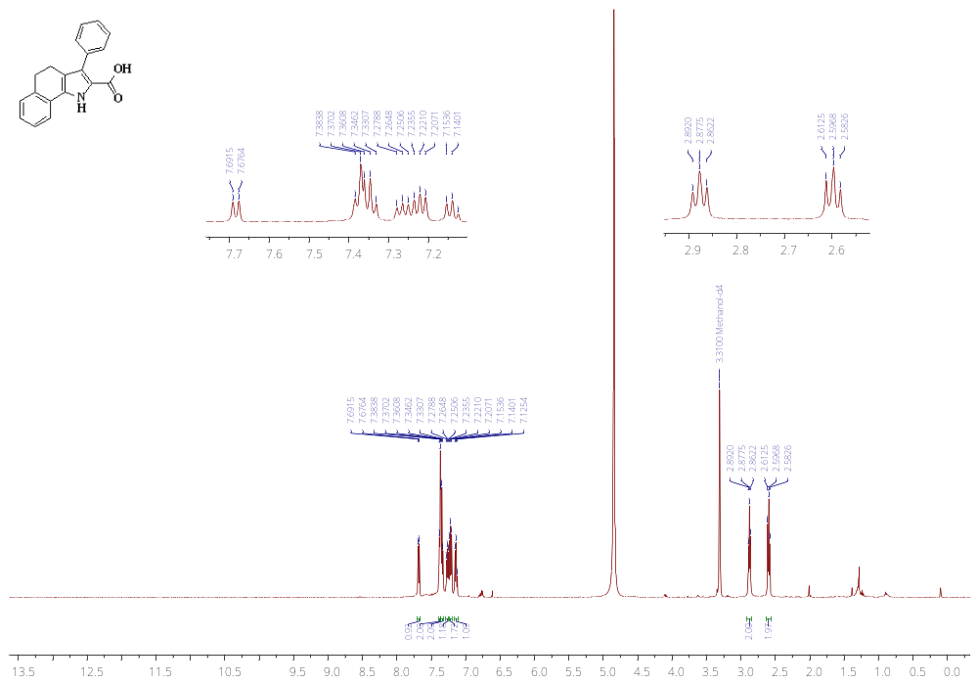
¹³C NMR of 17b (126 MHz, DMSO)
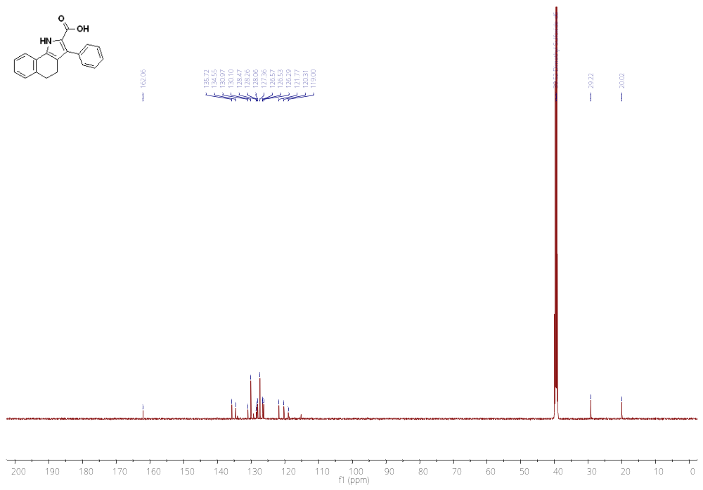
¹H NMR of 17c (500 MHz, MeOD)
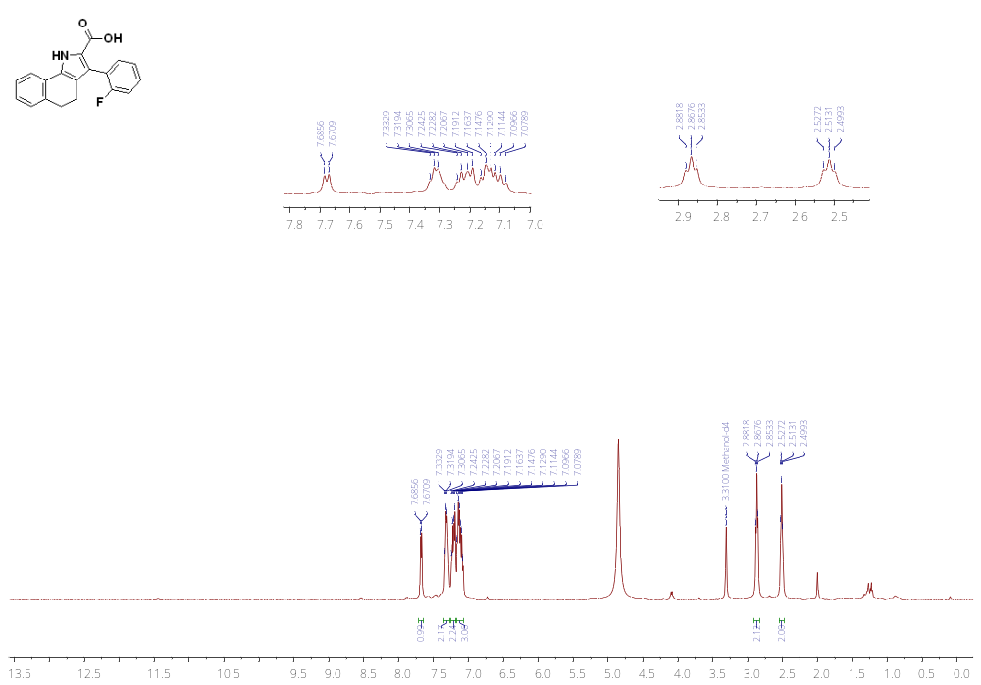
¹³C NMR of 17c (126 MHz, MeOD)
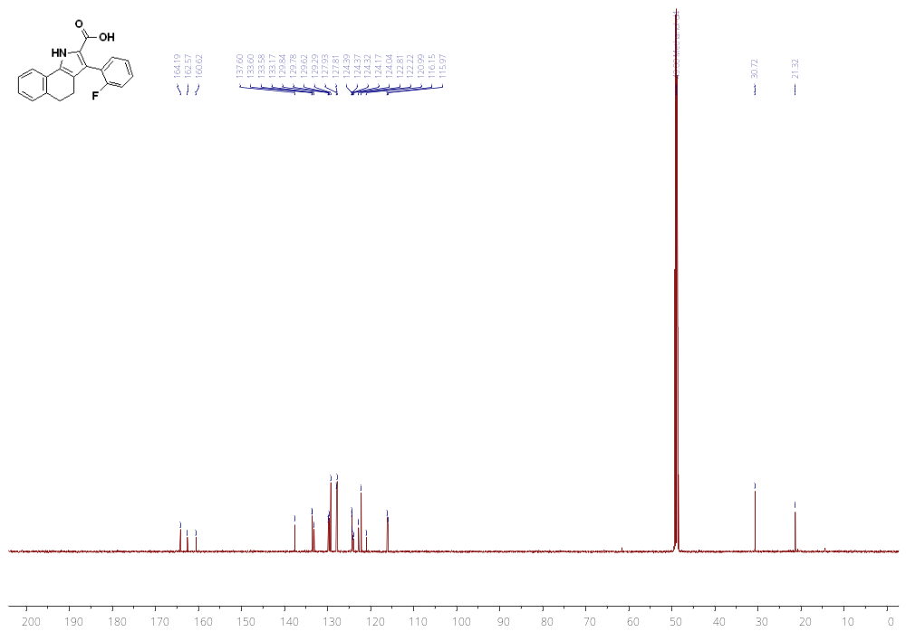
¹H NMR of 17d (500 MHz, MeOD)
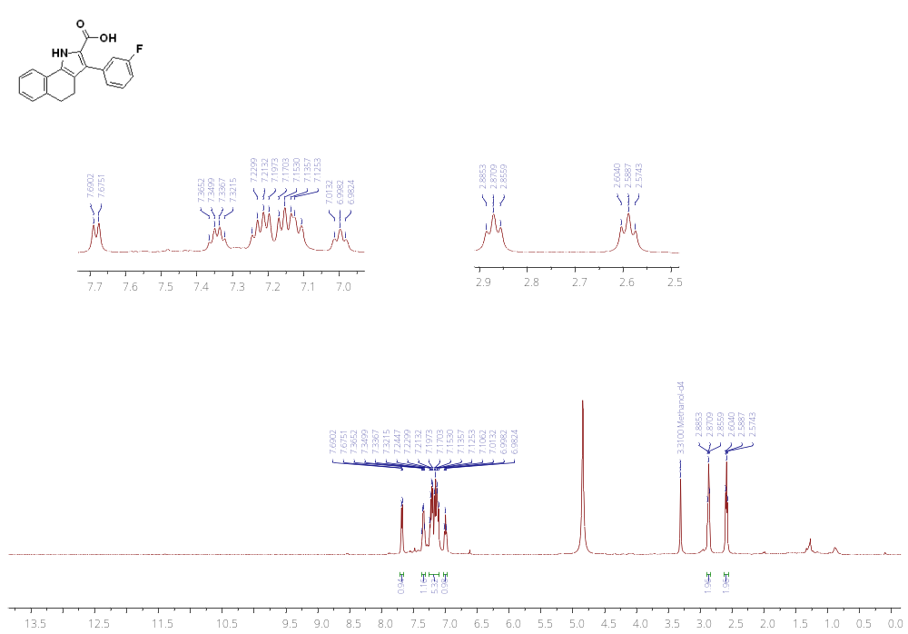
¹³C NMR of 17d (126 MHz, MeOD)
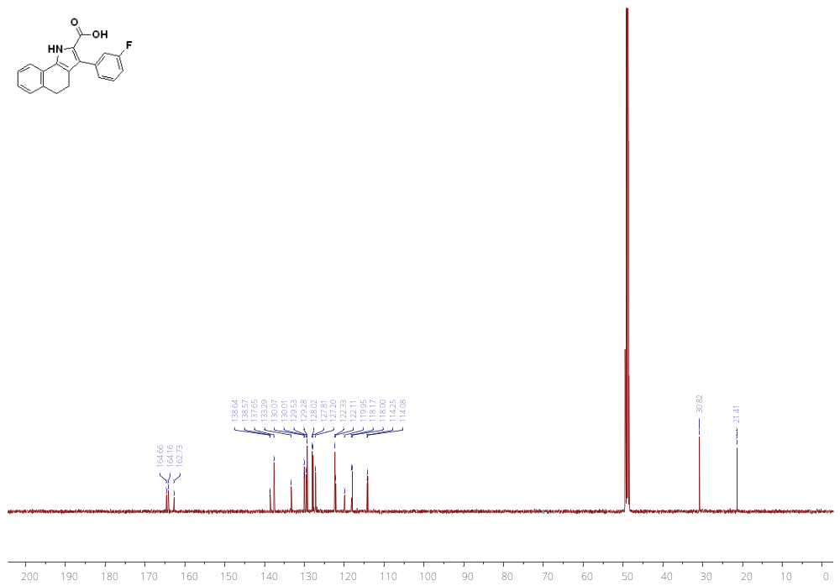
¹H NMR of 17e (500 MHz, MeOD)
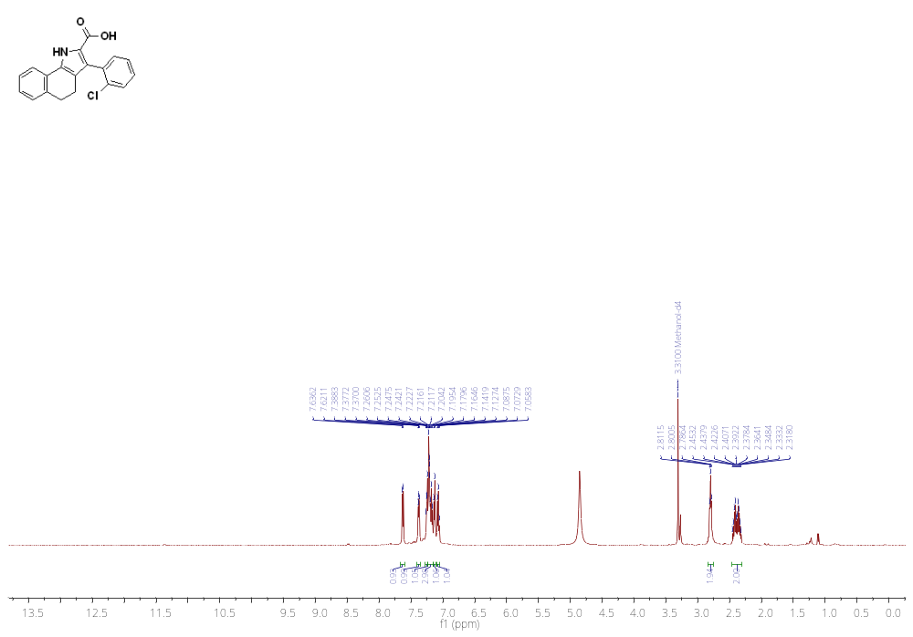
¹³C NMR of 17e (126 MHz, MeOD)
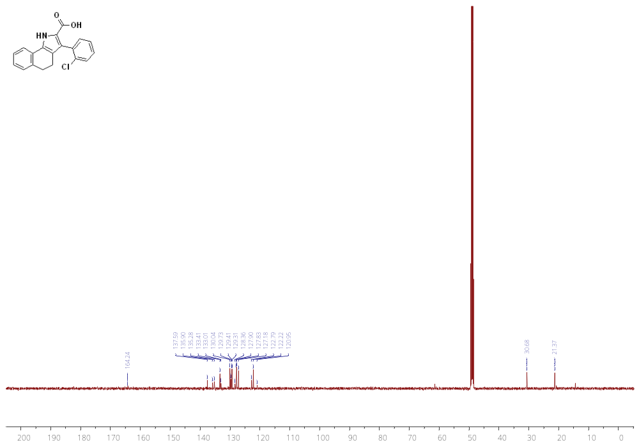
¹H NMR of 17f (500 MHz, MeOD)
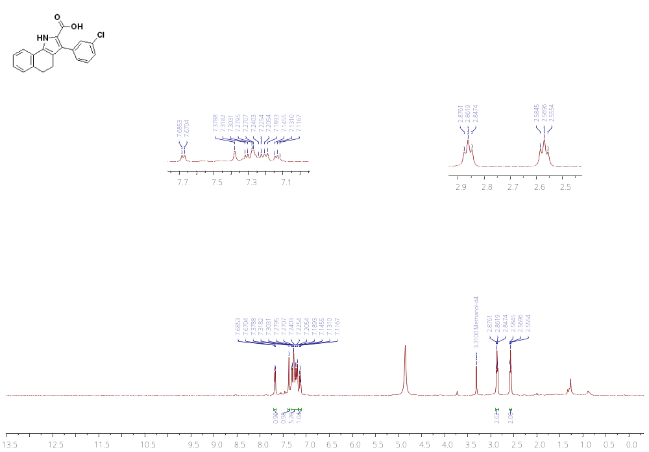
¹³C NMR of 17f (126 MHz, MeOD)
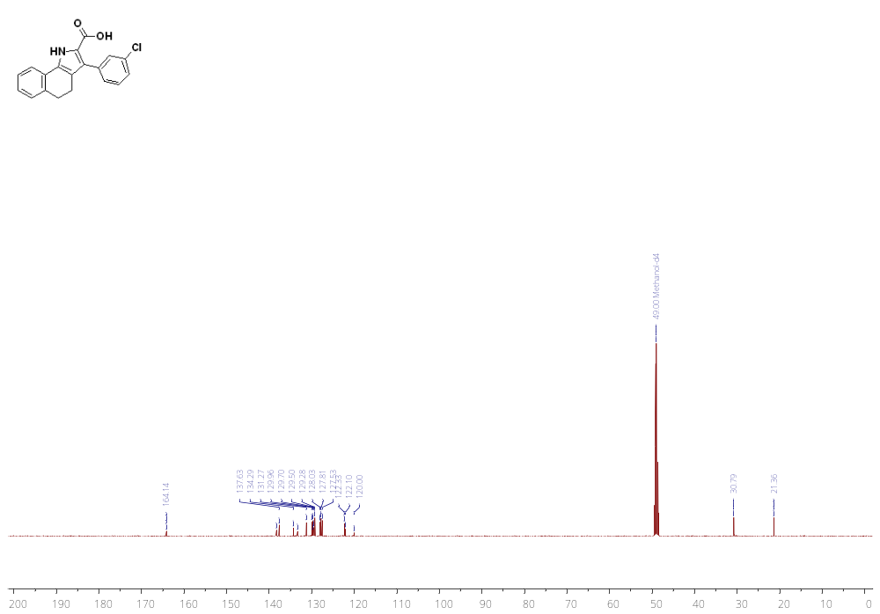
¹H NMR of 17g (500 MHz, DMSO)
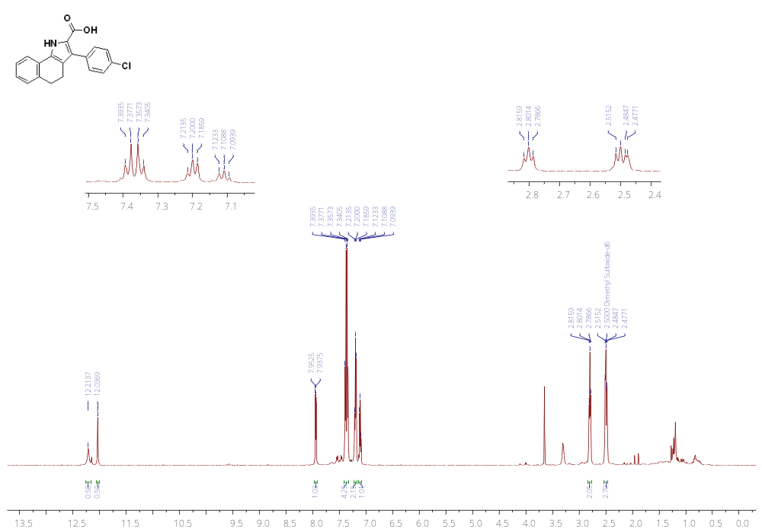
¹³C NMR of 17g (126 MHz, DMSO)
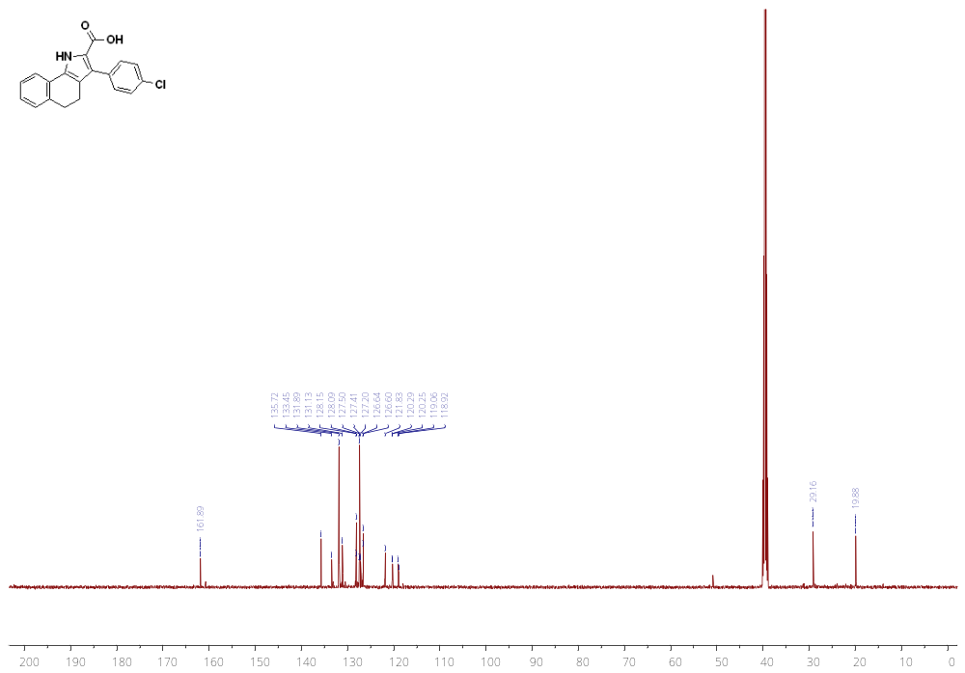
¹H NMR of 17h (500 MHz, MeOD)
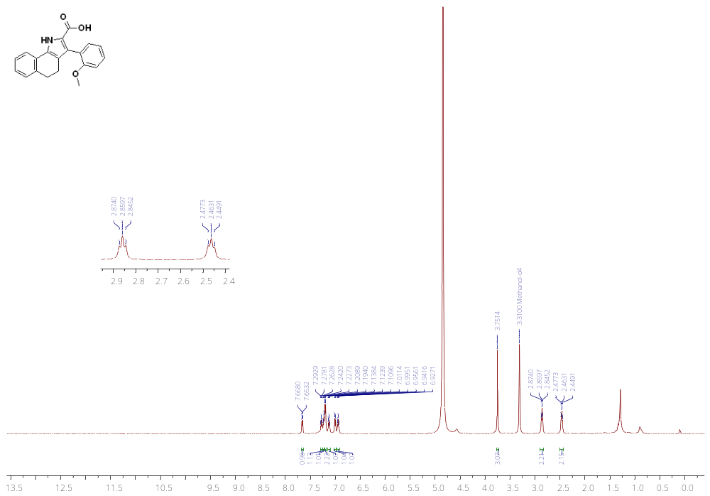
¹³C NMR of 17h (126 MHz, MeOD)
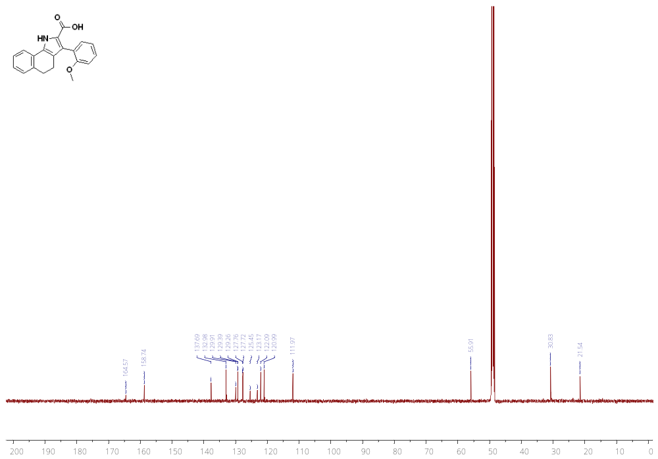
¹H NMR of 17i (500 MHz, MeOD)
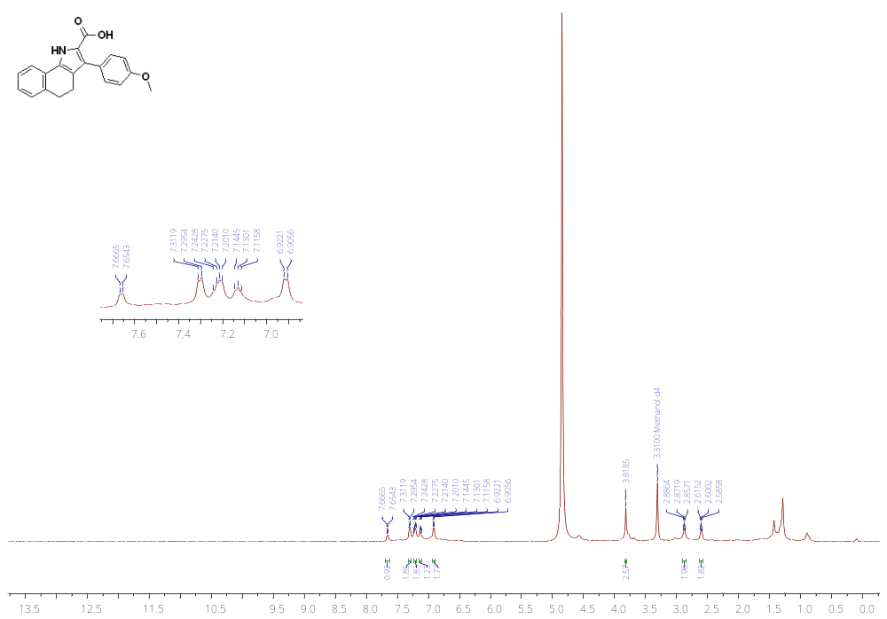
¹H NMR of 17j (301 MHz, CHLOROFORM-D)
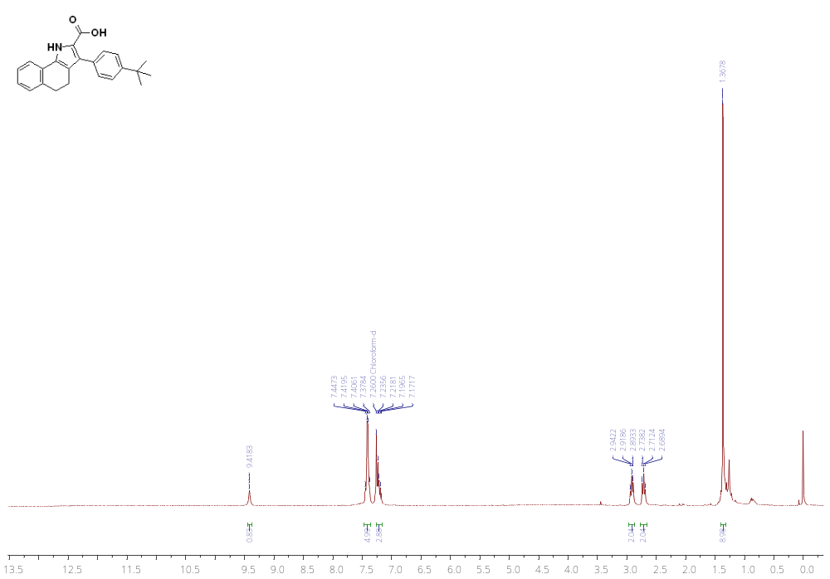
¹³C NMR of 17j (76 MHz, CHLOROFORM-D)
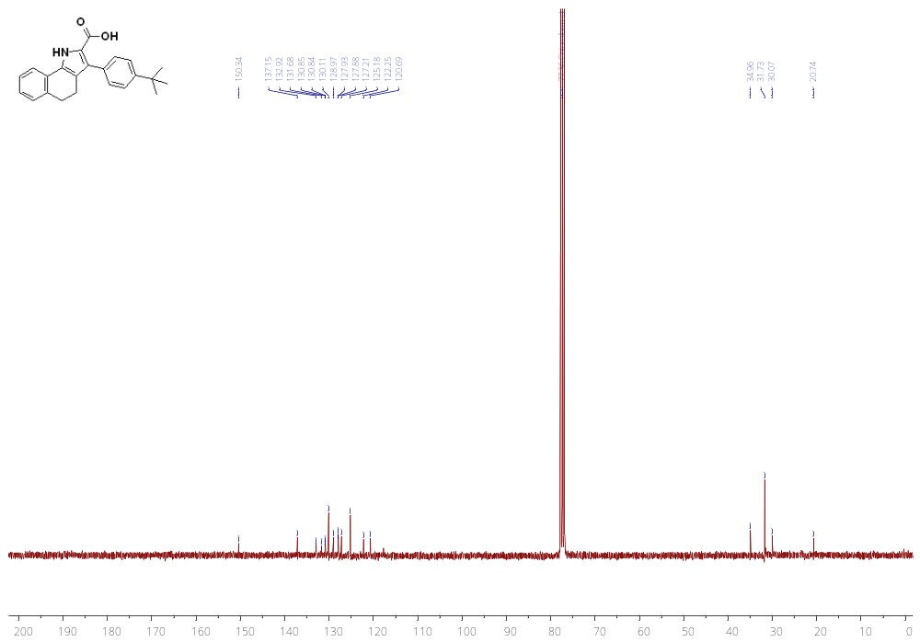
¹H NMR of 17k (500 MHz, MeOD)
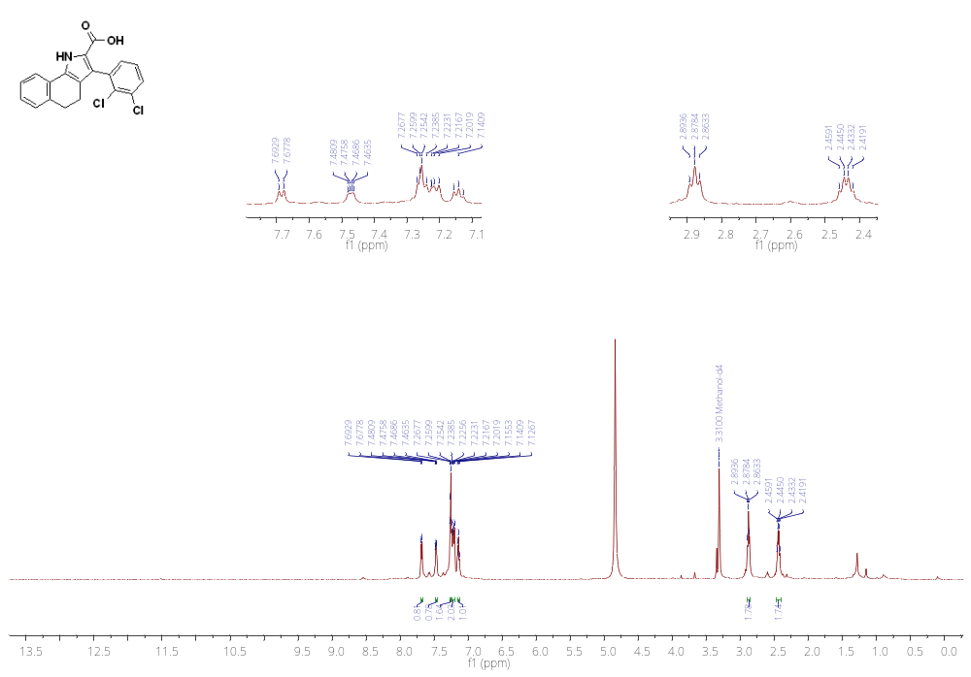
¹³C NMR of 17k (126 MHz, MeOD)
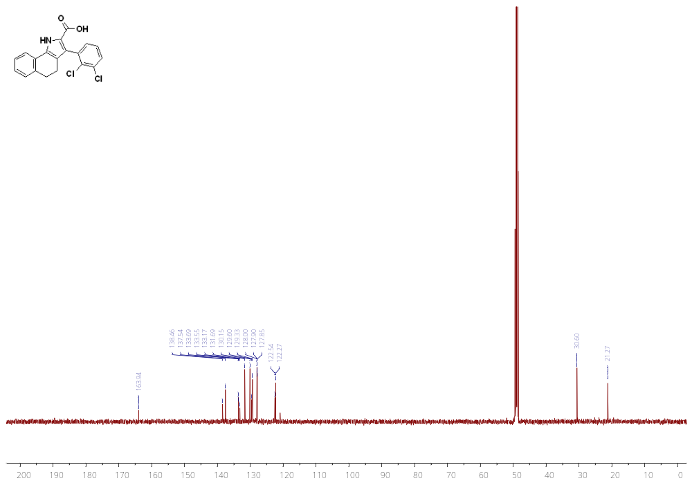
¹H NMR of 17l (500 MHz, MeOD)
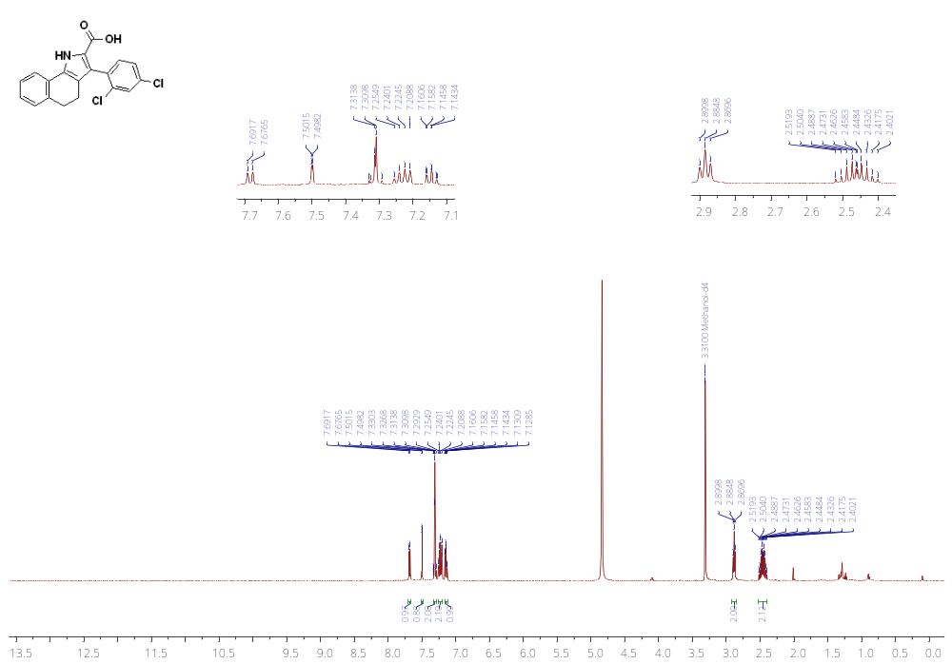
¹³C NMR of 17l (126 MHz, MeOD)
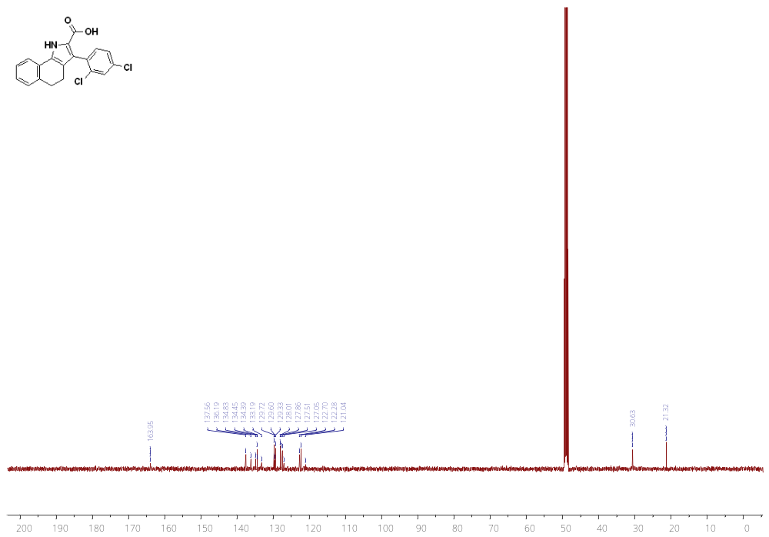
¹H NMR of 17m (500 MHz, MeOD)
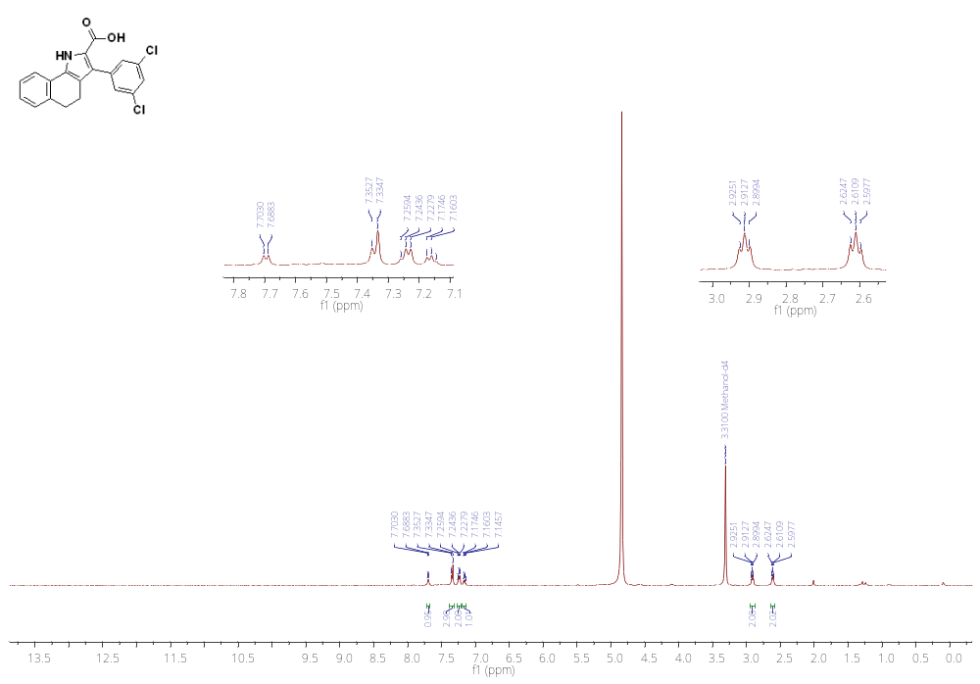
¹³C NMR of 17m (126 MHz, DMSO)
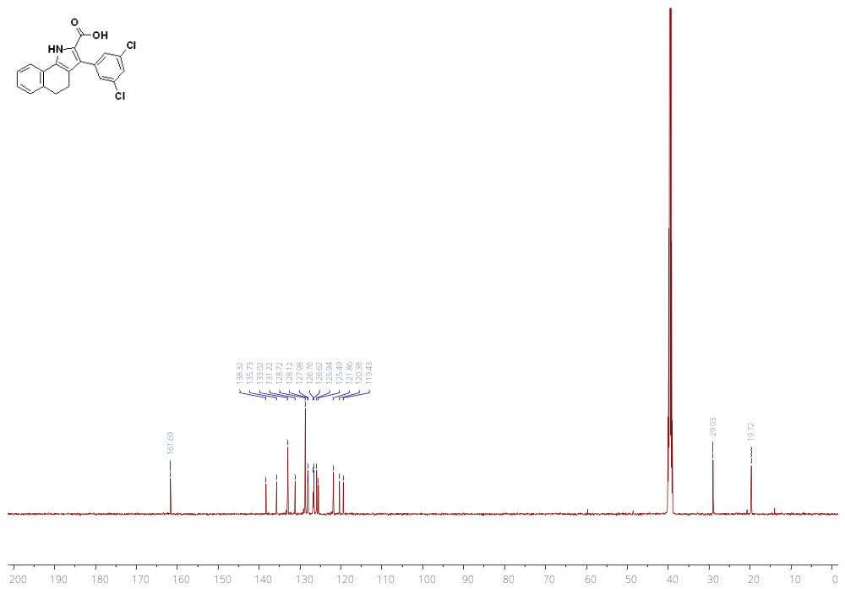
¹H NMR 17n (500 MHz, MeOD)
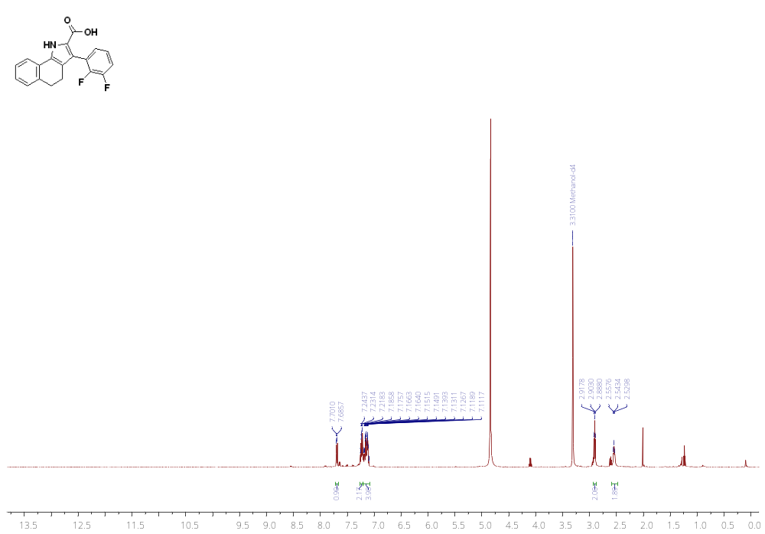
¹³C NMR 17n (126 MHz, DMSO)
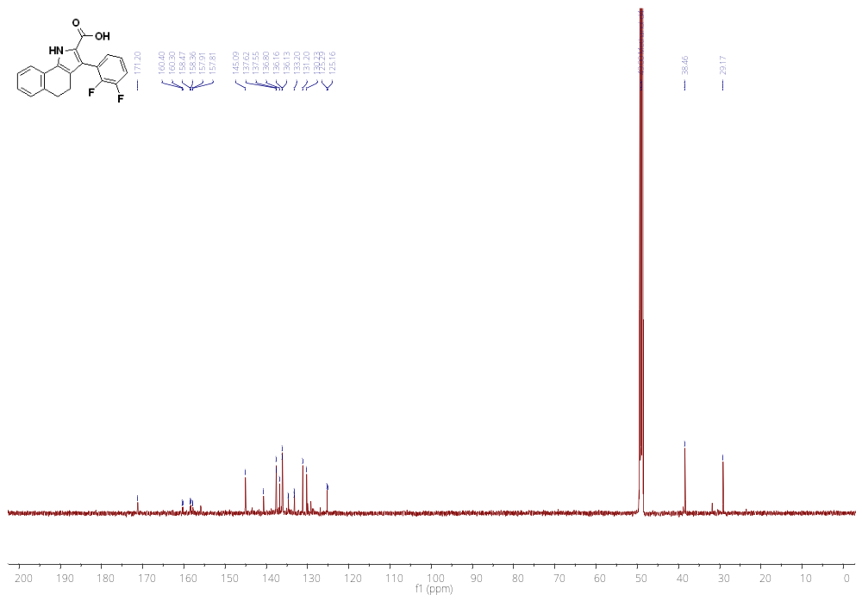
¹H NMR of 17o (500 MHz, MeOD)
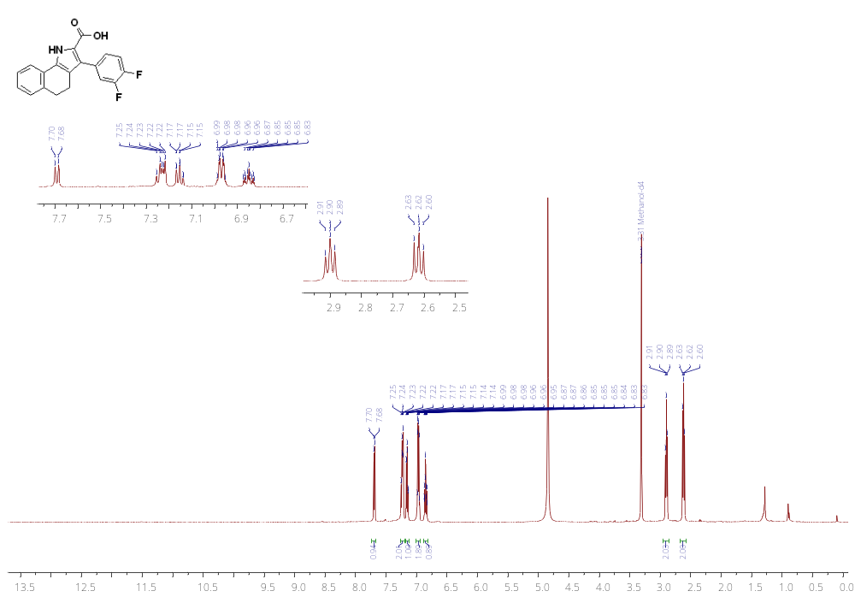
¹³C NMR of 17o (126 MHz, MeOD)
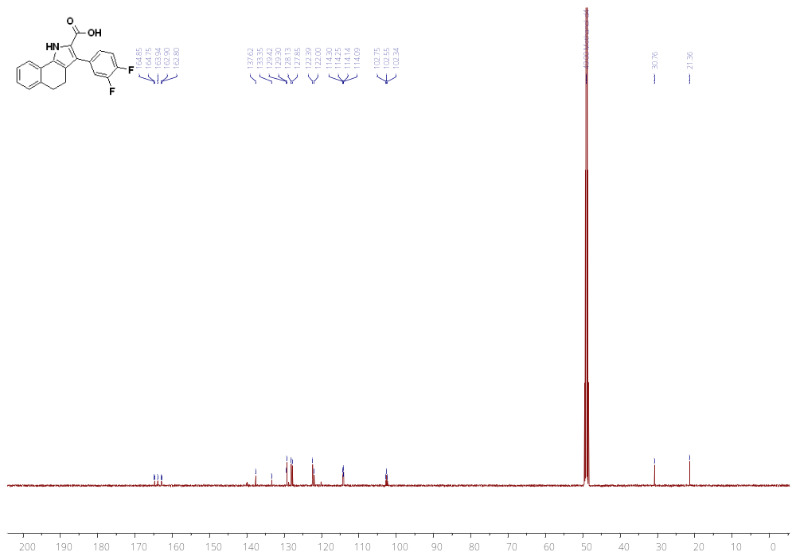
¹H NMR of 17p (500 MHz, MeOD)
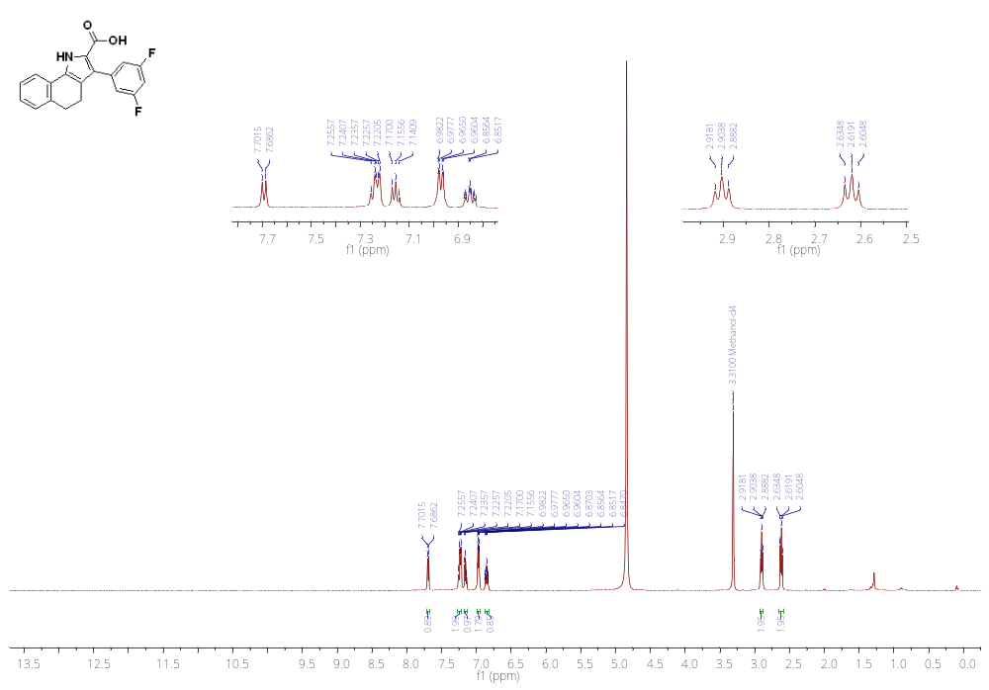
¹³C NMR of 17p (126 MHz, MeOD)
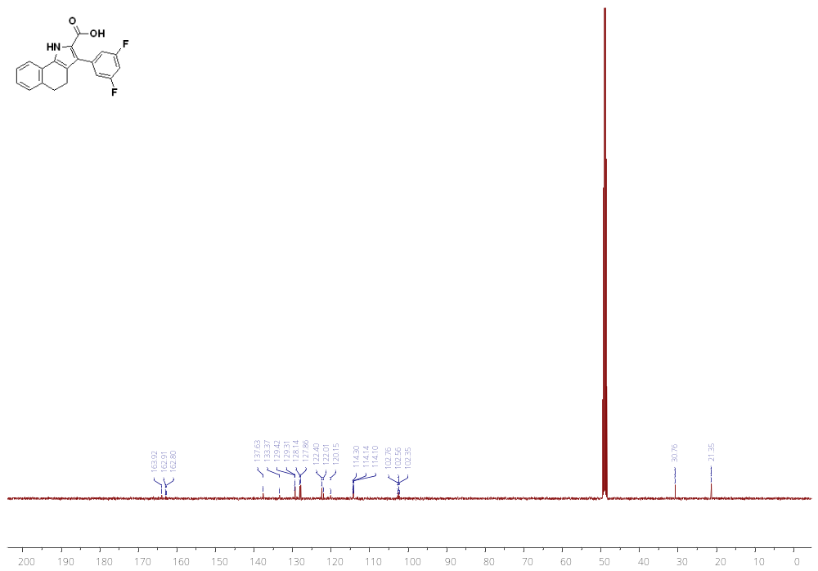
¹H NMR of 17q (500 MHz, DMSO)
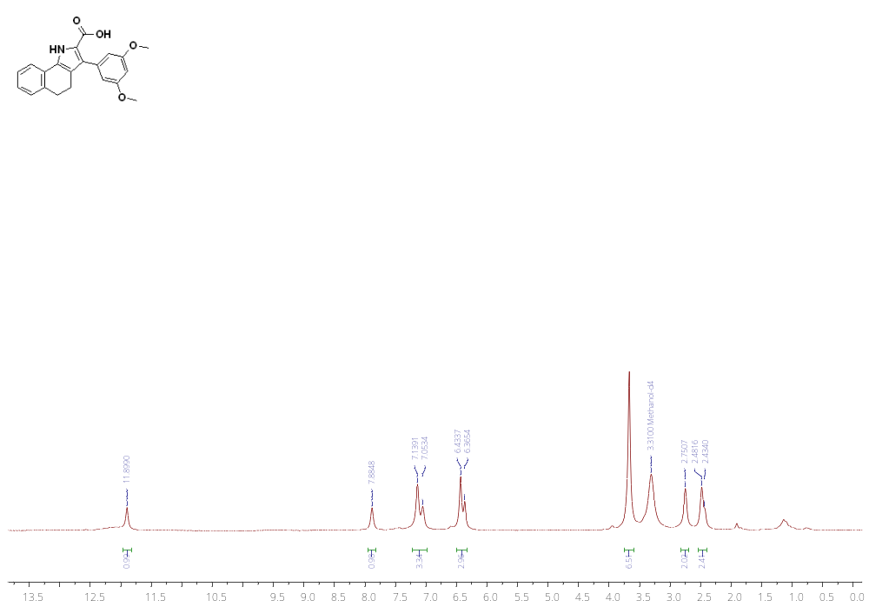¹³C NMR of 17q (126 MHz, DMSO)
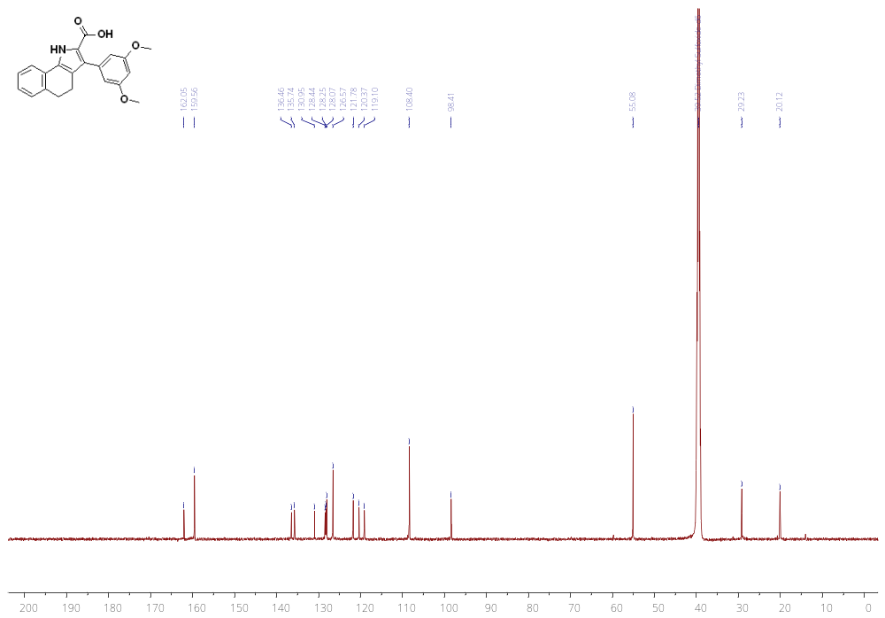

¹H NMR of 17r (500 MHz, MeOD)
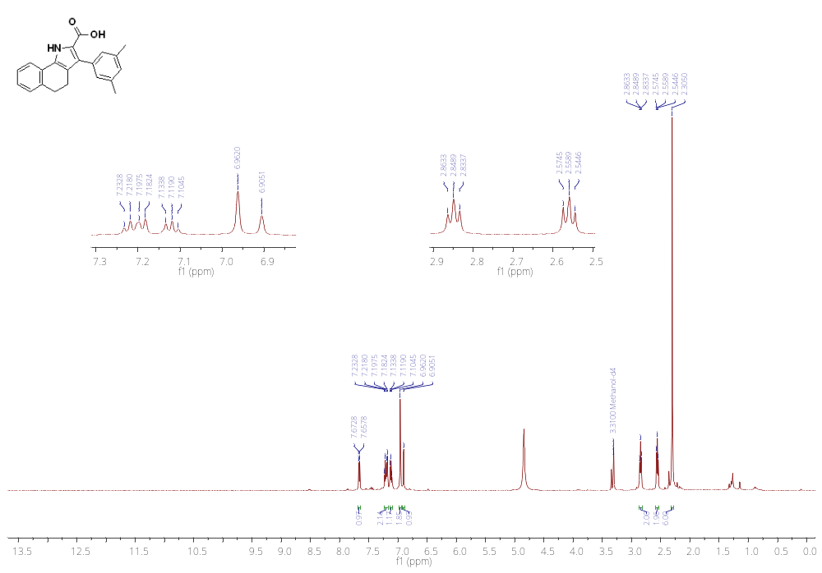
¹³C NMR of 17r (126 MHz, MeOD)
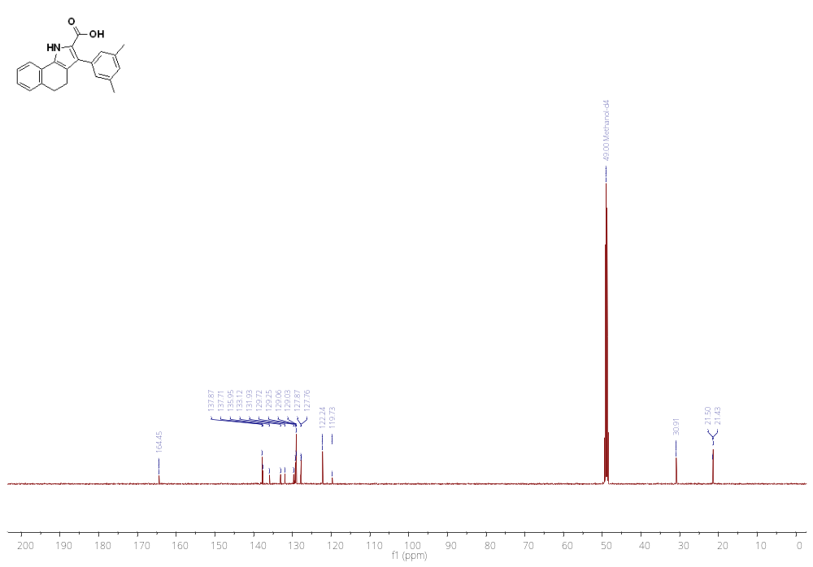
¹H NMR of 17s (500 MHz, MeOD)
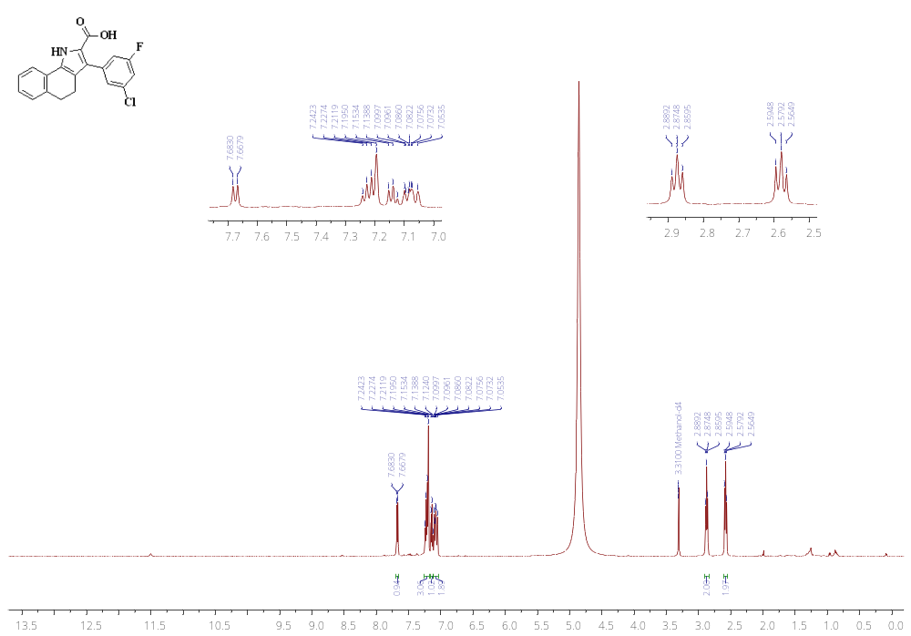
¹³C NMR of 17s (126 MHz, MeOD)
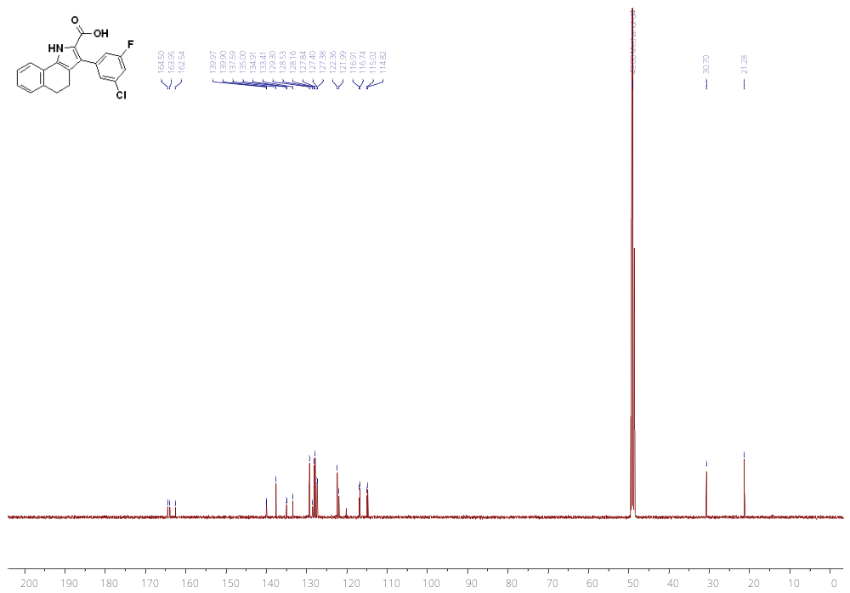
¹H NMR of 17t (500 MHz, MeOD)
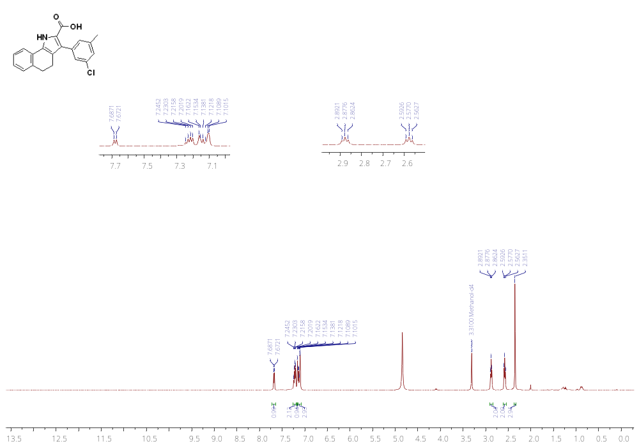
¹³C NMR of 17t (126 MHz, MeOD)
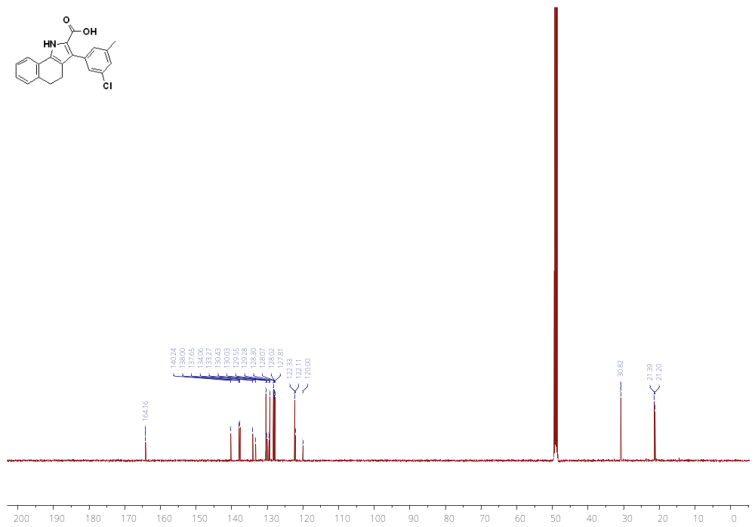
¹H NMR of 17u (500 MHz, MeOD)
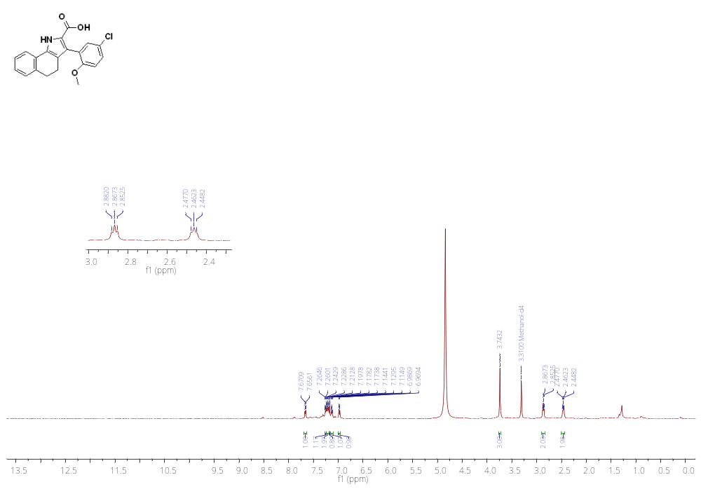
¹³C NMR of 17u (126 MHz, MeOD)
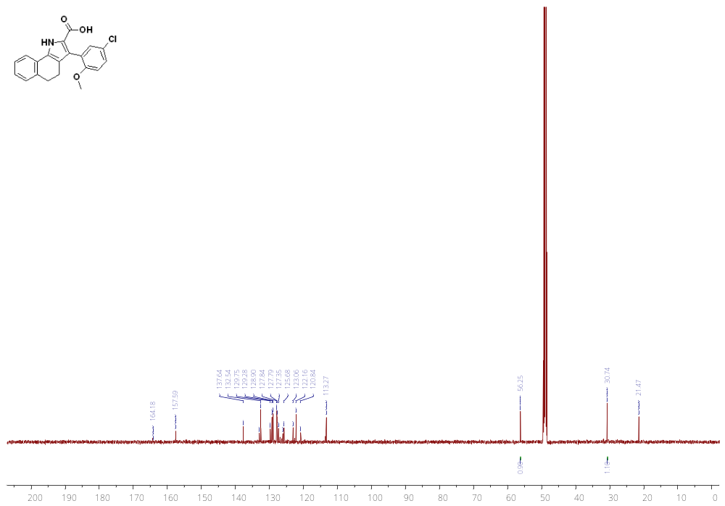
¹H NMR of 17v (500 MHz, MeOD)
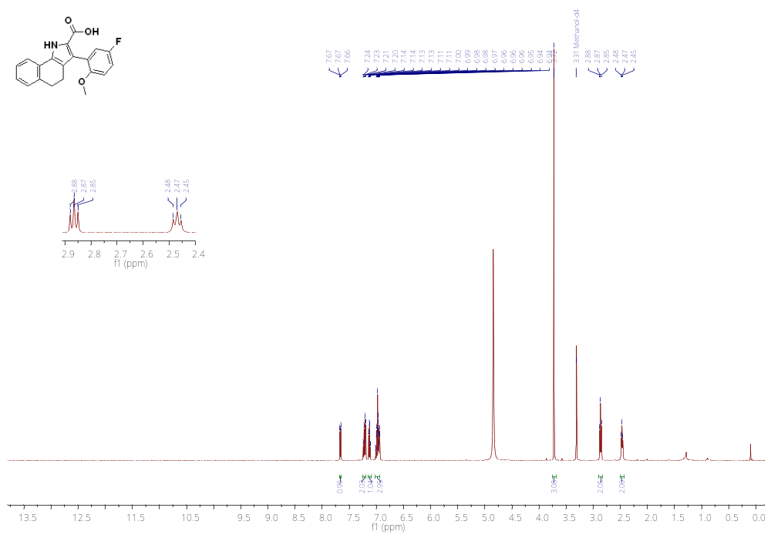

¹³C NMR of 17v (126 MHz, MeOD)
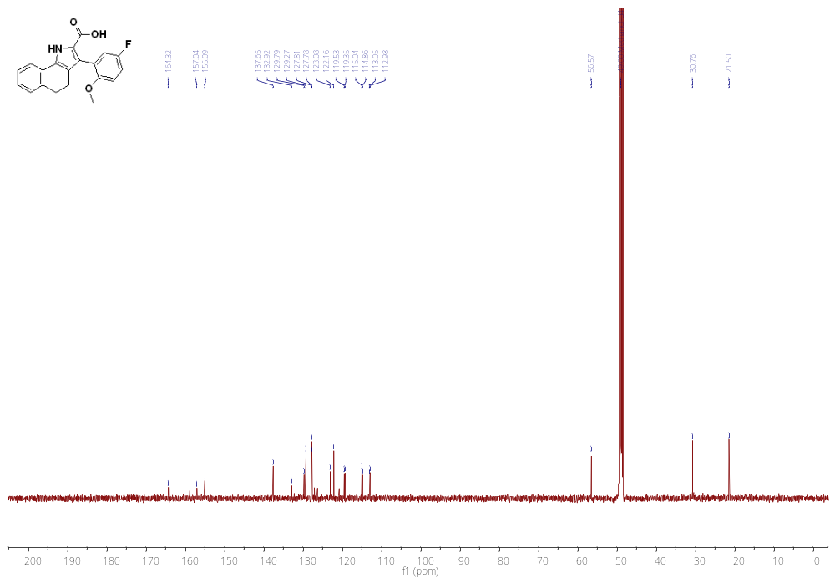
¹H NMR of 17w (500 MHz, MeOD)
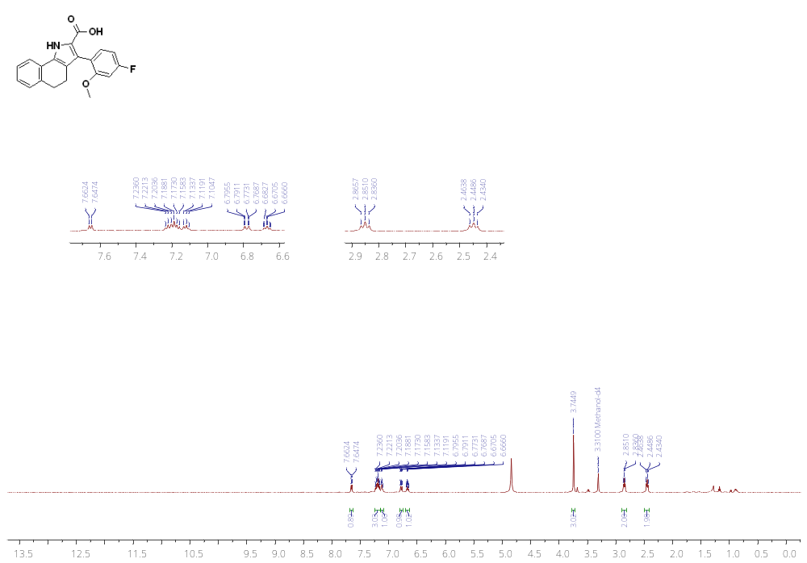
¹³C NMR of 17w (126 MHz, MeOD)
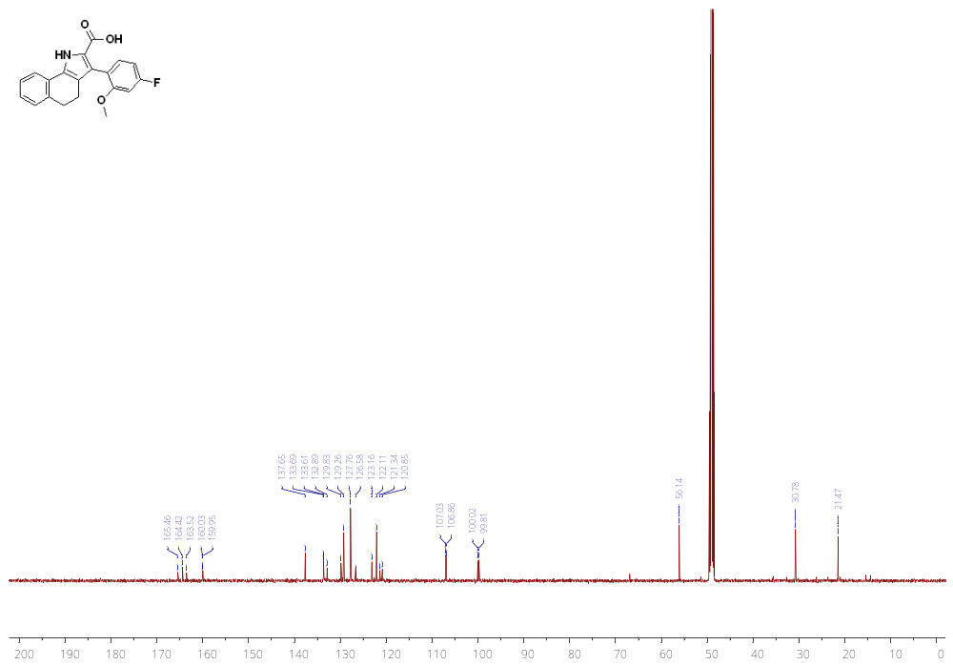
¹H NMR of 17x (500 MHz, MeOD)
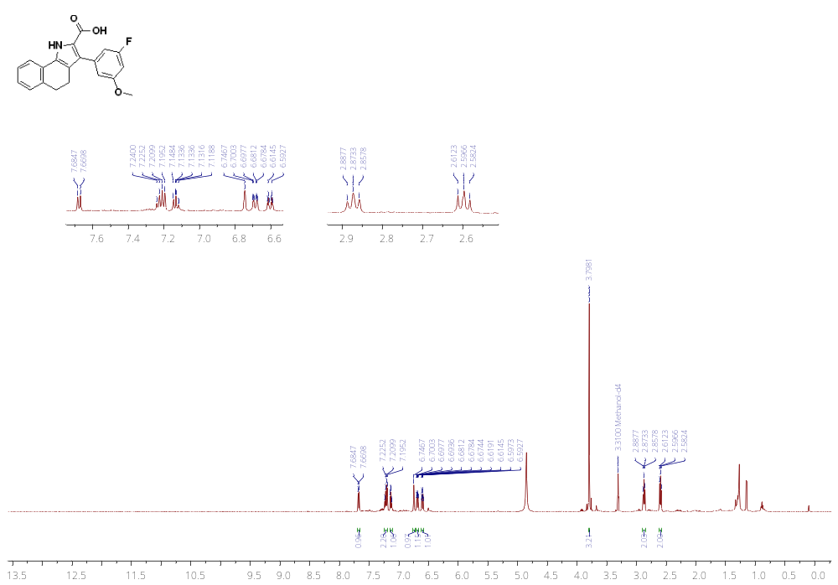
¹³C NMR of 17x (126 MHz, MeOD)
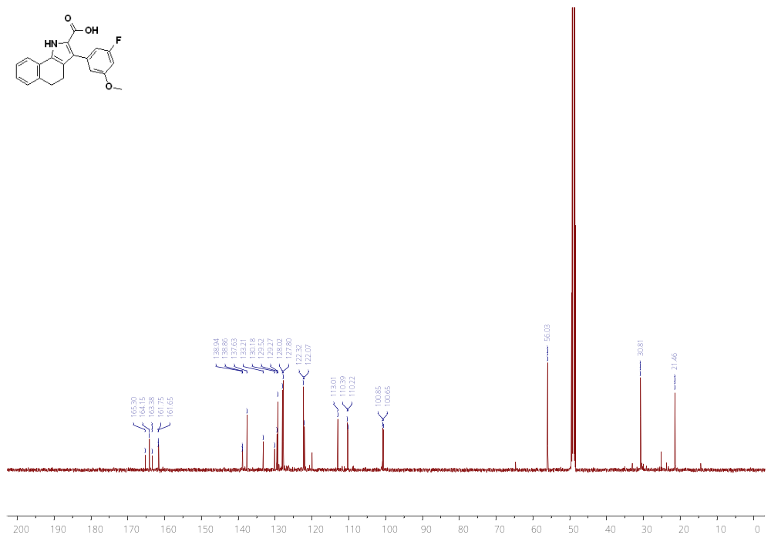
¹H NMR of 17y (500 MHz, MeOD)
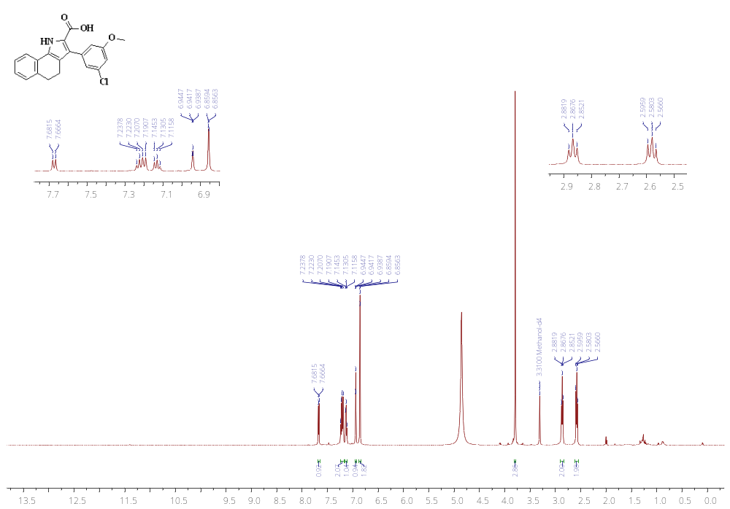
¹³C NMR of 17y (126 MHz, MeOD)
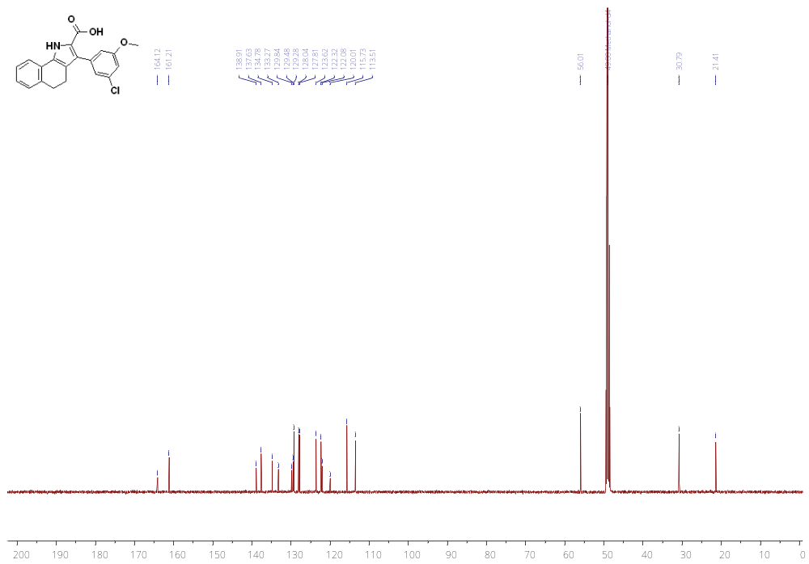
¹H NMR of 17z (500 MHz, MeOD)
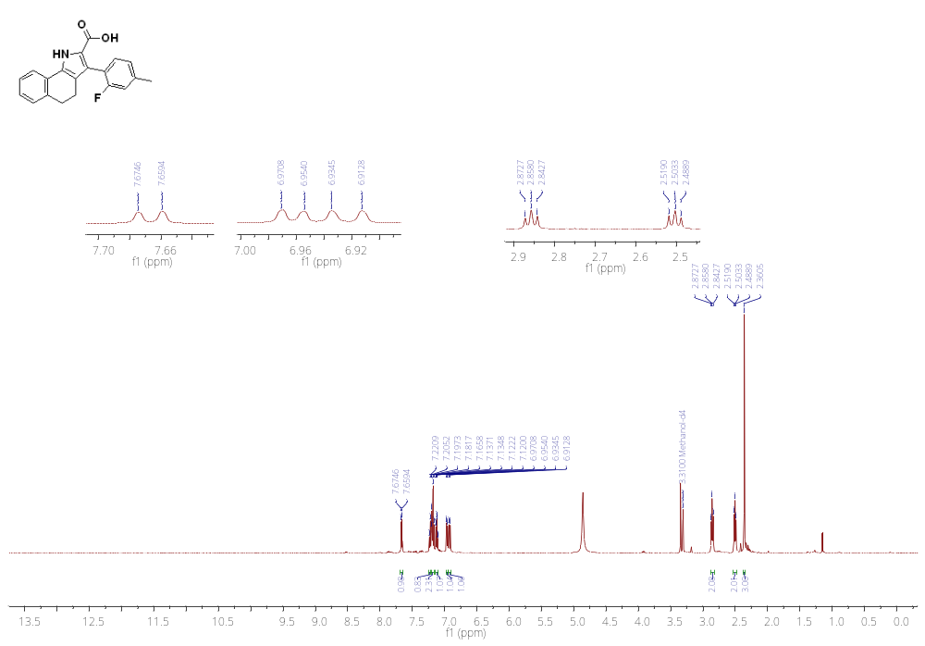
¹³C NMR of 17z (126 MHz, MeOD)
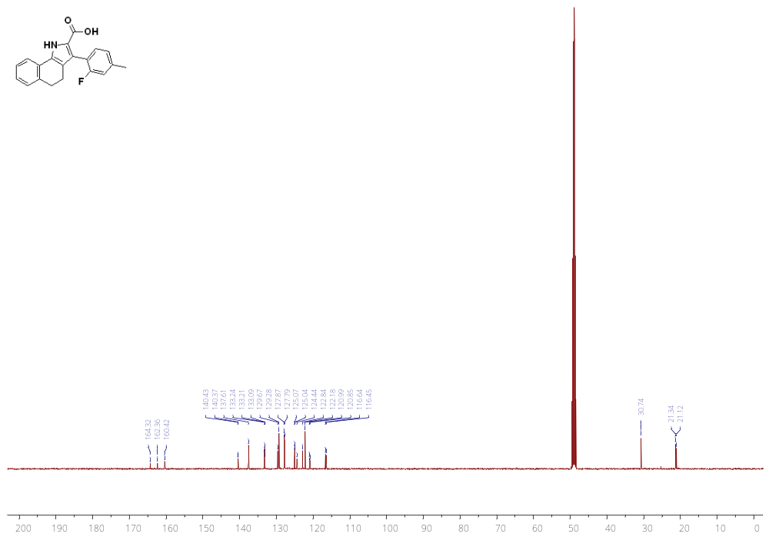
¹H NMR of 17aa (500 MHz, MeOD)
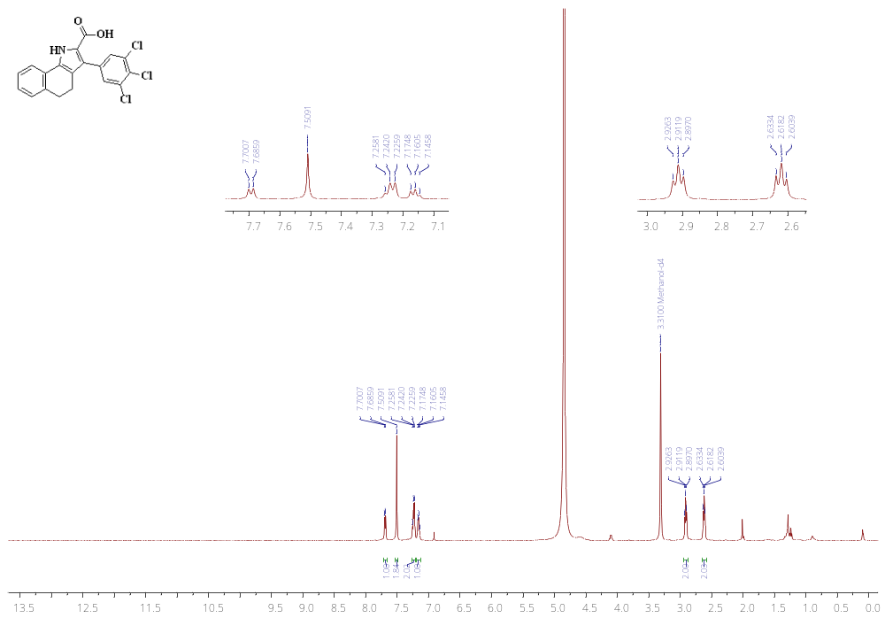
¹³C NMR of 17aa (126 MHz, MeOD)
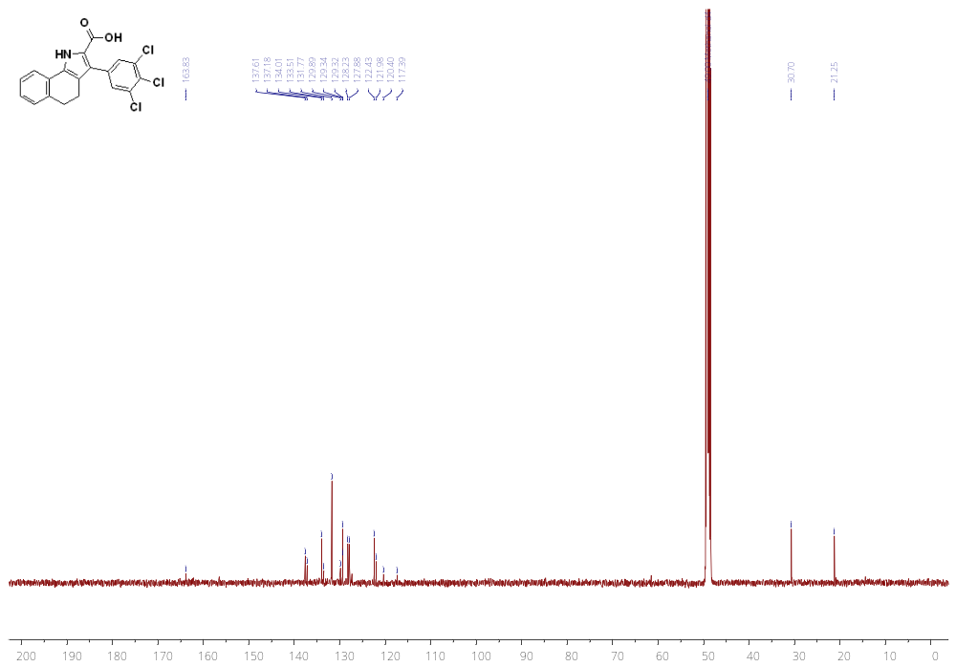
¹H NMR of 17ab (500 MHz, DMSO)
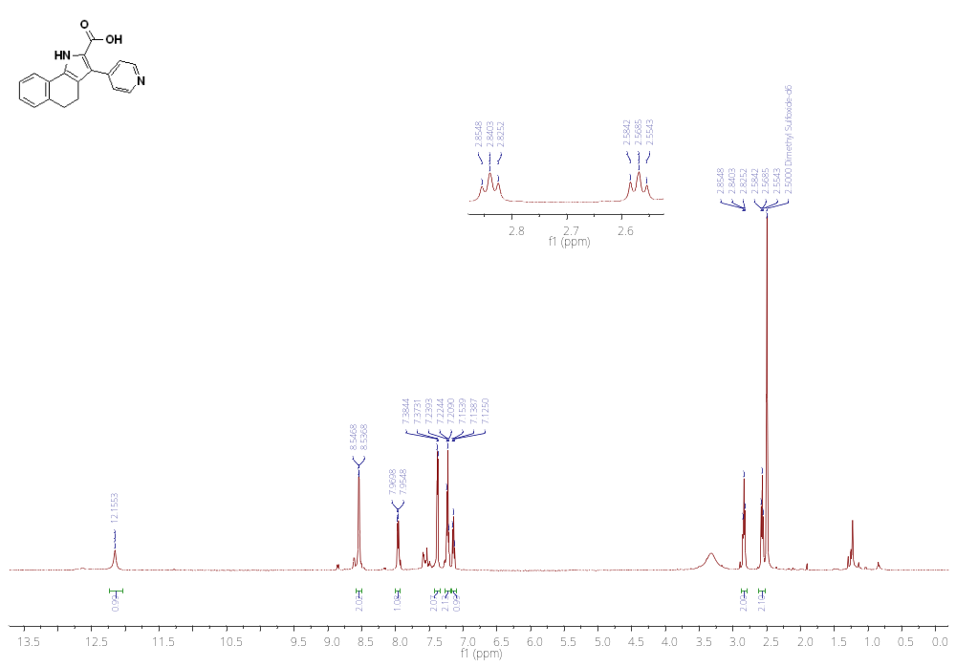
¹³C NMR of 17ab (126 MHz, DMSO)
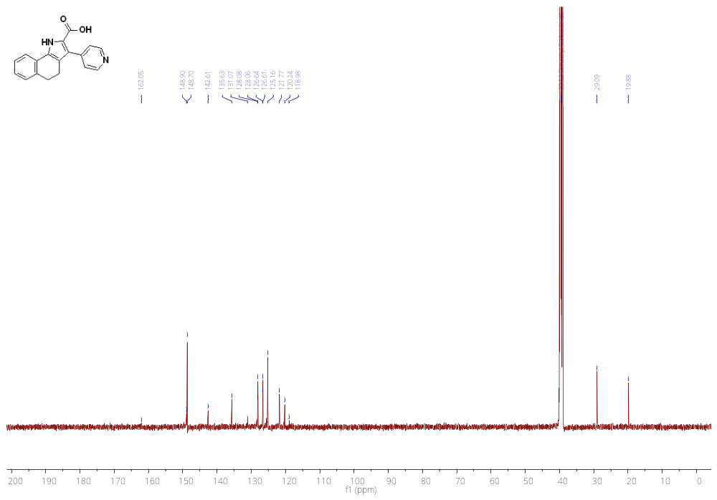
¹H NMR of 17ac (500 MHz, MeOD)
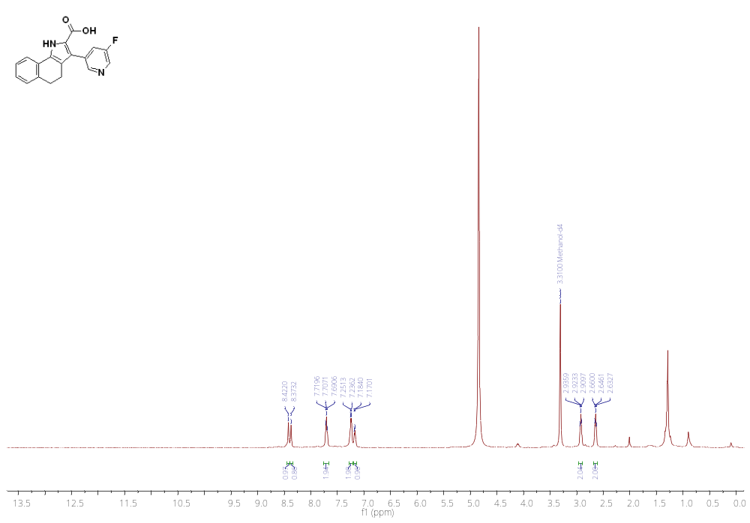
¹³C NMR of 17ac (126 MHz, MeOD)
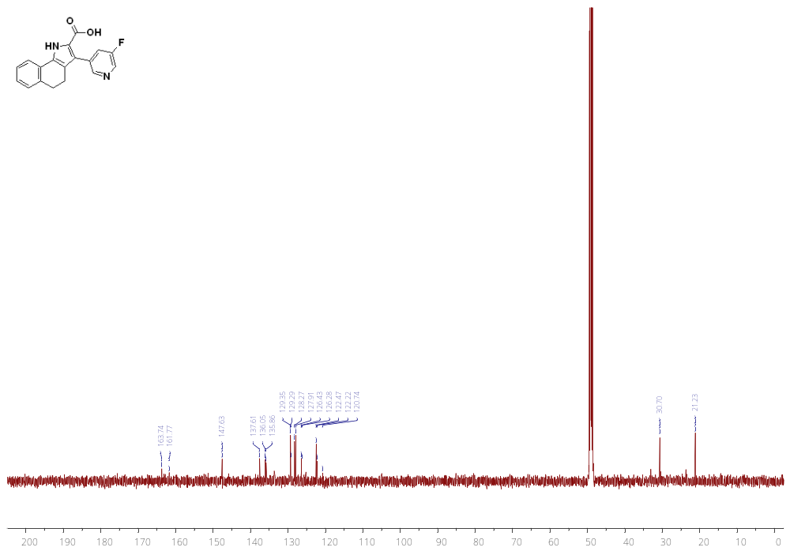
¹H NMR of 17ad (500 MHz, DMSO)
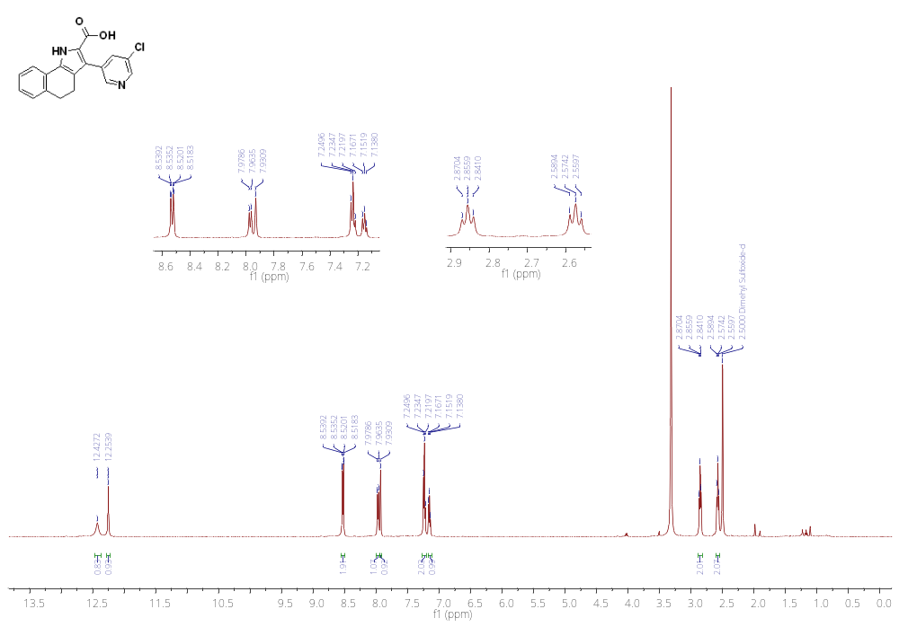
¹³C NMR of 17ad (126 MHz, DMSO)
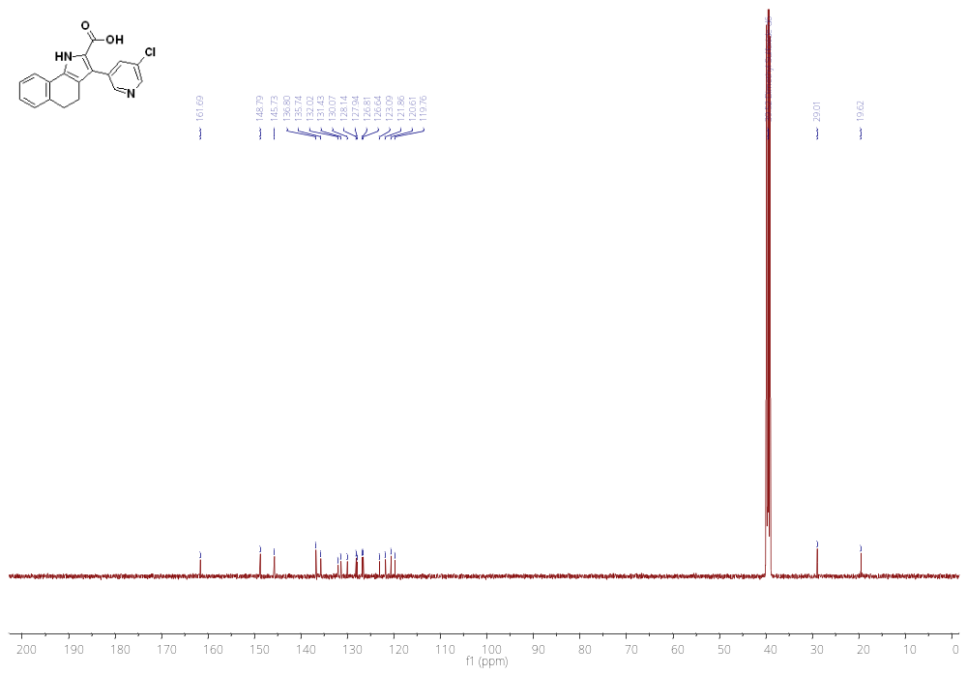
¹H NMR of 17ae 500 MHz, MeOD)
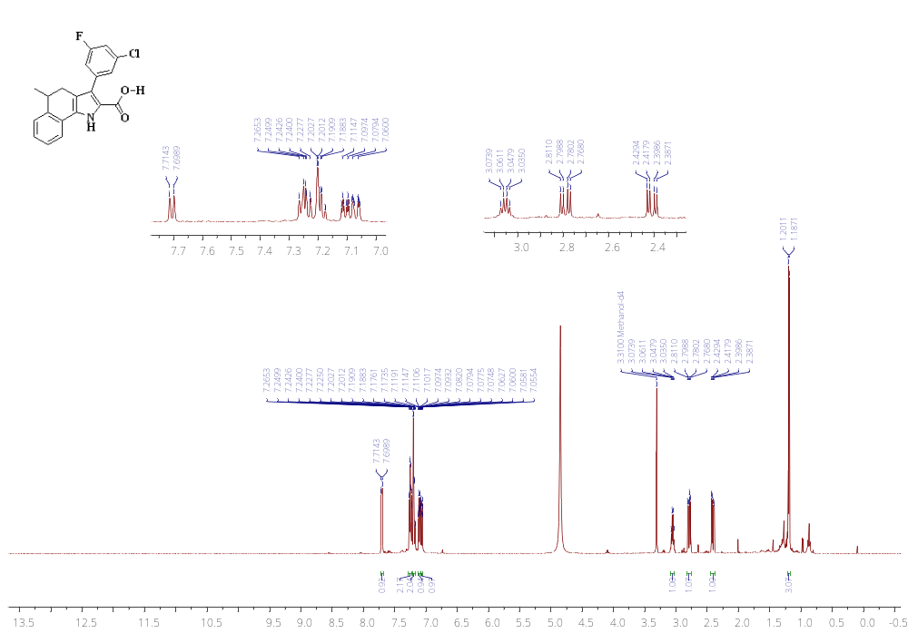
¹³C NMR of 17ae (126 MHz, DMSO)
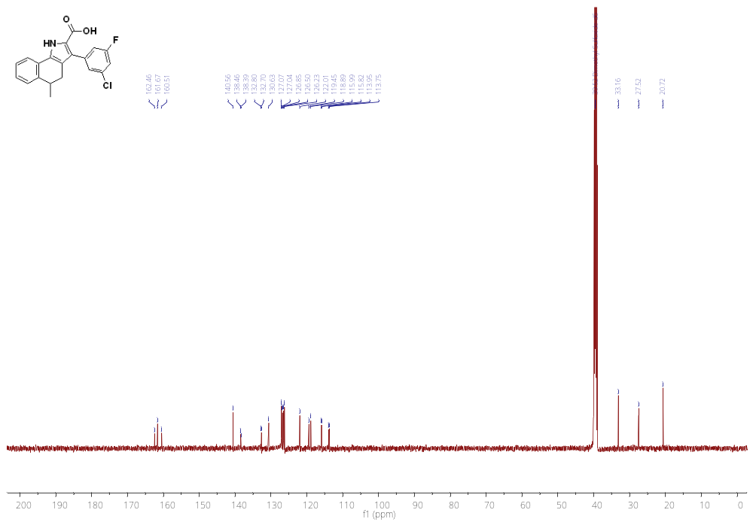
¹H NMR of 17af (500 MHz, DMSO)
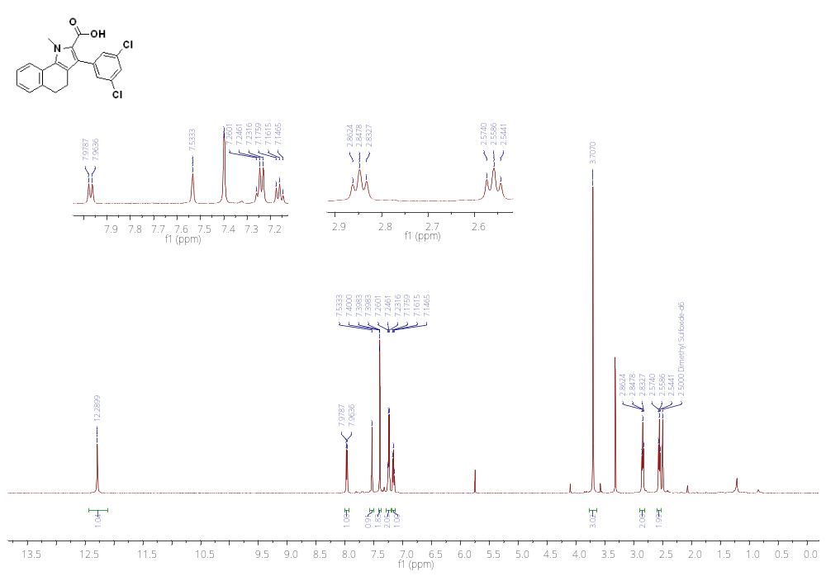
¹³C NMR of 17af (126 MHz, DMSO)
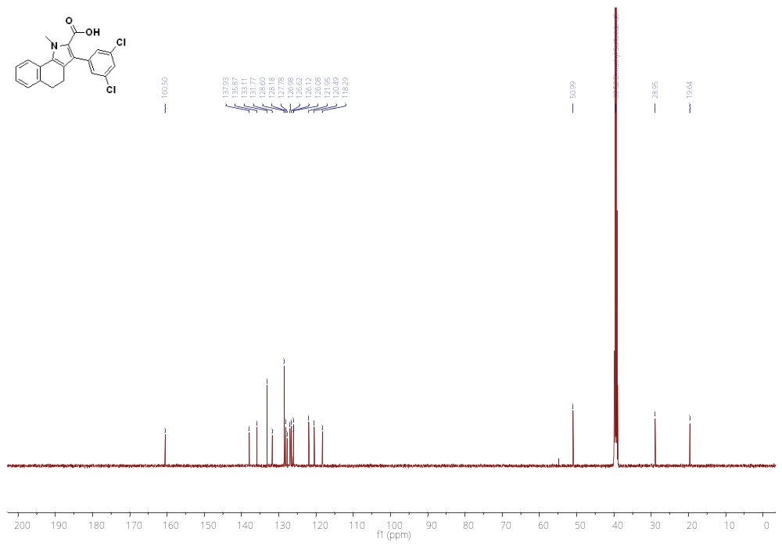HRMS DATA

17a
17b

17c
17d
17e
17f

17g

17h
17i
17j
17k
17l
17m
17n
17o
17p
17q
17r
17s
17t
17u
17v
17w
17x

17y
17z
17aa
17ab
17ac17ad
17ae17af
HPLC
17a

17b

17c

17d

17e

17f

17g

17h

17i

17j

17k

17l

17m

17n

17o

17p

17q

17r

17s

17t

17u

17v

17w

17x

17y

17z

17aa

17ab

17ac

17ad

17ae

