Extended Data Figures
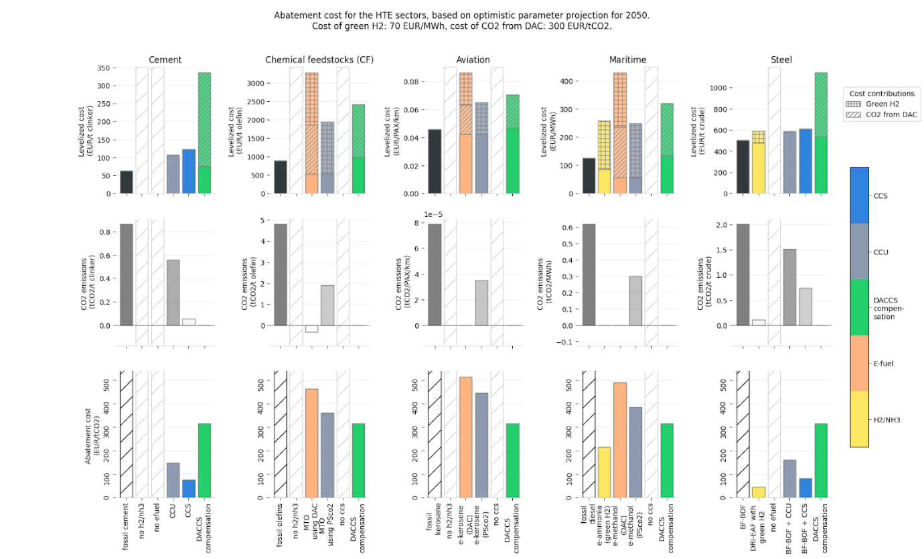
Extended Data Fig. 1. Calculating the fuel-switching CO₂ price (FSCP) for each abatement option available to the five hard-to-electrify sectors. The first row shows the levelized cost of the product (LCOX) concerned, with the cost contribution from green hydrogen (H₂) and CO₂ from direct-air capture (DAC) shown. The second row shows the CO₂ emissions, and the third row displays the FSCP. DACCS: DAC and CO₂ transport and storage. CCS: carbon capture and storage, CCU: carbon capture and utilization, NH₃: green ammonia. MTO: methanol-to-olefins, BF-BOF: blast furnace and basic oxygen furnace, DRI-EAF: direct reduction of iron and electric arc furnace.

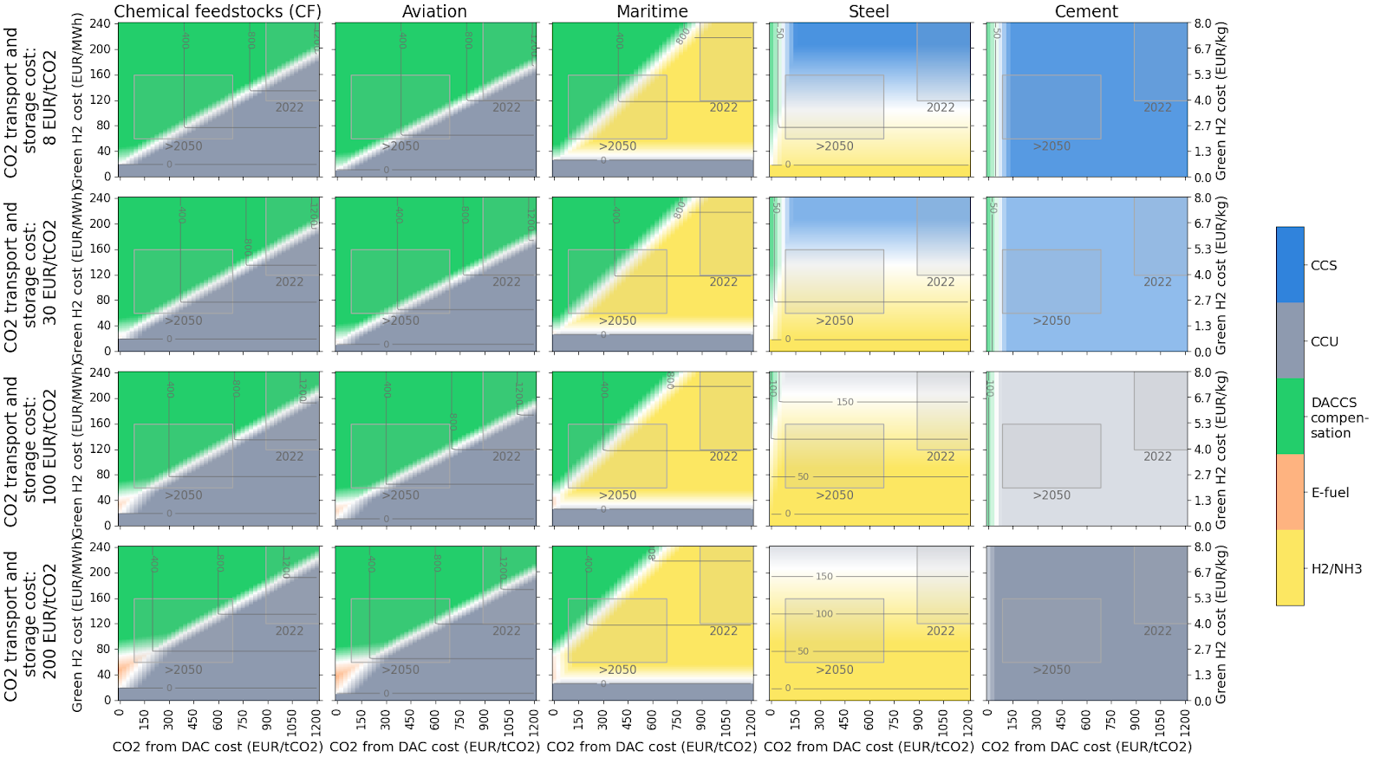
Extended Data Fig. 2. Sensitivity of the fuel-switching CO₂ price (FSCP) mitigation landscapes to the CO₂ transport and storage cost. Here, the calculation is repeated using a cost of €8/tCO₂, €30/tCO₂, €100/tCO₂ and €200/tCO₂. H₂: green hydrogen, DAC: direct-air capture, DACCS: DAC and CO₂ transport and storage. CCS: carbon capture and storage, CCU: carbon capture and utilization, NH₃: green ammonia.

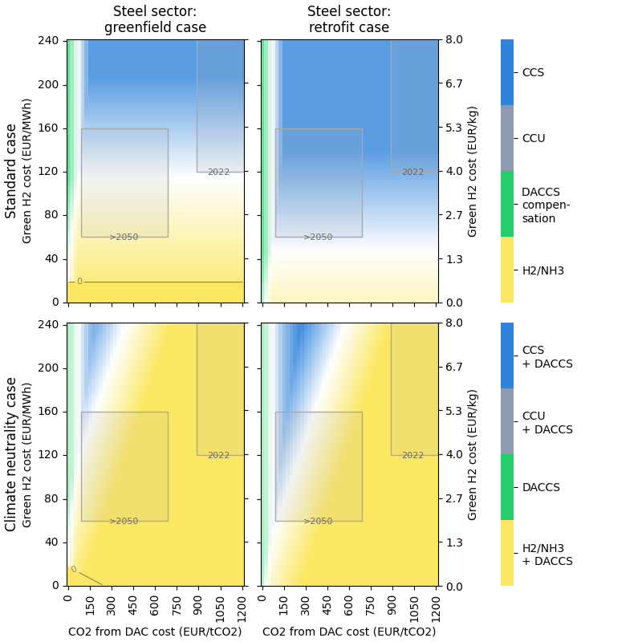
Extended Data Fig. 3. Greenfield and retrofit comparison for the steel sector, under the standard case and the climate-neutral case. In the first row, for the standard case, residual emissions are not compensated. In the climate-neutral case (second row), compatibility with climate neutrality is required by compensating for any residual CO₂ emissions using direct-air capture and CO₂ transport and storage (DACCS). CCS: carbon capture and storage, CCU: carbon capture and utilization, H₂: green hydrogen, NH₃: green ammonia, DAC: direct-air capture.

