Supplementary Figures
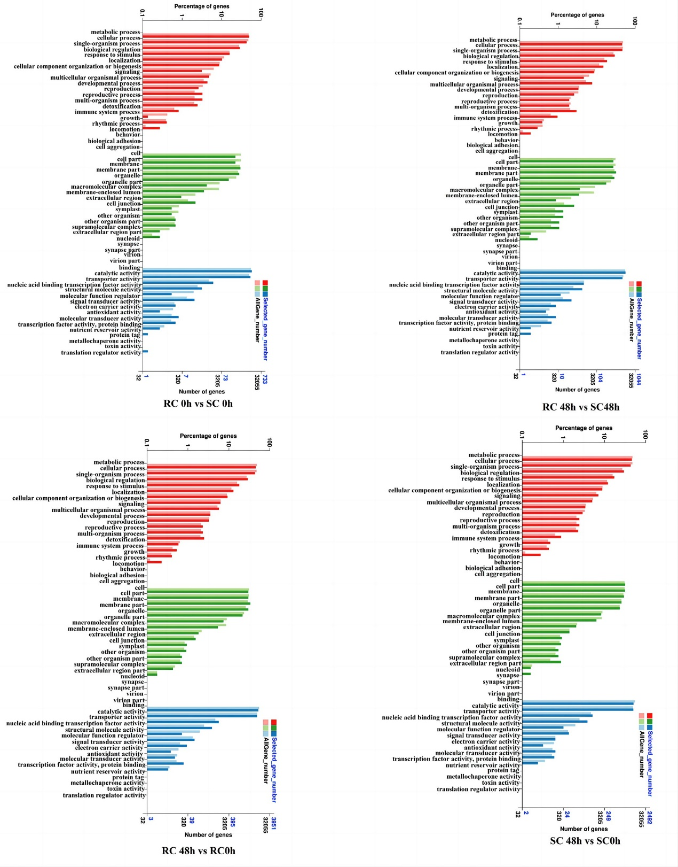
Supplementary Figure 1. Scatter plots for Go enrichment analysis of DEGs between the two sainfoins under low-temperature stress.
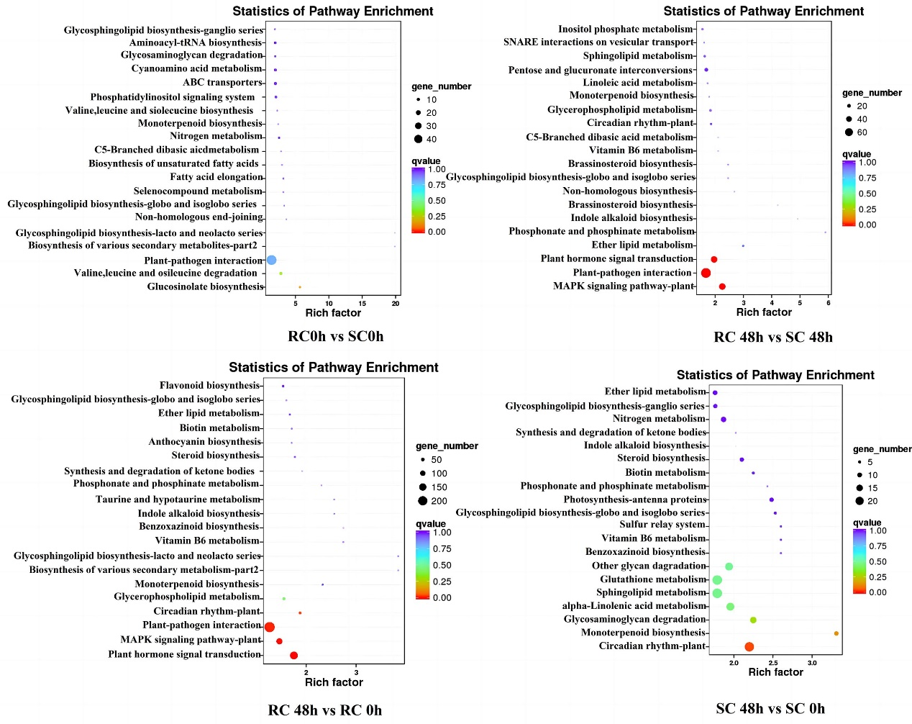
Supplementary Figure 2. Scatter plots for KEGG pathway enrichment analysis of DEGs between the two sainfoins at the same time.
Supplementary Table 1
ID | Primes
CSE | F:TGACAAGACCCTGAAGCCCATC  R:TTACATTACAGGCACAGCAAGAAGG
CHS | F: TTGACATGCCTGGTGCTGAT  R: TAGCACCTGCAAAACACCCT
F3H | F：TTCAGCCAATTGAGGGTGCT  R:CTGGTGCTGGGTTCTGGAAT
BPGM | F:ACAGATGATGATATGGGCAACAGTG  R:GAGGCTAGAGCAAGGTCAACAAG
PGK | F: ATCCTCGGCTTCGGCTCAAG  R: ACAACATTCGATTCGCTACTATCCC
DFR | F:TTTGATCCGGCAGTGAAGGG  R:TCGGGAGATTTTGGCCTTGT
actin | F:CAAAAGATGGCAGATGCTGAGGAT  R: CATGACACCAGTATGACGAGGTCG
The primers used in this study

Supplementary Table 2 The FPKM of 33 common DEGs in different comparison groups
ID | RC 0h | RC 48h | SC 0h | SC 48h
TRINITY_DN1154_c0_g1 | 553.69 | 39.41 | 228.22 | 109.6167
TRINITY_DN1221_c0_g1 | 21.11667 | 4.696667 | 46.76 | 17.17333
TRINITY_DN13604_c0_g1 | 47.48 | 212.6467 | 105.0733 | 400.91
TRINITY_DN1423_c1_g1 | 13.66667 | 63.13 | 5.706667 | 23.64
TRINITY_DN15362_c0_g1 | 267.5833 | 18.71 | 549.7033 | 165.6267
TRINITY_DN1656_c0_g1 | 86.84667 | 1.48 | 33.27333 | 9.17
TRINITY_DN165_c0_g1 | 199.0967 | 17.64 | 67.49667 | 25.98667
TRINITY_DN1707_c2_g1 | 396.4033 | 21.52667 | 214.6033 | 112.8233
TRINITY_DN19931_c0_g2 | 62.98333 | 10.08667 | 235.5667 | 90.34667
TRINITY_DN26710_c0_g1 | 16.87333 | 219.86 | 74.02 | 481.8733
TRINITY_DN2811_c0_g1 | 0 | 33.33 | 4.2 | 119.0233
TRINITY_DN3083_c0_g1 | 242.32 | 13.39333 | 96.10667 | 38.81333
TRINITY_DN3089_c1_g1 | 7.586667 | 1.74 | 13.56667 | 6.92
TRINITY_DN3254_c1_g1 | 1.673333 | 7.62 | 7.743333 | 1.603333
TRINITY_DN3426_c1_g1 | 65.72333 | 1.88 | 12.94333 | 5.703333
TRINITY_DN3741_c0_g1 | 6.113333 | 1.6 | 105.7033 | 41.20333
TRINITY_DN3888_c0_g1 | 12.23667 | 26.60333 | 3.263333 | 12.65333
TRINITY_DN4131_c0_g1 | 182.5933 | 165.98 | 29.79333 | 24.32667
TRINITY_DN4205_c0_g1 | 45.23667 | 17.92667 | 20.96333 | 11.88667
TRINITY_DN450_c2_g1 | 4.156667 | 9.126667 | 57.41 | 23.03333
TRINITY_DN4624_c0_g1 | 2.943333 | 39.84333 | 7.273333 | 17.98667
TRINITY_DN481_c0_g1 | 1.586667 | 8.163333 | 4.353333 | 15.73667
TRINITY_DN494_c0_g1 | 30.26 | 3.843333 | 123.98 | 16.59333
TRINITY_DN6231_c0_g1 | 2.766667 | 142.8867 | 9.366667 | 35.86
TRINITY_DN6257_c0_g1 | 262.6867 | 66.61 | 552.1433 | 236.78
TRINITY_DN635_c0_g1 | 307.6367 | 17.45 | 134.4733 | 51.58
TRINITY_DN6498_c0_g1 | 2.82 | 0.81 | 13.56 | 4.23
TRINITY_DN7096_c0_g1 | 38.87333 | 11.85 | 111.6367 | 46.80667
TRINITY_DN7448_c0_g1 | 261.9933 | 7.223333 | 104.7467 | 29.91667
TRINITY_DN7672_c1_g1 | 32.5 | 7.406667 | 12.24 | 3.98
TRINITY_DN84977_c0_g1 | 1733.013 | 4095.003 | 286.23 | 1053.49
TRINITY_DN856_c0_g1 | 5.59 | 32.13 | 26.11 | 82.31667
TRINITY_DN944_c0_g1 | 2580.05 | 806.1267 | 933.86 | 1817.047

Supplementary Table 3 The FPKM of 26 common DAMs in different comparison groups
ID | Name | Class | RC 0 h | RC 48 h | SC 0 h | SC 48 h
1 | Temsirolimus | other | 42.30 | 84.45 | 128.64 | 47.92
2 | PGP(a-25:0/20:3(6,8,11)-OH(5)) | other | 219.65 | 327.44 | 421.34 | 203.60
3 | Azukisaponin I | Terpene glycosides | 356.376 | 786.38 | 563.08 | 408.32
4 | Leukotriene D4 | Eicosanoids | 151.231 | 260.37 | 241.07 | 167.09
5 | PI(PGF2alpha/16:2(9Z,12Z)) | other | 604.471 | 1442.16 | 1121.67 | 812.52
6 | PI(PGF2alpha/18:0) | other | 97.95 | 266.58 | 210.92 | 152.02
7 | PI(20:0/20:4(5Z,8Z,11Z,14Z)-OH(20)) | other | 1667.11 | 3230.42 | 2380.84 | 1372.71
8 | Taurochenodeoxycholate | 、 | 166.54 | 312.61 | 244.34 | 149.97
9 | S-Methyl-KE-298 | Carbonyl compounds | 53007.5 | 139744.80 | 151978.74 | 50872.22
10 | Marmesin rutinoside | Furanocoumarins | 216.68 | 479.30 | 455.92 | 237.89
11 | (3S,7R)-16-Hydroxy-11-methoxy-6,8,19-trioxapentacyclo[10.7.0.02,9.03,7.013,17]nonadeca-1,4,9,11,13(17)-pentaen-18-one | Furanocoumarins | 174.16 | 553.49 | 273.64 | 150.15
12 | Prednicarbate | Pregnane steroids | 376.88 | 149.49 | 142.78 | 49.28
13 | Glucosylgalactosyl hydroxylysine | Fatty acyl glycosides | 72.27 | 258.23 | 156.15 | 65.41
14 | Fluorothymidine | Pyrimidine 2'-deoxyribonucleosides | 41.66 | 86.55 | 103.16 | 20.48
15 | PI(18:3(6Z,9Z,12Z)/PGE2) | other | 577.26 | 1247.36 | 1130.12 | 765.22
16 | beta1-Tomatidine | Steroidal glycosides | 4930.45 | 8273.65 | 7962.23 | 5315.72
17 | M-Secociguatoxin 4A | other | 1888.22 | 2729.47 | 2685.79 | 1815.74
18 | PIP(22:2(13Z,16Z)/20:5(7Z,9Z,11E,13E,17Z)-3OH(5,6,15)) | oter | 598.34 | 1265.92 | 1067.50 | 796.88
19 | PI(22:3(10Z,13Z,16Z)/22:6(4Z,7Z,10Z,12E,16Z,19Z)-OH(14)) | other | 413.11 | 868.13 | 881.10 | 560.40
20 | PI(PGE2/20:1(11Z)) | other | 495.12 | 835.93 | 726.12 | 529.73
21 | PE(DiMe(11,5)/6 keto-PGF1alpha) | other | 565.94 | 1213.49 | 944.04 | 626.86
22 | 7alpha-Hydroxydehydroepiandrosterone | other | 112.578 | 78.27 | 73.28 | 118.01
23 | PI(6 keto-PGF1alpha/22:2(13Z,16Z)) | other | 433.092 | 826.40 | 876.03 | 549.20
24 | PI(16:0/PGF2alpha) | other | 267.04 | 574.90 | 471.62 | 314.51
25 | L-2,4-Diaminobutanoate | Amino acids, peptides, and analogues | 102.56 | 56.44 | 43.11 | 89.17
26 | 7-Epizucchini factor A | Benzoic acids and derivatives | 83.18 | 154.94 | 149.81 | 86.40
Supplementary Table 4 The FPKM value of AP2/ERF-ERF TFs in sainfoin responded to low-temperature stress.
ID | RC 0h | RC48h | SC0h | SC48h
TRINITY_DN0_c1_g1 | 19.43 | 13.49333333 | 62.28333333 | 37.79666667
TRINITY_DN10270_c0_g1 | 72.33666667 | 0.873333333 | 78.34 | 1.62
TRINITY_DN1066_c0_g1 | 248.4333333 | 149.2 | 399.8633333 | 110.5233333
TRINITY_DN11305_c0_g1 | 5.55 | 0.626666667 | 1.54 | 1.1
TRINITY_DN11359_c0_g2 | 179.5433333 | 491.3766667 | 285.0933333 | 200.57
TRINITY_DN12476_c0_g1 | 22.76333333 | 78.45333333 | 55.67 | 107.2066667
TRINITY_DN1306_c8_g1 | 5.736666667 | 38.49 | 3.48 | 22.59333333
TRINITY_DN13478_c0_g1 | 42.69333333 | 24.06666667 | 33.25666667 | 14.26333333
TRINITY_DN1449_c0_g1 | 9.526666667 | 10.52 | 18.99 | 5.816666667
TRINITY_DN14657_c0_g1 | 4.03 | 1.11 | 16.05 | 2.136666667
TRINITY_DN19214_c0_g1 | 6.023333333 | 44.03 | 13.27666667 | 23.42666667
TRINITY_DN1977_c0_g1 | 67.78333333 | 5.35 | 60.45666667 | 16.47333333
TRINITY_DN2159_c0_g1 | 16.88333333 | 1.62 | 10.88 | 2.39
TRINITY_DN2411_c0_g2 | 83.45 | 56.61333333 | 120.5266667 | 128.46
TRINITY_DN2462_c0_g1 | 20.89 | 28.42666667 | 5.803333333 | 22.82666667
TRINITY_DN2609_c0_g1 | 40.64333333 | 2.226666667 | 20.17666667 | 2.063333333
TRINITY_DN2790_c0_g1 | 9.726666667 | 21.67 | 6.066666667 | 10.35666667
TRINITY_DN3072_c0_g1 | 600.9966667 | 223.1233333 | 1139.503333 | 594.42
TRINITY_DN34513_c0_g1 | 25.42666667 | 0.15 | 48.55 | 0.993333333
TRINITY_DN3671_c0_g1 | 90.65 | 76.66666667 | 75.24 | 25.82666667
TRINITY_DN4511_c0_g1 | 2.646666667 | 14.48 | 7.643333333 | 20.86333333
TRINITY_DN5127_c0_g1 | 14.08 | 1.6 | 7.426666667 | 0.843333333
TRINITY_DN5592_c1_g1 | 31.64333333 | 546.3066667 | 39.43666667 | 91.83
TRINITY_DN5628_c1_g1 | 135.9333333 | 99.62666667 | 135.63 | 199.7466667
TRINITY_DN5752_c0_g1 | 5.006666667 | 16.72333333 | 6.386666667 | 13.67666667
TRINITY_DN5755_c0_g1 | 112.13 | 28.28333333 | 162.21 | 182.2133333
TRINITY_DN6008_c0_g1 | 68.25666667 | 5.08 | 30.00666667 | 17.10333333
TRINITY_DN6225_c0_g1 | 0.163333333 | 15.21666667 | 0.036666667 | 4.743333333
TRINITY_DN6384_c0_g1 | 32.88333333 | 3.196666667 | 28.53333333 | 37.49
TRINITY_DN6541_c0_g1 | 32.17333333 | 106.74 | 20.09333333 | 30.09666667
TRINITY_DN7021_c0_g1 | 3.49 | 4.513333333 | 16.57 | 10.64
TRINITY_DN7081_c0_g1 | 42.99333333 | 154.1533333 | 93.6 | 170.53
TRINITY_DN7209_c0_g1 | 0.526666667 | 7.786666667 | 1.206666667 | 2.166666667
TRINITY_DN75981_c0_g1 | 1.903333333 | 6.38 | 3.6 | 6.656666667
TRINITY_DN8421_c0_g1 | 0.066666667 | 6.86 | 0.733333333 | 5.733333333
TRINITY_DN8451_c0_g1 | 449.5533333 | 57.68333333 | 700.2333333 | 154.85
TRINITY_DN8608_c0_g1 | 61.65666667 | 9.673333333 | 23.93 | 5.22
TRINITY_DN8754_c0_g1 | 136.39 | 10.86 | 136.4333333 | 24.90666667
TRINITY_DN9289_c0_g1 | 0 | 7.436666667 | 0.423333333 | 3.87
TRINITY_DN93075_c0_g1 | 138.38 | 124.7733333 | 209.9766667 | 99.56333333
TRINITY_DN942_c0_g1 | 50.15666667 | 63.37666667 | 47.93666667 | 104.8333333
TRINITY_DN948_c0_g1 | 4.25 | 23.59333333 | 4.11 | 13.80666667

Supplementary Table 5 The FPKM value of bHLH TFs in sainfoin responded to LW stress.
ID | RC0h | RC48h | SC0h | SC48h
TRINITY_DN10321_c0_g2 | 4.466666667 | 1.63 | 0.566666667 | 0.28
TRINITY_DN11581_c0_g1 | 204.7166667 | 0.373333333 | 74.27 | 1.073333333
TRINITY_DN1346_c3_g2 | 0.533333333 | 3.336666667 | 0.63 | 2.096666667
TRINITY_DN1362_c0_g2 | 30.81666667 | 72.76666667 | 38.44 | 60.55
TRINITY_DN13789_c0_g1 | 8.216666667 | 35.11666667 | 28.21666667 | 30.53666667
TRINITY_DN15431_c0_g1 | 4.056666667 | 6.726666667 | 5.01 | 3.693333333
TRINITY_DN1545_c0_g1 | 3.45 | 14.58666667 | 7.103333333 | 6.61
TRINITY_DN15763_c0_g1 | 14.09333333 | 11.88 | 14.57 | 16.6
TRINITY_DN15763_c0_g2 | 3.973333333 | 0.046666667 | 0.636666667 | 0
TRINITY_DN16042_c0_g1 | 4.993333333 | 0.176666667 | 2.133333333 | 0.11
TRINITY_DN18656_c0_g1 | 8.85 | 12.96 | 4.546666667 | 11.49666667
TRINITY_DN1974_c0_g1 | 24.73 | 81.97666667 | 20.06 | 39.21
TRINITY_DN21308_c0_g1 | 16.3 | 1.276666667 | 6.666666667 | 3.166666667
TRINITY_DN2450_c1_g1 | 48.01 | 320.52 | 73.79 | 181.1233333
TRINITY_DN2561_c1_g1 | 0.823333333 | 7.5 | 2.676666667 | 3.553333333
TRINITY_DN26457_c0_g1 | 5.456666667 | 13.17666667 | 5.776666667 | 12.86666667
TRINITY_DN27331_c0_g1 | 8.113333333 | 26.31 | 8.346666667 | 21.33666667
TRINITY_DN2871_c0_g1 | 17.76333333 | 37.91666667 | 15.94 | 26.73666667
TRINITY_DN32930_c0_g1 | 16.65333333 | 0.353333333 | 8.926666667 | 2.523333333
TRINITY_DN3527_c0_g1 | 125.62 | 24.74666667 | 63.22666667 | 40.02666667
TRINITY_DN3610_c1_g1 | 4.013333333 | 2.083333333 | 10.80666667 | 1.216666667
TRINITY_DN3664_c0_g1 | 19.67333333 | 40.65 | 22.55666667 | 24.10666667
TRINITY_DN393_c0_g1 | 41.75 | 60.28 | 29.56 | 30.01666667
TRINITY_DN4654_c2_g1 | 9.16 | 23.39333333 | 10.02333333 | 26.36333333
TRINITY_DN54148_c0_g1 | 6.46 | 1.28 | 1.103333333 | 0.176666667
TRINITY_DN5816_c0_g1 | 114.96 | 41.08333333 | 111.73 | 69.41666667
TRINITY_DN5838_c1_g1 | 16.21666667 | 88.27333333 | 30.20666667 | 54.26333333
TRINITY_DN6023_c0_g1 | 1.463333333 | 5.446666667 | 0.67 | 1.78
TRINITY_DN6849_c1_g1 | 19.94333333 | 10.14 | 34.28666667 | 6.533333333
TRINITY_DN7812_c0_g1 | 0.366666667 | 11.31333333 | 2.026666667 | 4.213333333
TRINITY_DN8286_c0_g1 | 18.15666667 | 0.35 | 28.99 | 1.856666667
TRINITY_DN8357_c0_g1 | 0.133333333 | 2.5 | 0.043333333 | 2.686666667
TRINITY_DN840_c0_g1 | 42.55333333 | 12.35333333 | 9.363333333 | 8.426666667
TRINITY_DN8632_c0_g1 | 0.396666667 | 2.256666667 | 0.596666667 | 2.353333333
TRINITY_DN9772_c0_g1 | 1.38 | 4.413333333 | 1.693333333 | 2.453333333

Supplementary Table 6 Expression profiles of DEGs associated with of biosynthetic pathways associated with anthocyanins respond to LW stress
ID | RC 0 h | RC 48 h | SC 0 h | SC 48 h | Name
TRINITY_DN14319_c0_g2 | 1.12 | 5.62 | 2.03 | 1.19 | PAL
TRINITY_DN3446_c0_g1 | 358.82 | 131.78 | 164.64 | 147.16 | PAL
TRINITY_DN3446_c0_g2 | 48.02 | 4.81 | 35.93 | 14.96 | PAL
TRINITY_DN1302_c0_g2 | 6.91 | 32.44 | 12.94 | 44.31 | 4CL
TRINITY_DN9784_c0_g1 | 3.07 | 0.13 | 1.99 | 0.57 | 4CL
TRINITY_DN7939_c0_g1 | 51.6 | 22.16 | 46.64 | 28.11 | 4CL
TRINITY_DN8356_c0_g1 | 1.87 | 0.92 | 8.29 | 0.85 | 4CL
TRINITY_DN4140_c0_g1 | 11.553 | 9.85 | 12.47 | 4.04 | 4CL
TRINITY_DN5000_c0_g1 | 115.86 | 49.77 | 67.46 | 32.3 | 4CL
TRINITY_DN1265_c1_g1 | 12.7 | 48.74 | 21.49 | 31.14 | HCT
TRINITY_DN8377_c0_g1 | 9.67 | 45.43 | 21.37 | 30.57 | HCT
TRINITY_DN5491_c0_g2 | 0.69 | 5.87 | 2.83 | 4.89 | HCT
TRINITY_DN4819_c0_g1 | 55.11 | 91.46 | 33.65 | 83.14 | HCT
TRINITY_DN16246_c0_g1 | 6.8 | 41.02 | 22.03 | 13.82 | HCT
TRINITY_DN4164_c1_g1 | 97.45 | 41.24 | 186.55 | 64.99 | CSE
TRINITY_DN14076_c0_g1 | 6.037 | 0.33 | 2.28 | 0.08 | C4H
TRINITY_DN7964_c0_g1 | 192.16 | 54.16 | 117.31 | 48.4 | C4H
TRINITY_DN239_c1_g2 | 84.05 | 28.42 | 53.72 | 29.42 | C4H
TRINITY_DN17621_c0_g1 | 249.25 | 77.18 | 176.55 | 92.56 | C4H
TRINITY_DN1547_c0_g1 | 43.92 | 124.75 | 40.21 | 150.63 | CHS
TRINITY_DN852_c1_g1 | 9.21 | 98.21 | 13.54 | 123.61 | CHS
TRINITY_DN5055_c0_g1 | 1.91 | 402.12 | 28.3 | 338.27 | CHS
TRINITY_DN17004_c0_g1 | 5.28 | 55.9 | 6.59 | 62.27 | CHS
TRINITY_DN1547_c0_g2 | 31.72 | 6.88 | 10.44 | 6.04 | CHS
TRINITY_DN2779_c0_g2 | 123.48 | 31.26 | 53.67 | 73.02 | CHI
TRINITY_DN16645_c0_g1 | 0.89 | 4.8 | 2.09 | 4.64 | F3,H
TRINITY_DN21359_c0_g1 | 66.3 | 21.26 | 70.53 | 41.36 | DFR
TRINITY_DN9928_c0_g1 | 2.21 | 27.07 | 6.54 | 26.79 | DFR
TRINITY_DN11923_c0_g2 | 79.2 | 1.27 | 24.64 | 4.02 | FLS
TRINITY_DN18964_c1_g1 | 11.57 | 159.74 | 27.42 | 150.75 | FLS
TRINITY_DN13546_c0_g1 | 37.77 | 16.12 | 33.14 | 24.58 | FLS
TRINITY_DN8693_c0_g1 | 9.36 | 98.75 | 19.19 | 103.66 | F3H
TRINITY_DN5662_c0_g1 | 8.18 | 7.44 | 4.68 | 11.61 | FLS

Supplementary Table 7 Expression profiles of DAMs of biosynthetic pathways associated with anthocyanins respond to LW stress
ID | name | RC 0 h | RC 48 h
pos_390 | (+)-Gallocatechin | 120.0839988 | 817.3567417
neg_3058 | Chlorogenic acid | 44345.42404 | 16070.37219
neg_4479 | 4-Coumaroylshikimate | 154.35517 | 64.0217482
pos_351 | Cinnamoyl-CoA | 94.54609437 | 725.9664399
neg_3058 | Chlorogenic acid | 44345.42404 | 16070.37219
pos_351 | Cinnamoyl-CoA | 94.54609437 | 725.9664399
pos_2067 | 4-Hydroxy-3-methoxy cinnamic acid | 603.9623104 | 1054.07936
neg_4479 | 4-Coumaroylshikimate | 154.35517 | 64.0217482
ID | name | SC 0 h | SC 48 h
pos_1916 | Delphinidin | 22731.54266 | 45916.03228
neg_3223 | Chavicol | 40.90499656 | 9.039460349

Supplementary Table 8 Expression profiles of DEGs associated with amino acid metabolism and TCA cycle pathway

ID | RC 0 h | RC 48 h | SC 0 h | SC 48 h | Name
TRINITY_DN4859_c0_g1 | 54.3 | 181.73 | 84.15 | 210.13 | B16
TRINITY_DN1848_c0_g2 | 13.67 | 31.51 | 14.63 | 31.73 | B17
TRINITY_DN17856_c0_g1 | 6.47 | 13.07 | 3.71 | 11.51 | B18
TRINITY_DN7147_c0_g2 | 8.64 | 44.78 | 23.33 | 41.86 | B19
TRINITY_DN13363_c0_g1 | 173.13 | 637.69 | 234.55 | 297.57 | FBA
TRINITY_DN6041_c1_g1 | 12.68 | 30.22 | 13.53 | 29.23 | PGK
TRINITY_DN9399_c0_g1 | 41.22 | 239.43 | 43.65 | 204.49 | BPGM
TRINITY_DN10365_c0_g1 | 19.22 | 55.17 | 26.7 | 37.61 | BPGM
TRINITY_DN4730_c0_g1 | 5.99 | 5.59 | 3.38 | 8.85 | BPGM
TRINITY_DN7739_c0_g1 | 13.39 | 94.6 | 15.8 | 83.46 | ENO
TRINITY_DN48012_c0_g1 | 1.98 | 5.38 | 4.24 | 4.8 | PK
TRINITY_DN10412_c0_g1 | 14.97 | 0.68 | 0.89 | 1.04 | GAPDH
TRINITY_DN4849_c0_g1 | 26.94 | 12.07 | 27.42 | 13.13 | B1
TRINITY_DN5070_c0_g1 | 32.36 | 12.11 | 29.2 | 14.22 | B2
TRINITY_DN3139_c0_g1 | 347.64 | 8.66 | 242.14 | 25.92 | B3
TRINITY_DN44748_c0_g2 | 33.17 | 66.57 | 27.46 | 51.97 | B4
TRINITY_DN9899_c0_g2 | 58.37 | 270.17 | 44.24 | 180.2 | B5
TRINITY_DN2370_c0_g1 | 20.41 | 78.56 | 22.27 | 60.27 | B6
TRINITY_DN5175_c0_g1 | 13.98 | 9.48 | 18.45 | 7.67 | B7
TRINITY_DN7901_c0_g1 | 8.47 | 3.92 | 7.26 | 3.58 | B8
TRINITY_DN7901_c0_g1 | 8.47 | 3.92 | 7.26 | 3.58 | B9
TRINITY_DN3474_c1_g1 | 20.9 | 9.21 | 18.39 | 11.05 | B10
TRINITY_DN7171_c0_g1 | 24.73 | 60.43 | 26.97 | 55.7 | B11
TRINITY_DN6190_c0_g1 | 75.56 | 183.34 | 116.65 | 226.51 | B12
TRINITY_DN740_c1_g1 | 1.4 | 13.61 | 5.13 | 3.95 | ProA
TRINITY_DN19548_c0_g1 | 1.03 | 7.12 | 1.14 | 2.4 | ProA
TRINITY_DN740_c1_g2 | 17.64 | 350.48 | 40.05 | 112.73 | ProA
TRINITY_DN8101_c0_g1 | 19.14 | 89.83 | 42.31 | 61.97 | ProA

Supplementary Table 9 Expression profiles of DAMs associated with amino acid metabolism and TCA cycle pathway
ID | RC 0 h | RC 48 h
L-Malic acid | 27844.97292 | 23159.66079
Fumarate | 92.94341374 | 40.96049872
S-Ribosyl-L-homocysteine | 80.35558897 | 283.7288388
N-Acetyl-L-glutamic acid | 1.475313034 | 24.77793178
S-Adenosyl-L-homocysteine | 236.4723758 | 111.2531667
L-Serine | 92.83018629 | 241.1890244
S-Adenosyl-L-methionine | 156.3234464 | 47.75456703
Shikimate | 20.38557822 | 128.2999755
O-Acetyl-L-serine | 81.63350341 | 108.2342509
L-2,4-Diaminobutanoate | 102.5635685 | 56.43864111
4-Hydroxyphenylpyruvate | 78.8222053 | 18.52755615
3-(4-Hydroxyphenyl)pyruvate | 53.66334087 | 133.0873755
ID | SC 0 h | SC 48 h
Fumarate | 135.3011085 | 52.13029792
S-Ribosyl-L-homocysteine | 62.91243615 | 285.3074841
N-Acetyl-L-glutamic acid | 5.133936568 | 34.88659159
N-(L-Arginino)succinate | 539.8593287 | 226.8862786
N-Succinyl-2-L-amino-6-oxoheptanedioate | 432.8398368 | 146.9032494
L-Serine | 115.1126429 | 238.5634303
D-Sedoheptulose 7-phosphate | 70.60562304 | 31.6850695
L-Proline | 86.71477412 | 204.0603109
L-2,4-Diaminobutanoate | 43.11222316 | 89.17418236
S-Adenosyl-L-methionine | 179.6075789 | 38.25344378

