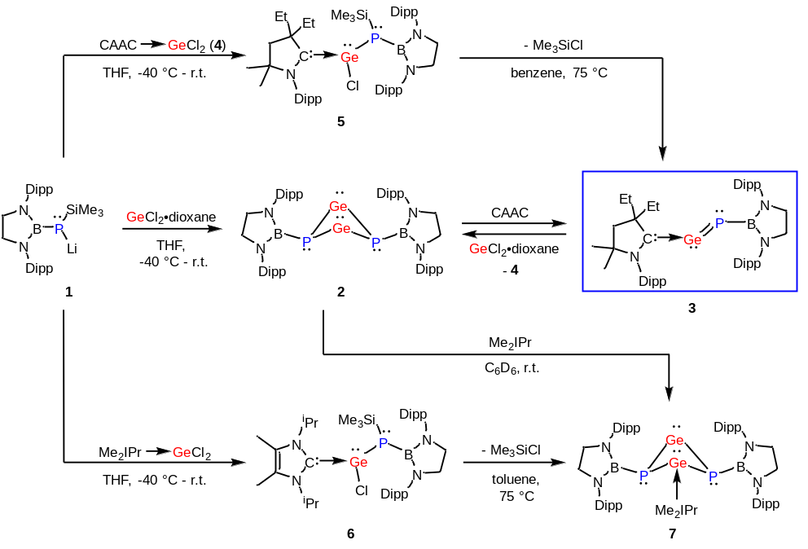
Scheme 1. Synthesis of compounds 2-7 (Dipp = 2,6-^{i}Pr₂C₆H₃, Me₂IPr = 1,3-diisopropyl-4,5-dimethylimidazol-2-ylidene, r.t. = room temperature).

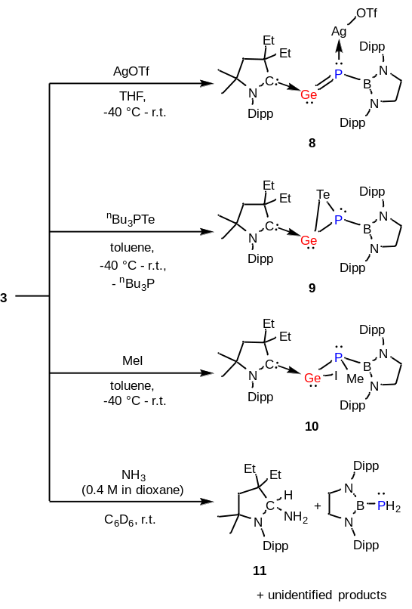
Scheme 2. Reactivity of 3 (Dipp = 2,6-^{i}Pr₂C₆H₃, OTf = F₃CSO₃).

