Supplementary material
Figure legends
Figure 1. Flow chart illustrating the study selection process.
Figure 2. a. The positive control group (micrometastasis detection of the tumor tissues of GC lesion by immunohistochemical staining for cytokeratin CK8/18; field of vision, ×100 times). b and c, the negative cases of 14v micrometastasis (immunohistochemical staining for cytokeratin CK8/18; field of vision, ×100 times; at the top right site, ×200 times).

Figure 1.
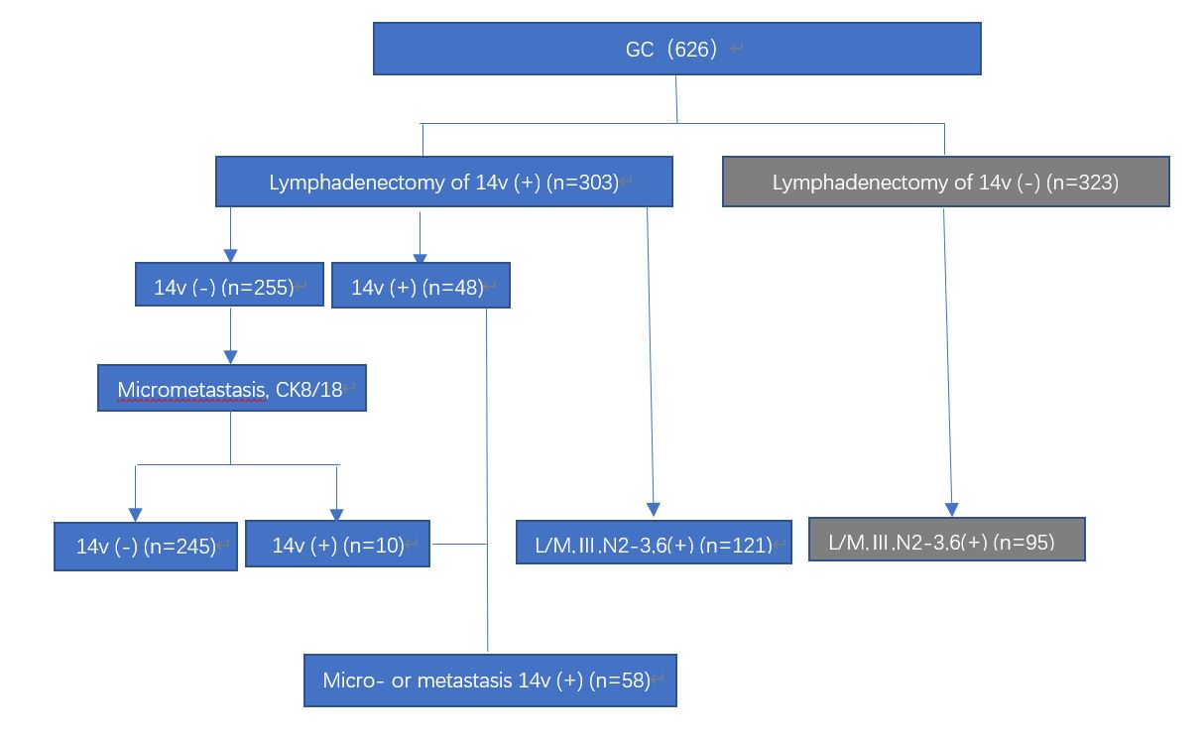

Figure 2.
a
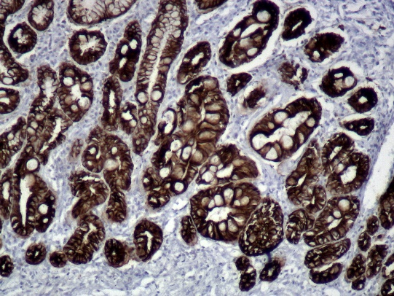

b
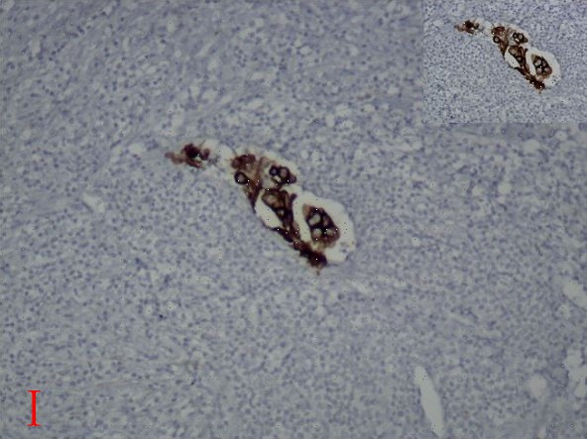

c
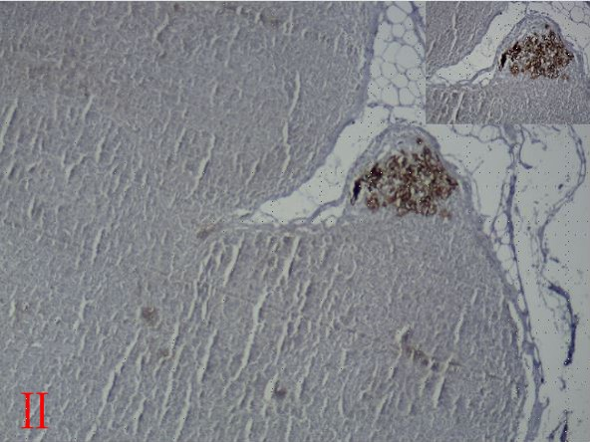l

