Table 1: Secondary phytochemical compounds identified By GC-MS in ethanolic extracts of S. vulgare
Peak RT | Area % | Name Of The Secondary Compounds | CID | Qual | Molecular  Formula | Chemical Structure
23.31  28.21 | 2.45  3.56 | 1-Iodotridecane | 545617 | 78 | C13H27I | 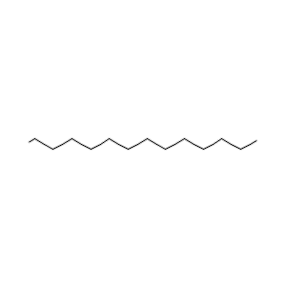
23.72 | 2.11 | 2,4-ditert-butylphenol | 7311 | 72 | C14H22O | 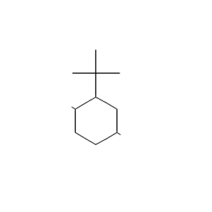
24.38 | 1.49 | 3,5dimethyloctan-2-one | 537874 | 72 | C10H20O | 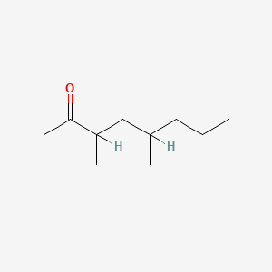
25.75 | 2.34 | tridecan-3-yl 2-methoxyacetate | 542291 | 72 | C16H32O3 | 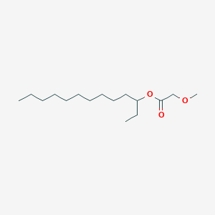
27.98 | 3.55 | Octadecane | 11635 | 72 | C18H38 | 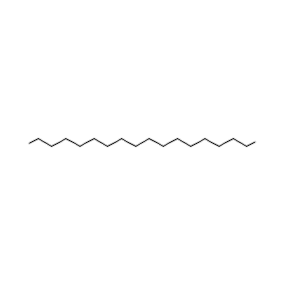
33.95 | 7.65 | ethyl hexadecanoate | 12366 | 98 | C18H36O2 | 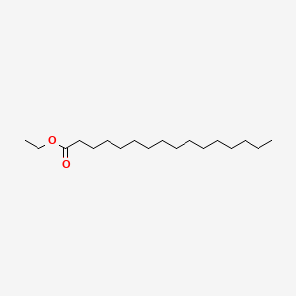
32.61 | 1.42 | 9-Octylicosane | 280905 | 64 | C28H58 | 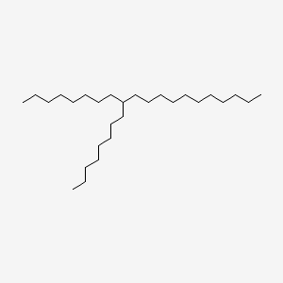
33.95 | 2.45 | Hentriacontane | 12410 | 68 | C31H64 | 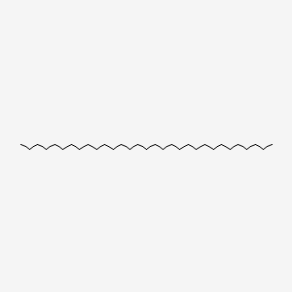
30.91 | 4.95 | 2-[12-(oxiran-2-yl)dodecyl]oxirane | 543423 | 50 | C16H30O2 | 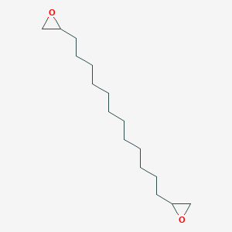
31.05 | 1.76 | 4-Methyldocosane | 520181 | 53 | C23H48 | 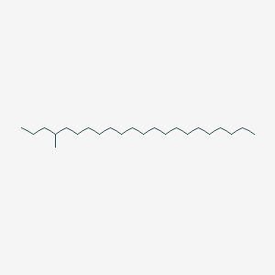
31.41 | 1.42 | (E)-1-methoxydodec-2-ene | 88030105 | 35 | C13H26O | 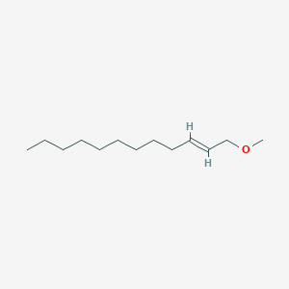
31.77 | 1.95 | 2,2,2-trichloroethyl undec-10-enyl carbonate | 6420633 | 46 | C14H23Cl3O3 | 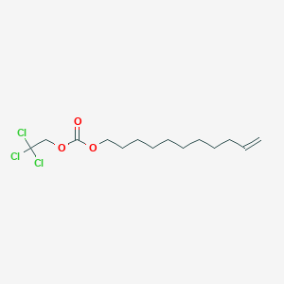
32.55 | 1.32 | 7,9-Ditert-Butyl-1-Oxaspiro[4.5]Deca-6,9-Diene-2,8-Dione | 545303 | 27 | C17H24O3 | 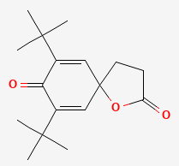
37.11 | 3.11 | Methyl (Z)-Octadec-6-Enoate | 5362717 | 46 | C19H36O2 | 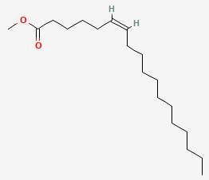
49.33 | 0.49 | Bis(6-Methylheptyl) Benzene-1,2-Dicarboxylate | 33934 | 58 | C24H38O4 | 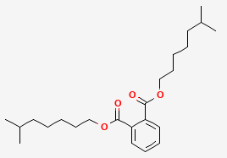
49.50 | 0.7287 | 1-Hydroxy-4-Methoxy-3,3-Dimethylindol-2-One | 610113 | 52 | C11H13NO3 | 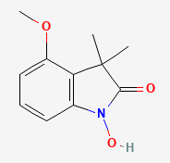

Table 2: Secondary phytochemical compounds identified by GC-MS in methanolic extracts of S. vulgare
Peak RT | Area % | Name Of The Secondary Compounds | CID | Qual | Molecular Formula | Chemical Structure
23.31 | 2.46 | Pentadecane | 12391 | 72 | C15H32 | 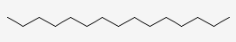
23.72 | 2.73 | 2,4-Di-Tert-Butylphenol | 7311 | 72 | C14H22O | 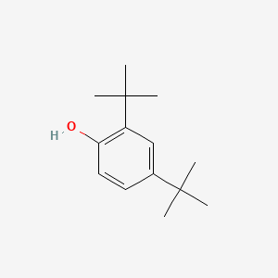
24.38 | 1.44 | Hexadecane | 11006 | 86 | C16H34 | 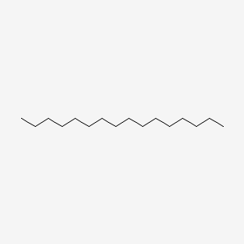
28.21 | 3.88 | 3-Ethyl-5-(2-Ethylbutyl)Octadecane | 292285 | 80 | C26H54 | 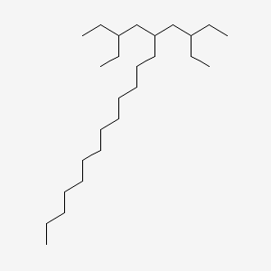
32.65 | 5.77 | methyl hexadecanoate | 8181 | 90 | C17H34O2 | 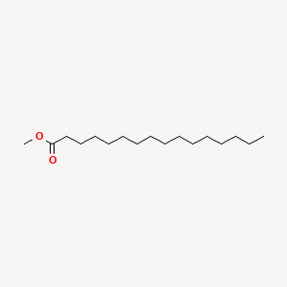
27.99 | 2.25 | Heptacosane | 11636 | 64 | C27H56 | 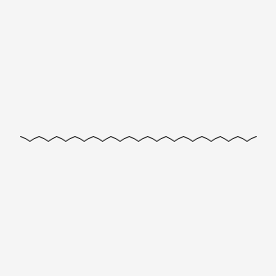
25.75 | 2.56 | 3,7-Dimethylundecane | 519387 | 53 | C13H28 | 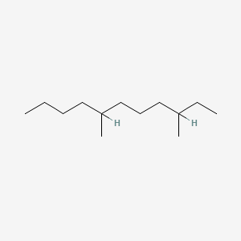
29.14 | 1.83 | Octacosane | 12408 | 59 | C28H58 | 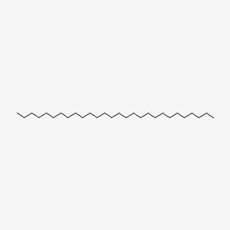
30.91 | 1.60 | Hept-2-Ynal | 549253 | 35 | C7H10O | 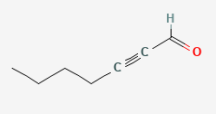
35.93 | 1.91 | 1-(2-Cyclohexyliminocyclopentyl)Ethanone | 610112 | 35 | C13H21NO | 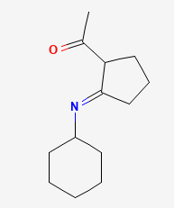
36.13 | 1.94 | (E,7r,11r)-3,7,11,15 Tetramethylhexadec-2-En-1-Ol | 5280435 | 49 | C20H40O | 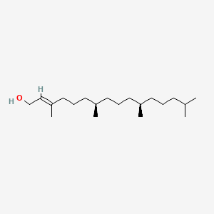
43.31 | 5.79 | Dioctyl Benzene-1,2-Dicarboxylate | 8346 | 50 | C17H34O2 | 