Supplementary Materials

Digital cooking could increase the availability of nutritious meals
Jonathan Blutinger^{1,*}, Shravan Karthik¹, Alissa Tsai¹,
Yorán Meijers^{1,2}, Hod Lipson¹

Contents:
Supplementary Background………………………………………………………………… 3
S1. Sample preparation……………………………………………………………………... 5
S2. Food recipes……………………………………………………………………………... 6
S3. Digitally-crafted meals………………………………………………………………….. 7
S4. Printing and cooking mechanism……………………………………………………… 8
S5. Slicer Engine (Juli3nne)………………………………………………………………… 9
S6. Calibrating ingredients………………………………………………………………….. 10
S7. Food printing logic…………………………………………………………………......... 11
S8. Software logic…………………………………………………………………............... 12
S9. Laser crusting cheesecake……………………………………………………….......... 13
S10. Laser specs…………………………………………………………………………...... 14
S11. Future work……………………………………………………………………………... 15
Figures S1 – S11…………………………………………………………………………….. 16
Tables S1 – S4……………………………………………………………………………….. 27
Supplementary References…………………………………………………………………. 33

¹ Creative Machines Laboratory, Mechanical Engineering, Columbia University, New York, NY 10027, USA.
² Wageningen University, 6708 PB Wageningen, Netherlands
Description: Supplementary Figures and Supplementary Discussion

File name: Video 1
Description: Seven-ingredient cheesecake print. This video illustrates the iterative process by which we assembled the printed cheesecake. Each multi-ingredient design was printed and iterated upon until a structurally stable print was achieved. Here, we illustrate our process and main results.
File name: Code
Description: Final cheesecake print. This file produced a successful cheesecake print when run on our machine. It combines coordinated movements to print seven ingredients and laser crust the top surface of the graham cracker crust. It was optimized for use on our gantry so it is not guaranteed to work on other machines.
Supplementary Background
While commercial food printers do exist, they are somewhat limited in their abilities to combine cooked foods. Food printing was first introduced at Solid Freeform Fabrication Symposium in 2007¹, and has since slowly burgeoned as a commercially viable application of AM. Current food fabricators being developed in industry include machines that can print customized pasta geometries², chocolate structures³, pizzas for separate oven baking⁴, user-inputted multi-material food products^{5,6}, and other confectionary sugary treats^{2,7}. All of these printers have the ability to combine one or—in some cases—more ingredients in a single printed object, however, they are limited by a lack of onboard heating. Hertafeld et al.⁸ investigated multi-material printing with in situ cooking via an infrared lamp on a food printer. This sort of simultaneous high-resolution heating is necessary on a food printer in order to achieve more complex recipe combinations.
Heat is a transformative process that affects the aroma and flavor development of foods⁹. Doughs and starch-containing products develop different microstructures and nutritional profiles when subject to heat and other prerequisites^{10–12}. Perhaps more familiar to most are the color and textural changes associated with protein denaturation, which is a common process undergone by animal proteins in the presence of sufficient heating^{13,14}. Another recognizable heat-driven process is non-enzymatic Maillard browning, which greatly affects the flavor development and aesthetic of heated foods^{15,16}. These chemical processes, which are typically achieved using conventional heating appliances¹⁷, can also be achieved via the use of diode and gas lasers^{18–21}.
Prior work with regards to laser cooking is quite limited. Fukuchi et al.²² cooked the fat portion of bacon on a laser cutter. A few patents exist around the use of lasers for cooking^{23–25}, but none properly parameterize in detail the requirements for proper cooking of food items. Our prior work investigates precision software cooking as it applies to lasers as a heating source^{18–21}.
We used two different laser apparatuses in this study: 1) a stationary blue (445 nm) laser beam redirected by a set of mirror galvanometers and 2) a movable near-infrared (980 nm) diode laser mounted to a Cartesian gantry. The blue laser was used to crust parts of the cheesecake and to brown the tofu mixes, while the near-infrared (NIR) laser was used to cook the dough and melt the cheese on the pizza. Through multiple iterations and trials, we successfully printed and cooked a few different recipes that were edible and tasty.

Supplementary Materials and Methods
S1. Sample preparation
To prepare the graham cracker paste, we bought graham crackers (Nabisco Grahams Original), butter, and powdered sugar from a local convenience store (Appletree Market, New York City, USA). First, we processed eight full sheets of graham crackers (140 g) through an FP-8GMFR Food Processor (Cuisinart, Stamford, USA) on high for 20 s. Next we added 2 tbs. of butter, 4 tsp. of water into the mixture, and proceeded to blend on high for 30 s. When thoroughly mixed, the result was a solid but formable mass.
The only other ingredient that was not off-the-shelf was the banana puree. We hand-mashed a banana with a fork until there were no solid clumps remaining that would obstruct extrusion from the syringe nozzle tip.
The peanut butter (Skippy, Austin, USA), jam (The J.M. Smucker Company, Orrville, USA), Nutella (Ferrero SpA, Alba, Italy), cake frosting (Betty Crocker, Minneapolis, USA), and cherry drizzle (Krasdale Foods Inc, The Bronx, USA) were acquired from local convenience and grocery stores (Appletree Market and Westside Market, New York City, USA) and required no additional processing prior to being packed into syringe barrels.
Once the materials were prepared, we packed each ingredient into a syringe barrel (PN: 7012134), which was outfitted with a 14 gauge tapered nozzle tip (PN: 7018052) (Nordson EFD, East Providence, USA). The barrels were carefully packed with a spoon and the material was packed from the top of the barrel downward to avoid bubbles or air pockets, which could cause issues during printing.
All ingredients were refrigerated prior to being packed into syringes for printing, this tended to thicken the ingredients and make them more structurally stable.

S2. Food recipes
Six different recipes were used in this software cooking study (Table S1). Recipe 2 took inspiration from a pizza recipe and combined dough sauce and cheese into one fully-cooked pizza pie. Granted, this laser-baked pizza was about the size of a Bagel Bite, it proves the ability to preliminarily bake dough and melt cheese via a NIR laser. Recipe 1 features a tofu bite that was laser-crusted on its top surface by the blue laser after printing. Lastly, Recipe 3 was inspired by a cheesecake dessert recipe and is the sweetest of three multi-ingredient objects. The dessert was also laser-crusted on the surface by the blue laser. All of the ingredients and food products for this three-course meal were combined and heated entirely using software cooking methods.

S3. Digitally-crafted meals
Satisfactory cooking of food via laser energy requires proper calibration of the cooking patterns and laser parameters. Similar to printing, specific adjustments were needed for different edible materials. With prior knowledge of laser-induced dough baking and browning^{18,20} and initial benchmarking, we operated the NIR laser at slower initial speeds to allow for sufficient heat to build up in the dough sample and gelatinize the starch granules.
Fabricating a pizza on our machine involved a series of steps: (1) printing a first layer of dough, (2) cooking the first layer of dough, (3) printing the next layer of sauce, (4) printing the next layer of cheese, (5) melting the top layer of cheese and sauce. We used a spiral cooking pattern that spanned across the 30 mm diameter of the printed dough. The spacing between each successive spiral was 3 mm and the total time for each pass of the pattern was just shy of 6 minutes. The pattern was run for six successive passes with the NIR laser operating at 8.5 W. For the first five heating tests, we used a 30 mm focal lens at a z-height beyond the beam waist, resulting in a spot size of 3 – 4 mm, but for the sixth heating trial we used a 50 mm focusing lens to reduce the spot size further (to 1 – 1.5 mm) and focus the laser energy to achieve crusting, which did occur. After the sauce and cheese were deposited on the laser-heated dough, the same spiral heating pattern was run three more times in succession to melt the cheese.
Unlike the pizza, the tofu bite and the cheesecake could have been eaten raw but we chose to heat parts of it with the laser to showcase the spatial and temporal control of our software-controlled laser cooking system. For these two food objects, we used our 5 W blue laser to crust parts of the exterior. A trochoid heating pattern was used since it was proven by Blutinger et al.²⁰ to be an efficient heating pattern.
We printed the tofu bite onto a cracker for ease of transport to the laser cooker and to show another use case of our printing setup. Once the tofu ingredients were printed, we traced a trochoid cooking pattern along the same path of the material deposition for two consecutive passes. The total cook time with the laser was 4 – 5 minutes. After heating, the miso glaze was printed inside of the tofu structure to create a two-ingredient final product.
S4. Printing and cooking mechanism
We retrofitted an X-Carve Cartesian gantry (Inventables, Chicago, USA) with a custom extrusion mechanism (Fig. S6), allowing us to pick-and-place ingredients for printing. Our printer can accommodate up to seven ingredients, which are all housed on the front tool carriage (Fig. S7). We control the motion of all of the axes with ClearPath brushless servomotors (CPM-SDSK-2311S-RQN). The same system is used by Hertafeld et al⁸.
A mounting plate needed to be added to the side of the extrusion mechanism to secure our blue laser to the printer. This effectively combined the printing and cooking process onto one single machine. We designed a mounting plate and laser-cut it from a clear sheet of acrylic. Four thermal threaded inserts were added to the plate to facilitate easier mounting and dismounting of the laser.
To attach the mounting plate to the side of the extrusion mechanism, a separate 3D-printed piece was designed. This piece fit into a rectangular gap on the side of the extrusion mechanism, and the mounting plate was then attached to the 3D-printed piece with screws. Fig. S3 shows the blue laser mounted to the extrusion mechanism on our gantry.

S5. Slicer Engine (Juli3nne)
Slic3r is an open-source flexible toolchain that helps convert model representation files into G-code²⁶, a computer numerical control programming language, which can be interpreted by printer firmware. The software is built using C++ with a Perl script interface and supports multiple configurations enabling a wide range of prints. The Slic3r engine is designed to print objects using metal and plastic filaments and thus requires modifications to enable the printing of food. Juli3nne is a fork of the Slic3r project which tweaks the parameters of the slicer engine to enable printing of food material.
Extrinsic and intrinsic parameters of the printer such as travel speed, in-fill density were adjusted to ensure the different food materials can be printed by modifying a single parameter—the extrusion multiplier. To determine the extrusion multiplier, each material is calibrated using a standard reference design. Once the extrusion multiplier is determined, each material and layer can be converted to its corresponding G-code.
In addition to generating the G-code with each layer, the grouping module in Juli3nne uses information from the STL file to assemble materials into a single entity. The order of the print and the starting 3D-coordinates for each layer is calculated to produce a single G-code file.
The final step before the code is ready to print is to add printer-specific custom code. This includes adding G-code for tool change of food cartridges, adding custom layers and offsets to enable cooking of printed material, and enabling custom control commands to help interface external tools such as lasers used for cooking. Once these steps are complete, a single G-code file capable of printing and cooking the designed object is created. Fig. S8 provides an overview of the steps involved in generating the G-code for the 7-layer cheesecake print.

S6. Calibrating ingredients
To determine the extrusion multiplier associated with each material, a reference design of a cuboid of surface area 1 square inch was printed. The initial two layers of the cube are forced to be infill layers of the cube with an infill ratio of nearly 1. The rectilinear infill pattern helps determine the extrusion multiplier that needs to be set to ensure each pattern line doesn’t overlap with the other. The extrusion multiplier is constantly adjusted until the pattern is smooth and there are no smudges in-between layers.
Heuristically, the extrusion multiplier is set to 0.08 for materials with very high viscosity (e.g. graham cracker paste) and 0.03 for materials with low viscosity (e.g. jelly and banana puree). The viscosity is determined qualitatively; materials that have greater resistance to flow are assigned a higher extrusion multiplier. These values are constantly adjusted by a factor of 0.005 until no overlap in infill layers is observed. Fig. S9 shows a sample of peanut butter that was calibrated using this method. The extrusion multipliers for each of the ingredients used in the experiments are presented in Table S4. Ingredients used in the recipes (Table S1) that do not appear in Table S4 were printed through the custom Matlab script (see Section S7), which does not use the extrusion multiplier variable.

S7. Food printing logic
We used Repetier-Host, an open source firmware, to interface with the machine and upload recipe files for printing. We generated custom printing and cooking files via custom scripts that were formulated in Matlab or Juli3nne (see Section S5).
Our Matlab printing script allowed us to vary parameters such as print speed, extrusion rate, and geometry of the printed object. Parameters such as number of ingredients, sides, size, height, and twist angle could be tailored in our G-code generator. Fig. S18 shows example geometries and ingredient combinations that are currently capable of being printed using our system. The variance in shape of the four structures can be attributed to five variables: number of sides (s), diameter (d, mm), number of layers (h), twist (t, °), and number of ingredients (i). Polygons of different size and shape were created by interpolating points along a circle. For simplicity, further mention of these variables to characterize the shape of an object will be in the form of the matrix [s,d,h,t,i].

S8. Software logic
Logic for the three-material pizza print was as follows: (1) print filled circle of dough, (2) cook dough via NIR laser for six heating cycles, (3) replace dough cartridge, (4) pick sauce cartridge, (5) print filled circle of sauce, (6) replace sauce cartridge, (7) pick cheese cartridge, (8) print filled circle of cheese, (9) melt cheese via NIR laser for three heating cycles, and (10) add pinch of basil salt.

S9. Laser crusting cheesecake
Seeing as the crust was more visibly affected by the blue laser light, we ran several more tests to observe to what extent we could spatially control heating to the crust. Fig. S5 shows the single-ingredient prints before and after laser heating. Cook time for square prints (Fig. S5e) were approximately 5 minutes, while circular prints (Fig. S5f–S5h) took closer to 7.5 minutes to cook. The speed of the laser along the trochoidal path for these trials were slower than the full cheesecake cook times in the prior test, so we only had to run one cooking cycle to slightly cook and crust the confectionary ingredient.
To show the degree of spatial control we can achieve with laser cooking, we added a bull’s-eye pattern into the crust to demonstrate the precision and customizability of the laser (Fig. S5h). We assumed that the blue laser was symmetric and Gaussian during the cooking trials, when in actuality it’s closer to an ellipsoid. As a result, it heats regions on certain parts of the path more so than others due to the speed and asymmetric spatial distribution of energy of the laser beam.

S10. Laser specs
Our cooking apparatus comprises a blue laser diode operating at 445 nm and a near-infrared laser operating at 980 nm. At a current draw of 3 A, the maximum output power of the blue laser can be modulated to 13.8 W. For the experiments presented in this paper, we kept the current at 1.1 – 1.25 A, corresponding to a power output of approximately 5 – 6 W. Table S3 presents more detailed specs on the laser spot size at various distances, as well as the divergence angle of the beam. Given the placement of the laser with respect to the food, the spot size of the laser was roughly ¼ inch in diameter.

S11. Future work
All of these meals were developed and constructed via software. As such, food products constructed in this manner can be tailored and adjusted for nutritional content for a user’s wants and needs. Future work would explore the extent to which we quantify the nutritional value of laser-cooked foods, since it’s a processing technology that is in its infancy for food. This sort of exploration would also provide more credibility and allow people to accept software cooking as a technology that will provide people with more nutritious and customized foods. We also hope to explore the printing and cooking of vegetables, and to ultimately develop a machine that integrates the printing and cooking of foods into one contained system.
We also plan to explore the idea of closed-loop cooking, which we think will become an integrable part of software-controlled cooking. Closed-loop cooking is imperative on a food printer, especially given that edible materials have vastly different heat capacities, material properties, and temperatures—just to name a few—after printing. Lastly, the idea of medically tailoring meals through this software-based cooking method could have serious repercussion on health care costs and general well-being^{26,27}.

Supplementary Figures
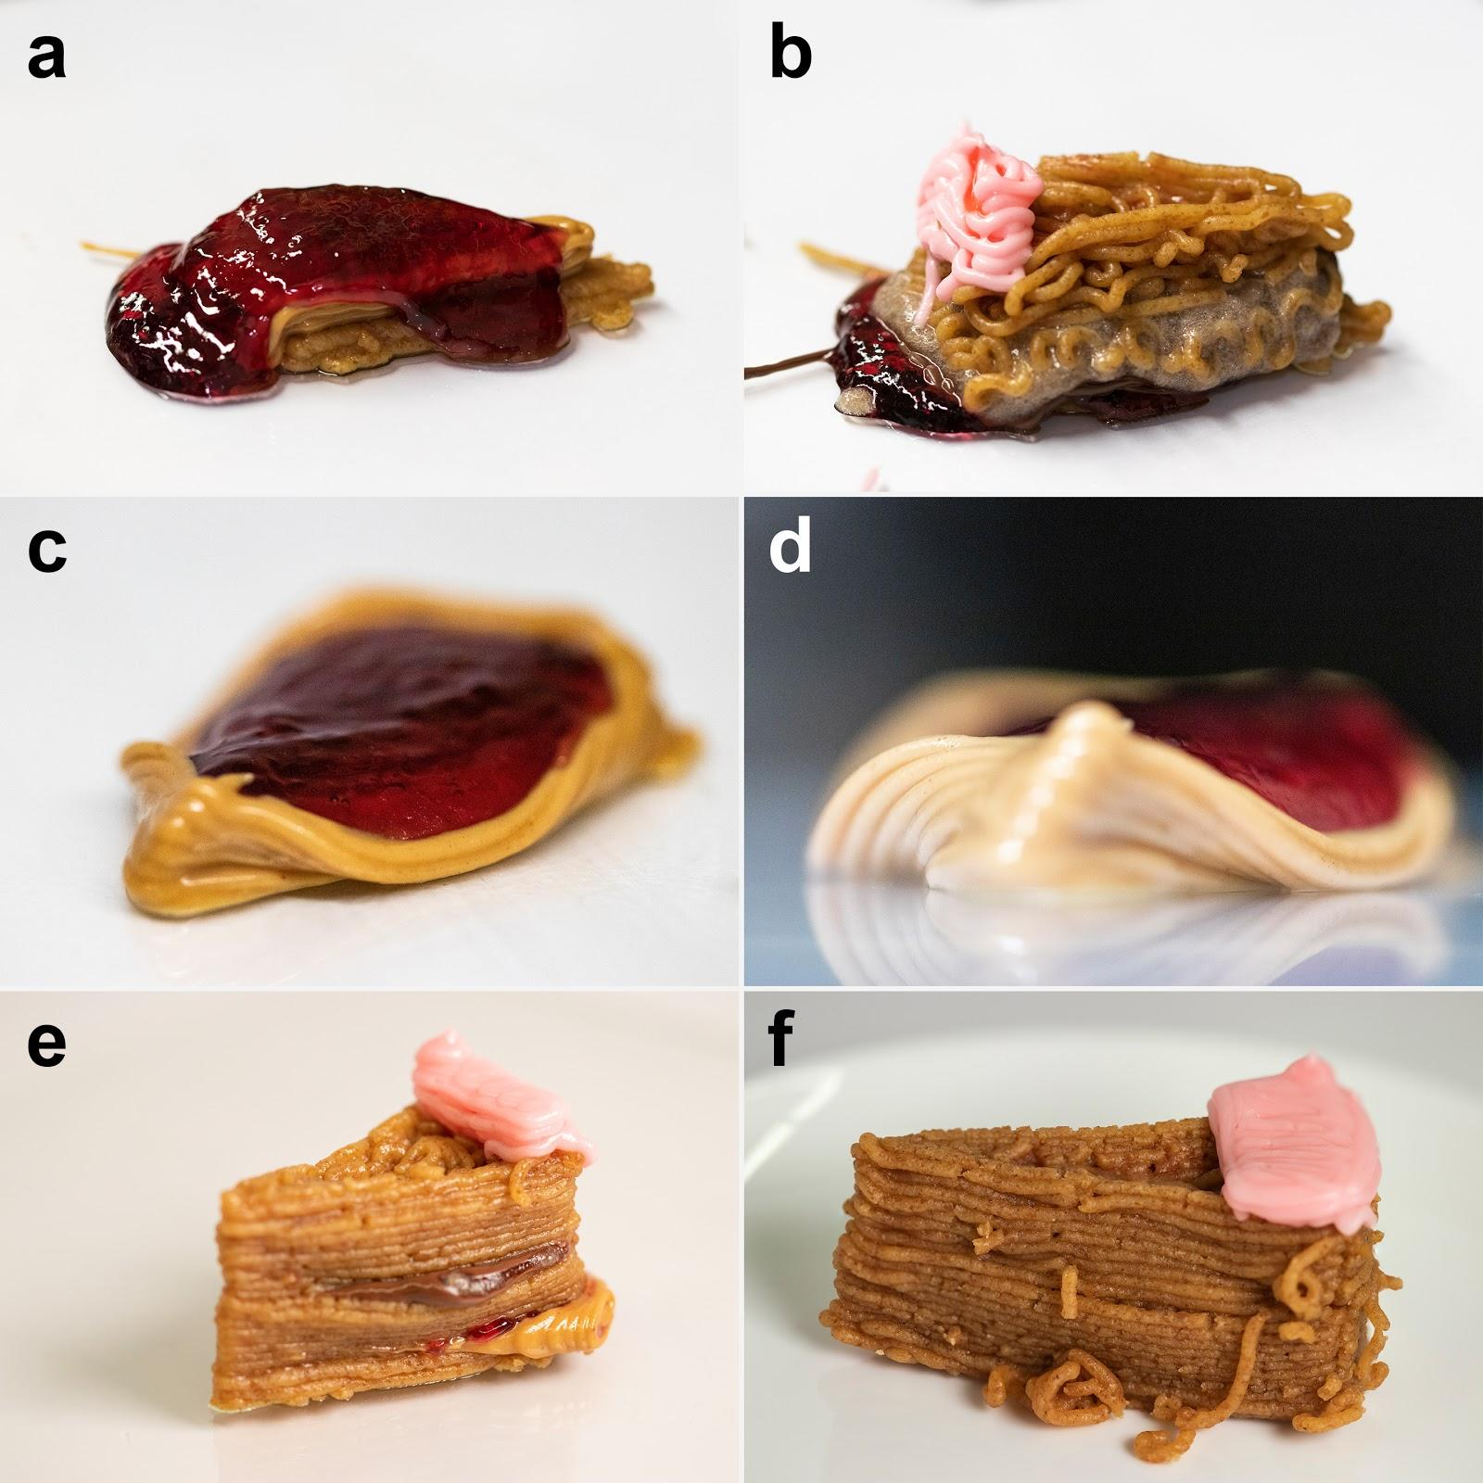
Fig. S1: Failed cheesecake prints. During initial prints, jam could not hold its shape (a) and graham cracker paste crushed all of the softer ingredients below it (b). We tried pooling softer ingredients but thin walls crumbled and couldn’t hold their shape (c, d). With the addition of graham cracker walls throughouts the structure, we started to get more smearing of ingredients due to a lack of clearance with the food nozzle (e); prompting us to scale up the model. Occasionally, the graham cracker paste would form squiggles (f) due to incorrect z-height or drying of the ingredient.
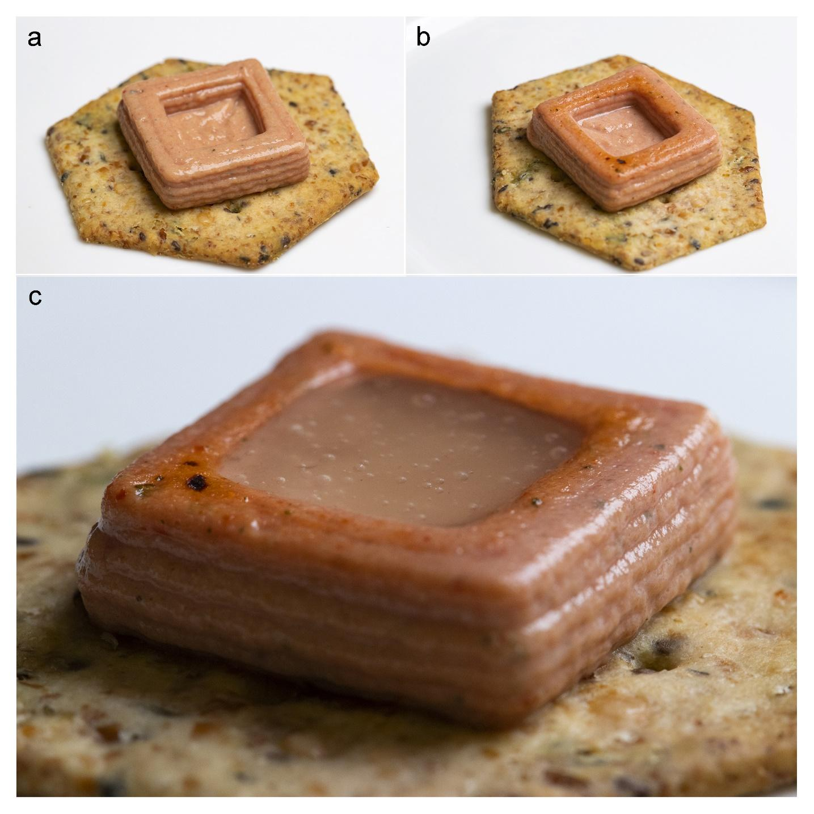
Fig. S2: Crafting the laser-crusted tofu bite. a: A cracker with a printed tofu structure on its surface. b: Printed tofu mix that has been broiled with a blue laser showing clear discoloration on the top surface. c: The finalized tofu bite with miso glaze added to the interior of the structure.

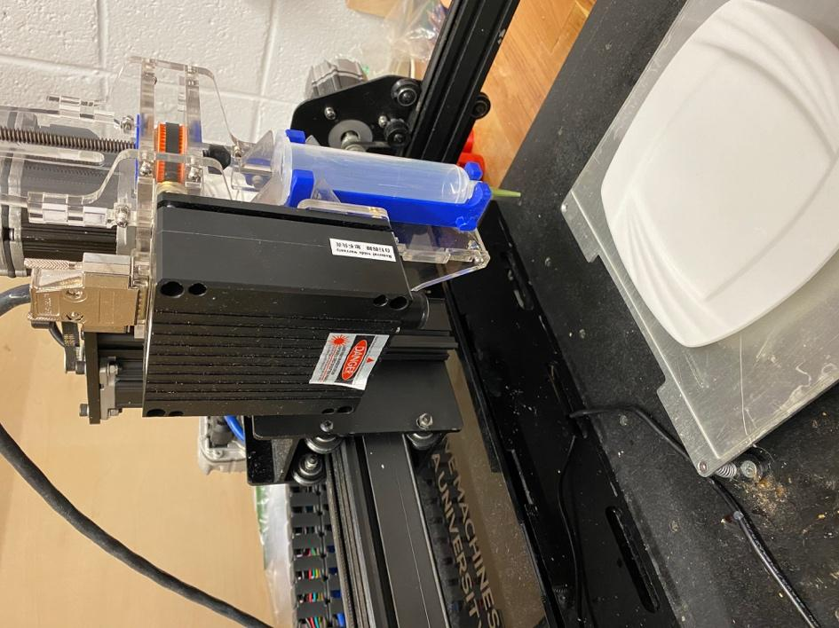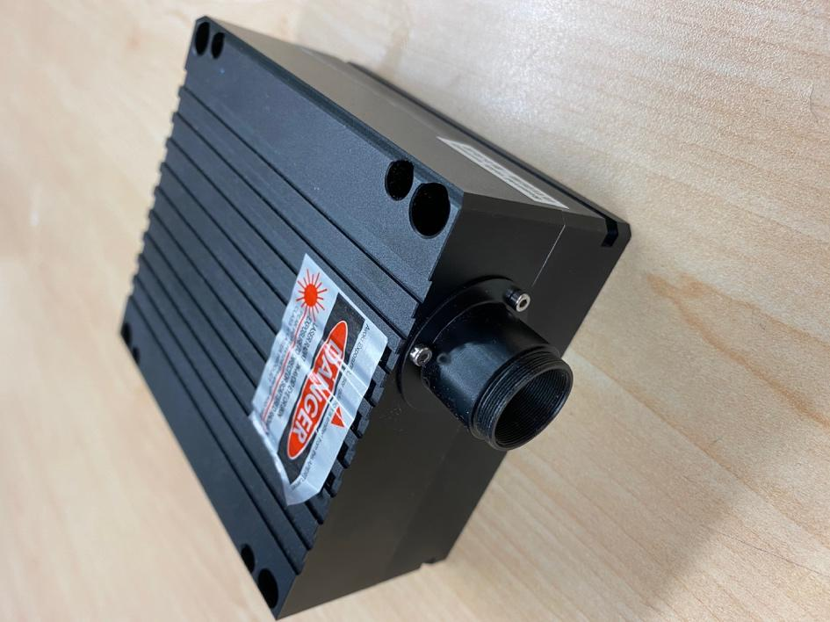
Fig. S3: Isometric view of mounted laser (left) and close-up view of blue laser (right).
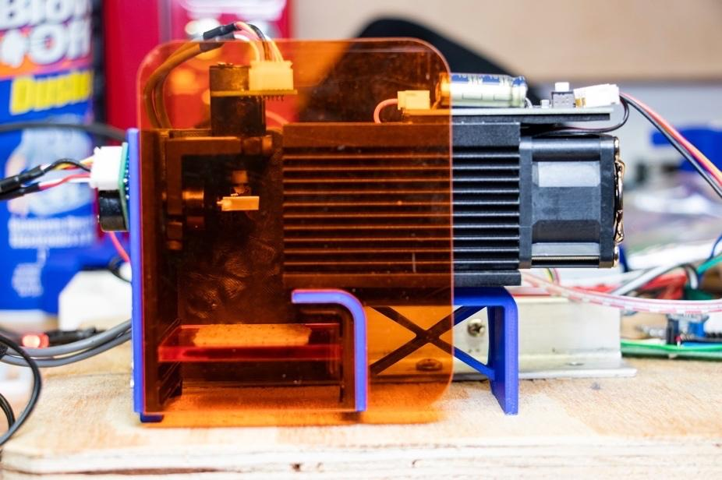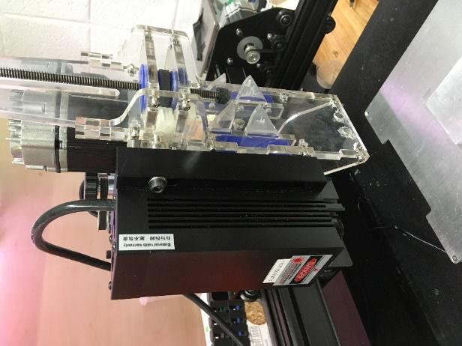
Fig. S4: Laser systems used in cooking trials. Left: Stationary blue diode laser with energy being redirected by dual axis mirror galvanometers. Right: Near-infrared diode laser mounted to a 3-axis gantry.

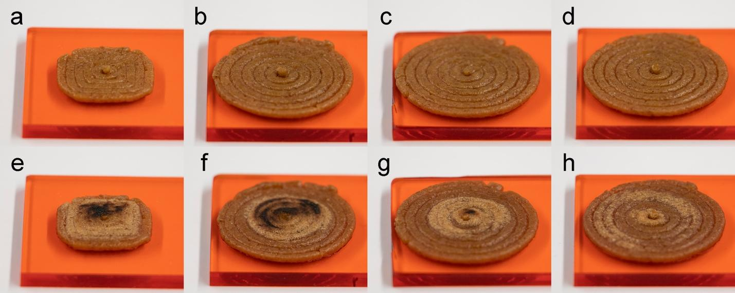
Fig. S5: Printed cheesecake crust (a–d) before and (e–h) after laser heating.

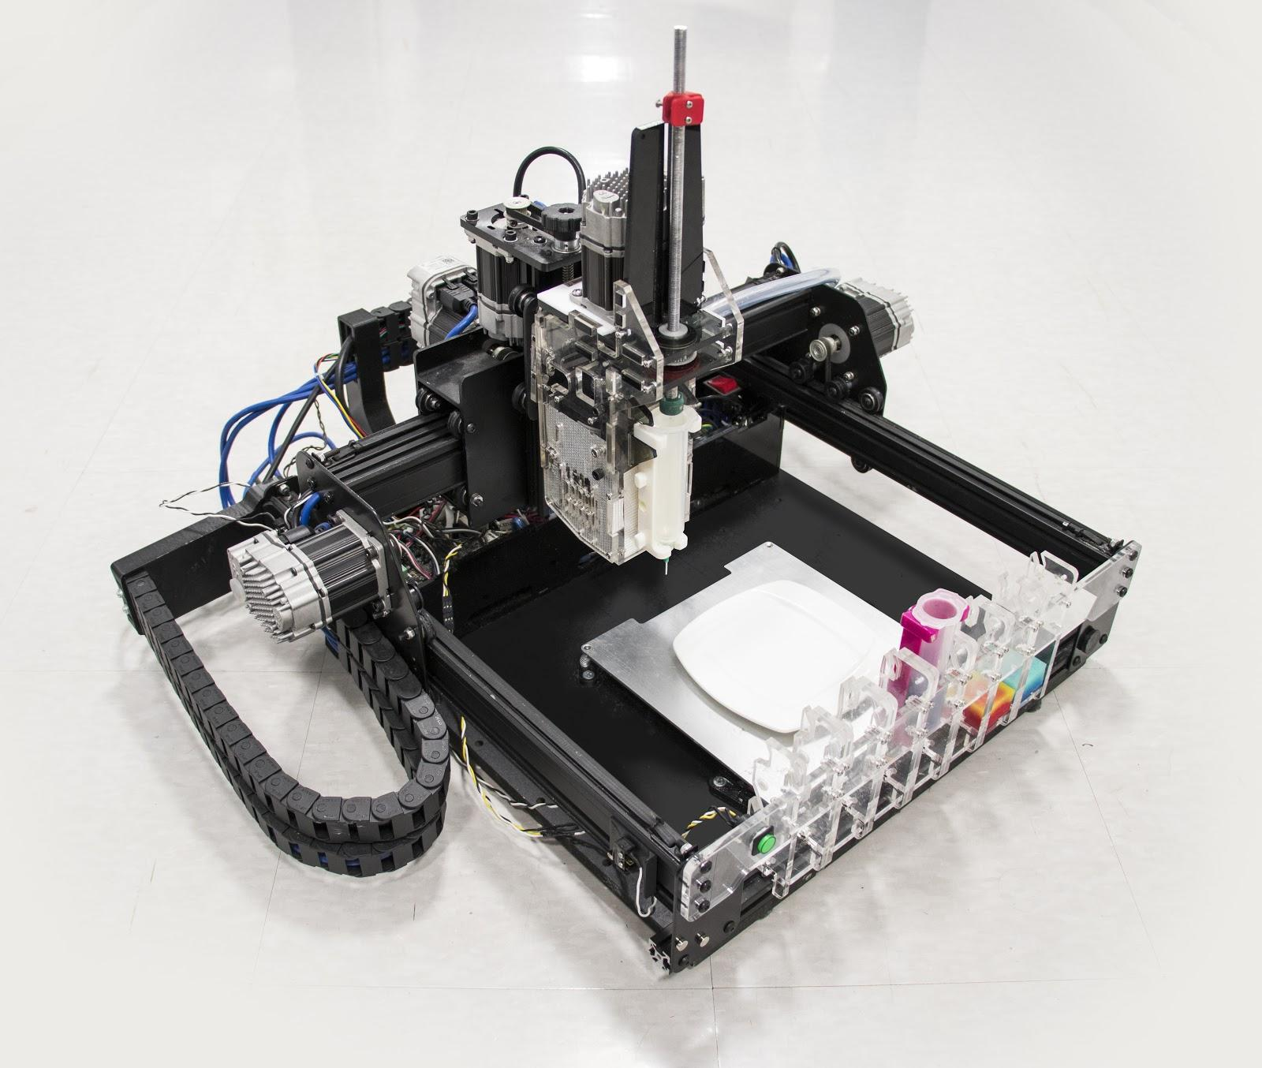
Fig. S6: Our customized food printer. The extrusion mechanism and tool carriage were designed and attached to the body of the machine. Printer can accommodate up to seven ingredients.

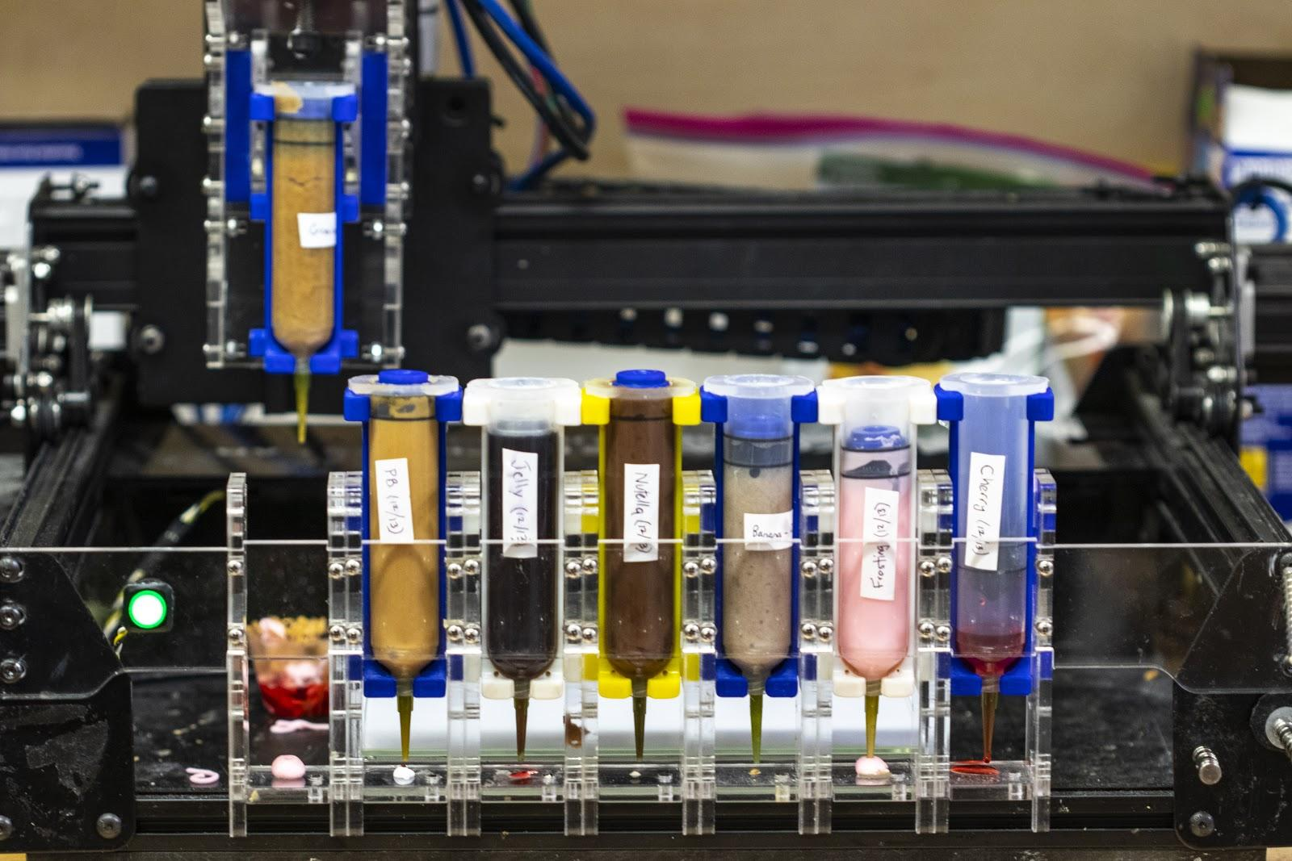
Fig. S7: Front view of food printer showing seven filled food cartridges. Each cartridge has its own tool post and can be picked and placed by the extrusion mechanism.

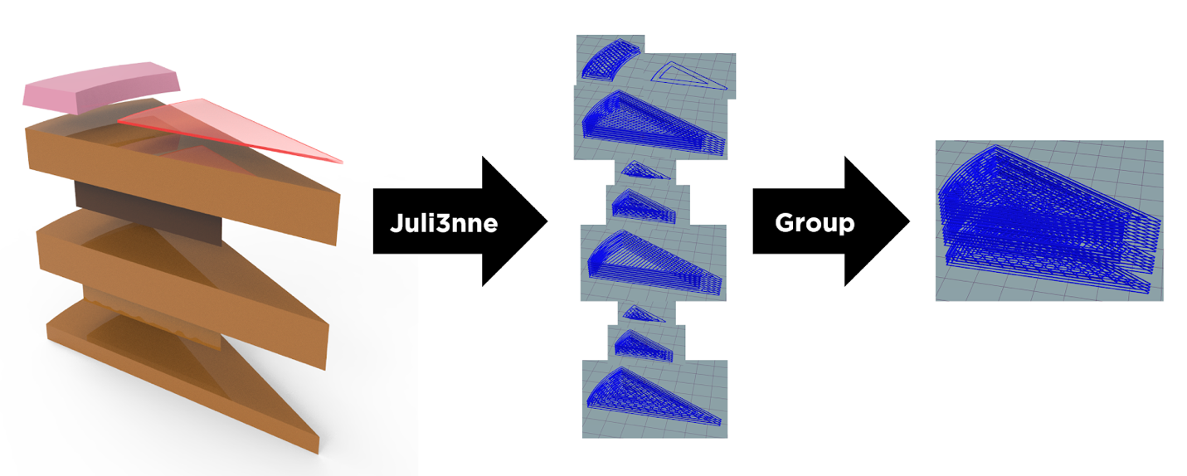
Fig. S8: Generation of G-code from STL files using Juli3nne. Individual object files are sliced to layers and assembled to provide a single printable file.

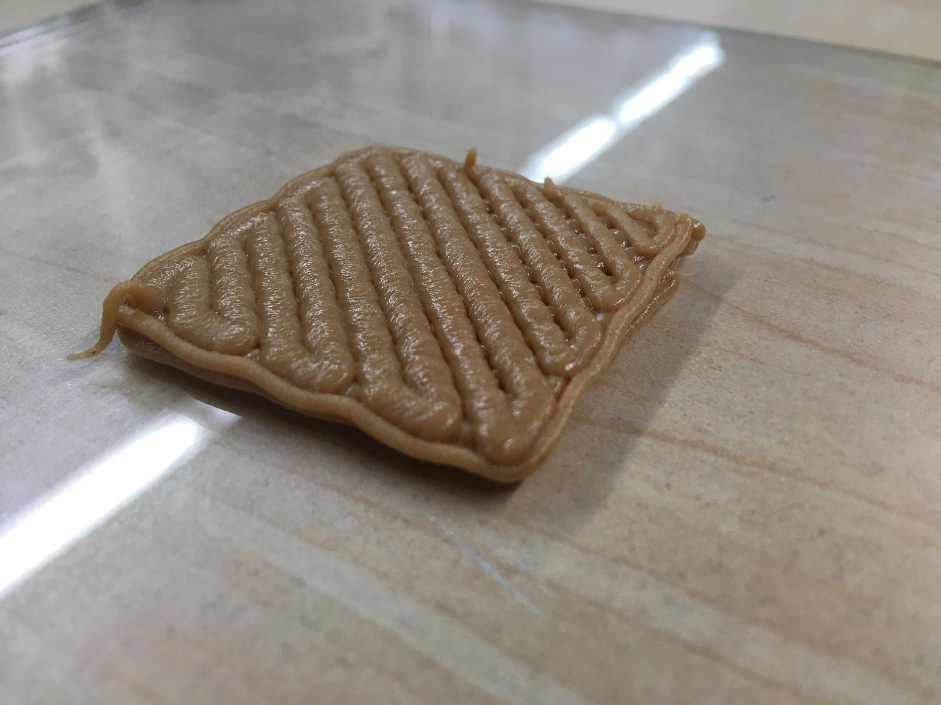
Fig. S9: Calibration of peanut butter. The extrusion multiplier is adjusted until the rectilinear infill pattern has no overlapping sections.

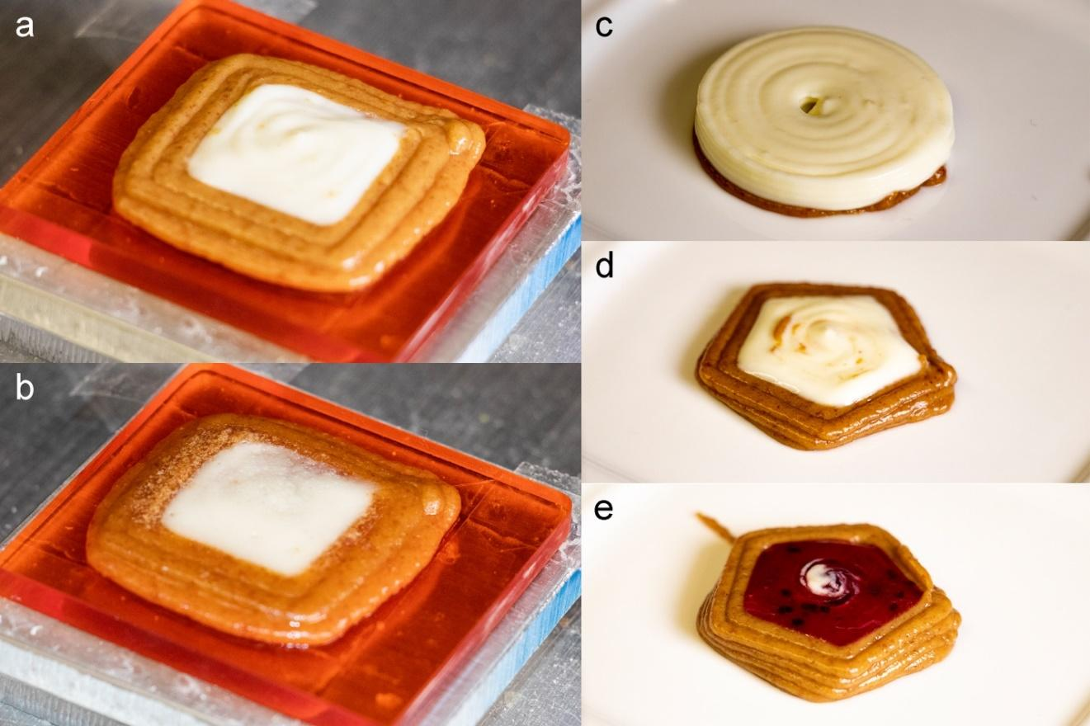
Fig. S10: A two-ingredient printed cheesecake (a) before and (b) after laser heating.

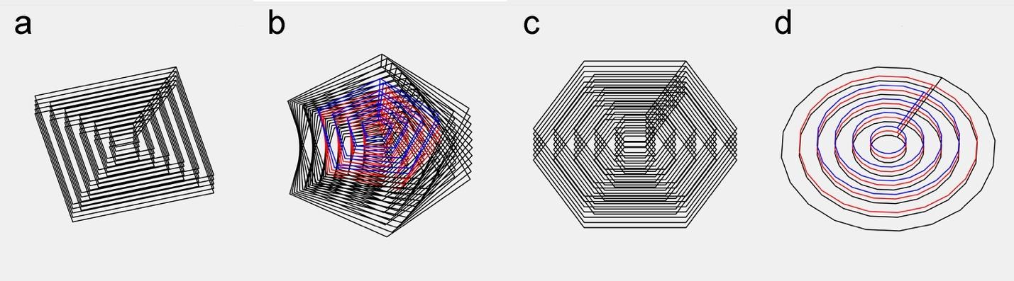
Fig. S11: Print paths that were generated via Matlab. The modeled food objects can be characterized in terms of number of sides (s), diameter (d, mm), number of layers (h), twist (t, °), and number of ingredients (i) in the form [s, d, h, t, i]: a [4, 36, 5, 0, 1], b [5, 36, 10, 3, 3], c [6, 30, 10, 0, 1], d [20, 36, 3, 0, 3].

Recipe # | Ingredients | Preparation
1. Laser-crusted tofu bite | 1 block (14 oz.) Medium firm tofu  6 oz. Tomato paste  1 tbs. Dehydrated mushrooms  1 tbs. Dried onions  1 tsp. Salt  1 tsp. Black pepper  2 tbs. Miso paste  6 oz. Water  2 tsp. Guar gum | Tofu mix: first process the dehydrated mushrooms and dried onions until they become a fine powder. Then, drain the medium firm tofu. Process the mushrooms, onions, tofu, tomato paste, salt and pepper until a creamy, even consistency is achieved.  Miso glaze: dissolve the miso paste in warm water. Then, using a cheesecloth or some kind of sieve, strain and discard the larger particles. Slowly stir in the guar gum. Let sit and congeal.
2. Laser-baked pizza | ½ cup All-purpose flour  ½ cup Water  1.5 oz. Tomato paste  1.5 oz. Ricotta  ½ tsp. Basil salt  ½ tsp. Paprika | Dough: mix or process the flour and water until an even consistency is achieved.  Sauce: Add basil salt and paprika to tomato paste and mix for uniform consistency.  Cheese: depending on consistency of ricotta, process for a few seconds in Cuisinart for uniform consistency.
3. Laser-crusted cheesecake | 8 graham cracker sheets (approx. 31 g)  1 tbs. Butter  2 tbs. Powdered sugar  2 oz. water  8 oz. plain cream cheese  4 tbs. Citron preserves  4 tbs. Black currant preserves  ½ orange, juiced  1 tsp. Vanilla extract | Crust: crush and process the graham cracker sheets until they become a fine powder. Then, mix the powdered sugar with 2 oz. cold water until it becomes a paste. Blend the crackers with the sugar paste. Melt the butter, and pour it into the graham “dough”.  Filling: first heat up the citron preserves so that the liquid separates from the solid. Blend the cream cheese, vanilla extract and orange juice together until it reaches an even consistency. Then, add the liquid from the citron preserves.  Glaze: heat up the black currant preserves and then separate the solids from the liquid.
4. Seven-ingredient cheesecake | 8 graham cracker sheets (approx. 31 g)  1 tbs. butter  2 oz. water  1 oz. peanut butter  1 oz. Jelly  1 oz. Nutella  ½ banana  1 oz. frosting  1 oz. cherry drizzle | Crust: crush and process the graham cracker sheets until they become a fine powder. Then, mix in ~1 tbs. of butter and 2 oz. of water and process until paste is uniform.  Banana: mash a banana by hand on a flat surface (plate works fine) with a fork. Pack into syringe and extrude ingredients one time through back onto plate to ensure uniform viscosity, then repack.  All other ingredients can be found off-the-shelf.
5. Carrot puree | 1 lb carrots  ¾ cup water  4 tbs. butter  1 tsp. kosher salt  1-2 tbs. lemon juice | Place all ingredients (except for lemon) in a saucepan and cook on high heat until water starts to boil. Reduce heat and cover, continue to cook until carrots are tender (~20 min). Once tender, place carrots in a blender to mash and add lemon to taste. Add more water from pan to reach desired consistency.
6. Tofu-curry pesto | ½ block of tofu  2 tsp. curry powder  2 oz. pesto | Drain the tofu and blend the curry powder with the tofu until a uniform consistency is achieved. Pesto can be purchased off-the-shelf or made from scratch with pine nuts, basil, parmesan, pepper, and olive oil (any homemade recipe as long as it’s uniform in consistency will work).
Table S1: Preparation techniques for three recipes used in experiments.

Ingredient | V1 | V2 | V3 | V4 | V5 | V6 | V7
Graham cracker | 32% | 33% | 33% | 59% | 64% | 73% | 71%
Peanut butter | 16% | 23% | 27% | 14% | 12% | 7% | 8%
Jelly | 16% | 8% | 4% | 4% | 4% | 2% | 3%
Nutella | 16% | 23% | 27% | 14% | 12% | 7% | 8%
Banana | 16% | 8% | 4% | 4% | 4% | 2% | 3%
Frosting | 4% | 4% | 4% | 4% | 4% | 7% | 7%
Cherry | 1% | 1% | 1% | 1% | 1% | 1% | 1%
Result | Failure | Failure | Failure | Failure | Failure | Success | Success
Table S2: Material composition of each printed structure and success rate

 | Horizontal | Vertical
Beam size at aperture (mm) | 5.21 | 5.99
Beam waist position (mm) | 0 | 0
Beam waist size (mm) | 5.21 | 5.99
Beam size at 4 m (mm) | 7.77 | 7.82
Beam size at 14 m (mm) | 12.59 | 22.35
Divergence (mRad) | 0.482 | 1.453
Table S3: Blue diode laser specifications.

Ingredient | Extrusion multiplier
Graham cracker paste | 0.100
Peanut butter | 0.050
Cake frosting | 0.045
Nutella | 0.040
Banana puree | 0.030
Strawberry jam | 0.030
Cherry drizzle | 0.005
Tofu | 0.050
Dough | 0.100
Tomato sauce | 0.030
Ricotta cheese | 0.040
Cream cheese | 0.050
Carrot puree | 0.040
Table S4: Extrusion multipliers used for printed ingredients.

Supplementary References
1. Periard, D., Schaal, N., Schaal, M., Malone, E. & Lipson, H. Printing Food. in Proceedings of the 18th Solid Freeform Fabrication Symposium 564–574 (2007).
2. Sol, E.-J., Vd Linden, D. & Bommel, K. V. 3D Food Printing: The Barilla collaboration. (2015).
3. Ltd, C. E. Complete 3D Chocolate Printing Guide [FAQ] Other.
4. Shah, A. BeeHex Aims to Bring 3D Printing to Print Food , One Pizza at a Time. Xconomy (2017). Available at: https://www.xconomy.com/texas/2017/02/01/beehex-aims-to-bring-3d-printing-to-food-one-pizza-at-a-time/.
5. Natural Machines: The makers of Foodini - a 3D food printer making all types of fresh, nutritious foods. Available at: https://www.naturalmachines.com/. (Accessed: 30th November 2017)
6. 3D Food Printer | Focus | byFlow. Available at: https://www.3dbyflow.com/. (Accessed: 23rd August 2019)
7. Willett, M. 3D Systems ChefJet Printers - Business Insider. Available at: http://www.businessinsider.com/3d-systems-chefjet-printers-2014-9. (Accessed: 30th November 2017)
8. Hertafeld, E. et al. Multi-material Three-Dimensional Food Printing with Simultaneous Infrared Cooking. 3D Print. Addit. Manuf. 3dp.2018.0042 (2018). doi:10.1089/3dp.2018.0042
9. Carmody, R. N. & Wrangham, R. W. The energetic significance of cooking. J. Hum. Evol. 57, 379–391 (2009).
10. Ratnayake, W. S. & Jackson, D. S. Starch gelatinization. Adv. Food Nutr. Res. 55, 221–68 (2009).
11. Lineback, D. R. & Wongsrikasem, E. Gelatinization of starch in baked products. J. Food Sci. 45, 71–74 (1980).
12. Zanoni, B., Schiraldi, A. & Simonetta, R. A naive model of starch gelatinization kinetics. J. Food Eng. 24, 25–33 (1995).
13. Tornberg, E. Effects of heat on meat proteins – Implications on structure and quality of meat products. Meat Sci. 70, 493–508 (2005).
14. Bircan, C. & Barringer, S. A. Determination of Protein Denaturation of Muscle Foods Using the Dielectric Properties. J. Food Sci. 67, 202–205 (2002).
15. Danehy, J. P. Maillard Reactions: Nonenzymatic Browning in Food Systems with Special Reference to the Development of Flavor. Adv. Food Res. 30, 77–138 (1986).
16. Purlis, E. Browning development in bakery products – A review. J. Food Eng. 99, 239–249 (2010).
17. Datta, A. K. & Rakesh, V. Principles of Microwave Combination Heating. Compr. Rev. Food Sci. Food Saf. 12, 24–39 (2013).
18. Blutinger, J. D. et al. Characterization of CO2 laser browning of dough. Innov. Food Sci. Emerg. Technol. 52, 145–157 (2019).
19. Blutinger, J. D., Meijers, Y. & Lipson, H. Selective laser broiling of Atlantic salmon. Food Res. Int. 120, 196–208 (2019).
20. Blutinger, J. D. et al. Characterization of dough baked via blue laser. J. Food Eng. 232, 56–64 (2018).
21. Chen, P. Y. et al. Visual modeling of laser-induced dough browning. J. Food Eng. 243, 9–21 (2019).
22. Fukuchi, K., Jo, K., Tomiyama, A. & Takao, S. Laser cooking. in Proceedings of the ACM multimedia 2012 workshop on Multimedia for cooking and eating activities - CEA ’12 55 (ACM Press, 2012). doi:10.1145/2390776.2390788
23. Gracia, A. & Sepulveda, E. Apparatus and method for heating and cooking food using laser beams and electromagnetic radiation WO 2016053681 A1. (2015).
24. Singh, I. Method and apparatus for plasma assisted laser cooking of food products US 2013/0344208 A1. 14 (2013).
25. Blutinger, J., Lipson, H. & Meijers, Y. Method and systems for laser-based cooking. (2019).
26. Ranellucci, A. & Lenox, J. Slic3r - Open source 3D printing toolbox. (2011). Available at: https://slic3r.org/. (Accessed: 5th May 2020)

