Assessing the Impact of Cooking on Bioactive Compounds in Tomato Sauces with Added Tomato Pomace: A Chemometric Study
Johana González-Coria^{a,b}, Camilla Mesirca-Prevedello,^{c,d} Julián Lozano-Castellón^{b,e,f}, Enrico Casadei^{c,d}, Enrico Valli^{c,d}, Anallely López-Yerena^{b,e}, Carolina Jaime-Rodríguez^{a,b}, Diana Pinto^{g}, Montse Illan^{e}, Xavier Torrado^{e}, Joan Romanyà^{a,b,f}, Anna Vallverdú-Queralt^{b,e,f}, Alessandra Bendini^{c,d,*}, Rosa M. Lamuela-Raventós^{b,e,f} , Maria Pérez ^{b,e,f,*}

ªDepartment of Biology, Health, and the Environment, Faculty of Pharmacy and Food Sciences, University of Barcelona, 08028 Barcelona, Spain.
^{b}Institute of Nutrition and Food Safety (INSA-UB), University of Barcelona, Barcelona, Spain.
^{c}Department of Agricultural and Food Sciences, Alma Mater Studiorum—Università di Bologna,
47521 Cesena, Italy
^{d}Interdepartmental Centre for Industrial Agrofood Research, Alma Mater Studiorum—Università di Bologna, 47521 Cesena, Italy
^{e}Polyphenol Research Group, Department of Nutrition, Food Science and Gastronomy, Faculty of Pharmacy and Food Sciences, University of Barcelona, 08028 Barcelona, Spain.
^{f}CIBER Physiopathology of Obesity and Nutrition (CIBEROBN), Institute of Health Carlos III, 28029 Madrid, Spain.
^{g}REQUIMTE/LAQV, Instituto Superior de Engenharia do Porto, Rua Dr. António Bernardino de Almeida, 4249-015 Porto, Portugal.
*Corresponding Authors: E-mail address: alessandra.bendini@unibo.it, mariaperez@ub.edu

Supplementary information 1
Table S1. Characteristics of bioactive compounds detected in tomato sauces.
Compound | Neutral molecular formula | RT (min) | Accurate mass | Experimental mass | Error (mmu) | MS² ions (m/z)
Phenolic acids
p-Hydroxybenzaldehyde | C₇H₆O₂ | 5.30 | 121.0295 | 121.0294 | 0.744 | 66.0682/93.0296
4-hydroxybenzoic acid* | C₇H₆O₃ | 4.13 | 137.0244 | 137.0242 | -0.227 | 930.339
2,5-dihydroxybenzoic acid* | C₇H₆O₄ | 4.19 | 153.0193 | 153.0190 | -0.322 | 109.0287
2,6-dihydroxybenzoic acid* | C₇H₆O₄ | 5.94 | 153.0193 | 153.0187 | -0.642 | 135.0079/109.0287
3,5-dihydroxybenzoic acid* | C₇H₆O₄ | 2.42 | 153.0193 | 153.0191 | -0.242 | 109.0289
Dihydroxybenzoic acid-O-pentoside | C₁₂H₁₄O₈ | 4.46 | 285.0615 | 285.0610 | -0.631 | 153.0182
Protocatechuic acid | C₇H₆O₄ | 2.38 | 153.0193 | 153.0190 | -0.372 | 106.0288
Caffeic acid | C₉H₈O₄ | 5.97 | 179.0339 | 179.0348 | 0.9050 | 135.0444
Gentisic acid* | C₇H₆O₄ | 6.28 | 153.0193 | 153.0190 | -0.322 | 109.0288
Caffeoylmalic acid | C₁₃H₁₂O₈ | 8.67 | 295.0459 | 295.0450 | -0.991 | 133.0135
Homovanillic acid hexose I | C₁₅H₂₀O₉ | 5.61 | 343.1034 | 343.1024 | -1.005 | 137.0600
Homovanillic acid hexose II | C₁₅H₂₀O₉ | 5.93 | 343.1034 | 343.1028 | -0.675 | 137.0600
Homovanillic acid hexose III | C₁₅H₂₀O₉ | 6.46 | 343.1034 | 343.1026 | -0.825 | 137.0600
p-Coumaric acid* | C₉H₈O₃ | 8.18 | 163.0400 | 163.0397 | -0.317 | 119.0495
Coumaric acid-O-hexoside (I, II, III) | C₁₅H₁₈O₈ | 6.21 | 325.0928 | 325.0919 | -0.911 | 163.0392/ 145.0286
Coumaroylquinic acid I | C₁₆H₁₈O₈ | 7.75 | 337.0928 | 337.0920 | -0.911 | 191.0571
Coumaroylquinic acid II | C₁₆H₁₈O₈ | 8.32 | 337.0928 | 337.0917 | -1.181 | 191.0571
Ferulic acid* | C₁₀H₁₀O₄ | 9.81 | 193.0506 | 193.0499 | -0.732 | 149.0599/178.0261
Isoferulic acid | C₁₀H₁₀O₄ | 14.3 | 193.0506 | 193.0503 | -0.342 | 149.0600/121.0652
Caffeoyl-hexose I (caffeic acid hexose) | C₁₅H₁₈O₉ | 4.38 | 341.0878 | 341.0873 | -0.525 | 179.0342
Caffeoyl-hexose II (caffeic acid hexose) | C₁₅H₁₈O₉ | 4.6 | 341.0878 | 341.0874 | -0.375 | 179.0342
Caffeoyl-hexose III (caffeic acid hexose) | C₁₅H₁₈O₉ | 5.18 | 341.0878 | 341.0872 | -0.645 | 179.0342
Caffeoyl-hexose IV (caffeic acid hexose) | C₁₅H₁₈O₉ | 5.71 | 341.0878 | 341.0874 | -0.375 | 179.0342
3-(2-Hydroxyphenyl) propanoic acid hexose | C₁₅H₂₀O₈ | 5.59 | 327.1085 | 327.1080 | -0.571 | 165.0550
3,4-Dihydroxyhydrocinnamic acid | C₉H₁₀O₄ | 5.55 | 181.0506 | 181.0503 | -0.312 | 137.0600
Sinapic acid-O-hexoside | C₁₇H₂₂O₁₀ | 6.61 | 385.1140 | 385.1130 | -1.040 | 223.0598
1-Caffeoylquinic acid | C₁₆H₁₈O₉ | 5.85 | 353.0878 | 353.0870 | -0.765 | 191.0551
3-Caffeoylquinic acid (chlorogenic acid) | C₁₆H₁₈O₉ | 6.59 | 353.0878 | 353.0873 | -0.495 | 191.0552/179.0342
5-Caffeoylquinic acid | C₁₆H₁₈O₉ | 7.84 | 353.0878 | 353.0868 | -0.985 | 191.0552/179.0342
3-(2-Hydroxy-4-methoxyphenyl) propanoic acid hexose | C₁₆H₂₂O₉ | 6.87 | 357.1191 | 357.1184 | -0.695 | 195.0655
Dicaffeoylquinic acid I | C₂₅H₂₄O₁₂ | 14.68 | 515.1194 | 515.1191 | -0.359 | 353.0856
Dicaffeoylquinic acid II | C₂₅H₂₄O₁₂ | 16.52 | 515.1194 | 515.1189 | -0.599 | 353.0856
Dicaffeoylquinic acid III | C₂₅H₂₄O₁₂ | 18.59 | 515.1194 | 515.1187 | -0.849 | 353.0856
3,4,5-Tricaffeoylquinic acid | C₃₄H₃₀O₁₅ | 18.57 | 677.1511 | 677.1505 | -0.683 | 515.1172
Flavonoids
Naringenin* | C₁₅H₁₂O₅ | 18.77 | 271.0611 | 271.0598 | -1.357 | 151.0028
Naringenin chalcone* | C₁₅H₁₂O₅ | 18.95 | 271.0611 | 271.0610 | -0227 | 151.0026
Naringenin 7-glucoside* | C₂₁H₂₂O₁₀ | 14.76 | 433.1140 | 433.1129 | -1.140 | 271.0596
Naringenin chalcone hexose I | C₂₁H₂₂O₁₀ | 11.34 | 433.1140 | 433.1127 | -1.320 | 271.0598
Naringenin chalcone hexose II | C₂₁H₂₂O₁₀ | 12.02 | 433.1140 | 433.1133 | -0.680 | 271.0598
Naringenin dihexose I | C₂₇H₃₂O₁₅ | 7.98 | 595.1668 | 595.1660 | -0.823 | 355.1008
Naringenin dihexose II | C₂₇H₃₂O₁₅ | 8.09 | 595.1668 | 595.1651 | -1.743 | 355.1008
O-acetylprurin | C₂₃H₂₄O₁₁ | 17.72 | 475.1245 | 475.1237 | -0.835 | 271.0597
Hesperetin* | C₁₆H₁₄O₆ | 19.1 | 301.0717 | 301.0716 | -0.171 | 286.0466/242.0571
Eriodictyol | C₁₅H₁₂O₆ | 17.6 | 287.0561 | 287.0558 | -0.291 | 151.0029
Eriodictyol chalcone | C₁₅H₁₂O₆ | 16.18 | 287.0561 | 287.0555 | -0.571 | 151.0029
Homoeriodictyol | C₁₆H₁₄O₆ | 18.92 | 301.0717 | 301.0718 | 0.079 | 151/ 177/165/107/233
Eriodictyol-O-hexoside | C₂₁H₂₂O₁₁ | 12.42 | 449.1089 | 449.1086 | -0.355 | 287.0547
Kaempferol* | C₁₅H₁₀O₆ | 19 | 285.0404 | 285.0400 | -0.481 | -
Dihydrokaempferol | C₁₅H₁₂O₆ | 18.19 | 287.0561 | 287.0558 | -0.321 | 151.0029
Kaempferol-O-hexoside | C₂₁H₂₀O₁₁ | 10.54 | 447.0932 | 447.0925 | -0.785 | -
Kaempferol-O-rutinoside | C₂₇H₃₀O₁₅ | 14.38 | 593.1511 | 593.1512 | -0.013 | 285.0389
Kaempferol-O-rutinoside-O-pentoside | C₃₂H₃₈O₁₉ | 13.06 | 725.1934 | 725.1927 | -0.762 | 593.1485/284.0308
Kaempferol-O-rutinoside-hexoside | C₃₃H₄₀O₂₀ | 9.22 | 755.2040 | 755.2034 | -0.647 | 593/285
Taxifolin* | C₁₅H₁₂O₇ | 10.94 | 303.0510 | 303.0504 | -0.576 | 285.0384
Isorhamnetin 3-sophoroside I | C₂₈H₃₂O₁₇ | 12.2 | 639.1566 | 639.1560 | -0.663 | 315.0510
Isorhamnetin 3-sophoroside II | C₂₈H₃₂O₁₇ | 12.83 | 639.1566 | 639.1561 | -0.603 | -
Quercetin O-hexoside | C₂₁H₂₀O₁₂ | 12.76 | 463.0881 | 463.0880 | -0.219 | 301.0336
Quercetin* | C₁₅H₁₀O₇ | 17.99 | 301.0353 | 301.0351 | -0.316 | 178.9981
Quercetin-3-O-rutinoside | C₂₇H₃₀O₁₆ | 12.58 | 609.1461 | 609.1466 | 0.502 | 301.0344/271.0239
Quercetin-O-dihexoside | C₂₇H₃₀O₁₇ | 10.41 | 625.1410 | 625.1403 | -0.702 | 300.0260/271.0232/ 343.0440/
Quercitrin | C₂₁H₂₀O₁₁ | 14.65 | 447.0932 | 447.0929 | -0.425 | 301.0341
Rutin pentoside | C₃₂H₃₈O₂₀ | 11.66 | 741.1883 | 741.1890 | 0.593 | 300.0268/ 609.1446
Quercetin-O-rutinoside-O-hexoside | C₃₃H₄₀O₂₁ | 7.87 | 771.1989 | 771.1985 | -0.441 | 609.1445
Rutin* | C₂₇H₃₀O₁₆ | 12.56 | 609.1461 | 609.1466 | 0.502 | 301.0335
Luteolincat | C₁₅H₁₀O₆ | 18.07 | 285.0394 | 285.0394 | -0.423 | 241.0491
Apigenin | C₁₅H₁₀O₅ | 18.86 | 269.0444 | 269.0453 | 0.322 | 225.0547
2-Methyl-6-methylene-2-octene-1,8-diol-8-O-(2,6-diacetyl-glucopyranoside) | C₂₀H₃₂O₉ | 13.8 | 415.1963 | 415.1969 | 0.601 | -
Apigenin acetylhexoside | C₂₁H₃₀O₁₂ | 14.95 | 473.1654 | 473.1660 | 0.597 | 431.1520
Phloridzin-C-diglycoside | C₃₃H₄₄O₂₀ | 11.06 | 759.2353 | 759.2341 | -1.247 | -
Phloretin-C-dihexoside | C₂₇H₃₄O₁₅ | 13.93 | 597.1813 | 597.1829 | 1.463 | 357.0962/387.1068/477.1386

Supplementary information 2
Table S2. Model validation parameters.
Model type | Factor | R2X (cum) | R2Y (cum) | Q2 (cum) | p-value CV-ANOVA
PCA
PLS-DA | TP-enrichment | 0.638 | 0.993 | 0.988 | 0.000
OPLS-DA | Cooking technique | 0.756 | 0.869 | 0.746 | 1.64E-30
OPLS-DA | Temperature | 0.790 | 0.963 | 0.870 | 1.04E-18
OPLS-DA | Time | 0.796 | 0.887 | 0.643 | 1.61E-07

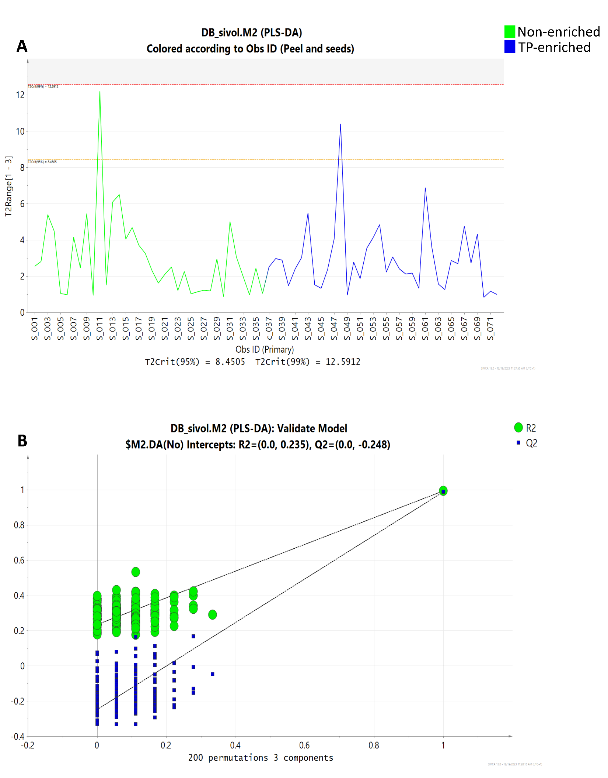
Figure S1. PLS-DA model using TP-enrichment as a factor A) Hotelling’s T2, B) Residuals N-plot.

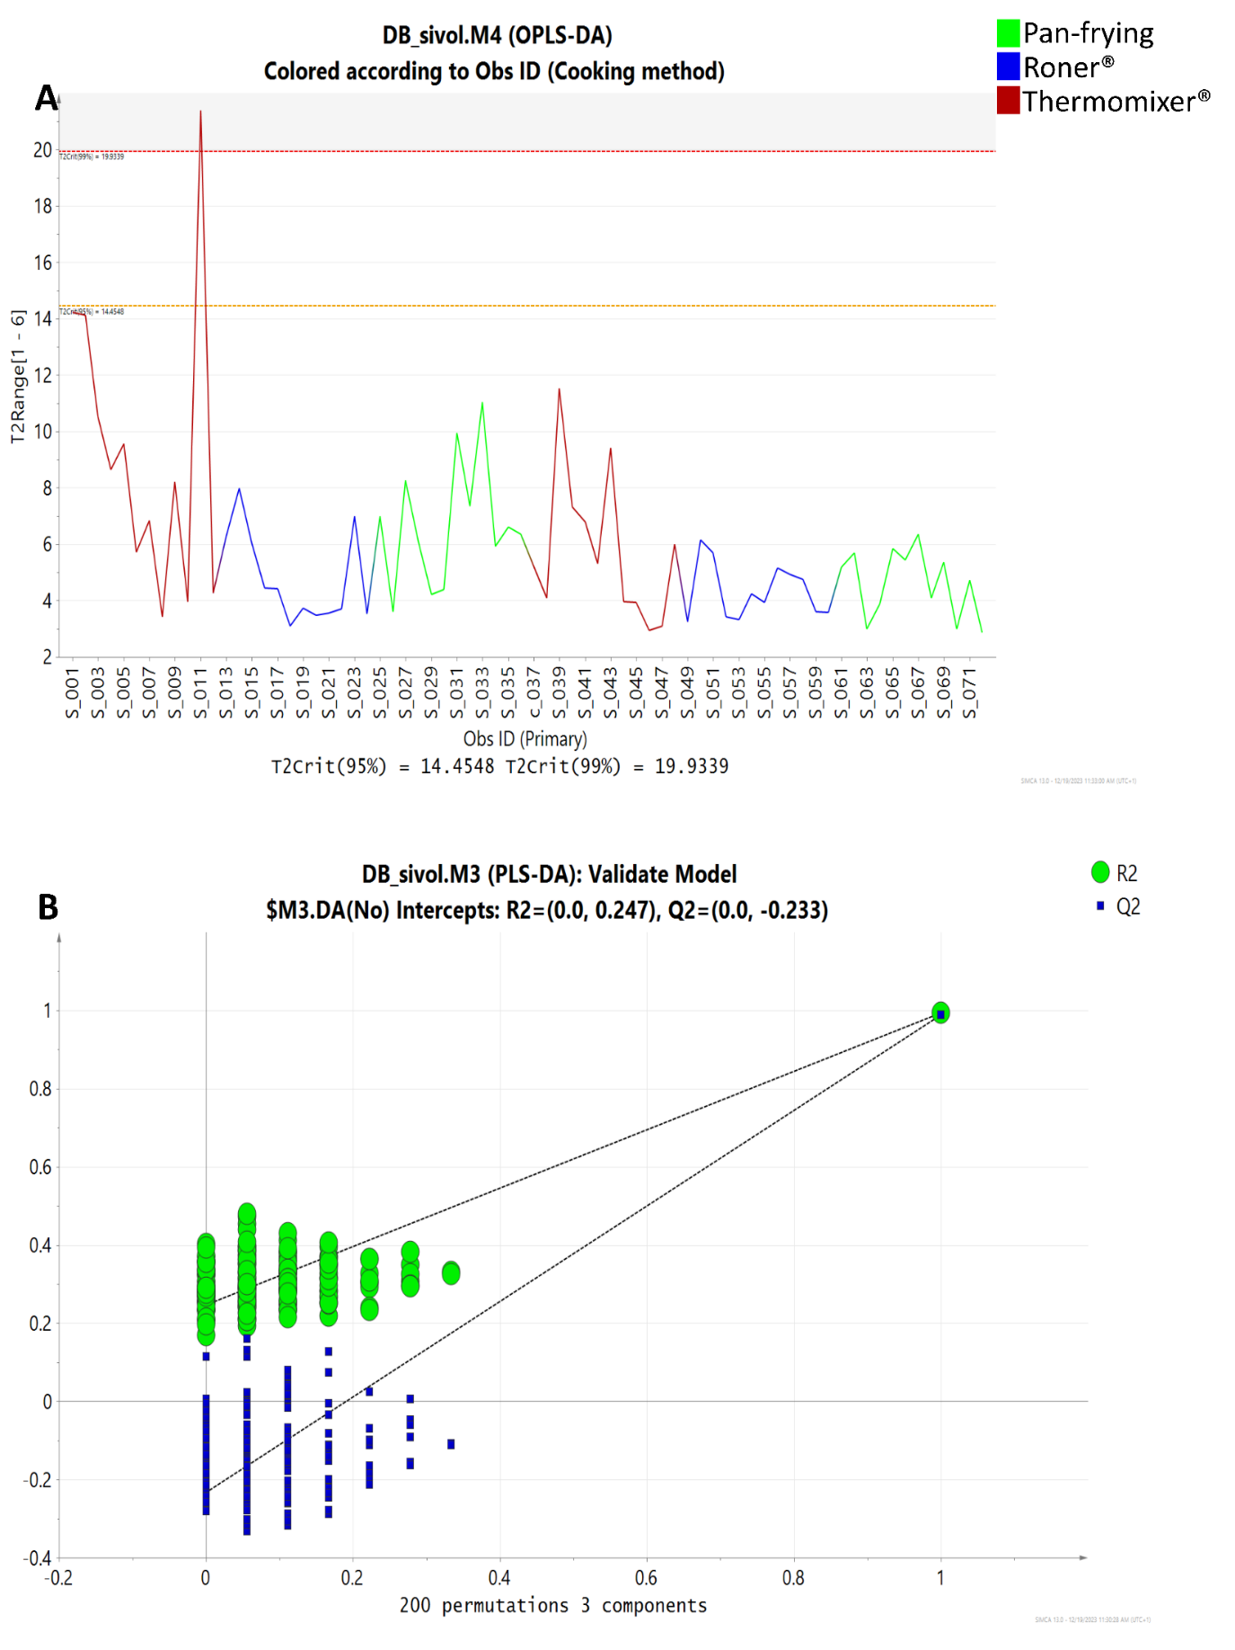

Figure S2. OPLS-DA model using cooking technique as a factor A) Hotelling’s T2, B) Residuals N-plot.

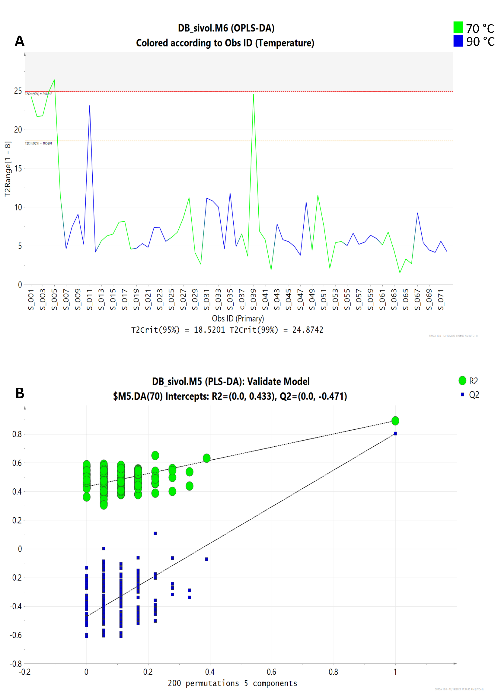

Figure S3. OPLS-DA model using temperature as a factor A) Hotelling’s T2, B) Residuals N-plot.

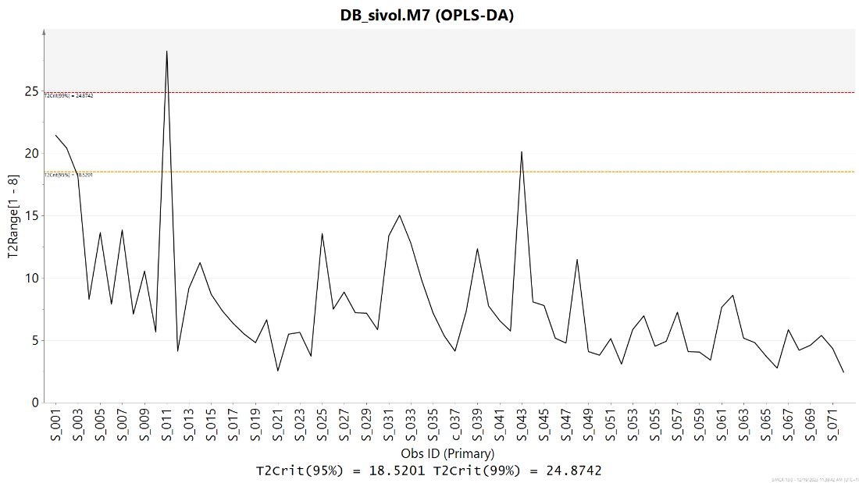
Figure S4. Hotelling’s of the OPLS-DA model using time as a factor

