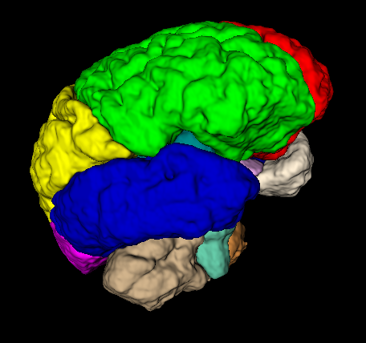
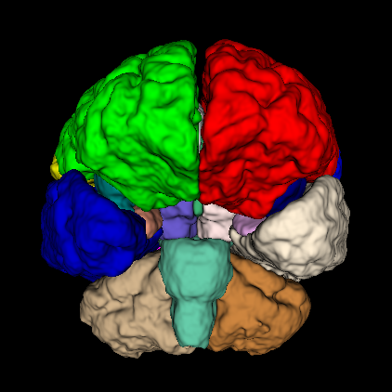
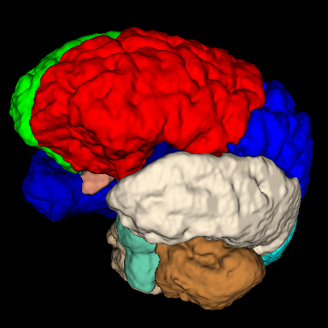
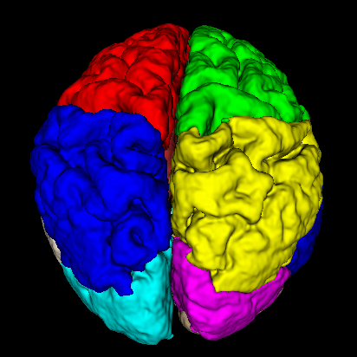

Supplementary Figure 1
Template used to determine the distribution of brain metastases, including bilateral frontal lobe, bilateral parietal lobe, bilateral temporal lobe, bilateral occipital lobe, cingulate gyrus, bilateral insula, bilateral lateral ventricle, bilateral inferior horn of lateral ventricle, third ventricle, fourth ventricle, bilateral basal ganglia, bilateral thalamus, bilateral cerebellum, brainstem, and corpus callosum.

Supplementary Figure 2
Distribution of brain metastases in each subgroup, including adenocarcinoma (A), female adenocarcinoma (B), male adenocarcinoma (C) and small cell lung cancer (D).

Supplementary Figure 3
Result of Kruskal-Wallis test
F=1814.247, P ＜ 0.001

