Appendix A: Additional results

Figure 1: Density of main variables
Paid work, women  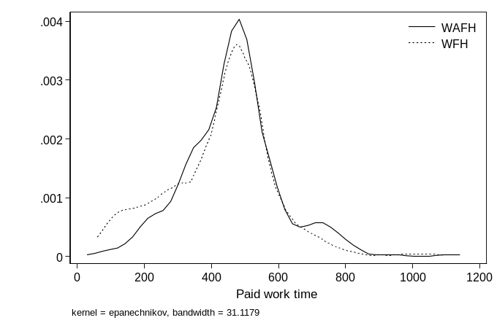 | Paid work, men  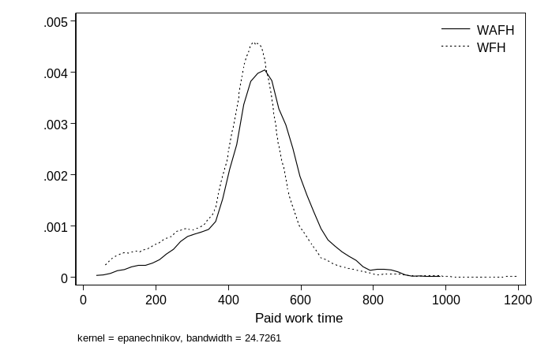
Leisure, women  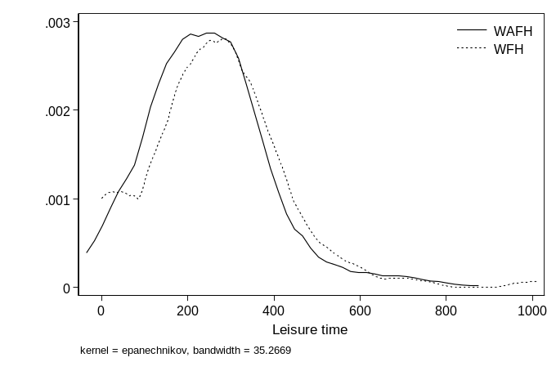 | Leisure, men  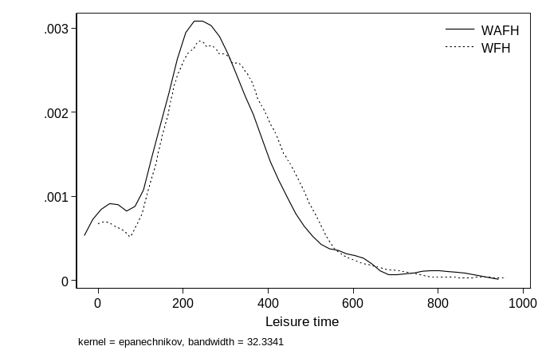
Unpaid work, women  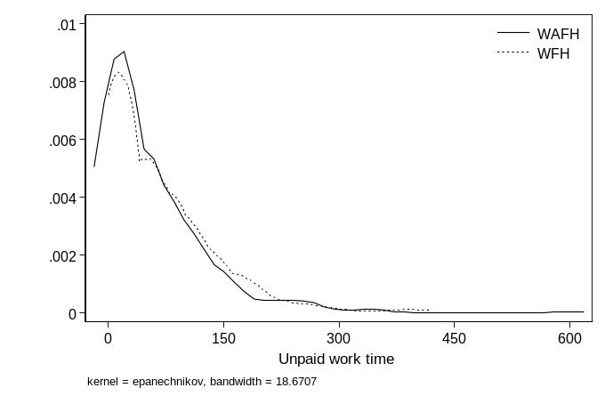 | Unpaid work, men  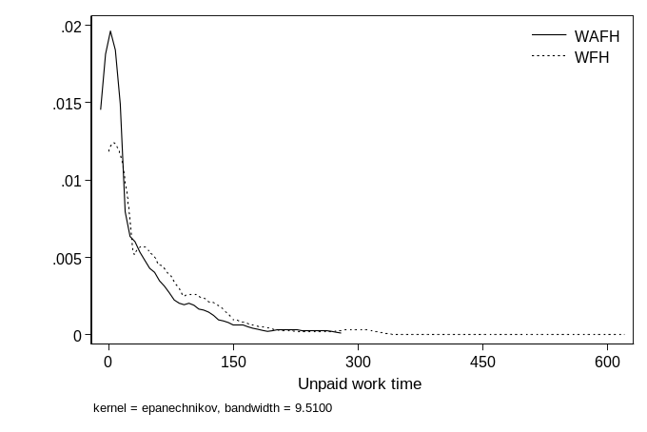
Note: The sample (CaDDI) is restricted to employed individuals that worked during the diary day. All time allocations are defined in minutes per day. WFH are defined as workers whose paid work activities were all reported at home.

Figure A2: The timing of paid work
Pre Covid-19
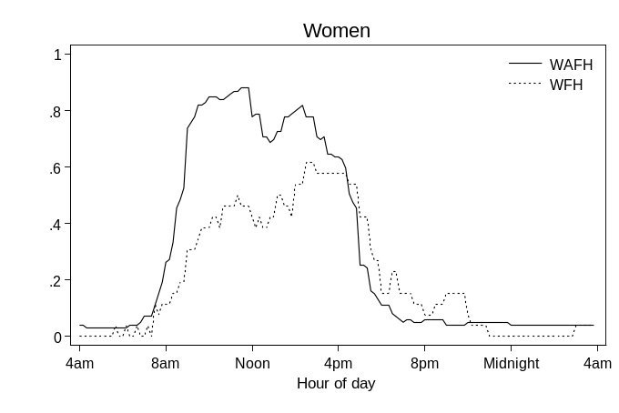 | 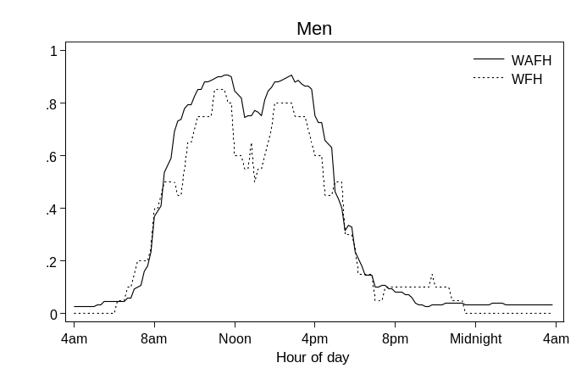
Lockdowns
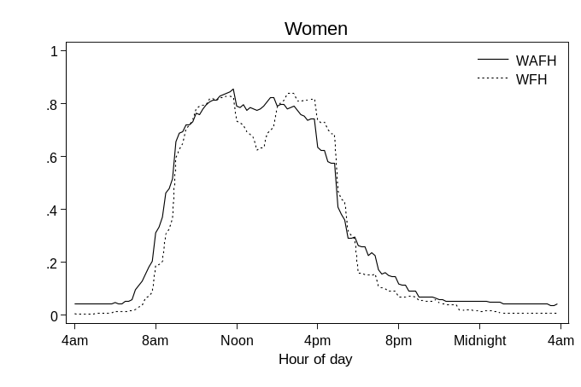 | 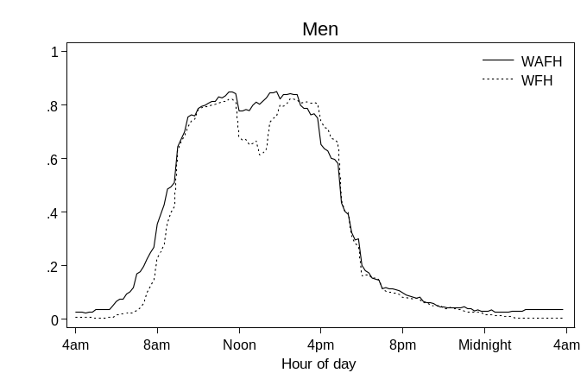
Relaxation
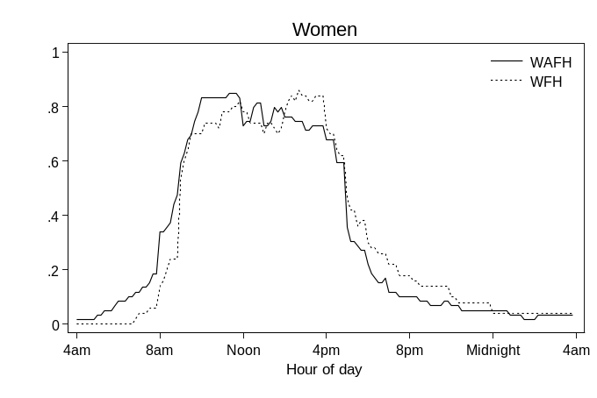 | 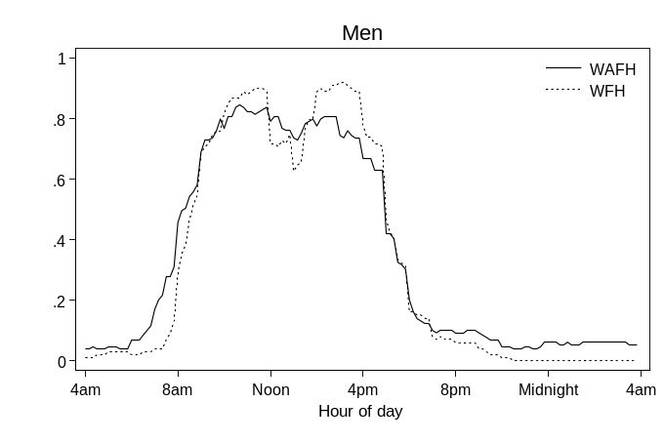
Note: The sample (CaDDI-episode) is restricted to employed individuals that worked during the diary day. WFH are defined as workers whose paid work activities were all reported at home.

Figure A3: The timing of leisure
Pre Covid-19
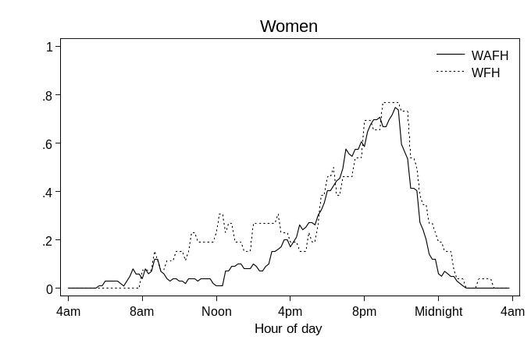 | 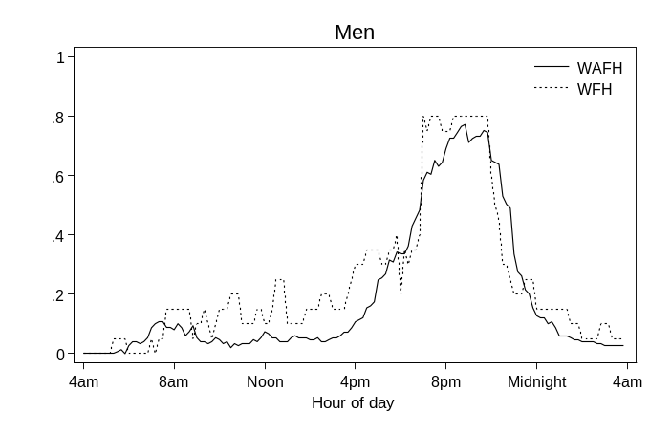
Lockdowns
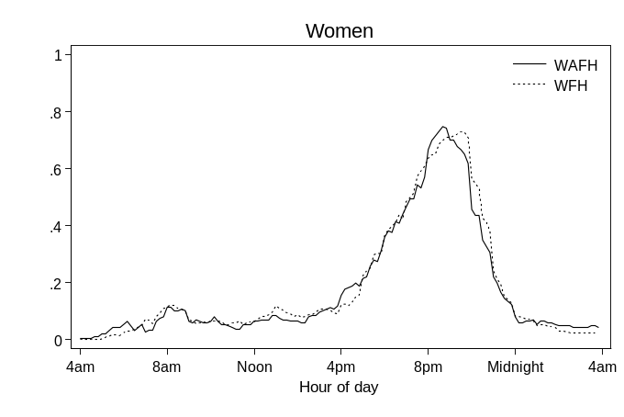 | 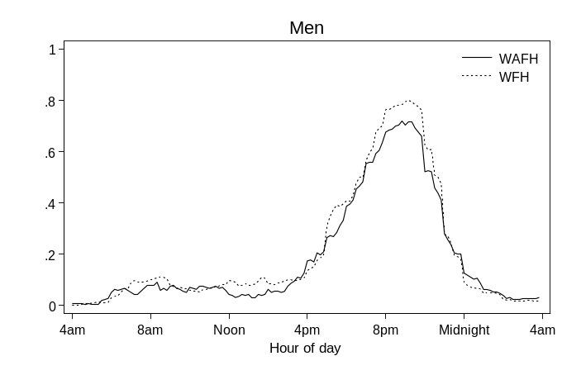
Relaxation
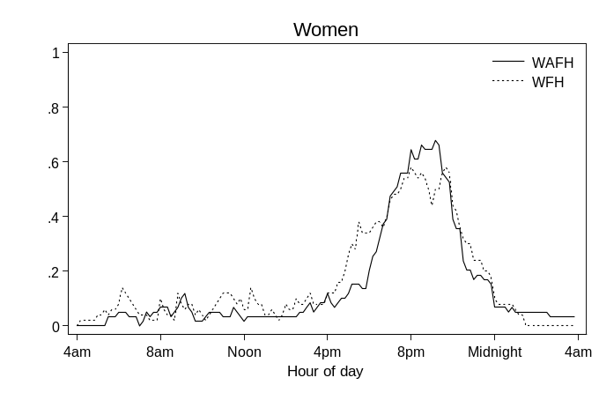 | 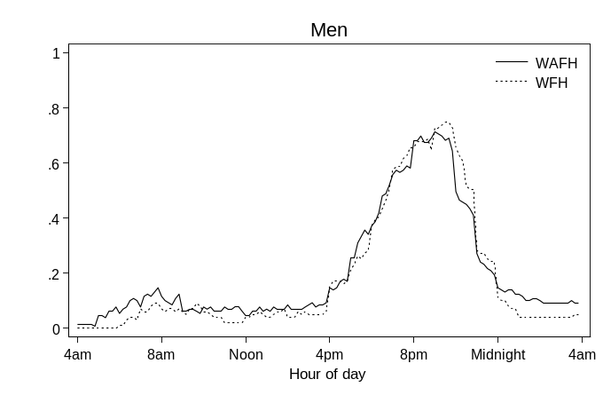
Note: The sample (CaDDI-episode) is restricted to employed individuals that worked during the diary day. WFH are defined as workers whose paid work activities were all reported at home.

Figure A4: The timing of unpaid work
Pre Covid-19
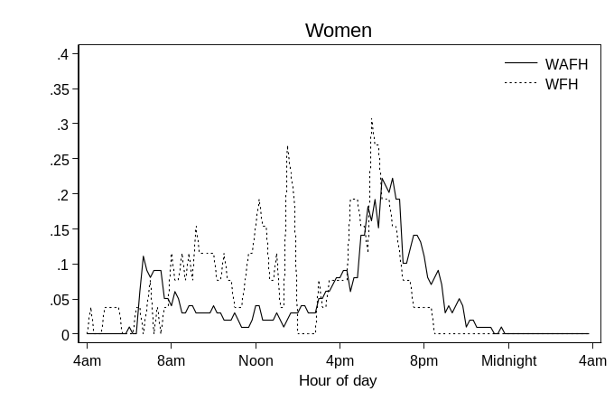 | 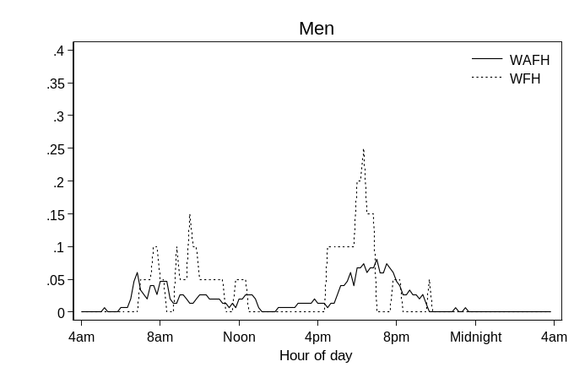
Lockdowns
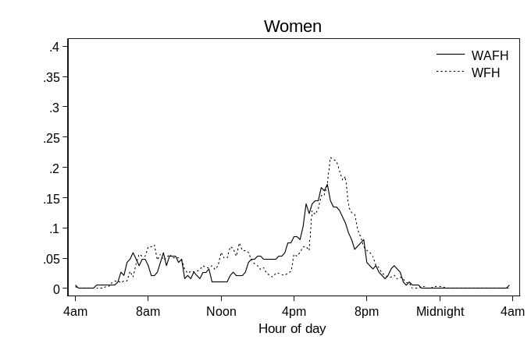 | 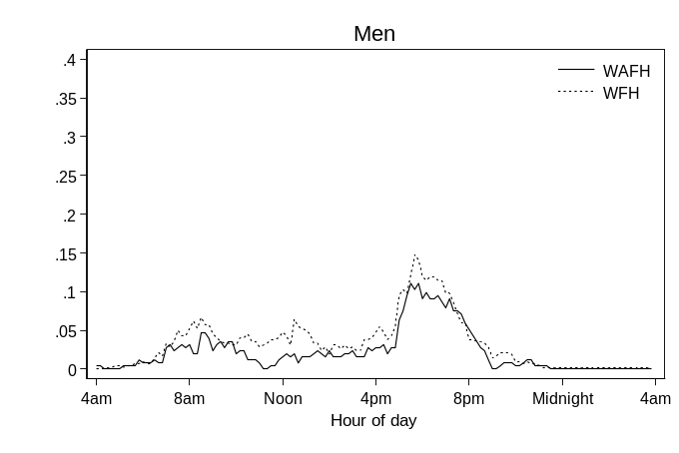
Relaxation
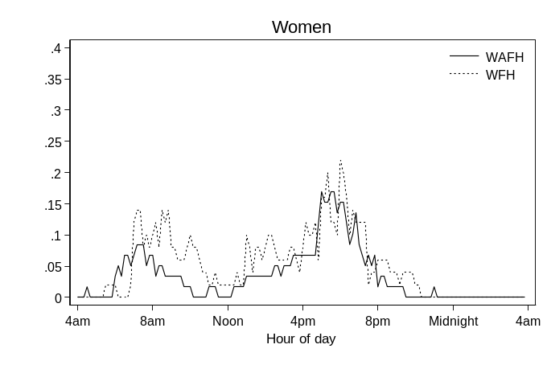 | 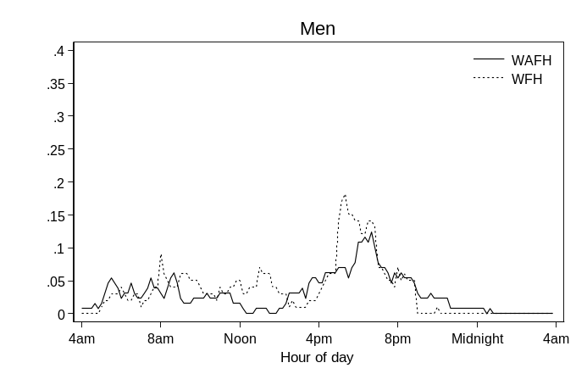
Note: The sample (CaDDI-episode) is restricted to employed individuals that worked during the diary day. WFH are defined as workers whose paid work activities were all reported at home.

Table A1: Sample composition
Period | Survey time | N. observations | N. individuals
Pre Covid-19 | Feb/Oct/Dec 2016 | 294 | 234
Lockdowns | May/Jun 2020 | 291 | 191
 | Nov 2020 | 501 | 326
 | Jan 2021 | 385 | 257
Relaxation | Aug/Sep 2021 | 337 | 202
Note: The sample (CaDDI) is restricted to employed individuals that worked during the diary day.

Table A2: Time use details
Activity | Code | Description
Paid work | 117 | Paid work including at home
 | 118 | Formal education
 | 125 | Work break
Leisure | 110 | Church, temple, synagogue, prayer
 | 111 | Walking, jogging
 | 119 | Recreational courses
 | 126 | Shopping
 | 127 | Watching tv, video, DVD, music
 | 128 | Reading including e-books
 | 129 | Playing sports, exercise
 | 130 | Going out to eat, drink
 | 131 | Walking, dog walking
 | 132 | Playing computer games
 | 133 | Eating or drinking in a restaurant or cafe
 | 134 | Telephone, text, email, letters
 | 135 | Cinema, theatre, sport etc.
 | 136 | Hobbies
Unpaid work | 105 | Preparing food, cooking etc.
 | 106 | Cleaning, tidying, housework
 | 107 | Clothes washing, mending
 | 108 | Maintenance, DIY, etc.
 | 120 | Voluntary work for organisation
 | 123 | Help, caring for cores adult
 | 124 | Help, caring for no coresidents
Note: Authors’ computations.

Table A3: Descriptive statistics of demographics
 | WAFH |  | WFH |  | Diff.
VARIABLES | Mean | S.Dev. | Mean | S.Dev. | Diff.
Being male | 0.569 | 0.495 | 0.539 | 0.499 | 0.030
Age | 41.619 | 12.254 | 43.285 | 13.196 | -1.666*
Educ: basic | 0.064 | 0.245 | 0.031 | 0.172 | 0.033***
Educ: secondary | 0.382 | 0.486 | 0.248 | 0.432 | 0.134***
Educ: University | 0.554 | 0.497 | 0.721 | 0.449 | -0.167***
Married/cohabiting | 0.056 | 0.230 | 0.070 | 0.255 | -0.014
UK citizen | 0.686 | 0.464 | 0.883 | 0.322 | -0.179***
Family size | 2.806 | 1.257 | 2.646 | 1.271 | -0.197***
# children | 0.699 | 0.941 | 0.590 | 0.902 | 0.160**
Employee | 0.903 | 0.296 | 0.865 | 0.342 | 0.109***
Self-employed | 0.097 | 0.296 | 0.135 | 0.342 | 0.038***
Weekly work hours | 36.351 | 9.445 | 35.973 | 9.462 | -0.038
Health: very bad | 0.002 | 0.048 | 0.001 | 0.031 | 0.378
Health: bad | 0.024 | 0.154 | 0.021 | 0.143 | 0.001
Health: fair | 0.275 | 0.447 | 0.258 | 0.438 | 0.003
Health: good | 0.476 | 0.500 | 0.575 | 0.495 | 0.017***
Health: very good | 0.223 | 0.416 | 0.146 | 0.353 | -0.099***
N. Observations | 875 |  | 933
Note: The sample (CaDDI) is restricted to employed individuals that worked during the diary day. Age is measured in years. WFH are defined as workers whose paid work activities were all reported at home. Difference defined as the average value for WAFH minus the average value for WFH. *** significant at the 1%; ** significant at the 5%; * significant at the 10%.

Table A4: Averages of episode variables (females)
 | PAID WORK EPSODES |  |  | LEISURE EPISODES |  |  | UNPAID WORK EPISODES
VARIABLES | WAFH | WFH | Diff. | WAFH | WFH | Diff. | WAFH | WFH | Diff.
A. Pre Covid-19
Average # episodes | 47.029 | 42.979 | 4.050*** | 31.921 | 43.196 | -11.28*** | 17.715 | 14.776 | 2.939**
Episode alone | 0.217 | 0.397 | -0.180*** | 0.309 | 0.256 | 0.053* | 0.358 | 0.412 | -0.054*
Episode with spouse | 0.036 | 0.150 | -0.114*** | 0.510 | 0.512 | -0.002 | 0.402 | 0.351 | 0.051
Episode with child | 0.007 | 0.086 | -0.079*** | 0.152 | 0.123 | 0.029*** | 0.174 | 0.143 | 0.031
Episode at home | 0.014 | - | - | 0.729 | 0.797 | -0.068*** | 0.917 | 0.990 | -0.073***
Episode at workplace | 0.975 | - | - | 0.040 | 0.001 | 0.039*** | 0.012 | 0.000 | 0.012*
Enjoyment | 4.081 | 5.446 | -1.365*** | 5.685 | 5.687 | -0.002 | 5.557 | 5.162 | 0.395**
N. episodes | 4,350 | 786 |  | 2,564 | 860 |  | 653 | 218
B. Lockdowns
Average # episodes | 51.679 | 48.464 | 3.215*** | 34.795 | 34.480 | 0.315*** | 13.757 | 13.876 | -0.119
Episode alone | 0.360 | 0.593 | -0.233*** | 0.473 | 0.429 | 0.044 | 0.368 | 0.349 | 0.019
Episode with spouse | 0.033 | 0.308 | -0.275*** | 0.379 | 0.415 | -0.036 | 0.418 | 0.492 | -0.074***
Episode with child | 0.022 | 0.122 | -0.100*** | 0.102 | 0.138 | -0.036** | 0.170 | 0.155 | 0.015
Episode at home | 0.037 | - | - | 0.848 | 0.921 | -0.073*** | 0.908 | 0.986 | -0.078***
Episode at workplace | 0.955 | - | - | 0.044 | 0.002 | 0.042*** | 0.054 | 0.002 | 0.052***
Enjoyment | 4.453 | 4.582 | -0.129*** | 5.390 | 5.385 | 0.005*** | 5.093 | 4.964 | 0.129***
N. episodes | 8,864 | 13,785 |  | 4,743 | 8,366 |  | 994 | 1,881
C. Relaxation
Average # episodes | 49.370 | 53.827 | -4.457*** | 29.445 | 35.285 | -5.840*** | 11.436 | 17.648 | -6.212***
Episode alone | 0.274 | 0.886 | -0.612*** | 0.353 | 0.525 | -0.172*** | 0.423 | 0.667 | -0.244***
Episode with spouse | 0.067 | 0.092 | -0.025*** | 0.437 | 0.314 | 0.123*** | 0.434 | 0.219 | 0.215***
Episode with child | 0.012 | 0.020 | -0.008** | 0.062 | 0.021 | 0.041*** | 0.066 | 0.052 | 0.014
Episode at home | 0.034 | - | - | 0.659 | 0.818 | -0.159*** | 0.975 | 0.959 | 0.016
Episode at workplace | 0.962 | - | - | 0.162 | 0.000 | 0.162*** | 0.007 | 0.000 | 0.007
Enjoyment | 4.560 | 4.863 | -0.303*** | 5.365 | 4.954 | 0.411*** | 5.147 | 4.660 | 0.487***
N. episodes | 2,728 | 2,317 |  | 1,216 | 1,159 |  | 288 | 364
Note: The sample (CaDDI-episode level) is restricted to episodes of employed individuals that worked during the diary day. Difference defined as the average value for WAFH minus the average value for WFH. *** significant at the 1%; ** significant at the 5%; * significant at the 10%.

Table A5: Averages of episode variables (males)
 | PAID WORK EPSODES |  |  | LEISURE EPISODES |  |  | UNPAID WORK EPISODES
VARIABLES | WAFH | WFH | Diff. | WAFH | WFH | Diff. | WAFH | WFH | Diff.
A. Pre Covid-19
Average # episodes | 51.705 | 52.829 | -1.124*** | 34.174 | 45.963 | -11.79*** | 8.693 | 11.247 | -2.554***
Episode alone | 0.354 | 0.568 | -0.214*** | 0.439 | 0.358 | 0.081 | 0.433 | 0.197 | 0.236***
Episode with spouse | 0.031 | 0.314 | -0.283*** | 0.402 | 0.473 | -0.071 | 0.403 | 0.664 | -0.261***
Episode with child | 0.002 | 0.084 | -0.082*** | 0.045 | 0.178 | -0.133*** | 0.025 | 0.197 | -0.172***
Episode at home | 0.013 | - | - | 0.740 | 0.818 | -0.078** | 0.906 | 0.988 | -0.082***
Episode at workplace | 0.982 | - | - | 0.070 | 0.000 | 0.070*** | 0.029 | 0.000 | 0.029*
Enjoyment | 4.399 | 4.818 | -0.419*** | 5.673 | 5.506 | 0.167*** | 4.935 | 5.092 | -0.157***
N. episodes | 7,400 | 844 |  | 4,046 | 679 |  | 384 | 78
B. Lockdowns
Average # episodes | 51.088 | 47.739 | 3.349*** | 34.555 | 36.992 | -2.437*** | 11.599 | 17.007 | -5.408***
Episode alone | 0.435 | 0.641 | -0.206*** | 0.320 | 0.375 | -0.055*** | 0.322 | 0.478 | -0.156***
Episode with spouse | 0.068 | 0.300 | -0.232*** | 0.536 | 0.515 | 0.021*** | 0.516 | 0.415 | 0.101***
Episode with child | 0.014 | 0.048 | -0.034*** | 0.131 | 0.080 | 0.051*** | 0.144 | 0.077 | 0.067***
Episode at home | 0.053 | - | - | 0.796 | 0.894 | -0.098*** | 0.915 | 0.996 | -0.081***
Episode at workplace | 0.938 | - | - | 0.094 | 0.002 | 0.092*** | 0.051 | 0.000 | 0.051***
Enjoyment | 4.925 | 4.786 | 0.139*** | 5.719 | 5.526 | 0.193*** | 5.561 | 4.920 | 0.641***
N. episodes | 12,165 | 18,245 |  | 6,775 | 12,482 |  | 815 | 2,028
C. Relaxation
Average # episodes | 53.224 | 51.016 | 2.208 | 42.476 | 36.671 | 5.805*** | 12.323 | 12.809 | -0.486
Episode alone | 0.342 | 0.605 | -0.263 | 0.259 | 0.346 | -0.087*** | 0.350 | 0.412 | -0.062***
Episode with spouse | 0.064 | 0.293 | -0.229 | 0.462 | 0.508 | -0.046*** | 0.462 | 0.519 | -0.057
Episode with child | 0.046 | 0.065 | -0.019 | 0.188 | 0.126 | 0.062*** | 0.156 | 0.095 | 0.061***
Episode at home | 0.041 | - | - | 0.622 | 0.822 | -0.200*** | 0.775 | 0.938 | -0.163***
Episode at workplace | 0.942 | - | - | 0.196 | 0.035 | 0.161*** | 0.206 | 0.025 | 0.181***
Enjoyment | 5.234 | 4.563 | 0.671 | 6.035 | 5.649 | 0.386*** | 5.420 | 5.067 | 0.353**
N. episodes | 6,319 | 4,583 |  | 3,750 | 2,625 |  | 551 | 501
Note: The sample (CaDDI-episode level) is restricted to episodes of employed individuals that worked during the diary day. Difference defined as the average value for WAFH minus the average value for WFH. *** significant at the 1%; ** significant at the 5%; * significant at the 10%.

Table A6: Estimates on worker time allocations, robustness checks
 | PAID WORK |  | LEISURE |  | UNPAID WORK
VARIABLES | Women  (1) | Men  (2) | Women  (3) | Men  (4) | Women  (5) | Men  (6)
A. ALTERNATIVE DEFINITION OF WFH (1hour+)
WFH (bis) | -86.053** | 18.413 | 30.505 | 38.917 | 8.748 | -4.104
 | (35.188) | (36.536) | (33.410) | (47.267) | (14.184) | (10.998)
Lockdown | 28.788 | -32.140 | 27.205 | 14.483 | -14.628 | 40.540**
 | (23.099) | (31.529) | (28.571) | (39.408) | (14.791) | (17.445)
Relaxation | 25.301 | -11.096 | -24.660 | 7.764 | -24.986 | 52.755***
 | (24.715) | (33.453) | (34.019) | (42.257) | (15.605) | (18.241)
WFH (bis) x Lockdown | 59.958 | -37.262 | -23.531 | -10.038 | 2.908 | 13.440
 | (37.521) | (38.818) | (36.650) | (49.006) | (16.135) | (13.214)
WFH (bis) x Relaxation | 133.472*** | -11.306 | -24.120 | -27.031 | 2.574 | -5.773
 | (42.127) | (40.538) | (43.680) | (52.866) | (18.414) | (13.616)
All other controls | Yes | Yes | Yes | Yes | Yes | Yes
Observations | 739 | 1,069 | 739 | 1,069 | 739 | 1,069
R-squared | 0.253 | 0.264 | 0.150 | 0.113 | 0.209 | 0.124
B. INVERSE SINH TRANSFORMATION OF TIME ALLOCATIONS
WFH | -0.425*** | -0.143 | 0.042 | 0.180 | 0.654 | -0.259
 | (0.134) | (0.146) | (0.234) | (0.304) | (0.421) | (0.621)
Lockdown | 0.117* | -0.114 | 0.254 | 0.320 | -0.286 | 0.618
 | (0.062) | (0.089) | (0.300) | (0.285) | (0.405) | (0.519)
Relaxation | 0.135** | -0.079 | -0.377 | 0.362 | -0.693 | 0.917
 | (0.067) | (0.096) | (0.357) | (0.304) | (0.481) | (0.565)
WFH x Lockdown | 0.281** | 0.043 | -0.208 | -0.152 | -0.213 | 0.668
 | (0.140) | (0.152) | (0.277) | (0.343) | (0.496) | (0.663)
WFH x Relaxation | 0.386*** | 0.125 | -0.383 | -0.683 | -0.247 | 0.258
 | (0.146) | (0.153) | (0.457) | (0.418) | (0.625) | (0.712)
All other controls | Yes | Yes | Yes | Yes | Yes | Yes
Observations | 739 | 1,069 | 739 | 1,069 | 739 | 1,069
R-squared | 0.268 | 0.264 | 0.154 | 0.083 | 0.156 | 0.115
C. WEEKDAYS ONLY
WFH | -82.116** | -13.662 | 35.585 | 26.579 | 13.337 | 1.825
 | (41.170) | (58.903) | (40.933) | (68.390) | (17.880) | (14.138)
Lockdown | 44.391* | -10.413 | 1.307 | -33.475 | -18.823 | 63.343***
 | (26.815) | (36.620) | (36.382) | (42.528) | (16.531) | (22.194)
Relaxation | 41.306 | 12.552 | -47.469 | -18.371 | -30.314* | 77.715***
 | (28.548) | (38.515) | (41.705) | (45.834) | (17.127) | (23.692)
WFH x Lockdown | 35.469 | -26.407 | -12.225 | 12.018 | -4.343 | 10.330
 | (44.307) | (61.016) | (45.156) | (69.257) | (19.954) | (16.937)
WFH x Relaxation | 112.072** | 4.338 | -0.698 | -67.718 | 0.838 | -7.866
 | (50.321) | (62.353) | (52.919) | (72.686) | (22.378) | (17.204)
All other controls | Yes | Yes | Yes | Yes | Yes | Yes
Observations | 542 | 801 | 542 | 801 | 542 | 801
R-squared | 0.270 | 0.299 | 0.159 | 0.128 | 0.244 | 0.135
Note: The sample (CaDDI) is restricted to employed individuals that worked during the diary day. Robust standard errors in parentheses. WFH are defined as workers whose paid work activities were all reported at home. Dependent variables are the time spent in paid work, leisure, or unpaid work, measured in minutes per day. *** significant at the 1%; ** significant at the 5%; * significant at the 10%.

Table A7: Paid work tempogram estimation details
 | (1) | (2) | (3) | (4) | (5) | (6) | (7) | (8) | (9) | (10) | (11) | (12)
VARIABLES | 4am | 5am | 6am | 7am | 8am | 9am | 10am | 11am | 12 noon | 1pm | 2pm | 3pm
A. Pre Covid 19, women
WFH | 0.001 | 0.001 | -0.054 | -0.025 | -0.187 | -0.383*** | -0.338** | -0.402*** | -0.310** | -0.167 | -0.106 | 0.073
 | (0.032) | (0.035) | (0.053) | (0.100) | (0.140) | (0.136) | (0.144) | (0.135) | (0.140) | (0.154) | (0.136) | (0.158)
All other controls | Yes | Yes | Yes | Yes | Yes | Yes | Yes | Yes | Yes | Yes | Yes | Yes
Observations | 125 | 125 | 125 | 125 | 125 | 125 | 125 | 125 | 125 | 125 | 125 | 125
A. Pre Covid 19, men
WFH | -0.005 | -0.016 | 0.066 | -0.022 | -0.202 | -0.177 | -0.242*** | -0.174** | -0.148 | -0.158 | -0.087 | -0.150
 | (0.025) | (0.039) | (0.076) | (0.127) | (0.147) | (0.115) | (0.081) | (0.071) | (0.091) | (0.096) | (0.089) | (0.100)
All other controls | Yes | Yes | Yes | Yes | Yes | Yes | Yes | Yes | Yes | Yes | Yes | Yes
Observations | 169 | 169 | 169 | 169 | 169 | 169 | 169 | 169 | 169 | 169 | 169 | 169
C. Lockdowns, women
WFH | -0.039*** | -0.033** | -0.038** | -0.079** | -0.104** | 0.005 | 0.002 | -0.055 | -0.061* | -0.059 | 0.060* | 0.028
 | (0.015) | (0.015) | (0.019) | (0.036) | (0.051) | (0.044) | (0.038) | (0.033) | (0.036) | (0.038) | (0.037) | (0.040)
All other controls | Yes | Yes | Yes | Yes | Yes | Yes | Yes | Yes | Yes | Yes | Yes | Yes
Observations | 505 | 505 | 505 | 505 | 505 | 505 | 505 | 505 | 505 | 505 | 505 | 505
D. Lockdowns, men
WFH | 0.001 | -0.021** | -0.051*** | -0.088** | -0.072 | -0.048 | -0.051 | -0.042 | -0.109*** | -0.084** | -0.044 | -0.032
 | (0.012) | (0.010) | (0.018) | (0.035) | (0.045) | (0.042) | (0.038) | (0.033) | (0.034) | (0.034) | (0.029) | (0.030)
All other controls | Yes | Yes | Yes | Yes | Yes | Yes | Yes | Yes | Yes | Yes | Yes | Yes
Observations | 672 | 672 | 672 | 672 | 672 | 672 | 672 | 672 | 672 | 672 | 672 | 672
E. Relaxation, women
WFH | -0.012 | -0.064* | -0.077* | -0.068 | -0.063 | -0.010 | -0.028 | 0.052 | -0.012 | -0.015 | 0.165** | 0.198**
 | (0.015) | (0.036) | (0.043) | (0.058) | (0.112) | (0.072) | (0.062) | (0.056) | (0.079) | (0.074) | (0.067) | (0.076)
All other controls | Yes | Yes | Yes | Yes | Yes | Yes | Yes | Yes | Yes | Yes | Yes | Yes
Observations | 109 | 109 | 109 | 109 | 109 | 109 | 109 | 109 | 109 | 109 | 109 | 109
F. Relaxation, men
WFH | -0.041** | -0.013 | -0.032 | -0.115* | 0.034 | -0.016 | 0.070 | 0.096** | -0.027 | 0.055 | 0.146*** | 0.163***
 | (0.021) | (0.032) | (0.040) | (0.062) | (0.073) | (0.059) | (0.045) | (0.044) | (0.051) | (0.055) | (0.046) | (0.048)
All other controls | Yes | Yes | Yes | Yes | Yes | Yes | Yes | Yes | Yes | Yes | Yes | Yes
Observations | 228 | 228 | 228 | 228 | 228 | 228 | 228 | 228 | 228 | 228 | 228 | 228
Note: The sample (CaDDI-episode) is restricted to employed individuals that worked during the diary day. Robust-clustered (at the individual level) standard errors in parentheses. WFH are defined as workers whose paid work activities were all reported at home. *** significant at the 1%; ** significant at the 5%; * significant at the 10%.

Table A7 (cont.): Paid work tempogram estimation details
 | (13) | (14) | (15) | (16) | (17) | (18) | (19) | (20) | (21) | (22) | (23) | (24)
VARIABLES | 4pm | 5pm | 6pm | 7pm | 8pm | 9pm | 10pm | 11pm | Midnight | 1am | 2am | 3am
A. Pre Covid 19, women
WFH | 0.126 | -0.052 | 0.125 | -0.031 | -0.105** | 0.011 | 0.014 | -0.016 | -0.032 | -0.032 | -0.032 | -0.033
 | (0.149) | (0.156) | (0.136) | (0.093) | (0.048) | (0.073) | (0.061) | (0.037) | (0.034) | (0.034) | (0.034) | (0.040)
All other controls | Yes | Yes | Yes | Yes | Yes | Yes | Yes | Yes | Yes | Yes | Yes | Yes
Observations | 125 | 125 | 125 | 125 | 125 | 125 | 125 | 125 | 125 | 125 | 125 | 125
A. Pre Covid 19, men
WFH | -0.207 | 0.117 | 0.107 | 0.076 | 0.085 | 0.135* | 0.136* | 0.095 | 0.009 | 0.009 | 0.007 | 0.007
 | (0.126) | (0.147) | (0.097) | (0.076) | (0.074) | (0.080) | (0.077) | (0.076) | (0.032) | (0.032) | (0.031) | (0.031)
All other controls | Yes | Yes | Yes | Yes | Yes | Yes | Yes | Yes | Yes | Yes | Yes | Yes
Observations | 169 | 169 | 169 | 169 | 169 | 169 | 169 | 169 | 169 | 169 | 169 | 169
C. Lockdowns, women
WFH | 0.102** | 0.066 | -0.073* | -0.033 | -0.075** | 0.003 | -0.014 | -0.012 | -0.018 | -0.021 | -0.025** | -0.030**
 | (0.048) | (0.051) | (0.043) | (0.039) | (0.034) | (0.023) | (0.020) | (0.016) | (0.016) | (0.014) | (0.012) | (0.013)
All other controls | Yes | Yes | Yes | Yes | Yes | Yes | Yes | Yes | Yes | Yes | Yes | Yes
Observations | 505 | 505 | 505 | 505 | 505 | 505 | 505 | 505 | 505 | 505 | 505 | 505
D. Lockdowns, men
WFH | 0.058 | 0.010 | 0.041 | 0.042 | 0.005 | 0.036 | 0.027 | 0.006 | 0.001 | -0.005 | -0.014 | -0.014
 | (0.039) | (0.044) | (0.037) | (0.030) | (0.026) | (0.023) | (0.020) | (0.018) | (0.016) | (0.014) | (0.014) | (0.014)
All other controls | Yes | Yes | Yes | Yes | Yes | Yes | Yes | Yes | Yes | Yes | Yes | Yes
Observations | 672 | 672 | 672 | 672 | 672 | 672 | 672 | 672 | 672 | 672 | 672 | 672
E. Relaxation, women
WFH | 0.096 | 0.257*** | 0.126 | 0.177** | 0.064 | 0.056 | 0.046 | 0.012 | -0.022 | 0.017 | 0.017 | 0.017
 | (0.095) | (0.092) | (0.091) | (0.084) | (0.078) | (0.063) | (0.049) | (0.047) | (0.044) | (0.037) | (0.037) | (0.037)
All other controls | Yes | Yes | Yes | Yes | Yes | Yes | Yes | Yes | Yes | Yes | Yes | Yes
Observations | 109 | 109 | 109 | 109 | 109 | 109 | 109 | 109 | 109 | 109 | 109 | 109
F. Relaxation, men
WFH | 0.054 | 0.032 | -0.000 | 0.010 | -0.004 | -0.022 | -0.013 | -0.085*** | -0.077** | -0.063** | -0.063** | -0.063**
 | (0.065) | (0.079) | (0.063) | (0.056) | (0.053) | (0.047) | (0.031) | (0.032) | (0.030) | (0.026) | (0.026) | (0.026)
All other controls | Yes | Yes | Yes | Yes | Yes | Yes | Yes | Yes | Yes | Yes | Yes | Yes
Observations | 228 | 228 | 228 | 228 | 228 | 228 | 228 | 228 | 228 | 228 | 228 | 228
Note: The sample (CaDDI-episode) is restricted to employed individuals that worked during the diary day. Robust-clustered (at the individual level) standard errors in parentheses. WFH are defined as workers whose paid work activities were all reported at home. *** significant at the 1%; ** significant at the 5%; * significant at the 10%.

Table A8: Leisure tempogram estimation details
 | (1) | (2) | (3) | (4) | (5) | (6) | (7) | (8) | (9) | (10) | (11) | (12)
VARIABLES | 4am | 5am | 6am | 7am | 8am | 9am | 10am | 11am | 12 noon | 1pm | 2pm | 3pm
A. Pre Covid 19, women
WFH | 0.000 | 0.005 | -0.027 | -0.001 | 0.032 | 0.108 | 0.155 | 0.039 | 0.257** | 0.137 | 0.135 | -0.085
 | (0.000) | (0.011) | (0.057) | (0.068) | (0.108) | (0.109) | (0.106) | (0.096) | (0.126) | (0.113) | (0.117) | (0.143)
All other controls | Yes | Yes | Yes | Yes | Yes | Yes | Yes | Yes | Yes | Yes | Yes | Yes
Observations | 125 | 125 | 125 | 125 | 125 | 125 | 125 | 125 | 125 | 125 | 125 | 125
A. Pre Covid 19, men
WFH | 0.000 | 0.038 | -0.106** | 0.018 | -0.002 | 0.206** | 0.177** | 0.142** | 0.119 | 0.087 | 0.142 | 0.167
 | (0.000) | (0.051) | (0.052) | (0.114) | (0.104) | (0.093) | (0.072) | (0.071) | (0.089) | (0.077) | (0.097) | (0.104)
All other controls | Yes | Yes | Yes | Yes | Yes | Yes | Yes | Yes | Yes | Yes | Yes | Yes
Observations | 169 | 169 | 169 | 169 | 169 | 169 | 169 | 169 | 169 | 169 | 169 | 169
C. Lockdowns, women
WFH | -0.004 | -0.022 | -0.038 | 0.034 | -0.015 | -0.009 | 0.040 | 0.011 | 0.010 | 0.062** | 0.017 | -0.028
 | (0.009) | (0.018) | (0.024) | (0.029) | (0.039) | (0.031) | (0.032) | (0.026) | (0.031) | (0.030) | (0.030) | (0.035)
All other controls | Yes | Yes | Yes | Yes | Yes | Yes | Yes | Yes | Yes | Yes | Yes | Yes
Observations | 505 | 505 | 505 | 505 | 505 | 505 | 505 | 505 | 505 | 505 | 505 | 505
D. Lockdowns, men
WFH | -0.001 | -0.016 | -0.033 | 0.007 | 0.002 | -0.021 | -0.012 | 0.044 | 0.075*** | 0.076*** | 0.040 | -0.012
 | (0.009) | (0.013) | (0.025) | (0.029) | (0.034) | (0.032) | (0.029) | (0.027) | (0.029) | (0.028) | (0.028) | (0.030)
All other controls | Yes | Yes | Yes | Yes | Yes | Yes | Yes | Yes | Yes | Yes | Yes | Yes
Observations | 672 | 672 | 672 | 672 | 672 | 672 | 672 | 672 | 672 | 672 | 672 | 672
E. Relaxation, women
WFH | 0.009 | 0.013 | 0.157** | -0.027 | 0.020 | 0.026 | 0.074 | 0.048 | 0.079* | 0.021 | 0.060 | -0.027
 | (0.012) | (0.034) | (0.062) | (0.057) | (0.076) | (0.077) | (0.047) | (0.044) | (0.042) | (0.034) | (0.048) | (0.066)
All other controls | Yes | Yes | Yes | Yes | Yes | Yes | Yes | Yes | Yes | Yes | Yes | Yes
Observations | 109 | 109 | 109 | 109 | 109 | 109 | 109 | 109 | 109 | 109 | 109 | 109
F. Relaxation, men
WFH | -0.026 | -0.100*** | -0.100** | -0.056 | -0.037 | 0.017 | -0.041 | -0.070** | -0.051 | -0.011 | -0.043 | -0.039
 | (0.018) | (0.031) | (0.047) | (0.059) | (0.052) | (0.047) | (0.040) | (0.034) | (0.036) | (0.035) | (0.035) | (0.039)
All other controls | Yes | Yes | Yes | Yes | Yes | Yes | Yes | Yes | Yes | Yes | Yes | Yes
Observations | 228 | 228 | 228 | 228 | 228 | 228 | 228 | 228 | 228 | 228 | 228 | 228
Note: The sample (CaDDI-episode) is restricted to employed individuals that worked during the diary day. Robust-clustered (at the individual level) standard errors in parentheses. WFH are defined as workers whose paid work activities were all reported at home. *** significant at the 1%; ** significant at the 5%; * significant at the 10%.

Table A8 (cont.): Leisure tempogram estimation details
 | (13) | (14) | (15) | (16) | (17) | (18) | (19) | (20) | (21) | (22) | (23) | (24)
VARIABLES | 4pm | 5pm | 6pm | 7pm | 8pm | 9pm | 10pm | 11pm | Midnight | 1am | 2am | 3am
A. Pre Covid 19, women
WFH | -0.194 | -0.276 | -0.202 | -0.092 | 0.166 | 0.011 | 0.008 | -0.093 | -0.029 | -0.098 | -0.001 | 0.000
 | (0.145) | (0.168) | (0.146) | (0.146) | (0.133) | (0.115) | (0.146) | (0.143) | (0.100) | (0.077) | (0.017) | (0.000)
All other controls | Yes | Yes | Yes | Yes | Yes | Yes | Yes | Yes | Yes | Yes | Yes | Yes
Observations | 125 | 125 | 125 | 125 | 125 | 125 | 125 | 125 | 125 | 125 | 125 | 125
A. Pre Covid 19, men
WFH | 0.159 | 0.093 | -0.040 | 0.057 | -0.082 | -0.001 | -0.089 | 0.065 | 0.095 | 0.072 | 0.114 | 0.107
 | (0.122) | (0.135) | (0.137) | (0.130) | (0.098) | (0.115) | (0.131) | (0.119) | (0.108) | (0.105) | (0.093) | (0.080)
All other controls | Yes | Yes | Yes | Yes | Yes | Yes | Yes | Yes | Yes | Yes | Yes | Yes
Observations | 169 | 169 | 169 | 169 | 169 | 169 | 169 | 169 | 169 | 169 | 169 | 169
C. Lockdowns, women
WFH | -0.025 | -0.010 | -0.013 | 0.050 | -0.014 | -0.022 | 0.069 | -0.004 | -0.002 | 0.005 | -0.005 | -0.004
 | (0.042) | (0.051) | (0.053) | (0.051) | (0.042) | (0.044) | (0.052) | (0.044) | (0.026) | (0.023) | (0.018) | (0.018)
All other controls | Yes | Yes | Yes | Yes | Yes | Yes | Yes | Yes | Yes | Yes | Yes | Yes
Observations | 505 | 505 | 505 | 505 | 505 | 505 | 505 | 505 | 505 | 505 | 505 | 505
D. Lockdowns, men
WFH | -0.021 | 0.006 | -0.027 | -0.025 | 0.003 | 0.017 | 0.089* | -0.026 | -0.028 | -0.009 | -0.015 | -0.005
 | (0.037) | (0.046) | (0.046) | (0.040) | (0.037) | (0.037) | (0.046) | (0.043) | (0.030) | (0.020) | (0.015) | (0.014)
All other controls | Yes | Yes | Yes | Yes | Yes | Yes | Yes | Yes | Yes | Yes | Yes | Yes
Observations | 672 | 672 | 672 | 672 | 672 | 672 | 672 | 672 | 672 | 672 | 672 | 672
E. Relaxation, women
WFH | -0.051 | 0.174* | -0.120 | -0.106 | -0.167 | -0.119 | 0.061 | -0.017 | -0.043 | -0.012 | -0.071*** | -0.063***
 | (0.077) | (0.099) | (0.110) | (0.109) | (0.103) | (0.093) | (0.108) | (0.082) | (0.054) | (0.032) | (0.025) | (0.022)
All other controls | Yes | Yes | Yes | Yes | Yes | Yes | Yes | Yes | Yes | Yes | Yes | Yes
Observations | 109 | 109 | 109 | 109 | 109 | 109 | 109 | 109 | 109 | 109 | 109 | 109
F. Relaxation, men
WFH | 0.045 | -0.198*** | -0.093 | 0.005 | -0.044 | -0.031 | 0.139* | 0.041 | 0.009 | -0.061 | -0.025 | -0.019
 | (0.057) | (0.076) | (0.080) | (0.077) | (0.072) | (0.071) | (0.076) | (0.070) | (0.050) | (0.040) | (0.033) | (0.033)
All other controls | Yes | Yes | Yes | Yes | Yes | Yes | Yes | Yes | Yes | Yes | Yes | Yes
Observations | 228 | 228 | 228 | 228 | 228 | 228 | 228 | 228 | 228 | 228 | 228 | 228
Note: The sample (CaDDI-episode) is restricted to employed individuals that worked during the diary day. Robust-clustered (at the individual level) standard errors in parentheses. WFH are defined as workers whose paid work activities were all reported at home. *** significant at the 1%; ** significant at the 5%; * significant at the 10%.

Table A9: Unpaid work tempogram estimation details
 | (1) | (2) | (3) | (4) | (5) | (6) | (7) | (8) | (9) | (10) | (11) | (12)
VARIABLES | 4am | 5am | 6am | 7am | 8am | 9am | 10am | 11am | 12 noon | 1pm | 2pm | 3pm
A. Pre Covid 19, women
WFH | -0.001 | -0.001 | -0.132* | -0.173** | 0.116 | 0.013 | 0.056 | 0.108 | 0.174 | 0.176 | -0.068 | -0.051
 | (0.017) | (0.017) | (0.075) | (0.086) | (0.111) | (0.100) | (0.108) | (0.105) | (0.113) | (0.109) | (0.042) | (0.082)
All other controls | Yes | Yes | Yes | Yes | Yes | Yes | Yes | Yes | Yes | Yes | Yes | Yes
Observations | 125 | 125 | 125 | 125 | 125 | 125 | 125 | 125 | 125 | 125 | 125 | 125
A. Pre Covid 19, men
WFH | 0.000 | -0.027 | -0.112** | -0.029 | 0.054 | 0.060 | 0.007 | 0.047 | -0.003 | -0.001 | -0.026 | -0.041
 | (0.000) | (0.025) | (0.048) | (0.066) | (0.070) | (0.074) | (0.043) | (0.054) | (0.063) | (0.007) | (0.025) | (0.036)
All other controls | Yes | Yes | Yes | Yes | Yes | Yes | Yes | Yes | Yes | Yes | Yes | Yes
Observations | 169 | 169 | 169 | 169 | 169 | 169 | 169 | 169 | 169 | 169 | 169 | 169
C. Lockdowns, women
WFH | -0.009 | -0.004 | -0.003 | -0.022 | 0.049 | 0.049* | 0.032 | 0.047** | 0.113*** | 0.083*** | -0.032 | -0.034
 | (0.008) | (0.005) | (0.025) | (0.033) | (0.032) | (0.026) | (0.026) | (0.023) | (0.028) | (0.029) | (0.023) | (0.029)
All other controls | Yes | Yes | Yes | Yes | Yes | Yes | Yes | Yes | Yes | Yes | Yes | Yes
Observations | 505 | 505 | 505 | 505 | 505 | 505 | 505 | 505 | 505 | 505 | 505 | 505
D. Lockdowns, men
WFH | 0.001 | -0.001 | -0.003 | -0.011 | 0.077** | 0.000 | 0.035* | 0.031** | 0.062** | 0.027 | 0.004 | 0.024
 | (0.006) | (0.011) | (0.015) | (0.025) | (0.031) | (0.026) | (0.020) | (0.015) | (0.025) | (0.024) | (0.021) | (0.021)
All other controls | Yes | Yes | Yes | Yes | Yes | Yes | Yes | Yes | Yes | Yes | Yes | Yes
Observations | 672 | 672 | 672 | 672 | 672 | 672 | 672 | 672 | 672 | 672 | 672 | 672
E. Relaxation, women
WFH | -0.010 | 0.008 | -0.076* | 0.022 | 0.134** | 0.064 | 0.079* | 0.032 | 0.025 | 0.104** | 0.025 | -0.022
 | (0.014) | (0.014) | (0.045) | (0.079) | (0.060) | (0.052) | (0.045) | (0.033) | (0.029) | (0.050) | (0.040) | (0.045)
All other controls | Yes | Yes | Yes | Yes | Yes | Yes | Yes | Yes | Yes | Yes | Yes | Yes
Observations | 109 | 109 | 109 | 109 | 109 | 109 | 109 | 109 | 109 | 109 | 109 | 109
F. Relaxation, men
WFH | -0.020 | -0.062 | -0.016 | -0.019 | -0.002 | 0.036 | 0.009 | -0.002 | -0.007 | 0.034* | -0.027 | -0.038
 | (0.016) | (0.042) | (0.046) | (0.035) | (0.040) | (0.037) | (0.031) | (0.024) | (0.020) | (0.020) | (0.027) | (0.036)
All other controls | Yes | Yes | Yes | Yes | Yes | Yes | Yes | Yes | Yes | Yes | Yes | Yes
Observations | 228 | 228 | 228 | 228 | 228 | 228 | 228 | 228 | 228 | 228 | 228 | 228
Note: The sample (CaDDI-episode) is restricted to employed individuals that worked during the diary day. Robust-clustered (at the individual level) standard errors in parentheses. WFH are defined as workers whose paid work activities were all reported at home. *** significant at the 1%; ** significant at the 5%; * significant at the 10%.

Table A9 (cont.): Unpaid work tempogram estimation details
 | (13) | (14) | (15) | (16) | (17) | (18) | (19) | (20) | (21) | (22) | (23) | (24)
VARIABLES | 4pm | 5pm | 6pm | 7pm | 8pm | 9pm | 10pm | 11pm | Midnight | 1am | 2am | 3am
A. Pre Covid 19, women
WFH | 0.112 | 0.187 | 0.093 | -0.074 | -0.066 | 0.002 | -0.037 | -0.040 | 0.000 | 0.000 | 0.000 | 0.000
 | (0.115) | (0.134) | (0.141) | (0.103) | (0.103) | (0.055) | (0.029) | (0.043) | (0.000) | (0.000) | (0.000) | (0.000)
All other controls | Yes | Yes | Yes | Yes | Yes | Yes | Yes | Yes | Yes | Yes | Yes | Yes
Observations | 125 | 125 | 125 | 125 | 125 | 125 | 125 | 125 | 125 | 125 | 125 | 125
A. Pre Covid 19, men
WFH | 0.046 | 0.006 | 0.120 | -0.147* | -0.000 | 0.029 | 0.000 | -0.014 | 0.000 | 0.000 | 0.000 | 0.000
 | (0.085) | (0.105) | (0.118) | (0.076) | (0.057) | (0.044) | (0.000) | (0.014) | (0.000) | (0.000) | (0.000) | (0.000)
All other controls | Yes | Yes | Yes | Yes | Yes | Yes | Yes | Yes | Yes | Yes | Yes | Yes
Observations | 169 | 169 | 169 | 169 | 169 | 169 | 169 | 169 | 169 | 169 | 169 | 169
C. Lockdowns, women
WFH | -0.015 | 0.015 | 0.133*** | 0.017 | 0.045* | -0.020 | -0.000 | 0.002 | 0.001 | 0.000 | 0.000 | 0.000
 | (0.036) | (0.048) | (0.049) | (0.041) | (0.026) | (0.019) | (0.014) | (0.002) | (0.001) | (0.000) | (0.000) | (0.001)
All other controls | Yes | Yes | Yes | Yes | Yes | Yes | Yes | Yes | Yes | Yes | Yes | Yes
Observations | 505 | 505 | 505 | 505 | 505 | 505 | 505 | 505 | 505 | 505 | 505 | 505
D. Lockdowns, men
WFH | 0.062*** | 0.031 | 0.047 | 0.015 | -0.029 | 0.023* | -0.003 | 0.008 | 0.007 | 0.007 | 0.007 | 0.007
 | (0.021) | (0.038) | (0.036) | (0.031) | (0.020) | (0.012) | (0.019) | (0.008) | (0.007) | (0.007) | (0.007) | (0.007)
All other controls | Yes | Yes | Yes | Yes | Yes | Yes | Yes | Yes | Yes | Yes | Yes | Yes
Observations | 672 | 672 | 672 | 672 | 672 | 672 | 672 | 672 | 672 | 672 | 672 | 672
E. Relaxation, women
WFH | 0.028 | -0.040 | -0.013 | 0.041 | 0.104* | 0.023 | 0.005 | -0.010 | 0.000 | 0.000 | 0.000 | 0.000
 | (0.057) | (0.076) | (0.089) | (0.069) | (0.061) | (0.055) | (0.013) | (0.012) | (0.000) | (0.000) | (0.000) | (0.000)
All other controls | Yes | Yes | Yes | Yes | Yes | Yes | Yes | Yes | Yes | Yes | Yes | Yes
Observations | 109 | 109 | 109 | 109 | 109 | 109 | 109 | 109 | 109 | 109 | 109 | 109
F. Relaxation, men
WFH | 0.044 | 0.090* | -0.067 | -0.057 | 0.002 | -0.069** | -0.032 | -0.012 | -0.034 | 0.000 | 0.000 | 0.000
 | (0.040) | (0.052) | (0.065) | (0.046) | (0.040) | (0.029) | (0.021) | (0.011) | (0.024) | (0.000) | (0.000) | (0.000)
All other controls | Yes | Yes | Yes | Yes | Yes | Yes | Yes | Yes | Yes | Yes | Yes | Yes
Observations | 228 | 228 | 228 | 228 | 228 | 228 | 228 | 228 | 228 | 228 | 228 | 228
Note: The sample (CaDDI-episode) is restricted to employed individuals that worked during the diary day. Robust-clustered (at the individual level) standard errors in parentheses. WFH are defined as workers whose paid work activities were all reported at home. *** significant at the 1%; ** significant at the 5%; * significant at the 10%.

Table A10: Estimates on enjoyment, robustness checks
 | PAID WORK EPISODES |  | LEISURE EPISODES |  | UNPAID WORK EPIDOSDES
VARIABLES | Women  (1) | Men  (2) | Women  (3) | Men  (4) | Women  (5) | Men  (6)
A. ALTERNATIVE DEFINITION OF WFH (1hour+)
WFH | -0.595 | 0.544 | -0.977*** | 0.271 | -0.535 | -0.716
 | (0.608) | (0.438) | (0.361) | (0.428) | (0.654) | (0.625)
Lockdown | 0.126 | -0.447 | -0.730* | 0.005 | 0.057 | -1.253**
 | (0.610) | (0.492) | (0.383) | (0.523) | (0.593) | (0.588)
Relaxation | 0.397 | 0.015 | -0.257 | 0.261 | -0.248 | -0.849
 | (0.610) | (0.515) | (0.408) | (0.518) | (0.773) | (0.629)
WFH x Lockdown | 0.319 | -0.533 | 1.197*** | -0.111 | 0.159 | 1.280*
 | (0.653) | (0.493) | (0.380) | (0.486) | (0.687) | (0.648)
WFH x Relaxation | 0.153 | -0.785 | 1.000* | -0.357 | 1.682* | 0.867
 | (0.669) | (0.575) | (0.510) | (0.462) | (0.870) | (0.705)
Constant | 5.441*** | 5.269*** | 3.130* | 6.100*** | 3.968* | 6.562***
 | (1.188) | (1.588) | (1.714) | (1.180) | (2.333) | (1.064)
All other controls | Yes | Yes | Yes | Yes | Yes | Yes
Observations | 5,602 | 8,979 | 4,366 | 8,820 | 726 | 882
R-squared | 0.512 | 0.464 | 0.429 | 0.329 | 0.625 | 0.637
B. WEEKDAYS ONLY
WFH | 0.130 | 0.735 | -0.909** | -0.042 | -2.068*** | 0.342
 | (0.647) | (0.560) | (0.404) | (0.493) | (0.746) | (0.587)
Lockdown | 0.027 | -0.582 | -0.935* | -0.331 | 0.227 | -1.161*
 | (0.814) | (0.525) | (0.513) | (0.746) | (0.806) | (0.696)
Relaxation | 0.389 | -0.505 | -0.305 | -0.130 | -0.166 | -0.653
 | (0.760) | (0.550) | (0.488) | (0.749) | (1.221) | (0.682)
WFH x Lockdown | -0.372 | -0.947 | 1.235*** | 0.296 | 3.242*** | -0.265
 | (0.754) | (0.634) | (0.459) | (0.559) | (1.137) | (0.643)
WFH x Relaxation | -0.329 | -1.132 | 0.852 | -0.075 | 0.668 | -0.389
 | (0.695) | (0.782) | (0.564) | (0.603) | (1.558) | (0.901)
Constant | 5.514*** | 3.149* | 2.719 | 6.712*** | 0.900 | 4.323***
 | (1.780) | (1.759) | (2.244) | (1.485) | (4.063) | (1.227)
All other controls | Yes | Yes | Yes | Yes | Yes | Yes
Observations | 4,015 | 6,629 | 3,251 | 6,346 | 475 | 646
R-squared | 0.523 | 0.532 | 0.483 | 0.344 | 0.742 | 0.691
Note: The sample (CaDDI-episode) is restricted to episodes of employed individuals that worked during the diary day. Robust-cluster (at the individual level) standard errors in parentheses. WFH are defined as workers whose paid work activities were all reported at home. The dependent variable is the enjoyment of paid work, leisure, or unpaid work episodes. *** significant at the 1%; ** significant at the 5%; * significant at the 10%.

