Supporting Information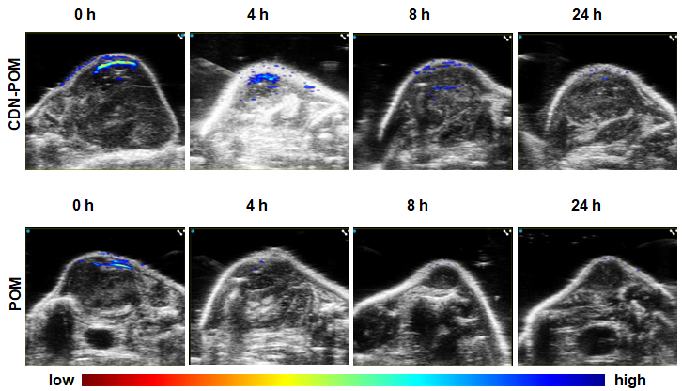
Figure.1 In Vivo near-infrared spectral photoacoustic imaging. PA images of the tumor region were obtained at 0, 4, 8 and 24 h post-injection of POM (1 mg/mL, 100 μL) and CDN-POM hydrogel (100μL, 1% wt POM).

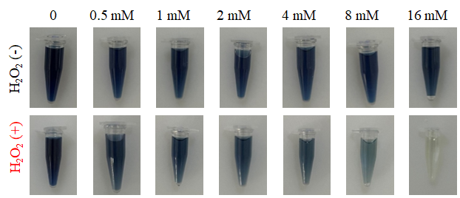
Figure.2 POM before and after incubation with H₂O₂ at various concentrations.

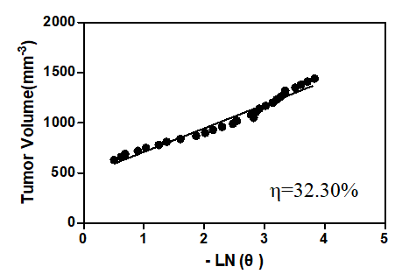
Figure.3 The photo-thermal conversion efficiency (η) was calculated as follows: η=hS (Tmax, POM-Tmax, solvent)/I(1-10-A808); t=-tsLnθ;θ=(T-Tsur)/(Tmax,NPs-Tsurr); hS=mdCd/s. The photo-thermal conversion efficiency of POM was 32.3%.

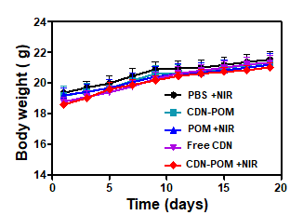
Figure.4 Body weights of mice from different treatment groups.

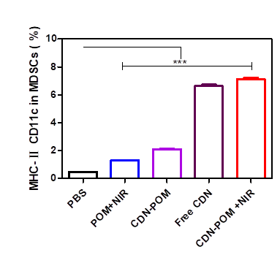

Figure.5 Quantitative analysis of MHC- II or CD11c cells in MDSCs (n=3).
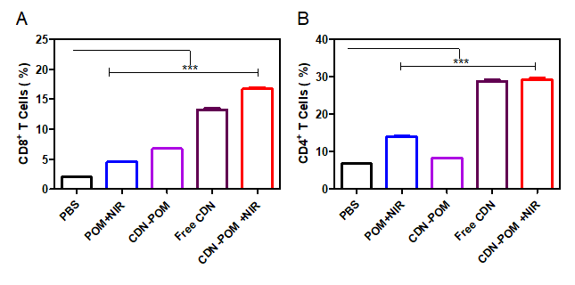
Figure.6 Quantitative analysis of CD8⁺ (A ) and CD4⁺ (B)T cells in the spleen (n=3).

