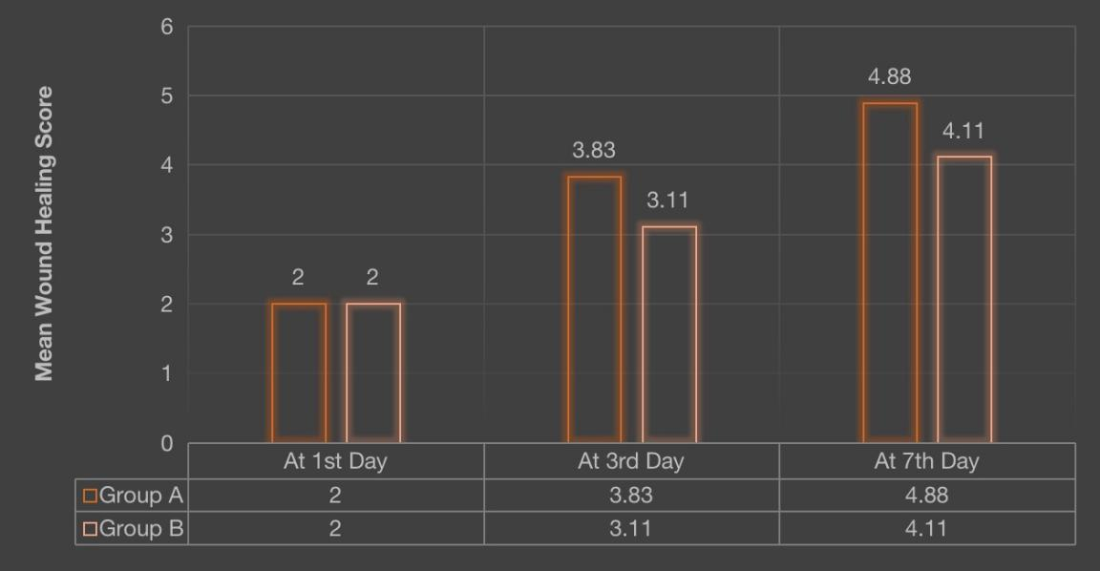
Graph - 1 : INTERGROUP COMPARISON OF MEAN WOUND HEALING SCORES AT DIFFERENT TIME INTERVALS

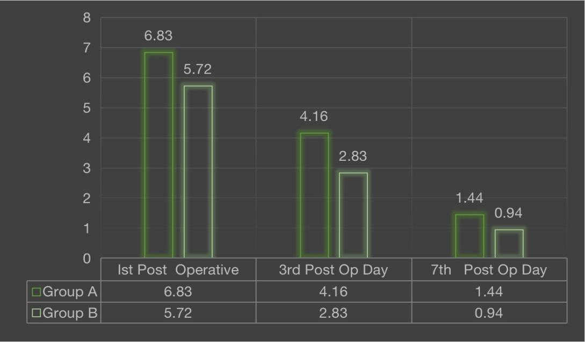
Graph - 2 : INTERGROUP COMPARISON OF MEAN PAIN SCORES AT DIFFERENT TIME INTERVALS
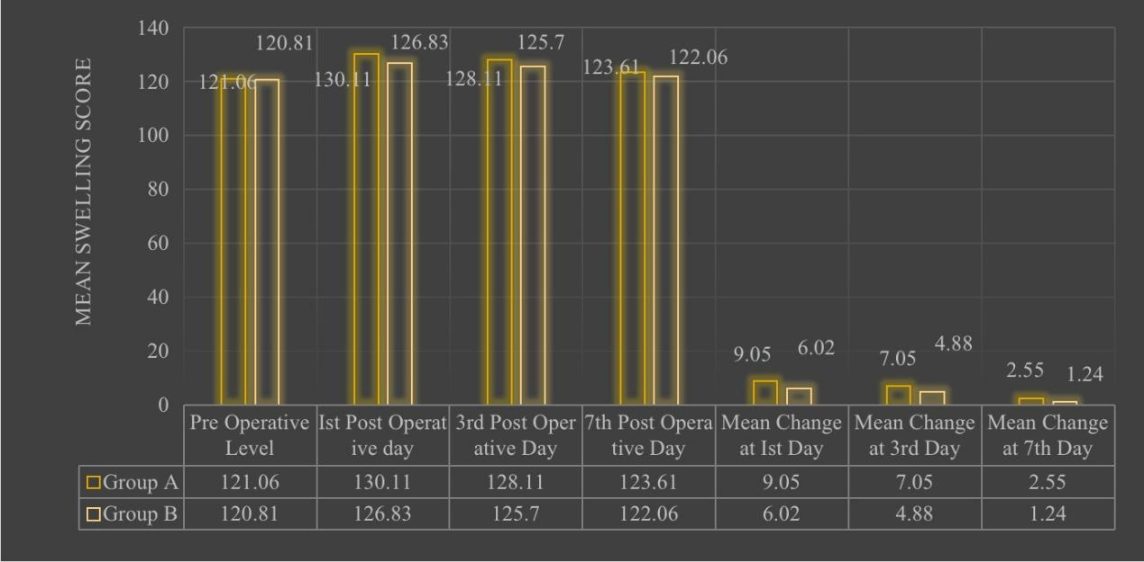
Graph - 3: INTERGROUP COMPARISON OF MEAN TRISMUS SCORES AT DIFFERENT TIME INTERVALS

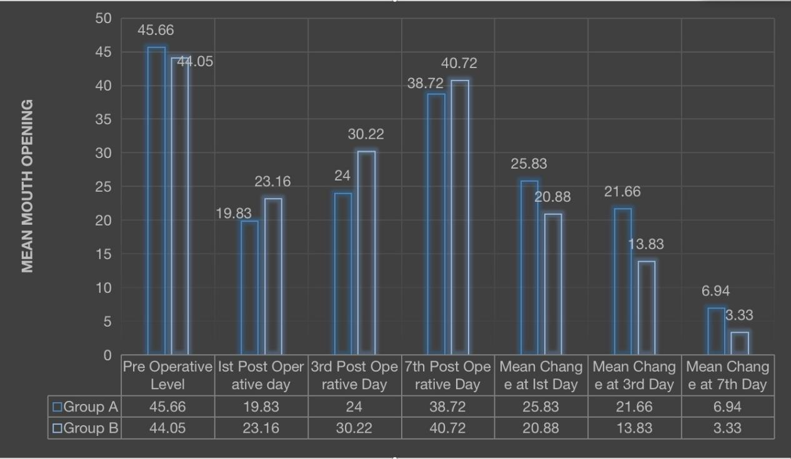
Graph - 4: INTERGROUP COMPARISON OF MEAN TRISMUS SCORES AT DIFFERENT TIME INTERVALS

